Harrison Stone
Uwtsd | 1904085
Networks and Cyber Security
Component 1 report

Introduction
This report will aim to discuss the possible threats that Che-Si’s Systems due to using weak security measures. Then it will explain what can be done to mitigate against the vulnerabilities they are open too. The report will also demonstrate a possible threat that could occur. Another aspect this report will cover is why encryption is important to use for added security and how encryption could also be useful to Che-Si’s network. Finally, it will go over a strategy to improve the current security policy in place.

Che-Si’s security flaws
Opening a network up to “staff members, clients and vendors to access their network from any locations and from any devices.” Is going to drastically decrease the security of the network.
The first problem with opening a network to so many different people on any device they want via a cloud server is that you may encounter a malicious insider threat. This is someone usually who has worked within or closely to the business or have gained access to an staff members account who in this case would all have access to the network and uses their inside knowledge to steal private or sensitive data. They could also be given the wrong role definition which may allow an admin to go rogue and collect client data for example. “21% of cyber-attacks were caused by insiders”. [1] And these attacks can often be much harder to trace back to the attacker “Since the insiders are familiar with the IT operations of their own companies, the attacks are generally difficult to be traced using forensic analysis.” [1]
The second possible issue is malware injection attacks. “cloud systems are also susceptible to malware injection attacks” [1] The most common of these attacks is a Structured Query Language (SQL)Structured Query Language injection attack. This can be used by a cybercriminal to steal confidential data. Which in Che-Si’s case would be “staff's personal data, business data and client's data”. They could also use this type of attack to retrieve passwords and login information and “gain unauthorised access to the backend databases.” [2]Which means they may gain access to all the files within the cloud storage. This is one of the most common form of hacks, so it is very important to protect yourself properly from them. “Research has shown that the SQLI attack is an extremely common hacking method. In the past 10 years SQLI has been linked to 90% of database records stolen.” [3]
Another Issue with the Che-Si’s policy is allowing people to use any device to access the network. Is that people that can access your network may be able to find out the cloud servers IP which In turn the person with malicious intent could take down the network with a DDOS Attack “Distributed denial of service (DDoS) attack presents a critical threat to cloud infrastructure” [3] This type of attack is done by sending to much data in the form of packets to a host for the host to process. This attack is usually carried out by a botnet which are computers which have been infected with malware which can be used by the attacker to launch larger attacks as there is more devices sending the packets. This is backed by “Once a botnet has been established, the attacker is able to direct an attack by sending remote instructions to each bot.” [4]. This type of attack may not steal personal data however it will allow the potential hacker to stop people accessing their accounts as the network would be inaccessible.
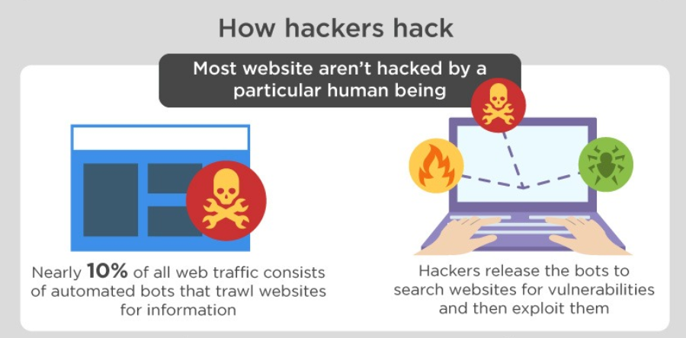

Che-Si’s system is a WAN network or wide are network this essentially mean that people can access it from anywhere as long as they have an internet connection. This comes with a range of other security threats as Nirav Shah [5] suggests –
- Security gaps
- Increased vulnerability to viruses and malware
- Susceptibility to phishing scams
- Data breaches
- Network compromise
“Security gaps” [5] refer to possible gaps currently in “network security measures, policy and procedure” [6]This could be a user with the wrong privileges on the network or a policy has not been correctly implemented.
“Increased vulnerability to viruses and malware” [5]This is because there are more people with access to the network there is better chance that a hacker infecting the network with malware.
“Susceptibility to phishing scams” [5] Phishing scams are instances where the criminal gains data from an organisation by using fake sites that could look identical to your networks site. But they use this to get the user to input personal data or credit card details. This is backed up by “. Email addresses in the wrong hands can be dangerous as it can likely lead to phishing scams and additional personal information being compromised.” [7]. This shows that hackers can gain information from a business and sell it to scammers which may harm employees and clients if they fall victim to these scams.
Data Breaches are when a cybercriminal gains” “‘unauthorised access to sensitive, protected or confidential data resulting in the compromise of either confidentiality, integrity or availability of an information asset’.” [8] They often do this by pretending to be someone working at the organisation making a email address almost identical to someone working there or impersonating via text.
Furthermore, Shah went on to say another issue was “Network compromise” [5]. Was another issue with this type of network. Sometimes you will not even know it compromised the malware they have installed could have been quietly taking data for multiple years without anyone seeing.

Conclusion of Che-Si’s cyber security issues

To conclude the building companies’ security has currently got a lot of security risks. The chance of these risks occurring are higher in a WAN network:
- Malicious insider threat
- Malware Injection attack
- DOS or DDOS attack
- Security Gaps
- Possible Data breaches
- Phishing Scam
- Network compromise
These 7 issues could drastically affect the overall security of the company’s network and are all likely to affect the things that Che-Si worries about. “which might compromise the security of staff's personal data, business data and client's data.”

Possible improvements
These improvements will aim to maximize the productivity and performance whilst also keeping the system as secure as possible.
Firstly, to improve security against all potential threats is to train staff to follow some guidelines to what an employee should and should not do whilst on the network which will be explained more in a later section.
Secondly the way to help ensure that an insider threat is less likely to occur is to ensure that the role management is done accurately ensuring no-one who is no longer working for the building company anymore still have admin privileges on the network and could still possibly log back in. Another solution is to use a monitoring system” agencies should consider automated monitoring of user activity, which can quickly alert managers to suspicious activity”. A good example of an alert that might pop up if the user is accessing it from a completely new device and will automatically downgrade their admin privileges until a manager can confirm if it is a threat or not.
Furthermore, Malware injection is also a major threat to the company’s personal data and security. A way to stop this is use a detection method. This would usually be covered by an antivirus software or firewall. “Conventional malware defences use signature-based techniques to search for known patterns in executable code.” [10] However you can never be sure that your anti-virus will pick up the threat. As new malware may be being used which has not yet been added to the virus protections database.
Another possible attack that the building company may experience is a DDOS attack or denial of service attack. The first thing Che-Si could do to help prevent against this kind of attack is planning. This would include using software and hardware which has higher level security. Usually these would be trusted well known vendors. It would also be useful to hire a team of a few people to monitor the network and ensure if any kind of attack occurs then they are tasked with responding to the issue. Set a plan on escalation procedures for example who to contact If an issue does arise and ensuring if it does occur, they effectively deal with the treat. It Is also to keep track of everyone who is connecting to the network as it may help to identify where the threat is coming from.

Security gap is also important to keep the network secure as without the correct policies in place people may use loopholes be responsible for causing problems. It is important to use an industry standard security framework “One of the most common frameworks is the ISO/EIC – 27002 standards.” [11] Asher also suggests these questions to be asked to minimalize risk of [11]
- How is access for new hires and terminations handled?
- Is there a standard role-based policy in place that helps ensure that the correct access is provided to each job position?
- How are changes implemented in your environment?
- Are there standard procedures and approvals that are required before a change is made?
- Is there a back-out procedure in case there is a problem?
- Is staff training provided to keep your company abreast of evolving security risks?
If all these questioned are answered by the company it will lower the chance of an issue of a security gap causing a data breach or allowing an unauthorized person to access the network.
Phishing scams are also likely to be a threat as they are very common. To mitigate the damage if a phishing scam ever tricks a staff member the National Cyber Security Centre (NCSC) recommends
“You should configure your staff accounts in advance using the principle of 'least privilege'. This means giving staff the lowest level of user rights required to perform their jobs, so if they are the victim of a phishing attack, the potential damage is reduced. ” [12]
This is a good method to do as its easy and has no cost to implement just simply go into the account settings for staff and reduce them to the privileges that they need to complete their tasks. Another way to avoid phishing scams is by “ensure that your staff don’t browse the web or check emails from an account with Administrator privileges” [12]This is because a user can do minimal damage on a non-admin account so avoiding going on the internet on an admin account is advised for security reasons.
I also recommend that Che-Si’s ensures their cloud provider has got good security measures in place and counter measures against the hackers. However, these would vary depending on sellers, but some cloud services have been compromised in the past. I would recommend using sync.com for a cloud service as it automatically encrypts data once it has been installed to the cloud and has all these benefits.
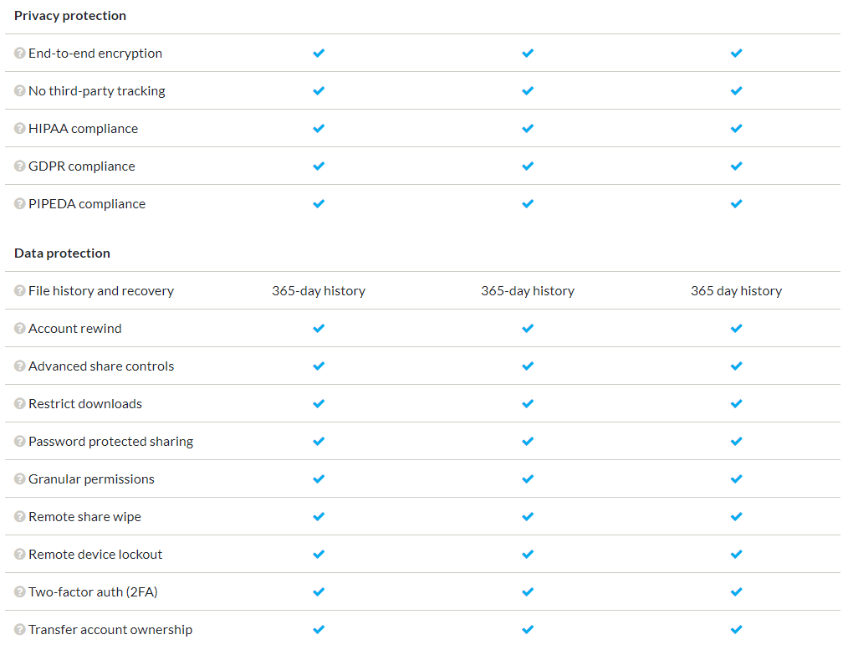
This cloud service will also help to mitigate the damages as it has file history so if information is lost it can be recovered. It encrypts files uploaded to the cloud which means that the files are secure as encryption makes a file impossible to understand without using a encryption key to decode. However, this cloud automatically encrypts and decrypts it for the user making it easy to use. And has 2 factor authentication which will help stop breaches as more forms of verification are needed to prove that the user is authorized to access the network.

Demonstration of packet sniffing on ubuntu using Wireshark.
This demonstrates a program called Wireshark which can be used to packet sniff. This demonstrates in use receiving a ping on the ubuntu network and can see the sender and receiver. This could also be used to find the data which is being sent which is why encryption is important.
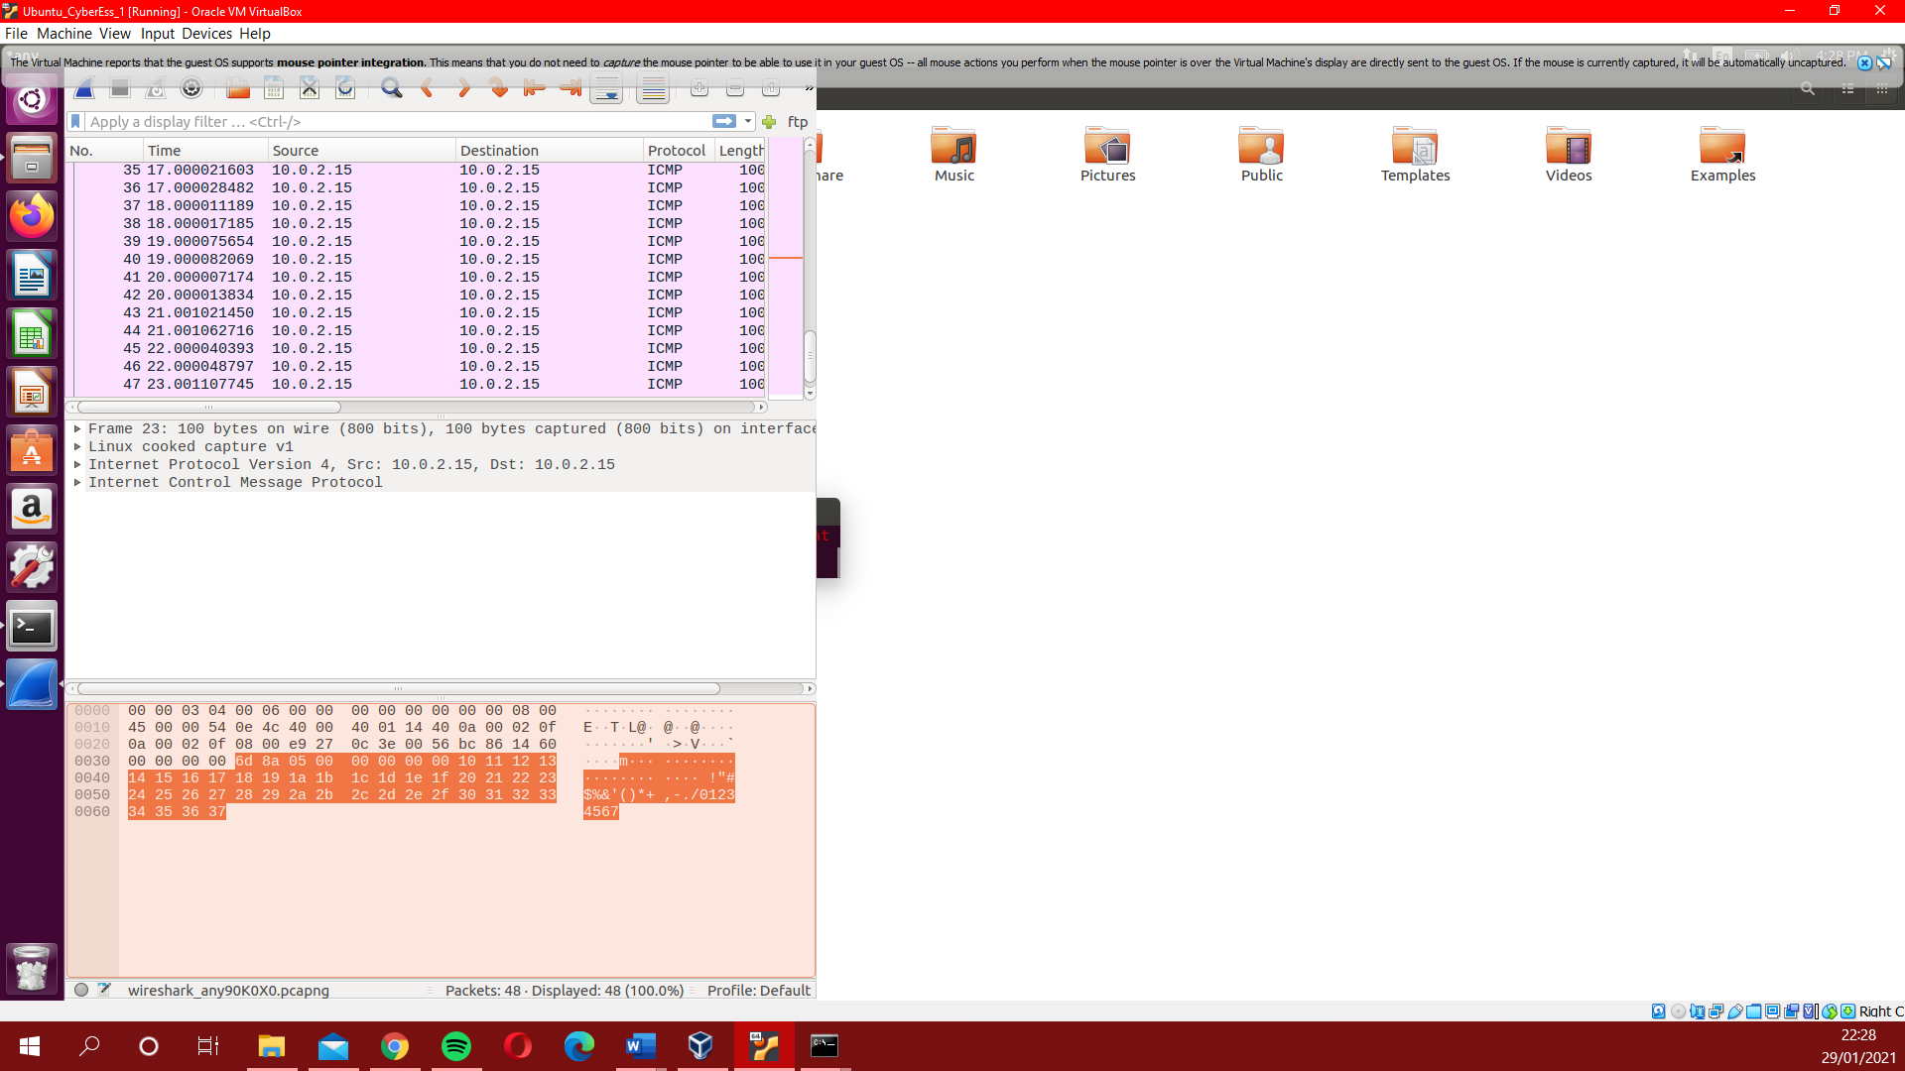
In this demo its only a ping however if it were a confidential file, they would be able to see the commands input to the server with login username and password for example. Which could then give them access to the server.

Protection via Encryption and digital signature
Digital signature is an easy to use but very strong method of ensuring who a message is really from. These use hash-based schemes. Which are generated by the user and can not be altered by unauthorized parties. This could be used in Che-Si’s company when sending information between staff members. To ensure there are no impersonators. Encryption is also a great way to ensure the safety of files. As if a file is encrypted a potential hacker will not be able to read it contents always keeping the information secure.” the process of converting information or data into a code, especially to prevent unauthorized access.” [13]there are lots of software’s which encrypt files for you. You can download one such as lastpass

