

ASSESSMENT COMPONENT 1: MARKETING ENVIRONMENT ANALYSIS
Module: Marketing Management
Lecturer: Dr Laila Maazouz
Student Name: Hasibul Hasan Shanto
Student ID:2434288
Submission Date: 21st November 2025

Table of Contents
Introduction 3
Task 1: Critical Analysis of the Macro Marketing Environment 3
Overview of the Macro Marketing Environment 3
The Technological Environment 3
Opportunities for Pioneering Organisations 3
Threats for Pioneering Organisations 4
Opportunities and Threats for Follower Organisations 4
The Environmental (Ecological) Environment 5
Opportunities for Pioneering Organisations 5
Opportunities and Threats for Follower Organisations 6
Comparative Analysis of Technological and Environmental Actors 6
Task 2: Strategic Responses to Technological and Environmental Factors 7
Pioneering Organizations’ Strategic Responses 7
Pioneering Firms: Strategic Proactivity through Digital Transformation 7
Pioneering Firms: Initiative-taking Green Innovation and Value Leadership 7
Follower Organizations’ Strategic Responses 9
Follower Firms: Strategic Imitation and Cost-Optimized Adoption 9
Follower Firms: Reactive Sustainability and Compliance-Based Strategy 9
Integrating Technology and Sustainability: Strategic Synergies for Competitiveness 10
Conclusion 11
Reference List 12

Introduction
The interaction between technology and the issue of environmental sustainability has emerged to be the center point of strategic marketing management in the present day. The organisations now are under constant pressure to not only be innovative digitally but also stay in line with the global sustainability requirements. Pioneering companies take the initiative approach to industries which transform digitally and add green innovation unlike their follower companies which take adaptive and balanced approaches to risk, cost, and competitiveness. The current report critically analyses the way senior and follow organisations effectively react on the forces of technology and environment to ensure that they reduce the leading position in the market. It uses appropriate literature and examples of how marketing strategies based on innovation, flexibility, and responsibility can contribute to long-term competitiveness.

Task 1: Critical Analysis of the Macro Marketing Environment

Overview of the Macro Marketing Environment

The Technological Environment
Technological change has been one of the most revolutionary processes in the marketing scene. The nature of the association between firms and consumers has been transformed with the emergence of artificial intelligence (AI) and big data analytics, and e-commerce platforms (Nair and Gupta, 2021). In instance where techno evolution is a fertile generator of innovation to the first mover firms, it could be a competitive impediment to the second mover firms of evolution and can serve as a means of adaptation. According to Saura (2021), organizations that can execute the structure of data science develop dynamic marketing capabilities, and their rivals could hardly replicate them within a comparatively brief period. Thus, technology is a current opportunity for leaders to possess market share with the capacity to shape the expectations of the customers.

Opportunities for Pioneering Organisations
Pioneer companies deploying AI and data-driven technology are claimed to achieve the high performance of marketing. Implementing AI in the marketing process, as Wu and Monfort (2023) say, it is possible to reach the accuracy of targeting, customer segmentation, and predictive analytics so that it is possible to increase customer contact and conversion rates. An example of this is the case study of Tesla, which is a technological leader in the automotive industry. This is attributed to the fact that its use of real-time data analytics and software patches that are provided via over-the-air has revolutionized customer experience and brand differentiation. Similarly, within the retail sector, Amazon has applied the AI-suggested recommendations to individualize customer interaction, and this has resulted in the long-term customer retention and dominion on data (Li and Zhang, 2021). Technological innovators can also have an impact on industry standards. They are the pioneers to reap the benefits of first movers in brand reputation and power of price since they have developed regulations in digital transformation.

Threats for Pioneering Organisations
Nevertheless, being the first in technological innovation is not a safe game. The high rate of change may make technological obsolescence a liability. Pioneers are extremely exposed to strategic risk due to large expenditure on research and development, uncertainty in the minds of the consumers and cyber security risks. The competitive advantage of the innovators can only be destroyed with the use of technology because, as Peattie (2023) notes, disruptive innovations occur at a faster pace that the innovator is unable to match. In fact, the initial smartphone successors like BlackBerry failed to stay on top of things when Apple re-invented user experience through the assistance of integrated ecosystem. There is also the ethical and privacy concern of AI marketing, which consists of algorithmic bias and data misuse which are likely to cause less credibility to a brand. Nair and Gupta (2021) caution that further encroaching with the use of AI in the marketing decision-making process, companies should have a thin boundary between customization and consumer privacy.

Opportunities and Threats for Follower Organisations
Learning also emerges with the follower firms, since they are not required to incur an excessive cost of innovation to imitate the technologies they observe. They often follow the tactic of adaptive imitation because they are used to building upon the existing technologies to fit in with the niche markets. To illustrate, Hyundai exploited the modern technology of Tesla in producing electric vehicles and manufactured hybrid cars that were made cheaply to the audience in the market, and this captured the low-end customers. Smaller e-commerce sellers, in their turn, replicate the forms of digital logistical networks offered by Amazon with the help of scalable online merchandise like Shopify. However, the followers are highly technologically dependent. Competitive agility of such companies is a factor of availability of external technological infrastructure which can restrict varicosities and margin expansion. Li and Zhang (2021) assume that in most instances, the follower firms are faced with issues of data fragmentation and failure to conduct analysis culminating in poor marketing knowledge. Thus, there is the democratization of the marketing innovation on one hand, and increased competition and the loss of strategic uniqueness among followers on the other hand.

The Environmental (Ecological) Environment

Opportunities for Pioneering Organisations
Reputational or financial gains can be attained by leading the pack of organisations that include environmental sustainability in the marketing policies. Individual companies that invest in environmental management based on eco-innovation and the circular economy become leaders in terms of environmentally responsible companies. An example of such is the company Patagonia that has been running its brand as an ecological activist, turning the ecological responsibility into a consumer trust and promotion. Tesla is another good example of marketing its brand at the boundary between innovation and environmental sustainability, and it is applied, once again, to the automotive industry. Tesla has earned the eco-conscious consumers and the government subsidy in every corner of the world with its leadership in the field of electric mobility and integration of renewable energy.
Threats for Pioneering Organisations
Despite these advantages, there are severe risks of operation that are linked to environmental leadership. Profit may be strained due to the cost of green technologies development, regulatory restriction, and varied customer needs. First-movers in the sustainability sector must address the issue of front-loaded investment as discussed by Peattie (2023), and the advantages of the green innovations are not likely to be effective initially. Further, more stakeholder attention can add to reputational damage in situations where sustainability arguments are seen as a kind of greenwashing. This, as Feng, Zhang, and Li (2022) remark, occurs among those companies that fail to invest in green innovation whose competitiveness on increasingly environmentally decentralized markets and carbon responsibility diminishes. Innovative businesses, in which sustainability participates in value propositions, can build emotional and moral bonds leading to the ultimate loyalty of a customer, as Sharma (2021) specifies.

Opportunities and Threats for Follower Organisations
The following organisations can adopt the proven green technologies in a strategic way once the pioneers have assured them that the technology is viable in the commercial aspect. They can place themselves in such a position as being cheap alternatives and address consumer environmental concerns. To explain the example, Toyota was initially left behind, in terms of being in front in terms of propelling the full-electric, but ultimately used a hybrid technology, which proved to be appealing to more people who appear to have trouble switching to full-electric power. However, the followers are also subjected to the loss of perception of value which is associated with the diminished environmental authenticity attributed by the consumers. In addition, the inability to conform to the environmental requirements in time can lead to the inability to meet the regulatory requirements and the reputational fines.

Comparative Analysis of Technological and Environmental Actors
Macro Actor | Pioneering Organisations – Opportunities | Pioneering Organisations – Threats | Follower Organisations – Opportunities | Follower Organisations – Threats
Technological | First-mover advantage; data-driven marketing innovation; AI-led customer insights (Wu & Monfort, 2023) | High R&D costs; rapid obsolescence; cybersecurity and ethical concerns (Nair & Gupta, 2021) | Learning from pioneers; reduced innovation costs; access to digital infrastructure (Li & Zhang, 2021) | Technological dependency; limited differentiation; data fragmentation (Peattie, 2023)
Environmental | Green brand leadership; access to eco-conscious markets; regulatory incentives (Sharma, 2021) | High investment in sustainability; reputational risk from greenwashing (Peattie, 2023) | Cost-effective green adaptation; reputation enhancement through compliance | Lagging brand image; regulatory penalties for delayed adaptation (Feng et al., 2022)

Task 2: Strategic Responses to Technological and Environmental Factors

Pioneering Organizations’ Strategic Responses

Pioneering Firms: Strategic Proactivity through Digital Transformation
Digital transformation with the assistance of strategic organisations enables a firm to fast-track its operations and redefine the industry standards in terms of marketing. Chen et al. (2022) allege that digital transformation opens the market environment and enhances the information environment that is beneficial to strategic agility. It is demonstrated by such companies as Amazon and Tesla that rely on high-level digital infrastructure to create a forecasting marketing system. The algorithmic recommendations offered by Amazon through the artificial intelligence technology make the customers experience hyper-personalised consumers, whereas the Tesla software is updated regularly and the vehicles become smart machines to ensure that the customers are ever conversing. These remain aligned with the models of digital transformation, which concern the integration of data, the centrality of customers, and continuous renewal of technology.
Technology creation also supports innovation through creation of value exchange cycles, which results in the development of more insights that could in turn guide the marketing decisions more accurately. Early movers are heavily entrenched in digital marketing ecosystems such as interaction of the omnichannel or personalised content which helps them to maintain their competitive presence. Like Kant et al. (2023) argue, the marketing strategy is interrelated with the long-term sustainability through entrepreneurial innovation. This is realised under technological differentiation that these organisations employ to accomplish high-quality products and proceed to grow with the support of product development of Ansoff Matrix structure. This confirms that frameworks of digital transformation such as strategic innovation models create effective competitive moats that can be used to lead in the industry over the long term.

Pioneering Firms: Initiative-taking Green Innovation and Value Leadership
First movers in green innovation in pioneering organisations are first to include the value of environmental responsibility in their value propositions. The environmental policy and strategic marketing are also connected with the governmental policies and subsidies to promote productivity and innovation in the new-energy industries (Lin and Zhang, 2023). Tesla is the example of those - making its electric cars at the intersection of technological and environmental sustainability, and the Unilever Sustainable Living brands shows that going eco-friendly initially positively impacts brand equity. The practices are reflective of the green marketing models, which are geared towards incorporation of sustainability, value of stakeholders and positive innovation.
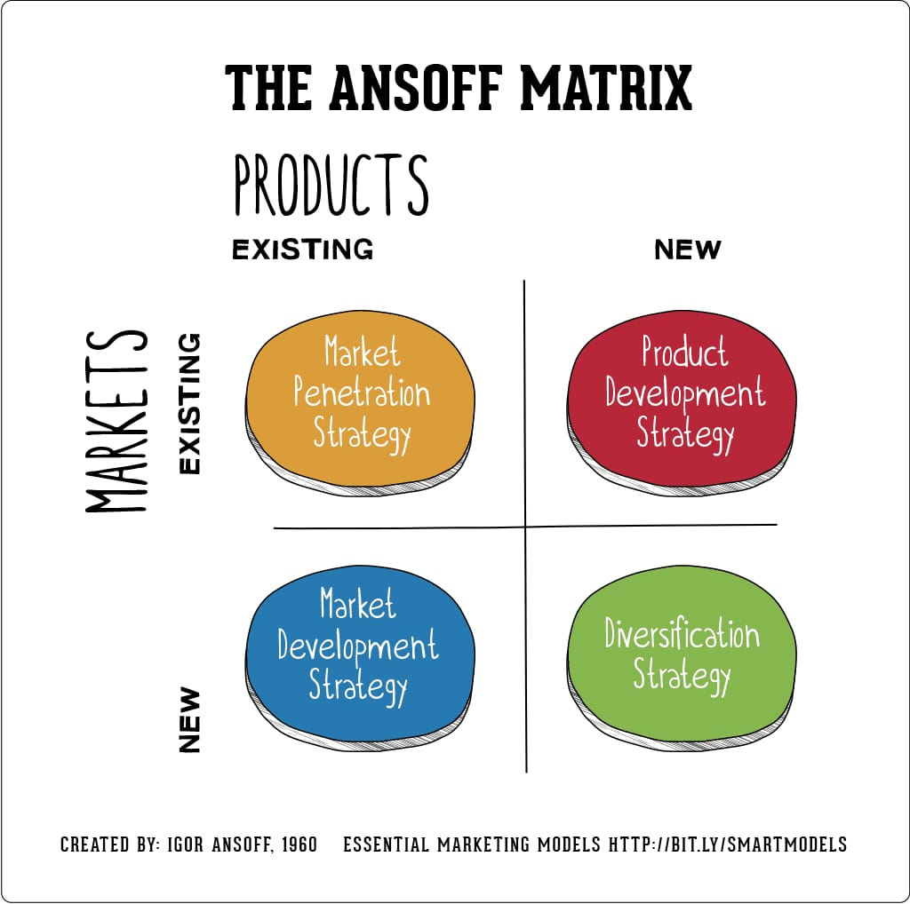
Green marketing also advocates the socialization and community-based conservation (Apaza-Panca, Quevedo and Reyes, 2024). The primary tool to the work on the equilibrium between ecological desires and consumer identity is to establish the top companies that regularly practice cause-based promotions and transform sustainability into not an obligatory measure, but a merit of the goods. The effectiveness of such strategies will be determined by the environmental attitudes of the consumers that indicate an improved brand authenticity and consumer confidence, as stressed by Kaur, Gangwar and Dash (2022). Through the market development strategy of the Ansoff Matrix paradigm, this has seen such organisations tap into markets that are sustainability-driven as well as exploit green innovation to acquire long term growth and competitive advantage.

Follower Organizations’ Strategic Responses

Follower Firms: Strategic Imitation and Cost-Optimized Adoption
Although follower organisations do not take the centre stage of digital transformation, they resemble the adaptive imitation and incremental innovation in their reaction to the strategy. An example of the follower response may be one point in the retail sector and the Walmart online response to Amazon takeover. The data analytics and mobile commerce later in the cycle allowed Walmart to sustain the cost of R&D as the scale was facilitated by the process of integration of logistics and supply chain. As Chen et al. (2022) opine, these followers are at the advantage of viewing the technical testing of innovations and, consequently, introduce new advanced and less threatening models.
Nonetheless, the achievement of the technological distinctiveness among the adherents is also predetermined by a drawback, which leads to the incessant competition on the price-related basis but not the diversity linked to innovation. To reduce this, the followers engage in strategic partnerships with the technology companies like the one that has been developed between the classic car companies like Ford and the software companies like Google. Through such collaborations, the followers are able to bridging the soft gap in the innovation without necessarily paying the full cost of the digital infrastructure. It is in these reasons that the followers are competitive with the help of strategic agility a balance between the application of the proven technologies and the maintenance of the cost efficiency.

Follower Firms: Reactive Sustainability and Compliance-Based Strategy
Instead, the reactive environmental strategy will be oriented to the regulatory pressure and the necessity of competition by the follower organisations. With this occupying this consideration of the energy industry, the most influential companies in the industry including the BP companies and Shell started rebranding themselves by investing in renewable energy to be in accord with the global sustainability requirement. Government incentives and subsidies are a reactive, rather than initiative-taking position in such companies, which finance their transition which has been mentioned by Lin and Zhang (2023).
Most of the time, the followers use green communication to refer to conformity, as opposed to ecological revolution (Majeed et al., 2022). However, it can lead to a short-term benefits image in reputation, this can be claimed to be greenwashing particularly in a sector where social responsibility is critiqued. The slow environmental invention like packaging minimization or optimization of emission hence keeps the followers organisations in the books of legitimacy but profitless. Despite this, with a certain segmentation, pricing activity, the cost-conscious portion of the market, which insists on environmental-friendly and products at affordable price can be regarded as a possibility.

Integrating Technology and Sustainability: Strategic Synergies for Competitiveness
The other frontier in offering a strategic marketing innovation frontier is digital transformation and environmental sustainability. A growing number of leading companies are uniting to develop digitally empowered green policies, quantifying, selling, and administering sustainability initiatives and programs using data and automation. As Chen et al. (2022) state, the idea of transparency evolves positively in the context of digitalization and provides an opportunity to credibly report on sustainability. Apple can be seen as an environmentally responsible company as an example of the digital supply chain traceability system and carbon accountability of suppliers. The second strategy that follower firms are enjoying is green digital transformation. The blockchain supply chain traceability aspect of investments at Walmart describes how the adherents can incorporate the utilization of technology along with sustainability compliance in enhancing customer confidence.
Similarly, Rollins et al. (2023) proves that marketing systems can affect the perception of society, and corporate messaging, especially in a controlled industry such as infant nutrition, can shape the policy of society and consumer behaviour. Thus, in a sense of infusing the marketing efforts with accountability and digital technologies, the adherents should employ the approach that would enable them to legitimize their position in the context of environmental accountability. According to Kant et al. (2023), entrepreneurial innovation enables companies to reorient the marketing processes as per the venture sustainability. Therefore, leaders and followers must not view technology and the environment as two agents who are not similar but rather one ought to view them as complementary debunking resources of competitive powers.

Conclusion
The competitive marketing strategies in the industries are still being redefined by technological advances and environmental sustainability. The pioneering organisations are leading by instilling innovation, digitalisation, and genuine green values into their organizations. On the other hand, follower organisations gain their competitiveness by being in strategic adjustment, partnering and cost-effective sustainability efforts. This merger between technology and concern over the environment has provided new ways of differentiation and involvement with the consumer. Finally, innovation, maturity and entrepreneurial spirit must be developed by both first movers and followers to succeed in turbulent global marketplaces. The secret of sustainable competitive advantage in the digital age is strategic responsiveness to technological and ecological pressures.

Reference List
Apaza-Panca, C.M., Quevedo, L.A.F. and Reyes, L.M.C., 2024. Green marketing to promote the natural protected area. Sustainable Technology and Entrepreneurship, 3(3), p.100067.
Chen, W., Zhang, L., Jiang, P., Meng, F. and Sun, Q., 2022. Can digital transformation improve the information environment of the capital market? Accounting & Finance, 62(2), pp.2543–2578.
Donthu, N., Kumar, S., Pattnaik, D. and Lim, W.M., 2021. A bibliometric retrospection of marketing from the lens of psychology: Insights from Psychology & Marketing. Psychology & Marketing, 38(5), pp.834–865.
Feng, S., Zhang, R. and Li, G., 2022. Environmental decentralization, digital finance and green technology innovation. Structural Change and Economic Dynamics, 61, pp.70–83.
Kant, S., Adula, M., Yadete, F.D. and Asefa, K., 2023. Entrepreneurial Innovation Mediating among Marketing Strategies and Venture Sustainability in Ethiopia's. International Journal of Entrepreneurship, Business and Creative Economy, 3(2), p.92.
Kaur, B., Gangwar, V.P. and Dash, G., 2022. Green marketing strategies, environmental attitude, and green buying intention: A multi-group analysis in an emerging economy context. Sustainability, 14(10), p.6107.
Li, L. and Zhang, J., 2021. Research and analysis of an enterprise E-commerce marketing system under the big data environment. Journal of Organizational and End User Computing (JOEUC), 33(6), pp.1–19.
Lin, B. and Zhang, A., 2023. Government subsidies, market competition and the TFP of new energy enterprises. Renewable Energy, 216, p.119090.
Majeed, M.U., Aslam, S., Murtaza, S.A., Attila, S. and Molnár, E., 2022. Green marketing approaches and their impact on green purchase intentions. Sustainability, 14(18), p.11703.
Nair, K. and Gupta, R., 2021. Application of AI technology in modern digital marketing environment. World Journal of Entrepreneurship, Management and Sustainable Development, 17(3), pp.318–328.
Peattie, K., 2023. The Marketing Environment for. Strategic Management in Tourism: [9789368424017], p.17.
Rollins, N., Piwoz, E., Baker, P., Kingston, G., Mabaso, K.M., McCoy, D., Neves, P.A.R., Pérez-Escamilla, R., Richter, L., Russ, K. and Sen, G., 2023. Marketing of commercial milk formula: a system to capture parents, communities, science, and policy. The Lancet, 401(10375), pp.486–502.
Saura, J.R., 2021. Using data sciences in digital marketing: Framework, methods, and performance metrics. Journal of Innovation & Knowledge, 6(2), pp.92–102.
Sharma, A.P., 2021. Consumers’ purchase behaviour and green marketing: A synthesis, review and agenda. International Journal of Consumer Studies, 45(6), pp.1217–1238.
Wu, C.W. and Monfort, A., 2023. Role of artificial intelligence in marketing strategies and performance. Psychology & Marketing, 40(3), pp.484–496.

