Module NaMe: ACCB6017 Usability Engineering
Module Code: ACCb6017
Student NAME: Gabriel Munteanu
Student ID: 2318069
Lecturer: Dr Nassir Ibrahim
Trinity saint david University of Wales (London Campus)

Table of contents
Contents
1. Introduction 3
2. Literature Review 4
3 Research Methodology 5
3.1 Research method 6
3.2 Participants 7
Table 1. Participant profile summary 7
3.3 Data analysis 8
3.4 Ethical and practical considerations 8
4 Questionnaire Results and Analysis 8
4.1 Participant Overview 8
Table 2. Participant Summary 9
Figure 2. Mobile Gaming Experience 9
4.2 Accessibility and Interface Preferences 9
Figure 3. Accessibility Preferences 10
4.3 Tutorial and Gameplay Information 10
Figure 4. Importance of Tutorial 10
4.4 User Suggestions 10
4.5 Summary of Findings 11
5. User Personas 11
6. Requirements Analysis 11
7. MoSCoW Prioritisation 11
8. Prototype Design 12
References 14

Introduction
As mobile gaming continuously grows a transformation has occurred in how users engage with digital entertainment and that is making usability a critical factor in the success of modern applications. The users expect the interfaces to be intuitive, visually appealing and accessible nor carrying about previous gaming experience. An interface that has a poor design can reduce user satisfaction increase frustration and stop users to continue playing . As another very important factor Usability engineering plays an important role in designing interactive systems that are both effective and enjoyable.
In this report we will show how usability engineering process taken during the design of Pandemic: UWTSD London Campus Edition. This is a mobile adaptation of the game Pandemic. Instead of creating a brand new game, our game adapts the original gameplay of Pandemic to a university environment by replacing cities with fictional locations around the university campus. The players cooperate to stop a fictional infectious disease that is spreading around the campus by treating infections, discovering cures and protecting key university locations before the outbreak takes full scale.
Our objective in this project is to develop a prototype that offers a pleasant user experience while keeping the functionality and mechanics of the original game. Special attention was given to the fact that the users need have a pleasant game experience while going thru various levels and could easily understand the interface, navigate the application efficiently and complete gameplay tasks with minimal effort. To be able to offer this recognised usability principles and user-centred design methods have been applied during the development process.
During the design we have followed the principles of ISO 9241-210 (2019), that advises involving users while developing the system to ensure that products are designed around user needs rather than technological limitations. In the beginning the decisions have been taken through questionnaire-based user research involving eight completed participant questionnaires that have been created for this project. The questions focused on participants' gaming habits, accessibility requirements, interface preferences and expectations for game usability.The answers have been analised to identify common themes that have been applied in the design of the prototype.
Some already established usability theories have been applied while the game was developed. Nielsen's (1994) Ten Usability Heuristics helped with interface consistency, visibility of system status and error prevention. Norman's (2013) Design Principles helped with the creation of intuitive controls and informed feedback. Fitts' Law was applied when positioning the interactive buttons, while Hick's Law supported reducing unnecessary complexity within the navigation structure.
While I was analysing the questioners I have noticed that most users were expecting an easy-to-follow tutorial to be highly important then emphasised the need for large readable text, preferred clear icons, and wanted game objectives and remaining actions to remain visible throughout gameplay. Participants also identified accessibility features such as high-contrast interfaces, simple navigation and clear visual indicators as important aspects of the user experience. The interface layout, navigation structure and visual design of the final prototype have been influenced by the reports provided by the questionnaires.
This report demonstrates how user-centred design methods can be successfully applied to develop an accessible, intuitive and engaging mobile adaptation of a well-established cooperative board game.

2. Literature Review

Usability engineering lays the foundation within HCI (Human Computer Interaction) and that focuses that the design of systems are efficient, effective and satisfying for users. The ISO (International Organization for Standardization) states that usability is defined as the extent to which specified users can achieve specified goals with effectiveness, efficiency and satisfaction within a particular context of use [1]. Instead of focusing only on system functionality, usability engineering is focusing on the needs expectations and behaviour of users while we design the system. Users are the most important during game development as they expect intuitive interfaces and engaging interactions while using devices with limited screen space.
One of the most important research documents in usability engineering is Nielsen's Ten Usability Heuristics [2]. Even if it has initially been developed for software interfaces those principles are extremely relevant also for games development. The heuristic of Visibility of System Status states that users should always be aware of what is happening within the system. For our game (Pandemic: UWTSD London Campus Edition) this principle made us decide to permanently display the number of remaining player actions, current infection level, player role and outbreak counter on the main gameplay screen. This has been also supported by the questionnaire findings as the participants stated that game objectives and remaining actions should always remain visible throughout gameplay.
Another important rule of thumb is Consistency and Standards [2]. This recommends that similar actions should create similar results . Consistent icons, colour patterns and navigation are reducing the learning curve for new users while minimising errors. As a result all navigation buttons are using the same colour patterns symbols and location on the screen allowing users to quickly recognise familiar actions regardless of where they are within the application.
Error prevention is another key aspect of Nielsen's usability principles [2]. Instead of displaying errors on the screen after a mistake is done the user should be prevented from making incorrect decisions . Within our proposed prototype confirmation prompts will be displayed before ending a turn or performing irreversible actions. These design features reduce accidental inputs while maintaining smooth gameplay.
Norman explains that good design needs five things: what an object can do, visual clues for the user, instant responses, logical layouts, and clear limits."[3] He is using the term affordances that describes the possible actions that users perceive they can perform, while signifiers communicate how those actions should be executed. . In this project, large interactive buttons with recognisable icons clearly indicate available actions such as Treat Disease, Move, Share Knowledge and End Turn. Immediate visual feedback following every action reassures users that the system has successfully registered their input.
Norman also argues that effective feedback reduces uncertainty and improves user confidence [3]. As an example, after treating an infected location, the disease counter reacts in real time, and an animation will confirm that the action has been successful. This reduces confusion and contributes to a more satisfying user experience.
The physical characteristics of mobile devices also influence usability. According to Fitts' Law larger targets positioned closer to the user's interaction area require less time and effort to select [4]. Because of that , the prototype will use large touch buttons positioned within easy reach of the thumb, particularly for commonly used actions. This design decision aligns with questionnaire responses where several participants expressed a preference for medium or large buttons and highlighted readability as an important usability factor.
Again referring to Fitts' Law and Hick's Law is suggested that increasing the number of available choices also increases decision-making time [5]. Mobile interfaces containing excessive menus or unnecessary options can therefore overwhelm users and increase cognitive load. So we can minimise the complexity of the game, the prototype groups related actions into clearly labelled menus and that will limit the number of visible controls during gameplay.
Accessibility has become a very important factor within digital design. The Web Content Accessibility Guidelines (WCAG 2.2) recommend sufficient colour contrast, scalable text, meaningful labels and interfaces that remain usable by players with diverse abilities [6]. Several questionnaire participants specifically requested larger fonts, higher contrast and clearer labels, particularly mature students who reported difficulty reading small text on mobile devices. Then in parallel , the prototype adopts a high-contrast colour palette, scalable typography and descriptive icons to improve readability and accessibility.
Modern game usability research also highlights the importance of reducing cognitive load while maintaining player engagement. Sweetser and Wyeth's GameFlow Model proposes that enjoyment increases when games provide clear goals, immediate feedback, appropriate challenge and a sense of player control [7]. These principles influenced the inclusion of a persistent objectives panel, interactive tutorial and clear progression indicators throughout the prototype.
Overall, the literature consistently demonstrates that successful interface design requires more than attractive graphics. Effective usability emerges through careful application of established human-computer interaction principles combined with continuous user feedback. The findings from the questionnaire were therefore interpreted alongside recognised usability theories to produce a prototype that is intuitive, accessible and engaging for both experienced gamers and users with limited gaming experience.

3 Research Methodology
The purpose of the user research was to understand what users would expect from a mobile version of the game. Before starting the games design it was important to understand what users find easy to use and which features they would expect from a mobile game. Because of that the questionnaire mainly focused on usability, accessibility, navigation, interface design and the overall gameplay experience.
A questionnaire was selected because it offered the possibility to ask the same questions to every participant, making the answers easier to compare afterwards. It also allowed information to be collected in a relatively short period of time without forcing the users to spend a long time completing the research.
Questionnaires are widely used in user-centred design because they can collect both numerical information and users' personal opinions. Closed questions make it possible to compare answers between participants, while open questions give users the opportunity to explain their own preferences and expectations.
The research followed the user-centred design approach stated in ISO 9241-210 [1], which recommends involving users during the design process instead of making decisions based only on technical assumptions. Because of this, the questionnaire was completed before the interface was fully designed. The information gathered from participants was then used to support many of the interface decisions that were made during the development of the prototype.

3.1 Research method
A structured questionnaire consisting of twenty questions was created for this project. The questions were divided into four different sections so that different aspects of the user experience could be investigated.
The questionnaire included:
- demographic questions;
- multiple-choice questions;
- five-point rating scale questions;
- open-ended questions.
The first section collected basic information about the participants. They were asked about their age, whether they were UWTSD students and how often they played mobile games. This helped identify whether the participants were regular mobile gamers or users with limited gaming experience.
The second section concentrated on interface preferences. Participants were asked which control style they preferred, what button size they found easiest to use and which visual theme they liked most. They have also been asked if game objectives and the number of remaining actions should always remain visible during gameplay. These questions were included in the questionnaire because mobile devices are providing limited screen space, so displaying too much or too little information can have a massive impact on usability.
The third section focused on accessibility and system feedback. Participants rated how important they considered readable text, recognisable icons, an easy tutorial and accessible interface design. Another set of questions asked were whether features such as sound effects and vibration feedback would help with their gaming experience.
The last part had open questions where participants could describe what information they considered most important during the gameplay and suggest any additional features they would like to have in the game . These responses proved useful because several participants suggested ideas that had not been included in the beginning like including offline play, automatic saving, high-contrast mode and clearer information about how diseases spread across the campus.

3.2 Participants
A total of eight completed questionnaires were analysed. Every participant confirmed that they were a UWTSD student, and all participants were aged 31 years or older. This means that the collected information mainly reflects the opinions of mature students, who represent a significant proportion of students studying at the London campus.
The participants also had different levels of experience with mobile gaming. Three participants reported playing mobile games every day, two played weekly, one played monthly and two stated that they rarely played mobile games. Having participants with different gaming experience was beneficial because the prototype needed to be suitable for both experienced players and people who may require additional guidance.
Only three participants had previously played the original Pandemic game, while the remaining five had never played it before. This became an important finding because the interface could not assume that users already understood the game rules or objectives. As a result, providing a clear tutorial became one of the priorities during the prototype design.

Table 1. Participant profile summary
Participant characteristic | Result
Total participants | 8
UWTSD students | 8
Aged 31 or above | 8
Played mobile games daily | 3
Played mobile games weekly | 2
Played mobile games monthly | 1
Played mobile games rarely | 2
Previously played Pandemic | 3
Had not played Pandemic | 5
The participant profile also suggested that the interface should remain simple and accessible rather than assuming that every user is already familiar with mobile games. Some participants commented that applications should not expect mature users to understand gaming interfaces immediately. One participant explained that small text is difficult to read on mobile devices and suggested using larger fonts together with stronger colour contrast. These comments reinforced the importance of accessibility throughout the design process.

3.3 Data analysis
The responses from the questionnaire were analysed using both quantitative and qualitative methods.
The closed questions were analysed by calculating totals, frequencies and percentages. For example, if seven out of eight participants selected the same answer, the result was expressed as 87.5%. Five-point rating questions were examined by calculating the average rating and identifying how many participants selected either four or five, indicating that they considered a feature to be important.

3.4 Ethical and practical considerations
When we designed the questionnaire we tried to avoid collecting unnecessary personal information. Participants were not asked to provide their names, contact details or any sensitive personal data. Gender was was not considered essential for achieving our research objectives.
Participation was completely voluntary, and the introduction to the questionnaire explained that the responses would only be used to support the development of the proposed prototype.
Another limitation is that participants completed the questionnaire before interacting with a fully working prototype. Their opinions were therefore based on expectations rather than practical experience.
Against all these limitations, the questionnaire produced valuable information for the first steps of development. The responses consistently showed the importance of readable text, visible objectives, recognisable icons, simple navigation and an easy-to-follow tutorial. These findings were combined with recognised usability principles, including visibility of system status, consistency, user control and error prevention helping to shape the overall design of the final prototype.

4 Questionnaire Results and Analysis
The questionnaire responses were analysed to identify the main usability requirements for the proposed mobile game. Both quantitative and qualitative responses were considered to understand users' preferences and expectations. The findings influenced the interface design, navigation and accessibility features of the prototype.

4.1 Participant Overview
Eight UWTSD students completed the questionnaire. Participants had different levels of mobile gaming experience, with three playing daily, two weekly, one monthly and two rarely. Only three participants had previously played Pandemic, meaning most users would require clear guidance before playing.

Table 2. Participant Summary
Characteristic | Result
Participants | 8
Daily gamers | 3
Weekly gamers | 2
Monthly gamers | 1
Rarely play | 2
Played Pandemic before | 3
Never played Pandemic | 5

Figure 2. Mobile Gaming Experience
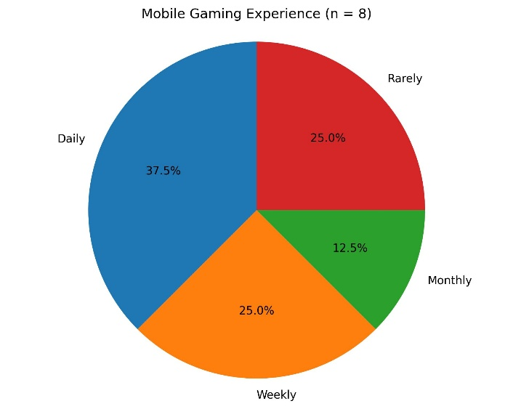

4.2 Accessibility and Interface Preferences
Most participants considered accessibility features to be important. Large text, clear icons and simple navigation received the highest ratings. Several respondents also preferred a high-contrast interface to improve readability.
These findings support the recommendations of WCAG 2.2, which promotes readable interfaces and accessible navigation [6].

Figure 3. Accessibility Preferences
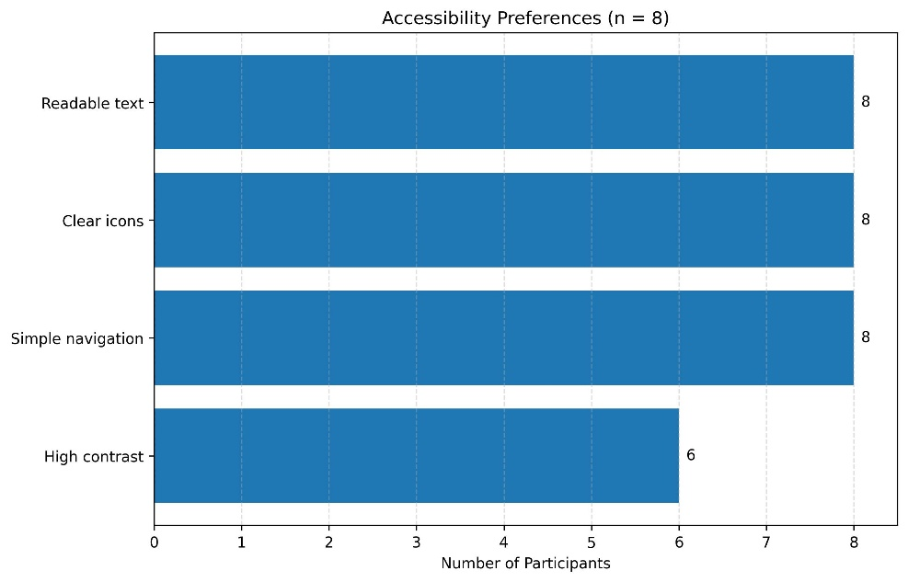

4.3 Tutorial and Gameplay Information
Six participants rated an interactive tutorial as very important, while the remaining two rated it as important. Participants also wanted key information, including remaining actions, infection level and current objectives, to remain visible throughout gameplay.
These findings support Nielsen's principle of Visibility of System Status, which states that users should always know what is happening within the system [2].

Figure 4. Importance of Tutorial
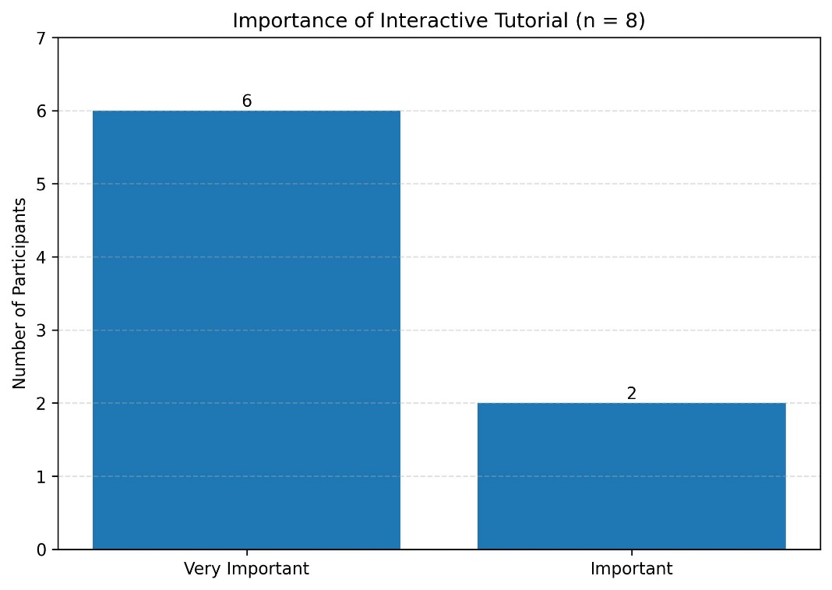

4.4 User Suggestions
The open-ended questions provided useful feedback. The most common suggestions included:
- offline mode;
- auto-save;
- larger text;
- clearer disease indicators;
- London Campus theme.
Although not all suggestions could be included in the prototype, they helped prioritise future development and informed the MoSCoW requirements analysis.

4.5 Summary of Findings
Overall, the questionnaire showed that users expected a simple and accessible interface with clear navigation and visible gameplay information. The results confirmed that tutorial support, readable text and intuitive controls should be prioritised during development. These findings were combined with established usability principles to guide the final prototype design [1], [2], [3].

5. User Personas
Two user types were identified from the questionnaire: an experienced mobile gamer and a casual user. The experienced user values fast navigation, visible game statistics and clear feedback. The casual user requires simple controls, readable text and tutorial guidance.
These user types influenced the prototype by ensuring that the interface was both efficient and accessible. The design therefore prioritised clear navigation, large buttons, visible objectives, readable information and an interactive tutorial.

6. Requirements Analysis
The questionnaire results and literature review were used to define the functional and usability requirements of the prototype. Participants identified the need for an interface that was simple to navigate, visually clear and suitable for users with different levels of gaming experience. Accessibility features, including readable text, clear icons and an interactive tutorial, were considered essential. The prototype was also designed to display game objectives, infection levels and player actions clearly throughout gameplay, supporting efficient decision-making and reducing user confusion.

7. MoSCoW Prioritisation
The MoSCoW technique was used to prioritise the project requirements.
Must Have
- Interactive tutorial
- Campus map gameplay
- Disease spread mechanics
- Clear objectives and status indicators
- Accessible interface
Should Have
- Player role selection
- Visual infection indicators
- Settings menu
Could Have
- Offline mode
- Auto-save
- Player statistics
Won't Have
- Online multiplayer
- Leaderboards
This prioritisation ensured that the prototype focused on delivering the core user requirements within the available development time.

8. Prototype Design
The prototype was developed using a human-centred design approach informed by the questionnaire findings and usability principles. The interface was designed to provide clear navigation, consistent feedback and accessible gameplay for both experienced and inexperienced users.
Figure 8 presents the storyboard illustrating the complete interaction flow. The user launches the application, navigates the main menu, selects a player role and enters the UWTSD London Campus game board. During gameplay, users perform actions to control disease outbreaks while monitoring infection levels and objectives. The game concludes with either a victory or game over screen depending on the player's performance.
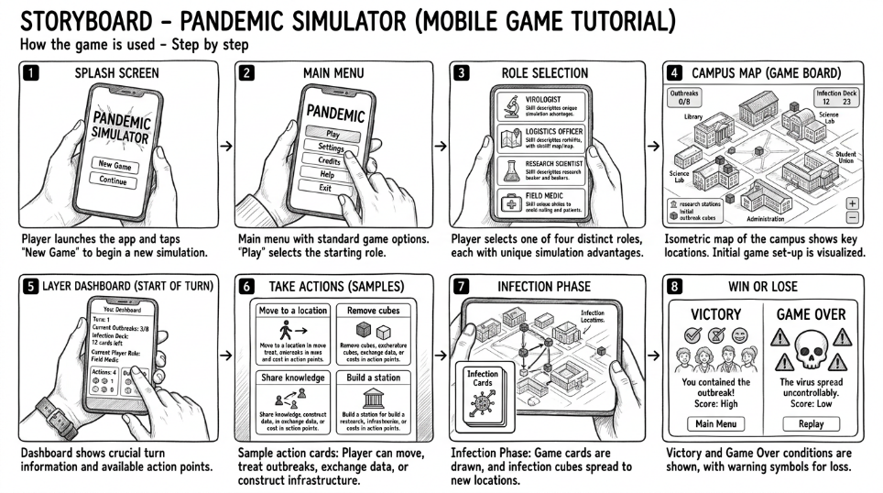
The storyboard demonstrates the intended user journey and shows how the interface supports efficient and intuitive interaction throughout the game.

Appendices :
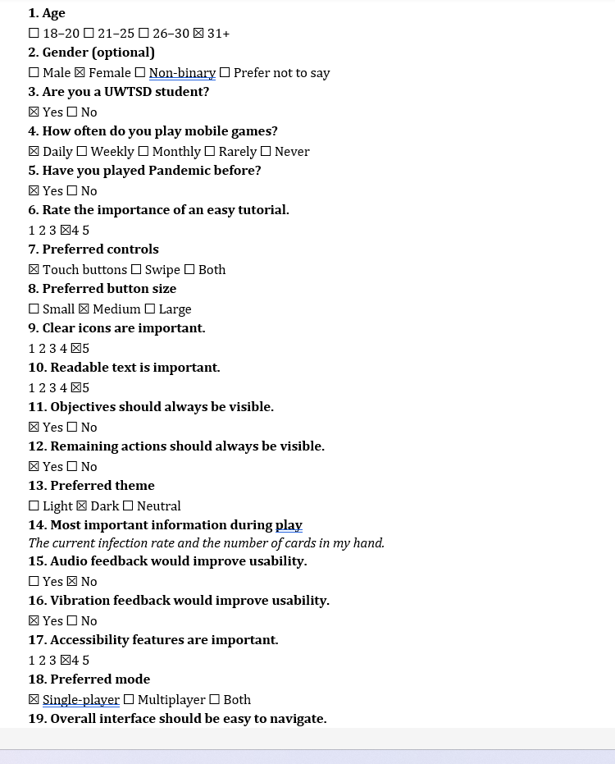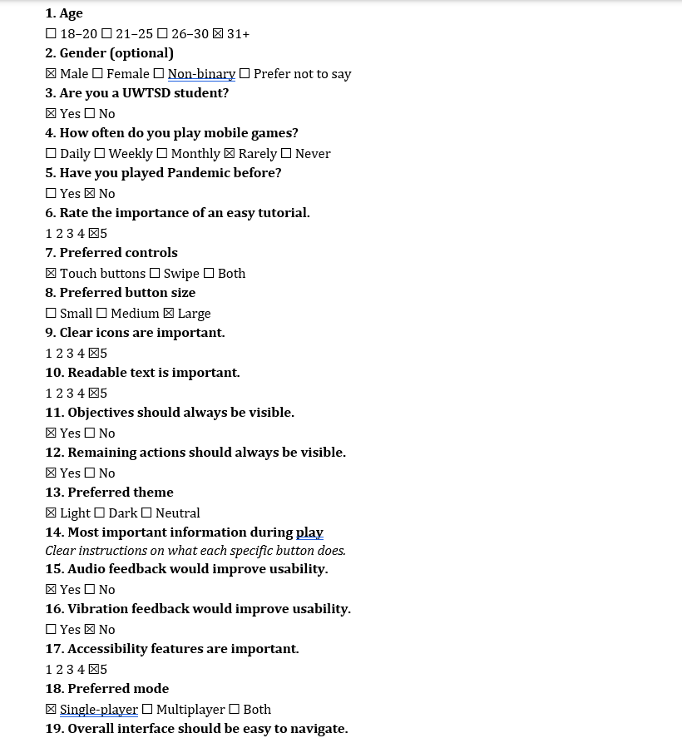

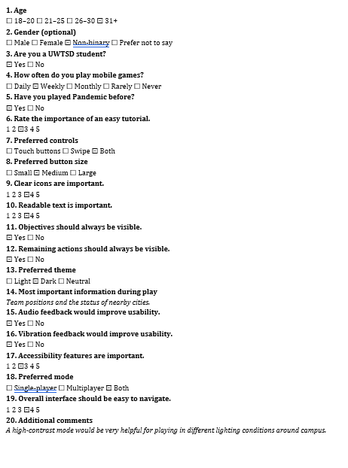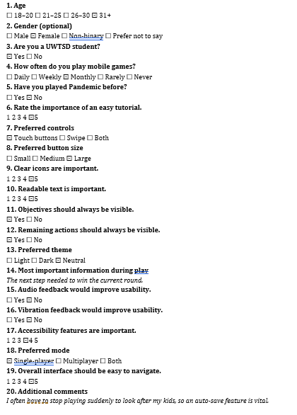

References
[1] ISO 9241-210:2019, Ergonomics of Human-System Interaction—Human-Centred Design for Interactive Systems. Geneva, Switzerland: International Organization for Standardization, 2019.
[2] J. Nielsen, Usability Engineering. San Francisco, CA, USA: Morgan Kaufmann, 1994.
[3] D. A. Norman, The Design of Everyday Things, Revised and Expanded Edition. New York, NY, USA: Basic Books, 2013.
[4] P. M. Fitts, "The information capacity of the human motor system in controlling the amplitude of movement," Journal of Experimental Psychology, vol. 47, no. 6, pp. 381–391, 1954.[5] W. E. Hick, "On the rate of gain of information," Quarterly Journal of Experimental Psychology, vol. 4, no. 1, pp. 11–26, 1952.
[6] World Wide Web Consortium (W3C), Web Content Accessibility Guidelines (WCAG) 2.2, 2023.
[7] P. Sweetser and P. Wyeth, "GameFlow: A Model for Evaluating Player Enjoyment in Games," Computers in Entertainment, vol. 3, no. 3, pp. 1–24, 2005.

