

The Enquiring Teacher – ECPP7001-C
1200616
Word Count – 6,054



RESULT

ASSIGNMENT DETAILS AND FEEDBACK
SOUTH WEST WALES CENTRE FOR TEACHER EDUCATION
Sections marked with * should be completed by module lead
Student name: | Iwan Rees | Student P number: | 1200616
Programme: * | PGCE Primary
Module: * | The Enquiring Teacher | Module Level (6 or 7):* | 7
Module code: * | M7X2152 | Contribution to Overall  Module Assessment (%): * | 100%
Module Lead:* | Catherine Morgan
Assignment Title:* | Write a critical and analytical essay that discusses your practitioner research ‘lesson study’ in relation to a chosen field. | Assignment No (x of x):* | 1/1
Start date:* | 09/01/18 | Submission deadline:* | 16/04/18
Return date of provisional marks & written feedback:*

Referencing: | In the main body of your submission you must give credit to authors on whose research your work is based. Append to your submission a reference list that indicates the books, articles, etc. that you have read or quoted in order to complete this assignment (e.g. for books: surname of author and initials, year of publication, title of book, edition, publisher: place of publication).
Submission: | All assignments must be submitted to Turnitin unless otherwise instructed by the Lecturer.  Note: the Turnitin version is the primary submission and acts as a receipt for the student. Late submission of the electronic version of the assignment will result in a late penalty. Penalties for late submission: Up to one week late, maximum grade D. Over one week late, Refer. Only the Extenuating Circumstances Panel may grant an extension. | Date: | 16/04/18

Module lead to tick to indicate if a hard copy version of the assignment must be submitted.* | YES
 | NO

Learning Outcomes tested  (from module syllabus) | Assessment Criteria: To achieve each outcome a student must demonstrate the ability to:
•Design and apply appropriate research methodologies demonstrating a critical understanding of the nature of educational research  •Conduct a small scale research enquiry to improve an aspect of personal practice and learner outcomes, showing some originality and rigour in the application of appropriate research skills  •Critically evaluate research evidence, showing sound judgement of complex data to support pedagogic decisions  •Critically reflect upon the importance of ethical procedures within classroom based research, and apply these procedures appropriately | - Discuss the intended professional data collection justifying its suitability and purpose;  - Support the study by referring to a range of relevant literature;  - Integrate theory and practice with regard to the pedagogic context;  - Undertake a critical evaluation of the study;  - Discuss the ethical issues that should be considered during the study  - Write a well-structured piece of work in a coherent writing style

TASK DESCRIPTION

Write a critical and analytical essay that discusses your practitioner research ‘lesson study’ in relation to a chosen field.

This should be 6000 words in length.

Further details regarding the structure of the work will be available on Moodle.

You will also be required to submit an Ethics Form as part of the assessment of this module. This will be submitted on the 28th February.

GUIDANCE FOR Students IN THE COMPLETION OF TASKS

NOTE: The guidance offered below is linked to the assessment criteria overleaf.

- Subject Knowledge and Understanding (which includes using research-informed literature and knowledge and understanding of the subject)

Your work must be informed and supported by scholarly material that is relevant to and focused on the task(s) set. You should provide evidence that you have accessed a wide range of sources, which may be academic and/or governmental; these sources may include academic journal articles, textbooks, current news articles, organisational documents, and websites. You should consider the credibility of your sources; academic journals are normally highly credible sources while websites require careful consideration/selection and should be used sparingly. Any sources you use should be current and up-to-date, mostly published within the last five years or so, though seminal/important works in the field may be older. You must provide evidence of your research/own reading throughout your work, using in-text citations in the main body of your work and a reference list that is alphabetical at the end of your work. Please use the Harvard referencing system.

Your work must demonstrate the growing extent of your knowledge and understanding of concepts and underlying principles associated with the subject area. Knowledge relates to the facts, information and skills you have acquired through your learning. You demonstrate your understanding by interpreting the meaning of the facts and information (knowledge). This means that you need to select and include in your work the concepts, techniques, models, theories, etc. appropriate to the task(s) set. You should be able to explain the theories, concepts, etc. meaningfully to show your understanding. Your mark/grade will also depend upon the extent to which you demonstrate your knowledge and understanding; ideally each should be complete and detailed, with comprehensive coverage.

- Intellectual Skills (Analysis)
Your work must contain evidence of logical, analytical thinking, evaluation and synthesis. For example, to examine and break information down into parts, make inferences, compile, compare and contrast information. This means not just describing what! But also justifying: Why? How? When? Who? Where? At all times, you must provide justification for your arguments and judgements. Evidence that you have reflected upon the ideas of others within the subject area is crucial to you providing a reasoned and informed debate within your work. Furthermore, you should provide evidence that you are able to make sound judgements and convincing arguments using data and concepts. Sound, valid conclusions are necessary and must be derived from the content of your work. There should be no new information presented within your conclusion. Where relevant, alternative solutions and recommendations may be proposed.

- Pedagogic and Professional Applications (Practical Application and Deployment)

You should be able to demonstrate how the subject-related concepts and ideas relate to pedagogic situations or a particular education context. How do they work in practice? You will deploy models, methods, techniques, and/or theories, in that context, to assess current situations, perhaps to formulate plans or solutions to solve problems, some of which may be innovative and creative. This is likely to involve, for instance, the use of pedagogic examples and cases, the application of a model within relevant educational context. You should show awareness of the limitations of concepts and theories when applied in particular educational contexts. Your work must provide evidence of the attributes expected in professional practice. This includes demonstrating your individual initiative and/or collaborative working. Where relevant, you should show awareness of any ethical issues that relate to your discussion.

- Key Transferable Skills (Skills for Professional Practice)
You must communicate effectively in a suitable format, which includes written and oral presentation. Work should be coherent and well structured in presentation and organisation.

marking criteria and Student FEEDBACK

This section details the assessment criteria. The extent to which these are demonstrated by you determines your mark. The marks available for each criterion are shown. Lecturers will use the space provided to comment on the achievement of the task(s), including those areas in which you have performed well and areas that would benefit from development/improvement.

Common Assessment Criteria Applied | Grade  awarded
1. Subject Knowledge and Understanding (which includes using research-informed literature and knowledge and understanding of the subject)
Extent of research and/or own reading, selection of credible sources, application of appropriate referencing conventions. Extent of knowledge and understanding of concepts and underlying principles associated with the discipline.
2. Intellectual Skills (Analysis)
Analysis, evaluation and synthesis; logic, argument and judgement; analytical reflection; organisation of ideas and evidence
3. Pedagogic and Professional Applications (Practical Application and Deployment)
Deployment of pedagogic methods, materials, tools and techniques; application of concepts; formulation of innovative and creative solutions to solve problems. Attributes in professional practice: individual and collaborative working
4.Key Transferable Skills
Deployment of appropriate media; presentation and organisation.

Assignment Grade (Assessment grades are subject to ratification at the Exam Board. These comments and marks are to give feedback on module work and are for guidance only until they are confirmed. ) | Late Submission Penalties (tick if appropriate)
 | Up to 1 week late | D Max
 | Over 1 week late | Fail

Level 7 | Assessment Criteria Descriptors for Primary PGCE with QTS  This format emphasizes the holistic nature of judgements to be made by markers. Equal weighting is given to each section. Plagiarism or non-submission will result in F (0%) grading.
Assessment Criteria | Fail - grade E | Weak pass– grade D | Pass – grade C | Pass – grade B | Pass – grade A
Assessment Criteria | Poor | Weak Pass | Satisfactory | Good | Excellent
Overall judgement | Poor understanding, unsystematic, incomplete and/or inaccurate | Understanding of main issues demonstrated | Satisfactory understanding demonstrated with satisfactory analysis | Good understanding of basic principles and relevant evidence, with a coherent and logical argument | Highly thoughtful answer informed by wider reading, showing clarity of thought, personal insight and some originality
Subject Knowledge and Understanding  (Conceptual)  (Reading) | Basic misunderstanding, misconceptions, or misinterpretations - Some superficial knowledge in places | Main concepts understood with limited evidence of critical insight | Sound understanding of concepts and critical engagement with ideas | Good understanding of key concepts; knowledge of wider implications; critical engagement | Engaged critically and systematically with the main concepts and theories: excellent engagement
Subject Knowledge and Understanding  (Conceptual)  (Reading) | Poor and/or inappropriate literature, lacking accuracy, unsound, limited/dated range of sources | Satisfactory range of reading overall although this may be limited in some way | Satisfactory range of reading drawn from the recommended list and other sources | Good range of relevant literature from a variety of sources beyond recommended list | Clear evidence of independent thinking informed by a selective range of reading from a variety of sources
Intellectual skills  (argument)  ( professional data collection: research design/data collection )  (presentation of findings/analysis)  (critical /reflective evaluation) | Little sense of an argument lacks coherence.  Generally descriptive or anecdotal | Argument is balanced with some differing viewpoints presented. Some questioning of assumptions | Argument presented shows satisfactory evidence of critical and analytical reflection. | Strong argument developed. Good evidence of critical and analytical reflection | A well-structured critical argument is presented with evidence of synthesis of viewpoints
 | Professional data collection is inappropriate/ flawed /not discussed | Professional data collection is mainly suited to purposed; beginnings of critical considerations | Professional data collection is suited to purpose and considered critically. | Professional data collection well suited to purpose, justified with clear identified focus | Professional data collection logical and sophisticated; comprehensive understanding of appropriate techniques
 | Findings presented with little or no framework or discussion; or discussion of findings is descriptive. Few conclusions are drawn or conclusions drawn are inappropriate. | Findings are presented with basic analysis and some limited but appropriate conclusions | Findings presented with some analysis and criticality with justified conclusions | Findings presented in a critical and analytical framework. Thoughtful conclusions, firmly based upon the evidence presented | Findings presented in a critical and analytical framework. Insightful conclusions, firmly based upon the evidence presented
 | Little or no evaluation attempted; no or limited reflection | Evaluation and reflection is present but may be limited | Satisfactory critical evaluation of study; satisfactory reflection | Good critical evaluation of study; good reflection | Critically reflective evaluation of work informed by excellent reflection.
Pedagogic and Professional applications  (linking theory to practice)  (professional reflection)  (working in a group)  (ethical conduct where appropriate) | Little or no evidence of engagement or superficial engagement and understanding with respect to the pedagogic and professional context(s) | Some engagement and understanding with respect to the pedagogic and professional context(s) | Sound engagement and understanding with respect to the pedagogic and professional context(s) | Good evidence of integration of theory and practice with respect to the pedagogic and professional context(s) | Excellent integration of theory and practice with respect to the pedagogic and professional context(s)
 | No evidence of reflection | Some evidence of reflection whilst beginning to make links with own practice and thinking | Satisfactory evidence of critical reflection whilst beginning to make links with own practice and thinking | Good evidence of critical reflection whilst making links with own practice and thinking | Demonstrates an excellent level of understanding of critical reflection as a learning process
 | Inability to work with others or works within a group but lacks self direction or group responsibility | Responsibility for planning and developing courses of action; shows awareness of group responsibility | Initiates and occasionally leads tasks/processes for won work and where appropriate for others. | Chooses goals and can self-direct; able to co-operate within a group and can take the lead | Accepts accountability for determining and achieving personal and/or group outcomes
 | Ethical issues not or superficially considered | Some awareness of ethical issues | Appropriate ethical issues raised and discussed; bias/prejudice not noted | Good, clear understanding of ethical issues; awareness of bias and prejudice | Ethical issues have been addressed effectively; bias/ prejudice discussion includes attempts to nullify this
Key/Transferable Skills  (presentation)  (spelling, punctuation and grammar)  (structure)  (referencing techniques) | Poor presentation of written work | Presentation of written work is weak | Satisfactory presentation of written work | Good presentation of written work | Excellent presentation of written work
 | Significant errors in spelling, punctuation or grammar | Some errors in spelling, punctuation or grammar | Spelling, punctuation and grammar are satisfactory; few errors in written language | Spelling, grammar and punctuation are good; very few errors in written language | Excellent standard of written language. No or very minor errors in written language
 | Poor structure with unclear writing style | Structure is present but may be underdeveloped, writing style is mostly coherent | Satisfactory structure with coherent writing style | Good structure with a coherent writing style | Effective structure and highly coherent writing style which fully engages the reader
 | No use or limited use of protocols and conventions including Harvard referencing | Some following of protocol and conventions of Harvard referencing | Satisfactory use of Harvard referencing protocols and conventions | Good use of Harvard referencing protocols and conventions | Harvard system used accurately, consistently and effectively with all sources

Student Self Evaluation Form

This section repeats in brief the common assessment criteria detailed on previous pages. The extent to which these are demonstrated by you determines your mark. Using these criteria, tick the box that best indicates the level of achievement you feel you have achieved with regard to each of them.

Common Assessment Criteria Applied
Common Assessment Criteria Applied | REFER |  | D |  | C |  | B | A
 | OUTRIGHT FAIL | UNSATISFACTORY | SATISFACTORY | GOOD |  | VERY GOOD |  | EXCELLENT
1. Subject Knowledge and Understanding (which includes using research-informed literature and knowledge and understanding of the subject)
 |  |  |  | x
2. Intellectual Skills (Analysis)
2. Intellectual Skills (Analysis) |  |  |  |  |  | x
3. Pedagogic and Professional Applications (Practical Application and Deployment)
 |  |  |  | x
4. Key Transferable Skills
4. Key Transferable Skills |  |  |  | x

PLEASE COMMENT ON AREAS IN WHICH YOU FEEL THAT YOU HAVE PERFORMED WELL | PLEASE COMMENT ON AREAS you feel that you need TO DEVELOP
- I feel the background of the assignment and the ethical considerations have been comprehensively done.  - My ability to critically evaluate relevant literature. | - To make links between theory and practice.  - Academic writing.

Student’s Name | Iwan Rees | Date | 15/4/2018
Student’s Signature | I.Rees

Table of Contents

Introduction 14
Research Context 14
Literature Review 15
Lesson Study Design 18
Ethical Considerations 21
Lesson Study 1 22
Lesson Study 2 25
Discussion 28
Conclusion 29
Recommendations 30
Reference List 31
Appendix 35

Introduction

The aim of this research study is to investigate the impact that behavioural charts have on pupil’s involvement and overall learning. In addition to this, to examine the pupil’s own views and opinions on the workings of the educational tool. This is a pertinent issue not only in the local area but throughout education, Shelton and Brownhill (2008) suggest that a variety of behaviour management philosophies, ideas and concepts are fundamental to successful teaching and learning. The author describes that constant refreshing attitudes towards managing behaviour is the key to tackling the problem. The founding research for this assignment will be gained from two lessons taught by myself and my colleague in schools that we have previously taught in. Extracted from those lessons will be information gathered through two sources, non-participant observations and semi structured interviews. Following on from this we will reflect upon both sessions, and correlating research will be connected to the information gathered in the classroom. Due to the sensitive nature of the research being conducted, there are extensive ethical measures being taking to remain in accordance with privacy policies and ethical guidelines.

Research Context

School A is a relatively small urban based school in Porthcawl, where most pupils who attend the school live locally. There are approximately 250 pupils on roll ageing from 3 – 11 and 15% of pupils are eligible for free school meals (FSM) which is below both national and local averages (Estyn, 2015). Regarding my personal experience in School A, the matter of behaviour management is the key element to address when aiming to achieve optimal level of learning in this reception class. There are many reasons for this, the large number of pupils; the pupils with ALN (Additional Learning Needs) and the wide range of ability levels in one class.
The second establishment in question is labelled school B, it is a large city school in Swansea which opened within the last 10 years. There are over 600 pupils on roll aged 3 – 11, having 20 full time classes and a FSM average of 16%, which is below the national average of 21%. In addition to this, approximately 34% of pupils come from backgrounds of ethnic minority and the figure for English as an additional language (EAL) stands at 30% (Estyn, 2014).
Having detailed discussions with my partner we reviewed many options regarding the focus of this research project, we both concluded that behaviour management strategies was the most suitable and applicable option. There were many contributing factors such as both classes using similar behaviour management tools, both classes have behavioural issues and require constant refreshing ideas to control and monitor conduct. Together we developed a research question,
“How can we improve involvement in an English focus task using behaviour charts in a Foundation Phase classroom?”
This will almost mean that the over emphasis on the use of the behavioural management strategy will, enhance involvement within the lesson and diminish negative behaviour creating a more economic and effective working environment.

Literature Review

In this section of the assignment relevant research and literature will be examined in relation to the topic of behaviour management. This is an area within classroom management which aims to assist both social/emotional learning and academic performance. (Evertson and Weinstein, 2006). Looking at the subject from different angles and perspectives to collate a descriptive argument for the importance of this area within classrooms. A viewpoint echoed by the Hay Mcber report (2008) on effective teaching, suggesting that the two most substantial effects on opportunities for pupils to learn are the classroom climate and lack of class disruption. Both can be directly affected by handling the topic of students’ discipline and task involvement.
It is extensively discussed that controlling behaviour within a primary classroom is fundamental to the effectiveness of the lesson. It is highlighted in the work by Clunies‐Ross et al, (2008) that teachers spend a considerable amount of time an effort attempting to manage behaviour. They also articulate that reactive management strategies have a negative impact on student’s behaviour (Clunies-Ross et al, 2008). This reiterates the importance of having refreshing initiatives in place for students, as reacting to behaviour and reprimanding it during the lesson is seen to have an adverse effect. However contradicting research implies that generic behavioural strategies pre-determined before the lesson will have a negative impact, it is stated that for a successful strategy to be put in place it takes knowledge of the participants within that classroom and at that very time (Wilks, 1996). However, taking into consideration that this research is over twenty years old so the reliability and relevancy can be questioned.
Looking at affecting inappropriate behaviour in a different way is seen in the work by Drifte (2008), she suggests ignoring the bad behaviour. Providing the pupil with any attention even negative will be almost rewarding that child, encouraging them to repeat the behaviour. Ignoring the pupil and depriving them of the attention they crave and displaying that the negative attitude will not get them anywhere (Drifte, 2008). Although there are conflicting views, it is suggested that if a child is exhibiting inappropriate actions and disruptive behaviour, this could be the child’s way of communicating for help and to make the teacher aware that they have a problem (Cooper, 1999).
Instead of reprimanding negative behaviour, Drifte (2008) expands the notion of rewarding positive actions and celebrating good attitudes, this leading to a successful working environment. An example of this is by giving a pupil a concrete reward such as a sticker or star on the chart, this will display that the teacher appreciate the child’s efforts (Drifte, 2008). A concurring study highlights the importance on focusing on positive behaviour, constant and clear communication to pupils in a positive demeanour can improve behaviour (D'Souza and Jament, 2015). They also suggest that a level of clarity and respect to the children is paramount and to not offer sympathy but empathy.
There is a comprehensive research study conducted predominantly in the United States as well as many other European countries, they piloted a variety of different interventions aimed at improving students outcomes in behaviour, social, emotional and motivation. Korpershoek et al, (2016) that the interventions worked more on improving the pupil’s social and emotional development. This suggesting that the interventions helped pupils to work together within the class, this reducing negative behaviour through social interaction and providing pupils with the ability to handle stressful situations.
A main area associated with coping mechanisms for behaviour is praise and positive reinforcement. A small-scale study carried out in Australia focuses on the importance of praise and feedback within primary schools, they suggest that when using feedback targeting effort and ability is more beneficial as opposed to general (Burnett and Mandel, 2010). They also suggest that positive feedback created an uplifting atmosphere and environment which improved the relationship between pupils and educator.
Although, work by Hattie and Timperley (2007) eludes to praise on a personal level being rarely effective, they have examined feedback and suggested that “To be effective, feedback needs to be clear, purposeful, meaningful, and compatible with students' prior knowledge and to provide logical connections” (Hattie & Timperley, 2007. p104). Understandably the research is in-depth and complicated, but it can be adapted in a child friendly manor to suit pupils in a foundation phase for feedback to be utilised effectively. This is agreed by the work by Ellis and Todd (2014) who claim that positive feedback is more useful that praise, it is said to be related to the learning and can improve performance rather than providing the ‘feel good factor’.
Finally, the comprehensive research by Ellis and Todd (2014) suggests that not no single strategy will work for all pupils because there are a range of different personalities and experiences from both students and teachers. However, this is contradictory to the Department for education’s (DfE) statement that a clear school policy regarding behaviour should be consistent throughout with parents, teacher and pupils having the knowledge of it (DfE, 2014). The importance of promoting good behaviour and discipline with a range of behaviour tactics can lead to self-regulated behaviour and a more engaging and efficient classroom climate (Ellis and Todd, 2014).

Lesson Study Design

Within this section appropriate literature will be linked to our research methodology, two sources of data collection will be given context by supporting information and scrutinised upon due to their benefits and drawbacks. Throughout this assignment action research which is a form of lesson study is the use of research methodology, we aim find out if behavioural charts effect involvement levels and in turn improve overall practice. We aim to collect both quantitative and qualitative data through two sources, semi structured interviews and non-participant observations. The use of lesson study is seen to aid the development of educator’s knowledge, views and attitudes within the classroom (Flick, 2011). This opinion is echoed in the work by Dudley (2011) stating that the adoption of lesson study across all schools can improve ongoing development of teachers.
The choice of pupils involved in the data collection process was narrowed down initially by the assent and parental consent procedure. During the selection process, we felt that random sampling was key to produce unbiased and trustworthy data. Shenton (2004) eludes to the use of random sampling being one of several vital aspects when selecting participants for a research project. Concerning our assignment this was completed by asking a Learning Support Officer (LSO) from within the school to choose three from the list of names. This randomised aspect can validate researcher’s findings by showing that there is no preference of individuals in the study (Barlett et al, 2001). Due to precautionary measures, additional children were also randomly selected as a contingency. This was done in case the three pupils initially chosen wanted to remove themselves from the process or were absent on the day of the visit.
Observation
A prepared observation method will be implemented to gain information on involvement and behaviour traits amongst the pupils. This non-participant observational tool will be focused using two key documents, Leuven Scale of Involvement (LSI) which is seen (appendix 1) and an event sampling checklist created by my colleague and I (appendix 2). The use of this data collection tool is crucial in obtaining the real-life happenings of what occurred (Alderson, 2005). Applying both the LIS and the behavioural trait sheet will assist the observer in being able to measure and correlate his findings. As shown in appendix 1 the LIS differentiates pupils involvement into five categories, ranging from 1 demonstrating no involvement by the child to 5 which is complete concentration and motivation with any disruption being largely frustrating to the smooth flow of the activity (Laevers, 2003). The LIS has been widely tested with over 3,000 teachers using it to observe on over 30,000 students (Pascal & Bertram, 1995 cited in Laevers, 2003). This cementing the reliability of the scale and in specific relation to using it with pupils in a foundation phase setting.
The behavioural trait tick sheet will be done through event sampling, this means that at 5-minute intervals the observer will tick specific behaviour patterns and how many times it occurs that both myself and my colleague agreed upon. We perceive this element to exhibit clear positive and negative aspects of behaviour, the desired outcome would be that after the interjection of the behaviour chart there would be an increase in the number of positive aspects and a reduction of the negatives. Event sampling is said to be especially effective when observing emotional wellbeing or affect (Reis and Gable, 2000). This is directly linked to this project as a child’s wellbeing could be a direct result of the behaviour trait that they are demonstrating. However, there is an opposing view that due to the nature of event sampling, counting how many times an event takes place may lead to views being misconstrued and misinterpreted (Killen, 2014). This will be considered when observing lessons, ensuring that there isn’t over emphasis on noting behaviours that aren’t there.

Semi Structured Interviews

Semi structured interviews have been selected as the second data collection tool as it creates a relaxed atmosphere whereby pupils can express feelings openly. They are a said to be a flexible tool that are especially effective in small scale studies (Drever, 1995). The interview will take place between the teacher and the target children where a pre-selected open-ended question will be asked to students. This may lead into a fruitful conversation between all the pupils and teacher where a range of topics will be discussed covering the areas that are needed. However, if not there are alternative child friendly questions created that will aid improving discussion if the pupils feel uninclined to engage. Both the teacher and the observer will be listening intently and taking notes whenever important elements are discussed.
We have prepared a set of questions that will cover certain areas but due to the interviews being semi structured those questions may not be asked. This system is almost mirrored by the system used in the work by Pathak and Intratat (2012), they highlighted topics and sub topics they wanted to cover and just based questions that would lead in the direction of those topics. The conclusions from their study was that minimal and broad questions in the interviews were effective as it became less formal and enhance the naturality of the responses (Pathak and Intratat, 2012). Although elements of this research are valid, the context of this research is completely different to the research being undertaken in this assignment in terms of people involved in the study and the geographical location. This study was completed investigating teachers’ perceptions of pupils’ collaboration.
When conducting semi structured interviews there are precautionary measures that need to be sanctioned to remove any discomfort or ill feeling amongst participants. DiCicco-Bloom and Crabtree (2006) underline the importance of wording the opening question carefully to make the pupils feel at ease. Another crucial aspect when directing semi structured interviews especially with pupils of a younger age is to build a rapport with them (Spencer at al, 2003, Rubin and Rubin 2011). Relating back to the assignment this connection between interviewer and interviewees has already been made as I have previously taught the pupils.
On the other hand, due to the challenging and thought-provoking nature of semi structured interviews Whiting (2008) suggests, that there is too much of a challenge for novice participants and researchers. In addition to this group dynamics in interviews can affect the responses from applicants in the group and this is another area that must be managed correctly (DiCicco-Bloom and Crabtree, 2006). Finally, the recording of data in this assignment is done through note taking to comply with agreed ethical guidelines. Using the note taking system it is stated that key dialogue can be missed and therefore voice or video recording is a more comprehensive way of exporting the data from the interviews (Spencer et al, 2003).
ARC (Assisted Reflective Conclusion)
The component of reflection is a fundamental tool in the process of developing information to knowledge and gaining a full understanding of a concept (Kolb, 1976). To assist in the deep learning of the information obtained, the researchers have chosen the ARC model of reflection. This will be done instantly after the lesson has taken place to extrapolate the most from the session. The collaborative effort between both researchers will provide us with extensive data to link to research. The ARC model almost interlinks with theory of Blooms Taxonomy (see appendix 3), which aims to encourage higher levels of thinking within schools, evaluating procedures and concepts rather than just memorising them (Anderson et al, 2001). This reiterating that the use of this technique will extend the knowledge of the research when reflecting and depicting the data from the interviews.

Ethical Considerations

When conducting research in a primary setting there are several ethical implications that need to be considered, these have been addressed in detail within an ethics form that comprehensively explores potential risks and ways to overcome them. The ethics form was constructed by the university ethics committee and completed by myself. Throughout this process each area of ethical approval has been cross referenced with British Educational Research Association (BERA, 2011) guidelines and Data Protection Act (1998).
Due to the age range and the nature of the investigation a child friendly announcement will explained to the pupils informing them of their rights. Details of the investigation and the knowledge that they can withdraw from the process at any time will be highlighted to ensure the pupils do not feel under an obligation or pressure when involved. Consent from the pupils was seen to be unnecessary, as this would imply the students fully understood the nature of the assignment, to combat this problem a consent form was sent to the parents of the pupils for them to sign on their behalf (see appendix 4). This is agreed in the research conducted by Mukherji and Albon (2010), they state that it’s implausible for pupils of that age to understand and willingly give permission therefore, rendering the process unethical. In addition to this, DuBois (2002) highlights consent can be gathered on behalf of minor students under the knowledge that personal identification isn’t apparent, and information is destroyed when the study is concluded.
In addition to the parental consent form, assent will be collected on the children in keeping with the BERA (2011) guidelines. A seating plan will be created as seen in (appendix 5) and a traffic light system will be carried out and pupils will select how happy they are to continue from green being happy to red being unhappy. This will be done in both schools A and B, the observer in either school will note down at the back of the classroom the pupil’s responses.
As stated in research above all data taken from the research will not contain any personal details of the participants, anonymity will be held throughout adhering to the privacy policy. Schools will be labelled as stated above as A and B, individuals will be given pseudonyms as numbers instead of their name to ensure confidentiality.

Lesson Study 1

Analysis
Lesson study one was delivered in school B taught by the researcher that had previously worked in the school, the advantages of this is that the pupils were familiar to him and as highlighted above the rapport and connection made between the reception class and educator had already been built. The other investigator took on the role of non-participant observer at the back of the classroom.
In school B the behavioural chart is documented as a traffic light system, ranging from green being minor behaviour issues that need addressing to red which is contacting the headteacher for either serious problem or repeated offences after warnings. The lesson followed a pattern when a previous story was re-told to the pupils in the introductory part of the lesson, students then had to cut out pictures and images in chronological order to show the story in a visually progressive way.
Observations
Throughout the lesson there were many changes in behaviour throughout the lesson, pupils were initially engaged with the session and teacher as the researcher teaching the lesson was previously known to them. The beginning of the lesson the teacher modelled an example too the pupils on what he wanted them to do, engagement and thinking levels were high. After the first period of the lesson the behaviour chart was mentioned, pupils reacted by looking at each other and displaying enhanced concentration and focus.
Once the modelled demonstration had finished and the grouped moved to the table to complete written work, disruption started to occur. From the transition period discipline levels wavered and this carried on initially during the focused task, this was when the first pupil was put on the behaviour chart. An interesting situation where the pupil didn’t feel that they deserved to be on the chart and it almost cause a problematic situation or the teacher, resistance was met by the pupil which further disrupted the flow of the task. This can be seen by the edited Leuvens Scale in (appendix 6) where child 4 went from a level 4 on the LSI to a level 3 showing decreasing involvement.
Regarding pupil 4 being put on the behaviour chart, this did however have a beneficial effect on the overall behaviour of the group. The observer witnessed a rapid change in a few negative behaviour traits such as lack of concentration; high noise level and disengagement with the task. This is evident in the LSI (appendix 6) where both child 5 and 6 moved to the increased level of involvement. Pupil 6 mentioned to a peer in the group “shhh, stop talking otherwise we’ll be on yellow”, this highlighting the feeling of not wanting to be on the chart and a specific behaviour that would result in progressing to the negative zone.
Due to the intricate aspect of the lesson using fine motor skills to cut out and stick images in the correct order, child 4 who was already on the yellow section became increasingly frustrated. This resulted in even further deterioration of behaviour and disruption of other pupils, in reaction to this the teacher moved him onto the orange category of the behaviour chart. This pupil became completely disengaged from the lesson and failed to achieve the lesson objectives. This is seen as the pupil digressed from the moderate level of involvement to low and held that position for the duration of the activity see (appendix 6)
Semi Structured Interviews
Pupils found it difficult to respond in a coherent and exploratory manor when posed questions about the behaviour chart. This could have been in relation to many factors such as their age, regular use of the chart or how engaged with the process of it. This could be an area of modification in terms of a research tool. Another reason why grouped interviews failed to have the expected impact was the way pupils just agreed with what a peer had already said, for example, child 4 said “I don’t like going on the chart in front of everyone else” and then all the pupil seemed to agree with the same statement.
During the interviews child 5 and 6 both responded to the question of how it made you feel when you were on the behaviour chart? with “I’ve never been on it”. This points towards a lack of use of the behavioural chart which would impede the knowledge and understanding of the concept. This is an area that could improve the lesson within school A. Too educate the pupils on the behavioural charts and be consistent in its use across the curriculum. However, child 4 responded in a slightly different manor which may point towards why his behaviour deteriorated further, he discussed it as “I get mad it’s not fair”. His personality is different to others and he feels that it by him going on the behaviour chart he is being targeted personally.
A recurring theme that developed throughout the interviews was the welcoming response to positive feedback in relation to pupil’s work. Pupil 5 stated “When they say my works good I feel like doing more” this statement mirrored by the response from pupil 6 who suggested “when sir tells me I’ve done well, I feel happy and want to tell my mum”. This is a resounding answer from all pupils in the study, articulating positive feedback as boosting motivation and attitude towards lesson engagement.

ARC
The ARC model of reflection will be completed by both researchers after the first lesson to analyse the research activity. This was a vital tool to be able to reflect and adjust where there have been inconsistencies in the data collection process. Key questions evoked areas that need to be altered, this was agreed by both investigators and changes were made to attempt to gain more thorough information from the data collection methods.
A clear area that hadn’t been covered within the first behaviour chart was to have a section to celebrate good behaviour rather than just discipline and highlighting negative aspects. This was consistent with research of relevant literature and responses from pupils. Providing pupils with positive feedback was a way of altering pupils behaviour both directly and indirectly.
The second key misconception highlighted in the reflective process was to check with the teacher of the class in school A the knowledge and understanding the pupils had of the behaviour tool. This was a direct reaction to the specific pupils having varied knowledge of the process as they hadn’t been put on there before.

Lesson Study 2

Analysis
The format of the researchers teaching and observing are identical as explained in the analysis of lesson study 1. The behaviour chart within school A is slightly different to that of school B, it is a cloud and sun system. If pupils are showing positive behaviour out of the bounds of regular practice in school they are moved to the sun, if however there is noteworthy negative behaviour you are put on the first cloud. Continued breaking of classroom rules will move pupils further down the cloud system equalling larger consequences. Lesson plan can be accessed in appendix 7.
Observation
The lesson was a re telling of a story that the pupils had previously read, the researcher read the story back to the pupils while introducing actions connected to each sentence for the them to imitate. Many of the pupils within the group achieved the outcome of the lesson in retelling the story but not everyone. As the story was being gestured too some pupils, focus drifted to other groups or just lack of attention, once this had occurred a few times the first introduction of the behaviour chart was highlighted.
Due to the disruptive participants within the class and the nature of the lesson it was evident how behaviour elevated and reduced throughout the session. However, when the warning of the behaviour chart was introduced the level of attention and concentration pupils all rose. While warnings were being issued behaviour levels and involvement levels between the three target pupils fluctuated somewhat displaying no clear pattern or trend. The noticeable change in behaviour came when child 1 had to be moved onto the first cloud. The surrounding pupils in the researchers group completely changed their behaviour as almost the realisation that if one pupil can be put on the behaviour chart then so can others. There is a clear indication of the improvement by child 2 and 3 as their scores raise by at least one point on the LSI see (appendix 8).
Another interesting change in behaviour was how the pupils reacted to a peer being rewarded, this was for good behaviour and moved to the sun on the behaviour chart. The observer almost saw a reaction of jealousy amongst some pupils that they weren’t on the sun themselves. Consequently, those pupils decided to improve their behaviour to get that accolade. On the other hand, a select few pupils including child 1 reacted negatively towards this, the observer sensed that pupils who are already on the chart have the mindset that ‘once on the cloud there’s no going back’ which had an adverse effect on engagement and attention to the lesson.
Semi Structured Interviews
The way in which questions were targeted to the pupils were to start broad and each question develop more focus and detail in relation to the chart. Both researchers envisaged that this method would ease students into the interview providing them the opportunity to give more detail as the interview progressed. Unfortunately, all three target pupils struggled at times to communicate truthful and reliable answers when posed with questions on behaviour management. A contributing factor to this could be the age of the pupils and their awareness and memory of the reward system. Another element that points towards the age of participants being a concern when organising interviews in a group is that pupils will just agree with someone else’s statement than providing their own opinion.
In response to “How do you feel when somebody else is put on the behaviour chart?” all target pupils responded with similar feelings. Child 2 responded with “it makes me feel sad” and child 3 stated “when it is my friends I don’t like it”. This is showing that pupils care about their peers as well as themselves, an additional question that was asked in response to their reactions was “Would you try and help the person get off the cloud?” All target pupils resoundingly responded with positive remarks detailing many ways they could try and alter the behaviour of the specific pupil.
An interesting answer from the pupils which was a split of opinion was when asked what you dislike about the behaviour chart? Both child 2 and 3 expressed that they found this chart “boring”, the discussed how cloud system is mentioned every lesson and drawing on alternatives they would welcome a different type of behaviour chart. This could be tailored to the interests of the pupils within the class, an agreed chart by pupils and teacher.
An additional question that developed through the conversational nature of semi structured interviews was the feeling when you receive positive reinforcement and are allocated on the sun. The response was unanimous in feelings of happiness and achievement. Child 1 excitedly responded with “I’m so happy because I’ve been good, and I could be in the sunshine book and go up on stage in assembly”. A reply that signifies how imperative positive feedback is to a child’s mindset and attitude, it also demonstrates how recognition not only in front of class members but the whole school can boost pupils feeling of motivation and self-esteem.

Discussion

Findings gathered from this investigation can be connected to supporting research discussed in the literature review, amalgamating the two can provide crucial material for the use of behavioural management strategies affecting involvement in primary classrooms. To change or modify behaviour you need to alter the person attitude within the specific surroundings their in (Skinner, 1984). The use of behavioural charts is to improve discipline which will consequently enhance involvement by all pupils.
Data collected from both lesson provided extensive information on the use of behavioural charts and pupils perceptions of their use within the classroom. An interesting aspect taken from the feedback in the semi structured interviews was the idea that one disciplinary strategy can be monotonous and ineffective. The viewpoint held by students is repeated in the research by Clunies-Ross et al (2008), they elaborate that several different approaches to managing behaviour is crucial in keeping pupil interested and removing any boredom with one constant idea.
Additionally, Ellis and Todd (2014) agree with the use of many different tactics but for different reasons. They believe there can be no single strategy because there are so many different personalities within a classroom, different systems will suit different personalities of pupils which will aid behaviour rather than provoke it.
A key area that both researchers agreed prior to the study that they wanted to see was the impact the behavioural chart had socially. How pupils reacted to the chart and whether pupils were affected when peers were involved, this produced intriguing answer within the semi structured interviews that is also highlighted in further literature. It is suggested by Korpershoek et al (2016) that, a way of managing behaviour can be done through social interaction amongst pupils and working together. Almost signifying at times pupils could govern themselves, under the supervision of a teacher. Understandably the idea of reception pupils controlling their own behaviour seems drastic however, the pupils discussed how they would help a pupil if their showing signs of misbehaviour.
Finally, the most apparent feature concerning behaviour management from observations to semi structured interviews and related literature is the idea of positive feedback. The idea of rewards and symbols of positive behaviour instead of reprimanding bad behaviour (Drifte, 2008), is also one that the pupils highlighted as their preference. The pupil had a stronger and more encouraging reaction to positive feedback in both observations and questioning responses.
Additional literature develops the theory of positive feedback, stating that it should be attributed to effort and ability (Burnett and Mandel, 2010). Pupils emphasised their appreciation when a teacher gives them positive feedback on how good their work is. A different perspective regarding positive feedback is tackling how to provide it rather than just giving it to children. Hattie and Timperley (2007) explore how it must hold a purpose and be meaningful regarding a pupils learning. Moving forward with this class it could be reasons why people are put on the sun and explain to the pupil and the class.
The responses from the study were limited in the depth and range of answers due to the age range of the pupils; the size of the scale and the methods of data collection in relation to participant group. Areas of strengths were that pupils did express a clear and concise opinion however is was limited and at times difficult to collate. The use of semi structured interviews was constructed as it was ethically feasible and created a comfortable atmosphere for pupils. Nevertheless, it hindered the totally truthfulness of the answers.

Conclusion

The purpose of this assignment was to conduct a lesson study to determine whether the use of behavioural charts could improve behaviour and increase involvement in foundation phase classroom. Using semi structured interviews with pupils of such a young age was a limitation within the process, the level of understanding and ability to verbalise their opinions on the charts was minimal. It was difficult to gain unequivocal answers from the two lesson studies as pupils at times displayed no regard for the behavioural chart or demonstrated adverse effects when it was being used. However, the use of carousel activities provided the pupils with additional transition periods and a more active climate where behaviour does waver. This was a strength in the study as it led to behaviour naturally deteriorate which did emphasise the use of the chart.
Both researchers came to the decision that their next steps for this lesson study would be using a behaviour chart more for celebrating positive behaviour rather than penalising negative behaviour. There were two main reasons for this, positive feedback was a consistent pattern throughout both data collection methods and when reviewing further literature linked to this subject. To progress positive feedback further the work by Hattie and Timperley (2007) states that it needs to be meaningful and hold a purpose. This could be done by having different levels of positive aspects and when you place a pupil’s name on the different sections you could have a bank of positive behaviour traits and label why they have achieved positive recognition.
Another area of the study that had limitations was the research methodology, the LSI was used to gauge pupil’s involvement in relation to the behavioural chart. The generic descriptions of each involvement stage on the LSI was hindered the specificity of the study, if the study was to be repeated these levels could be tailored to the participants age range and level of attainment. Also, the manor both researchers used the event sampling process note taking every five minutes vital information could’ve been missed and this is area that would be altered moving forward.

Recommendations

The complex nature of teaching would mean similar studies on a larger scale with more participants would be useful in gathering more information (James et al, 2006). The outcomes of the study may only have little relevance due to the study being on a small scale.
To fully understand whether behavioural charts have an impact on involvement further specific research needs to be collected on primary school pupils. In addition to this, to improve the validity of the study first time researches would need to be educated further on how to interpret semi structured interviews to gain more of an understanding. Improving the way, you conduct the semi structured interviews would enhance the information and improve the responses by asking targeted questions that would provide answers with more clarity.

Reference List

Alderson, P. (2005) Designing ethical research with children. Ethical research with children, pp.27-36.
Anderson, L. W., Krathwohl, D. R., Airasian, P., Cruikshank, K., Mayer, R., Pintrich, P., ... & Wittrock, M. (2001). A taxonomy for learning, teaching and assessing: A revision of Bloom’s taxonomy. New York. Longman Publishing.
Barlett, J. E., Kotrlik, J. W., & Higgins, C. C. (2001). Organizational research: Determining appropriate sample size in survey research. Information technology, learning, and performance journal, 19(1), 43.

Burnett, P. C., & Mandel, V. (2010). Praise and Feedback in the Primary Classroom: Teachers' and Students' Perspectives. Australian Journal of Educational & Developmental Psychology, 10, 145-154.
Clunies‐Ross, P., Little, E., & Kienhuis, M. (2008). Self‐reported and actual use of proactive and reactive classroom management strategies and their relationship with teacher stress and student behaviour. Educational Psychology, 28(6), 693-710.
Cooper, R. (1999). Improving intergroup relations: Lessons learned from cooperative learning programs. Journal of Social issues, 55(4), 647-663.

DfE (2014) Behaviour and Discipline in Schools: Advice for Headteachers and School Staff. Available online from
www.gov.uk/government/uploads/attachment_data/file/277662/Behaviour_and_Discipline_-_A_Guide_for_headteachers_and_school_staff.pdf (accessed 9 April 2018).
DiCicco‐Bloom, B., & Crabtree, B. F. (2006). The qualitative research interview. Medical education, 40(4), 314-321.
D'Souza, M., & Jament, J. (2015). Providing effective support to teachers in addressing social, emotional and behavioural difficulties in mainstream classrooms in a Bangalore pre‐primary school. Support for Learning, 30(3), 239-251.

Drever, E. (1995). Using Semi-Structured Interviews in Small-Scale Research. A Teacher's Guide.
Drifte, C. (2008). Encouraging Positive Behaviour in the Early Years: a practical guide. Sage
DuBois, J. M. (2002). When is informed consent appropriate in educational research?: regulatory and ethical issues. IRB: Ethics and Human Research, 24(1), 1-8.

Dudley, P. (2011). Lesson Study development in England: from school networks to national policy. International Journal for Lesson and Learning Studies, 1(1), 85-100.

Ellis, S., & Tod, J. (2014). Promoting behaviour for learning in the classroom: Effective strategies, personal style and professionalism. Routledge.
Estyn, (2014). School Report on a Primary School. Swansea
Estyn, (2015). School Report on a Primary School. Porthcawl
Evertson, C. M., & Neal, K. W. (2006). Looking into Learning-Centered Classrooms: Implications for Classroom Management. Working Paper. National Education Association Research Department.

Flick, U. (2014). An introduction to qualitative research. Sage.

Hattie, J., & Timperley, H. (2007). The power of feedback. Review of educational research, 77(1), 81-112.
Killen, M. (2014). Social and moral development in early childhood. In Handbook of moral behavior and development(pp. 137-160). Psychology Press.
Kolb, D. A. (1976). Learning style inventory technical manual. Boston, MA: McBer.
Korpershoek, H., Harms, T., de Boer, H., van Kuijk, M., & Doolaard, S. (2016). A meta-analysis of the effects of classroom management strategies and classroom management programs on students’ academic, behavioral, emotional, and motivational outcomes. Review of Educational Research, 86(3), 643-680.

Laevers, F. (2003). Experiential education: Making care and education more effective through well-being and involvement. Involvement of children and teacher style. Insights from an international study on experiential education, 13-24.
McBer, H. (2000). A model of teacher effectiveness. Department for Education and Employment. Recuperado el, 15, 01-06.
Mukherji, P., & Albon, D. (2010). Positivist research, Research methods in early childhood: An introductory guide, 9-21.

Pathak, A., & Intratat, C. (2012). Use of semi-structured interviews to investigate teacher perceptions of student collaboration. Malaysian Journal of ELT Research, 8(1), 1.
Reis, H. T., & Gable, S. L. (2000). Event-sampling and other methods for studying everyday experience. Handbook of research methods in social and personality psychology, 190-222.
Rubin, H. J., & Rubin, I. S. (2011). Qualitative interviewing: The art of hearing data. Sage.
Shelton, F., & Brownhill, S. (2008). Effective behaviour management in the primary classroom. McGraw-Hill Education (UK).
Shenton, A. K. (2004). Strategies for ensuring trustworthiness in qualitative research projects. Education for information, 22(2), 63-75.

Skinner, B. F. (1984). The evolution of behavior. Journal of the experimental analysis of behavior, 41(2), 217-221.
Spencer, L., Ritchie, J., Lewis, J., & Dillon, L. (2003). Quality in qualitative evaluation: a framework for assessing research evidence.
Whiting, L. S. (2008). Semi-structured interviews: guidance for novice researchers. Nursing Standard (through 2013), 22(23), 35.
Wilks, R. (1996). Classroom management in primary schools: A review of the literature. Behaviour Change, 13(1), 20-32.
.

Appendix

Appendix 1
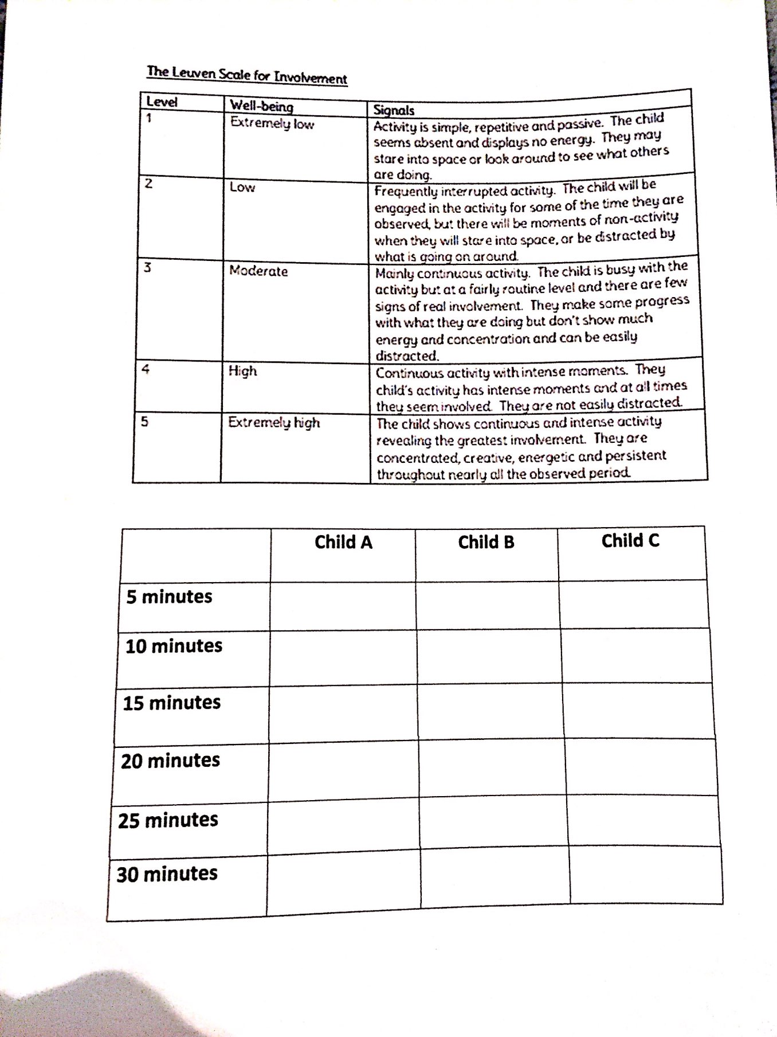
Appendix 2
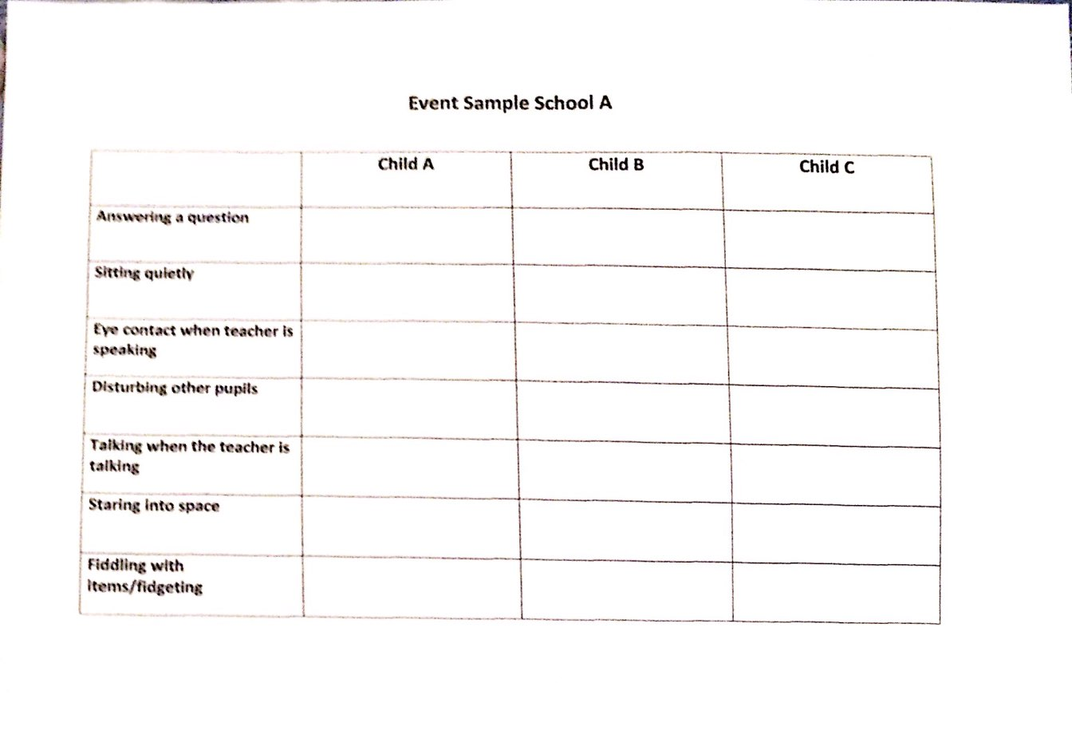
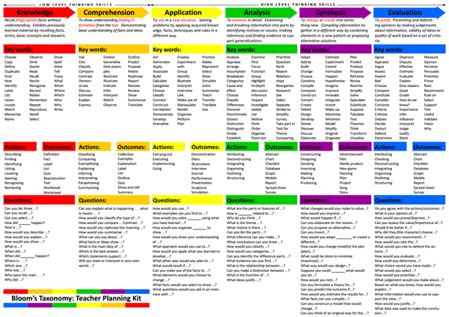
Appendix 3

Appendix 4
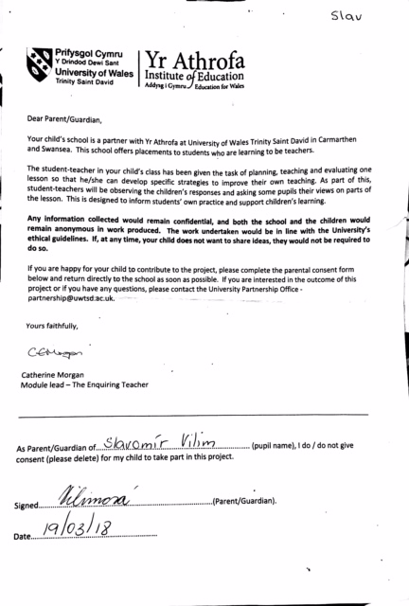

Appendix 5

1 | 2 | 3 | 4 | 5 | 6 | 7
8 | 9 | 10 | 11 | 12 | 13 | 14
15 | 16 | 17 | 18 | 19 | 20 | 21
22 | 23 | 24 | 25 | 26 | 27 | 28
29 | 30 | 31 | 32 | 33 | 34 | 35
Assent Form
White - Absent
Green – Happy to participate
Amber – Unsure
Red – Don’t want to participate

Appendix 6
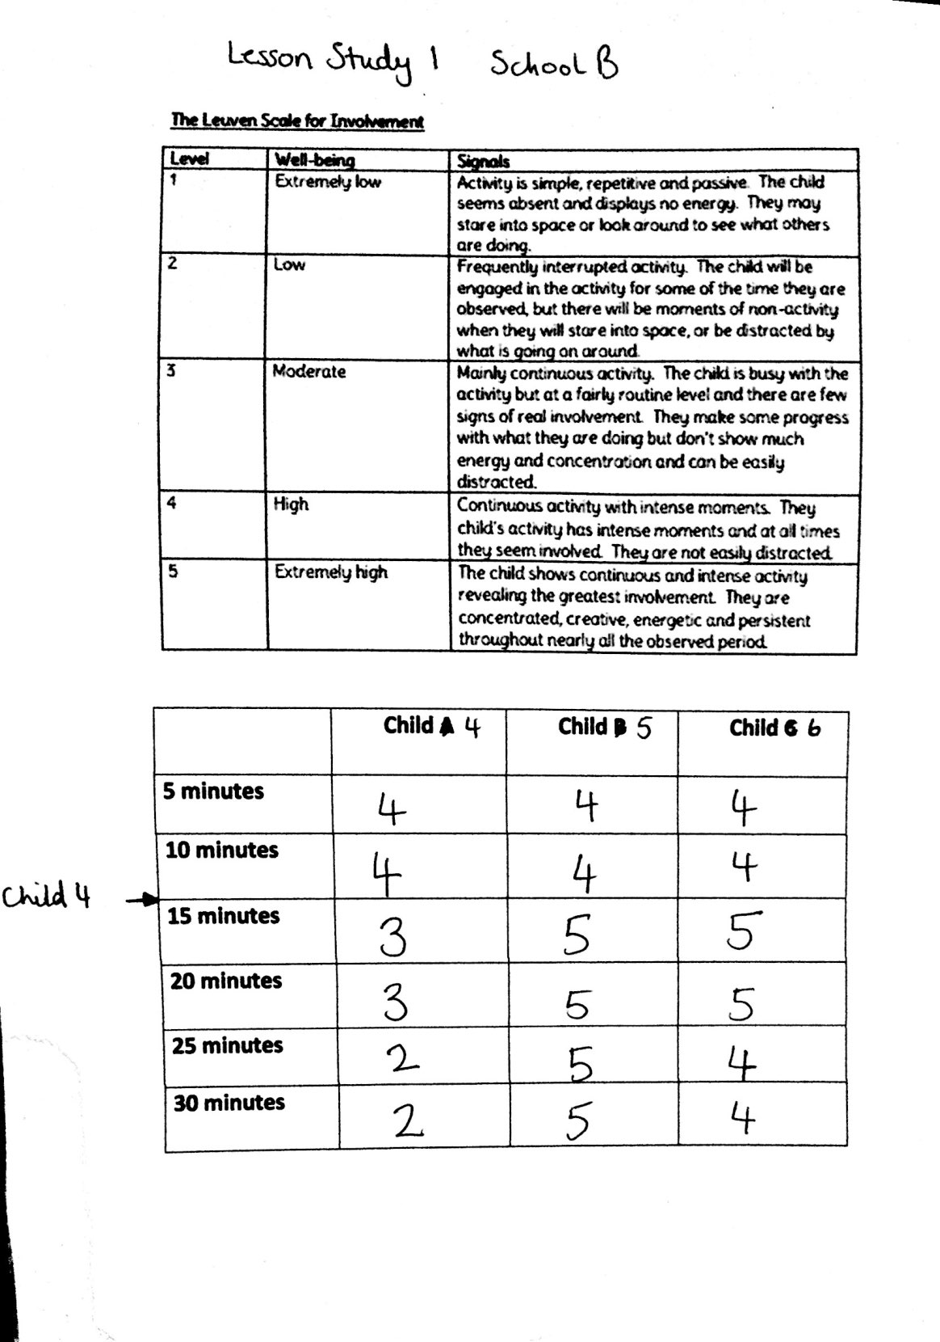

Appendix 7
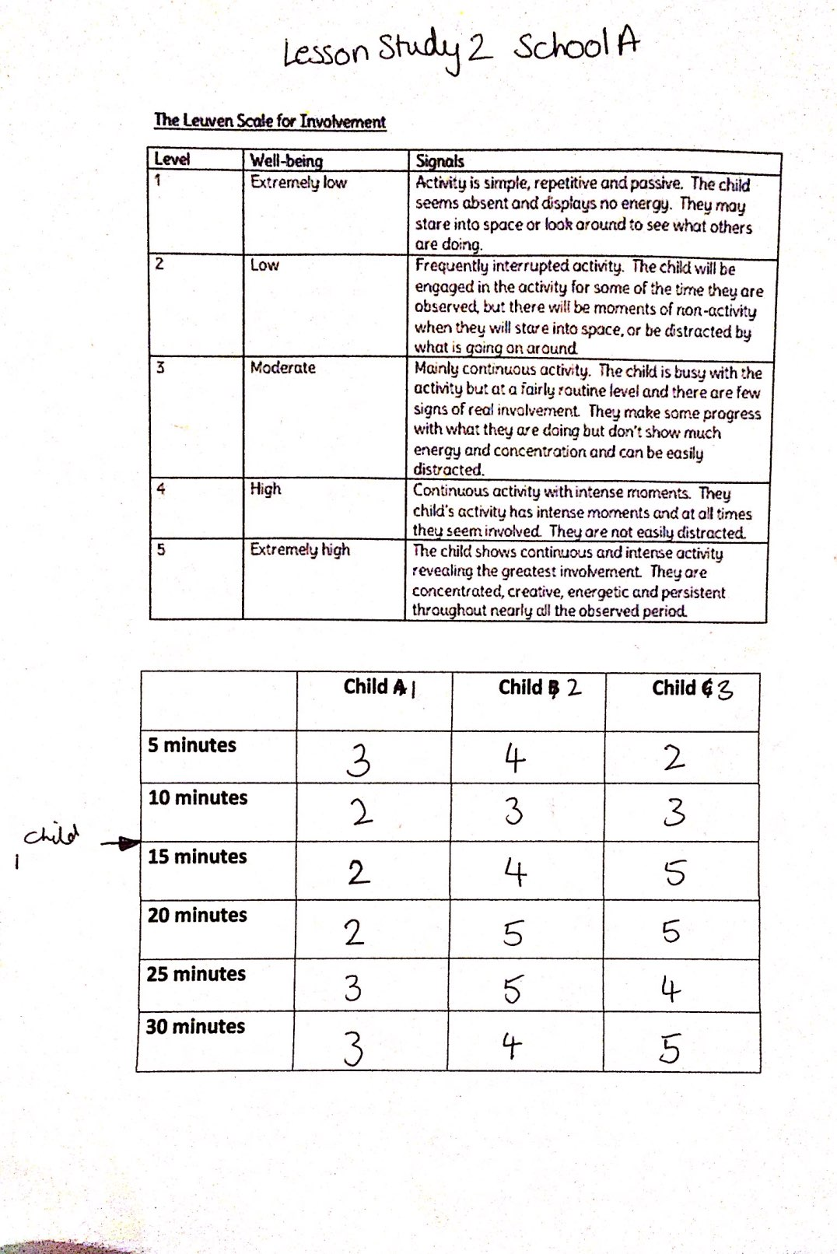

Appendix 8


