Student name: | Sunny A Anibaba | Student ID number: | 2210976
Programme: | CertHE Computing Skills for Workplace
Module: | Software Solutions for Business
Module code: | ACCA4026 | Contribution to  Overall Module Assessment (%): | 100%
Lecturer: | Rajeev Nath | Internal Verifier: | Suneth Fernanado
Assignment Title: | Component 1- Coursework: Portfolio | Word count (or equivalent): | 4000 Words
Submission deadline: | Monday [15-12-2025]  14:00 (2PM) | Return date of provisional marks & written feedback: | 19th January 2026

Table of Contents
Introduction 2
Task 1. e-Commerce Website builders or software solutions 2
1.1 WooCommerce 2
1.2 Wix 2
Task 2. Mind-map of contemporary software applications 4
a. The benefits of using mind mapping in business operations 4
b. Mind map showing contemporary software applications. 7
Task 3. Office Applications 8
a. Four office software solutions for business operations 8
Main Types of Applications 8
Microsoft Word Overview 9
Major Features 9
Benefits of Microsoft Word 10
Limitations of Microsoft Word 12
MS PowerPoint 12
Major Features of PowerPoint 13
Benefits of PowerPoint Presentations 14
Limitations of MS PowerPoint 15
MS Excel 16
Introduction 16

Major Features 16
Benefits 17
Limitations 17
MS Access 18
Introduction 18
Major Features 18
Benefits 19
Limitations 19
b. Practical demonstration of Two Office Features 21
If Statement 21
Apply Traffic Light Icons in Excel 21
1. Select column C5 to C13 Data Highlight the cells that contain the values you want to format (e.g., percentages, scores, or sales figures). 21
2. Select cells C5 through C13. Do this by dragging from C5 to C13. 22
3. On the Home tab, click Conditional Formatting > Highlight cells rule > More Rules. 22
4. Edit “New formatting Rule dialogue” box: Click “Style”, and select 3-colour Scale, edit: Minimum, Midpoint, and Maximum Rules, by selecting the appropriate “Traffic lights” in relation to the figures in the table. Click “OK”. 22
5. The highest expenses are showing RED, The medium expenses in Amber, the lowest medium in Yellow, and the lowest expenses in Green. 22
Task 4. Communication and Collaboration applications 23
a. One contemporary Communication and one Online Collaboration applications/tools 23
Analysis of MS Outlook 24
Advantages. 24
Seamless Microsoft Ecosystem 24
Outlook integrates tightly with the wider Microsoft 365 suite, including Word, Excel, Teams, and OneDrive. This makes it easy to centralize workflows and move seamlessly between communication, document creation, and collaboration. [11]. 24
Powerful Organization 24
The platform offers advanced tools to manage email and tasks effectively. Features such as rules, categories, flags, snooze, and scheduled send allow users to stay on top of their inbox and prioritize work with precision. [11] 24
Multi-Account Management 24
Outlook supports multiple accounts, enabling users to manage both professional and personal email within a single application. This reduces the need to switch between different platforms and keeps communication streamlined. [11]. 24
Enterprise Security and Compliance 24
Businesses benefit from Outlook’s strong security features, including advanced threat protection, data loss prevention, and compliance tools. These safeguards make it a trusted solution for organizations handling sensitive information. [11]. 24
Calendar and Scheduling 24
Outlook’s calendar is a powerful scheduling tool. It supports meeting organization, shared calendars, and even voting buttons for quick polls, making it easier to coordinate across teams. 24
Offline Access 24
Outlook provides robust offline functionality, allowing users to continue working without an internet connection. However, newer versions have introduced some limitations, particularly when accessing shared resources. . [11] 24
[11] 26
Disadvantages. 26
Complexity 26
Despite its strengths, the breadth of features can be overwhelming, especially for new users. The learning curve is steeper compared to simpler email applications, which may slow adoption. [11] 26
Performance Issues 26
Users occasionally report slower performance, crashes, or bugs. These issues can disrupt productivity, particularly in environments with heavy email traffic. [11] 26
Cost 26
Outlook is primarily available through a Microsoft 365 subscription. While this model ensures regular updates and integration, it also represents an ongoing expense for individuals and organisations. [11] 26
Limitations in the New Outlook 26
Recent versions of Outlook have removed some classic features. PST file support, COM add-ins, and direct access to shared mailboxes or calendars are no longer available, which can frustrate long-time users. [11] 26
Restrictions on Attachments and Saving 26
The new Outlook limits saving options to local storage or OneDrive, excluding SharePoint. It also restricts offline access to shared items, reducing flexibility for certain workflows. [11] 26
Update Disruption 26
Frequent updates, while intended to improve functionality, can disrupt established workflows. Users often need time to adapt to changes, which may temporarily reduce efficiency. [11] 26
while intended to improve the product, can disrupt workflows and require users to adapt quickly to changes. [11] 27
Conclusion 27
MS Teams 27
Microsoft Teams: Analysis 27
b. One feature of a freely available Communication (1) and one feature of a Collaboration (1) application 30
MS Outlook 30
Ms Teams 33
Conclusion 33
References 33

Introduction
The purpose of this assignment is to demonstrate how a range of software applications and tools can be applied to strengthen technology-based solutions in the workplace. The focus is on showing how these tools can improve key aspects of my chosen career path, (project management), including productivity, workflow, communication, and decision-making. I will be providing practical examples of how these tools can be integrated into project management processes, whether in planning, scheduling, resource allocation, or team collaboration. I will be highlighting their relevance and impact. [1]

Task 1. e-Commerce Website builders or software solutions

1.1 WooCommerce
WooCommerce is a popular, open-source e-commerce plugin for WordPress that allows users to create and manage online stores. WooCommerce provides a familiar interface for anyone already accustomed to the content management system (CMS). It adds necessary e-commerce functionality, such as product pages, a shopping cart, a checkout process, B2C, Online booking and Services, Drop Shipping and an administration dashboard, (as illustrated in Figure 1) directly into the WordPress environment [1].
Users can sell a wide range of products, including physical goods, digital downloads, services, subscriptions, and affiliate items. The platform offers comprehensive tools for managing product data, variations (like size or colour), pricing, and inventory tracking. [1]
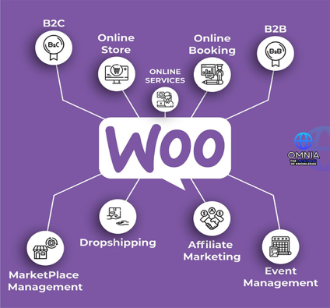
Figure 1 Benefits of Woo to the commercial world at large. [1]

It supports integration with popular payment gateways like PayPal, Stripe and Woo-Payments, and offers options for various shipping methods, including flat rates, free shipping, and real-time carrier calculations. Automated tax calculations are also available, as an open-source platform, WooCommerce provides nearly unlimited customisation options through thousands of free and paid themes, plugins, and extensions. This modular approach allows businesses to scale their online store, from small startups to high-volume enterprises, by adding features as needed without being locked into a rigid platform or paying monthly platform fees. [1]
Store owners retain full ownership of their site, code, and customer data. While security is a shared responsibility, WooCommerce provides the necessary infrastructure and is regularly updated to help maintain a secure environment, with support for SSL certificates and additional security plugins. [1]
The WooCommerce offers deep customisation options with thousands of themes and plugins, allowing for unique storefronts and advanced functionality.
A free mobile app is available for iOS and Android, allowing store owners to manage orders and monitor store performance on the go. [1]

1.2 Wix

Figure 2 The impact of Wix globally [2]
Wix is a versatile online platform and website builder that allows users to create professional websites using different platforms like PC, tablet, Mobile phones, a drag-and-drop editor, pre-designed templates, and various built-in tools (as illustrated in Figure 2). It is designed to be user-friendly for people with no coding experience and offers a wide range of features for online businesses, including e-commerce, marketing, and booking systems. The platform operates on a freemium model, with a free option for basic sites and paid premium plans for advanced features and domain connection. [2]
The platform has a wide selection of professional, customisable templates to get users started quickly. Beyond just website building, Wix is an all-in-one business solution, it offers a suite of tools for managing online businesses, such as email marketing, e-commerce features like payment processing and inventory management, and online booking. [2]

Wix also integrates AI-powered features like a text creator, image creator, and layouts tool to assist in the design process. Although users can create a free website but need to upgrade to a paid plan to remove ads, connect a custom domain, and access more advanced features like e-commerce. A marketplace with a wide variety of free and paid apps allows users to add functionality to their sites, such as blog features, music playlists, and social media feeds. [2]
Regarding target-audience, Wix caters to a wide range of users, from individuals creating a personal portfolio or blog to small business owners, freelancers, and large enterprises looking to establish a professional, scalable online presence without the need for extensive technical expertise or coding skills. [2]

Figure 3, A good example of website, created using Wix [3].

Task 2. Mind-map of contemporary software applications
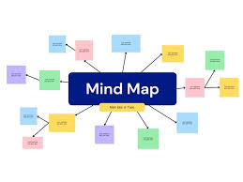
Figure 4 Using Canva to create Mind Mapping example

The benefits of using mind mapping in business operations

A Mind Map is an easy way to brainstorm thoughts organically without worrying about order and structure. While allowing you to visually structure your ideas to help with analysis and recall, it is also a diagram for representing tasks, words, concepts, or items linked to and arranged around a central concept or subject using a non-linear graphical layout that allows the user to build an intuitive framework around a central concept.
Another brilliant output or production is that Mind Map can turn a long list of monotonous information into a colourful, memorable and highly organised diagram that works in line with your brain's natural way of doing things and project management.
Mind mapping enhances productivity, creativity, and collaboration in business operation making complex tasks more manageable and improving decision-making processes.
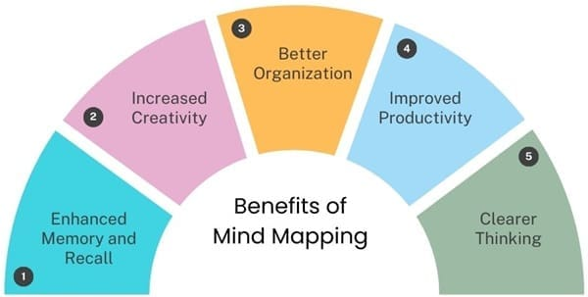
Figure 5 Benefits of Mind Mapping. [4].

Key Benefits of Mind Mapping
Improved Productivity: Mind mapping helps teams organise their thoughts and ideas
visually, which streamlines communication and reduces misunderstandings.
This clarity allows teams to align on goals and work more efficiently towards desired
outcomes. [4]
Enhanced Creativity: By visually connecting different ideas, mind mapping encourages creative thinking. It allows team members to explore various perspectives and generate innovative solutions to problems, fostering a culture of creativity within the organisation
Effective Problem Solving: Mind maps facilitate a comprehensive view of problems,
enabling teams to break down complex issues into manageable parts. [4]
This structured approach aids in identifying potential solutions and making informed decisions.
Facilitated Collaboration: Mind mapping serves as a collaborative tool that visually
represents how different departments or team members contribute to overarching goals. This visual aid enhances teamwork and ensures that everyone is on the same page, promoting a more cohesive work environment. [4]

Streamlined Decision-making: by organising information in a clear and concise manner, mind maps help teams quickly assess options and make decisions. This efficiency is particularly beneficial in fast-paced business environments where timely decisions are crucial.
Simplified Project Management: Mind mapping can be used to outline project plans, track
progress and identify key milestones. This visual representation helps project managers and
teams stay organised and focused on their objectives. [4]
Enhanced Learning and Retention: Mind maps promote meaningful learning by connecting
new information to existing knowledge. This technique not only aids in understanding complex
concepts but also improves memory retention, which is valuable for training and development
initiatives. [4]
Versatile Applications: Mind mapping can be applied in various business contexts, including brainstorming sessions, strategic planning, and knowledge management. Its flexibilities make it a valuable tool for diverse business needs. [4]
In summary, mind mapping is a powerful technique that can significantly enhance business operations by improving productivity, fostering creativity, facilitating collaboration, and streamlining decision-making processes. By adopting mind mapping practices, organisations can better manage complexity and drive successful outcomes. The above can also be classified as Key Benefits (as further illustrated in Fig 6) [4]

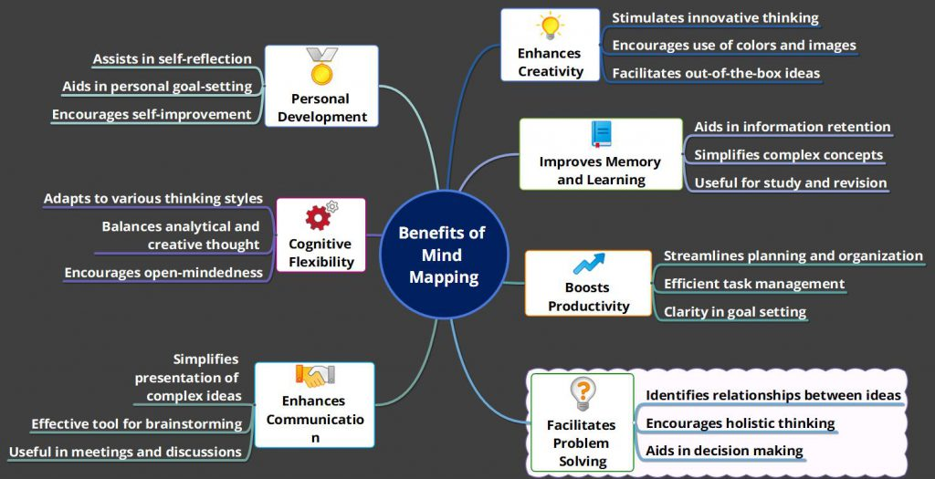
Figure 6, Key Benefits of Mind Mapping [4]
These benefits make mindmapping a valuable tool for enhancing productivity and creativity in business environments.

Mind map showing contemporary software applications.

This is an example of my mind map of ‘software Applications’ created from Mind-Meister App (as shown in Figure 7).
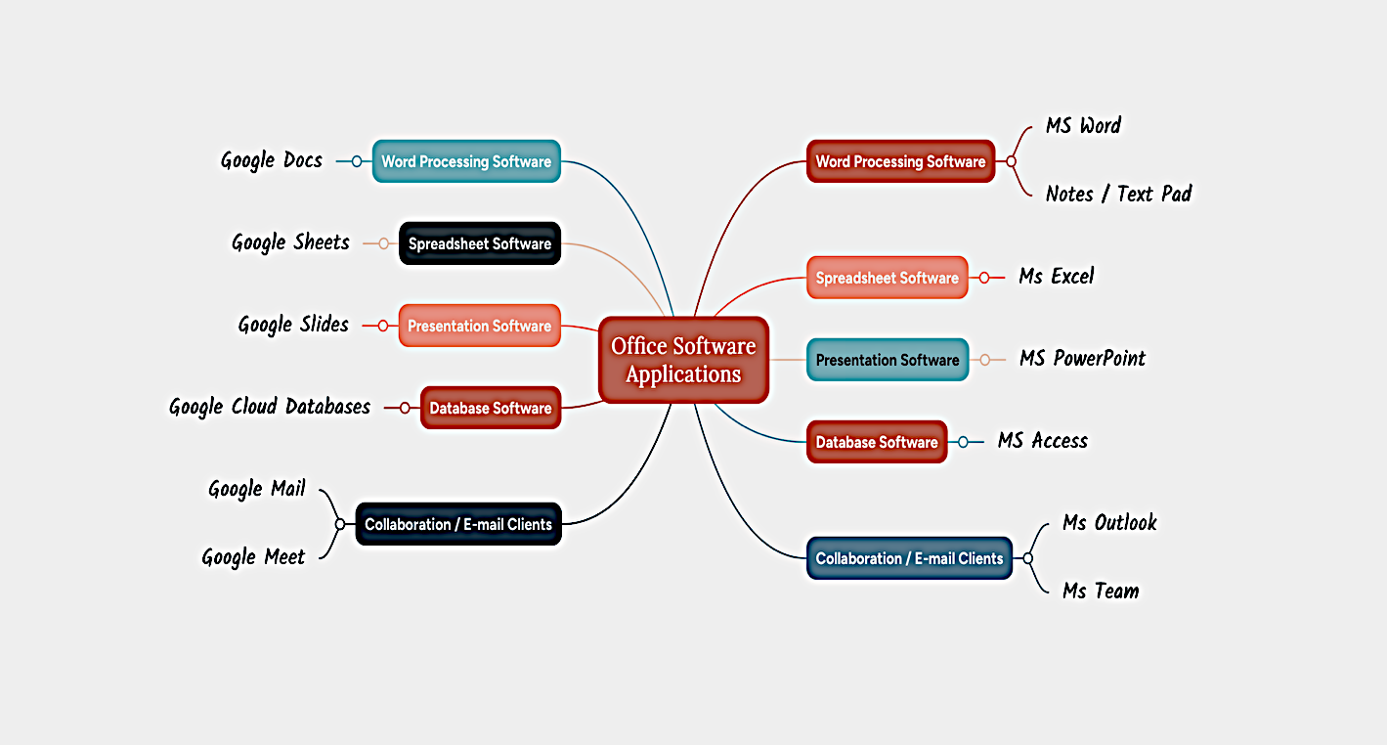

Figure 7, Office Software Compares using Mind Meister app by Sunny Anibaba.

Task 3. Office Applications

Four office software solutions for business operations

Modern office suites bring together several tools for working with information whether you’re creating, storing, analysing, or presenting it. The two most widely used suites are Microsoft 365 (formerly Microsoft Office) and Google Workspace.

Main Types of Applications
Spreadsheets: Excel, this is the go-to tool for handling data. This organises information in rows and columns, making it easy to calculate with formulas, sort and filter, and build charts or graphs. Excel stands out with advanced features like PivotTables for spotting trends.
Databases: Microsoft Access is the solution when data grows too large or needs to be linked across multiple tables, a database is more efficient than a spreadsheet. Access lets you run detailed queries with SQL, design forms for entering data, and generate reports all while keeping data consistent and reliable.
Presentation Software: Microsoft PowerPoint is designed for creating slideshows that communicate findings clearly. Charts and visuals from spreadsheets can be dropped straight into slides, helping you share insights with an audience in a polished way.
Word Processors: Microsoft Word, while mainly used for writing, this Word processor is also essential for creating reports. They allow you to combine text, images, and charts into professional documents that explain data and results in detail.
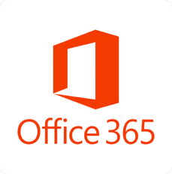Figure 8, Office 365 is online MS Office suite, containing: Word, Excel, PowerPoint & Notes

Microsoft Word Overview
Microsoft Word is one of the most widely used word processing programs and an essential part of the Microsoft 365 suite. It is designed to help users create, edit, and format documents with accuracy and ease. Its broad range of features makes it suitable for both personal and professional tasks, supporting everything from simple letters to complex reports.

Major Features
Figure 9, Microsoft Word
Microsoft Word provides a rich set of tools that simplify document creation. Users can customise text with different fonts, sizes, colours, and alignments, and adjust page margins and orientation to achieve the desired layout. Built-in proofing tools, such as spell check, grammar correction, and a thesaurus, help ensure documents are polished and error-free. The program also offers a wide variety of templates for resumes, letters, and reports, saving time and giving documents a professional look.
Beyond text formatting, Word allows users to insert images, charts, and other visual elements seamlessly. Collaboration is another strong point, with features like real-time co-authoring, “Track Changes,” and commenting, which make it easy for multiple people to work on the same document. Organisational tools, including tables of contents, headers, footers, and a navigation pane, help structure longer documents. Additionally, the Mail Merge feature enables users to create personalised letters or labels for large groups by linking documents to a data source.

Benefits of Microsoft Word
Today, Microsoft Word and other word processors serve as central platforms for writing and document creation. They are no longer just simple tools for typing text; instead, they function as comprehensive hubs that bring together a wide range of writing technologies. Over time, Word has steadily expanded its features, offering users tools for formatting, editing, collaboration, and design. This growth has allowed the program to support diverse needs, from academic writing and professional reports to creative projects and everyday communication.
By integrating functions such as spell-check, grammar suggestions, templates, and real-time collaboration, Word has become more than a digital typewriter. It provides a flexible environment where writers can focus on content while also managing layout, style, and presentation. The continuous expansion of its portfolio demonstrates how Word adapts to the evolving demands of modern writing, making it a versatile and reliable choice for individuals and organisations alike.
Microsoft Word’s popularity comes from its powerful features and compatibility. It enables users to produce professional-quality documents with advanced formatting and design options. Time-saving tools such as templates, autocorrect, and copy-paste functions make document creation faster and more efficient. Word integrates smoothly with other Microsoft Office applications like Excel and PowerPoint, allowing easy sharing of data and objects. Documents can be saved in multiple formats and accessed from anywhere through Microsoft 365’s cloud services, making it convenient for users on different devices. Its user-friendly interface also makes it easy for beginners to learn and use effectively.

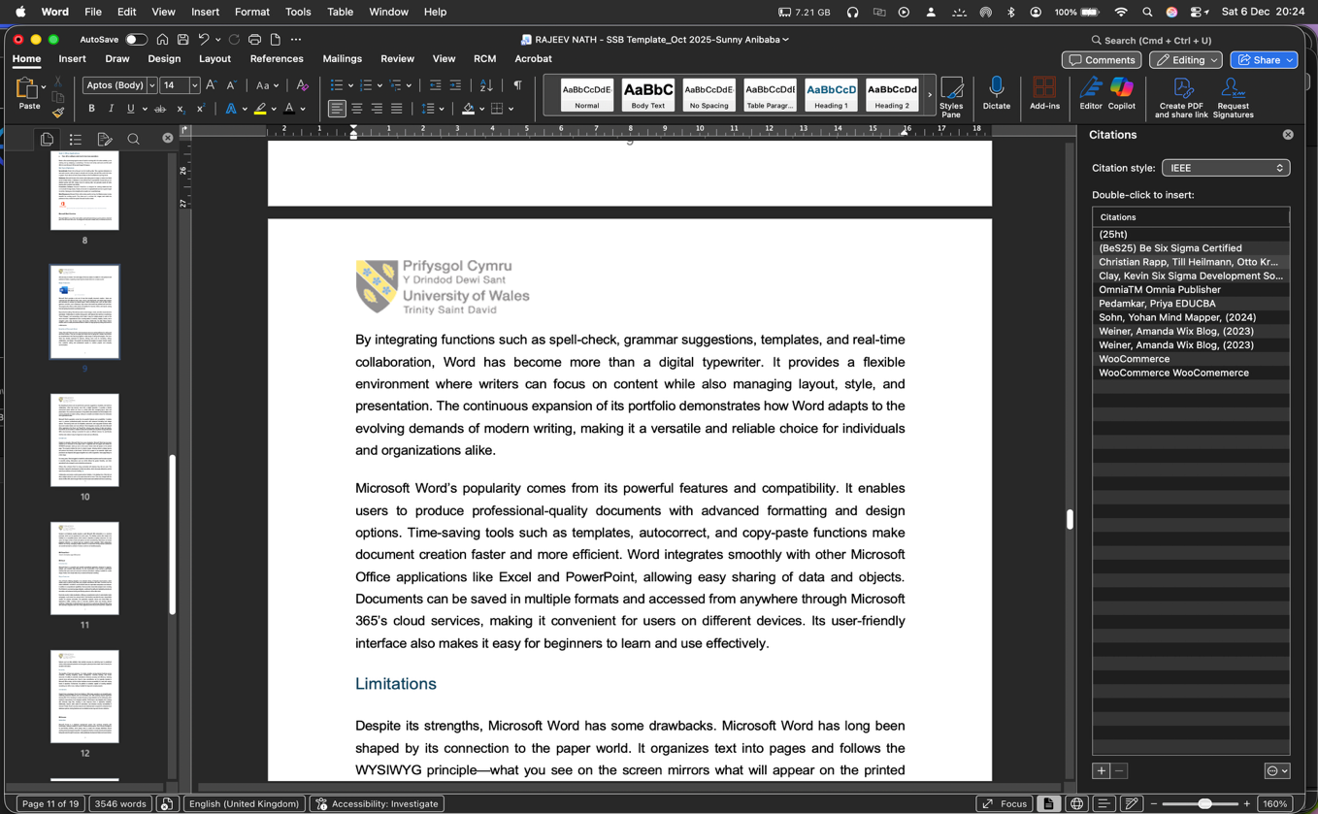
Citations Pane for Reference selection
Thumbnail: Allows you to quickly select desired page
Figure 10, Print screen - showing Thumbnail and Citations together for easy editing, as shown in the picture.
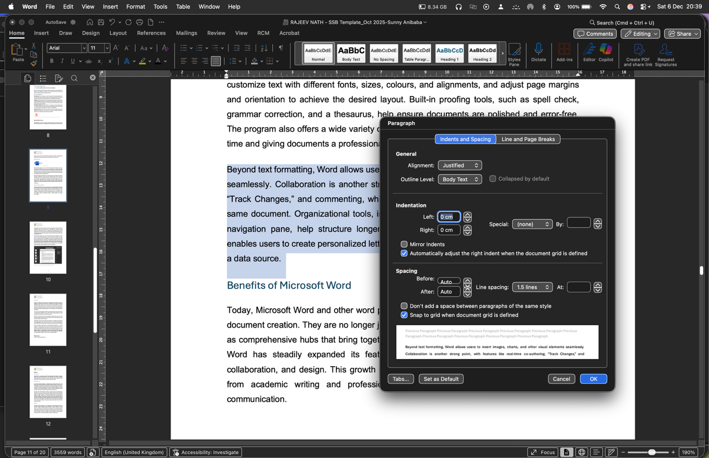
New Line spacing
Open the Paragraph dialogue box for editing
Open the Paragraph dialogue box for editing
New Line spacing
Figure 11, Screenshot of Paragraph Editing in MS Word, as shown in the picture.

Limitations of Microsoft Word
Despite its strengths, Microsoft Word has some drawbacks. Microsoft Word has long been shaped by its connection to the paper world. It organises text into pages and follows the WYSIWYG principle—what you see on the screen mirrors what will appear on the printed page. The program imitates the look of a sheet of paper, allowing writers to design layouts and produce text directly in that format. Yet this link to paper is not essential: digital word processors can dispense with pages altogether and, unlike a typewriter, leave page design to a later stage.
For many years, Word struggled to handle the mathematical equations and formulas required in scientific writing. Alternatives such as LaTeX offered far greater flexibility, and other specialised tools emerged to serve disciplines and genres.
Writers often criticised Word for being overloaded with features they did not need. This frustration inspired the development of plain-text editors, which strip away distractions and let users focus entirely on the act of writing. [5]
Open the Paragraph dialogue box for editing
Collaboration and version control posed another limitation. In its desktop form, Word did not allow multiple authors to work on the same document at once. That only changed with the arrival of Office 365, which brought Word into the browser and enabled real-time co-authoring.
Access to all features usually requires a paid Microsoft 365 subscription or a one-time purchase, which can be expensive for some users. The desktop version also needs to be installed on a compatible device, which means it depends on system resources. For new users, the large number of tools and options can feel overwhelming. Word does not include plagiarism detection, so external tools are needed to check originality. While collaboration features are strong, managing multiple versions of a document among several contributors can sometimes lead to confusion if version control is not handled properly.

MS PowerPoint

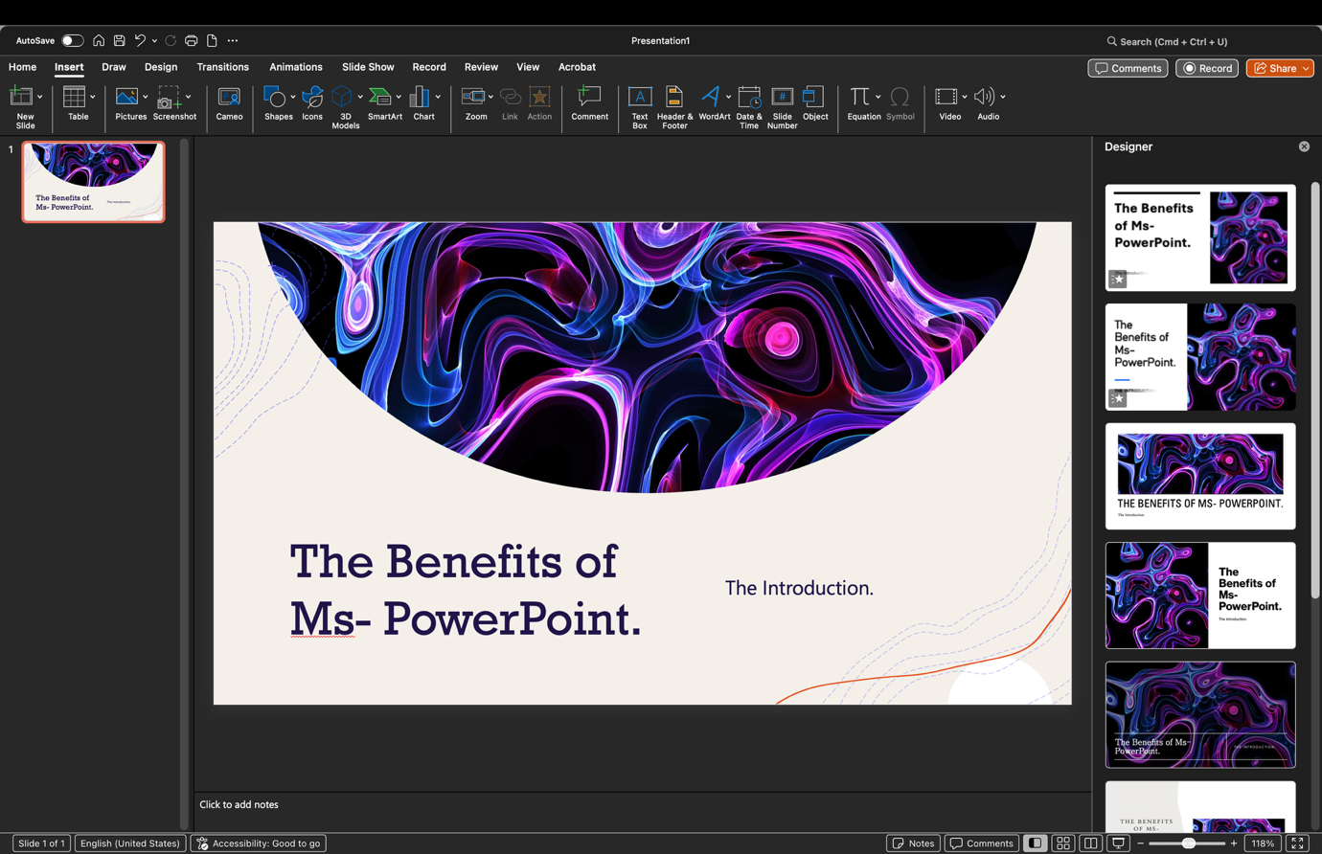
Various template designs available for selection
Figure 12, PowerPoint Screenshot of Selection of desired template for editing

Major Features of PowerPoint
PowerPoint is one of the most widely used presentation tools, offering a variety of features that help users design and deliver effective presentations. Its slide design and layout options are central to creating presentations that look professional and are easy to follow. The program provides a wide selection of themes and customisable layouts, making it simple to adapt slides to different purposes. Text can be formatted with clear fonts and sizes, while images, diagrams, and other visuals can be added to reinforce key points. Consistency in colours, fonts, and alignment across slides ensures a polished and cohesive presentation.
Another strength of PowerPoint is its ability to integrate multimedia. Presenters can insert images, video clips, and audio to go beyond text, adding demonstrations, storytelling, or background narration to make the presentation more engaging, thereby capturing audience attention. [6]
Animations and transitions also play an important role in making presentations dynamic. highlighting important information, guide the audience’s focus, and maintain interest throughout the presentation.
Complex ideas and data can be difficult to explain with text alone, but PowerPoint’s SmartArt graphics and chart tools make it easier to present information visually.
Collaboration and sharing are another area where PowerPoint excels. Multiple people can work on the same presentation at once through real-time co-authoring, with changes visible immediately and comments added to guide revisions. Presentations can also be shared easily via email or cloud platforms, ensuring colleagues and audiences can access them without difficulty. [6]
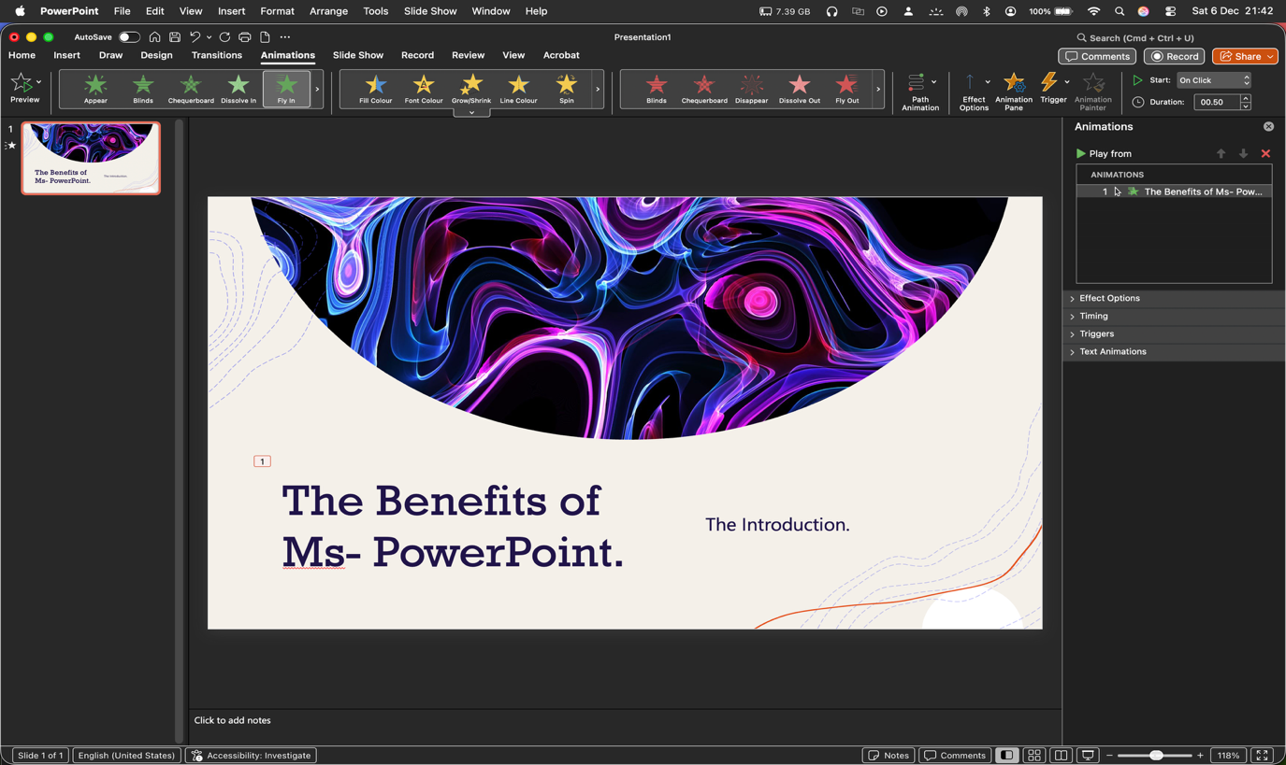
Animation editing in PowerPoint.
Figure 13, The Picture above shows an example of Animation editing in MS PowerPoint.

Benefits of PowerPoint Presentations
PowerPoint has become a highly collaborative tool. No longer do teams need to gather around a single computer with one person controlling the slides. Instead, multiple users can access, edit, and comment on the same presentation at the same time. This real-time collaboration makes teamwork more efficient and ensures that everyone’s input can be included seamlessly.
Another major benefit is the flexibility of design. PowerPoint gives presenters full control over the look and feel of their slides, allowing them to create dynamic and visually engaging presentations that capture attention. Themes, layouts, and formatting options can be customised to suit the tone and purpose of the presentation, while images, graphics, and other visual elements add impact and clarity.
The software also supports modern working styles. With cloud storage and licensing, presentations can be accessed and edited from virtually anywhere, making PowerPoint especially useful in hybrid and remote work environments. This mobility ensures that users can continue working on their projects whether they are in the office, at home, or on the move.
PowerPoint provides flexibility in how presentations are shared as well. Files are not limited to the standard .pptx format; they can be exported as PDFs for easy distribution, converted into image files such as .png or .jpg for individual slides, or even saved as video files in formats like mp4. This versatility makes it simple to adapt presentations to different contexts and audiences.
Compatibility with other Microsoft Office programs adds another layer of convenience. Tables from Word and charts from Excel can be integrated directly into slides, making it easy to enrich presentations with data and supporting material. Templates can also be created and reused, saving time and ensuring consistency across future projects.
Finally, PowerPoint is widely accessible. Most companies already have the Microsoft Office suite installed and licensed, and educational institutions provide it to students and teachers. This broad availability means that users can connect, collaborate, and share presentations without barriers, making PowerPoint a practical solution for both professional and academic purposes. [6]

Limitations of MS PowerPoint
Despite its popularity, PowerPoint has several limitations that can affect the quality and delivery of a presentation. One of the most common challenges is technology itself. Even with careful preparation, issues such as faulty HDMI or VGA connections, missing fonts, or inaccessible files can disrupt a presentation. Technical glitches like projector malfunctions, computer crashes, or connectivity problems are always a risk, making backup plans essential. Compatibility can also be an issue, as slides created on one computer may not display correctly on another, especially when multimedia elements are involved. [7]
Another limitation lies in how presenters use the software. Many rely too heavily on their slides, treating them as a script rather than a visual aid. This dependence can weaken delivery, as audiences are more engaged by the speaker’s story than by text-heavy slides.
Overloading slides with too much information or sticking to default templates often results in monotonous presentations, sometimes referred to as “death by PowerPoint.” The effectiveness of a presentation ultimately depends on the presenter’s ability to communicate clearly and interact with the audience, rather than on the slides alone.
Customisation, while a strength, can also be a drawback. With so many design options available, presenters may become distracted and dilute their message by focusing too much on style rather than substance. For specialists, PowerPoint’s tools may feel restrictive compared to dedicated design or data visualisation software. Large file sizes and the cost of Microsoft 365 subscriptions add further practical concerns, especially when compared to free alternatives such as google slides. [7]

MS Excel

Introduction
Microsoft Excel (logo shown in Fig 14 below), is a powerful and versatile spreadsheet application designed to organise, analyse, and visualise data efficiently. Its core functionality is built around a grid-based interface that uses rows and columns to structure information, making it suitable for a wide range of tasks, from simple data entry to advanced financial modelling.


Figure 14, The current Excel version logo, Office 365 [8]

Major Features
One of Excel’s defining strengths is its extensive library of formulas and functions, as shown in Fig 15, An example of “Average Function” I used in Excel to create graph illustration.
which enable users to perform both basic
Excel also excels in data visualisation, offering a comprehensive suite of customisable charts and graphs such as bar, line, and pie charts that transform raw data into clear, interpretable visuals. For process automation, the application supports macros and Visual Basic for Applications (VBA), enabling users to automate repetitive tasks and develop tailored workflows. Collaboration is streamlined through real-time co-authoring in Microsoft 365, along with seamless integration with other Office applications like Word and PowerPoint. Additional features such as data validation help maintain accuracy by restricting input to predefined criteria, while password protection and encryption options provide a basic level of security for sensitive information.
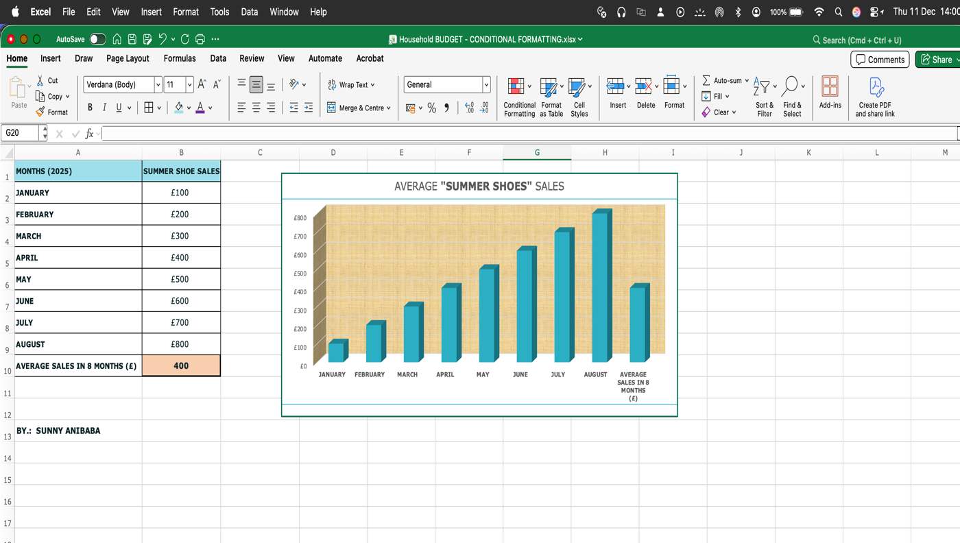
Table showing the AVERAGE sales for 8 months
Figure 15, An example of “Average Function” I used in Excel to create graph illustration.

Benefits
The benefits of Excel are extensive. It is highly versatile, serving diverse functions across industries, including budgeting, project management, inventory tracking, and human resources. Its ability to automate calculations enhances accuracy and efficiency, reducing manual errors and saving time. Excel is also cost-effective, as it is typically included in Microsoft Office suites, and its intuitive interface ensures accessibility for users with varying levels of expertise. Furthermore, the platform is scalable, capable of handling datasets exceeding one million rows, making it suitable for large and complex projects.

Limitations
Despite these advantages, Excel has limitations. While basic operations are straightforward, mastering advanced features such as PivotTables and VBA scripting requires significant learning effort. Error handling in complex formulas or large datasets can be challenging, often leading to inaccuracies if not managed carefully. Performance may degrade when working with extremely large files, resulting in slow response times or application instability. Additionally, macros, while useful for automation, can introduce security vulnerabilities if misused. Finally, Excel’s security measures are relatively basic compared to enterprise-level database systems, lacking features such as detailed access logs and intrusion detection.

MS Access

Introduction
Microsoft Access (Logo shown in Fig 16) is a database management system that combines simplicity with functionality, making it suitable for small to medium-sized projects. One of its key strengths is its user-friendly interface, which allows users to create and manage databases without needing advanced programming skills. The graphical interface includes wizards and templates that guide users through the process, making database development faster and more intuitive.
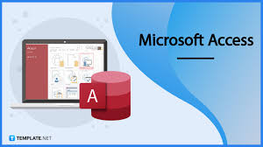
Figure 16, Shows MS Access logo [9]

Major Features
Access provides all the essential tools for building a complete database application. Tables are used for storing data, queries allow users to retrieve and manipulate information, forms make data entry easier and reports present data in a structured and readable format. It also integrates seamlessly with other Microsoft Office applications such as Excel and Word,
enabling smooth data import, export, and linking for analysis and reporting. Additionally, Access supports automation through macros, which help streamline repetitive tasks, and it allows the creation of relationships between tables to maintain data integrity and reduce redundancy.

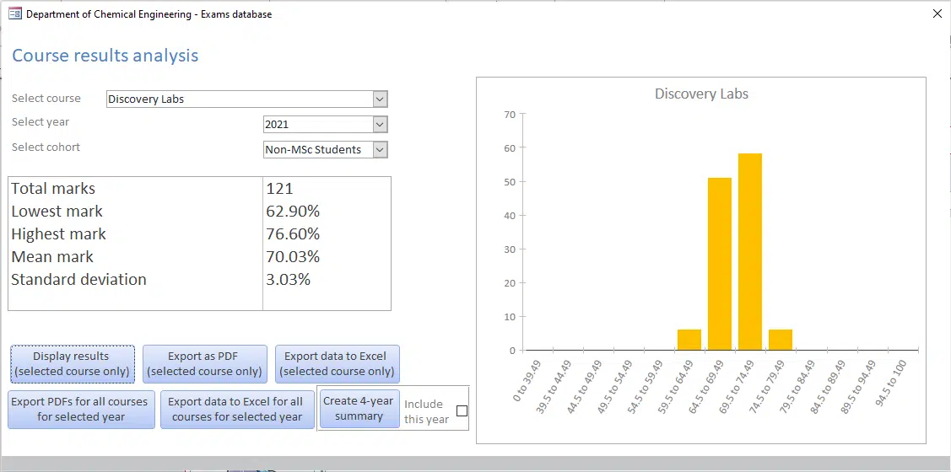
Figure 217, example of Course result in MS Access output. [10]

Benefits
The main benefits of Microsoft Access include ease of use, affordability, and rapid development. Because it is included in most Microsoft Office suites, it offers a cost-effective solution compared to purchasing enterprise-level database software. Its built-in templates and wizards make it ideal for quick prototyping, and users can customise databases to meet specific needs. For those who require more advanced functionality, Access also supports the addition of custom code.

Limitations
Despite these advantages, Access has several limitations. It is not designed for large-scale applications, as databases are limited to a maximum size of 2GB and performance can degrade when multiple users access the system simultaneously. Security features are basic, offering only simple user permissions and lacking the robust encryption and user-level controls found in enterprise systems. Collaboration is another challenge, as Access does not provide strong built-in tools for multiple users to work on the same database at the same time, although integration with SharePoint can offer some web-based access. There is also a risk of file corruption if databases are not properly maintained or if network issues occur. Finally, Access is primarily a Windows-based application, which can lead to compatibility problems when upgrading to newer versions or working in mixed environments.
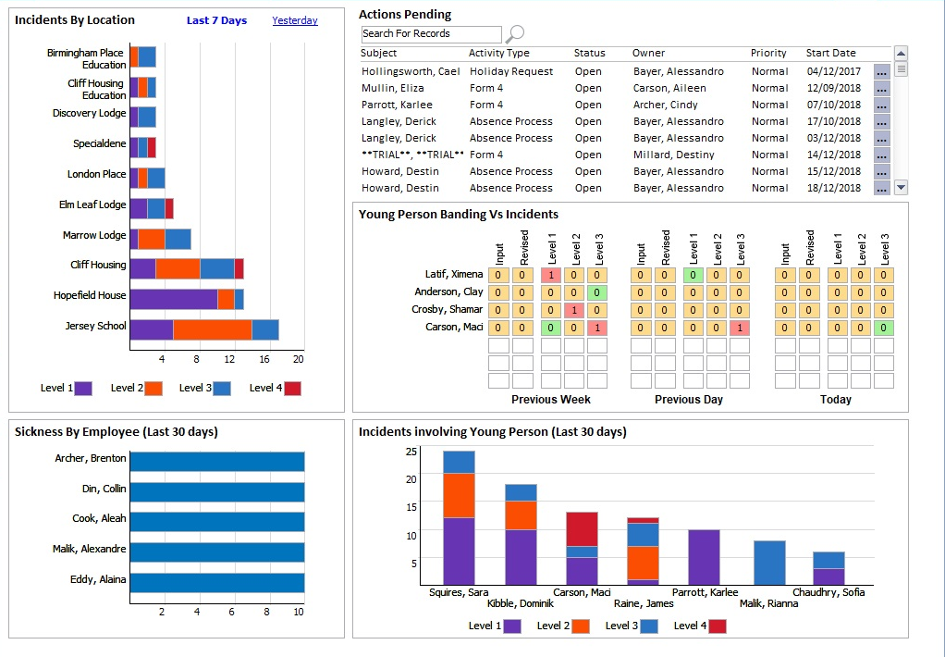
Figure 18, Another example of MS Access output
In summary, Microsoft Access is an excellent choice for small businesses, individuals, or teams that need a quick and affordable way to manage data. However, it is not suitable for large, complex, or highly secure applications, and organisations should consider these limitations when deciding whether to use it.

Practical demonstration of Two Office Features

If Statement
Conditional Formatting in Excel lets you automatically change how cells look using colours, icons, or data bars—based on rules you set. It’s a quick way to highlight patterns, spot trends, and identify outliers in your data immediately [21]

To create traffic lights in Excel using "if" statement, Conditional Formatting is preferred.

Apply Traffic Light Icons in Excel

Select column C5 to C13 Data
Highlight the cells that contain the values you want to format (e.g., percentages, scores, or sales figures).
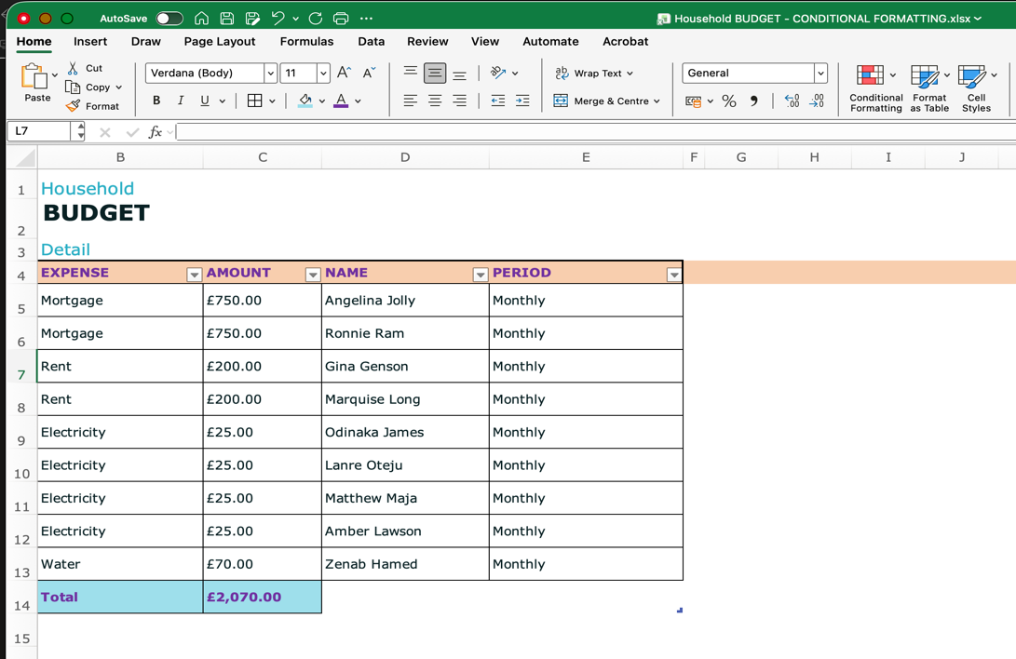
Highlight the “Amount” column and click “Conditional Formatting” from the top menu.

Figure 19, Table I made up for Conditional Formatting
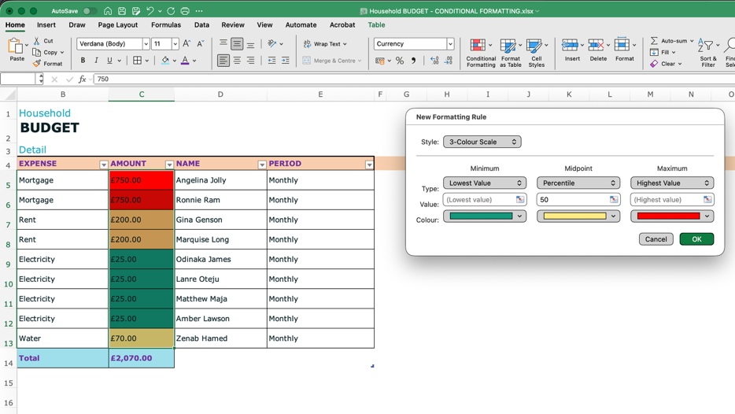
From the NEW Formatting Rule” select 3-colour Scale, select appropriate traffic lights colours, and click ok.

Figure 20 Creating new Rules with IF condition
To create first rule: Go to the Home tab, click Conditional Formatting, from the drop-down menu, choose 3 Traffic Lights:

Select cells C5 through C13. Do this by dragging from C5 to C13.

On the Home tab, click Conditional Formatting > Highlight cells rule > More Rules.

Edit “New formatting Rule dialogue” box:
Click “Style”, and select 3-colour Scale, edit: Minimum, Midpoint, and Maximum Rules, by selecting the appropriate “Traffic lights” in relation to the figures in the table. Click “OK”.

The highest expenses are showing RED, The medium expenses in Amber, the lowest medium in Yellow, and the lowest expenses in Green.
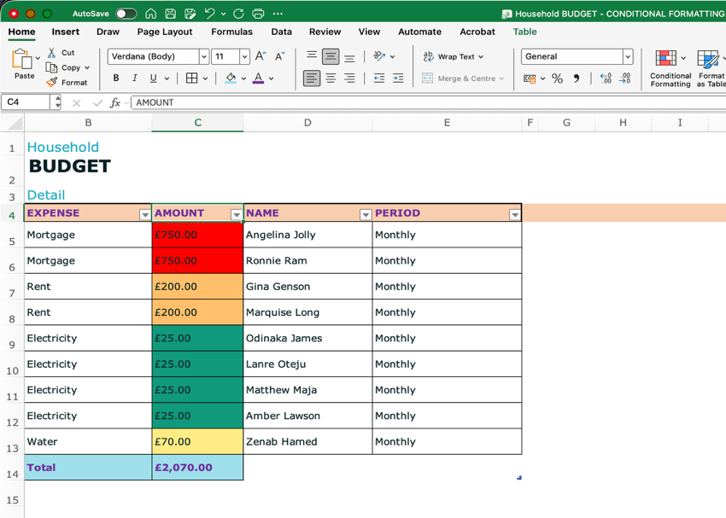
This is the final result.

Figure 21, Final result

Task 4. Communication and Collaboration applications

One contemporary Communication and one Online Collaboration applications/tools


Figure 19, Communication and Collaboration tools [11].

Analysis of MS Outlook

Advantages.

Seamless Microsoft Ecosystem

Outlook integrates tightly with the wider Microsoft 365 suite, including Word, Excel, Teams, and OneDrive. This makes it easy to centralize workflows and move seamlessly between communication, document creation, and collaboration. [11].

Powerful Organization

The platform offers advanced tools to manage email and tasks effectively. Features such as rules, categories, flags, snooze, and scheduled send allow users to stay on top of their inbox and prioritize work with precision. [11]

Multi-Account Management

Outlook supports multiple accounts, enabling users to manage both professional and personal email within a single application. This reduces the need to switch between different platforms and keeps communication streamlined. [11].

Enterprise Security and Compliance

Businesses benefit from Outlook’s strong security features, including advanced threat protection, data loss prevention, and compliance tools. These safeguards make it a trusted solution for organizations handling sensitive information. [11].

Calendar and Scheduling

Outlook’s calendar is a powerful scheduling tool. It supports meeting organization, shared calendars, and even voting buttons for quick polls, making it easier to coordinate across teams.

Offline Access

Outlook provides robust offline functionality, allowing users to continue working without an internet connection. However, newer versions have introduced some limitations, particularly when accessing shared resources. . [11]

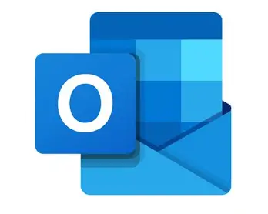
Figure 20, Icon of MS Outlook, [11].

[11]

Disadvantages.

Complexity

Despite its strengths, the breadth of features can be overwhelming, especially for new users. The learning curve is steeper compared to simpler email applications, which may slow adoption. [11]

Performance Issues

Users occasionally report slower performance, crashes, or bugs. These issues can disrupt productivity, particularly in environments with heavy email traffic. [11]

Cost

Outlook is primarily available through a Microsoft 365 subscription. While this model ensures regular updates and integration, it also represents an ongoing expense for individuals and organisations. [11]

Limitations in the New Outlook

Recent versions of Outlook have removed some classic features. PST file support, COM add-ins, and direct access to shared mailboxes or calendars are no longer available, which can frustrate long-time users. [11]

Restrictions on Attachments and Saving

The new Outlook limits saving options to local storage or OneDrive, excluding SharePoint. It also restricts offline access to shared items, reducing flexibility for certain workflows. [11]

Update Disruption

Frequent updates, while intended to improve functionality, can disrupt established workflows. Users often need time to adapt to changes, which may temporarily reduce efficiency. [11]

while intended to improve the product, can disrupt workflows and require users to adapt quickly to changes. [11]

Conclusion

In conclusion, although MS Outlook is a dynamic contemporary communication tool, the differences between the classic and new versions of Outlook are significant. The new Outlook offers a cleaner, more modern interface, improved Copilot integration, easier file insertion, pinned emails, and scheduled send options. However, these improvements come at the cost of some long-standing features. The new version does not support PST files, limits access to shared mailboxes and calendars, removes COM add-ins, and requires an internet connection to start. [11]

MS Teams

Microsoft Teams: Analysis

Advantages of Microsoft Teams

Unified Communication Hub
Microsoft Teams brings together instant messaging, video and voice calls, and file sharing in one application. This consolidation reduces the need to switch between multiple tools and creates a central space for collaboration. [12].

Seamless Microsoft 365 Integration
Teams integrates smoothly with Outlook, OneDrive, SharePoint, Word, Excel, and PowerPoint. This allows real-time co-authoring, easy document access, and a streamlined workflow across the Microsoft ecosystem. [12].

Enhanced Productivity and Focus
By organising conversations and files into dedicated channels based on projects or topics, Teams helps users stay focused. This structure also reduces email overload and keeps communication more targeted. [12].

Remote Work and Accessibility
As a cloud-based platform, Teams supports hybrid and remote work models. Employees can access information and collaborate from anywhere, on any device, ensuring flexibility and continuity. [12].

Easy Onboarding
New members can quickly catch up by reviewing past conversations and files stored within channels. This makes onboarding smoother and helps teams maintain momentum. [12].

Cost-Effective for Existing Users
For organizations already subscribed to Microsoft 365, Teams is included at no additional cost, making it a budget-friendly solution for collaboration. [12].

Disadvantages of Microsoft Teams

Steep Learning Curve and Complex Interface
Users unfamiliar with Microsoft applications may find Teams’ interface overwhelming. Compared to simpler chat tools, the learning curve can be steep and requires training. [12]

Confusing File Structure
Files uploaded in Teams are stored in SharePoint. If files are moved or reorganized there, links in Teams conversations may break, leading to confusion and inefficiency. [12].

Limited Flexibility in Permissions
Managing granular permissions can be challenging. By default, all members of a Team have access to its channels and files, which makes it difficult to restrict sensitive information within the same group. [12].

Resource-Intensive
Teams can consume significant CPU and memory resources. On older devices, this may result in slower performance or faster battery drain, especially during video calls. [12].

Dependence on Internet Connection
Unlike Outlook, which offers some offline functionality, Teams requires a constant internet connection. This can be problematic in areas with unreliable connectivity. [12].

Difficult Transition from Outlook
Shifting internal communication entirely from Outlook to Teams can be disruptive. Certain features, such as integrated group calendar views, still require users to return to Outlook, complicating the transition. [12].

One feature of a freely available Communication (1) and one feature of a Collaboration (1) application

MS Outlook
Click “New” and select “Mail” from the drop-down menu

How to send out new email with attachment.

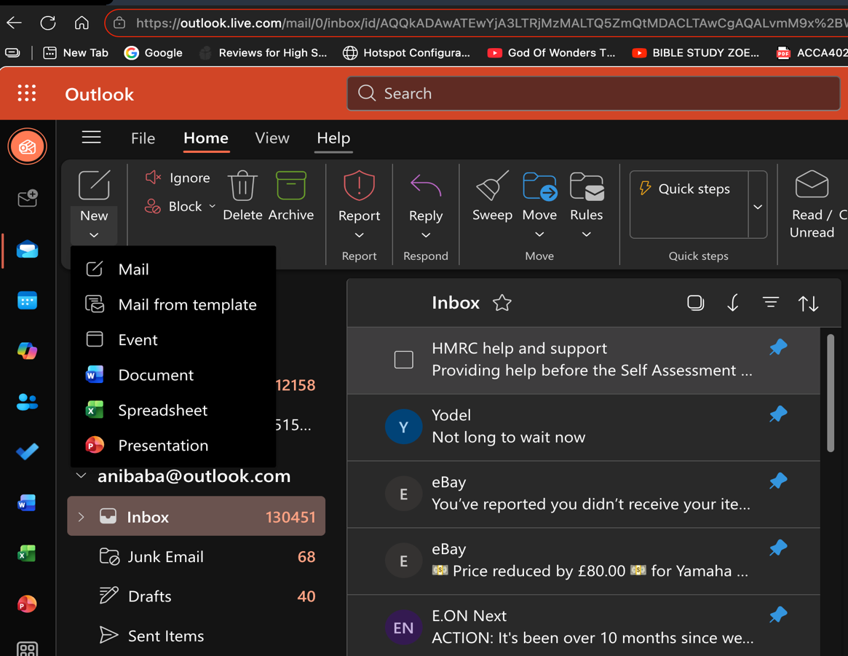
Figure 21 Create New email

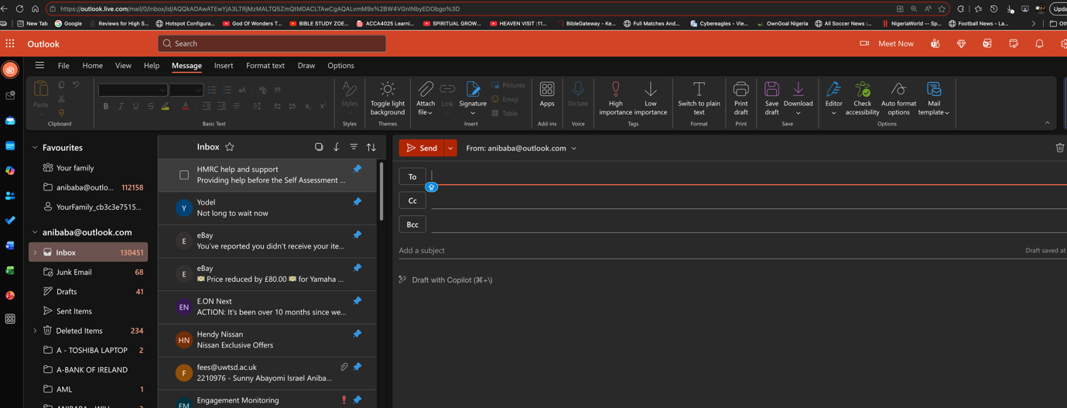
New mail now opens for recipient details and contents to be filled.
Figure 22 New email now created.

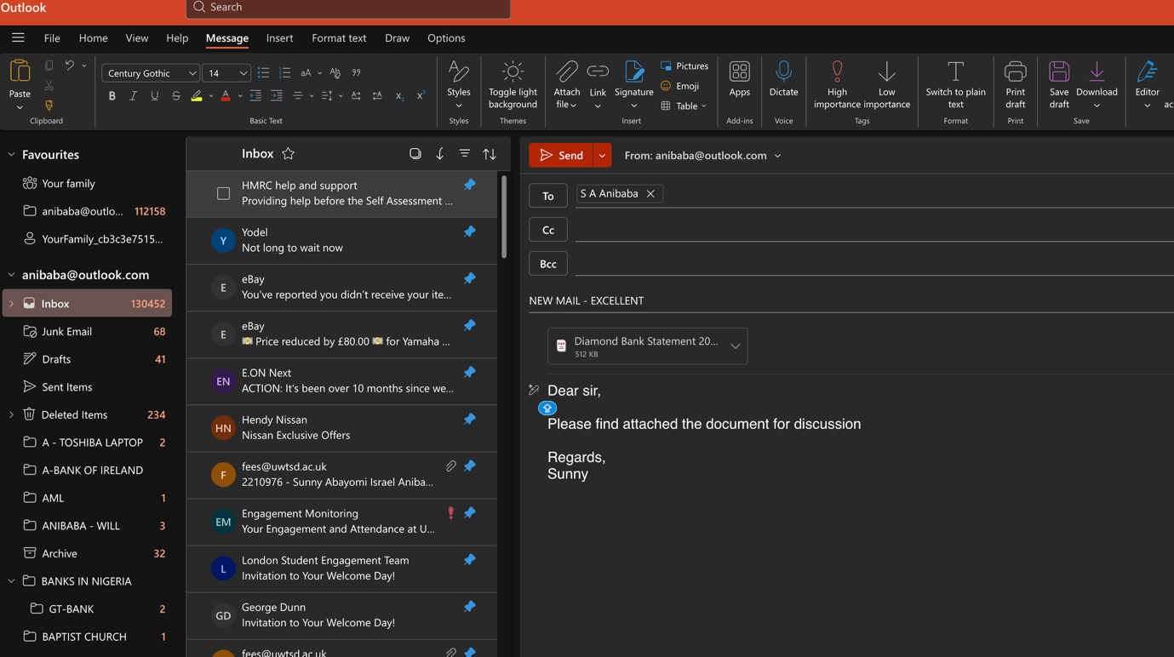
email ready to be sent out to recipient.

Figure 23 New email now created, ready for attachment.

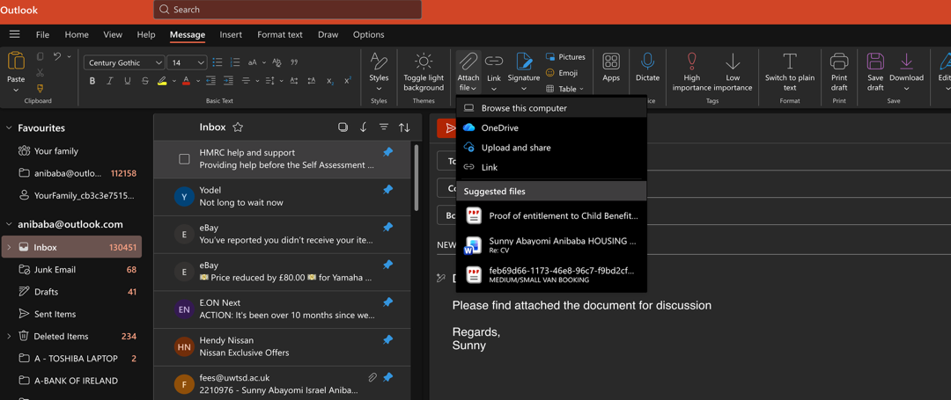
From the top menu, select “Attach file”, then click “Browse this computer” to attach file.

Figure 24 The above shows how to attach a file.

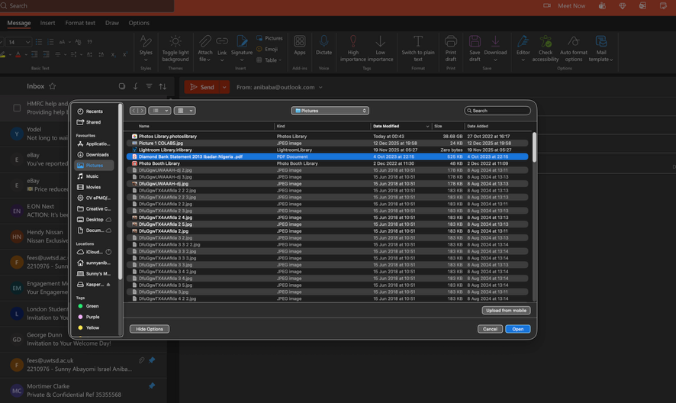
Select desired file and click “Open” to attach the file to the email.

Figure 25 How to select desired file to an email.

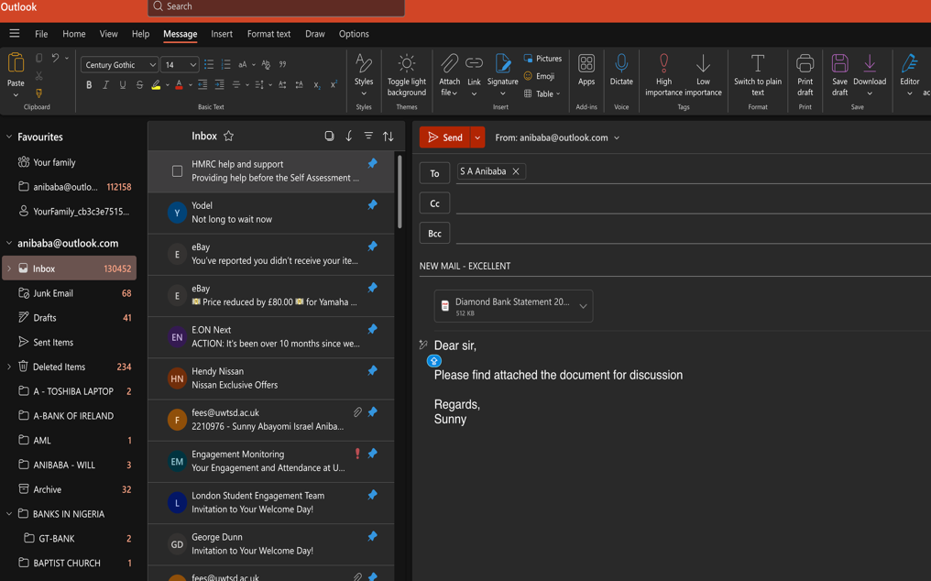
File now attached and email ready to be sent out by clicking SEND.

Figure 26 The above show file attached to the email.

Ms Teams
<Insert screenshots with captions>

Conclusion
Digital tools are now central to how businesses and teams work. E-commerce website builders such as Shopify, Wix, Squarespace, and WooCommerce make it straightforward to set up online stores with ready-made templates, payment systems, and mobile-friendly designs. They’re a fast way for small businesses to get started and grow, though subscription fees and limited customisation can be drawbacks compared to building a site from scratch. [13]
Beyond e-commerce, software applications cover productivity, creativity, and collaboration. Microsoft Office remains a staple with Word, Excel, PowerPoint, and Outlook supporting documents, data, presentations, and communication. While newer AI and analytics tools add automation and insights. For teamwork, applications such as Microsoft Teams, Slack, Zoom, Trello, and Asana help reduce email overload, keep projects organized, and support hybrid work. Together, these tools form an ecosystem that keeps people connected, productive, and adaptable. [14]

References

[1] | OmniaTM, “Omnia Publisher,” Omnia, [Online]. Available: https://www.omniapublisher.com/prodotto/woocommerce/. [Accessed 6 December 2025].
[2] | P. Pedamkar, “EDUCBA,” [Online]. Available: https://www.educba.com/author/priya-pedamkar/. [Accessed 3 DECEMBER 2025].
[3] | A. Weiner, “Wix Blog,” 12 July 2023. [Online]. Available: https://www.wix.com/blog/how-to-make-a-website. [Accessed 3 December 2025].
[4] | K. Clay, “Six Sigma Development Solutions Inc,” [Online]. Available: https://sixsigmadsi.com/mind-mapping/. [Accessed 6 December 2025].
[5] | Christian Rapp, Till Heilmann, Otto Kruse, “Beyond MS Word: Alternatives and Developments,” Springer Nature, pp. pp 33-47, 2023.
[6] | “The Knowledge Academy,” The Knowledge Academy , 21 November 2023. [Online]. Available: https://www.theknowledgeacademy.com/blog/features-of-powerpoint/. [Accessed 7 December 2025].
[7] | “PRESENTATION GEEKS,” Presentation Geeks, [Online]. Available: https://presentationgeeks.com/blog/benefits-of-powerpoint-presentation/. [Accessed 7 December 2025].
[8] | Wikipedia, “Wikipedia,” 2025. [Online]. Available: https://en.wikipedia.org/wiki/Microsoft_Excel. [Accessed 11 December 2025].
[9] | Template.com, Template.com, 2 September 2025. [Online]. Available: https://www.template.net/office/microsoft-access/. [Accessed 11 December 2025].
[10] | “The IT Service,” 2025. [Online]. Available: https://theitservice.co.uk/microsoft-access-objects/. [Accessed 12 December 2025].
[11] | S. Advice, 12 December 2025. [Online]. Available: https://www.softwareadvice.com/productivity/microsoft-365-profile/vs/microsoft-outlook/. [Accessed 12 December 2025].
[12] | B. Carlos, “The Redaction Team,” 31 August 2023. [Online]. Available: https://barrazacarlos.com/advantages-and-disadvantages-of-microsoft-teams/. [Accessed 13 December 2025].
[13] | C. Tomczyk, “SITELINT,” 28 July 2024. [Online]. Available: https://www.sitelint.com/blog/online-website-builder-advantages-and-disadvantages. [Accessed 13 December 2025].
[14] | P. DODD, “Develo Designs,” [Online]. Available: https://www.develodesign.co.uk/blog/ecommerce-website-builders-popular-choices-pros-and-cons. [Accessed 13 December 2025].
[15] | “Be Six Sigma Certified,” Six Sigma Development Solutions, Inc, [Online]. Available: https://sixsigmadsi.com/mind-mapping/. [Accessed 15 11 2025].
[16] | WooCommerce, [Online]. Available: https://woocommerce.com/woocommerce/. [Accessed 26 November 2025].
[17] | WooCommerce. [Online]. Available: https://woocommerce.com/woocommerce/. [Accessed 26 November 2025].
[18] | WooCommerce, “WooComemerce,” [Online]. Available: https://woocommerce.com/woocommerce/. [Accessed 2025 November 2025].
[19] | A. Weiner, “Wix Blog,” 12 July 2023. [Online]. Available: https://www.wix.com/blog/how-to-make-a-website. [Accessed 3 December 2025].
[20] | Y. Sohn, “Mind Mapper,” 24 September 2024. [Online]. Available: https://mindmapper.com/blog/. [Accessed 6 December 2025].
[21] | Ashley, “The History and Origins of Excel Mac,” in Conditional Formatting. Automate Library, 2025.

