

Module: Dissertation
Module Code: LCBB6000
Assignment Title: Individual Dissertation
Student Name: Beatricia Corsan
Student ID: 2013038
Topic title: The Impact of Leadership Style on Employee Motivation in Human Resource Management Practice
Declaration
I hereby declare that in submitting this research entitled, "The Impact of Leadership Style on Employee Motivation in Human Resource Management Practice", this work has not been presented in any other University for the award of any other degree or professional qualification. Citations of all the sources of information have been made. This research is carried out due to the course work needs and the objective here is to establish the relationship between leadership styles and motivation of employees in organisations.

Acknowledgement
I want to express my deep thankfulness to all the people who supported my decision and helped me in this research process. First and foremost, I would like to showcase my appreciation to teachers for providing me with helpful advice, critical comments and moral support. I could not have attained this work without their information, effort and guidance. I would also like to thank my friends for their support, encouragement and discussions that we had throughout this process. Moreover, I intend to extend my deepest gratitude and regards to my beloved parents for always being there for me and for guiding me patiently.

Abstract
Employee motivation plays a valuable role within an organisation by allowing staff to work better, provide effective services and remain engaged with their companies. Leadership is vital in elevating the motivation within a human resource practice. This research work has been based on the role of an appropriate leadership approach in uplifting staff encouragement. The introduction section has included a clear aim along with defining some objectives of the study. Moreover, the rationale for conducting the research to fill the literature gap and find suitable solutions for the leadership issues has been discussed here. The literature review section has involved secondary information collected from various credible sources. Transformational, servant and transactional these three types of leadership approaches have been discussed in the section. Additionally, the relationship between staff engagement and leadership has been described in a detailed manner. This research project has discussed a methodology that provides a brief description of the process to perform this research. It has also discussed various approaches including research onion, methods, philosophy, approach, design, sampling, strategy and data collection tool. Ethical considerations have also been mentioned in this research project. Different methods have assisted in meeting the objectives of this topic. Findings and analysis have also been mentioned in this project. Discussions of this research project have also been described that provide a brief description of the findings and relate it with the literature review part. The conclusion has shown that the research objectives have been met by answering the questions by reviewing existing literature and analysing the data received from surveying employees of different organisations. Additionally, some recommendations have been provided for leaders and organisations to implement to see better employee motivation levels. The potential future implications have also been listed to see the way this research can help future researchers and leaders understand the impact of leadership styles on employee motivation.
Glossary
Job satisfaction- Job satisfaction is referred to as the overall feelings about their service.
Motivation- Motivation is described as an internal state that engages the employees in their job.
Leadership styles- Leadership style is a path that motivates the employees by providing well-being, motivation and common goals.
HRM- Human resource management (HRM) refers to an organisational function that assists a company in dealing with employees.
Productivity- It is a measurement of an economic performance that compares with a number of services and goods.

Table of Contents
Chapter One: Introduction 4
1.1 Introduction 4
1.2 Background of the Study 5
1.3 Problem Statement 5
1.4 Aim and Objectives 6
1.5 Research Questions 6
1.6 Research Rationale 6
1.7 Scope of the Study 7
1.8 Structure of the Dissertation 7
1.9 Summary of the chapter 8
Chapter Two: Literature Review 9
2.1 Introduction 9
2.2 Various Leadership philosophies used in HRM practices 11
2.3 Evaluating Employee Motivation Levels Inside Organisations 12
2.4 Connection Between Employee Motivation and Leadership Style 14
2.5 Literature Gap 15
2.6 Summary 16
Chapter Three: Research Methodology 17
3.1 Introduction 17
3.2 Research onion 17
3.3 Research Philosophy 18
3.4 Research approach 18
3.5 Research design 19
3.6 Research method 19
3.7 Research Strategy 20
3.8 Data collection tool 20
3.9 Data analysis process 20
3.10 Sampling 21
3.11 Ethical consideration 21
3.12 Summary 22

Chapter One: Introduction

1.1 Introduction
The impact of leadership style on employee motivation in the context of Human Resource Management (HRM) practice is of great importance for the success of an organisation. Efficient leadership can motivate, authorise, and involve individuals, resulting in increased production and the development of a favourable workplace culture. In contrast, inadequate leadership may result in employee disengagement, diminished morale, and decreased performance. Several points will be highlighted in the introduction chapter to provide background knowledge as well as direction for the research. Such research will start with a brief overview of the topic. The rationale for the study will focus on highlighting the importance of understanding how leadership behaviour affects motivation in the workforce. The proposed research objectives and the specific aim of the research will be defined first before proceeding to research questions and hypotheses. This is where the justification of the research will be presented to show the research gaps in the existing literature and the issues affecting the organisations in the UK. Finally, the chapter will conclude by outlining the structure of the whole dissertation.

1.2 Background of the Study
The Opinions of the leadership on the motivation of the employees are considered a core area of research in the human resource management practice. Leadership impacts organisational culture and engagement of the staff, which in turn affects the efficiency of the organisation (Josie Cox, 2023). Leadership motivation is dependent on the type of leadership which can be transformational, transactional and laissez-faire. Leaders are seen as supportive and inspirational figures by employees in the UK. On the contrary, low-quality leadership increases employee turnover intentions. Such insights enable organisations to put into practice organisational development that promotes workforce motivation, hence the achievement of organisational objectives and competitiveness (Paais and Pattiruhu, 2020).

1.3 Problem Statement
The study will address several significant concerns in leadership development that influence HRM in organisations, particularly employee motivation. Lack of proper management and poor delegation of tasks and responsibilities can cause the employees to submit low-quality work, demotivate others and initiate high absenteeism rates. 43% of employees in the UK have said that their lack of motivation is a result of the leadership they experience at their workplace (Clark, 2024). However, studying organisational leadership failures indicates that poor leadership can lead to high stress levels and lower levels of employee satisfaction that are likely to affect the performance of the organisation. Through examining the relationship between leaders and factors affecting employee engagement, this research aims to detect successful leadership practices.

1.4 Aim and Objectives
Aim
To understand the influence of leadership style on employee motivation in Human Resource Management.
Objectives
1. To classify and identify the various leadership philosophies that are used in HRM practice.
2. To evaluate the employee motivation levels inside organisations.
3. To Examine the Connection Between Employee Motivation and Leadership Style.

Research Questions
1. What are the predominant leadership styles employed in HRM practice?
2. How do employees perceive their levels of motivation within the organisation?
3. What is the relationship between transformational leadership and employee motivation?
4. How does transactional leadership impact employee motivation levels?

1.6 Research Rationale
The justification for this study is to provide insights into the existing literature gap that concerns the effects of leadership behaviours on the motivation of employees in the aspect of HRM. Even though there is a huge source of literature regarding general leadership impacts, little research attention has been paid to how specific leadership paradigms affect motivation. Addressing this gap is crucial, as current data from this research will reveal significant challenges. Employees in the UK have revealed that they are not currently encouraged due to the way that their managers lead them (mckinsey, 2023). Hence, the research focuses on successful leadership practices and the extent to which motivation can be improved.

1.7 Scope of the Study
The researcher seeks to establish a correlation in the level of motivation of the employees with different types of leadership in UK organisations. The advantages of the study include the fact that HR professionals and organisational leaders are able to get insights with actual proof on the leadership practices to adopt. It is therefore beneficial if these organisations can note how various methods of leadership affect motivation appropriately (Mwesigwa et al., 2020). This will enhance the usage of correct motivation methods to enhance employee satisfaction and productivity. Further, this study will be significant in academic research with an understanding of leadership and motivation to create a framework for subsequent empirical examinations.

1.8 Structure of the Dissertation
Chapters | Content description
Introduction | This chapter will introduce the research topic, with an impression of the background, problem statement, aim, objectives, and rationale for the work. It will set the stage for the following chapters by highlighting the importance of investigating the influence of leadership patterns on employee inspiration.
Literature review | This chapter will review existing sources on various leadership patterns and staff engagement. It will classify gaps in this research and establish a theoretical context for the study. Key theories and models relevant to the topic will be discussed.
Research Methodology | It will outline the research design and methodology. This chapter will describe the data collection methods, sampling techniques, and analysis procedures that will be used to test the research hypothesis. Ethical considerations of the study will also be addressed.
Data analysis and discussion | This chapter will present and analyse the data collected through a survey during the research. It will examine the connection between leadership styles and worker motivation, discussing the findings in relation to the present literature.
Conclusion and recommendations | It will summarise the research findings and draw conclusions. It will deliver ideas for HR practices and recommend areas for future study based on the study’s results.

1.9 Summary of the chapter
The first chapter of the dissertation has provided context on the background of the research, focusing on the influence of leadership behaviours on motivation aspects concerning HRM. Moreover, the problem statements have identified enormous leadership issues that impact the motivation of employees within organisations operating in the UK. The chapter has stated the purpose and objectives in addition to outlining the research questions in the study. Additionally, the rationale has presented the reasons for conducting the research to cover gaps in the existing literature and the scope of the study has described what the readers will gain from it. Finally, the chapter has outlined the work in context and presented an overview of the entire structure of the dissertation.

Chapter Two: Literature Review

2.1 Introduction
The second chapter of the research will evaluate the assessment of the main issues to ensure the fulfilment of the goals and objectives through acquiring secondary sources. This chapter will support the use of a range of resources from several sources to gauge the effects of leadership type on staff encouragement in the field of HRM. In this chapter, the respective classification and identification of the available leadership paradigms applied to HRM practice will be described. This will also measure the level of motivation among employees in organisations and compare the extent of motivation of employees in different forms of organisations with leadership styles. Therefore, the analysis of these aspects will give a theoretical understanding of how various leadership styles affect the employees' organisational loyalty, commitment and productivity.

2.2 Various Leadership philosophies used in HRM practices
Transformational leadership
Transformational leadership constitutes an enormously popular management approach in HRM that aims at encouraging employee performance to the total expectations and beyond the limit of possibility. According to Salas‐Vallina et al. (2021), it calls for delegation of tasks, encouragement of people and creation of vision. Transformational leaders interact with the organisational members and lead them so that they all are on the same level, promoting the invention of more creativity. Thus, it encloses the concept of growth of the employees by appreciating their efforts and ensuring that the individual goals set down by the employees are in harmony with the goals of the organisation. Greimel et al. (2023) determined, that this leadership supports the leader as a role model by displaying integrity and high ethical standards when dealing with the employees. It means that the engagement will be higher and people will be more satisfied and, consequently, better-performing employees. However, it is most useful in situations that are constantly evolving and require changes to be made and new ideas implemented.
Servant leadership
Asbari (2020), interpreted another important leadership system in the field of HRM as servant leadership that also aims at the needs of employees. The approach is distinct from other leadership paradigms based on the amount of control that a leader has; instead, it revolves around the care that a leader should provide to their subordinates. As opined by Canavesi and Minelli (2022), managers who embrace this business philosophy ensure they are servants to their subordinates through offering them optimal organisational support tools, as well as opportunities for development. This assists in engaging in two-way communication with the employees in which ideas, feelings and perceptions are received and understood. Meuser and Smallfield (2023) discussed that with those particular focuses on employees' growth and welfare, servant leadership can improve satisfaction rates among the workers, strengthen their loyalty, and thus minimise staff turnover.
Transactional leadership
As depicted by Jacobsen et al. (2022), transactional leadership is an instinctual and systematic approach to HRM that is based on the exchange of mutual obligation between a leader and subordinates in organisations. Essentially, this leadership style is based on giving bonuses and penalties. Transactional leaders always clarify who does what, where, and when; and also give feedback depending on the performance. It also helps in maintaining work ethic, productivity, and order in organisations to produce competent results. As observed by Nurlina (2022), being subordinate to organisational politics, transactional leaders always establish the line of authority and rely on structural processes to assess people's performance. This leadership style is therefore suitable in organisations that do not experience change and operate in stable organisational environments.

2.3 Evaluating Employee Motivation Levels Inside Organisations

Utilising Key Motivational Theories to evaluate motivational theories
According to Bushi (2021), leaders are required to assess employee performance, employee relations and organisational culture to understand the effectiveness of the motivational tools. Thus, each leadership styles have different focus areas based on which it assesses whether employees feel driven to work. Thus, leaders can employ motivational theories to understand key areas that show motivational levels. Navy (2020) for instance stresses on the Maslow’s hierarchy of needs shows various physiological and psychological needs of employees that act as the driving force behind their actions and behaviours. Thus, satisfaction of these needs is important to keep employees motivated. Watters (2021) also states various motivational theories such as Vroom’s expectancy theory and Adams's equity theories for estimation of various motivational factors within the organisation. The Vroom’s model depicts that motivation of employees is directly connect with their expectations that will result from the action. Thus, an employee makes choices that will minimise the pain and maximise the pleasure. While Adams equity theory of motivation presents the idea that a proper balance between the amount of work given by the employee and its outcome determines motivation. Therefore, leaders can use these theories to understand the various factors that determine the satisfaction and motivation of the employees. Based on this, leaders should select the type of leadership style that ensures conduct which solves the issues.

Using key performance indicators
Wuryani et al. (2021) stated that setting key performance indicators helps leaders understand the motivation levels within the organisation. Thus, collecting information regarding absenteeism, employee turnover and productivity will help to determine whether employees are motivated or demotivated. For instance, it has been observed that highly motivated employees took fewer leaves in comparison to demotivated employees. Organisations with unsatisfied employees tend to have higher employee turnover as employees resign for better opportunities.
Evaluating motivation based on productivity levels and Survey
Moreover, productivity levels are recorded to be higher in the organisations that had motivated employees who were self-driven. Thus, analysis of these performance metrics facilitates the evaluation of the motivation. At the same time, Carvalho et al. (2020) argue that various methods to assess the impact of the leadership style and changes in the motivational levels. These include conducting surveys by making questionnaires that cover various organisational aspects and require employees to give ratings. The survey can also have a space for the employee to express their opinions and provide beneficial recommendations. There are various other methods that the author discusses such as conducting interviews, observational studies and psychology tests.

2.4 Connection Between Employee Motivation and Leadership Style
Values and Motivation
Dewi and Wibow (2020) stress the importance of leadership style in determining the motivation of employees in an organisational setting. For instance, the transformational leadership style inspires the employees to embrace the same values and work ethic followed by the leader who they see as their role model. Thus, a transformational leader encourages creativity within the employees and provides individual consideration to ensure development. Thus, in this type of leadership style, the leaders are invested in the development of the employees earning their admiration and trust. This increases motivation in the employees and they tend to work harder which improves their performance. In contrast, the authoritarian leadership style has low levels of motivation as it doesn't provide employees with the freedom to express their thoughts and opinions which makes them feel unworthy. Autocratic leaders make all the decisions and employees are expected to comply.
Level of freedom and Motivation
Therefore, leadership style determines the level of freedom employee have to express their ideas thereby determining their overall satisfaction and motivation. Bojovic and Jovanovic (2020) argues that the motivation of employees largely depends on the satisfaction of their needs using Maslow’s hierarchy of needs and Herzberg’s two-factor theory. It is the responsibility of leaders to look after the various needs of employees and ensure their well-being. Thus, each leadership style focuses on different needs to keep employees motivated. For instance, transactional leadership motivates employees by using recognition and reward systems. Under this style, employees work hard solely for monetary benefit and are required to comply with the commands given by the leader.
Decision-making and Motivation
Northhouse (2021) also discusses the way different leadership styles can be adopted to achieve the desired impact on the employees. For instance, democratic leadership styles are largely adopted by organisations to achieve a high level of employee engagement and motivation. Democratic leaders allow the employees to take part in the decision-making thus encouraging communication. As a result, employees feel invested in the workings of the organisation and feel motivated to achieve organisational goals. However, leaders have control over the operation and have the final say in the discussion. Employee freedom is highest under a laissez-faire leadership style under which leaders allow employees to make all the decisions and solve problems on their own which inspires innovation and personal growth. Arikan (2020) says that motivation is highest under transformational leadership instead of democratic and laissez-faire. Under these styles, there is a chance of communication failure and is not beneficial in cases where employees are unskilled.

2.5 Literature Gap
This part aimed to find the most relevant works of literature that help in addressing the research objectives. Salas‐Vallina (2021) have discussed the importance of encouraging employees to work in an organisation and the role leadership plays in HRM in achieving it. However, the literature did not mention or discuss about various leadership philosophies influencing motivation. Wibow (2020) have discussed the significance of leadership in ensuring motivation. The literature has intricately focused on the interrelation between the HRM and leaders in an organization. However, it lacked specification and explored multiple aspects that influence the activities of human resource. Moreover, the literature discussed here were not able to provide detailed information about absolute methods for measuring employee motivation levels.

2.6 Summary
The literature review section in this research has primarily focused on discussing the opinions of previous researchers and elaborating on the existing data. Leadership philosophies that are related to the HRM practices in any organisation have been discussed here. Detailed analyses of the impacts that various leaders can have on regular HRM practices have been analysed here. Moreover, various methods can help in evaluating the motivation level and the way employees perceive motivation levels have been analysed here. Connection between employee motivation and leadership styles have been explained in this section.

Chapter Three: Research Methodology

3.1 Introduction
Research methodology is the systematic procedure of gathering, analysing and interpreting data to answer the research questions and test hypotheses. It outlines the tools, techniques and procedures used to collect information, ensuring the work’s validity and reliability. This will use the Saunders’ Research Onion to understand the different stages of the methodology. The study uses quantitative research, drawing on a comprehensive literature analysis that emphasises the substantial impact of leadership styles on organisational results, with a specific focus on the importance of transformational leadership in promoting intrinsic motivation. The survey approach will be used to get quantitative data on employees' views of leadership styles and levels of motivation. Furthermore, the research philosophy will be discussed, along with the approach, design and method.

3.2 Research onion
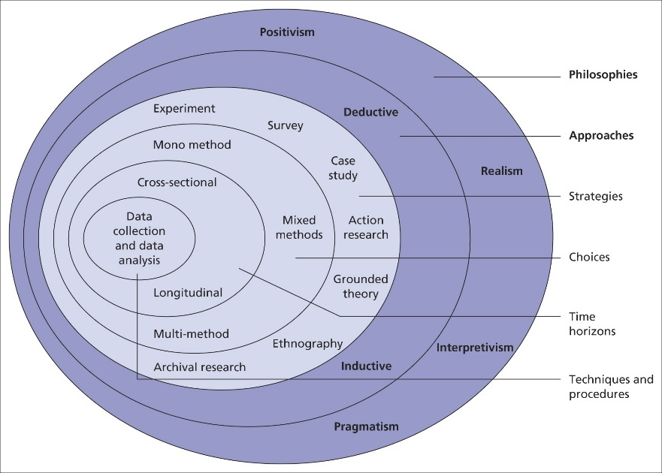
Figure: Research Onion
Source: (Iovino and Tsitsianis, 2020)
Saunders' Research Onion illustrates the stages involved in the development of a research which gives a more detailed progression through the stages of a research methodology (Iovino and Tsitsianis, 2020). The approach for using this framework is to move from the outer to the inner layers of the model. It is a useful framework that has helped the researcher to think holistically about the methodology and understand the decisions that had to be made as per the research design.

3.3 Research Philosophy
Research philosophy is associated with the knowledge, assumptions and nature of the work. It is a belief about the way information is collected, evaluated and used (Mauthner, 2020). Three main types of research philosophy can be used which are positivism, pragmatism and interpretivism. This research has used positivism since it depends on quantitative data which works as a legitimate source of information. Positivism also follows a well-defined structure while conducting research which makes it more accurate during applications by following specific rules using scientific and objective mathematical tools (Park et al., 2020). It has helped to uncover patterns, trends and correlations which has assisted with experimentally examining the correlation between employee motivation and leadership styles in HRM.

3.4 Research approach
The research approach is the procedure which is used to investigate a problem or a research question, hiding the way data is gathered, assessed and interpreted (De Oliveira, 2023). There are mainly three types of research approaches that researchers can consider which are deductive, inductive and abductive. This research has used the deductive approach to establish the correlation between leadership styles and staff motivation. Using the deductive approach has helped the researcher to develop a hypothesis relying on the existing theory to design a research strategy for testing the said hypothesis. Additionally, the results achieved from using this approach are often relatable and replicable with statistical analysis establishing causality (Salomão, 2023). It is also well-suited to the quantitative research method that has been utilised for this particular study. The data collected can be generalised to a large population and it allows for control of extraneous variables.

3.5 Research design
Research design is the plan which details the way a study is conducted, including methods for data analysis and collection which ensures that the research is systematic and structured (Huntington-Klein, 2021). Exploratory, descriptive and conclusive are the three main types of research designs that can be considered. This research has utilised the descriptive design since the quantitative data is used to give a holistic understanding of the research topic. It has also allowed the research to be conducted in the natural environment of the respondent, snoring that only high-quality and honest data has been collected. Descriptive design has also helped conduct the entire data collection process quickly and cost-effectively.

3.6 Research method
Research method is the specific technique and procedure that is used by the researcher to collect, analyse and interpret information to address the research objectives effectively (Lê and Schmid, 2022). There are three types of research methods which are mono, multi and mixed. This research has used a mono method using quantitative surveys. The quantitative method has been used for the accuracy and impartiality of the data that it provides using the survey questions. It is also faster and easier to run particularly for mobile and online surveys, the results of which can be checked in real time. The data remains anonymous offering a continuous and reliable flow of information which can be repeated to gain consistent trend data.

3.7 Research Strategy
A research strategy is the main part of a project that primarily focuses on the perspectives of the research methods (Johannesson et al., 2021). It is considered as an overall plan for conducting any research work to reach the goals. There are various strategies including Surveys, case studies, experiments, interviews and observations. A researcher has chosen surveys that provide clear outcomes of a particular topic. It provides a better understanding of a specific knowledge and helps in gaining potential conclusions. This survey has taken place between 30 people from three different organisations of retail sectors that can provide actual and real data. It also assisted in realising the perspectives of a group of people who will be participating in the survey.

3.8 Data collection tool
Data collection tools are the techniques used to collect data from a particular source. It has several methods including primary and secondary. Primary data collection tools include paper questionnaires (Taherdoost, 2021). The researcher has used primary data collection tools and form questionnaires to conduct the survey. It has assisted in gathering the same type of information from each person. This approach is more reliable and accurate and comes from a direct source. It is also appropriate for collecting real-time data, tracking events and monitoring the procedures.

3.9 Data analysis process
Data analysis method is defined as the observations of numerical data that are arranged by an individual (Nguyen et al., 2020). It is useful for analysing the information and managing potential outcomes. There are various types of procedures including qualitative and quantitative. The individual has taken a quantitative method that assists in analysing the numerical data of the research. This type of approach is essential for gaining reliable insights and understanding the patterns and trends. It has assisted in communicating through numbers and statistics. A survey questionnaire will be design based on my research questions and objectives. The data will be presented in the form of histogram or bear chats, with together with participants, views, and experiences.

3.10 Sampling
Sampling methods refer to the techniques for gaining statistical information targeting a group of people. It has some techniques including simple random, systematic, cluster, convenience and stratified sampling methods. It assists in analysing the inferences and engaging in gaining results. A simple random sampling method has been taken by the researcher. This type of approach is referred to select random people for conducting a survey. It has helped to provide equal chances to participants (Taconeli and de Lara, 2022). This type of method assisted an individual in gaining real information on a specific topic. There was no specific boundary of age and occupation for performing the survey. The researcher has chosen a group of random people inside the organisation. The target sample for this study 10-15 people. The participants are the mixed of colleagues who work at various organisation. The survey questioners will be sent to them via email contact. The reason is that I’ve worked there before and I have contacts with them.

3.11 Ethical consideration
Ethical considerations are a set of rules that guide a researcher to conduct research. It has various principles regarding the survey (Akdeniz et al., 2021). Considerations include anonymity, confidentiality, results communication and informed consent. The researcher has maintained the information confidential. No people were harmed or forced during this research. Results of this research were not biased, and the participants provided their perspectives on the questions. There were no specific group of people that has been participated. Hence, the results are not biased and trustable. The trust has been maintained during the process and all the details are kept secure.

3.12 Summary
Methodology is a specific term that is used to ensure the methods and approaches to analyse the information. It allows a researcher to make potential outcomes of a research topic. This chapter has discussed a detailed methodology that includes research onion, philosophy, strategy, method, data collection and sampling. An individual has taken different approaches to prepare a research project that assists in meeting the objectives of this project. A deductive approach, primary data collection, simple random, survey and other methods has been chosen.

Chapter Four: Data presentation, analysis and discussion

4.0 The presentation will be represented by charts, followed by the analysis and discussion of the related topic. It will follow an analysis of the questionnaire results and the third discussion of fundings in relation to secondary data.

4.1 Primary analysis
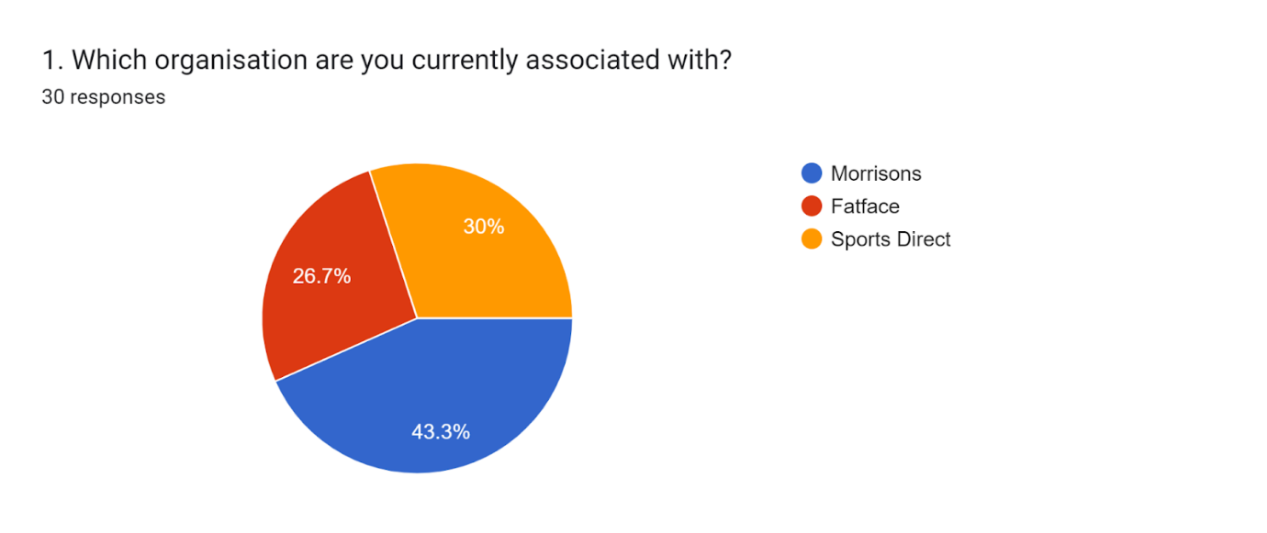

Source: (Google Forms, 2024)
Analysis
The survey has been conducted with 15 workers from three UK organisations which are Morrisons, Fatface and Sports Direct. These three companies have been chosen from the retail sector for this survey and the first question has been asked to get insights about how many employees from a particular organisation have participated in this research. As per the aforementioned chart, it can be stated that most of the participants (43.3%) belong to Morrisons while 30% of workers have been taken from Sports Direct. Moreover, 26.7% of people who took part in this research belong to Fatface, a UK-based SME.

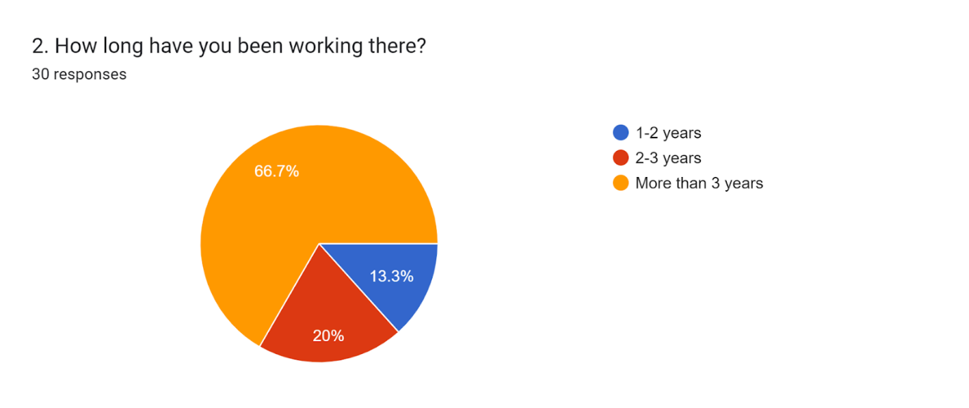
Figure 2
Source: (Google Forms, 2024)
Analysis
The second question of the survey has been made to know about the work experience of the participants to confirm their ideas regarding their organisation's leadership strategy. According to their answers, it has been known that the maximum respondents (66.7%) have more than three years of experience. Along with this, 20% of people claimed that they have been associated with their organisations for 2 years. The remaining 13.3% of workers have 1-2 years of working experience in the companies and the findings have confirmed the basic understanding of the participants regarding leadership approaches followed by their leaders.
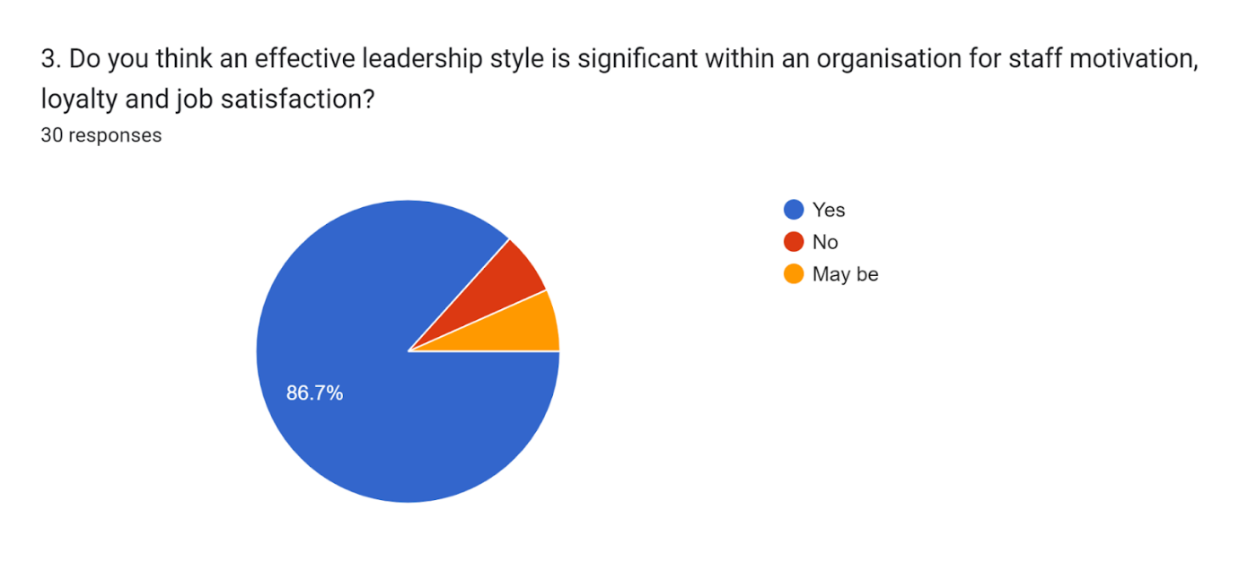
Figure 3
Source: (Google Forms, 2024)
Analysis
The importance of leadership styles in motivating employees has been asked of the survey participants. Each of them has stated their own knowledge by pointing out 'yes', 'no' or 'maybe'. 86.7% of the total respondents have supported the role of leadership patterns within their own organisations in staff motivation. Contrarily, only 6% of people have denied this which showcases that they do not find it significant in the factor of motivation. Additionally, the rest of the survey participants, which is similar to 7%, have claimed that they are not sure about this matter as they do not possess enough ideas regarding the connection between motivation and leadership.
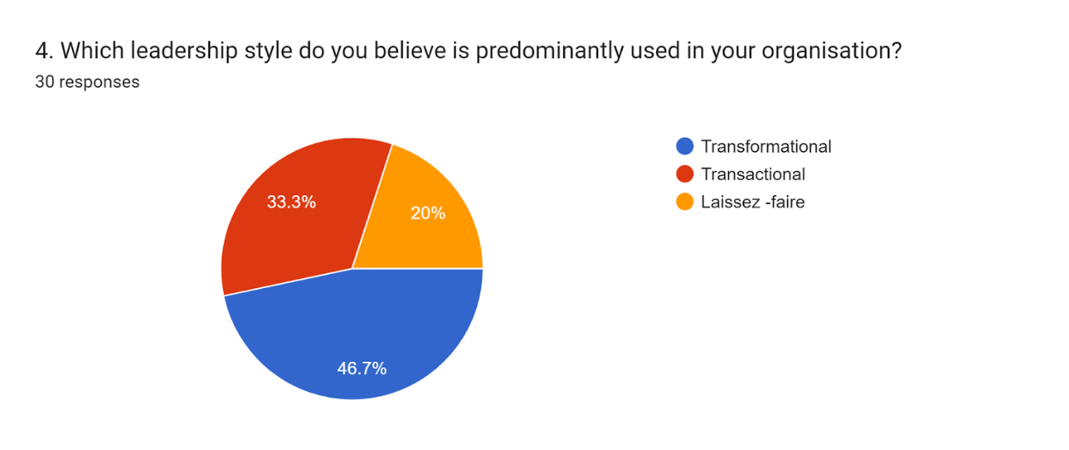
Figure 4
Source: (Google Forms, 2024)
Analysis
The fourth question has been constructed to get information about the leadership structure that the organisations in the retail sector follow. Here, respondents have pointed out the style they think their organisations use. 46.7% of workers have identified a transformational leadership style while 33.3% of people stated that their organisations obtain transactional patterns. Moreover, 20% of participants have highlighted the laissez-faire leadership style adopted by their companies. Therefore, from the percentage, it has been noted that most of the organisations use either transactional or transformational structure in their HRM practices.
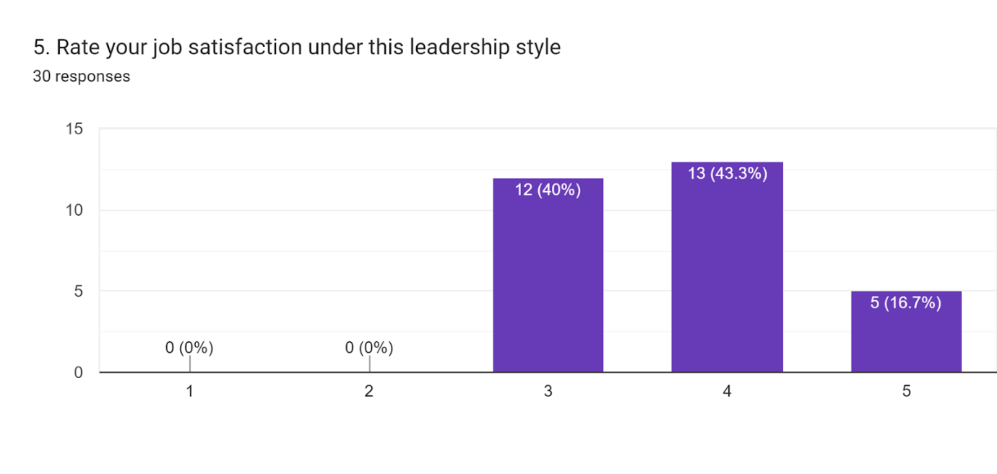
Figure 5
Source: (Google Forms, 2024)
Analysis
The fifth question of the primary research included a rating part where participants were asked to rate their satisfaction level. Here, the above chart shows a positive rating and there is no low satisfaction level among the workers. 43.3% of people responded 3 while 40% of the total workers rated 3. These findings indicate that almost all of the participants are satisfied with their jobs. 16.7% of people rated the highest level which is 5 which showcases their utmost satisfaction as well as impression towards their organisations.
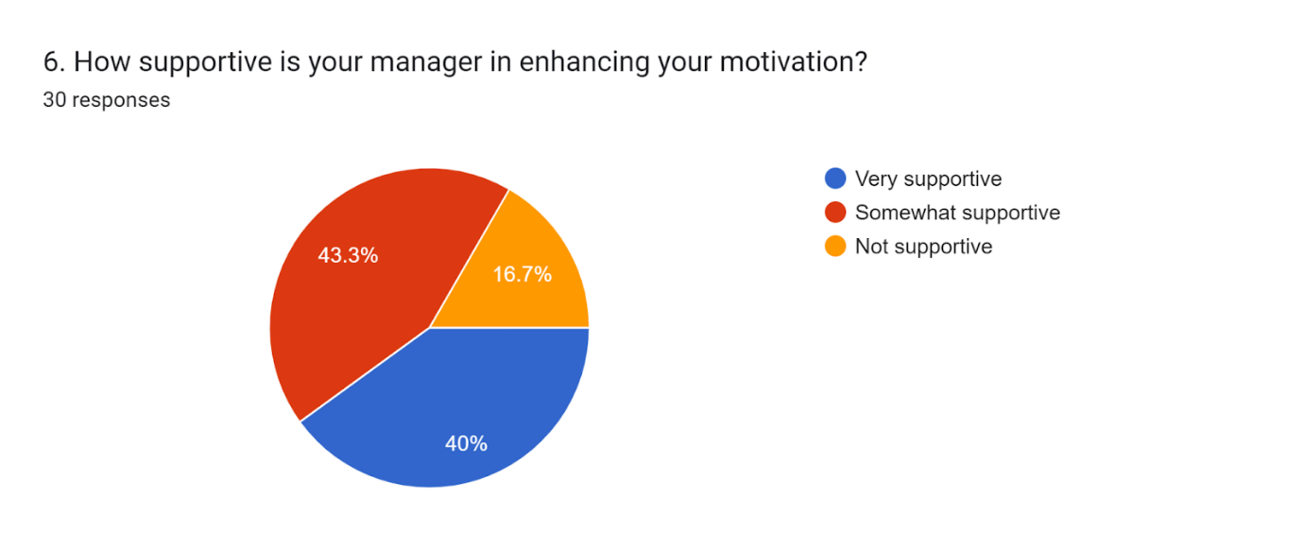
Figure 6
Source: (Google Forms, 2024)
Analysis
Manager plays a vital role within an organisation by encouraging people and motivating them for the purpose of increasing overall business productivity. Therefore, the sixth question has been made to understand participants' opinions on whether they are motivated by their manager or not. The findings have concluded that 40% of people found it very supportive and 43.3% of respondents claimed that their managers' cooperation is somewhat supportive. However, only 16.7% of workers do not think that their managers are supportive at all. This data clearly shows that most of the employees of the three chosen companies are satisfied with their managers.
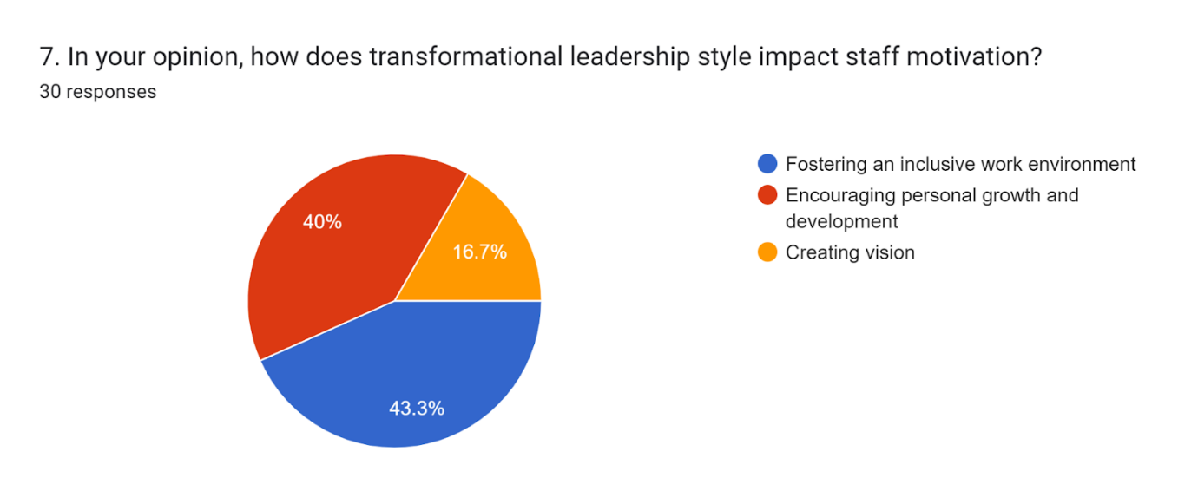
Figure 7
Source: (Google Forms, 2024)
Analysis
The seventh query has significant value as it directly relates to the research question to get insights regarding the role of transformational leadership patterns in motivating people within organisations. According to the data collected through the survey, it fosters an inclusive work environment, supported by 43.3% of respondents. Moreover, 40% of participants have pointed out that this style encourages their personal growth as well as development. It plays another vital role in creating a clear vision as stated by 16.7% of the total population in the survey.
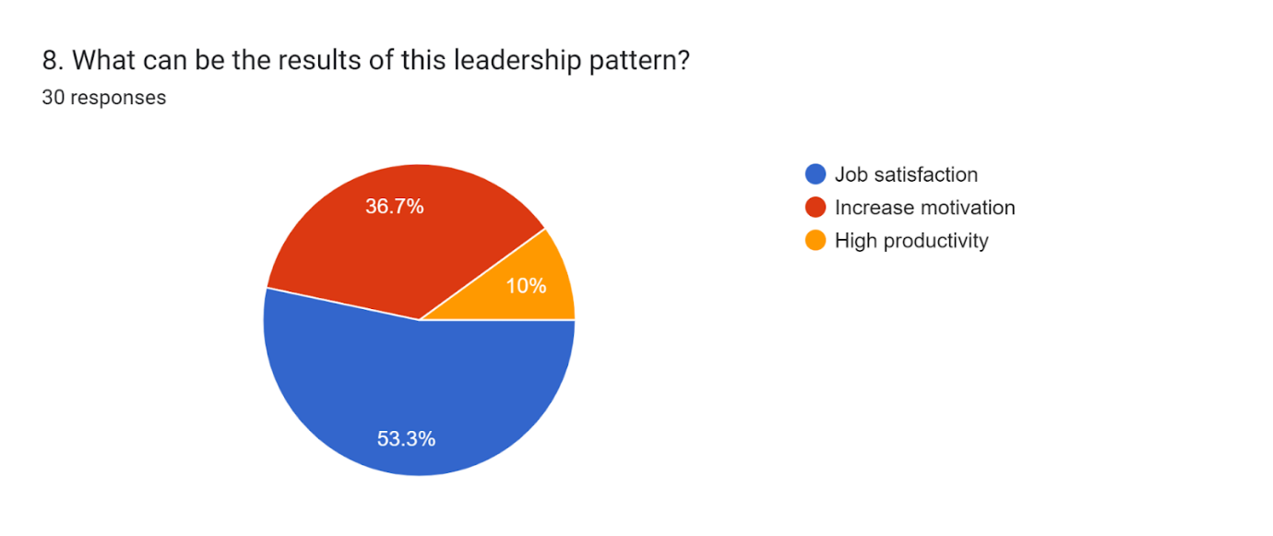
Figure 8
Source: (Google Forms, 2024)
Analysis
It was necessary to find out the implications of the adoption of transformational patterns in the HRM system. 53.3% of respondents have stated that organisations experience high job satisfaction which in turn reduces turnover. Additionally, 36.7% of people have claimed that their motivation has increased due to the employment of the practice which is effective for the organisation also. 10% of participants found high productivity as the effect of this leadership, however, this is the ultimate result of the aforementioned improvements within the workplace. Therefore, employees of those retail organisations believe in the strategy for the enhancement of both staff and companies as well.
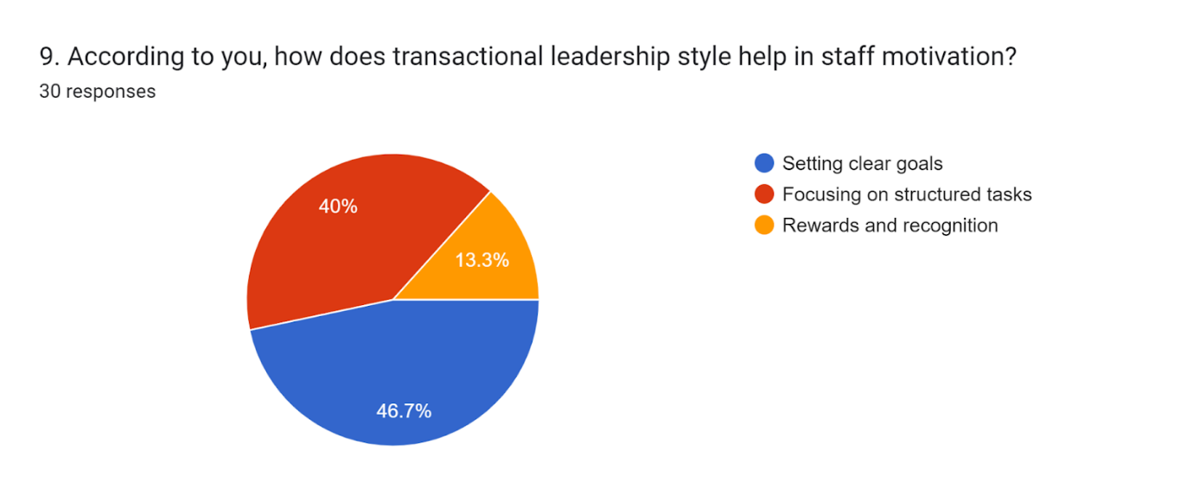
Figure 9
Source: (Google Forms, 2024)
Analysis
This question has included the query of the role of transactional leadership patterns within retail businesses in impressing staff. According to the survey outcomes, it has been known that this practice helps in setting clear goals that 46.7% of people have found valuable. Rewards and recognition are another vital aspect as per 13.3% of people. Contrarily, 40% of participants think that this pattern allows leaders to focus on structured or organised tasks that motivate them to work. All of the data highlights the significance of the leadership approach in uplifting staff motivation within a workplace.
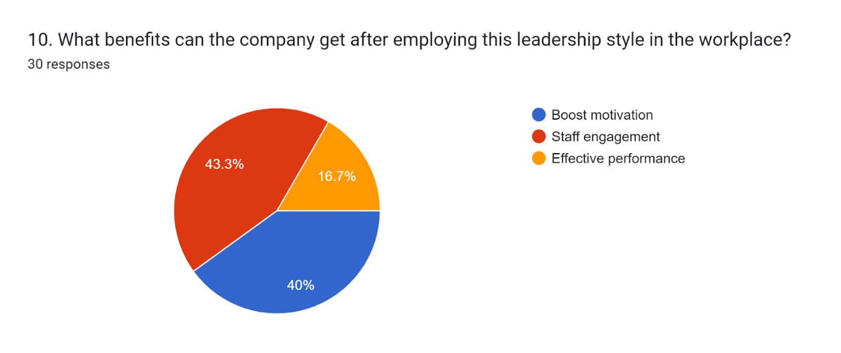
Figure 10
Source: (Google Forms, 2024)
Analysis
The final survey question has been based on the role of transactional style in an organisation by motivating people. A large number of workers, equal to 43.3% have mentioned that staff engagement or collaboration increases as a result of the proper implementation of the pattern. Another 40% have claimed that motivation of employees is boosted which in turn helps organisations meet their business goals. Finally, 16.7% of participants believe in performance enhancement as the implication of transactional leadership as it drives motivational factors. Overall, it can be stated that this pattern is useful along with the transformational one in employee motivation and satisfaction.

4.2 Discussion
The above analysis has shown that effective leadership styles are essential for employee motivation and job satisfaction. It shows that most of the people have considered it as a strategy for staff motivation. Similarly, according to Dewi and Wibow (2020), a motivated employee helps in structuring an organisation. Inspiring by positive leadership a person may follow the ethics of a workplace. It also assists in improving the performance of a company and building trust. This approach increases the satisfaction level of the staff and also assists in staff retention. Bojovic and Jovanovic (2020) have stated that staff motivation is mainly dependent on the satisfaction and the needs of the employees. The motivation depends on both psychological and physiological needs. The figures have shown that most participants agreed that effective leadership styles provide job satisfaction. Similarly, Watters (2021) has suggested that employee satisfaction is important to meet the expectations of the staff. Various leadership models such as Vroom’s model are the appropriate model for employee satisfaction. Leaders may utilise this approach to provide satisfaction to the staff. The above figure portrays that transformational leadership theory is appropriate for an organisation. Salas‐Vallina et al. (2021) have suggested that this leadership style permits managers to interact with the employees. It provides better communication with the members of a company. This style ensures the staff reaches its goals and also grows its career. The findings have shown that transformational leadership impacts employee motivation. On the contrary, Greimel et al. (2023) have mentioned that the transformational style supports the managers to maintain the ethical standards to deal with the employees. The findings have shown that transactional leadership is appropriate for setting goals. On the contrary, Jacobsen et al. (2022) have suggested that this style is engaged in giving feedback and recognition to the employees. These styles provide on giving bonuses and penalties to the staff. It also assists the employees to engage with the company. This leadership inspires the staff to enhance productivity and performance in the workplace. The figures have determined that effective leadership styles assist in staff engagement. Carvalho et al. (2020) have stated that it also helps in employee engagement in the workplace. Various leadership styles assist in providing motivation and due to this action it engages more staff in the company.

Chapter Five: Conclusion and Recommendations

5.1 Conclusion
The purpose of this research was to understand the correlation between leadership styles and employee motivation in the constantly evolving field of HRM. It is found that effective leadership styles can have a significant impact on the motivation levels of the staff in an organisation. The findings of this study have established that transformational leadership is claimed to be more influential in employee motivation than laissez-faire and transactional leadership styles. This also asserts that employee engagement, productivity and job satisfaction tend to be greater in business firms that make use of transformational leadership. There has been thorough research conducted on the concept and key characteristics of transformational leadership to analyse the hypothesis and pass an effective verdict on it. The research has shown that transformational leaders engage with the members of the organisation to lead them to work on the same level, fostering creativity. Transformational leadership has been found to focus on the development of staff by appreciating their contributions and ensuring that their personal goals are aligned with organisational goals. It has also been established that the servant leadership style acts as a servant to their subordinates to provide them with optimal opportunities for development and support tools. Such a distinct approach to leadership emphasises employees' welfare and growth, enhancing their satisfaction rates, and stretching their loyalty, thereby solidifying staff motivation which also reduces staff turnover. Contrarily, the transactional approach has been found to be an instinctual approach to HRM due to the mutual obligation established between the members and the leader of an organisation. Adequate clarification of job roles, positions and duties depending on feedback has helped to maintain the work ethic, productivity and motivation of the employees. Hence, the literature review has demonstrated that leadership style plays a significant role in determining the level of freedom of the employees that results in overall motivation and satisfaction. Analysing the data from the survey has helped to discover the personal inclinations of the employees on this subject. It has been established that 86.7% of all the participating employees think that an effective leadership style has helped them to stay motivated, loyal and satisfied with their job. Most of them have been found to be enjoying the transformational approach to leadership for its inclusive work environment which creates vision and encourages personal development. The data analysis has also shown that transactional leadership has helped the employees to set their goals and focus on tasks which has boosted their motivation and engagement. Hence, the study based on the literature review has shown that transactional, transformational and servant leadership are effective in boosting employee motivation. Contrarily, data gathered from surveying the employees have established that only transactional and transformational leadership styles are the most effective for cultivating employee motivation levels.

5.2 Recommendation
Most participating employees in the survey have spoken in favour of the transformational leadership style for increasing their job satisfaction and motivation level. Hence, this leadership style must be further developed to help with the development of the employees to boost their morale and productivity.
Improving the approach to Transformational leadership
Leaders are suggested to start with a clear vision for the future to be able to articulate their future goals effectively. They can use this vision to cultivate the talents and skill sets of their employees to align their personal development goals with those of the organisation (Greimel et al., 2023). Hence, it is recommended for such transformational leaders to focus on continuous learning and development of the staff which will also make them better equipped to tackle new challenges and duties. Fulfilling all such duties to maintain employee satisfaction and motivation may also require the leader to enrol in leadership training programs to reap the benefits effectively. They must focus on acquiring communication skills such as identifying staff needs and resolving workplace conflicts, which will in turn help with improving employee well-being (Cherry, 2024). It is highly recommended that transformational leaders delegate authority over tasks to the expert staff in their competence areas which will enable them to be creative and create innovative solutions to problems. People can see if a person is honest and genuine, hence the leader must be authentic in nature to be able to build trust. It is recommended for the leaders to be open to change which will help to adopt new ways to improve staff satisfaction, motivation and their overall organisational operations. Finally, these leaders are recommended to be intellectually curious to understand complicated issues to be able to motivate the staff even more effectively.
Focusing on employee motivation instead of on outcomes
Many companies are focused on organisational outcomes instead of improving employee motivation and well-being. Hence, able leaders are recommended to appreciate the distinct qualities of each employee and adjust expectations based on the pace and skill set of the staff. It is highly recommended to implement some models of motivation such as Maslow’s Hierarchy of Needs (Hopper, 2020). This will help them to understand and cater to all kinds of needs of the employees going through all the bases to immensely boost their motivation levels. The leaders are recommended to survey the team members regularly and take informal feedback seriously to update policies and regulations according to the input (Cross, 2023). It is also highly recommended to create an employee mentorship programme which can boost their morale while actively encouraging teamwork over individualism to trigger motivation through collaboration.

5.3 Future Implications
The analysis of the findings from the survey and review of the literature will help leaders and emerging entrepreneurs focus more on employee development and cultivation to receive better organisational outcomes. Additionally, the literature review has helped to fill some gaps on the subject which can be used by future researchers with an interest in pursuing this subject. The recommendations provided can also help organisations incorporate better mentoring and development programmes to support employees with personal developmental goals. Such programmes will help the staff to develop more loyalty to their organisation and improve their productivity. Utilising the recommended strategies can help organisations enhance job satisfaction among employees to further develop their motivation levels by focusing more on the leadership style.

References
Akdeniz, M., Yardımcı, B. and Kavukcu, E., (2021). Ethical considerations at the end-of-life care. SAGE open medicine, 9, p.20503121211000918.
Arikan, C.L., (2020) An overview of leadership styles for organizations. Romanian Economic and Business Review, 15(3), pp.45-54.
Asbari, M., (2020). Is transformational leadership suitable for future organizational needs?. International Journal of Social, Policy and Law, 1(1), pp.51-55.
Augusto Taconeli, C. and Rodrigues de Lara, I.A., (2022). Discrete Weibull distribution: Different estimation methods under ranked set sampling and simple random sampling. Journal of Statistical Computation and Simulation, 92(8), pp.1740-1762.
Bojovic, I. and Jovanovic, S.S., (2020) Transformational leadership and psychological needs of employees. Technium Soc. Sci. J., 7, p.226
Bushi, F., (2021) An overview of motivation theories: The impact of employee motivation on achieving organizational goals. Calitatea, 22(183), pp.8-12.
Canavesi, A. and Minelli, E., (2022). Servant leadership: A systematic literature review and network analysis. Employee Responsibilities and Rights Journal, 34(3), pp.267-289.
Cherry, K., (2024). How Transformational Leadership Can Inspire Others. [Online] Available at: https://www.verywellmind.com/what-is-transformational-leadership-2795313 [Accessed 9 July 2024].
Clark, D., (2024). Employment rate in the United Kingdom from March 1971 to April 2024. [Online] Available at: https://www.statista.com/statistics/281992/employment-rate-in-the-united-kingdom/ [Accessed 02 July 2024].
Cross, A., (2023). 20+ Strategies to Increase Employee Motivation [Shared by CEO's and HR Leaders]. [Online] Available at: https://nectarhr.com/blog/how-to-increase-employee-motivation [Accessed 9 July 2024].
De Oliveira, B., (2023). Participatory action research as a research approach: Advantages, limitations and criticisms. Qualitative Research Journal, 23(3), pp.287-297.
Dewi, N. and Wibow, R., (2020) The effect of leadership style, organizational culture and motivation on employee performance. Management Science Letters, 10(9), pp.2037-2044.
Greimel, N.S., Kanbach, D.K. and Chelaru, M., (2023). Virtual teams and transformational leadership: An integrative literature review and avenues for further research. Journal of Innovation & Knowledge, 8(2), p.100351.
Greimel, N.S., Kanbach, D.K. and Chelaru, M., (2023). Virtual teams and transformational leadership: An integrative literature review and avenues for further research. Journal of Innovation & Knowledge, 8(2), p.100351.
Hopper, E., (2020). Maslow’s hierarchy of needs explained. ThoughtCo, ThoughtCo, 24, pp.1-3.
Huntington-Klein, N., (2021). The effect: An introduction to research design and causality. Chapman and Hall/CRC.
Iovino, F. and Tsitsianis, N., (2020). The methodology of the research. In Changes in European energy markets (pp. 79-95). Emerald Publishing Limited.
Jacobsen, C.B., Andersen, L.B., Bøllingtoft, A. and Eriksen, T.L.M., (2022). Can leadership training improve organizational effectiveness? Evidence from a randomized field experiment on transformational and transactional leadership. Public Administration Review, 82(1), pp.117-131.
Johannesson, P., Perjons, E., Johannesson, P. and Perjons, E., (2021). Research strategies and methods. An introduction to design science, pp.41-75.
Josie Cox, (2023). 'A real sense of chaos ensued': Is it time to embrace the corporate ladder?. [Online] Available at: https://www.bbc.com/worklife/article/20230711-a-real-sense-of-chaos-ensued-is-it-time-to-embrace-the-corporate-ladder [Accessed 02 July 2024].
Lê, J.K. and Schmid, T., (2022). The practice of innovating research methods. Organizational Research Methods, 25(2), pp.308-336.
Mauthner, N.S., (2020). Research philosophies and why they matter. In How to Keep your Doctoraste on Track (pp. 76-86). Edward Elgar Publishing.
mckinsey, (2023). The State of Organizations 2023: Ten shifts transforming organizations. [Online] Available at: https://www.mckinsey.com/capabilities/people-and-organizational-performance/our-insights/the-state-of-organizations-2023 [Accessed 02 July 2024].
Meuser, J.D. and Smallfield, J., (2023). Servant leadership: The missing community component. Business Horizons, 66(2), pp.251-264.
Mwesigwa, R., Tusiime, I. and Ssekiziyivu, B., (2020). Leadership styles, job satisfaction and organizational commitment among academic staff in public universities. Journal of Management development, 39(2), pp.253-268.
Navy, S.L., (2020) Theory of human motivation—Abraham Maslow. Science education in theory and practice: An introductory guide to learning theory, pp.17-28.
Nguyen, A., Gardner, L. and Sheridan, D., (2020). Data analytics in higher education: An integrated view. Journal of Information Systems Education, 31(1), p.61.
Northouse, P.G., (2021) Leadership: Theory and practice. Sage publications.
Nurlina, N., (2022). Examining linkage between transactional leadership, organizational culture, commitment and compensation on work satisfaction and performance. Golden Ratio of Human Resource Management, 2(2), pp.108-122.
Park, Y.S., Konge, L. and Artino Jr, A.R., (2020). The positivism paradigm of research. Academic medicine, 95(5), pp.690-694.
Riva, F., Magrizos, S. and Rubel, M.R.B., (2021). Investigating the link between managers' green knowledge and leadership style, and their firms' environmental performance: The mediation role of green creativity. Business Strategy and the Environment, 30(7), pp.3228-3240.
Rivaldo, Y., (2021). Leadership and motivation to performance through job satisfaction of hotel employees at D'Merlion Batam. The Winners, 22(1), pp.25-30.
Salas‐Vallina, A., Alegre, J. and López‐Cabrales, Á., (2021). The challenge of increasing employees' well‐being and performance: How human resource management practices and engaging leadership work together toward reaching this goal. Human Resource Management, 60(3), pp.333-347.
Salomão, A., (2023). Inductive vs Deductive Research: Two Approaches to Data Analysis. [Online] Available at: https://mindthegraph.com/blog/inductive-vs-deductive-research/ [Accessed 6 July 2024].
Taherdoost, H., (2021). Data collection methods and tools for research; a step-by-step guide to choose data collection technique for academic and business research projects. International Journal of Academic Research in Management (IJARM), 10(1), pp.10-38.

Appendices

Appendix 1: Gantt Chart
Gantt Chart
Key aspects | 1st week | 2nd week | 3rd week | 4th week | 5th week | 6th week | 7th week | 8thweek
Literature review
Research Design

Questionnaire
Development
Pre-testing
Data Collection
Data Analysis
Interpretation

Final Report Formulation

Appendix 2: Questionnaire
1. Which organisation are you currently associated with?
Morrisons
Fatface
Sports Direct
2. How long are you working there?
1-2 years
2-3 years
More than 3 years
3. Do you think an effective leadership style is significant within an organisation for staff motivation, loyalty and job satisfaction?
Yes
No
May be
4. Which leadership style do you believe is predominantly used in your organisation?
Transformational
Transactional
Laissez -faire
5. Rate your job satisfaction under this leadership style
1 2 3 4 5
6. How supportive is your manager in enhancing your motivation?
Very supportive
Somewhat supportive
Not supportive
7. In your opinion, how does transformational leadership style impact staff motivation?
Fostering an inclusive work environment
Encouraging personal growth and development
Creating vision
8. What can be the results of this leadership pattern?
Job satisfaction
Increase motivation
High productivity
9. According to you, how does transactional leadership style help in staff motivation?
Setting clear goals
Focusing on structured tasks
Rewards and recognition
10. What benefits can the company get after employing this leadership style in the workplace?
Boost motivation
Staff engagement
Effective performance

Appendix 2: Figures


