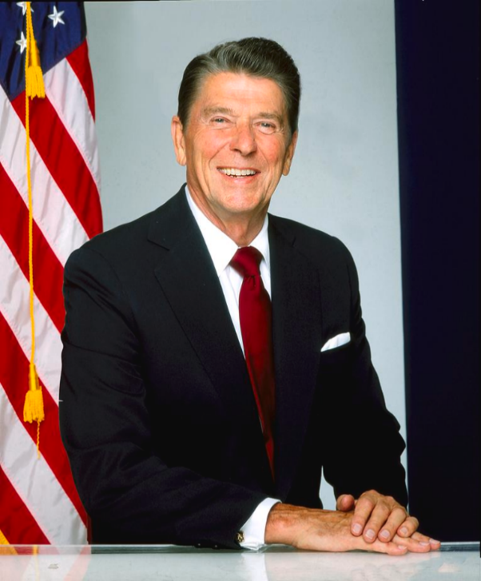
The Cold War was a series of tensions which began in 1947 and ended in 1991 with the downfall of the Soviet Union. The conflict was primarily focused around tensions between the United States of America and the Soviet Union. However due to its highly tense nature; a wide range of other countries would find themselves dragged into the conflict in one way or another due to their respective alliances or conflicts with the leading powers. The President of the United States at the time of the Cold War changed multiple times, and arguably the most impactful in establishing a peaceful resolution may well have been President Ronald Reagan. Reagan was the 40th President of the United States, serving in office from 1981 to 1989. This essay will be observing Reagan’s time as President through use of a variety of sources, including his own Autobiography, An American Life. Using the information provided in these sources, this essay will consider what exactly Reagan’s attitude was towards the Cold War, how effective and impactful his mentality and actions were and ultimately what impact Reagan’s time in power would have on American Politics as a whole.
Fig 1: President Ronald Reagan photographed in 1980.
Firstly, when considering Reagan’s time as President, one must first look into the geopolitical state of the United States at the time which he came to power. It must be noted that the Cold War was a war on Communism for the United States, a war in which, prior to Reagan’s leadership, the U.S. had quite recently suffered quite a heavy loss in the form of the Vietnam War; which lasted from 1955-1975, all of which was during the time of the Cold War. Not only were the North Vietnamese, whom the U.S. were against during the war, Communist, they were also being heavily aided by Chinese and Soviet forces, both of which were Communist states. This is important to note because it showcases the fact of the matter that the Vietnam War was not only the United States facing against and losing to another military, but also that Russia was playing a role in America’s ultimate defeat in the conflict also. By default then, the Vietnam War was little more than one of the many conflicts that were likely the direct result of the Cold War. Max Hastings, a British Journalist and Military Historian, furthers this in his book, Vietnam: an Epic Tragedy, by stating that Ho Chi Minh, the leader of the Viet Cong rebellion, was nothing but a ‘pawn’ to China and Russia. Thus, the loss for the U.S. in Vietnam was clearly by extension a loss to Russia. A moment of weakness for the U.S. during a time wherein they could not afford to appear weak. However, what is important to note in the case of Vietnam is that it was not the first time that a war backed by the Soviets had faltered the U.S. war machine in conflicts against arguably much smaller states. For example in 1961, the U.S. lost a conflict with Cuba in the Bay of Pigs invasion. Fundamentally, in both Cuba and Vietnam, the U.S. was going toe-to-toe with much smaller states, and it was losing. Perhaps, it is possible that the U.S. was avoiding direct confrontation with Russia at this time due to fears of a full blown nuclear war. However, the United States could have been quite quickly losing its overall standing as a ruthless superpower by taking part in small scale conflicts which were resulting in meaningless casualty numbers, and defeats where they would otherwise be securing victory. Rest assured, this was likely the mentality of many U.S. citizens at the time. After all, these small scale wars were likely perceived as a waste of resources, and the Government was funding wars against smaller states, as opposed to opening more effective communication with the problem at hand that was the USSR. Not only this, but the loss suffered in the Vietnam war would establish a new form of fear in the U.S. A fear of bloodshed, a fear of uncertain results from warfare, it had shattered the confidence that America once had that it was an unstoppable power. This fear would become known as ‘Vietnam Syndrome.’ This Vietnam Syndrome did not go away when Reagan came to power. In fact, Cynthia Arnson, a former Foreign Policy Legislative and Senior Foreign Policy Aide who worked under many Presidents, including Reagan; states in her book, Crossroads: Congress, the president, and Central America, 1976-1993, that the Reagan Administration’s argument that ‘failure to support administration policy would lead to the very interventions the public feared.’ This shows that at times the Reagan Administration would have the very adverse effect to that which was intended. It did not stabilise confidence in the Administration to resolve the Central America crisis of 1980, which would see conflict between the citizens of Central America and Congress. It instead reinforced the fear that Reagan’s Administration were planning to deploy military force to deal with the crisis, which of course the United States had been doing and would continue to do so. What is important to note here is that this crisis began long before Reagan came to power, and the conflicts which came about with it were often under Reagan’s Administration.
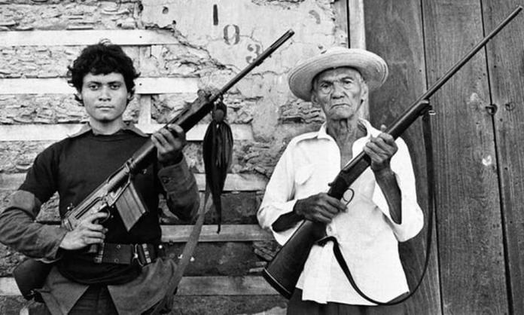
One key conflict which Reagan would become ‘obsessed’ with in the Central America Crisis was undeniably Nicaragua. In 1979, the vast majority of the Nicaraguan population revolted and overthrew the dictatorial Somoza regime, which was supported by the U.S. By 1981 when Reagan had achieved presidency, Nicaragua had become almost solely dependant on Russia for its military power, this had only increased by 1984, and by 1986, it was no longer only arms which Nicaragua was dependant on Russia for, but most trade and almost all of their oil. The Nicaragua crisis seemingly echoes that of Cuba in 1961. A revolution against a U.S. backed leader is successful due to the assistance of the Soviet Union, when the state has established a new power it finds itself almost fully dependant on the USSR, and the Eastern Bloc, for its trade and supplies. It appears that this is a matter that very much concerned Reagan, not only at the time, but after the fact also. In his autobiography, Reagan states ‘And every day there was more evidence that Fidel Castro, the proxy of Moscow, was shipping more arms and Communist “advisors” into Central America, and that Nicaragua was becoming a base camp for Communizing all of Central America.’ This quote makes it clear that Reagan strongly believed that given the involvement of the Soviet Union, and Fidel Castro within this crisis, that this was less a country’s war for independence against a tyrannical dictator, and much more a Soviet attempt to turn Nicaragua into a communist state, an ‘enemy within’ U.S. territories. This is something that neither Reagan, nor his administration would want. This is further supported by Arnson who acknowledges that the goal of the Soviet Union here is to purely ‘make Nicaragua the new Cuba of the Western Hemisphere.’ She furthers this stating that ‘should the lawful government of Nicaragua fall, the Marxist terrorist forces would be the Chief Beneficiaries.’ Whilst this certainly makes it clear that the United States perceived the revolutionaries to be terrorists wanting to establish communism in the West; one must also ask whether this really was the truth, after all, the United States always brand themselves as the symbol of freedom,. However, in the cases of Nicaragua and Cuba, the United States was outright supporting Dictatorial leaders.
Fig 2: The Nicaragua revolution would see a large number of the population rise up against its leader.
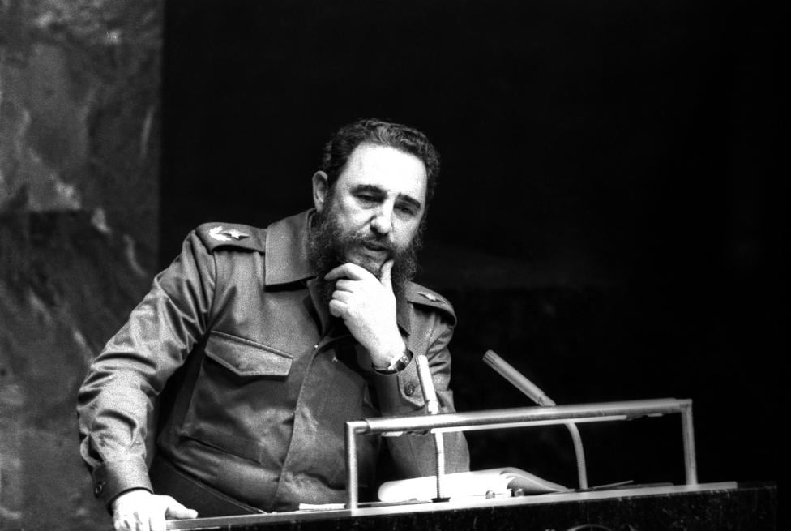
Furthermore, neither the Nicaraguan rebels, nor Fidel Castro ever vocally considered themselves to be Communists, both instead used the term ‘Marxist-Leninist.’ In fact, in Castro’s case, in an interview in 1975 long after the Cuban Revolution, but still during the Cold War, he would maintain that he was never a Communist, and this was merely a label which the United States would place on him to vilify his actions. With this in mind, it could well be that, much like the U.S. attempted to do to Fidel Castro; Reagan too would use the term Communist, even when there was no real evidence of said party being as such, in attempt to rally the American people against anyone who was being aided by the Soviet Union; and to further paint the Soviet Union as the ‘Evil Empire’ which Reagan perceived them to be throughout his presidency, and even afterwards. However, it is also important to note that during the Cold War, any and all aid provided from the Soviet Union was seen as a threat to the United States. This is due to the very real threat which the Soviet Union were posing at the time, and both sides were terrified of an escalation in the conflict; so of course there would always be blame placed on heads, even when it may have been unwarranted. On the other hand, it is always possible that these factions were told specifically by the Soviet Union to deny being Communist, as to avoid making it appear as if the USSR was were taking direct steps against the Western world. This becomes less coincidental when we consider that both of these rebel groups would call themselves ‘Marxist-Leninists.’ In this instance, it could well be argued that Reagan’s stern anti-Communist mentality blinded him to the very truth behind why states were rebelling against the U.S. It may have been less because their ideals were outright Communist; but perhaps instead that for many years the U.S. had been supporting Dictatorships which would see nationals suffer, and the only escape from tyranny for these people may well have been to accept Soviet aid.
Fig 3: ‘Proxy of Moscow’, Fidel Castro played a key role in aiding the Nicaragua revolution. Pictured in 1979.
Reagan’s war on communism may well have been the very foundation which would ultimately see the end of the Cold War, and the end of the Soviet Union as a whole. Firstly, Reagan would greatly increase Defense Spending to excessive measures. Historian and Professor, Jules Tygiel states in his book, Ronald Reagan and the triumph of American conservatism, that the defence spending presented by Reagan in 1982, was so excessive that military chiefs ‘simply went to the shelf and took off everything that had been on their wish lists, even low priority items.’ This statement makes it apparent that even given the highly tense nature of the Cold War, Reagan was almost fanatical about re-establishing America’s standing as a formidable military foe. There are likely two primary reasons for this; firstly, he likely hoped that it would deter the Soviet Union and their allies from escalating their efforts in the Cold War, due to fear of the huge military budget the United States now had. Secondly, he likely hoped that it would rekindle the U.S. populace’s confidence in their military power. Thus, effectively ending the Vietnam Syndrome that had plagued the United States for many years.
What is also important to note is that Reagan had put this excessive military funding into effect from almost the moment he was elected into Presidency; making it apparent that this was likely something Reagan had been planning to do from the very moment he became President. In his memoirs, Reagan states that this defence spending was exactly what the U.S. population wanted also. He recounts that ‘nobody wanted a second-class army, navy, or air force defending our country.’ A point which he furthers stating that every time he would mention the need to bolster national security the congress audience ‘roared’ in support. As a further note, Reagan states that this major boost in military spending was only a single instance, he claims in his memoirs that the budget was expected to even out by 1984 at the latest as a result of his tax reforms. This budget balance, however never came to be during Reagan’s time as President; in 1983, it was becoming quite clear that it was not going to be effective by 1984, and worse yet, by October 1987, the American stock market; which had been rising consistently for several years, suddenly crashed. Though it could be argued that this was not necessarily solely the result of Reagan’s military funding, it must be noted that the economic health of the U.S. had been in decline during Reagan’s early years as President, which undeniably would have contributed to the stock market crash. In regards to Reagan’s decision to spend such excessive amounts of the budget on military funding, it quite possibly was a risk for Reagan to do, though ultimately it was not detrimental to his Presidency, he was re-elected in 1984, with fifty-nine percent of the votes. Clearly, the massive spending on defence paid off, at least in the eyes of the electorate who voted Reagan in for another term in office.
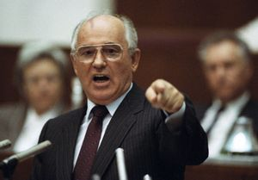
Additionally, when considering Ronald Reagan’s attitude towards the Cold War, one must note the Soviet leaders whom were ruling the USSR. Early in Reagan’s time as President, from 1982 until 1985, the Soviet leaders were immovable, formed by the World Wars and the Cold War they were hardened, and as Tygiel states they all ‘represented the Soviet Old Guard.’ These old rulers were not only stubborn, but simply put none of them remained in power for long enough for peace talks to be successful. All three Soviet leaders during these few years passed away within quick succession of each other Bresnev passing away in November 1982, Andropov passed in February 1984, and Cherneko in March 1985. This is a point Reagan himself acknowledges stating ‘For more than five years, I’d made little progress with my efforts at quiet diplomacy—for one thing, the Soviet leaders kept dying on me.’ However, the next man to take control of the Soviet Union seemed different to Reagan; Mikhail Gorbachev seemed to be open to discussions of peace with Reagan, though he certainly had reservations, as did Reagan. A further note as to why Gorbachev may well have been open to diplomacy was not only because he was younger and less stubborn than his predecessors, but also because the Soviet economy had heavily faltered by the time he came to power. Both Reagan and Gorbachev seemed to view each other to be in a unique position, both wanted peace and to end the war. Yet at the same time both firmly believed in their own ideals, and would criticise each other in in private. Despite this, it is still important to note that they had a common goal and would work together to establish the groundwork for peace despite their glaring personal and political differences, which in turn, would certainly help Gorbachev and George W. Bush to officially end the Cold War in 1991. Here it is identifiable that despite Reagan’s hard-line mentality, and his anti-Communist mindset; he could put his differences aside to understand that ultimately if the war was to end, it would require co-operation from both parties. He was also well aware that any further escalation in the conflict could well result in Mutually Assured Destruction. However, this does not mean to say that the road to peace was a smooth one, nor does it mean that both the U.S. and post Soviet Russia are without their conflicts, even in the modern day.
Fig 4: Reagan’s Soviet Counterpart from 1985, Mikhaiel Gorbachev pictured in 1991.
In conclusion, Ronald Reagan’s attitude with regards to the Cold War shaped his decision making all throughout his presidency. His hard-line, anti-Communist mindset certainly meant that some of his decisions were questionable, but undeniably he put pressure on the Soviet Union, and ultimately he was able to begin the peace talks with Gorbachev. Furthermore, Reagan had seen lasting impacts from the Vietnam sickness which had led him to bolster the U.S. defence spending with varying results. It is clear that Reagan was highly impactful both in regards to escalating the tensions between the United States and the Soviet Union, and yet at the same time he had managed to establish a shaky, but understood statement on the importance of peace between the two countries. Though the war would likely have ended at some point around the time it did regardless due to the poor economic state of the USSR at the time, it is unclear as to whether it would have been so successful without the work of Reagan. Therefore, it must be argued that Reagan was crucial in transforming American politics, and re-establishing the political and military standing of the U.S. after the Vietnam War.

Bibliography
Arnson, Cynthia, Crossroads: Congress, the president, and Central America, 1976-1993, (University Park: Pennsylvania State University Press, 1993).
Hastings, Max, Vietnam: an Epic Tragedy, (London: HarperCollins, 2018).
Kapcia, Antoni, Havana: the making of Cuban culture, (New York: Berg, 2005).
Leikin, Robert S. and Rubin, Barry M. The Central American crisis reader, (New York : Summit Books, 1987).
Mankiewicz, Frank, Jones, Kirby, Castro, Fidel, With Fidel: a portrait of Castro and Cuba, (Chicago: Playboy Press, 1975).
Martz, John D. United States policy in Latin America: a decade of crisis and challenge, (Lincoln: University of Nebraska Press, 1995).
Reagan, Ronald, An American Life, (New York: Simon and Schuster, 1990).
Thomas, Hugh, The Cuban Revolution, (London: Weidenfeld and Nicolson, 1986).
Tygiel, Jules, Ronald Reagan and the triumph of American conservatism, (New York: Pearson Longman, 2006).
List of Images Used
Cross, Richard, ‘An 87-year-old veteran of the first Sandino rebellion stands with an 18-year-old Sandinista guerrilla holding an assault rifle in Leon, Nicaragua’, June 19, 1979. <https://todaynicaragua.com/daughter-of-the-nicaragua-revolution-archive-1984/> [Accessed 19/12/2024].
Langdon, Harry, ‘President Ronald Reagan Portrait Session’, 1980 <https://photos.com/featured/president-ronald-reagan-portrait-session-harry-langdon.html> [Accessed 15/12/2024].
Unknown Photographer’ ‘Fidel Castro addresses the audience as president of the Non-Aligned Movement at the United Nations in New York’, October 12th 1979 <https://www.geo.tv/latest/121691-In-Pictures-Revolutionary-Fidel> [Accessed 19/12/2024].
Yurchenko, Boris, ‘Mikhail Gorbachev’ 1991 <https://www.britannica.com/place/Russia/The-Gorbachev-era-perestroika-and-glasnost> [Accessed 19/12/2024].

Ronald Reagan, An American Life, (New York: Simon and Schuster, 1990).
Max Hastings, Vietnam: an Epic Tragedy, (London: HarperCollins, 2018). p.86.
Ibid, p.86.
Hugh Thomas, The Cuban Revolution, (London: Weidenfeld and Nicolson, 1986), p.593.
Cynthia Arnson, Crossroads: Congress, the president, and Central America, 1976-1993, (University Park: Pennsylvania State University Press, 1993). p.286.
Ibid, P.286.
John D. Martz, United States policy in Latin America: a decade of crisis and challenge, (Lincoln: University of Nebraska Press, 1995). p.4.
Robert S. Leikin, and Barry M. Rubin, The Central American crisis reader, (New York : Summit Books, 1987). P 134.
Ibid, P. 33.
Reagan, An American Life, P.251.
Arnson, Crossroads, p.31.
Ibid, p.31.
Leikin, and Rubin, The Central American crisis reader, P. 24.
Antoni Kapcia, Havana: the making of Cuban culture, (New York: Berg, 2005). p.37.
Leikin, and Rubin, The Central American crisis reader, P. 24.
Frank Mankiewicz, Kirby Jones, Fidel Castro, With Fidel: a portrait of Castro and Cuba, (Chicago: Playboy Press, 1975). P.80.
Reagan, An American Life, p.587.
Leikin, and Rubin, The Central American crisis reader, P. 31.
Jules Tygiel, Ronald Reagan and the triumph of American conservatism, (New York: Pearson Longman, 2006). p.159.
Reagan, An American Life, p.197.
Ibid, p.197.
Ibid, p.197.
Tygiel, Ronald Reagan and the triumph of American conservatism, p.100.
Ibid, p.227.
Ibid, p.n15.
Ibid, p.190.
Ibid, p.195.
Ibid, p.194.
Ibid p.194.
Ibid, p.195.
Reagan, An American Life, p.14.
Ibid, p.14.
Tygiel, Ronald Reagan and the triumph of American conservatism, p.195.
Ibid, p.203.
Reagan, An American Life, p.13.

