RISK BENEFIT ASSESSMENT

Location / Activity: | Woodlands | Date: | 25th March 2025
Assessor: | Alanis Jones | Review date: | 20th March 2025

The boxes in the table below will expand as you type into them; pre-entered text is simply for illustration. You should delete irrelevant items and replace with text relevant to your circumstances.
Your overall risk rating – Low, medium or high – is based on your judgement about whether the BENEFITS of the activity or opportunity outweigh the RISKS.

Experience exploring outdoor space in photograph | How will young people BENEFIT from this activity? | Hazards and associated risks | Who is at risk? | PRECAUTIONS in place to reduce the risk of injury | Overall risk after precautions  RATING: L/M/H
Walking to the woodlands, steps or uneven ground | Help the children learn how to balance and walk down steps properly and carefully.  Children get to see and walk on different grounds such as grass and mud. | Children could fall over or trip.  Can cause injuries such as cuts, bruises or sprains. | Children and Adults | Discuss with the children how to walk down steps carefully and explain that the ground may be uneven and slippery. Make sure they have appropriate clothing on such as wellies, waterproof clothes and long trousers/sleeves. | L
Playing with the environment outdoors – flowers, plants, rocks and insects | Explore new environments and materials.  Get to see new colours and different textures  Learn about new creatures and living things. | Allergies or poisonous plants/insects.  Children could put things in their mouth which are poisonous.  May get small cuts or rashes from sharp plants | Adults and Children | Explain to the children that nothing should go in their mouths and should only be touched by hands.  Ensure their hands are washed and clean after being outside.  Explain certain which things they can and cannot collect and what is safe to play with.  Make sure Adults are aware and monitoring the children. | L
Playing with water | Learn how water flows and moves, and they get to see different creatures and plants that grow in the pond.  Helps the children use their trajectory schema by playing with running water. | Could fall in and get cold or could drown  May get hypothermia from getting cold  Could hurt themselves from the rocks in the pond – cuts and bruises | Adults and Children | Have adults monitor the water and make sure everyone is playing safely and ensure nobody falls in.  Make sure they have warm clothes on, bring spare clothes in case they do get wet they don’t get too cold.  Wear waterproofs to keep dry. | L
Public and environment outside |  | Stranger danger  Litter and rubbish being left around  People not picking up after their dogs | Children and Adults | Ensure the children know to not talk to anyone they do not know and to stay in sight of the adults in charge.  Litter pick before the activity. Tell the children to not touch any rubbish and to let an adult know if they find any so the adult can put it in the bin.  Make sure the children stay away from any dogs as they won’t know if they are friendly or not. Also stay away from any dog mess left in the woodlands. | L
Cars and Carpark | Learn road safety | Moving cars in the car park, can be dangerous as the children could get knocked down or hurt if not careful. | Children and adults | Have the children wear high visibility vests to ensure the cars can see them. Make sure you explain that they need to stay in line behind the teacher and not wonder off in the car park. Ask the university if they could limit cars during the time the children are using the outdoor area. | L
Trees, wood and manmade structures. | Learn about different types of trees and learn how to climb and move on uneven surfaces.  Can play in shelters and look at bug houses and inspect what is living in bug houses.  Let’s children use they trajectory and orientation schemas. | Falling off trees and injuring themselves.  Tripping over loose logs and branches.  Splinters from wood. | Children and Adults | Make sure children are being monitored when climbing trees. Have the trees checked first to make sure there are no rotten branches that could snap off. Have the teachers explain that the children should not climb too high, so they do not get stuck up the tree.  If they are playing with piles of wood or loose logs, make sure the children are careful and look where they are stepping so they do not trip and fall.  If the children get a splinter, make sure the teachers are first aid trained and know how to deal with getting a splinter removed. | L
Weather changes | Playing in the environment in all weathers.  Get a chance to play in rain, mud and sunny weather. | The children could get cold and wet and uncomfortable.  The children could get sun burnt from the sun or dehydrated. | Children | Make sure the children have warm and waterproof clothes. Also have them bring spare clothes to change into in case they get too wet or dirty.  If it is sunny make sure the children have sun cream, a hat and lots of water. | L
Children’s needs | First aid kit  Snacks/pack lunch  Emergency contacts/consent forms | Children can injure themselves playing outside by falling over or playing with different plants/objects in nature  If children are playing outside all day, they could get hungry and thirsty  Children may need to go home if there is an emergency. | Children | Make sure all staff are first aid trained and can help the children if they hurt themselves.  Ask the parents/guardians to pack a lunch or snacks for the children to have on break time.  Consent forms will need to be signed by guardians to ensure they are happy for children to play outside. Also need the guardian’s contact information in case of any emergencies. | L

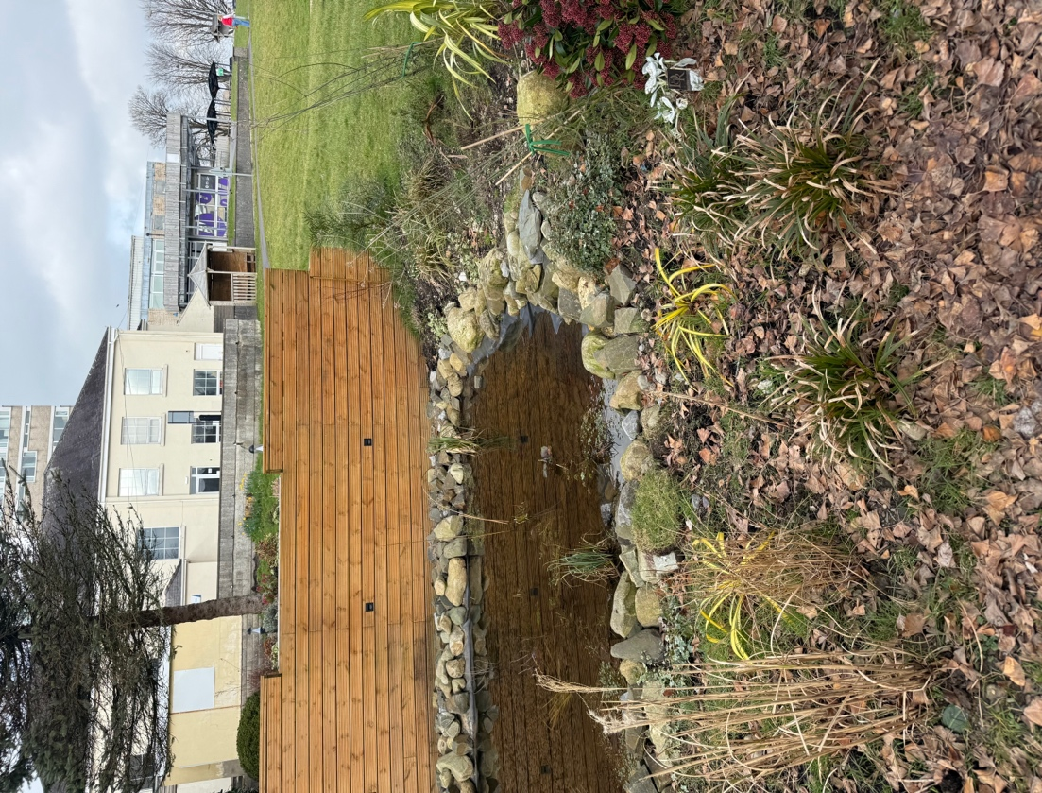

In this woodland area, three teachers decided to take a group of young children ages 4-5 to go and explore outside and to see if there was anything fun and interesting to do. Before giving the children, a chance to explore the teachers decided to have a guess of what the children may play with ands they will find the most enticing. Miss Jones thought the children would be most interested in rolling down the hill and experiencing gravity and the speed of going down slopes. Whereas the other teachers thought the children would enjoy playing with the water the most and seeing how it flowed and moved around.
Rolling, jumping, and sliding down hills provides an exciting and enriching opportunity to investigate the fundamental concepts of the Curriculum for Wales (2023). These activities combine physical development, scientific inquiry, maths skills communication, and environmental awareness. Teachers may create an interesting learning environment for students to develop both cognitively and physically by incorporating outdoor play into the curriculum. The Curriculum for Wales (2023) promotes experiential learning, and these outdoor activities demonstrate how young children can relate play to educational results, all while fostering a love of learning in nature.
Whilst outside Miss jones notices a little boy running up and down a small slope and rolling around on the floor, Miss Jones decided to go over and observe to see what he was learning as he was running and rolling around.
Student – “Miss why do we roll so fast downhill?”
Miss Jones – “Good question, shall we test it out?”
Student – “Yes”
Miss Jones – “Maybe start off rolling down a small slope and then rolling down a bigger slope and see if there is a difference”
The little boy enjoyed rolling down the slope and he started to realise the bigger and steeper the slope the faster he went. To support the use of science in the environment miss jones decided to explain the force of gravity to the little boy to help him understand how gravity works and why is makes things moves faster.
Miss Jones – “Gravity is like an invisible force that pushes everything down to the ground. Imagine rolling a ball down a hill. When you let go of the ball, gravity drags it down the slope, causing it to roll faster and faster. The higher the hill, the faster the ball will travel since gravity has more space to drag it down. It's like gravity is giving the ball little push to get it moving”
Miss Jones decided to bring a ball outside and handed it to the little boy to let him experience rolling the ball down the hill and seeing different speeds it was moving from different heights. The boy played for a long time rolling the ball down the hill and trying to chase it to the bottom to see how fast it was moving.
Miss Jones then recognised the boy was counting down when letting go of the ball. The little boy would shout “3..2..1.. blast off” then letting go of the ball so it could roll down the hill quickly.
From the Welsh Government (2020) the student has been able to follow progression step one of the ‘being curious and searching for answers is essential to understanding and predicating phenomena” section of the description of learning in science and technology. These steps were ‘I can show curiosity and question how things work’ and ‘I can explore the environment, make observations and communicate my ideas’. The student completed these by asking the teacher questions on why he rolls so quickly when going down the slope and how he explored the outside area and found the slope to play with and experiment with. When counting down to let the ball roll down the hill the student used progression step 1 which is ‘I have experienced the counting sequence of numbers in different ways, reciting forwards and backwards, and starting at different points’ of ‘the number system is used to represent and compare relationships between numbers and quantities’ in the descriptions of learning in mathematics and numeracy section of Welsh Government (2020).
This little boy was very focused on using his trajectory schema. The Welsh Government (2022) explained the trajectory schema as ‘An interest in how people and objects move vertically and horizontally, developing and building vertical or horizontal constructions’. Some examples of a trajectory schema include Rolling objects, Bouncing objects, pressing buttons continually and Stacking objects and some activities that children take part in can include Children to problem solve how to make something go faster/slower, construct own moving model, Sort objects based on pushing and pulling and measuring heights and distances.
A few other children decided to play with the water in the pond. The children asked Miss Jones if there were any buckets to play with the water. Miss Jones decided to give them some buckets, cups and measuring cylinders to see if they would use them to experiment with the water. The children started off filling up the buckets by scooping up the water in the pond and then throwing the water back in to cause a splash.
Student – “Hey Miss watch this big splash”
Miss Jones. – “Wow! I wonder what happens if you all chuck the water at the same time”
Student – “It made an even bigger splash!”
Miss Jones – “Why do you think that happened”
Student – “Because there is more water to throw at the pond”
Miss Jones then went on to explain why throwing objects into water or a pond creates a splash.
Miss Jones – “When you throw an object into water, it generates a force that pushes the water away as it enters. This is because the object needs to move the water to make space for itself. As the object enters, the water cannot simply "disappear" or flow around it. Instead, it is thrown upward and outward in all directions, resulting in a splash”.
The children then went on to using the cups and measuring cylinders to use to fill up the buckets. They would fill up the measuring cylinder and pour that water into the cup and then pour the cup of water into the bucket, they would repeat this cycle until the bucket was full.
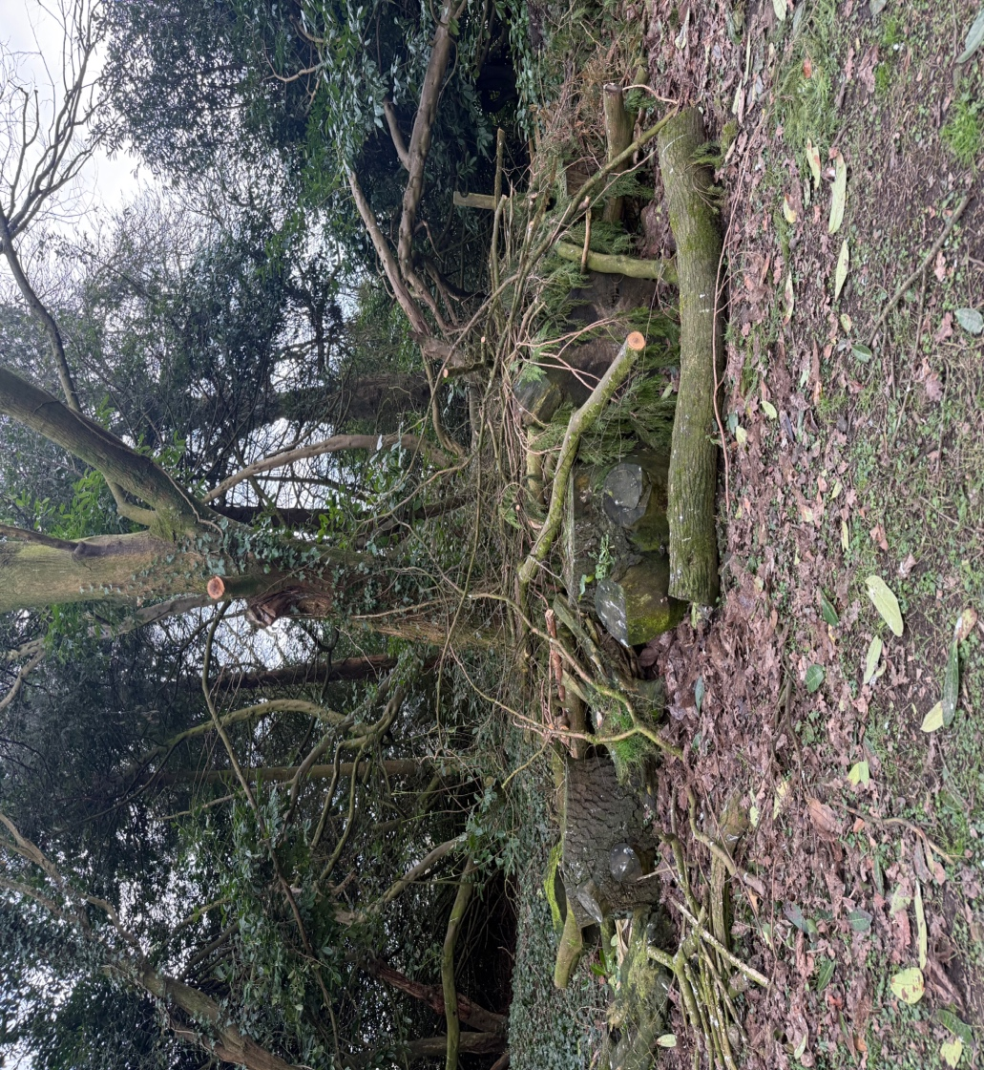
When young children pour and transfer water, they can make patterns or sequences by pouring it from one container to another in a certain order. For example, creating a sequence by filling one container, pouring it into another, and repeating the process. This can help students understand sequencing and patterns (University of South Wales,2022). When playing with the water outside the children were learning how to sequence and use patterns which is part of their mathematical skills. The children were able to use a variety of objects to measure, begin to understand the need to repeat the same physical unit without any gaps when measuring and identify, follow and begin to create sequences and patterns in everyday activities. Which are all the progressions step one in the science and technology and the mathematics and numeracy in the descriptions of learning of the Welsh Government (2022). This group children have shown that they like to use their transporting schema as they enjoying putting water into buckets and containers. The Welsh Government (2022) explained the transporting schema as ‘An interest in moving oneself or objects around ‘some examples of transporting schemas include filling and emptying water jugs, filling and emptying bags, boxes, and containers, stacking boxes and using a cart or wheelbarrow to move things.

There was a pile of logs, leaves and plants over in the corner which a group of children took an interest in. Miss Jones went over to observe them and noticed they were climbing on the logs and balancing whilst walking across the larger logs but also were interested at looking at all the plants and different insects in the wood.
Student – “Miss Jones what type of leaf is this?”
Miss Jones – “I think it could be an oak leaf”
Student – “What about this bug Miss Jones?”
Miss Jones – “What type of bug do you think it is?”, “it’s long, a little hairy and has six legs”
Student – “Is it a caterpillar?”
Miss Jones – “Yes well done!”
This group of children were able to complete progression step 1 of the ‘World around us is full of living things which depend on each other for survival’ section in the science and technology descriptions of learning for Welsh Government (2020). This group were focused on their orientation schema as they were climbing and balancing on the logs and trees. The Welsh government (2022) describe the orientation schema as ‘An interest in examining balance, height, width, and length by looking at things from different angles, through holes, and transparent objects’. Climbing and balancing on trees/logs links to science because when climbing a tree or balancing on a branch, young children must understand their centre of gravity, which is the point at which their weight is distributed equally. If they lean too much in one direction, they risk losing equilibrium and falling. Climbing teaches young children how to alter their body posture so that their centre of gravity remains within their base of support (Welsh Government, 2023).

This section of the essay explores the adult’s role in supporting mathematical and scientific learning outdoors by drawing on the theories of Lev Vygotsky, Jerome Bruner, and Maria Montessori. It will also consider how this approach aligns with the Curriculum for Wales, which emphasises experiential and holistic learning.
Outdoor learning and exploring nature provide a rich environment for young children to discover, inquire, and learn mathematical and scientific concepts through hands-on experiences (Welsh Government, 2024 and National Association for the Education of Young Children, 2017). The role of the adult is important in facilitating and scaffolding these experiences, ensuring children make meaningful connections and develop critical thinking skills (Welsh Government, 2024). Outdoor learning offers children opportunities to engage with the natural world, fostering curiosity and promoting active exploration. According to Woods (2017), outdoor experiences stimulate sensory, physical, and cognitive development, which encourages mathematical and scientific learning. The open-ended nature of outdoor activities inspires children to investigate patterns, make predictions, classify objects, and problem-solve fundamental scientific and mathematical processes, which also helps them use different types of schemas such orientation schema, trajectory schema and positioning schema (Woods 2017, and White, 2020).
Lev Vygotsky’s sociocultural theory highlights the importance of social interaction in cognitive development. According to Vygotsky (1978 cited in Zurek et al, 2014), children learn through shared experiences with more knowledgeable others, such as adults and peers. When applied to outdoor learning, the adult can act as a guide, scaffolding children’s exploration by asking open-ended questions, providing language support, and introducing relevant concepts. For example, when children are investigating the concept of gravity by rolling a ball down a hill, the adult might scaffold the experience by introducing vocabulary such as speed, force, or mass. By asking questions like, “Will the ball go faster down a smaller slope or a bigger slope” the adult encourages children to think critically and apply scientific reasoning (Beames et al, 2014). Bruner (1961, cited in Akpan and Kennedy, 2025) emphasized the significance of discovery learning, where children construct knowledge through exploration and problem-solving. Bruner’s concept of scaffolding aligns with Vygotsky’s (1978) highlighting the adult’s role in providing support and then gradually reducing it as children become more capable. In outdoor settings, Bruner (1961, cited in Akpan and Kennedy,2025) theory can be applied by creating environments that promote problem-solving and investigation. For instance, adults can provide materials such as measuring jugs/cylinders, magnifying glasses, and scales to further the children’s scientific and mathematical development outside. Through Bruner (1961) theory of guided discovery, children can explore concepts such as symmetry, weight, and volume while receiving gentle support from adults. Maria Montessori (1912, cited in Bertolino, and Filippa, 2021) stated that Montessori advocated for hands-on, child-led learning experiences, with a strong emphasis on the natural environment. Montessori (1912) believed that children learn best through direct interaction with their surroundings, developing sensory awareness and problem-solving skills. In an outdoor context, adults can support Montessori’s principles by providing a prepared environment rich in natural materials. Activities such as collecting and sorting rocks, building structures with sticks, or counting bugs allow children to engage with mathematical and scientific concepts in meaningful ways. The adult’s role is to observe, facilitate, and intervene only when necessary, allowing children to follow their curiosity (Issacs, 2018). According to Montessori (1912, cited in Issacs, 2018) the outdoors can help children develop their mathematical skills by counting experiences, such as counting petals, pebbles, or other objects found in nature.
The adult plays a key role in encouraging one-to-one correspondence, number recognition, and counting strategies. By asking questions like, “How many leaves do you have altogether?” or “What happens if we add two more?” adults encourage children to practice addition and subtraction in a real-world context. Outdoor environments provide natural opportunities for measuring and estimating for example, children can compare the height of plants or sticks, measure distances with footsteps, or estimate how long it will take an object to sink in water (Zureck 2014 and Davis 2015). In the outside world, adults are responsible for introducing and modelling mathematical language such as taller, shorter, heavier, and lighter. Adults can help young children comprehend mathematical concepts such as patterns, symmetry, and sequencing by engaging in activities like lining up sticks to see height differences from smallest to shortest and arranging petals or leaves in colour order from darkest to lightest (Sahrakhiz, 2018 and Waters and Bateman, 2015). According to Kong and Chen (2024) children naturally ask questions such as, "Why is the leaf green?" and "Where did the worm go?" In this circumstance, it is the adult's responsibility to promote curiosity by giving opportunities for close observation and assisting children in making predictions and testing hypotheses. The adult can accomplish this by assisting the children in watching and investigating certain aspects of nature that interest them, as well as scaffolding any learning experiences along the way by addressing any questions they may have about what they are seeing outside.
The Welsh government (2015) promotes a holistic and experiential approach to learning, which aligns well with outdoor education. The curriculum for Wales (2022) focuses on four purposes: ambitious, capable learners; enterprising, creative contributors; ethical, informed citizens; and healthy, confident individuals. In the Curriculum for Wales mathematics is integrated within the Areas of Learning and Experience (AoLE) framework, specifically under “Mathematics and Numeracy. (Welsh Government, 2020). Outdoor learning supports this by enabling children to apply mathematical concepts in real-world contexts, such as measuring distances, identifying shapes, or estimating quantities (Welsh Government, 2020). Furthermore, the Welsh Government (2020) stated that outdoor learning also supports the “Science and Technology” AoLE, which emphasises inquiry, observation, and experimentation. By facilitating outdoor investigations, adults encourage children to develop scientific reasoning, understand cause-and-effect relationships, and appreciate the natural world. The Curriculum for Wales also recognises the importance of physical and emotional well-being, and the Welsh Government (2020) specified that outdoor learning promotes physical activity, enhances motor skills, and contributes to mental health and well-being. By promoting safe exploration, managing risks, and encouraging children to take appropriate physical challenges the adult is helping the children ensure they mental health and physical health is also made a priority. For adults in outdoor education, practical ideas such as providing loose components and natural items spark creative and mathematical play to enable open-ended inquiry; using open-ended questions like "What do you think will happen if...?" helps to promote scientific thinking. Children are assisted in developing critical inquiry skills by adults who model and scaffold scientific processes including observation, recording, and result analysis. Promoting reflection helps children express their ideas and thinking, which improves their conceptual understanding and helps in this process. (Welsh government, 2025).
To conclude, Mathematical and scientific concepts become more understandable when outdoor learning is connected to children's everyday experiences. A strong foundation for developing young children's scientific and mathematical development is provided by outdoor learning. Vygotsky, Bruner, and Montessori's theories can be used by adults to successfully scaffold and support meaningful learning experiences. The importance of outdoor learning in growing curiosity, problem-solving abilities, and overall development is emphasised in the Curriculum for Wales. To encourage children's mathematical and scientific thinking and create a solid basis for lifetime learning, adults must engage in guided discovery, reflection, and inquiry.
References
Akpan, B. and Kennedy, T (2025) science education in theory and practice. 2nd edition. London: Waterstones.
Beames, S., Higgins, P.J. and Nicol, R. (2012) Learning outside the classroom: theory and guidelines for practice. 1st ed. New York, N.Y: Routledge.
Bertolino, F., & Filippa, M. (2021). The Pedagogy of Nature according to Maria Montessori. Journal of Theories and Research in Education, 16(2), 133–147. Available at: https://rpd.unibo.it/article/view/12192 (Accessed: 26 March 2025)
Davis, E.A., 2015. Scaffolding learning. Encyclopedia of science education, 21(2), pp.362-364. Available at: https://scholar.google.co.uk/scholar?q=scaffolding+children+learning+in+nature&hl=en&as_sdt=0&as_vis=1&oi=scholart#d=gs_cit&t=1743257048916&u=%2Fscholar%3Fq%3Dinfo%3AKQyaBxY8L7kJ%3Ascholar.google.com%2F%26output%3Dcite%26scirp%3D3%26hl%3Den
Isaacs, B. (2018) Understanding the Montessori approach: early years education in practice. 2nd edition. New York: Routledge.
Jones, A. (2025) Pile of logs. [Photograph].
Jones, A. (2025) University of Wales Trinity Saint David Garden. [Photograph].
Kong, C. and Chen, J. (2024) ‘School Garden and instructional interventions foster children’s interest in nature’, People and nature (Hoboken, N.J.), 6(2), pp. 712–732. Available at: https://doi.org/10.1002/pan3.10597. (Accessed: 26 March 2025).
National Association for the Education of Young Children (2017). ‘Maths learning and a touch of science in the outdoor world’. Available at: https://www.naeyc.org/resources/pubs/tyc/apr2017/math-learning-outdoors (Accessed: 22 March 2025).
Sahrakhiz, S. (2018) ‘The “outdoor school” as a school improvement process: empirical results from the perspective of teachers in Germany’, Education 3-13, 46(7), pp. 825–837. Available at: https://doi.org/10.1080/03004279.2017.1371202.
Waters, J. and Bateman, A. (2015) ‘Revealing the interactional features of learning and teaching moments in outdoor activity’, European early childhood education research journal, 23(2), pp. 264–276. Available at: https://doi.org/10.1080/1350293X.2013.798099. (Accessed: 26 March 2025)
Welsh Government (2015) ‘The four purposes of the curriculum of Wales’ Curriculum for Wales. Available at https://primarysite-prod-sorted.s3.amazonaws.com/morriston/UploadedDocument/30972c1288244552ae2f8f11e6777c1d/the-four-purposes-of-the-curriculum-for-wales.pdf (Accessed: 27 March 2025).
Welsh Government (2020) ‘Health and Wellbeing’ Guidance to help schools and settings develop their own curriculum, enabling learners to develop towards the four purposes. Available at: https://hwb.gov.wales/curriculum-for-wales/health-and-well-being (Accessed: 27 March 2025).
Welsh Government (2020) Mathematics and Numeracy. Description of Learning. Available at: https://hwb.gov.wales/curriculum-for-wales/mathematics-and-numeracy/descriptions-of-learning/ (Accessed: 20 March 2025).
Welsh Government (2020) Science and Technology. Description of Learning. Available at: https://hwb.gov.wales/curriculum-for-wales/science-and-technology/descriptions-of-learning/ (Accessed: 20 March 2025).
Welsh Government (2022) Toolkit: Schematic Development and the Curriculum for Funded Non-maintained Nursery Settings. Available at: https://hwb.gov.wales/api/storage/c2721be7-e21d-4cd1-af56-002e551cd881/Schematic%20Development%20Toolkit%202022.pdf (Accessed: 22 March 2025).
Welsh Government (2023) ‘Teaching and learning in the outdoors’. The current state of outdoor learning in schools in Wales. Available at: https://hwb.gov.wales/api/storage/177a33a6-7c70-4843-bb63-903e70a04154/teaching-and-learning-in-the-outdoors-the-current-state-of-outdoor-learning-in-schools-in-wales.pdf (Accessed: 22 March 2025).
White, J. (2020) Playing and learning outdoors: the practical guide and sourcebook for excellence in outdoor provision and practice with young children. Third edition. London; Routledge.
Woods, A. (2017) Elemental play and outdoor learning: young children’s playful connections with people, places and things. 1st ed. New York, N.Y: Routledge
Zurek, A., Torquati, J., and Acar, I. (2014). ‘Scaffolding as a Tool for Environmental Education in Early Childhood’ International Journal of Early Childhood Environmental Education. 2(1). Pp.27-57. Available at: https://eric.ed.gov/?id=EJ1108033 (Accessed: 23 March 2025)

