Student Profile

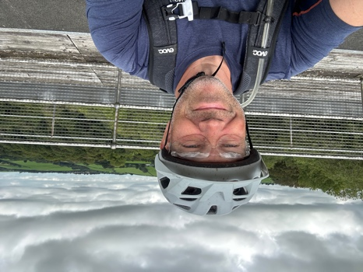 | Name / Enw: Simon Chaplin
 | Student number / Rhif myfyriwr: 2310719

Please use the remaining space to give a brief outline of why you have chosen your course of study and any relevant special interests or experiences:
Defnyddiwch y gofod sy'n weddill i roi amlinelliad byr o pam rydych wedi dewis eich cwrs ac unrhyw fuddiannau neu brofiadau perthnasol arbennig:
I have been interested in the outdoors for many years (since 13 years old), this was being through being a member of the Army Cadet Force and also completing my Duke of Edinburgh Award Gold. I went on to complete a mountaineering course with the military so that I could take cadets out. I have spent the last 25+ years working and assessing expeditions for the DofE scheme with a number of organisations and within the last few years gained various NGB’s so that I can provide courses and work Freelance.
I decided that I had worked enough for the same organisation and that I needed a change and this would be to work more in the Outdoor sector.
To be able to understand the processes involved and how I could provide meaningful training to all I decided that I wanted to complement my qualifications with a degree in this field.

Thinking of your strengths/ Weaknesses/ Opportunities and Threats let us know what you would like support with:
Yn meddwl am eich cryfderau/gwendidau/cyfleon/bygythiadau, rhowch wybod beth hoffech gymorth gyda:
I have been out of formal education since 1987 and therefore the elements surrounding writing meaningful essays and doing research will need some assistance. Referencing is something that I have never had to do and again gaining assistance with this will be valuable.

