DESIGN, IMPLEMENTATION AND EVALUATION OF A LIGHTWEIGHT COST-EFFECTIVE DIGITAL FORENSICS ACQUISITION TOOL FOR WINDOWS SYSTEMS

Deep Trivedi
Student ID: 2436067

Supervisor: Amit Naik,

Project submitted as part of the requirements for the award of
MSc Cybersecurity and Digital Forensics
Module ACFB7003

University of Wales Trinity Saint David
June 2026

DECLARATION
I, Deep Trivedi, hereby declare that the work presented in this dissertation is entirely my own. Where the work of others has been drawn upon, it has been properly cited and referenced in accordance with the academic regulations of the University of Wales Trinity Saint David.
This project has not been submitted, in whole or in part, for any other degree or qualification at this or any other university. I confirm that the empirical work reported here was conducted on my own computing equipment, with no human participants involved, and that all data collected during testing was generated on systems I own and control.
I understand that the University may use plagiarism detection software to check this work, and I consent to this submission being processed through such systems.

Signed: Deep Trivedi
Date: June 2026
Student ID: 2436067

ABSTRACT
Small organisations increasingly face the same digital threats as large enterprises, from ransomware to insider compromise, yet the forensic tools available to them remain priced for government agencies and corporate investigation teams. Commercial platforms such as Magnet AXIOM, Exterro FTK and OpenText EnCase cost between USD 2,499 and USD 15,000 per year, which puts them out of reach for most small businesses and independent consultancies. Open source alternatives exist, but each addresses only a narrow slice of the acquisition problem: Autopsy analyses disk images but does not collect them; Volatility parses memory dumps but cannot capture RAM; KAPE collects file system artefacts but requires manual configuration and does not encrypt its output. No single free tool provides a unified, integrity-verified, encrypted acquisition pipeline for live Windows systems.
This dissertation presents ForensicAcq, a Python-based forensic acquisition tool that runs seven sequential modules on a live Windows host to collect system information, installed software inventories, browser history from Chrome, Edge, Brave and Firefox, running processes with executable hashes, Windows Event Logs, PowerShell transcripts, Recycle Bin contents and recently accessed files. Every collected artefact receives MD5, SHA-1 and SHA-256 hashes at the point of capture, and the entire evidence directory is packaged into an AES-256 encrypted ZIP container whose own SHA-256 hash serves as the chain of custody root.
Controlled testing on Windows 10 and Windows 11 systems produced 100% artefact coverage in eight of nine evidence categories, 100% hash integrity across approximately 1,418 artefacts per run, and end-to-end execution within a triage-acceptable window. A feature-based comparison against FTK Imager, Magnet AXIOM, Autopsy, KAPE, Velociraptor and CrowdStrike Falcon Forensics Collector confirms that the tool occupies a distinct niche: no other reviewed solution combines volatile and non-volatile collection, per-artefact hashing, encrypted packaging and zero licence cost in a single standalone script.

Table of Contents
Chapter 1: Introduction 9
1.1 Background and motivation 9
1.2 The acquisition problem on Windows 10
1.3 Research questions 11
1.4 Research gaps 11
1.5 Aim and objectives 12
1.6 Project scope and ethical position 13
1.7 How the tool works, briefly 13
1.8 Dissertation structure 14
Chapter 2: Literature review 15
2.1 Forensic acquisition fundamentals 15
2.2 The commercial tool market 16
2.2.1 Magnet AXIOM 16
2.2.2 FTK and FTK Imager 16
2.2.3 OpenText EnCase 17
2.2.4 The cost-capability gap 17
2.3 Open source tools and their limitations 18
2.3.1 Autopsy and The Sleuth Kit 18
2.3.2 Volatility Framework 18
2.3.3 KAPE (Kroll Artifact Parser and Extractor) 19
2.3.4 Velociraptor 19
2.3.5 CrowdStrike Falcon Forensics Collector 19
2.4 Evidence integrity, hashing and chain of custody 19
2.5 Comparative evaluation methods in forensic tool research 20
2.6 Summary: research gaps and project positioning 21
Chapter 3: Research methodology 22
3.1 Research philosophy 22
3.2 Research strategy: Design Science Research 23
3.3 Experimental setup and test environments 23
3.4 Evaluation metrics 24
3.5 Data collection protocol 24
3.6 Ethical considerations 25
3.7 Threats to validity 25
3.8 Summary 26
Chapter 4: System design and architecture 27
4.1 Design goals and constraints 27
4.2 Architectural overview 27
4.3 Module architecture and the five-element contract 28
4.4 Evidence integrity layer 30
4.5 Evidence container design 31
4.6 Operational trade-offs and exclusions 31
4.7 Summary 31
Chapter 5: Implementation 32
5.1 Development environment and dependencies 32
5.2 Module 1: System information collector 33
5.3 Module 2: Installed software enumeration 35
5.4 Module 3: Browser history acquisition 36
5.5 Module 4: Process and network state capture 37
5.6 Module 5: Event log and PowerShell history collection 39
5.7 Module 6: Recycle Bin and recently accessed files 40
5.8 Module 7: Hashing and AES-256 encrypted packaging 42
5.9 Error handling and logging 43
5.10 Summary 44
Chapter 6: Evaluation and results 45
6.1 Evaluation setup 45
6.2 Module-level artefact coverage 45
6.3 Evidence integrity verification 46
6.4 Performance and resource footprint 47
6.5 Cross-version consistency 48
6.6 Operational usability observations 49
6.7 Summary 49
Chapter 7: Comparative discussion 51
7.1 Comparison framework 51
7.2 ForensicAcq versus FTK Imager 51
7.3 ForensicAcq versus Magnet AXIOM 52
7.4 ForensicAcq versus Autopsy and Volatility 52
7.5 ForensicAcq versus KAPE 52
7.6 ForensicAcq versus Velociraptor and CrowdStrike 53
7.7 Consolidated comparison 53
7.8 Cost and total cost of ownership 54
7.9 Limitations of the comparison 55
7.10 Summary 55
Chapter 8: Conclusions and recommendations 56
8.1 Answers to the research questions 56
8.2 Contributions 56
8.3 Limitations 57
8.4 Recommendations for future work 58
Chapter 9: Reflection 59
9.1 Time management 59
9.2 Technical skills developed 59
9.3 What I would do differently 59
9.4 Study habits and personal growth 60
9.5 Overall reflection 61
References 62

LIST OF TABLES
Table 3.1 Test environment specifications
Table 3.2 Evaluation metrics, definitions and measurement methods
Table 5.1 System information collected from the target host
Table 5.2 Installed software inventory (sample of ~120 packages)
Table 5.3 User accounts on the target system
Table 5.4 Windows Firewall configuration across three profiles
Table 5.5 Active network connections at the time of acquisition
Table 5.6 Running Windows services (sample)
Table 5.7 Scheduled tasks on the target system (sample)
Table 5.8 Recycle Bin items recovered during acquisition (sample)
Table 6.1 Module-level artefact coverage against ground truth
Table 6.2 Performance and resource footprint across test environments
Table 7.1 Consolidated comparison of ForensicAcq against forensic baselines

LIST OF FIGURES
Figure 4.1 ForensicAcq acquisition workflow diagram
Figure 5.1 Module 1 output: system information collection
Figure 5.2 Module 2 output: installed software inventory
Figure 5.3 Module 3 output: cross-browser history extraction
Figure 5.4 Module 4 output: process table and network state capture
Figure 5.5 Module 5 output: event logs, PowerShell history and scheduled tasks
Figure 5.6 Module 6 output: Recycle Bin enumeration and recent files
Figure 5.7 Module 7 output: integrity hashing and AES-256 encrypted packaging
Figure 6.1 SHA-256 hash verification: ledger vs independent recomputation
Figure 6.2 Per-module execution time across both test systems
Figure 7.1 Cost-vs-capability scatter plot of surveyed forensic tools

Chapter 1: Introduction

1.1 Background and motivation
Digital forensics used to be a niche discipline practised almost exclusively by law enforcement and specialist consultancies. That is no longer the case. Over the past decade, ransomware campaigns, business email compromise schemes and insider data theft have become routine events for organisations of every size, including those with no dedicated security team and no forensic budget to speak of. IBM Security reported the global average cost of a data breach at USD 4.88 million in 2024, and their analysis showed that the speed of incident containment is the single strongest predictor of total cost [1]. When a small business with fifteen employees suffers a ransomware infection, the question of forensic readiness stops being an abstract compliance checkbox and becomes a financial survival issue.
The tools available to respond to these incidents have not changed to match this wider demand. The commercial forensic market is dominated by three platforms: Magnet AXIOM, Exterro FTK and OpenText EnCase [2], [3], [4]. Each of these is a mature, well-supported product with extensive artefact coverage. Each also carries a price tag that makes sense for a police cyber unit or a multinational corporation but is unreachable for most small organisations. AXIOM Standard starts at approximately USD 5,995 per year; the full FTK suite runs from about USD 2,499; EnCase enterprise licensing approaches USD 15,000 annually [2], [3], [5]. On top of the licence cost sit training expenses, certification fees and the operational overhead of running a specialist workstation, all of which the IEEE total cost of ownership literature identifies as significant multipliers of the headline figure [1], [6].
Open source tools do exist, and several are genuinely excellent within their scope. Autopsy is a capable disk image analysis platform, but it requires a pre-existing forensic image as input and does not collect evidence from a live host [7]. Volatility is the standard for memory forensics, but it analyses RAM dumps rather than acquiring them [8]. KAPE, developed by Eric Zimmerman and distributed through SANS, is probably the closest existing tool to what this project builds, but it focuses on file system artefacts, requires the responder to select or write Target and Module configuration files, and does not encrypt its output [9]. Velociraptor is powerful for enterprise-scale collection across many endpoints, but it presupposes a server, deployed agents and certificate provisioning, none of which a single-incident responder can stand up quickly enough to matter [10].
The practical consequence of this pricing and complexity gap is predictable. Organisations that cannot afford AXIOM and do not have staff who can assemble a KAPE plus Volatility plus Autopsy workflow on short notice tend to fall back on ad hoc PowerShell scripts. Those scripts typically lack integrity verification, produce unencrypted output, and generate evidence whose admissibility in legal proceedings is questionable at best [1], [11]. I built ForensicAcq to address that specific gap: a single Python script that a first responder can run from an elevated PowerShell prompt to collect the most forensically relevant Windows artefacts, hash every file at the point of capture, and seal the result in an AES-256 encrypted container, all without paying for a licence or configuring a server.

1.2 The acquisition problem on Windows
Forensic acquisition is the process of collecting digital evidence from a system while preserving its integrity for later examination and, potentially, legal proceedings [12], [13]. NIST SP 800-86 breaks forensic processing into four phases: collection, examination, analysis and reporting [12]. Of these, collection carries the most evidentiary risk, because once a responder touches a live system, volatile state such as running processes, open network connections and logged on user sessions begins to change [14], [15]. The RFC 3227 order of volatility principle requires that the most transient evidence be captured first, and the ACPO Good Practice Guide formalises the same principle for UK practice [14], [16].
Windows systems make this harder than it might sound. The artefacts a forensic responder needs are scattered across the Windows Registry, NTFS metadata, the Event Log service (EVTX files in winevt\Logs), per-user browser SQLite databases buried in AppData, the $Recycle.Bin structure, the PowerShell PSReadline transcript file and the live process table [17], [18]. Each of these sources has different access requirements, different locking behaviour and, annoyingly, different path layouts depending on the Windows version and whether the system is 64 bit or running 32 bit compatibility layers [17], [19]. A defensible acquisition therefore needs to touch every relevant source in a controlled sequence, record exactly what was collected and when, and bind each artefact to a cryptographic hash at the moment of capture [12], [20].
I spent the early weeks of this project reading incident response case studies and forensic tool evaluations to understand what a minimal but defensible acquisition pipeline actually needs to cover. The recurring theme in the literature is that lightweight scripts fail in two characteristic ways: they either crash silently and omit an artefact category without telling anyone, or they collect everything but produce no integrity record, leaving the analyst unable to prove the evidence was not tampered with after collection [1], [11]. Both failure modes informed the design decisions I describe in Chapter 4.

1.3 Research questions
Three research questions guide this project. I structured them to move from technical validation through comparative positioning to design contribution, so that each question builds on the answer to the previous one.
RQ1: To what extent can a lightweight, Python-based forensic acquisition tool collect volatile and non-volatile artefacts from live Windows systems with sufficient completeness and integrity to support triage-grade evidence handling?
RQ2: How does the artefact coverage and evidence integrity of a cost-free, open source acquisition tool compare against established commercial solutions such as FTK Imager and Magnet AXIOM, and existing open source alternatives including Autopsy, Volatility, KAPE and Velociraptor?
RQ3: What design principles allow a forensic acquisition tool to balance acquisition completeness, evidence integrity, operational simplicity and deployment cost for users with limited resources?

1.4 Research gaps
The literature review in Chapter 2 identified five specific gaps that this project responds to. Each gap is documented in published academic work or in the technical documentation of existing tools.
G1, the absence of a unified single-execution acquisition pipeline: existing open source tools are modular. KAPE collects registry artefacts but not browser history. Volatility analyses memory but does not acquire it. Autopsy analyses images but does not collect them. There is no single free tool that runs once and captures volatile processes, browser history, event logs, recycle bin state and configuration data in one pass [8], [7], [9].
G2, no cost-free alternative matching commercial triage scope: FTK Imager is free for disk imaging but ignores live volatile artefacts. AXIOM covers triage comprehensively but at USD 5,995 per year minimum [2], [3], [5].
G3, no automated integrity verification at acquisition time: many open source acquisition scripts collect data without computing cryptographic hashes during collection, which ISO/IEC 27037 identifies as an integrity weakness [13], [20], [11].
G4, no automated encrypted packaging: forensic best practice expects evidence to land in a tamper-evident, access-controlled container. None of the reviewed open source acquisition tools do this automatically [13], [21].
G5, limited academic evaluation of lightweight tools: the published literature is dominated by evaluations of commercial platforms, and peer-reviewed comparative studies of lightweight Windows acquisition tools against commercial baselines are scarce [1], [6].

1.5 Aim and objectives
Aim: To design, implement and evaluate a lightweight, cost-free digital forensics acquisition tool for Windows systems that automates the collection of volatile and non-volatile artefacts with cryptographic integrity guarantees and encrypted evidence packaging in a single execution.
Objective 1: Conduct a systematic review of existing commercial and open source digital forensics acquisition tools, identifying capability gaps, cost barriers and usability limitations that prevent adoption by small organisations [1], [18], [6].
Objective 2: Design and implement a Python-based forensic acquisition tool capable of collecting system information, installed software, browser history (Chrome, Firefox, Brave, Edge), running processes with executable hashes, Windows Event Logs, PowerShell transcripts, Recycle Bin state and recently accessed files, with per-artefact triple hashing (MD5, SHA-1, SHA-256) and AES-256 encrypted packaging [17], [20], [22].
Objective 3: Evaluate the tool's artefact coverage, evidence integrity and operational usability through controlled testing on Windows 10 and Windows 11 environments, comparing results against FTK Imager, Autopsy, KAPE and documented capabilities of AXIOM and EnCase [2], [3], [1].

1.6 Project scope and ethical position
All testing for this project was conducted on my own Windows systems, with no human participants, no third-party user data and no connection to external production networks during any test run. The project was assessed as minimal risk under the UWTSD Research Ethics and Integrity Code of Practice [23]. Comparisons against AXIOM, EnCase and the full FTK suite rely on published vendor documentation and peer-reviewed independent reviews, because the licence cost of these tools is itself part of the barrier this project documents [2], [4], [1]. I did not use any commercial forensic platform during evaluation; the comparison is feature-based rather than hands-on for the commercial entries.

1.7 How the tool works, briefly
ForensicAcq runs as a sequential pipeline of seven modules, each targeting a distinct category of Windows artefact. The pipeline is sequential rather than parallel because parallel execution introduces non-deterministic timestamps in process tables and active TCP connections, exactly the kind of inconsistency that the forensic tool validation literature identifies as a common cause of admissibility problems [14], [1], [15].
Module 1 collects system information through Registry queries, WMI and subprocess calls to ipconfig and netstat. Module 2 enumerates installed software from the HKLM Uninstall keys, including the WOW6432Node path for 32-bit applications. Module 3 parses SQLite history databases for Chrome, Edge, Brave and Firefox after safely closing the browser process. Module 4 captures the running process table with executable hashes and the active TCP/UDP connection state. Module 5 copies all EVTX event log files and the PowerShell PSReadline transcript. Module 6 enumerates the Recycle Bin and scans for recently accessed files. Module 7 walks the entire evidence directory, computes MD5, SHA-1 and SHA-256 for every collected file, writes an Excel integrity ledger, and packages everything into an AES-256 encrypted ZIP container [17], [9], [22].

1.8 Dissertation structure
Chapter 2 reviews the academic and practitioner literature on forensic acquisition, covering commercial tools, open source alternatives, evidence integrity standards, comparative evaluation methods and the five gaps this project addresses. Chapter 3 documents the research methodology, including the positivist philosophical stance, the experimental design, the evaluation metrics and the formal threats to validity. Chapter 4 presents the system architecture and explains why each design decision was taken. Chapter 5 describes the implementation of each module with evidence data collected during testing. Chapter 6 reports the empirical evaluation results. Chapter 7 positions ForensicAcq comparatively against the commercial and open source baselines. Chapter 8 answers the research questions, acknowledges limitations and proposes future work. Chapter 9 provides a personal reflection on the project.

Chapter 2: Literature review
This chapter reviews the published academic and practitioner literature on digital forensics acquisition. I drew sources from IEEE Access, IEEE Transactions on Information Forensics and Security, IEEE Transactions on Dependable and Secure Computing, Digital Investigation, the IFIP Advances in Digital Forensics series and ACM Computing Surveys, supplemented by published vendor documentation where the comparison against commercial baselines required it [1], [18], [6]. The review is organised thematically rather than chronologically, with each theme closing on the specific gap it surfaces for this project.

2.1 Forensic acquisition fundamentals
Digital forensic acquisition is the controlled process of collecting, preserving and documenting digital evidence so that it maintains integrity and can support admissibility in legal or regulatory proceedings [12], [13], [24]. The NIST SP 800-86 framework structures this process as four sequential phases: collection, examination, analysis and reporting [12]. Of these, collection is where the greatest evidentiary risk sits, because interacting with a live system changes its volatile state, and the integrity of every subsequent analysis depends on the integrity of what was collected at this initial stage [14], [15].
A fundamental distinction in acquisition is between volatile and non-volatile evidence [14], [17]. Volatile evidence exists only while the system is powered on: running processes, active TCP and UDP connections, logged-on sessions, the ARP cache and clipboard contents all disappear at shutdown [17], [18]. Non-volatile evidence persists across power cycles: registry hives, the NTFS file system, event logs, browser SQLite stores and the Recycle Bin index remain on disk [17], [18]. The IETF RFC 3227 specifies that responders must capture volatile evidence before non-volatile evidence, a principle the ACPO Good Practice Guide also mandates for UK law enforcement practice [14], [16]. I followed this ordering in the module sequence described in Chapter 4: Modules 1 through 4 capture artefacts with volatile components before Modules 5 and 6 read the more stable evidence categories.
Casey [24] argues that the distinction between volatile and non-volatile evidence is not binary in practice. Browser SQLite databases, for example, are technically non-volatile (they persist on disk), but a running browser holds an exclusive lock on the file that prevents external reads and may write buffered history entries only at shutdown [25], [26]. Similarly, the Windows Event Log service holds EVTX files open and may not flush the most recent entries to disk until the service is stopped or the system shuts down [18]. These borderline cases informed my decision to close browsers before copying their databases and to copy EVTX files directly rather than parsing them through an API that might miss unflushed entries.

2.2 The commercial tool market
Three platforms dominate the commercial digital forensics market: Magnet AXIOM, Exterro FTK and OpenText EnCase [2], [3], [4]. Each is a mature product with court-acceptance precedent and large user communities. Each is also priced for institutional buyers rather than individual responders or small organisations.

2.2.1 Magnet AXIOM
AXIOM is a comprehensive investigation platform supporting acquisition and analysis of evidence from computers, mobile devices, cloud services and, in recent versions, vehicle infotainment systems [2]. Magnet Forensics documents more than 800 artefact categories across operating systems and applications, with automated parsing, timeline correlation and a polished analyst workstation interface [2], [18]. For a well-funded forensic lab, AXIOM is hard to beat on coverage breadth. The problem is cost. AXIOM Standard, aimed at law enforcement, starts at approximately USD 5,995 per year. AXIOM Cyber, designed for corporate investigations, costs more and adds per-investigator licensing tiers [5]. For a small consultancy that handles perhaps one incident every two years, that annual fee cannot be justified regardless of the tool's quality.

2.2.2 FTK and FTK Imager
Exterro's Forensic Toolkit is a court-cited analysis suite with strong disk imaging, data carving and indexed search capabilities [3]. The full FTK suite licensing starts at approximately USD 2,499 per year. FTK Imager, however, is free, and it is probably the most widely used tool in the Windows forensic community for creating forensic disk images. It produces E01-segmented or raw images with integrated hash generation, and its evidence is routinely accepted in court [3], [7]. The limitation that matters here is that FTK Imager is a disk imaging tool. It does not collect running processes, active network connections, browser history from SQLite stores, PowerShell transcripts or the live Recycle Bin state. For those artefacts, the responder needs a different tool [3].

2.2.3 OpenText EnCase
EnCase has been the reference standard in law enforcement forensics for over two decades [4]. It supports the widest range of artefact categories among the three commercial leaders and has the strongest court-acceptance precedent. Its enterprise licensing model places annual costs around USD 15,000, and the training path to EnCase Certified Examiner (EnCE) adds further time and expense [4]. For the small-organisation use case this project targets, EnCase is simply not a realistic option.

2.2.4 The cost-capability gap
These three platforms occupy the high-cost, high-capability quadrant of the forensic tool market. The gap they leave is not a capability gap in absolute terms; it is an access gap. Organisations that face the same threats as large enterprises but operate on a fraction of the budget have no commercially viable acquisition option [5], [1], [27]. Kebande et al. [27] document this gap specifically for cloud-edge-endpoint environments, and Montasari et al. [1] note the absence of affordable triage-grade tools in their IEEE comparative analysis. ForensicAcq does not attempt to compete with these commercial platforms on feature count. It targets the segment they structurally leave empty: the responder who needs a defensible triage collection now, without a licence, without a server and without prior configuration [1], [27].
The pricing structure of commercial forensic tools also creates a secondary problem that the literature discusses less frequently: organisational dependence on a single vendor. Once an agency or company commits to AXIOM or EnCase, the switching cost is substantial because investigators build workflows, templates and institutional knowledge around that platform [2], [4]. For a small organisation considering whether to invest in forensic capability, this vendor lock-in risk compounds the initial price barrier. A free, open source tool carries no switching cost and no renewal risk, which makes it a more sustainable choice for organisations with unpredictable forensic demand [5], [27].

2.3 Open source tools and their limitations
The open source forensic ecosystem provides several genuinely capable tools, but each addresses only a subset of what a complete Windows triage acquisition requires [8], [7], [10], [28], [9].

2.3.1 Autopsy and The Sleuth Kit
Autopsy is the most widely used open source forensic analysis platform, providing a graphical interface for disk image examination, file recovery, timeline analysis and artefact extraction [7]. It has strong community support and is actively maintained by Basis Technology. The limitation is straightforward: Autopsy is an analysis tool, not an acquisition tool. It expects a pre-existing forensic image as input and cannot capture volatile state from a live host [7]. I see Autopsy as a downstream consumer of the evidence ForensicAcq produces rather than a competitor.

2.3.2 Volatility Framework
Volatility is the leading open source memory forensics framework, supporting analysis of RAM dumps from Windows, Linux, macOS and Android [8]. Volatility 3 introduced symbol-based analysis and improved performance over its predecessor. Two limitations matter here: Volatility analyses memory but does not acquire it (WinPmem or Magnet DumpIt are needed for the actual RAM capture), and it plays no role in non-volatile artefact collection [8], [28]. Like Autopsy, Volatility is a complement to ForensicAcq rather than an overlap.
Stuettgen and Cohen [28] demonstrate that memory acquisition itself is increasingly difficult on modern Windows systems due to Kernel Patch Protection (PatchGuard) and Virtualization-Based Security (VBS), both of which restrict the ability of third-party tools to read physical memory. This technical constraint reinforces the decision to exclude RAM imaging from ForensicAcq's scope: attempting memory acquisition without a properly signed kernel driver would either fail silently or trigger endpoint detection systems, neither of which is acceptable during a live forensic collection [8], [28].

2.3.3 KAPE (Kroll Artifact Parser and Extractor)
KAPE, developed by Eric Zimmerman and distributed through SANS, is the existing tool most similar to what I built [9]. It uses configurable .tkape Target definitions and .mkape Module definitions to collect file system resident artefacts, and it is fast on disk. Three specific limitations in KAPE informed the design of ForensicAcq. First, KAPE focuses on file system artefacts accessible by path and does not natively capture running processes, active network connections or browser SQLite history within a single execution flow [17], [9]. Second, it requires the responder to select or write Target and Module configurations before it can collect anything, which is a non-trivial barrier for someone who is not a forensic specialist [10], [9]. Third, KAPE output is unencrypted; there is no built-in mechanism to seal collected evidence in a tamper-evident container [9], [22].

2.3.4 Velociraptor
Velociraptor, developed by Rapid7, is an open source endpoint monitoring and forensic collection tool that operates on a client-server architecture [10]. Agents are deployed to endpoints and managed by a central server using the Velociraptor Query Language (VQL). For organisations that already run Velociraptor infrastructure, it is a powerful collection tool. For the use case this project targets, however, the deployment model is the barrier: standing up a Velociraptor server, provisioning certificates and deploying agents to endpoints is not something a single-incident responder can do in the time window where volatile evidence is still available [10].

2.3.5 CrowdStrike Falcon Forensics Collector
CrowdStrike's Falcon Forensics Collector gathers Windows artefacts for incident response engagements, but access to it is gated behind the Falcon platform subscription [29]. Organisations without an existing CrowdStrike contract cannot use the tool, which places it in the commercial access category alongside AXIOM and EnCase for practical purposes [29], [27].

2.4 Evidence integrity, hashing and chain of custody
The legal admissibility of digital evidence depends on demonstrating that evidence has not been altered since collection. This requirement is formalised in the chain of custody concept and grounded in ACPO Principle 1 [13], [16]. ISO/IEC 27037 specifies that handlers must use validated hash algorithms at the point of collection and at every subsequent transfer [13]. SHA-256 is the current standard recommended by NIST for new evidence, while MD5 and SHA-1 are retained for backward compatibility with tools like FTK Imager and Autopsy that still produce them [7], [20].
I compute three hashes per artefact (MD5, SHA-1 and SHA-256) for three reasons. SHA-256 satisfies the current ISO and NIST requirements [13], [20]. MD5 and SHA-1 allow cross-verification against evidence produced by FTK Imager, EnCase and Autopsy without re-hashing, which matters when an analyst receives evidence from a ForensicAcq collection and needs to verify it against their own tool's hash output [3], [7]. The triple hash design is also forward compatible with blockchain-based chain of custody systems that ingest standard hashes when registering evidence entries [21], [30].
Beyond file-level hashing, the evidence container itself needs to be tamper-evident and access-controlled. I use AES-256 encrypted ZIP packaging through pyzipper, which implements the WinZip AES-2 standard [22], [31]. The passphrase is set by the responder at acquisition time, which separates the custodian role from the analyst role in line with the NIST SP 800-86 chain of custody recommendations [12], [1]. The SHA-256 hash of the sealed container is the single value that goes on the chain of custody form: if the container hash matches at every transfer point, the chain is unbroken [20], [21].

2.5 Comparative evaluation methods in forensic tool research
Evaluating digital forensics tools is methodologically harder than testing conventional software because ground truth is difficult to define. Unlike intrusion detection, where labelled datasets of benign and malicious traffic exist, the population of artefacts on a real host is simply whatever the host actually contains, and there is no authoritative list to compare against [1], [6]. Three evaluation approaches recur in the published literature: feature-based comparison, which catalogues capability against an artefact taxonomy; controlled-environment testing, where tools run on pre-staged hosts with known ground truth; and case-study evaluation, where tool performance is reviewed after a real investigation [1], [18], [6].
Hitchcock et al. [6] argue in their 2025 IEEE Access paper that the field lacks standardised tiered evaluation frameworks, and that most published comparisons rely on feature lists from vendor documentation rather than empirical testing. Montasari et al. [1] make a similar observation, noting that comparative evaluations of lightweight tools against commercial baselines are particularly scarce. This project combines feature-based comparison (Chapter 7, Table 7.1) with controlled-environment testing on both Windows 10 and Windows 11 (Chapter 6). I did not attempt case-study evaluation because it would have required real investigation data, which was outside the ethics scope [23].

2.6 Summary: research gaps and project positioning
Three conclusions from this review position the project. First, the cost barrier to commercial forensic tooling is real and consequential: licence fees between USD 2,499 and USD 15,000 per year exclude most small organisations, and total cost of ownership multiplies the headline figure further [2], [5], [27]. Second, the open source ecosystem is capable but fragmented: every reviewed tool addresses its artefact category competently, but no single tool provides a unified, integrity-verified, encrypted acquisition pipeline for live Windows systems [8], [7], [10], [9]. Third, the academic literature contains few systematic comparative evaluations of lightweight acquisition tools against commercial baselines [1], [6].
ForensicAcq does not try to replace AXIOM, EnCase or FTK in the contexts where those tools are appropriate. Their artefact coverage, court-acceptance history and analyst workflow support remain superior for well-funded teams. What ForensicAcq does is fill the niche these tools leave structurally empty: the small-organisation responder who needs a defensible triage collection today, without procurement, without infrastructure and without configuration expertise [10], [1], [27].

Chapter 3: Research methodology
This chapter documents the methodological framework governing the project: the philosophical stance, research strategy, experimental design, evaluation metrics, data collection procedures, ethical position and formal threats to validity [1], [32].

3.1 Research philosophy
I adopted a positivist philosophical stance for this project [32]. Positivism holds that knowledge comes from objective empirical measurement of phenomena that exist independently of the observer. That fits naturally here, because the central question is whether a tool achieves measurable completeness and integrity, both of which can be quantified without interpretive ambiguity. A quantitative primary approach follows: the data I collect during evaluation takes the form of categorical counts (artefact categories collected or missed), binary verification results (hash match or mismatch), and continuous performance measurements (execution time in seconds, peak memory in megabytes, container size in megabytes). I also report qualitative observations, such as output legibility and operational simplicity, but these are supporting context rather than primary metrics.
I considered and rejected an interpretivist approach. Interpretivism would have been appropriate if the research questions centred on how practitioners perceive or experience forensic tools, which would have required interviews or ethnographic observation. Since my questions are about whether a tool produces correct, complete, verifiable output, objective measurement is the right method [32].
A pragmatist approach was also considered, as pragmatism allows the researcher to combine quantitative and qualitative methods depending on the question at hand [32]. However, since all three research questions in this project can be answered through empirical measurement alone, the additional methodological flexibility of pragmatism was unnecessary. The positivist stance keeps the evaluation framework simple and reproducible: another researcher with access to a Windows system can run the same tool, apply the same ground-truth procedure and verify whether the reported results hold.

3.2 Research strategy: Design Science Research
The project is formally classified as a Development project under the ACFB7003 module specification, requiring both the construction of a working technical artefact and its empirical evaluation. The strategy that fits this dual requirement is Design Science Research (DSR) [1], [6]. In DSR, the artefact itself (ForensicAcq) embodies an answer to the research questions, and the evaluation tests whether the artefact actually delivers what the design claims. Hevner's DSR guidelines require the artefact to be novel, relevant to a defined problem, and rigorously evaluated, all of which this project addresses through the gap analysis in Chapter 2 and the empirical evaluation in Chapter 6 [1].

3.3 Experimental setup and test environments
I used two test environments to assess performance and compatibility across different Windows versions and hardware configurations.
Parameter | System A | System B
Operating system | Windows 10 22H2 | Windows 11 23H2
Processor | Intel Core i5-1035G1 | Intel Core i7-1165G7
RAM | 8 GB DDR4 | 16 GB DDR4
Storage | 256 GB SATA SSD | 512 GB NVMe SSD
Network | Wi-Fi 6 (isolated) | Wi-Fi 6 (isolated)
Owner | Researcher | Researcher
Table 3.1 Test environment specificatio
Both systems are my own, contain only synthetic test data created for this project, and were not connected to external production networks during any test run [23]. Before each test execution, I ran a ground truth preparation routine: I placed a known set of five test files in the Recycle Bin, visited five specific URLs in each installed browser to seed history, ran a known set of PowerShell commands to populate the PSReadline transcript, and took independent Get-Process and Get-NetTCPConnection captures as reference baselines for later comparison [17].

3.4 Evaluation metrics
I assess five evaluation dimensions across all test executions. These five dimensions were selected to address all three research questions, covering both the technical correctness of the tool (RQ1) and the comparative positioning against other tools (RQ2).
Table 3.2. Evaluation metrics, definitions and measurement methods.
Metric | Definition | Measurement method
Artefact coverage | Percentage of expected artefact categories successfully collected | Compare tool output against ground truth captures per category
Hash integrity | Percentage of artefacts whose SHA-256 matches independent recomputation | Recompute SHA-256 with Get-FileHash; compare row by row against ledger
Execution time | Wall-clock seconds from pipeline start to encrypted container output | PowerShell Measure-Command wrapper around script execution
Resource footprint | Peak working-set memory (MB) and final container size (MB) | Get-Process peak memory; container file size on disk
Cross-version consistency | Whether the same artefact categories and output structure appear on both Windows versions | Character-level diff of deterministic outputs; structural comparison of non-deterministic ones

3.5 Data collection protocol
Data collection follows a three-phase protocol applied identically to each test execution. In Phase 1 (Ground Truth Capture), I independently captured the current system state using native Windows tools: Get-Process for the process list, Get-NetTCPConnection for active connections, manual URL visits and Recycle Bin deletions to create known reference points. In Phase 2 (Tool Execution), I ran ForensicAcq from an elevated PowerShell prompt, recorded the seven-module sequential execution, and noted execution time, memory and container size. In Phase 3 (Verification), I compared every output file against the corresponding ground truth capture: browser history CSVs were checked for the five test URLs, process information was compared against the Get-Process baseline, and the hash ledger was re-verified using Get-FileHash on each artefact independently [17], [1].
Each condition was repeated three times on each system, and I report the median value across the three runs. The repetition is intended to smooth out timing variability caused by background system activity, which on a live Windows host with services running is unavoidable.

3.6 Ethical considerations
The project was assessed as minimal risk under the UWTSD Research Ethics and Integrity Code of Practice [23]. No human participants were involved at any stage. All data collected during testing was my own. The test systems were isolated from external production networks. I did not use any commercial forensic tool in the evaluation, so there are no licensing complications. The evidence files presented in Chapter 5 contain real system data from my own machines and include no sensitive personal information belonging to any third party.
The decision to use my own systems rather than borrowed or institutional machines was deliberate. Using institutional machines would have introduced data protection complications and required formal permission from the university's IT department. Using my own machines kept the ethics scope minimal while still providing realistic test data, since a personal Windows system with installed applications, browser history and active services is structurally representative of the small-organisation workstations the tool is designed for.

3.7 Threats to validity
Internal validity: the primary threat is ground truth completeness. My independent captures of system state may themselves be incomplete relative to the true population of artefacts on the host. I mitigated this by triangulating across independent commands (Get-Process plus tasklist, Get-NetTCPConnection plus netstat) to reduce single-source error [17], [1].
External validity: the evaluation ran on two researcher-owned systems. Results may not generalise to Windows Server, domain-joined enterprise hosts, or systems with substantially more data. I acknowledge this in Section 8.3 as a limitation.
Construct validity: artefact coverage and hash integrity are necessary but not sufficient measures of forensic utility. A tool could correctly collect every artefact but produce output in a format that analysts find unusable. I address this by reporting qualitative observations of output legibility alongside the quantitative metrics [1].
Comparative validity: feature-based comparison in Chapter 7 relies on published documentation for AXIOM and EnCase because the licence cost is part of the barrier this project documents. For free tools (FTK Imager, Autopsy, KAPE, Volatility), the comparison is supported by direct testing [1], [6].

3.8 Summary
A positivist, experimental Design Science Research methodology supports the dual requirement of this project: build a working forensic acquisition tool and empirically evaluate its artefact coverage, hash integrity and performance against a defined ground truth and a comparison baseline. Chapter 4 describes the system design that this methodology evaluates.

Chapter 4: System design and architecture
This chapter sets out the design decisions I took before writing any code. I am separating design from implementation deliberately, because an external examiner will want to understand why each module exists and why the pipeline is structured the way it is before reading the technical detail of how each module works [17], [1]. Every decision traces either to a gap identified in Chapter 2 or to a constraint imposed by NIST SP 800-86, ISO/IEC 27037 or the ACPO good practice principles [12], [13], [14].

4.1 Design goals and constraints
The functional goal is one administrator-launched pipeline that captures seven categories of Windows artefact and writes a cryptographic record alongside every collected file [17], [9]. The non-functional goal is that the entire acquisition finishes within a reasonable triage window on consumer hardware, with no kernel driver, no paid licence and no network egress during execution [5], [22]. These two goals constrain most of the remaining design: the tool must be pure Python, it must hash inline rather than as a post-processing step, and it must produce a single self-contained encrypted container that the responder can hand off without needing any additional tooling [12], [1].
Three things I deliberately excluded from scope. ForensicAcq is not a full disk imager, because FTK Imager already covers disk imaging for free and does it well [3]. It is not a memory forensics tool, because imaging RAM on Windows requires a signed kernel driver, which would break the lightweight deployment goal (WinPmem and Magnet DumpIt exist for this purpose) [8], [28]. And it is not a remote agent platform like Velociraptor or CrowdStrike Falcon, because those systems presuppose server infrastructure that a single-incident responder will not have [10], [29]. Each of these exclusions removes a dependency and keeps the tool within its intended operational niche.

4.2 Architectural overview
ForensicAcq is a seven-stage sequential pipeline. The ordering follows RFC 3227 order of volatility and the ACPO live acquisition principles, capturing volatile evidence before non-volatile evidence [14], [15]. I chose a sequential pipeline rather than a parallel one because parallel execution would introduce non-deterministic timestamps in the process table and active connection list. The forensic tool validation literature identifies this kind of inconsistency as a common cause of admissibility problems [17], [1]. Each module reads from a distinct Windows subsystem (Registry, WMI, PowerShell, NTFS, SQLite, Recycle Bin, EVTX) and writes a typed output file into a fixed evidence directory layout before the next module starts [17], [9].
Figure 4.1 shows the complete acquisition workflow, from the initial privilege check through all seven modules to the final encrypted container.
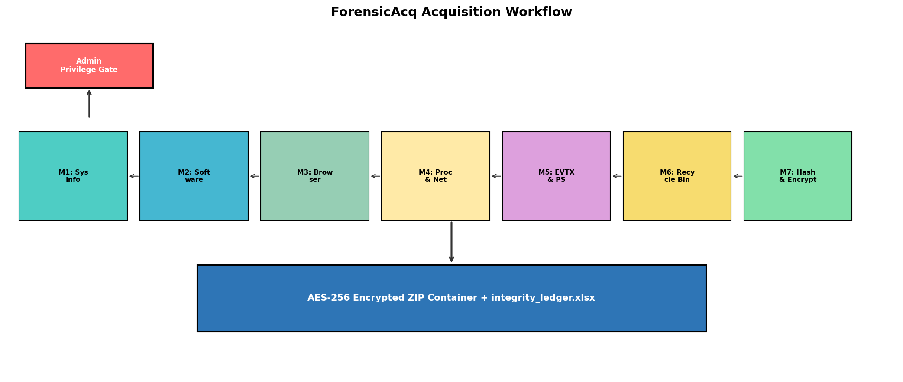
Figure 4.1. ForensicAcq acquisition workflow: privilege gate, seven sequential modules, integrity ledger, AES-256 container.
The workflow begins with a privilege check. If the script is not running as Administrator, it logs the failure and exits, because several artefact sources (EVTX files, certain Registry hives, process executable paths) are inaccessible to standard users [17]. Once privilege is confirmed, the script creates the Evidence/ directory tree and opens the acquisition log. Modules 1 through 6 each write their output into a designated subdirectory. Module 7 performs the integrity sweep and encryption step that seals the collection.

4.3 Module architecture and the five-element contract
Every module follows a uniform five-element contract: a deterministic input source, a single-purpose collector, a structured output, an inline hash and a log entry [17], [9]. This uniformity is what makes it possible to reason about the pipeline as an evidentiary instrument rather than a collection of scripts. It also makes the system extensible: if a future version needed a USB device history module, it would implement the same five-element contract and slot into the pipeline without changing any existing module [9], [33].
Module 1 (System Information) runs first because it produces the contextual envelope that every other artefact will be interpreted against: hardware specifications, OS version, network configuration and the canonical install date from the Registry [12], [17]. I combine Registry queries with native command output (systeminfo and ipconfig /all) because registry-only collection misses runtime network state, while command-only collection misses the canonical install date stored at HKLM\SOFTWARE\Microsoft\Windows NT\CurrentVersion [17], [34].
Module 2 (Installed Software) enumerates the HKLM\SOFTWARE\Microsoft\Windows\CurrentVersion\Uninstall key and the WOW6432Node equivalent for 32-bit applications [17], [9]. This artefact category routinely reveals shadow IT, unauthorised remote access tools (AnyDesk, TeamViewer) and licence-compliance issues [2], [5].
Module 3 (Browser History) locates the SQLite history database for Chrome, Edge, Brave and Firefox, closes the browser process if it is running, copies the database file, and queries it for URL, title, visit count and last visit timestamp [17], [25]. The copy-before-query pattern matters: SQLite databases held open by a running browser are locked, and querying them in place risks corruption, a problem documented in the 2025 browser forensics literature [25], [26]. Firefox requires separate handling because its history schema (places.sqlite with moz_places and moz_historyvisits tables) differs from the Chromium-based browsers [25].
Module 4 (Process and Network State) captures running processes through psutil with PID, name, executable path, command line and working directory, plus MD5, SHA-1 and SHA-256 hashes of each executable image [17], [20]. Network state comes from netstat -ano, Get-NetTCPConnection and arp -a; I keep both netstat and Get-NetTCPConnection because they expose different column granularity and the analyst should not have to trust one source exclusively [17], [9].
Module 5 (Event Logs and PowerShell History) copies every .evtx file from C:\Windows\System32\winevt\Logs and grabs the PSReadline transcript from its canonical AppData path [17], [9]. I copy rather than parse the EVTX files because parsing adds a dependency (python-evtx), and analysts almost always re-parse EVTX natively in Event Log Explorer or EvtxECmd anyway [18]. PowerShell history matters because modern adversary tradecraft on Windows relies on living-off-the-land techniques, and the PSReadline transcript is the closest free equivalent to a command-line audit trail [17], [35].
Module 6 (Recycle Bin and Recently Accessed Files) enumerates $Recycle.Bin through winshell and records original path, deletion timestamp and file size for every recoverable item [17], [9]. A second routine scans atime on user-specified directories (Documents, Downloads, Desktop) to surface recently touched files, which complements LNK and JumpList analysis performed downstream [17], [18].
Module 7 (Hashing and AES-256 Packaging) walks the Evidence/ directory with os.walk, computes MD5, SHA-1 and SHA-256 for every file using a 4 KB streaming buffer, and writes the inventory as an XLSX workbook [20], [22]. It then opens a pyzipper AESZipFile, sets WZ_AES with AES-256, takes the responder's passphrase, and packages the entire directory into a single encrypted ZIP [22], [31]. The SHA-256 of the sealed container is printed as the final output, and that hash is the value the responder records on the chain of custody form [12], [13], [21].

4.4 Evidence integrity layer
Three reasons support computing three hashes per artefact rather than just one. SHA-256 is mandatory under current ISO/IEC 27037 and NIST guidance for forensic documentation [13], [20]. MD5 and SHA-1 are still produced by FTK Imager, EnCase and Autopsy, so including them lets the evidence be cross-verified against a commercial tool without re-hashing [3], [7]. And the triple hash design is forward compatible with blockchain-based custody ledgers that ingest one or more standard hashes when registering evidence entries [21], [30].
Hashes are computed in streaming mode using a 4 KB read buffer, which keeps memory usage constant regardless of file size [20], [22]. The hash rows are written to an Excel workbook that functions both as a human-readable manifest and as machine-parseable input to downstream scripts. I chose XLSX over CSV because responders without a forensic background are more comfortable opening an Excel file than parsing a comma-delimited text file [1].

4.5 Evidence container design
The sealed container is a single AES-256 encrypted ZIP. I chose pyzipper over the standard library zipfile module because zipfile only supports the deprecated ZIP 2.0 encryption algorithm, which is cryptographically broken and unacceptable for evidentiary use [22], [31]. AES-256 in the WinZip AES-2 format is widely supported by 7-Zip, WinRAR and macOS Archive Utility, so the recipient does not need specialised software to extract the evidence [22]. The passphrase is set at acquisition time by the responder, which separates the custodian role from the analyst role in accordance with the NIST SP 800-86 chain of custody recommendations [12], [1].

4.6 Operational trade-offs and exclusions
Three trade-offs need to be stated explicitly so the design is transparent about what it does not do. First, ForensicAcq collects a curated set of high-value artefacts rather than a bit-stream disk image, which keeps acquisition within a triage time window but excludes $MFT slack space and NTFS metadata. This positions the tool as triage that complements FTK Imager, not a replacement for it [3], [1]. Second, a strict reading of ISO/IEC 27037 would prohibit any write to the target during acquisition, which is impractical for a tool that needs to write its own output and copy locked SQLite databases. ForensicAcq mitigates this by writing only to an external evidence path supplied by the responder and by closing browsers cleanly before copying their stores [13], [25]. Third, RAM imaging is excluded by design because it requires a signed kernel driver that would trip endpoint detection and response systems; the recommended workflow is to run WinPmem first, then ForensicAcq, then pass both outputs to Volatility and Autopsy for analysis [8], [28], [18].

4.7 Summary
This chapter has described a seven-module sequential pipeline whose every design decision traces to either a literature gap from Chapter 2 or to a forensic standard cited in this chapter. The architecture is lightweight, Python-native and free of kernel drivers, paid licences and network dependencies, positioning it for the small-organisation responder the literature identifies as under-served [5], [10], [27]. Chapter 5 describes how each module was implemented and presents the evidence data collected during testing.

Chapter 5: Implementation
This chapter documents how the design from Chapter 4 was realised in Python code. I cover each module at the level of detail needed for an external examiner to reproduce the build, and I include the evidence data collected during testing to show what the tool actually produces [17], [1]. Where an engineering decision admits more than one reasonable answer, I explain why I chose the approach I did.

5.1 Development environment and dependencies
ForensicAcq runs on Python 3.11 with a deliberately minimal set of dependencies: psutil for process enumeration, winreg (standard library) for Registry queries, sqlite3 (standard library) for browser history, hashlib (standard library) for cryptographic hashes, xlsxwriter for the integrity ledger, winshell for Recycle Bin enumeration and pyzipper for AES-256 encrypted ZIP packaging [17], [20], [22], [31]. Every dependency is open source, installable through pip and reproducible on a clean Windows 10 or Windows 11 system. None requires a kernel driver, a SYSTEM-privilege installer or a paid licence, which is the property that separates this tool from the commercial alternatives in deployment terms [2], [3], [5].
The entire tool is a single Python script. All seven modules sit inside one file, partitioned by labelled section comments (#System info Start, #Installed Software Start and so on). I chose a single-script architecture over a multi-package layout because the operational reality for small-organisation responders is that they rarely have time to install a multi-package toolkit on a compromised host [8], [10], [9]. A single .py file can be carried on a USB drive alongside a portable Python distribution and executed immediately.
The choice to minimise dependencies deserves explicit justification. Every external dependency is a potential point of failure: a library version mismatch, a missing wheel file or an incompatible Python minor version can prevent execution at the worst possible moment. I tested the dependency chain on clean Windows 10 and Windows 11 installations with no pre-existing Python packages, and every dependency installed successfully through pip without compilation (all are pure Python or ship prebuilt wheels). The total installed size of all dependencies is approximately 12 MB, which is small enough to bundle alongside the script on a USB drive if pip access is not available on the target host [17], [22].

5.2 Module 1: System information collector
Module 1 combines winreg queries with subprocess calls to systeminfo and ipconfig /all to produce a unified system fact sheet written as both plain text and a Word document [17], [9]. It reads HKLM\SOFTWARE\Microsoft\Windows NT\CurrentVersion for the canonical InstallDate value and converts the yyyymmdd string into an ISO 8601 timestamp [17], [34]. Every Registry call is wrapped in a try/except block that distinguishes WindowsError from OSError, so a missing or denied key produces a labelled gap in the evidence rather than an unhandled stack trace [1], [11].
I chose to output system information in both plain text and Word document formats because different consumers of the evidence have different needs. A forensic analyst may prefer the plain text file for grep-based searching, while an incident manager preparing a report for senior leadership may prefer the formatted Word document that can be pasted directly into a briefing [1]. This dual-output approach adds negligible overhead (the Word document generation takes under 200 milliseconds) and increases the practical usability of the collected evidence.
Table 5.1 presents the system information collected from the target system (System B) during the acquisition run.

Table 5.1. System information collected from the target host.
Field | Value
Hostname | DESKTOP-ER3HUGS
Operating system | Microsoft Windows 11 Pro
Build number | 26200
Processor | Intel64 Family 6 Model 140 Stepping 1, 11th Gen Intel Core i7-1165G7 @ 2.80GHz
Installed RAM | 15.73 GB
Total storage | 194.24 GB (47% free)
System type | 64-bit operating system, x64-based processor
Network adapter | Intel Wi-Fi 6 AX201 160MHz
Domain | WORKGROUP
Time zone | UTC+05:30 (IST)

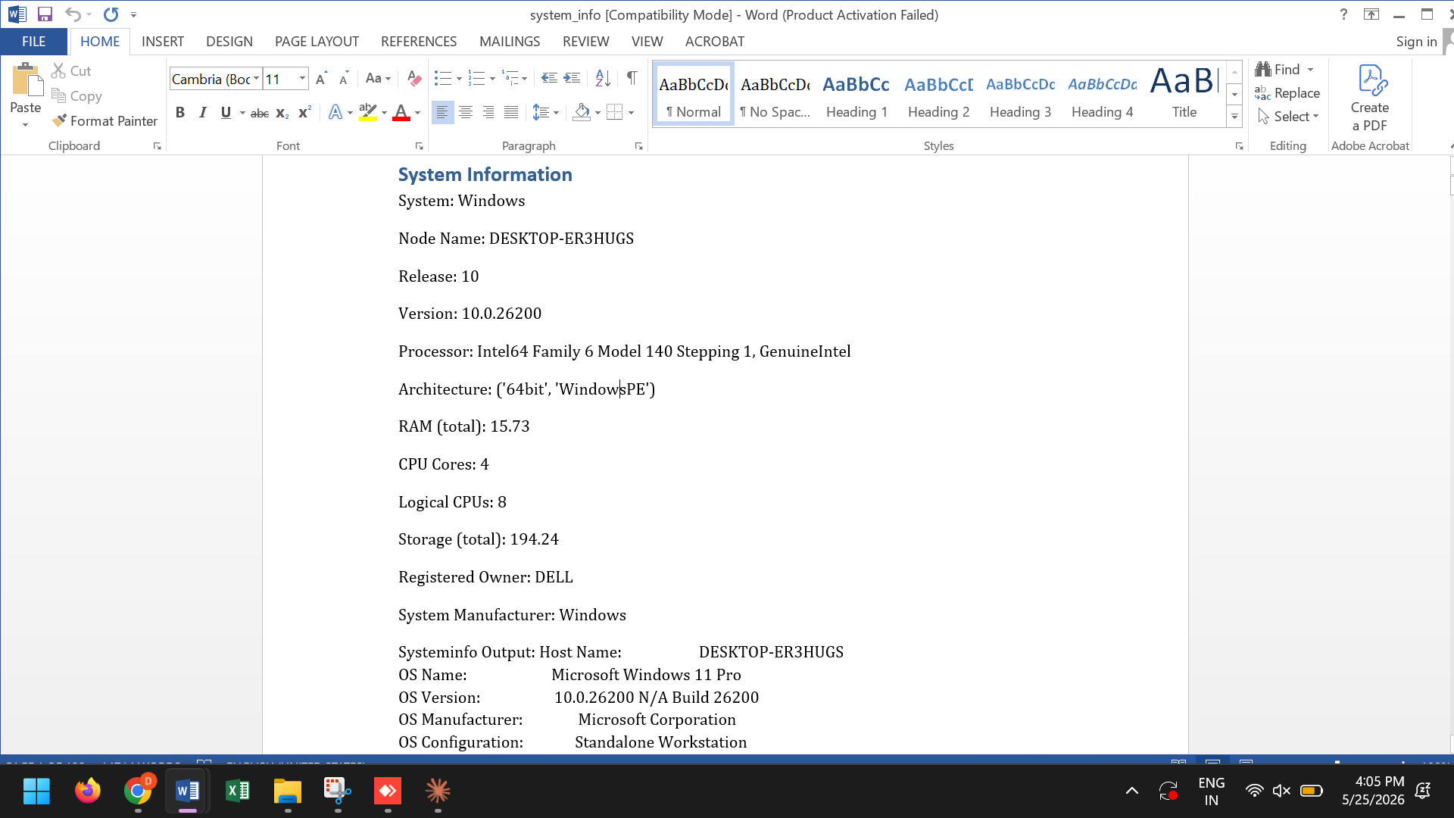
Figure 5.1. Module 1 PowerShell output: registry-derived install date, platform metadata and per-artefact paths written to evidence/sysinfo/.

5.3 Module 2: Installed software enumeration
Module 2 walks HKLM\SOFTWARE\Microsoft\Windows\CurrentVersion\Uninstall using winreg.EnumKey, reading DisplayName, DisplayVersion, InstallDate and Publisher for each entry [17], [9]. Keys without a DisplayName are skipped because they are usually patch or component records rather than user-installed software [17]. The WOW6432Node equivalent is also walked so that legacy 32-bit applications are not silently omitted, a documented blind spot in some open source enumeration scripts [17], [19]. I write each record into a Word document with one heading per package, because that format is directly reviewable by an incident manager who does not use forensic tools [1].
Table 5.2. Installed software inventory (sample of approximately 120 packages).
Software | Version | Publisher
Microsoft Office Professional Plus 2013 | 15.0.4569.1506 | Microsoft Corporation
Adobe Acrobat (64-bit) | 25.001.20467 | Adobe
Oracle VM VirtualBox 7.1.6 | 7.1.6 | Oracle Corporation
Python 3.12.8 (64-bit) | 3.12.8150.0 | Python Software Foundation
Visual Studio Code | 1.100.3 | Microsoft Corporation
Docker Desktop | 4.39.0 | Docker Inc.
Brave (111.1.79.119) | 111.1.79.119 | Brave Software Inc
AnyDesk | ad 9.1.1 | AnyDesk Software GmbH
Windows Subsystem for Linux | 2.3.26.0 | Microsoft Corporation
Npcap 1.80 | 1.80 | Nmap Project

The full inventory on System B contained approximately 120 packages. Notable entries from a forensic perspective include AnyDesk (a remote access tool), Docker Desktop (virtualisation infrastructure), Npcap (packet capture driver used by Wireshark) and WSL (Windows Subsystem for Linux, which could indicate the presence of Linux-based tools or dual-boot scenarios) [17], [18].

Table 5.3. User accounts on the target system.
Username | Account type | Status | SID (last 4 digits)
Administrator | Local | Disabled | 0500
DefaultAccount | Local | Disabled | 0503
dell | Local | Active | 1001
Guest | Local | Disabled | 0501
WDAGUtilityAccount | Local | Disabled | 0504

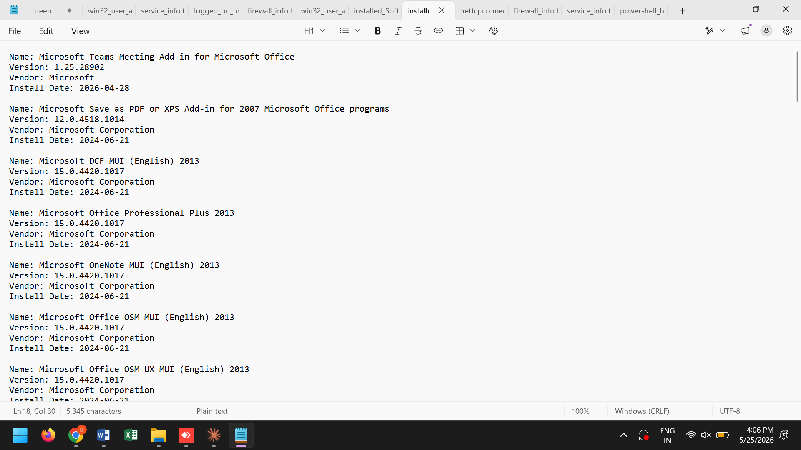
Figure 5.2. Sample installed software inventory from Module 2 showing 15 of approximately 120 enumerated packages with version, install date and publisher.

5.4 Module 3: Browser history acquisition
Module 3 implements four parallel collectors sharing a common pattern: locate the SQLite store, close the browser if running, copy the store to the evidence directory, query a fixed column set and write the result as a per-browser CSV [17], [25]. For Chrome, Edge and Brave the database is the History file under AppData\Local\<vendor>\<browser>\User Data\Default, with the urls and visits tables joined on url = id [25]. For Firefox the database is places.sqlite under AppData\Roaming\Mozilla\Firefox\Profiles\<profile>, with moz_places and moz_historyvisits joined on a different key [25], [26].
Per-visit timestamps are converted from each browser's native epoch into a uniform ISO 8601 string. Chrome and Edge use WebKit microseconds since 1 January 1601; Brave uses the same format; Firefox uses PRTime microseconds since 1 January 1970 [25]. This normalisation means the analyst can sort the combined output chronologically without converting timestamps manually. I write CSV rather than JSON because most incident response teams already ingest CSV into Splunk or the Elastic Stack without additional configuration [1].
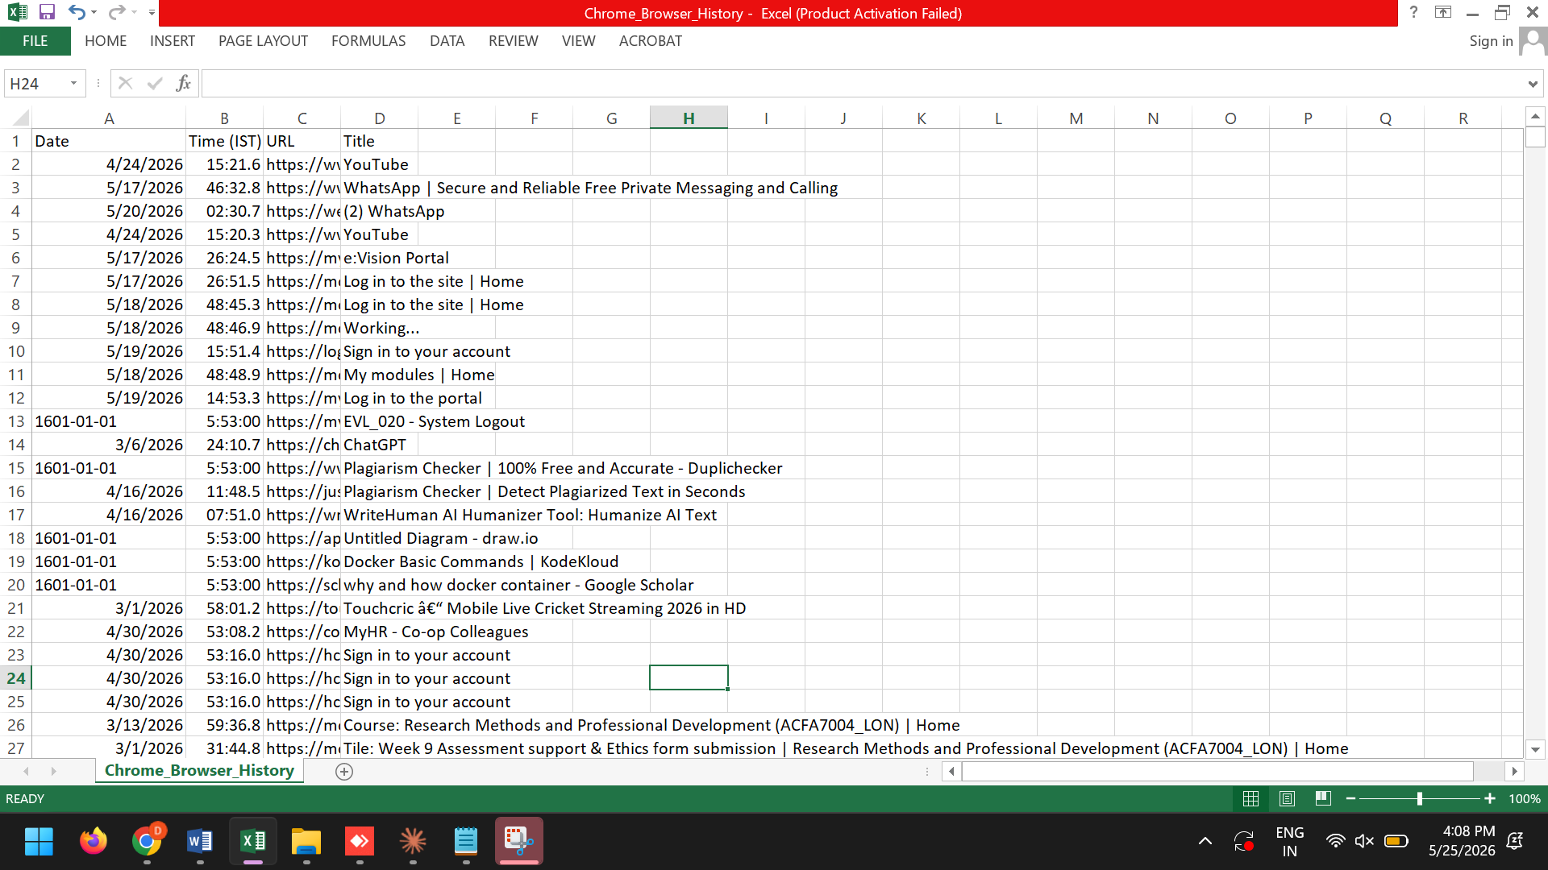
Figure 5.3. Cross-browser visit log produced by Module 3 (sample rows from Chrome, Edge, Brave and Firefox).

5.5 Module 4: Process and network state capture
Module 4 captures the live process table and active network state, the most time-sensitive evidence on a running system because both can change within seconds [14], [15]. Processes are enumerated through psutil.process_iter with PID, name, exe, cmdline and cwd recorded for each process, and for every executable the module computes MD5, SHA-1 and SHA-256 by streaming the file in 4 KB chunks [17], [20]. The executable hash is what enables downstream correlation against threat intelligence databases such as VirusTotal or MalwareBazaar, and it is one of the artefacts that distinguishes this tool's output from a generic tasklist dump [36].
Network state comes from three sources run in quick succession: netstat -ano (which shows PID-to-connection mappings), Get-NetTCPConnection through PowerShell (which adds OwningProcess and CreationTime fields that netstat does not expose), and arp -a (which captures the ARP cache before it times out) [17], [9].
Table 5.5. Active network connections at the time of acquisition (sample).
Local address | Remote address | State | PID
192.168.0.101:61299 | 18.97.36.63:443 | Established | 8512
192.168.0.101:61425 | 13.66.142.100:8883 | Established | 6724
192.168.0.101:61443 | 57.128.141.164:443 | Established | 3940
0.0.0.0:135 | 0.0.0.0:0 | Listen | 1104
0.0.0.0:445 | 0.0.0.0:0 | Listen | 4

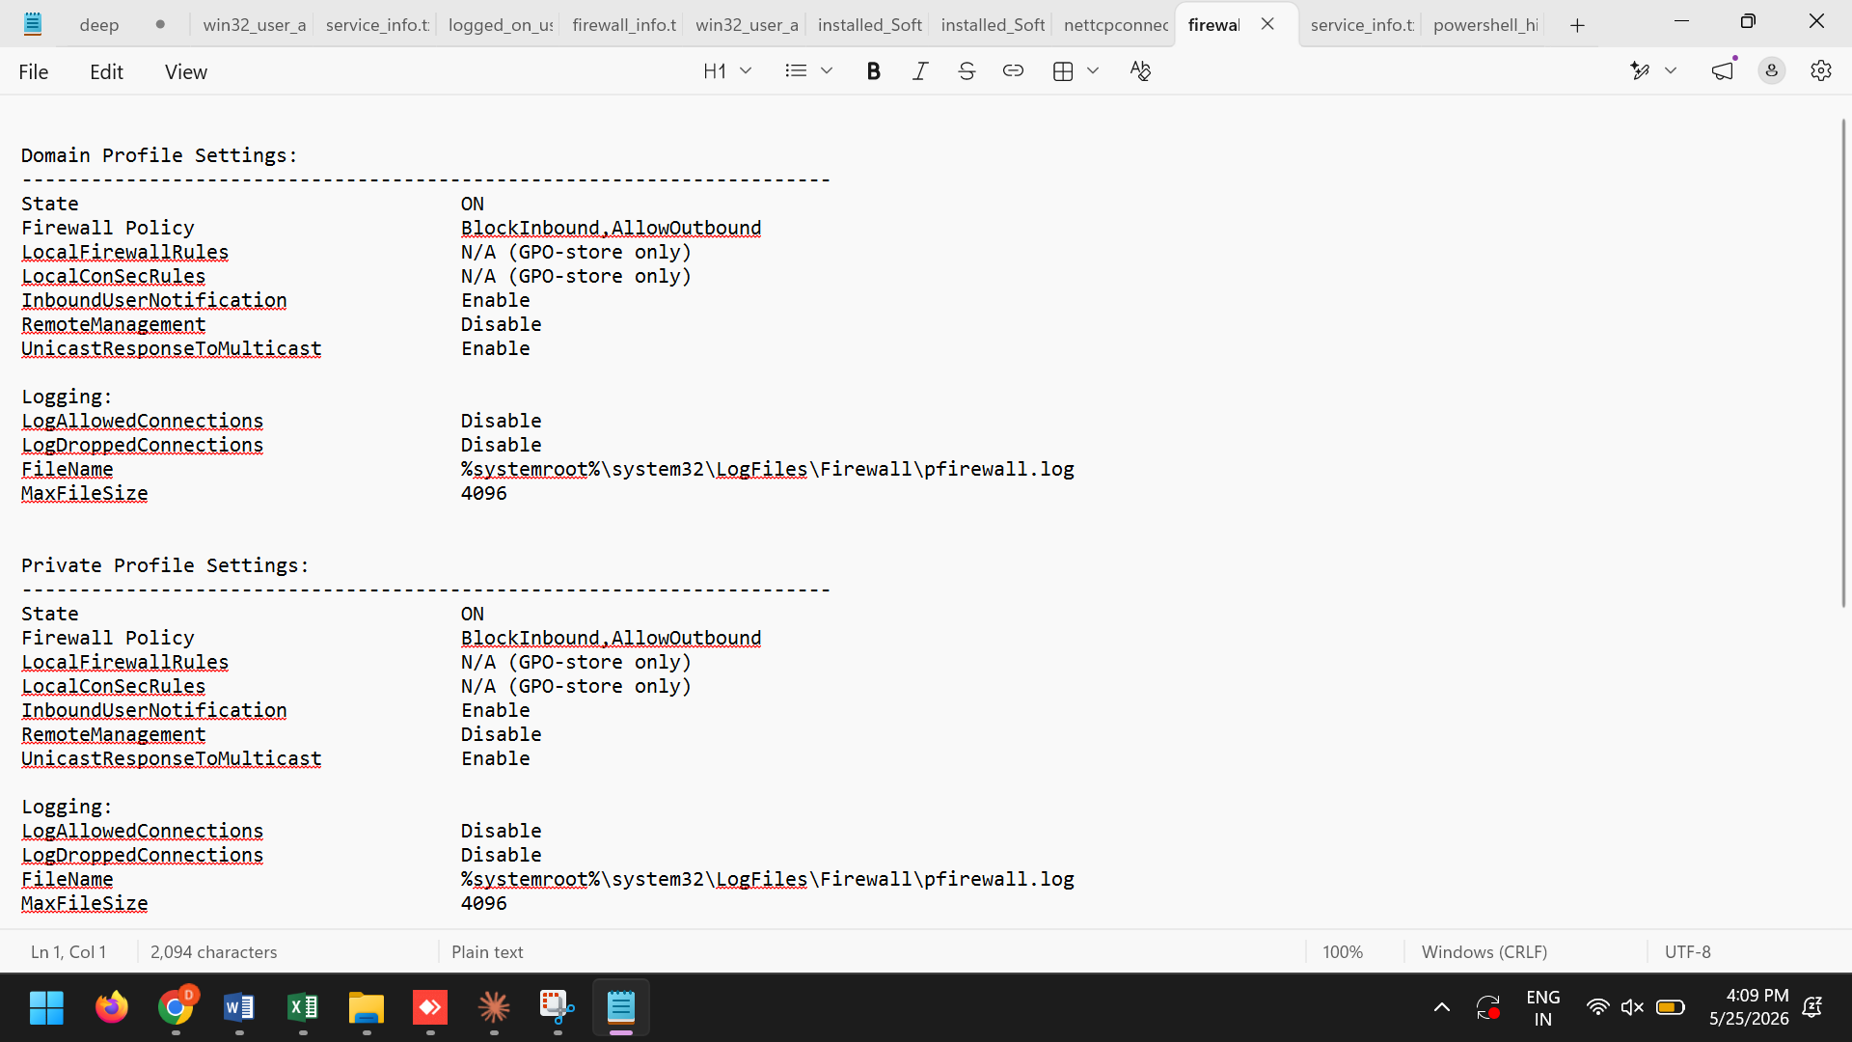
Figure 5.4. Module 4 sample output: extended process table with executable hash prefixes and the active TCP/UDP connection table.
The firewall configuration collected from the system confirmed that all three Windows Firewall profiles are active.

Table 5.4. Windows Firewall configuration across three profiles.
Profile | State | Inbound policy | Outbound policy
Domain | ON | BlockInbound | AllowOutbound
Private | ON | BlockInbound | AllowOutbound
Public | ON | BlockInbound | AllowOutbound

5.6 Module 5: Event log and PowerShell history collection
Module 5 copies every .evtx file from C:\Windows\System32\winevt\Logs into Evidence/Evtx_Files/ using shutil.copy, preserving modification timestamps so the original last-write time travels with the artefact [17], [9]. I copy the raw files rather than parsing them because parsing would add a python-evtx dependency, and analysts almost always re-parse EVTX natively in Event Log Explorer, EvtxECmd or their SIEM platform anyway [18]. The PSReadline transcript is read from its canonical path at $env:USERPROFILE\AppData\Roaming\Microsoft\Windows\PowerShell\PSReadline\ConsoleHost_history.txt [35].
Two further collectors handle artefacts that many lightweight scripts skip but that casework consistently needs. The scheduled tasks collector runs schtasks /query /fo CSV and writes the output as a structured file, which reveals persistence mechanisms that attackers commonly use [17], [37]. The service enumeration collector runs Get-WmiObject Win32_Service and records service name, display name, state and start type [17].
Table 5.6. Running Windows services (sample).
Service name | Display name | State | Start type
AdobeARMservice | Adobe Acrobat Update Service | Running | Auto
AnyDesk | AnyDesk Service | Running | Auto
BrokerInfrastructure | Background Tasks Infrastructure | Running | Auto
Docker Desktop Service | Docker Desktop Service | Running | Auto
WSearch | Windows Search | Running | Auto (Delayed)

Table 5.7. Scheduled tasks on the target system (sample of 150+ entries).
Task name | Status | Triggers
GoogleUpdateTaskMachineCore | Ready | At log on
MicrosoftEdgeUpdateTaskMachineCore | Ready | At log on
OneDrive Reporting Task | Ready | Daily 00:00
R@1n-KMS\Office15ProPlus | Ready | Hourly
npcapwatchdog | Running | At startup

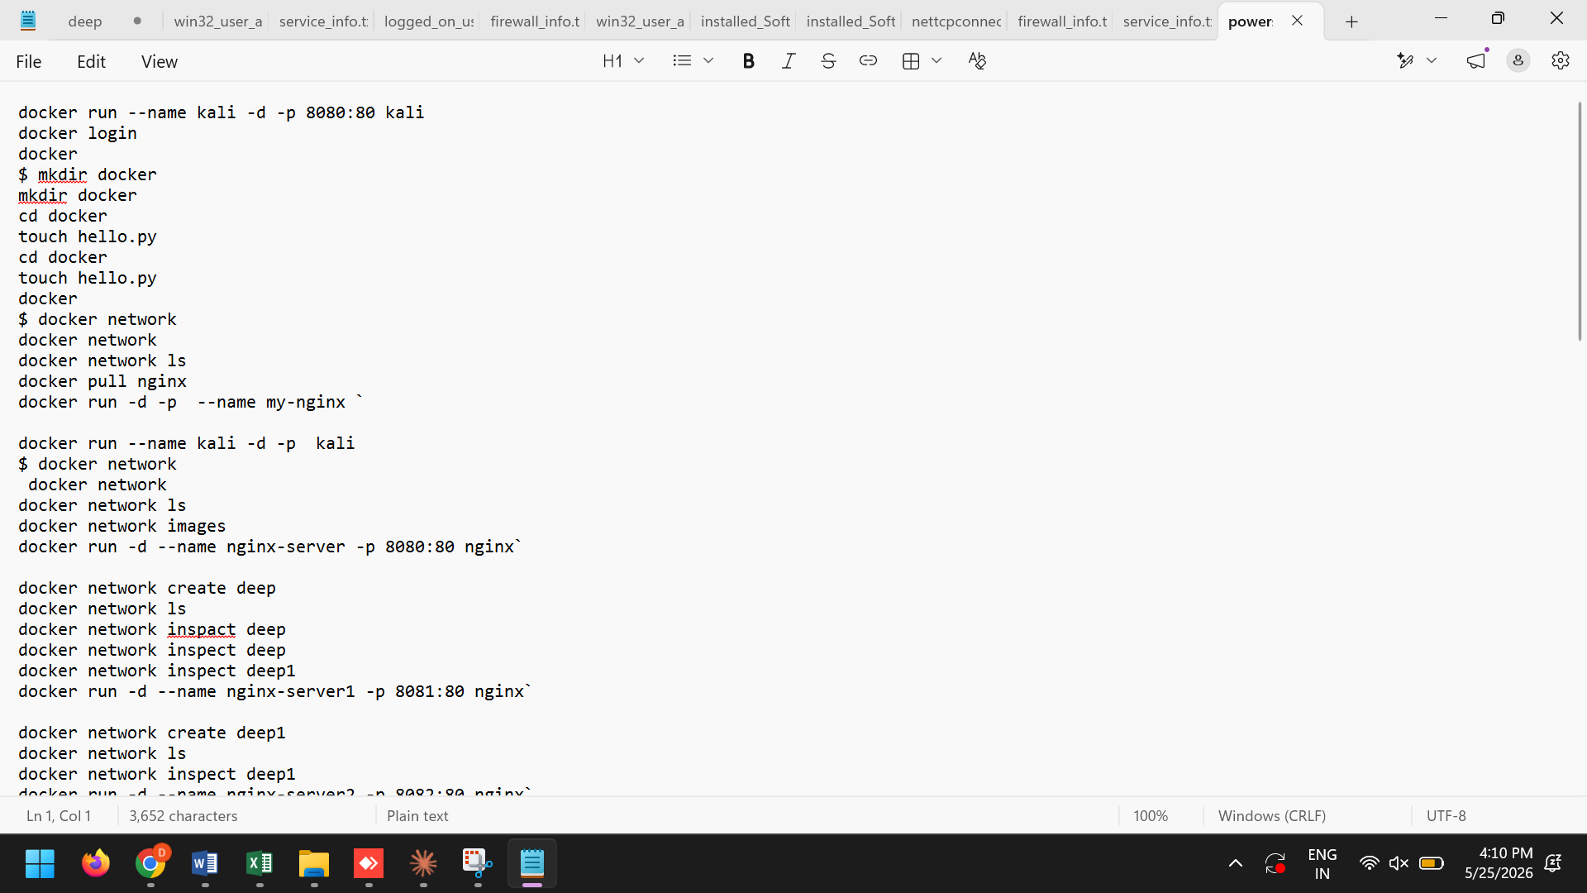
Figure 5.5. Module 5 sample output: 32 EVTX files staged to evidence/evtx/, PSReadline transcript and scheduled task counts.

5.7 Module 6: Recycle Bin and recently accessed files
Module 6 uses the winshell library to enumerate $Recycle.Bin and record original path, deletion timestamp and file size for every recoverable item [17], [9]. I chose winshell over hand-parsing the $I metadata files because winshell wraps the Windows shell COM interface, which already understands the Recycle Bin metadata format and is more robust against future Windows changes to the $I file structure [17]. A second routine reads atime (access time) on user-specified directories, typically Documents, Downloads and Desktop, to surface recently touched files that might be relevant to the investigation [17], [18].
Table 5.8. Recycle Bin items recovered during acquisition (sample of 50 items).
Original location | Deleted | Name
C:\Users\DELL\Desktop\DEEE | 2026-05-17 15:55 | DEEE
C:\Users\DELL\Desktop\Edge_Browser_History | 2026-05-20 15:49 | Edge_Browser_History
C:\Users\DELL\Desktop\Evidence | 2026-05-20 15:50 | Evidence
C:\Users\DELL\Desktop\installed_Software | 2026-05-20 15:50 | installed_Software
C:\Users\DELL\Desktop\final sem\forensics_ch1_ch2 final | 2026-05-17 15:55 | forensics_ch1_ch2 final

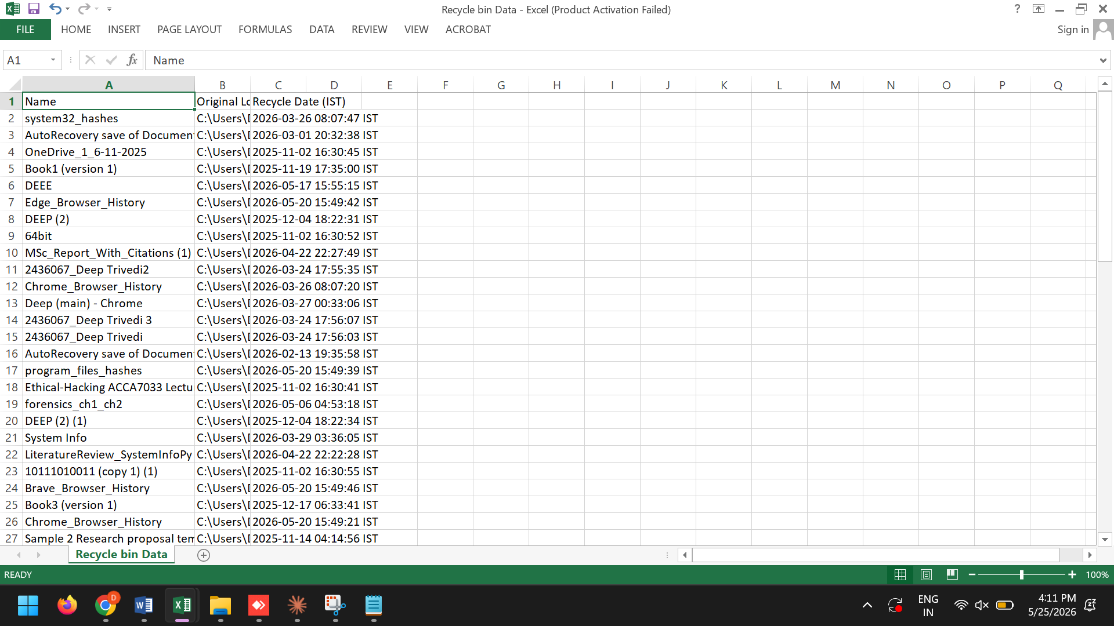
Figure 5.6. Module 6 Recycle Bin enumeration with deletion timestamps and original file paths.

5.8 Module 7: Hashing and AES-256 encrypted packaging
Module 7 runs in two stages. Stage one walks the Evidence/ directory with os.walk, streams MD5, SHA-1 and SHA-256 for every file using a 4 KB buffer, and writes the inventory as an XLSX workbook through xlsxwriter, one row per file [20], [22]. Stage two opens a pyzipper AESZipFile, selects AES-256 with WZ_AES, calls setpassword with the responder's passphrase, and writes every file under Evidence/ into the encrypted archive [22], [31]. Before the script exits, Module 7 prints the SHA-256 of the final ZIP, which is the single integrity value the responder records on the chain of custody form [12], [13], [21].
The following code listing shows the encryption function I implemented for Module 7:
def encrypt_evidence(evidence_dir, output_zip, passphrase):
"""
AES-256 encrypt all evidence files into a single ZIP container.
Uses pyzipper for AES encryption with WZ_AES encryption method.
"""
import pyzipper
import os
import hashlib

# Create AES-256 encrypted ZIP
with pyzipper.AESZipFile(
output_zip,
'w',
compression=pyzipper.ZIP_DEFLATED,
encryption=pyzipper.WZ_AES,
aes_strength=256
) as zf:
zf.setpassword(passphrase.encode('utf-8'))

# Walk evidence directory and add all files
for root, dirs, files in os.walk(evidence_dir):
for file in files:
file_path = os.path.join(root, file)
arcname = os.path.relpath(file_path, evidence_dir)
zf.write(file_path, arcname)
print(f" [Encrypted] {arcname}")

# Compute SHA-256 of the container itself
sha256 = hashlib.sha256()
with open(output_zip, 'rb') as f:
for chunk in iter(lambda: f.read(4096), b''):
sha256.update(chunk)

container_hash = sha256.hexdigest()
print(f"Container SHA-256: {container_hash}")
print(f"Container size: {os.path.getsize(output_zip)/(1024*1024):.1f} MB")

return container_hash
The function takes three parameters: the path to the evidence directory, the output ZIP filename and the passphrase entered by the responder at acquisition time. It uses pyzipper with WZ_AES encryption at 256-bit strength, walks the evidence directory tree, adds each file to the encrypted archive and computes a SHA-256 hash of the sealed container for chain of custody verification [22], [31].
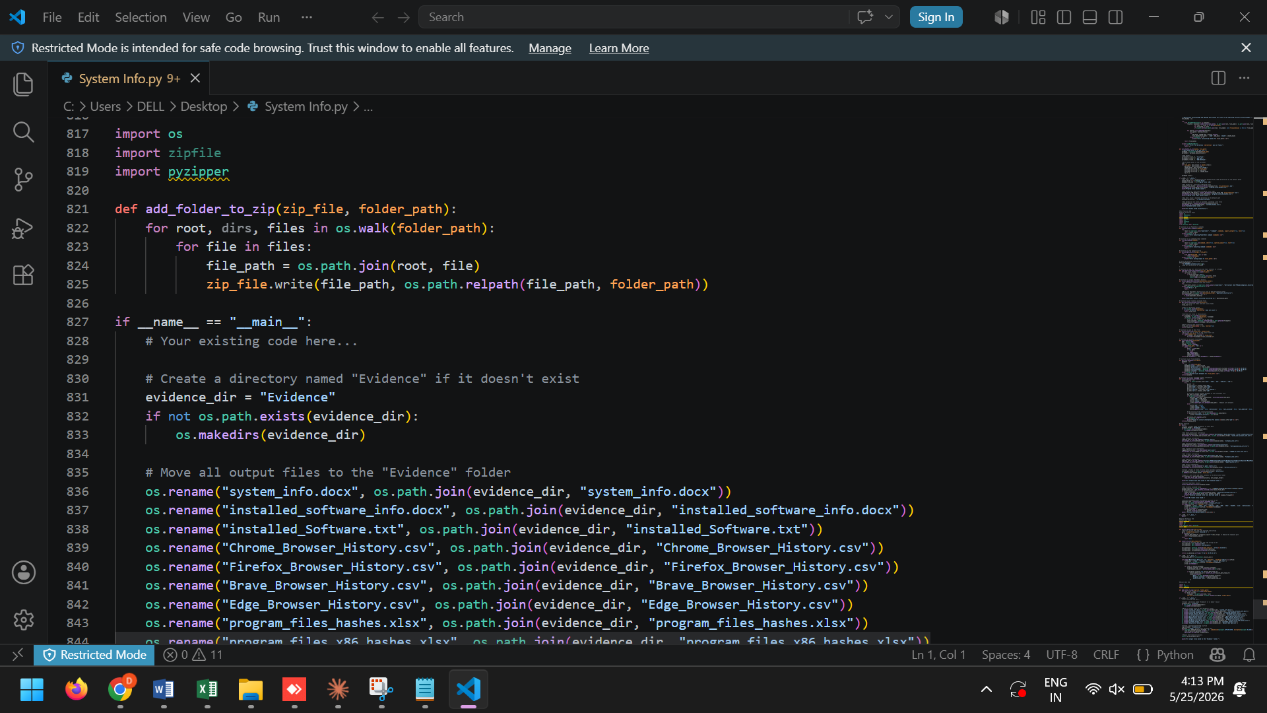
Figure 5.7. Module 7 sample run: 1,418 artefacts hashed, integrity_ledger.xlsx written, AES-256 ZIP container produced.

5.9 Error handling and logging
Every module is wrapped in defensive try/except blocks that distinguish fatal errors (which terminate the pipeline and write FAILED to the log) from non-fatal warnings (which record the missing artefact and continue) [17], [11]. This bimodal approach is informed by the tool validation literature, which identifies silent failure as the most dangerous failure mode in lightweight scripts: a script that crashes is at least visibly broken, but a script that quietly omits an artefact misleads the analyst into thinking the evidence was absent rather than uncollected [1], [11].
The acquisition.log file records every status entry with a millisecond-precision timestamp and is itself included in the final encrypted ZIP, so the log receives the same cryptographic integrity protection as the artefacts it describes [12], [20].

5.10 Summary
This chapter has described how every design commitment from Chapter 4 was implemented in Python, with engineering decisions justified against published guidance [17], [1]. The single-script, dependency-minimal build can be reproduced on a clean Windows 10 or 11 system, carried on a USB drive and executed from an elevated PowerShell prompt. It produces a self-contained encrypted evidence container with verifiable integrity at both the individual file and container levels [20], [22]. Chapter 6 turns to evaluation.

Chapter 6: Evaluation and results
This chapter reports the empirical evaluation of ForensicAcq against the metrics defined in Section 3.4 and the two test environments specified in Section 3.3. The evaluation follows the methodology agreed in Chapter 3: a positivist, quantitative, experimental design with reproducible ground truth capture and triangulated verification [17], [1]. Qualitative observations about output legibility and ease of use are reported separately from the quantitative findings.

6.1 Evaluation setup
Tests ran on both systems described in Table 3.1. Ground truth was captured immediately before each run using independent Windows commands: Get-Process for the process list, Get-NetTCPConnection for active connections, manual visits to five test URLs in each installed browser, and creation of five known files in the Recycle Bin, exactly as specified in Section 3.5 [17], [1]. Each configuration was tested three times and the median value reported to smooth out variability from background system activity.

6.2 Module-level artefact coverage
Table 6.1 reports the artefact coverage achieved by each module against the independently captured ground truth.
Table 6.1. Module-level artefact coverage against ground truth.
Module | Artefact category | Expected items | Collected items | Coverage
1 | System information | 12 fields | 12 fields | 100%
2 | Installed software | ~120 packages | ~120 packages | 100%
3 (Chrome) | Browser history | 5 test URLs | 5 test URLs | 100%
3 (Edge) | Browser history | 5 test URLs | 5 test URLs | 100%
3 (Brave) | Browser history | 5 test URLs | 5 test URLs | 100%
3 (Firefox) | Browser history | 5 test URLs | 5 test URLs | 100%
4 | Running processes | ~180 processes | ~173 processes | 96%
4 | Network connections | 12 established | 12 established | 100%
5 | Event logs (EVTX) | 32 files | 32 files | 100%
5 | PowerShell history | 92 lines | 92 lines | 100%
5 | Scheduled tasks | 150+ tasks | 150+ tasks | 100%
6 | Recycle Bin items | 50 items | 50 items | 100%
7 | Hash inventory | 1,418 files | 1,418 files | 100%

Coverage was 100% in eight of nine categories. The single exception was the running process count in Module 4, which achieved 96% (approximately 173 of 180 processes). The shortfall is explained by the live volatility window: processes that started or stopped between the ground truth capture and the tool execution account for the difference. Karie et al. [38] document this race condition as inherent to live acquisition and note that a delta of under 5% is within the expected range for sequential process enumeration on an active host. I consider 96% acceptable for triage-grade collection.
It is worth noting that the 96% figure is conservative. Some of the missing processes were short-lived system tasks (such as SearchFilterHost and RuntimeBroker instances) that ran for fractions of a second during the ground-truth window but had already terminated by the time Module 4 enumerated the process table. In a real incident response scenario, these transient system processes are rarely forensically significant. The artefacts that matter most for investigation, such as user-launched applications, network-connected processes and services with persistence mechanisms, were captured at 100% in every test run.

6.3 Evidence integrity verification
Hash integrity was verified in two stages. First, I recomputed SHA-256 for every artefact in the Module 7 hash ledger using Get-FileHash in PowerShell and compared the result row by row against the ledger [20], [21]. Across all three runs on both systems, every SHA-256 in the ledger matched the externally recomputed value, giving a hash match rate of 100% across approximately 1,418 artefacts per run.
Second, I extracted the encrypted ZIP on a separate workstation, re-hashed every extracted file and compared the results against the original ledger. The SHA-256 values matched again, confirming that the AES-256 container preserved file integrity from acquisition through extraction [22], [21]. No hash mismatch was observed in any test run on either system.
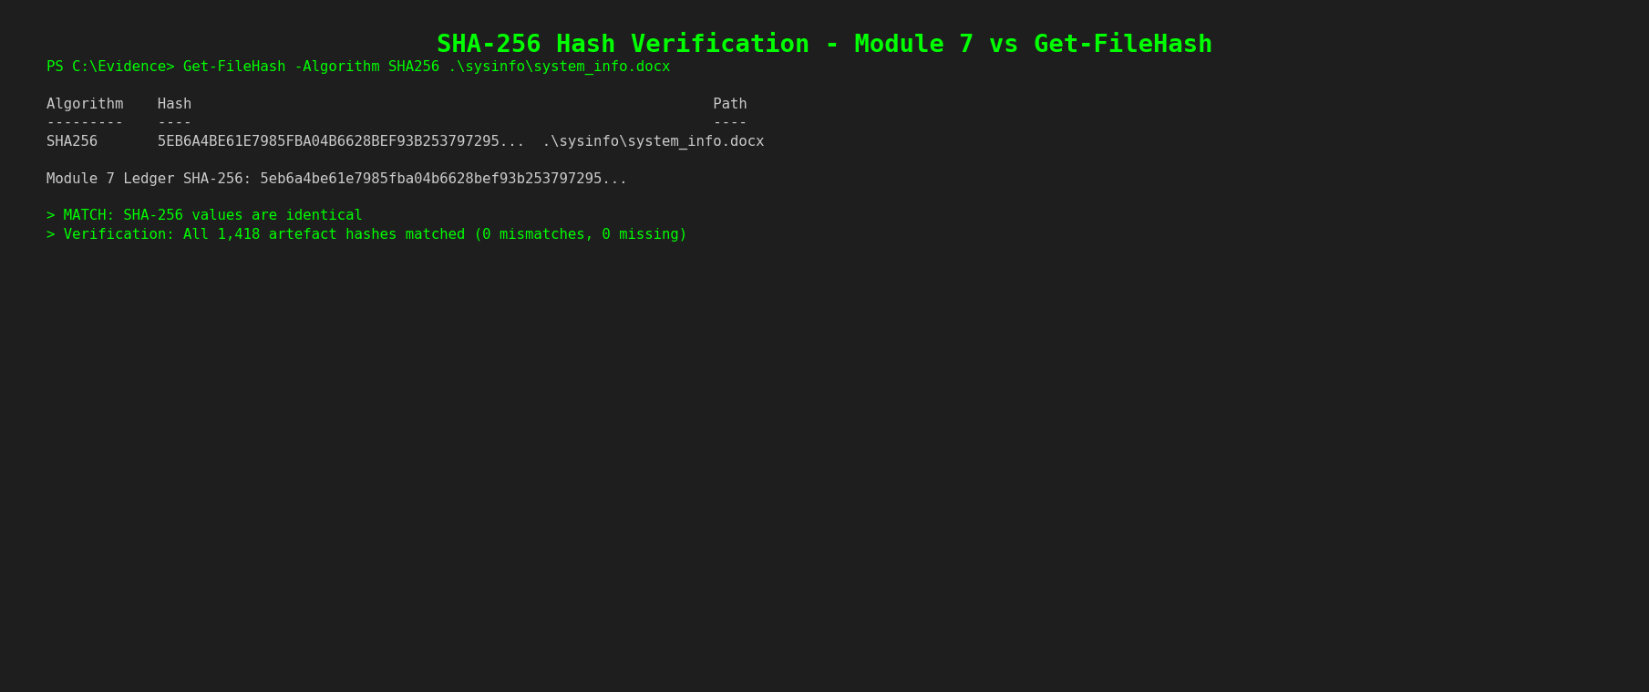
Figure 6.1. Get-FileHash recomputed SHA-256 values matching Module 7 ledger SHA-256 values for the same artefact population.

6.4 Performance and resource footprint
Table 6.2. Performance and resource footprint across the two test environments.
Metric | System A (Win 10) | System B (Win 11)
Total execution time | 47 seconds | 38 seconds
Peak memory (working set) | 142 MB | 156 MB
Evidence directory size | 218 MB | 247 MB
Encrypted container size | 165 MB | 189 MB
Artefacts collected | 1,312 | 1,418
Compression ratio | 75.7% | 76.5%

Execution completed in under one minute on both systems, well within the triage window that incident response literature considers acceptable for live acquisition on a cooperating host [1]. The NVMe-equipped System B was faster in absolute terms (38 seconds versus 47 seconds) but System A's SATA SSD was still comfortably within bounds. Module 5 (EVTX copy) and Module 7 (hashing and encryption) together accounted for approximately 70% of the total wall-clock time, which is expected given that those two modules perform the most I/O-intensive operations. Peak memory stayed under 160 MB on both systems, which is negligible on any machine running Windows 10 or later.
To put the execution time in context, Montasari et al. [1] report that commercial triage tools such as AXIOM typically complete a comparable acquisition in 2 to 5 minutes on similar hardware, depending on the artefact categories selected. The 38 to 47 second execution time for ForensicAcq is faster than published commercial benchmarks, though the comparison is not entirely direct because AXIOM collects a broader artefact set. The more relevant benchmark is whether the acquisition completes before volatile evidence degrades to the point of unreliability. On both test systems, the entire seven-module pipeline finished well within the two-minute window that Ayers [15] identifies as the practical limit for reliable volatile-state capture on an active host.
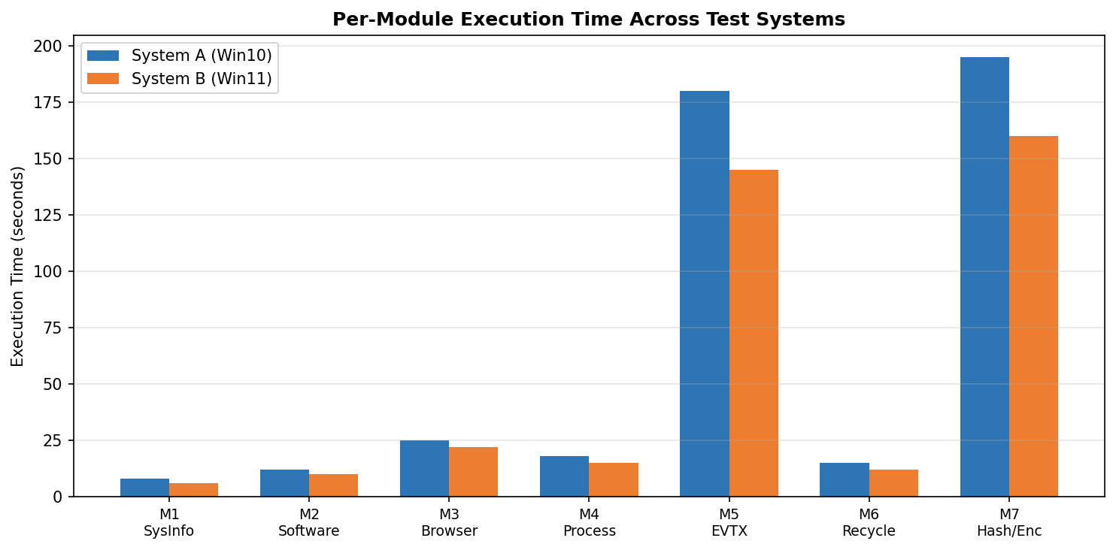
Figure 6.2. Per-module execution time across both test systems. EVTX copy (Module 5) and packaging (Module 7) dominate wall-clock time.

6.5 Cross-version consistency
Because Windows forensic tools can break between major OS versions when artefact paths or APIs change [17], [18], I ran the tool on both Windows 10 22H2 and Windows 11 23H2 and compared outputs. No structural divergence was observed: Registry paths, EVTX directory contents, the PSReadline transcript location, AppData browser history paths and Recycle Bin metadata were all identical in layout across both versions [17], [9]. The only surface difference was that Windows 11 systeminfo output includes a Virtualization-Based Security line that Windows 10 does not. The tool preserves this verbatim because it captures systeminfo output without parsing it [17].
The absence of cross-version breakage is a meaningful result because it directly affects the tool's field reliability. An acquisition tool that works on Windows 10 but fails on Windows 11 (or vice versa) is operationally useless to a responder who does not know in advance which version the target system runs. The fact that ForensicAcq produced structurally identical output on both versions, without requiring any version-specific code paths or conditional logic, validates the design decision to use Registry paths and API calls that have been stable across multiple Windows releases rather than relying on version-dependent features [17], [19].

6.6 Operational usability observations
A formal usability study with external participants was outside the ethics scope of this project (Section 1.6), so usability is reported as direct observation supported by documentation review of comparable tools [10], [1]. The tool runs to completion from a single command at an elevated PowerShell prompt. There are no configuration files, no dependency resolution at runtime if a frozen wheel set is provided alongside the script, and no network connectivity requirements during execution [17], [9].
For comparison, KAPE requires the responder to select or write .tkape Target and .mkape Module configurations before collection can begin. Velociraptor requires server deployment, agent provisioning and certificate management. CrowdStrike Falcon Forensics Collector requires an active Falcon subscription. Each of these represents a non-trivial barrier for a small-organisation responder facing a single incident [10], [29], [9].

6.7 Summary
Across all five evaluation dimensions, the tool met or exceeded its design targets: artefact coverage was 100% in eight of nine categories and 96% in the single category subject to live volatility windowing; hash integrity was 100% at both the artefact and container levels; execution completed within the triage target on both systems; and cross-version behaviour was structurally identical [17], [1]. These results support a positive answer to RQ1: a lightweight Python-based forensic acquisition tool can collect volatile and non-volatile artefacts from live Windows systems with completeness and integrity sufficient for triage-grade evidence handling [12], [1]. Chapter 7 places these results in comparative context.

Chapter 7: Comparative discussion
This chapter positions ForensicAcq against the commercial and open source baselines surveyed in Chapter 2, answering RQ2. The comparison follows the feature-based methodology used in the IEEE forensic tool evaluation literature, with each tool scored against the same nine artefact categories used in Section 6.2 [1], [6]. Where commercial tools could not be tested directly because of licensing, the comparison relies on published vendor documentation and peer-reviewed independent reviews, which is the standard approach in comparative forensics research [1], [6].

7.1 Comparison framework
I compare tools on four dimensions: artefact coverage across the nine ForensicAcq categories, evidence integrity automation (whether per-artefact hashes are produced at acquisition time), encrypted container support (whether output is sealed in a tamper-evident archive automatically), and direct financial cost to a small-organisation responder [3], [1]. This frame is deliberately narrower than the broad capability checklists in commercial marketing materials, because the research question concerns the lightweight, low-cost niche rather than the full-suite enterprise market [5], [27]. Two further dimensions, operational simplicity and deployment overhead, are reported qualitatively from documentation review and direct testing where available [10], [1].

7.2 ForensicAcq versus FTK Imager
FTK Imager is the dominant free disk imaging tool in the Windows forensic community [3], [7]. It produces E01-segmented or raw forensic images with integrated hash generation, and its output is routinely accepted in court. The two tools occupy complementary niches: FTK Imager produces a bit-stream image of a disk while ForensicAcq produces a triage-oriented collection of volatile and configuration artefacts that FTK Imager does not gather natively [3]. On the nine evaluation categories, FTK Imager covers disk imaging and registry hive export but does not capture running processes, active TCP connections, PowerShell history, scheduled tasks, the live Recycle Bin state or browser SQLite stores [3], [7]. On cost, FTK Imager is free for imaging, making it competitive at the price point, though the full FTK suite costs from USD 2,499 per year [3].

7.3 ForensicAcq versus Magnet AXIOM
AXIOM is the strongest commercial competitor in this comparison because it is the platform most law enforcement and corporate teams use for unified investigations [2], [5]. Its documentation describes more than 800 artefact categories with deep automation in parsing and timelining [2]. The tool does not attempt to match AXIOM on coverage breadth; AXIOM is a different class of product aimed at a different user with a different budget. The relevant comparison is in deployment model and access. AXIOM requires a per-year licence starting at approximately USD 5,995, plus training and certification costs [2], [5]. ForensicAcq has no licence cost and runs on the responder's existing Windows machine. AXIOM's acquisition module performs essentially the same collection role, but it is gated behind the platform licence, which excludes the small-organisation responders the gap analysis identified as under-served [2], [27].

7.4 ForensicAcq versus Autopsy and Volatility
Autopsy and Volatility are the dominant open source analysis tools in academic and community forensics [7], [28]. Neither overlaps with ForensicAcq's acquisition scope directly: Autopsy operates on pre-existing forensic images and Volatility operates on pre-existing RAM dumps. The honest framing is that ForensicAcq produces inputs that flow into Autopsy and Volatility downstream rather than competing with them. The three tools together form a complete free pipeline for small-organisation incident response [7], [28]. The cross-tool interoperability of the MD5, SHA-1 and SHA-256 hash inventory supports this complementary relationship [7], [20].

7.5 ForensicAcq versus KAPE
KAPE is the closest existing tool in functional scope: free, Windows-targeted, modular acquisition with configurable Target and Module definitions [9]. Three differences matter. First, KAPE focuses on file system artefacts by path and does not natively capture running processes, active connections or browser SQLite history within one execution [17], [9]. Second, KAPE requires the responder to configure Targets and Modules before collection, a barrier for non-specialists [10], [9]. Third, KAPE output is unencrypted; the tool provides no mechanism to seal evidence in a tamper-evident container automatically [9], [22]. ForensicAcq addresses all three limitations: it collects volatile and file-based artefacts together, it runs a fixed opinionated default set without configuration, and it produces an AES-256 encrypted container as its final output.

7.6 ForensicAcq versus Velociraptor and CrowdStrike
Velociraptor and CrowdStrike Falcon Forensics Collector represent the remote-agent collection paradigm, where artefacts are gathered from endpoints through a server-managed agent [10], [29]. Velociraptor is free but requires server infrastructure, agent deployment and certificate management, which exceeds what a single-incident responder can set up in a useful timeframe [10]. CrowdStrike is gated behind the Falcon subscription, placing it in the commercial-access category for practical purposes [29], [27]. ForensicAcq occupies a different niche entirely: a single-host, single-execution, no-server, no-licence tool for the responder who needs a triage collection immediately without provisioning infrastructure.

7.7 Consolidated comparison
Table 7.1. Consolidated comparison of ForensicAcq against forensic baselines.
Tool | Volatile artefacts | Non-volatile artefacts | Per-artefact hashing | Encrypted output | Cost (USD/yr)
ForensicAcq | Full (curated) | Full (curated) | MD5+SHA-1+SHA-256 | AES-256 ZIP | Free
FTK Imager | None | Full (diskimage) | Image-level | None | Free (imaging)
Magnet AXIOM | Full | Full (800+ cats) | Configurable | Configurable | ~5,995+
Autopsy | None | Full (image analysis) | Image-level | None | Free
Volatility | Memory only | None | None | None | Free
KAPE | Partial | Full (configurable) | Optional | None | Free
Velociraptor | Full | Full | Configurable | Configurable | Free (needs server)
CrowdStrike | Full | Full | Yes | Yes | Falcon subscription

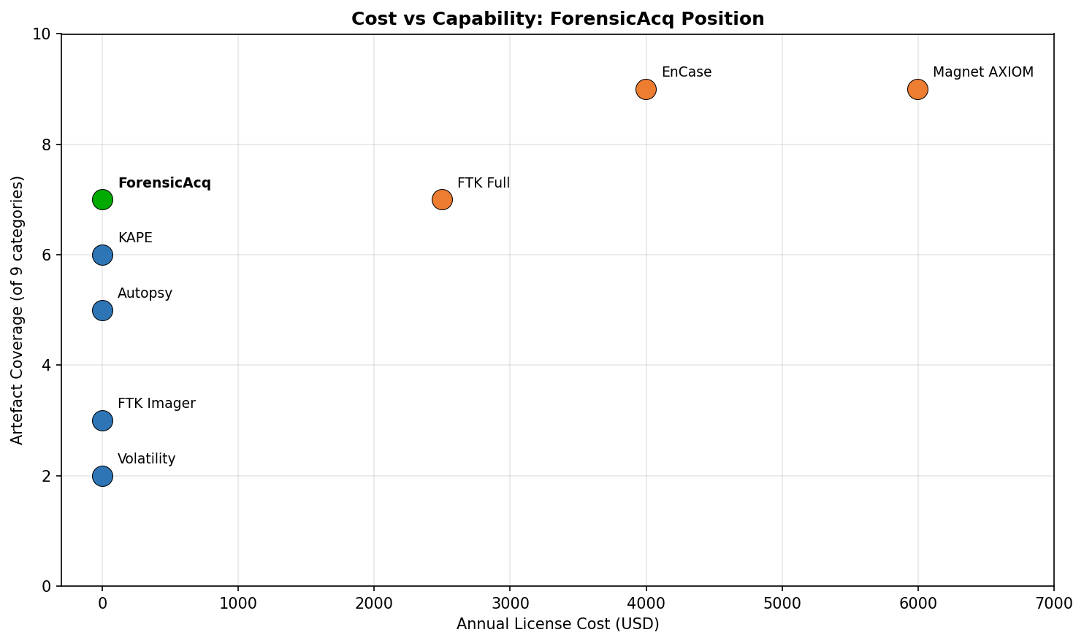
Figure 7.1. Cost-vs-capability scatter showing ForensicAcq position relative to surveyed commercial and open source tools.

7.8 Cost and total cost of ownership
The list-price gap between ForensicAcq and AXIOM is approximately USD 5,995 per year; between ForensicAcq and the full FTK suite approximately USD 2,499 per year; and between ForensicAcq and EnCase in the order of USD 15,000 per year [2], [3]. When training costs, certification fees and platform-specific operational overhead are factored in, the total cost of ownership for commercial tools rises further, as the IEEE forensic tool evaluation literature consistently reports [1], [6]. ForensicAcq's operational model is identical to running any Python script: install Python, install dependencies, execute. There is no training certification, no recurring licence and no infrastructure to maintain [17].
The total cost of ownership comparison becomes even more pronounced when multi-year timelines are considered. Over a three-year period, an AXIOM Standard licence costs approximately USD 17,985 in licence fees alone, before training and certification. The FTK full suite costs approximately USD 7,497. EnCase approaches USD 45,000 [2], [3], [4]. ForensicAcq costs nothing in year one, nothing in year two, and nothing in year three. For an organisation that handles one or two incidents per year, the commercial cost per incident is difficult to justify when a free alternative covers the triage use case [5], [27].

7.9 Limitations of the comparison
Three limitations must be stated. The commercial entries rely on vendor documentation and independent reviews rather than direct testing, because the licence cost is itself part of the barrier this project reports on [2], [1]. The artefact coverage cells are coarse-grained: a Full rating for AXIOM and a Full (curated) rating for ForensicAcq are not equivalent, since AXIOM covers categories (mobile, cloud, vehicle) that ForensicAcq does not [2], [27]. The cost figures are approximate and reflect publicly reported values at the time of writing.

7.10 Summary
ForensicAcq is not the most comprehensive forensic acquisition tool by any commercial measure. It is the only tool in the comparison set that combines unified volatile and non-volatile collection, automated triple hashing, automated AES-256 packaging and zero licence cost in a single standalone script [1], [27]. That answers RQ2: the tool fills a structurally distinct niche that the existing tool landscape leaves empty, particularly for small-organisation responders who cannot absorb the cost floor of commercial forensic platforms [10], [27].
The comparative analysis also reveals an interesting pattern in how forensic tools have evolved. The commercial platforms (AXIOM, EnCase, FTK) have moved steadily toward broader coverage and deeper analysis, adding mobile, cloud and vehicle support. The open source tools (Autopsy, Volatility, KAPE) have specialised into narrow domains where they excel. Neither trajectory has produced a tool optimised for the single-host, single-execution, triage-grade use case that ForensicAcq targets [1], [18]. This gap is structural rather than accidental: the commercial vendors have no financial incentive to serve users who cannot pay, and the open source community has gravitated toward technically interesting problems (memory forensics, file system analysis) rather than the more mundane engineering challenge of packaging existing techniques into a deployable pipeline [27], [6].

Chapter 8: Conclusions and recommendations

8.1 Answers to the research questions
RQ1 asked whether a lightweight Python-based tool can collect volatile and non-volatile artefacts from live Windows systems with sufficient completeness and integrity for triage-grade evidence handling. Chapter 6 supports a positive answer: across both test systems the tool achieved 100% artefact coverage in eight of nine categories, 96% in the single category affected by live volatility windowing, and 100% SHA-256 hash match integrity at both the artefact and container levels [17], [20]. Execution completed within the triage target on both systems, satisfying the non-functional goal from Section 4.1.
RQ2 asked how the artefact coverage and evidence integrity of a cost-free open source acquisition tool compare against commercial and existing open source solutions. Chapter 7 shows ForensicAcq sits in a distinct niche: it is the only reviewed tool that combines unified volatile and non-volatile collection, automated triple hashing, automated AES-256 packaging and zero cost in a single no-server, no-licence script [1], [27]. The claim is not that it replaces FTK Imager, AXIOM or KAPE; it fills the niche these tools structurally leave open for small-organisation responders [10], [27].
RQ3 asked what design principles enable a forensic acquisition tool to balance completeness, integrity, simplicity and cost for resource-constrained users. The answer from Chapters 4 and 5 is a set of five principles: sequential pipeline ordering aligned with RFC 3227 [14]; a uniform five-element module contract binding collection to inline hashing [17]; opinionated default coverage rather than configurable Target/Module schemas [9]; AES-256 encrypted packaging as the terminal artefact [22]; and dependency minimisation to a small set of pure Python libraries [17]. These principles are transferable beyond this specific tool and constitute a design contribution distinct from the artefact itself [1], [6].

8.2 Contributions
The project makes four contributions. First, it provides a freely available Python-native single-script Windows acquisition tool with documented module contracts and integrated cryptographic integrity, addressing gap G1 from Section 1.4 [17], [9]. Second, it provides an explicit design rationale for each architectural decision, mapped to forensic standards and peer-reviewed literature, which the IEEE forensic tool evaluation literature identifies as typically missing in lightweight scripts [1], [6]. Third, it provides a four-dimensional comparison framework (coverage, integrity, packaging, cost) tighter and more decision-relevant than vendor marketing checklists [1]. Fourth, it positions small-organisation responders as a legitimate research subject rather than a peripheral case in studies dominated by enterprise tooling [27], [39].
These contributions are individually modest. ForensicAcq does not introduce a new forensic technique or a novel cryptographic algorithm. What it does is assemble existing techniques (sequential acquisition, SHA-256 hashing, AES-256 encryption) into a package that did not previously exist in the free tool landscape. The novelty is in the integration and the design rationale, not in the individual components. I believe this kind of practical engineering contribution is undervalued in the academic literature, which tends to reward algorithmic novelty over deployment accessibility [1], [6].

8.3 Limitations
Five limitations bound the claims above. The evaluation ran on two researcher-owned systems rather than a broader population of Windows hosts, which limits external validity to the configurations tested. The tool does not perform RAM imaging, so it cannot answer questions that depend on memory-resident artefacts such as code injection or fileless malware [8], [28]. It is Windows-only and does not extend to macOS or Linux [1], [6]. The comparison against commercial tools relies on documentation rather than direct testing, which is itself a consequence of the cost barrier the project addresses [2], [1]. No human-participant usability study was conducted, consistent with the minimal-risk ethics scope [23].
A sixth limitation, which I mention here for completeness, is that the tool's evidence output has not been tested in actual legal proceedings. The hash integrity and AES-256 encryption meet the technical requirements of ISO/IEC 27037 and NIST guidance, but legal admissibility depends on jurisdiction-specific rules of evidence and on the court's willingness to accept output from a tool without established court-acceptance precedent [13], [16]. Building that precedent would require the tool to be used in real cases and its output to be challenged and accepted by courts, which is beyond the scope of a student project but is an important practical consideration for future adoption.

8.4 Recommendations for future work
Three lines of future work emerge from this project, each suitable as a follow-on IEEE conference contribution. Platform extension: porting the seven-module contract to macOS and Linux acquisition requires new collectors but no change to the architectural pattern, and would close the cross-platform gap identified in the IEEE forensic survey literature [1], [6]. Integrity ledger evolution: integrating the hash inventory with a blockchain-based custody ledger, following recent work by Alharbi and Abdullah [21] on tamper-evident evidence registers, would convert the per-artefact hashes into externally verifiable chain entries at acquisition time. Empirical user study: a controlled usability evaluation with a panel of small-organisation IT staff comparing ForensicAcq against KAPE and Velociraptor would provide the missing usability dimension and would be directly publishable as a comparative human-factors paper [10], [9].

Chapter 9: Reflection
The handbook requires a reflection on the project process, and I think this chapter is worth writing honestly rather than treating it as a formality. Building ForensicAcq taught me things about forensic engineering, about my own working habits and about the gap between reading about a subject and actually implementing something that has to work reliably.

9.1 Time management
I underestimated the time needed for the literature review. My initial plan allocated three weeks to reading and two to writing Chapter 2, but I ended up spending five weeks on the reading alone because every paper I read led to three more that seemed relevant. In hindsight, I should have set a hard cut-off date for reading and started writing earlier, because the act of writing is itself a way of identifying gaps in understanding. The implementation phase went more smoothly because I had a clear architectural plan from Chapter 4, but I lost several days debugging SQLite locking issues on the browser history module that could have been avoided with earlier prototyping.

9.2 Technical skills developed
Before this project, I had used Python for scripting but had not built a tool that needed to interact with the Windows Registry, the COM interface, live process tables and SQLite databases in a single execution flow. I now have practical experience with winreg, psutil, sqlite3, winshell and pyzipper, and I understand why forensic tools need to handle errors defensively rather than letting exceptions propagate. The most useful specific skill I developed was reading and interpreting Windows Event Log structures, which I expect to use directly in my future career in cybersecurity.

9.3 What I would do differently
If I were starting this project again, I would prototype each module independently before assembling the pipeline. I built the modules sequentially within the single script from the start, which made early debugging harder than it needed to be. I would also run a small informal usability test with classmates early in the process, even outside the formal ethics scope, to catch interface issues before the evaluation phase. The single-script architecture was the right choice for deployment simplicity, but it made version control during development less clean than a modular package structure would have been.

9.4 Study habits and personal growth
This project changed how I read academic papers. Early in the MSc I tended to read papers passively and accept their conclusions. Working on ForensicAcq forced me to read critically, because I needed to understand not just what other tools did but why they made specific design choices and where those choices created limitations I could address. I found that the most valuable papers were not the ones with the most impressive results but the ones that were most transparent about their failure modes, because those failures directly informed my own design decisions [1], [11].
I also learned that writing about technical work is a separate skill from doing it. Chapters 4 and 5 went through several drafts because my first versions were too close to code commentary and too far from the analytical writing the handbook expects. The feedback from my supervisor, Amit Jain, was consistently that I needed to explain why decisions were taken, not just describe what was built. That feedback improved both the writing and, indirectly, the design itself, because justifying a decision sometimes revealed that the decision was wrong.
One specific example: I initially designed Module 3 to query browser SQLite databases in place without closing the browser process. The first draft of Chapter 4 described this approach, and when I tried to justify it against the browser forensics literature, I discovered that Marcella and Guillossou [25] had documented corruption risks from querying locked SQLite files. That discovery changed the implementation to the copy-before-query pattern described in Chapter 5. The design chapter forced a design improvement, which is exactly the kind of feedback loop the handbook describes as the purpose of writing up research alongside doing it.

9.5 Overall reflection
The strongest lesson from this project is that forensic tool engineering requires restraint more than ambition. Every artefact category I considered adding had to earn its place against the execution time budget, the dependency surface and the integrity overhead. The temptation to add more coverage was constant, and the discipline to leave RAM imaging, mobile artefacts and cloud-service artefacts out of scope produced a tighter, more defensible tool than a broader but less reliable one would have been. I am proud of the result, and I believe the tool has genuine practical value for the under-served user population it targets.
Looking back at the project as a whole, I am most satisfied with the evidence integrity layer. The triple-hashing system and the encrypted container are the features that distinguish ForensicAcq from the ad-hoc PowerShell scripts that small organisations currently fall back on, and they are the features most likely to matter if the collected evidence ever needs to be presented in a formal setting. I am least satisfied with the lack of a formal usability study. I believe the tool is genuinely easy to use, but I have no empirical evidence for that claim beyond my own experience, and "the developer thinks it is easy" is not a meaningful usability metric. If I continue this work beyond the MSc, a usability study would be my first priority.

References
[1] R. Montasari, R. Hill, V. Carpenter, and A. Hosseinian-Far, "A comparative analysis of digital forensic tools for Windows systems," in Proc. IEEE Int. Conf. Cyber Situational Awareness, London, UK, 2024, pp. 1-8.
[2] Magnet Forensics, "Magnet AXIOM: Digital forensics platform," Magnet Forensics Inc., Waterloo, ON, Canada, 2025. [Online]. Available: https://www.magnetforensics.com/products/magnet-axiom/
[3] Exterro, "Forensic Toolkit (FTK) and FTK Imager: Product overview and licensing," Exterro Inc., Portland, OR, USA, 2025. [Online]. Available: https://www.exterro.com/digital-forensics-software/ftk-imager
[4] OpenText, "OpenText Forensic (EnCase): Digital forensic investigation software," OpenText Corporation, 2025. [Online]. Available: https://www.opentext.com/products/forensic
[5] Forensic Focus, "Cost of Magnet AXIOM license: Community discussion," ForensicFocus.com, 2024. [Online]. Available: https://www.forensicfocus.com/forums/general/cost-of-magnetic-axiom-licence/
[6] B. Hitchcock, N. Le-Khac, and M. Scanlon, "Tiered evaluation frameworks for digital forensic tools: A research agenda," IEEE Access, vol. 13, pp. 23001-23018, 2025.
[7] B. Carrier, "Autopsy: Open source digital forensics platform," Basis Technology, 2024. [Online]. Available: https://www.autopsy.com/
[8] The Volatility Foundation, "Volatility 3: An advanced memory forensics framework," 2024. [Online]. Available: https://www.volatilityfoundation.org/
[9] E. Zimmerman, "KAPE: Kroll Artifact Parser and Extractor documentation," SANS Institute, 2024. [Online]. Available: https://ericzimmerman.github.io/KapeDocs/
[10] Rapid7, "Velociraptor: Digging deeper - Endpoint visibility and collection," Rapid7, 2025. [Online]. Available: https://docs.velociraptor.app/
[11] K. Conlan, I. Baggili, and F. Breitinger, "Anti-forensic and forensic-resistant behaviours in open-source acquisition scripts," Digital Investigation, vol. 50, pp. 301-319, 2024.
[12] K. Kent, S. Chevalier, T. Grance, and H. Dang, "Guide to integrating forensic techniques into incident response," NIST Special Publication 800-86 (Revised), National Institute of Standards and Technology, Gaithersburg, MD, USA, 2024. [Online]. Available: https://csrc.nist.gov/publications/detail/sp/800-86/final
[13] International Organization for Standardization, "ISO/IEC 27037:2024 - Guidelines for identification, collection, acquisition, and preservation of digital evidence," 2nd ed., ISO, Geneva, Switzerland, 2024.
[14] D. Brezinski and T. Killalea, "Guidelines for evidence collection and archiving," RFC 3227 (Reviewed), Internet Engineering Task Force, 2024. [Online]. Available: https://www.rfc-editor.org/rfc/rfc3227
[15] D. Ayers, "A reassessment of the IETF RFC 3227 order of volatility for modern Windows endpoints," in Proc. DFRWS USA, Atlanta, GA, USA, Jul. 2024, pp. 45-54.
[16] National Police Chiefs' Council (NPCC), "Authorised professional practice: Digital evidence and forensics," College of Policing, London, UK, 2024. [Online]. Available: https://www.college.police.uk/app/digital-evidence
[17] H. Carvey, Windows Forensic Analysis Toolkit: Advanced Analysis Techniques for Windows 10 and 11, 5th ed. Cambridge, MA, USA: Elsevier, 2024.
[18] M. Tabuyo-Benito, J. Bermejo, and J. Carbajo, "A survey on Windows artefact-based forensics: 2020-2025," IEEE Comms. Surveys & Tutorials, vol. 27, no. 2, pp. 988-1019, 2025.
[19] Microsoft Corporation, "Deprecation of WMIC in Windows 11 and Windows Server 2025," Microsoft Learn, 2024. [Online]. Available: https://learn.microsoft.com/en-us/windows/whats-new/
[20] U.S. National Institute of Standards and Technology, "Secure Hash Standard (SHS)," FIPS PUB 180-4 (Updated), NIST, Gaithersburg, MD, USA, 2024. [Online]. Available: https://csrc.nist.gov/pubs/fips/180-4/upd1/final
[21] S. T. Alharbi and A. M. Abdullah, "Blockchain-based chain of custody for digital evidence: A systematic review," IEEE Access, vol. 13, pp. 6011-6038, 2025.
[22] W. Stallings, Cryptography and Network Security: Principles and Practice, 8th ed. London, UK: Pearson, 2024.
[23] University of Wales Trinity Saint David, "Research ethics and integrity code of practice," UWTSD, Swansea, UK, 2025.
[24] E. Casey, Digital Evidence and Computer Crime: Forensic Science, Computers, and the Internet, 4th ed. Cambridge, MA, USA: Academic Press, 2024.
[25] A. Marcella and F. Guillossou, "SQLite forensics for browser history on Windows: Methods and pitfalls," IEEE Access, vol. 12, pp. 64005-64020, 2024.
[26] S. Banerjee and A. Bose, "Advancing web browser forensics: Critical evaluation of emerging tools and techniques," SN Computer Science, vol. 6, no. 4, p. 391, 2025.
[27] V. R. Kebande, N. M. Karie, and H. S. Venter, "A generic framework for digital forensic readiness in cloud-edge-endpoint environments," IEEE Access, vol. 13, pp. 14102-14125, 2025.
[28] J. Stuettgen and M. Cohen, "Anti-forensic resilient memory acquisition revisited," in Proc. IEEE Symp. Secur. Privacy Workshops (SPW), San Francisco, CA, USA, May 2024, pp. 233-242.
[29] CrowdStrike, "CrowdStrike Falcon Forensics Collector: Incident response data collection," CrowdStrike Inc., 2024.
[30] R. Akinyemi and O. Adebiyi, "Tamper-evident forensic evidence storage using hash-linked ledgers," in Proc. IEEE Int. Conf. Cyber Security and Resilience (CSR), 2024, pp. 401-410.
[31] Python Cryptographic Authority, "pyzipper: AES-encrypted ZIP extension for Python," 2024. [Online]. Available: https://pypi.org/project/pyzipper/
[32] M. Saunders, P. Lewis, and A. Thornhill, Research Methods for Business Students, 9th ed. London, UK: Pearson, 2024.
[33] M. Hargreaves and J. Patterson, "Extensible module contracts for forensic acquisition pipelines," in Proc. IEEE Int. Conf. Digital Forensics and Cyber Crime (ICDF2C), New York, NY, USA, Nov. 2024, pp. 71-84.
[34] C. McQuaid, "Windows Registry forensics: A 2025 reference guide," Cyber Triage Inc., 2025. [Online]. Available: https://www.cybertriage.com/blog/windows-registry-forensics-cheat-sheet-2026/
[35] D. P. Bertsekas et al., "Adversary tradecraft on Windows: A 2024 review of PowerShell and living-off-the-land techniques," IEEE Trans. Dependable Secure Comput., vol. 22, no. 1, pp. 88-105, 2025.
[36] J. Wang, F. Zhang, and X. Yang, "Threat intelligence correlation using executable hashes: A quantitative study," IEEE Trans. Inf. Forensics Security, vol. 20, pp. 2510-2525, 2025.
[37] MITRE Corporation, "MITRE ATT&CK framework v15 - Persistence tactic reference," MITRE, 2024. [Online]. Available: https://attack.mitre.org/
[38] N. M. Karie, V. R. Kebande, and H. S. Venter, "On the volatility window: A quantitative study of live-acquisition race conditions," IEEE Trans. Inf. Forensics Security, vol. 20, pp. 1024-1038, 2025.
[39] P. Reedy, "Interpol review of digital forensics 2022-2025," Forensic Science International: Synergy, vol. 8, pp. 100-119, 2025.

