Discuss the implications of the factors of frequency and wavelength in:

Internal sound management
The main factors that we would need to take into consideration are that different wavelengths and frequencies have different rates of absorption and transmission. Lower frequency rates transmit sound well but have a poor absorption, whereas higher frequency is great at absorbing sound but poorly transmits it.
To eliminate echoes ceiling heights and suspended ceiling reflectors can be installed. It can also be used to eliminate sound transfer within the selected building.
There are numerous different types of reflectors. Concave reflectors focus on sound quality where convex reflectors concentrate on spreading the sound. Pane reflectors are adjustable and are most used in open spaces like theatres to reflect sound towards the audience. For this to be carried out correctly the sound must not be delayed and will need to be reflected evenly throughout the audience.
Acoustic quality is crucial for sound absorption. Sound absorption is the loss of sound energy when sound waves meets an absorbent material such as ceilings, walls, floors, and other objects, as a result the sound will not be reflected back into the space. At a point of the room the effect of absorption is used by measuring the sound pressure caused by a steady sound power source. As the number of reflections arrive at the given point of the room the sound level will stabilise. The rate compensated by the rate of energy is absorbed by the surfaces in the room.
Sound absorption have 3 main types of absorbers. Cavity absorbers are used for specific frequencies and are enclosed air with one small opening where the small opening would be used as an absorber when the opening is made to vibrate, and the air drag would remove the sound wave energy. Secondly, the panel absorber is used for lower rates of frequency of around 40Hz to 400Hz. They are constructed as continual sheets with an air gap/space in behind. The panel will absorb sound energy by creating mechanical vibrations within the panel and the sheets will then lose energy due to friction. The final method of absorption is porous absorbers, these are most effective over 1khz and are made from material with cellular network within pores. The pores can transfer sound energy into head.

Section 2
Partition Wall construction technique
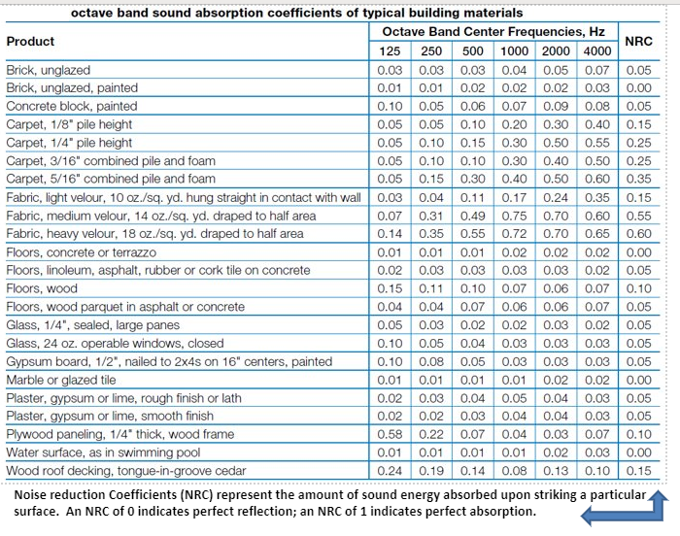
Image taken from (Classnotes, 2021) Last accessed 20.04.21
The table above is used to calculate abilities of sound absorption of materials. Showing that the more dense and heavier materials such as bricks would have a higher reflective power. However, they would not absorb sound well. Soft and porous materials are better sound absorbers but on the other hand they aren’t the greatest at reflecting sound.
As a sound wave travels through the surface of a material some energy is absorbed, and some is reflected away and the remainder is stored as energy within the material.
Partition wall construction techniques are amended to suit the lower frequencies as they don’t absorb the energy as well.

Section 3 The Insulation material choice.
Air flow within a building isn’t straight forward due to being time dependent and multi-directional. The understanding of the way air flow works through and within buildings amusing that wind forces and its thermal effects associated with mechanical cooling, heating, and other ventilation systems. These are key factors relating to air pressure within building performance. In Wales airtightness testing has been mandatory for most new buildings since 2006.they have to demonstrate that the air tightness targets used in the calculations as part L of building regulations comply and have been achieved.

