Mobile enabled website utilizing REST services (JSON)
Web and mobile technoligies
WON17834179 (Michelle Wong) 27/05/2021
2021
Contents
Introduction 2
Running Demo 2
Components 5
Cat Image 5
Cat List 6
Famous Cats 7
Annotated Code 10
Conclusion 13
Bibliography 14

Introduction
The interest that I have chosen for the website is my interest in cats and all the cat breeds that there is. I have found multiple cat API’s and have implemented them to my mobile application and have added in my own API to it that goes with my interest onto the mobile application.

Running Demo
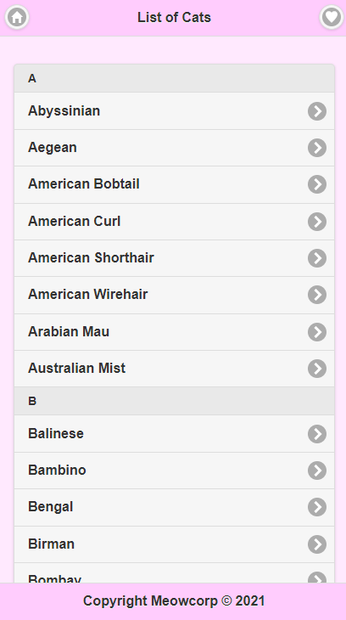
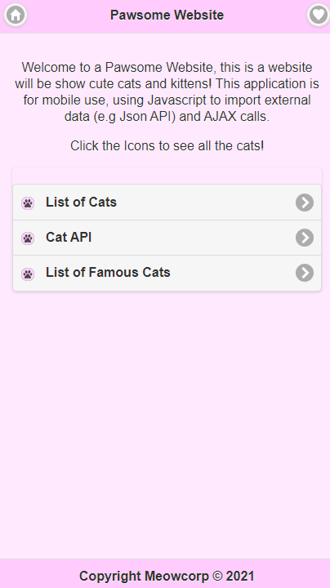

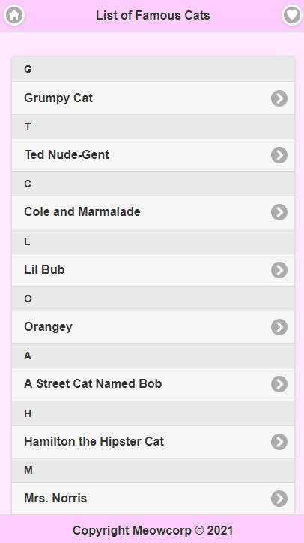
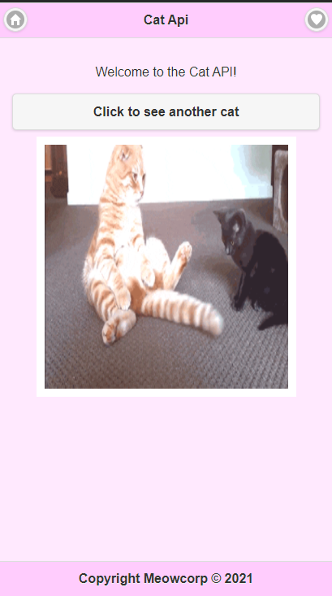

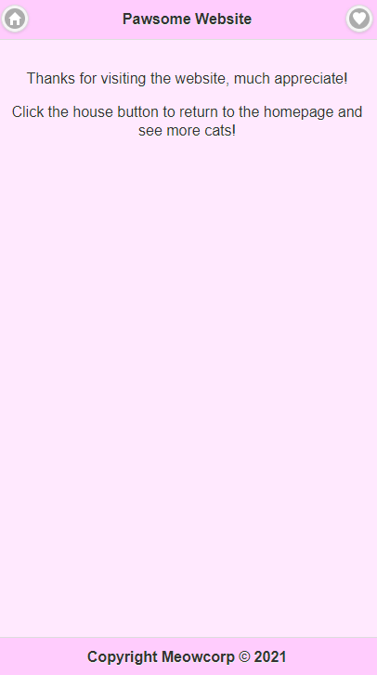
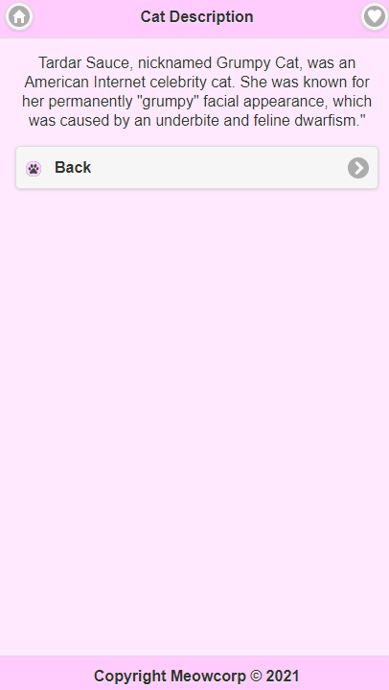

Components

Cat Image
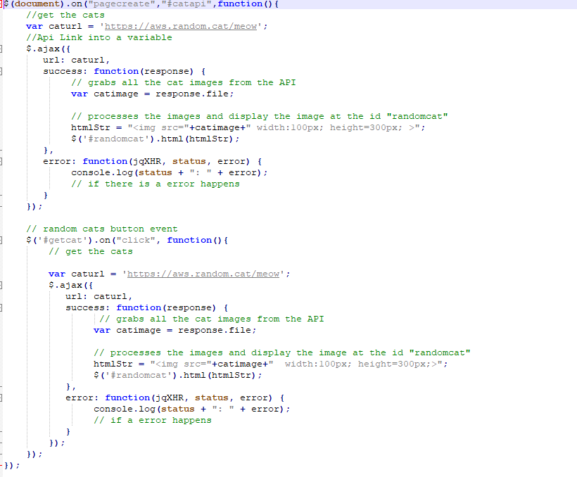
This component is the random cat picture. The first part of the component is basically getting the cat pictures API and checking the URL that is in the screenshot that is under the code, it shows that the response I get back from the website would be a file so the response to that would be doing response.file which then allows me to get all the images that is in the API then after that I would want to process the images and display the image which includes the width of height that I want them to be on the application.
After that, the next code is for the button to get the next image from the API, the first code would be whenever it is clicked it should have the function of getting the cat pictures from the URL that is screenshotted below and show that image the way I want it to be, it has the same code as the first but the difference with this one would be the button event. At the end of each of the codes would be the error message if anything wrong happens.
The reasons of doing this way to tackle this would be that when a page is created, the function of the code would be that the variable would be the cat API, and then getting it to respond, then code it so it will show up the image on the webpage, if there is an error then there would be an error function. The same goes with the button event as if the button is pressed it would show the next cat in the API.

Cat List
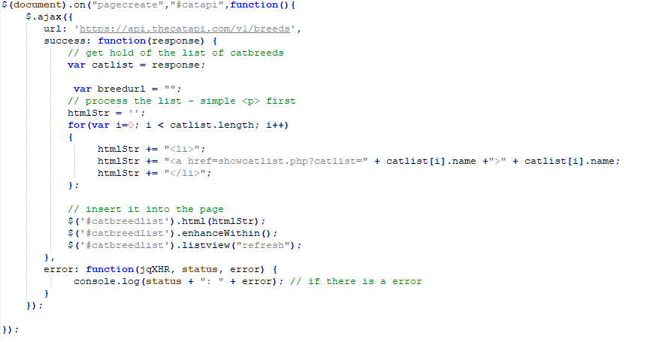
This component Is the cat list, this code is like the other components code, as it works with what I want it to do which is showing a list of cat breeds whenever going to the cat API page, it will display a list of the cat breeds that is stored in the cat API. When the page cat API is displayed/created it will look at the URL that I have added, which is the cat breeds then it will get the hold of the list from the API, then after that it will process list in the format that I have put in, that will display it as a list of the cat breeds in it. After that, would be the part of the code that will insert the information on the page.
The reasons why I decided to choose this way to tackle this, would be that I am like the previous components that allows me to know that it is able to function as well. The code also allowed me to make displaying the information easy as I can somewhat design part of the table in this script and then display it on the page.

Famous Cats
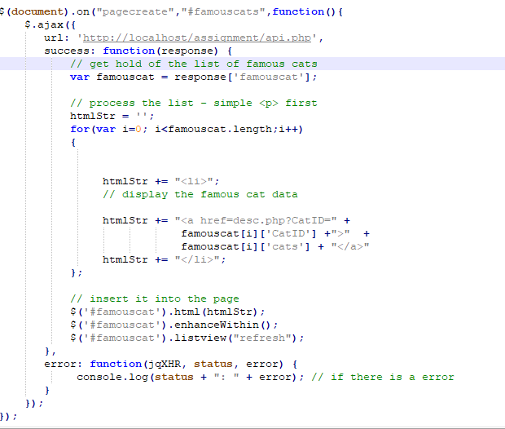
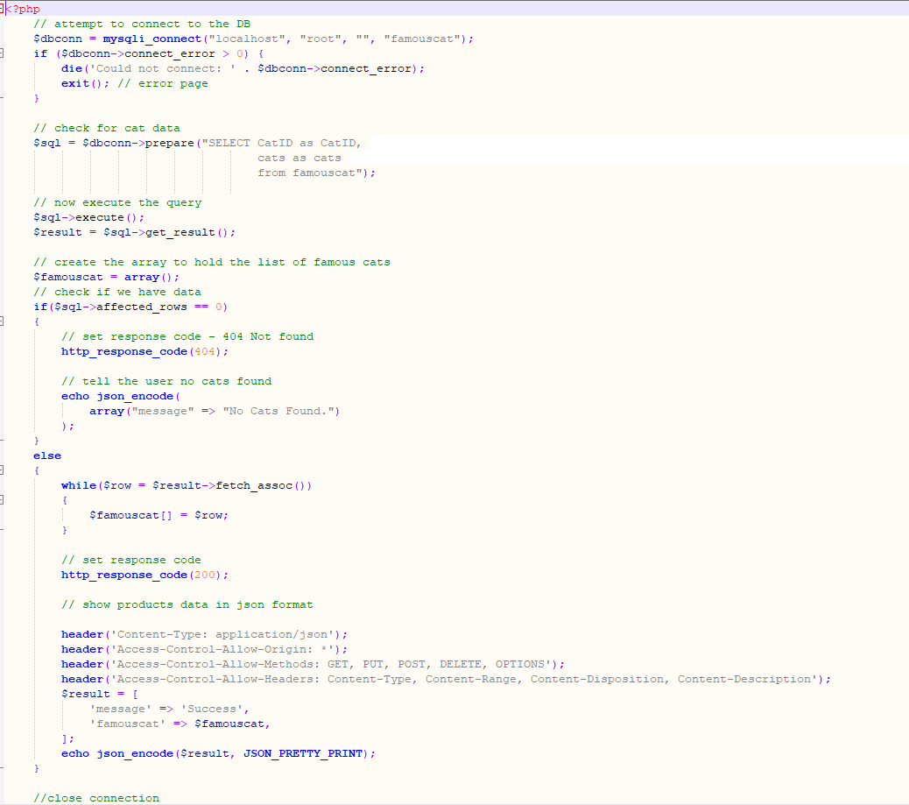
This component is the famous cat list, I recycled the other components to make this to work but this is my own API as it is grabbing information from a database instead. It will get the data from the database that I have made in MySQL and that in the first screenshot it is how it will be displayed on the webpage and that I have chosen to do a list again to show the famous cats. The 2nd screenshot is getting the data from the database and showing the data in a Json format.
I chose this way to do display the list of famous cats as I have used it previously and that I know it is a code that I can change it the way I want it to, for it to work and that it gets the work done by getting the information from the database and displaying it. They both work the way I want it to and that there are no problems with it at all.

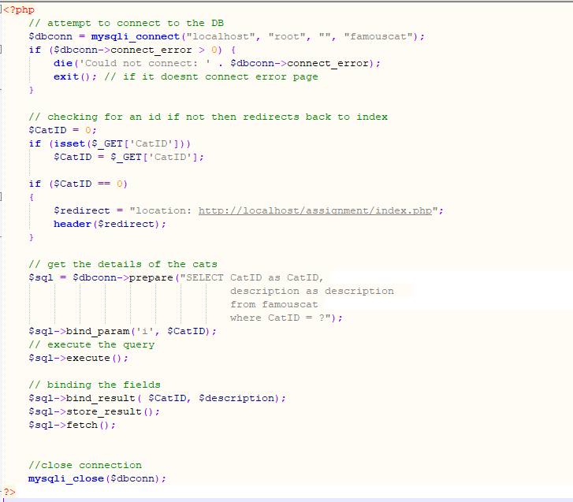
This is the component for getting the description of the cat from the database, this is completely php. It gets the id for the famous cats in the database and then it would go and find the description. This will work like basically whenever a certain ID is clicked on the famous cat list it will get the description of the cat that it is connected to and display the famous cat’s description along with it on the next page.
I chose this way to tackle this as I am more familiar with this tactic with getting information from a database and displaying it on the page, I also chose this as it has done what I wanted to do by getting the ID and the description and displaying the right description with the right cat.

Annotated Code
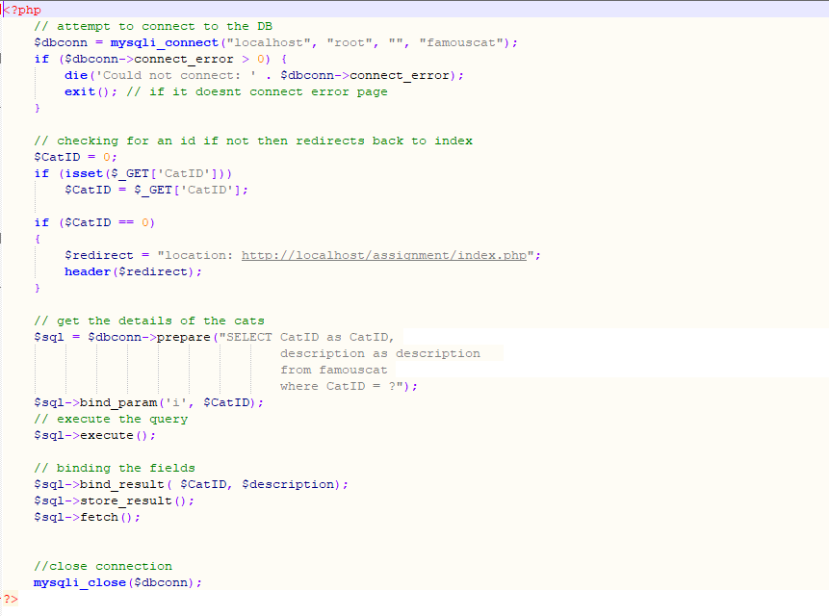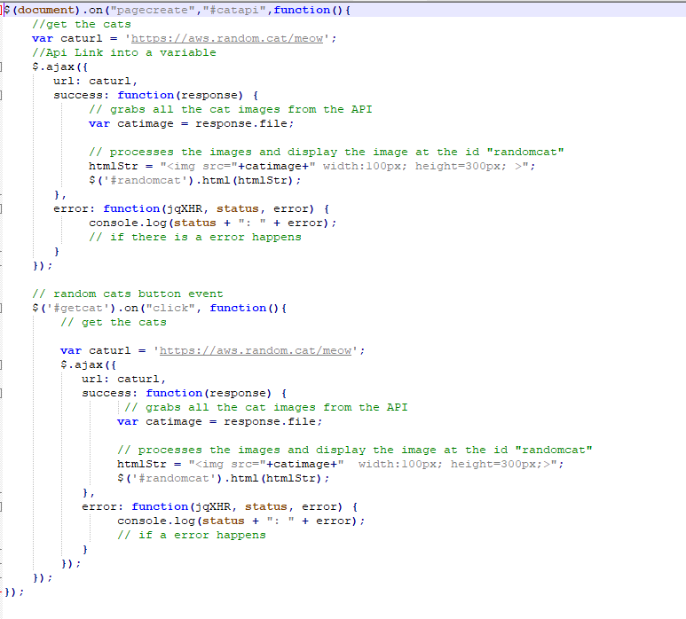
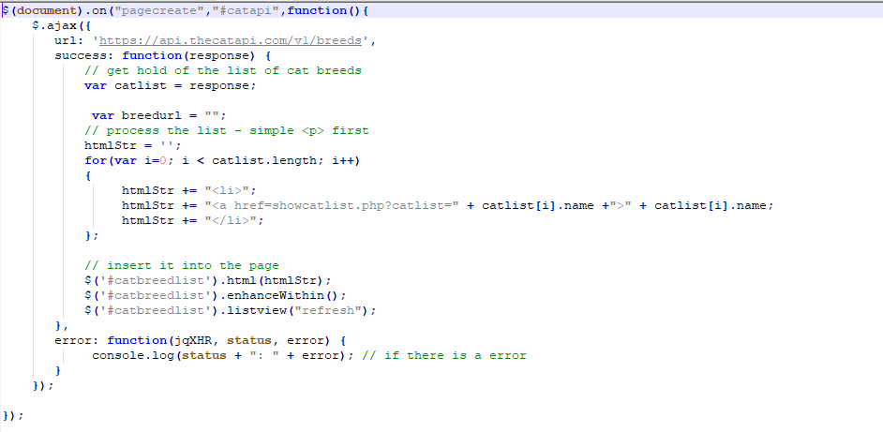
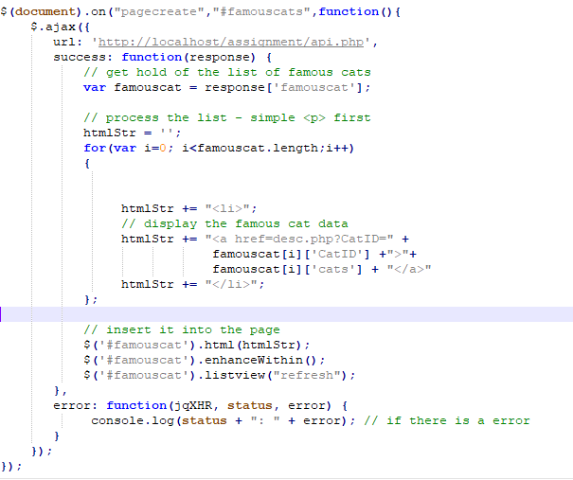
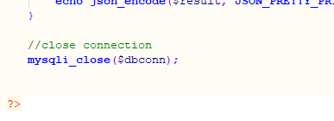

Conclusion
In conclusion, I have made all the components work the way I want it to work, I have two pages that are connected to a third-party API which is cats and, I have added in my own API to the website by making a database and then displaying the information that connects to what I am clicking on. I am very happy that every component works the way I want it to work and that I found this somewhat challenging and some of the problems made me think throughout this. If I would get the chance to do this application again would be adding and learning more about implementing more of the third-party API.

Bibliography

[1] | “Cat API,” [Online]. Available: https://docs.thecatapi.com/.
[2] | “CatAPI,” [Online]. Available: http:\/\/aws.random.cat\/meow.

