

Assessment 1 – Reading Task Template
PART 1: Upload your photo of your A3 in-class notes here:
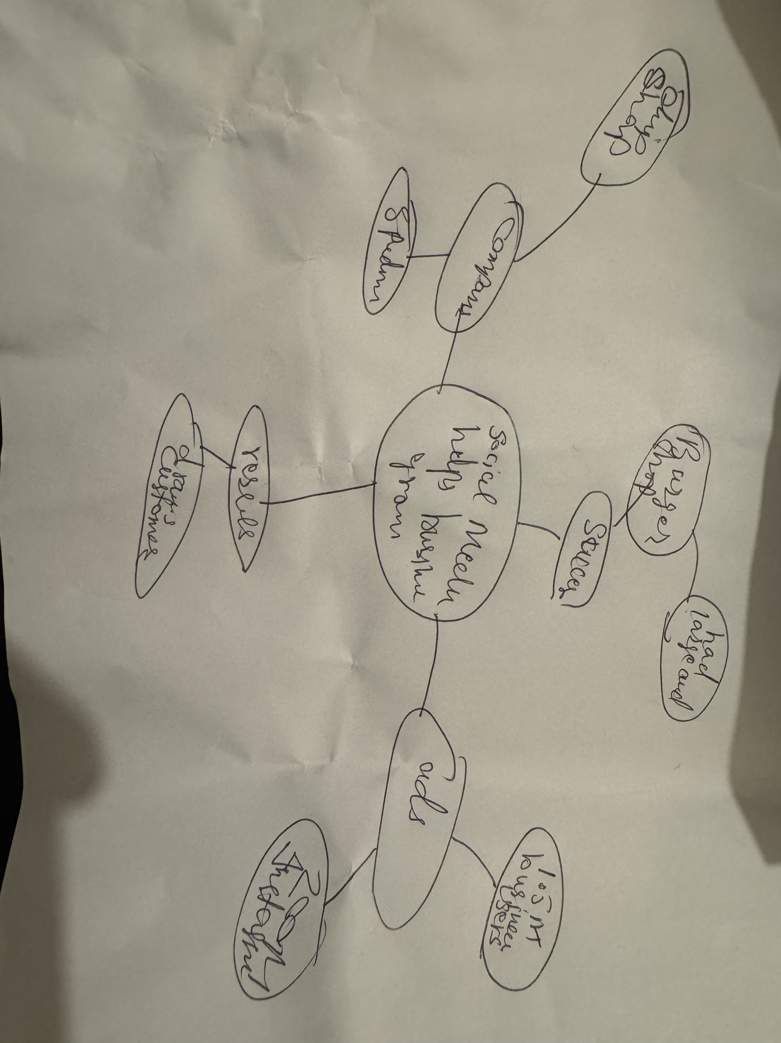

PART 2:
- Answer every question below in 1-3 full sentences.
- Use your own words. Do not use generative AI to answer these questions.
- Include a specific detail from the text when asked.
REMINDER
- The main idea is the overall message of the whole text.
- A key point helps to explain the main idea.
- A specific detail or example from the text shows that the key point is true.

- What is the main idea of the whole text?
Main idea is about the necessity of social media.

- What is one key point that supports the main idea, and which specific example from the text shows this?
Key point is topic effects our daily lives as it show examples of multiple businesses

- What is a different key point that supports the main idea, and which specific example from the text shows this?
The different idea the alternative opinions and perspectives about the topic.

Which part of the text do you think is most important, and why? conclusion
It summarizes the the whole argument and helps the reader to understand.

Reflection:
- What did you find difficult in this task (including in-class components), and why was it difficult?
Nothing

What helped you with this difficulty, and how did it help you?

