DAPAAH TWENEBOAH (1916217)
Supervisor: Gladius David Kulothungan
DISSERTATION PROPOSAL
The Impact of Customer Satisfaction and Brand Image on The Brand Loyalty Of ASDA

The Impact of Customer Satisfaction and Brand Image on The Brand Loyalty Of ASDA
1. Introduction
The tendency towards brand loyalty is especially concerning among retailers, as loyal consumers are the ones who can bring recurring income, provide positive word-of-mouth, and, thus, have higher price resistance levels (Jones, P., and Comfort, 2020). ASDA is a supermarket company based in the UK that faces competition from other giant brands, including Tesco, Sainsbury, and Morrison's, to retain users' loyalty due to changes in customer consideration and demand.
The two major aspects that provide the foundation for brand loyalty in the current retail industry are customer satisfaction and brand image. Satisfaction encompasses customers' feelings towards any aspect of their experiences, products, services, and perceived value (Urbanska, 2024). A satisfied customer will always prefer buying the same brand rather than looking for a different one (Ahmad et al., 2022). At the same time, brand image refers to the values, reputation, and identity or differentiation the customer associates with the brand, which determines the probability of the customer repurchasing the brand. All of these aspects influence customer perception and resulting behaviour pattern, which largely determines the ASDA's brand fidelity.
Hence, the current research aims to analyze the impact of customer satisfaction and brand image on brand loyalty with special reference to ASDA shoppers. This research is particularly relevant to ASDA because it looks at retaining customers in a competitive environment (Samdani, 2020). This paper will contribute quantitative evidence to help the ASDA's management understand the customers' perceptions of how the brand can deliver better services and build a positive brand image that will portray customer loyalty.
2. Aims, Objectives, and Research Questions
Aim
This study aims to quantitatively analyze the influence of customer satisfaction and brand image on brand loyalty among ASDA customers.
Objectives
- To measure customer satisfaction levels among ASDA’s customer base.
- To evaluate the perception of ASDA’s brand image among customers.
- To assess the correlation between customer satisfaction and brand loyalty.
- To determine the relationship between brand image and brand loyalty.
- To provide recommendations for ASDA's management on enhancing customer satisfaction and brand image to strengthen brand loyalty.
Research Questions
- How does customer satisfaction impact brand loyalty among ASDA customers?
- What effect does ASDA’s brand image have on brand loyalty?
- How can ASDA improve customer satisfaction and brand image to increase brand loyalty?

Hypotheses
- H1: Higher levels of customer satisfaction are positively correlated with greater brand loyalty among ASDA’s customers.
- H2: A positive brand image significantly impacts brand loyalty within ASDA's customer base.
3. Methodology
The research design of this study employs a quantitative research technique to analyze the linkages between customers' satisfaction, brand image, and brand loyalty regarding ASDA customers. Quantitative research would be suitable for this study since the variables can be measured at a distance, and the actual value of the variables can be inferred from observed behaviour. Thus, patterns and relationships are detected.
Research Design
The methodology of the planned study will be a cross-sectional survey to get data from the ASDA customers. A standardized customer survey of structured questions will be used to assess customer satisfaction, brand image, and loyalty levels (Connelly, 2016). This design permits the concurrent measurement of customer attitude and perception, offering a cross-sectional view of several such relations.
Data Collection
The study will use a questionnaire as the main tool of data collection. The questionnaire is self-completed, and the questionnaire will be distributed randomly to ASDA consumers in different outlets in the UK. The questionnaire will be divided into three sections:
  - Customer Satisfaction: The next part of this research will examine the customers’ attitude to the products sold by ASDA, their services and the quality of their prices, the outlook of shops, and the overall customers’ experience (Carpino et al., 2019). But it is equally important to point out that participants will rate their satisfaction using the Likert scale labelling the response options as strongly disagree, disagree, neutral, agree, and strongly agree.
  - Brand Image: Specifically in this section, the customers shall give their perception regarding the ASDA brand image of reputation, trust, value, and uniqueness. Questions for measuring them will also contain a Likert scale to give a measure of these perceptions.
  - Brand Loyalty: The brand loyalty part will also create a perception of customer loyalty by developing questions based on the response questions of how frequently the customers use ASDA, the propensity to recommend the company, and the customer’s purchase intention in the future (Mazhar et al., 2021). The perceived commitment level will be created by asking the respondents some Likert scale questions in order to determine their level of agreement.
The survey will be conducted online using e-mail and social media, targeting 100 respondents. The sample size will encompass a broad spectrum of ASDA's clientele, including age and shopping frequency.

Sample and Sampling Technique
In this study, a probability sampling will randomly select participants from ASDA's customer base. To make some of the customers selected more general, customers in several groups will be taken in the study to represent customers in ASDA (Rahman, 2023). It is deemed appropriate to propose a target of 100 participants for statistical analysis and to generalize the results in the present context among ASDA’s customers.
Data Analysis
The findings from the survey will be managed, assessed, and compared using statistical software to determine the relationship between customer satisfaction, brand image, and brand loyalty. Through descriptive and inferential analysis, understanding will be derived on how each variable impacts customer loyalty levels at ASDA. The following statistical tools shall be used to facilitate the accomplishment of the objectives of this study.
Descriptive Statistics
The collected data will be analysed using frequent tables, graphs, general descriptions, and analytical statistics. To complete this analysis, averages, ranging from arithmetic means to medians and modes and standard deviations, will be employed to discuss customer characteristics, satisfaction levels, brand image attitude, and levels of loyalty (Cooksey and Cooksey, 2020). Collecting these basics of demographics, attitude, and behaviour, the study can paint the picture of a normal ASDA customer and set concrete benchmarks and labels for satisfaction, brand image, and loyalty, upon which subsequent analyses will build. Frequency distributions will assist in establishing general trends or differential phenomena in customers' perception of their experiences, providing a better picture of the customer experience.

Correlation Analysis
Correlation analysis will be used to determine the extent of the relationship between customer satisfaction, brand image, and brand loyalty. This study will use correlation coefficient analysis to determine the degree and direction of the relationship between satisfaction with brand image and loyalty towards ASDA customers (Franzese and Iuliano, 2018). Regression analysis will be conducted to determine the feasibility of the cause-effect assumption and to compute the correlation coefficient to show the nature and strength of the relationships between two variables. Consequently, it is necessary to comprehend these relations, and the study must ascertain whether satisfaction and positive brand image mean raised consumer loyalty. Such a relationship means that increased satisfaction and improved brand image would lead to increased loyalty, confirming the importance of the two factors in ASDA's brand strategy.
Regression Analysis
This research will provide numeric measurement of each of the variables under study by conducting a regression analysis to determine the level of correlation between customer satisfaction, brand image, and brand loyalty. Multiple regression will be used to establish which hypothesis periods of customer satisfaction and brand image influence brand loyalty while controlling the other factors. Unlike the previous approach, this method affords the breakdown of the specific ways through which the various factors impact loyalty amid a predictive model that may aspire to quantify the contribution of satisfaction and brand image to the loyalty of customers (Shrestha, 2020). Through regression analysis, coefficients will be produced to show the degree of influence of each independent variable in favour of the dependent variable, loyalty, enabling ASDA to understand which factor has the greatest impact and, therefore, where loyalty improvement should be directed.
Analysis of Variance (ANOVA)
To compare brand loyalty levels, ANOVA will be used. Since business-to-business organisations have different levels of brand loyalty; the study will employ ANOVA to compare brand loyalty. This technique will help establish the differences in loyalty concerning satisfaction levels and brand image. Using ANOVA, the researcher can compare the mean of outsourcing loyalty between high, medium, and low satisfaction levels and brand image (Connelly, 2021). For example, this analysis might help demonstrate that consumers with high satisfaction are considerably more loyal than consumers with poor satisfaction; in other words, these results will prove that such criteria matter. The help of ANOVA lies in the fact that, based on the study results, it will be possible to confirm or refute the hypotheses set and determine to what extent satisfaction and brand image influence customer loyalty in groups of customers.
4. Literature Review
Customer Satisfaction
Perceived satisfaction is an important factor in building customer loyalty for different industries. It has emerged to mean the level of satisfaction the customer acquires from a product, which depends on factors such as quality of service, stockholding, and price. Studies have found that consumers who are happy with a product will revisit a brand, buy from it again and even lobby others to patronise(Sharma et al., 2020). In the retail industry, customer satisfaction is a key indicator of success that can include the setting of stores, the price ranges, customer services, and the quality of products on offer. These customers are loyal and always get value for their money when purchasing their products, which makes the customer base stable and the brand value.
Brand Image
Brand image encompasses the customer evaluation of the brand regarding reputation, values, quality, and differentiation. A favourable brand image creates an attitude relationship between the brand and consumer, guiding them to remain loyal. This is especially important with retail competition; the correct brand image puts passive or active consumers in its category and makes the set brand more appealing. Some loyal customer benefits include increasing trust; customers are more inclined to go for that brand than any other (Benhardy et al., 2020). To ASDA, enhancing the brand image means that consumers with a positive perception of the brand may feel a form of love towards the brand, hence a better commitment.
Brand Loyalty
On the other hand, brand commitment refers to the extent to which a customer will accord regular patronage to a particular brand. Customer commitment involves repeat purchases, brand, outside pressure, and positive word of mouth. It is also advantageous to stick with customers since they retain brand loyalty, decrease customer acquisition costs, increase the customer lifetime value, and assure an enormous revenue stream. In the retail business, where consumers have many channel options, customers' brand commitment is influenced by perceived shopping experiences, satisfaction, and trust (Bernarto et al., 2020). ASDA has always been aware of the factors that create brand loyalty for a business since it is key in creating a customer base for consistent growth.
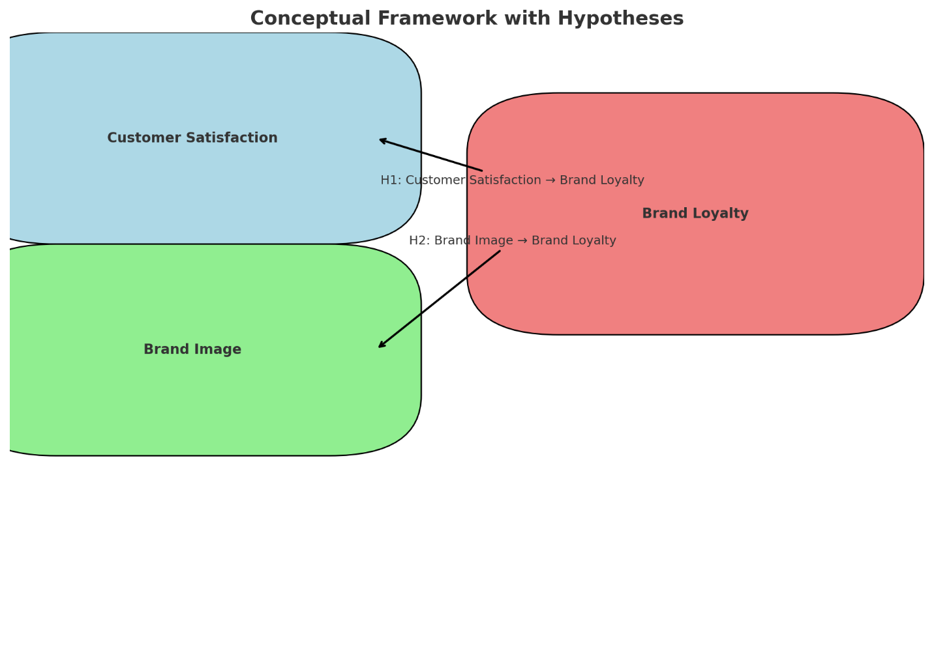
5. Limitations
- Sample Representation: Although a sample of 100 is considered adequate, it may only capture some demographic nuances of ASDA's customer base, potentially limiting the generalizability of results.
- Survey Constraints: The survey relies on self-reported data, which may introduce biases as participants may provide responses based on perceived expectations rather than actual opinions.
- Cross-sectional Design: As the study is cross-sectional, it captures customer attitudes at a single point in time, which may not reflect changes in satisfaction, brand image, or loyalty over time.
- Scope Limitation: This study focuses solely on ASDA, meaning the findings may not apply to other retail brands or sectors.
6. Ethical Considerations
Informed Consent
Before any data will be collected on the participants, informed consent will be sought so that all of them have adequate knowledge of their participation in the research project. To ensure participant comprehension, they shall first be read over the overtures of the study, and their duties and details of their data shall be explained to the participant. Regardless of the specific design chosen, this information will help them explain the aim of the research, the kind of questions they will respond to, and how that reaction will assist the study's overall conclusion. In order to maintain participants' ethical anonymity, they will have to indicate clearly and definitely whether they agree to participate in the survey.
Confidentiality and Anonymity
The identity of all the participants will be safeguarded strictly right from the time the study commences. Besides, it is important to ensure that any of the participant's details, such as name, address, or any other details that are permitted to be given as ID numbers, will be avoided during data collection or if collected, be anonymised. Therefore, participants will be assured anonymity and privacy since data will be stored in encrypted files available only to the research team. It will also ensure that the answers cannot be attributed to individual people, which wil ensure respondent trust, and more accurate information.

Voluntary Participation
The responses in the study will be formed based on the volunteers' willingness, which means no person will be compelled to participate in the research. They shall be made aware of their right to withdraw from the study at any time. This right can be exercised when data is collected from the participants so that if the participant feels uncomfortable, he or she can opt out at any time. This complies with the principles of voluntary involvement because implying that someone has to do something against his own will violates the participant's freedom of choice, and all data collected, therefore, are offered freely.
Data Protection
According to the data protection regulations, all collected data should be kept secure and only used for research (Head, 2020). As mentioned in the initial part of the study, the data will be saved on encrypted devices or cloud storage so third parties cannot access the data. After the completion of the research, data will be stored or destroyed based on data management of research findings. This approach ensures that participants' privacy is respected and that data is properly managed, preferably in a manner that adheres to the research ethics.

7. Timeframe
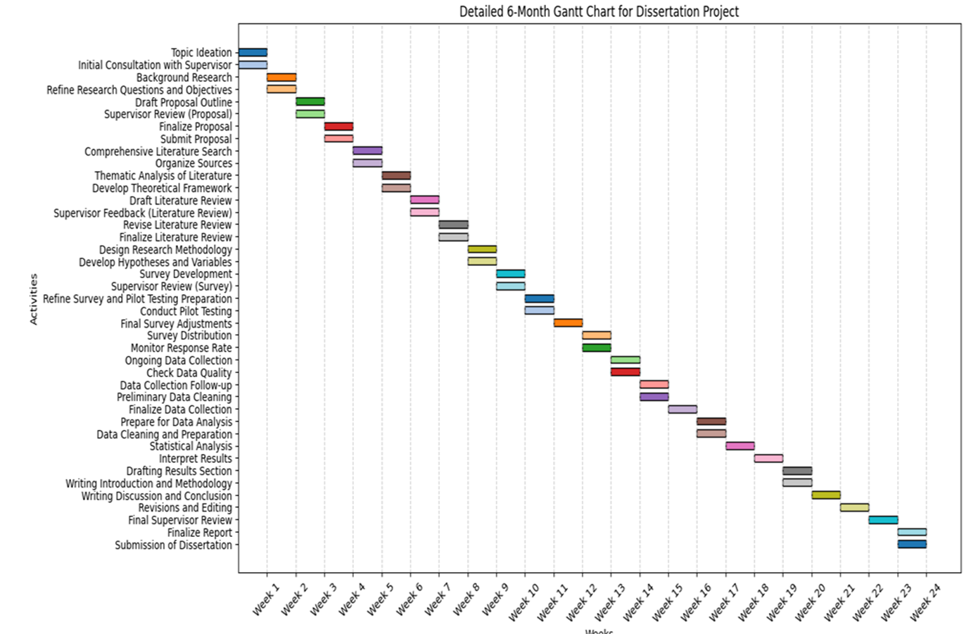

8. Conclusion
The objectives of this research include Measuring the extent of the relationship between customer satisfaction and brand loyalty in the context of ASDA customers. Understanding how these factors impact the loyalty of customers, this research will help ASDA improve the satisfaction level of the customers, promote a favourable brand image, and develop loyal customers. Loyalty in family retailing is essential in light of the increased frequency of power retailing, as is the case for ASDA. With courtesy improvement and proper brand placement, ASDA has an opportunity to influence and develop closer contact with its consumers to have them make more repeat purchases while promoting the brand. The outcome of this study would be useful for ASDA in analysing and developing effective and efficient measures to make its long-term customer loyalty agenda possible.

References
Ahmad, A. M. K., Shattal, M. H. A., Rawashdeh, L. A., Ghasawneh, J., and Nusairat, N. (2022). Corporate social responsibility and brand equity of operating telecoms: brand reputation as a mediating effect. International Journal of Sustainable Economy, 14(1), 78-97.
Benhardy, K., Hardiyansyah, H., Putranto, A., and Ronadi, M. (2020). Brand image and price perceptions impact on purchase intentions: mediating brand trust. Management Science Letters, 10(14), 3425-3432.
Bernarto, I., Berlianto, M. P., Meilani, Y. F. C. P., Masman, R. R., and Suryawan, I. N. (2020). The influence of brand awareness, brand image, and brand trust on brand loyalty. Jurnal Manajemen, 24(3), 412-426.
Carpino, C., Mora, D., and De Simone, M. (2019). On the use of questionnaires in residential buildings. A review of collected data, methodologies, and objectives. Energy and Buildings, 186, 297-318.
Connelly, L. M. (2016). Cross-sectional survey research. Medsurg Nursing, 25(5).
Connelly, L. M. (2021). Introduction to Analysis of Variance (ANOVA). Medsurg Nursing, 30(3).
Cooksey, R. W., and Cooksey, R. W. (2020). Descriptive statistics for summarising data. Illustrating statistical procedures: Finding meaning in quantitative data, 61–139.
Franzese, M., and Iuliano, A. (2018). Correlation analysis. In Encyclopedia of bioinformatics and computational biology: ABC of bioinformatics (Vol. 1, pp. 706-721). Elsevier.
Head, G. (2020). Ethics in educational research: Review boards, ethical issues, and researcher development. European Educational Research Journal, 19(1), 72–83.
Jones, P., and Comfort, D. (2020). Customer Engagement: Storytelling and the UK's Leading Retailers. In Handbook of Research on Contemporary Consumerism (pp. 57–71). IGI Global.
Mazhar, S. A., Anjum, R., Anwar, A. I., and Khan, A. A. (2021). Methods of data collection: A fundamental tool of research. Journal of Integrated Community Health (ISSN 2319-9113), 10(1), 6-10.
Rahman, M. M. (2023). Sample size determination for survey research and non-probability sampling techniques: A review and recommendations. Journal of Entrepreneurship, Business and Economics, 11(1), 42-62.
Samdani, T. (2020). Impact of Tesco's Private Label Brands on Buying Behaviour of Millennials in Terms of Brand Preference in the Irish Market (Doctoral dissertation, Dublin, National College of Ireland).
Sharma, A., Gupta, J., Gera, L., Sati, M., and Sharma, S. (2020). Relationship between customer satisfaction and loyalty. Sharma, A., Gupta, J., Gera, L., Sati, M., and Sharma, S.(2020) Relationship between Customer Satisfaction and Loyalty. Social Science Research Network.
Shrestha, N. (2020). Detecting multicollinearity in regression analysis. American Journal of Applied Mathematics and Statistics, 8(2), 39–42.
Urbanska, M. (2024). The impact of customer satisfaction and brand image on the brand loyalty of Marks and Spencer plc in London (Doctoral dissertation, University of Wales Trinity Saint David).

