THE IMPORTANCE OF EFFECTIVELY MONITORING GUEST SERVICE APPROACHES
Executive Summary
The boutique brand Hotel Indigo specializes in providing distinctive, locally inspired accommodations. The study advises embracing technology, improving sustainability, cultivating local alliances, boosting loyalty programs, managing online reputations, expanding globally with a local flair, and doing frequent property improvements in order to preserve its edge. These tactics will strengthen Hotel Indigo's standing in the hospitality industry and keep it there.

Table of Contents
Introduction 4
Background of the Industry 4
Main Findings 5
Reputation Management 5
Service Culture 5
Brand Consistency 6
Hotel Standards 6
Customer Loyalty 7
Future technological impacts 7
Service failure 8
Conclusion 8
Recommendations 8
Reference List 10

Introduction
Hotel Indigo has taken great delight in offering visitors a singular experience that expertly combines convenience, elegance, and regional authenticity. In differentiate from conventional hotels, Hotel Indigo is known for its commitment to capturing the soul of the communities it calls domestic. Hotel Indigo gives guests a genuine sense of association with their area since each resort has been fastidiously developed to reflect the social, verifiable, and tasteful qualities of its put. This outline will jump into the company's commitment to conveying extraordinary, immersive encounters, analyzing its benefit reasoning, consideration to maintainability, and the given taking after it has pulled in sightseers trying to find more than essentially a put to remain.

Background of the Industry
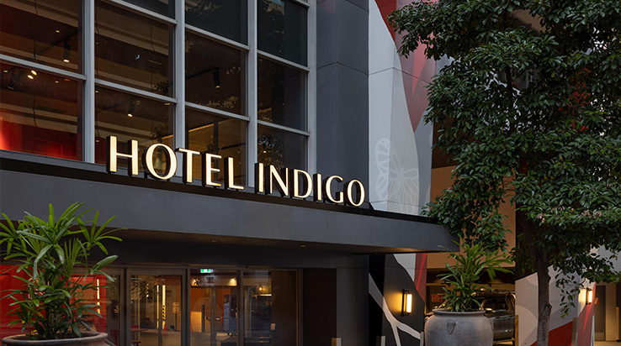
Figure: Brand Image of Hotel Indigo
(Source: Ihgplc, 2023)
Intercontinental Hotels Group (IHG) claims the boutique lodging brand Hotel Indigo, which gives voyagers looking to completely submerge themselves within the nearby culture of their area with a particular and customized involvement. Hotel Indigo was created in 2004 to fulfil the expanding requirement for special and honest-to-goodness lodging (Ord and Behr, 2023). The brand's particular quality is its devotion to utilizing its services and plans to communicate the culture and history of the neighbourhood. From the interior design to the regionally inspired food served in its restaurants, every Hotel Indigo property is carefully chosen to reflect the soul of its setting. This strategy establishes a strong bond between visitors and the towns they travel to in addition to developing a feeling of place.
The expansion of Hotel Indigo has been astounding, with locations in important cities and international cultural centres. Travellers looking for more than simply a place to stay have developed a devoted following for it because of its creative approach to hospitality. Hotel Indigo consistently aspires to redefine the boutique hotel experience, whether it is through the conversion of an old property into a boutique hotel or the addition of local character to a contemporary building (Al-Mannai., 2021). A mix of comfort, flair, and authenticity set Hotel Indigo apart in a fiercely competitive market, making it a desirable option for tourists seeking an unforgettable and engaging experience. Hotel Indigo has carved out a position for itself in the hotel industry because of its dedication to highlighting the distinctive tales of each location.

Main Findings

Reputation Management
Through a mix of individualized service, distinctive local experiences, and consistently favourable guest reviews, Hotel Indigo maintains a great reputation. On review sites, they actively interact with clients, immediately resolving issues and appreciating positive feedback. High service standards are guaranteed via programs for personnel training and quality assurance (Padma and Ahn, 2020). The brand's dedication to sustainability and involvement in the community also improves its reputation. Hotel Indigo has established a reputation for authenticity and client pleasure by concentrating on providing extraordinary experiences that capture the spirit of each place. As a result, travellers who are looking for a distinctive and unforgettable hotel experience may choose with confidence from Hotel Indigo.

Service Culture
The foundation of Hotel Indigo's service culture is a dedication to providing each guest with a unique and regionally inspired experience. Staff members are prepared to provide individualized advice and support by being attentive, amiable, and informed about the distinctive features of the location. The brand lays a priority on the comfort and happiness of its guests, making sure that each stay is both warm and memorable. The service culture at Hotel Indigo encourages a sense of neighbourhood and connection as well. To fully immerse visitors in the neighbourhood's culture, events are frequently planned or relationships with nearby companies are formed. Hotel Indigo stands out in the hospitality sector because of its commitment to providing sincere and caring service (Walker, 2021).

Brand Consistency
By fusing a distinctive design concept with a dedication to representing the local culture at each of its hotels, Hotel Indigo keeps its brand consistent. The brand modifies its interior design, decor, and services to reflect the distinctive character of each place while maintaining a consistent logo, colour scheme, and overall appearance (Juliá-Nehme et al., 2023). This guarantees that visitors get familiar with the Hotel Indigo brand while also being fully immersed in the neighbourhood. A trusted option for tourists looking for both authenticity and dependability in their hotel stays, Hotel Indigo is known for its consistency in service standards, quality, and guest experience.

Hotel Standards
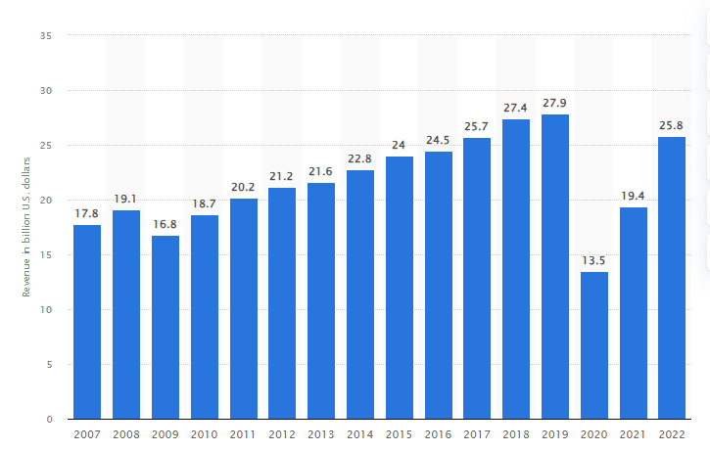
Figure: Intercontinental Hotels Group gross revenue worldwide
(Source: Statista, 2023)
In order to provide a consistent and outstanding guest experience, Hotel Indigo respects a set of strict criteria. These standards include a wide range of topics, such as design, service, and facilities. The InterContinental Hotels Group's hotel brands produced over 25.8 billion dollars in gross revenue in fiscal year 2022. The hotel brands InterContinental, Crowned Plaza, Holiday Inn, Holiday Inn Express, Stalybridge Suites, Candlewood Suites, and Hotel Indigo are all owned by the InterContinental Hotels Group. To make customers' experiences better, service requirements include individualized attention, a welcoming staff, and local knowledge (Wu and Gao, 2019). Processes for ensuring quality uphold the highest standards of comfort and cleanliness.

Customer Loyalty
Through its distinctive combination of individualized experiences, cultural immersion, and dependable quality, Hotel Indigo promotes client loyalty. The company's unusual accommodations encourage visitors to stay at each location again and discover new areas within the Hotel Indigo network. Loyalty programs, like IHG Rewards, encourage repeat visits by offering rewards like special deals, points, and exclusive advantages (Kang and Lee, 2022). Additionally, Hotel Indigo places a high value on customer input and aggressively handles issues, which helps to build trust. Hotel Indigo develops enduring relationships with its customers by regularly providing unique, culturally rich experiences. This ensures their loyalty and advocacy in the cutthroat hotel sector.

Future technological impacts
Emerging technologies are set to influence the future of Hotel Indigo. Virtual concierge services and chatbots driven by AI will provide smooth and individualized guest encounters (Lukanova and Ilieva, 2019). To improve visitor comfort and energy efficiency, smart room controls for lighting, climate, and entertainment will become commonplace. Keyless entrance and contactless check-in/out will put convenience and safety first. More individualized marketing and recommendations will be made possible by data analytics (Lee et al., 2019). Eco-conscious tendencies will be supported by sustainable technology, including waste-reduction strategies and energy-efficient devices. In general, technology will be essential for enhancing future sustainability initiatives, operational effectiveness, and guest experiences at Hotel Indigo facilities.

Service failure
Although Hotel Indigo is renowned for its excellent service, occasionally things go wrong. Examples could include poor room cleanliness, lengthy check-in or check-out procedures, or staff members who are slow to attend to the requirements of the customers. Such errors may result in unsatisfied visitors and unfavourable evaluations. However, Hotel Indigo's dedication to customer satisfaction frequently entails prompt issue resolution, providing compensation, and strengthening procedures to avoid future failures (Iqbal et al., 2021). Despite sporadic hiccups, the company works to retain a solid reputation for great service and views these service failures as chances for progress.

Conclusion
In conclusion, the experience of Hotel Indigo in the hospitality sector demonstrates a commitment to fusing the distinctive aspects of regional culture with the highest possible standards of quality and service. Hotel Indigo has improved the boutique hotel experience by creating unique stays that immerse visitors in the heart of their preferred places. Its dedication to community involvement, sustainability, and customer happiness has strengthened its position as a well-liked and trusted brand among travellers all over the world. Hotel Indigo is prepared to adjust and adopt innovations that improve the guest experience while adhering to its basic principles as technology continues to advance. Hotel Indigo is a shining example of individualized hospitality in a world where tourists are becoming more and more interested in authenticity, providing a real connection to the locations they visit.

Recommendations
Hotel Indigo should keep making investments in cutting-edge technologies to stay competitive and improve the guest experience. To simplify operations and increase visitor comfort, this includes adopting smart room controls, contactless check-in/check-out, and AI-powered concierge services. Hotel Indigo can improve its commitment to sustainability as environmental awareness rises (Partini et al., 2023). In order to achieve this, eco-friendly building and operating methods may be used. Single-use plastics may also be decreased, and energy efficiency may be promoted. Travellers who are environmentally aware may find value in open reporting on sustainability initiatives.
Partnering with local companies and craftsmen can further enhance Hotel Indigo's emphasis on local immersion. Collaborations with nearby eateries, artists, and cultural organizations may provide visitors with experiences that are even more genuine and memorable (Castellani et al., 2020). It is essential to uphold the high standards of service set by the brand. Regular staff training programs may guarantee that all staff members are educated about the brand's distinctive products and are competent to continuously provide individualized service. Hotel Indigo may improve its loyalty program by providing exclusive discounts, customized packages, and one-of-a-kind experiences that cater to the needs of its loyal patrons.
It is critical to maintain a careful check on customer evaluations and comments posted online (Chen et al., 2020). Service lapses may be minimized and a strong online image can be maintained through prompt replies to unfavourable reviews and aggressive visitor involvement. Hotel Indigo should make sure that each new site embraces the distinctive qualities of the host city or neighbourhood while staying faithful to the core values of the brand.

Reference List
Al-Mannai, S.E., 2021. Reviving the Concept of Caravanserai: A Critical Study for the Adaptive Design of an Indigenous Boutique Hotel in the North District of Qatar (Doctoral dissertation, Hamad Bin Khalifa University (Qatar)).
Castellani, P., Bonfanti, A., Canestrino, R. and Magliocca, P., 2020. Dimensions and triggers of memorable tourism experiences: evidence from Italian social enterprises. The TQM Journal, 32(6), pp.1115-1138.
Chen, W.K., Riantama, D. and Chen, L.S., 2020. Using a text mining approach to hear voices of customers from social media toward the fast-food restaurant industry. Sustainability, 13(1), p.268.
Ihgplc, 2023. Hotel Indigo - our brands - InterContinental Hotels Group PLC. Available at: https://www.ihgplc.com/en/our-brands/hotel-indigo.
Iqbal, K., Munawar, H.S., Inam, H. and Qayyum, S., 2021. Promoting customer loyalty and satisfaction in financial institutions through technology integration: The roles of service quality, awareness, and perceptions. Sustainability, 13(23), p.12951.
Juliá-Nehme, B., Yoon, S.Y., Cumsille, P. and Rodríguez, E., 2023. Assessing Spatial User Experience for Design Guidelines: A Comparative Study of Outpatient Waiting Rooms With Conventional Versus Modern Features. HERD: Health Environments Research & Design Journal, p.19375867231163338.
Kang, E.M. and Lee, S.K., 2022. The Impact of Monetary Benefits in a Pandemic Situation—Navigating Changes in Customer Loyalty through Negative Switching Barriers in the Hotel Industry. Sustainability, 14(13), p.8079.
Lee, M., Lee, S. and Koh, Y., 2019. Multisensory experience for enhancing hotel guest experience: Empirical evidence from big data analytics. International Journal of Contemporary Hospitality Management, 31(11), pp.4313-4337.
Lukanova, G. and Ilieva, G., 2019. Robots, artificial intelligence, and service automation in hotels. In Robots, artificial intelligence, and service automation in travel, tourism and hospitality (pp. 157-183). Emerald Publishing Limited.
Ord, M. and Behr, A., 2023. Curating the music city: The accommodation sector in Glasgow’s music tourism ecology. Tourist Studies, p.14687976231177963.
Padma, P. and Ahn, J., 2020. Guest satisfaction & dissatisfaction in luxury hotels: An application of big data. International Journal of Hospitality Management, 84, p.102318.
Partini, N.M.S., Sari, I. and Astawa, I.K., 2023. MICE Management Functions Strategy Oriented to Sustainable MICE Dimensions at Hotel Indigo Bali Seminyak Beach (Doctoral dissertation, Politeknik Negeri Bali).
Statista, 2023. Intercontinental Hotels Group gross revenue worldwide 2022, Statista. Available at: https://www.statista.com/statistics/223353/intercontinental-hotels-group-revenue/.
Walker, J.R., 2021. Introduction to hospitality. United Kingdom: Pearson.
Wu, S.H. and Gao, Y., 2019. Understanding emotional customer experience and co-creation behaviours in luxury hotels. International Journal of Contemporary Hospitality Management, 31(11), pp.4247-4275.

