Operating Systems
Computer Architecture and Operating Systems – Assignment 1


Software Engineering

Kayleigh Davies
Student Number: 2316137

Table of Contents
Introduction 3
Key Functions of General Operating Systems 3
Using Windows OS CLI Commands 5
Batch Commands 5
PowerShell Commands 8
Using Linux OS CLI Commands 12
Using Windows OS Scripts 18
Using Linux OS Scripts 27
Conclusion 34
References 34
Appendices 35
Tutorial Activity - OS Types 35
Online Certified Course 35

Introduction
Throughout this report I will explore the key functions of general operating systems and how the use of commands and scripts can impact their performance. I will also test some basic commands and scripts to demonstrate the use of Bash, Batch and PowerShell.

Key Functions of General Operating Systems
Operating systems can be described as the software that manages the resources and operations of a computer [1]. The systems act as an interface between the computer’s hardware by providing common services for computer programs [1].
Examples of operating systems include Microsoft Windows, Linux, Android and IOS [2]. These systems allow users to communicate with their devices to perform functions and tasks [3]. Operating systems also have a range of other functions, including the following:
Memory and Process Management
Operating systems allocate sufficient space to enable processes for storing and sharing information for the different programs and applications installed on a computer [3].
This allows users to run more than one program simultaneously while having more than one document open at the same time. [2]. The operating systems will determine how much memory each of the programs require and will ensure enough space is allocated for them [2}.
System Security and Network Management
The systems can enhance security by protecting your data from cyberattacks [3] by preventing someone from using or interfering with your resources from your computer systems illegally. Measures can be taken to ensure the users who can access data and programs are authorized users and can be trusted working with your system. This can be achieved by controlling the users, programs, and processes of a computer system [4].
Device Management: (I/O Devices and Device Drivers)
Operating systems may be used to manage may of the devices we may connect to out system. This can include a mouse, keyboards, and printers [5]. It is important that these devices are monitored to ensure the users can communicate with these devices to perform their tasks. The operating system will keep track of all the devices by monitoring their status and allocate them when required [5].
File System and Directory Management
As a computer system stores all its data in files, folders and drives it’s important that this data can be organized and managed effectively [6]. This is achieved using root directories and a hierarchical structure which can be managed using Windows CLI Commands. Having systems in place to do this will ensure users can easily find the data they need within their files management system [6].
System Performance Monitoring and Management
The system performance monitoring and management is “crucial in operating systems as it directly impacts the user experience” [7]. This is because it will determine how well a system can complete the users’ tasks and how they respond to their requests. Plus, there are multiple factors that can impact the system performance which can include the network traffic, memory, and CPU [7]. Having applications available to monitor and measure performance will identify areas that are causing problems to the system such as impacting the speed of processes.
User Interface Provision (GUI and CLI)
A user interface can be explained as a suite of programs that allow users to interact with computers to complete their desired tasks. Examples of these suites include Command Line Interfaces and Graphical User Interfaces. These are used to display apps and files making the easier for the users to find.
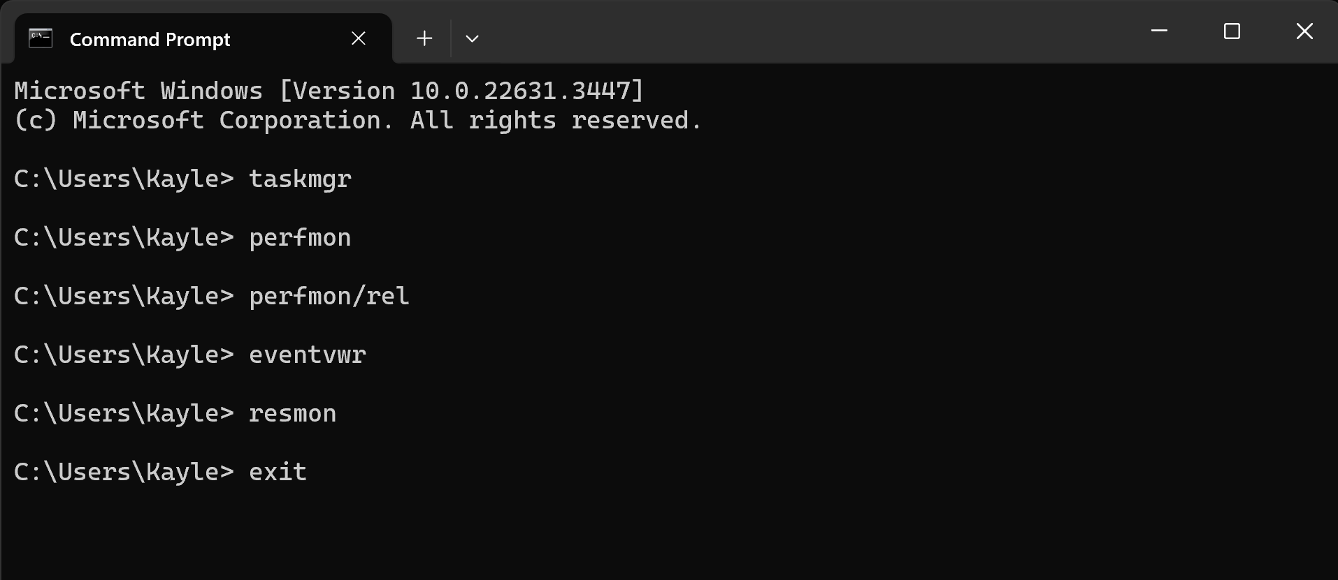
Above are a list of the Batch Commands I have used to test the windows performance monitoring and management tools to review the technical details and reports of my laptop. After reviewing each of these tools, I used the exit command to close the command prompt. Some of the outputs for these commands can be seen in Task 2 of the report.

Using Windows OS CLI Commands
For this section of the report, I have tested some Windows CLI Commands using Batch and PowerShell Commands. I have used some commands to open applications, provide information and display user input messages.

Batch Commands
Firstly, I tested some batch commands using the windows command prompt. I used commands that will open applications such as task manager and resource monitor so I can review the performance of my laptop with some applications running as well as reviewing information about the memory and networks.

Command 1 - taskmgr
The first command I tested in the windows command prompt was the “taskmgr” command. This command automatically opened the task manager application allowing the user to review their systems performance and resources.

Output - Process and Memory Management
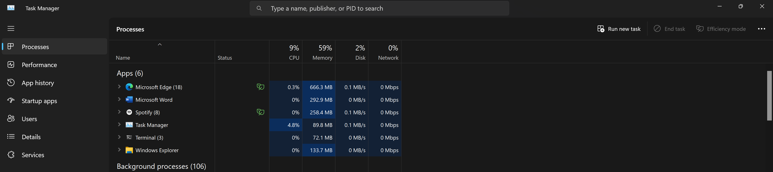
Once the task manager application had opened, I could review each of the appliactions and the running processes on my system as shown in the image above.
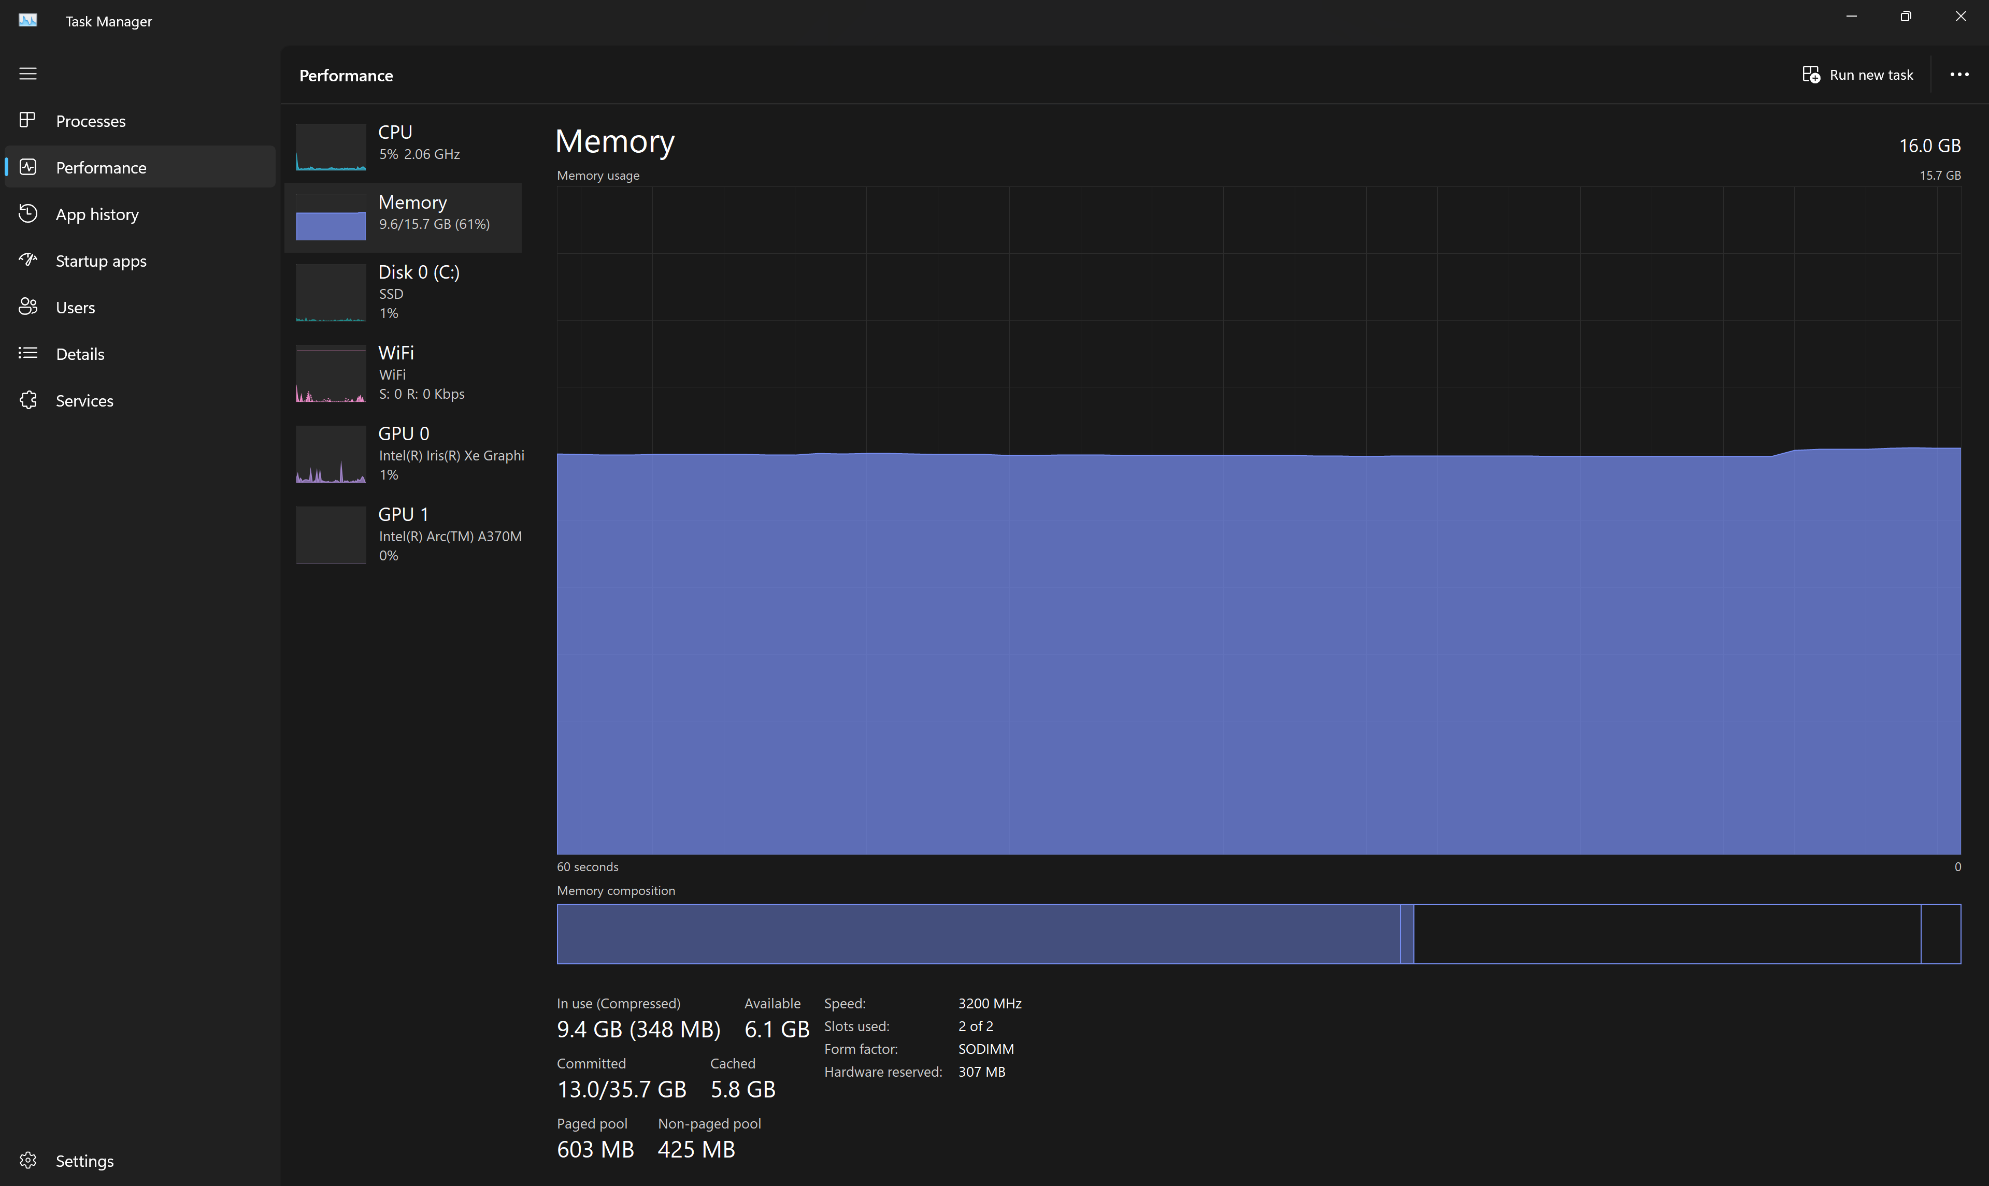
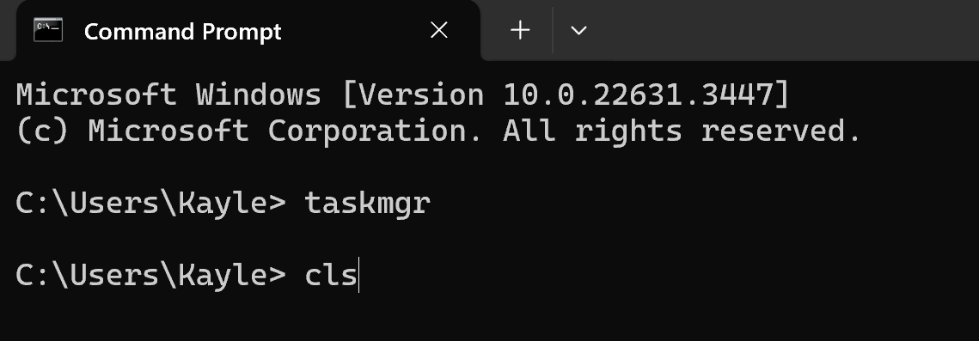
Here I have reviewed the performance of my laptop focusing on the memory avaible on the system and how much memore is in use.

After I had finished revewing the task manager application, I used the “cls” command to cler the command prompt so I could move onto testing another command.
Command – perfmon
Here I have used the “perfmon” command to open the performance monitor to show a summary of the performance of my laptop.
Command Output – Performance Monitor
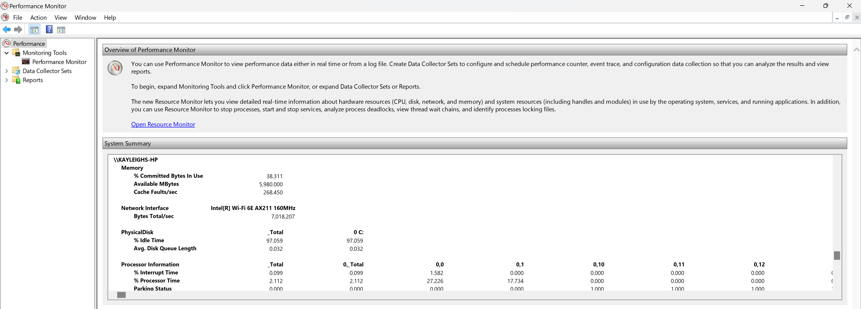
The performance monitor shows information about the memory, network, processor and disk of my laptop.
Command - resmon
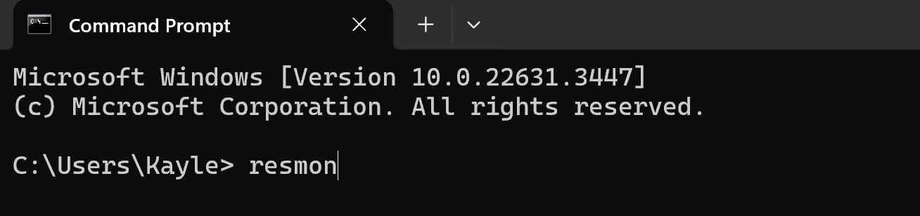

I have used the the “resmon” command to open the resource montior application, which will allow me to look at the data about the CPU, Disk, Network and Memory in more detail than what’s given in the performance monitor summary.
Command Output – Resource Monitor
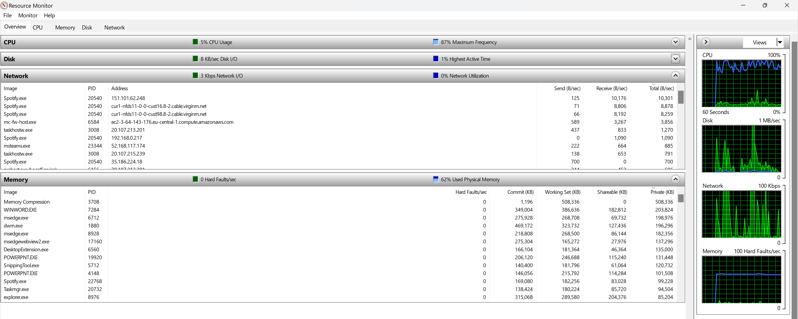
Command – Echo
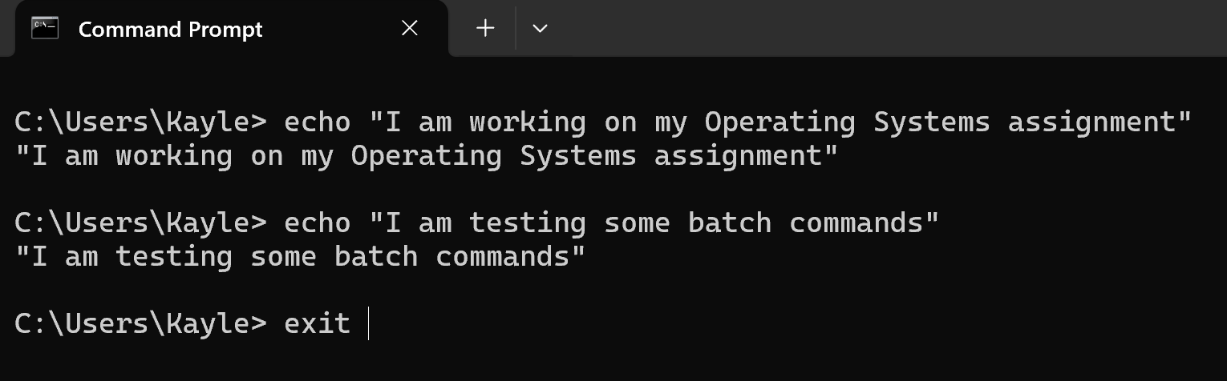
Here I have used the “echo” command to test and display messages in the command prompt. It can also be used to display variables which is demonstated later on in the report in my scripting sections. Once I was finished with testing this command, I used the “exit” command to close the command prompt application.

PowerShell Commands
To understand the language of PowerShell, I have tested some commands and processes to learn how to use the application. The commands I used helped me gather lists of the processes and commands and function available for PowerShell and understand the processes running on my laptop.

Command – get-help
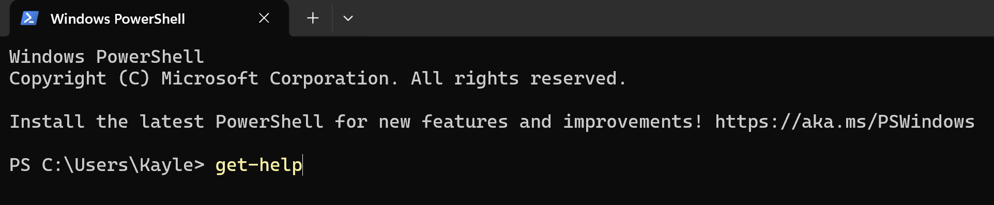
First, I used the “get-help” command to provide me with details about where I can find help and support about using the PowerShell application.
Command Output – get-help
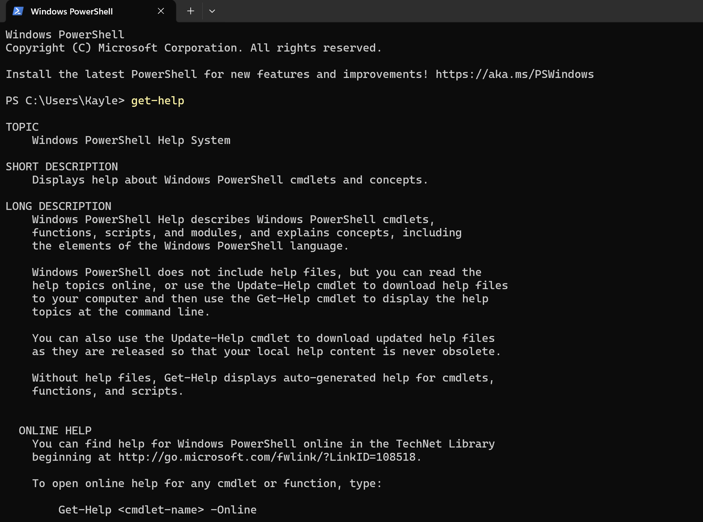
The “get-help” command has provided descriptions about where and how I can find help for using PowerShell, Plus, It has given me another command to use that will open help online.
Command – clear-host
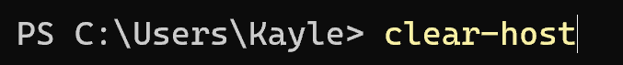
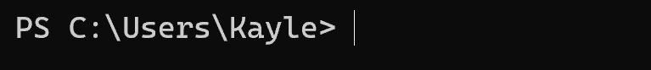
After I was finished testing and reviewing the “get-help” command, I used the “clear-host” command to clear all the previous commands from view.
Command – get-help get-process -online
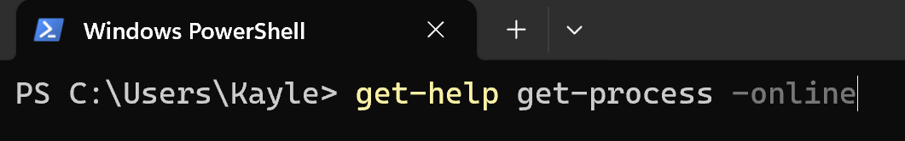
Once I tested the “get-help” command, I decided to try the “get-help get-process -online” command to see what help will be available online through the Microsoft website.
Command Output – get-help get-process – online
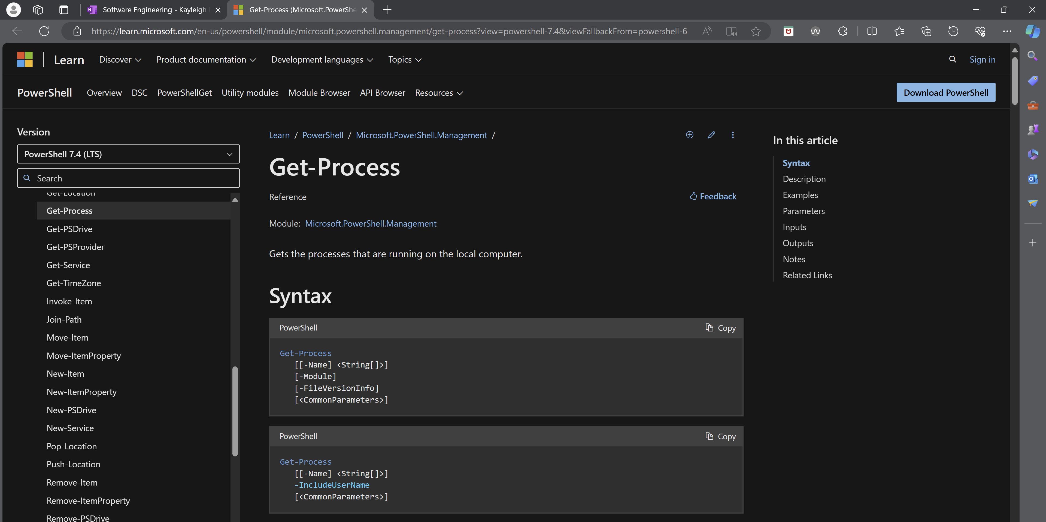
When running the command, it has taken me to the Microsoft website and has listed various syntax for some of the processes I can use on PowerShell. It has also the code typed out, allowing the user to copy and paste them straight into the PowerShell application.
Command – get-process
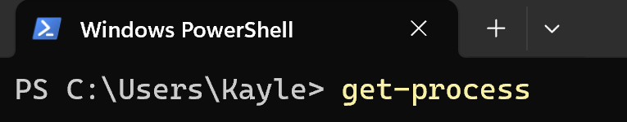
I have tested the “get-process” command to understand what processes are currently running on my laptop.
Command Output - get-process
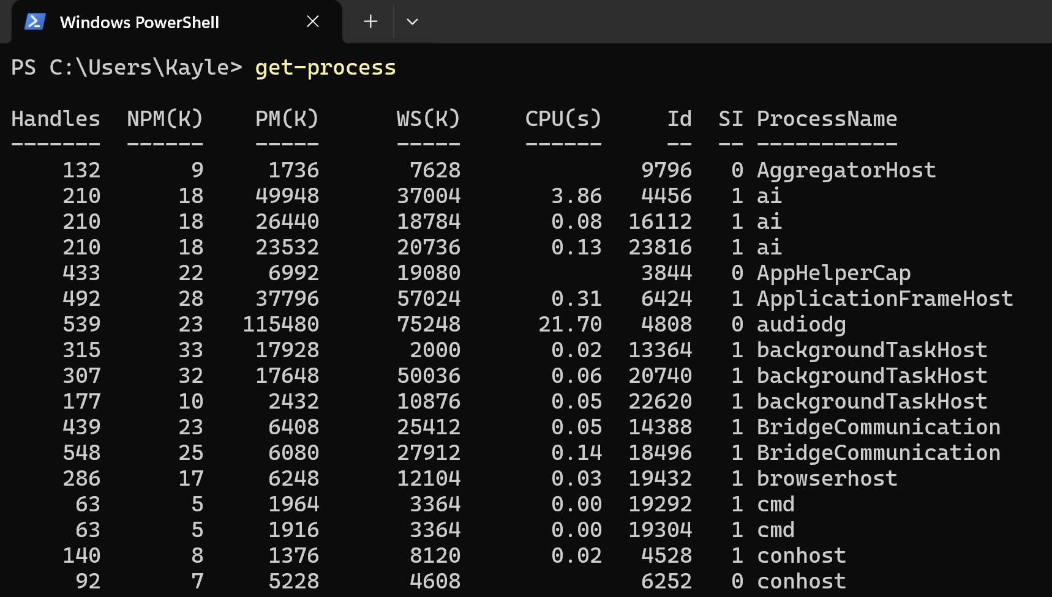
Above is a table that shows each of the applications currently running on my system, along with their ID and Process Names.
To change the format of how the processes are displayed on screen, I have tested the “get-process | format-list” command to view this information in another format. Below is a screenshot of the command before it was tested:
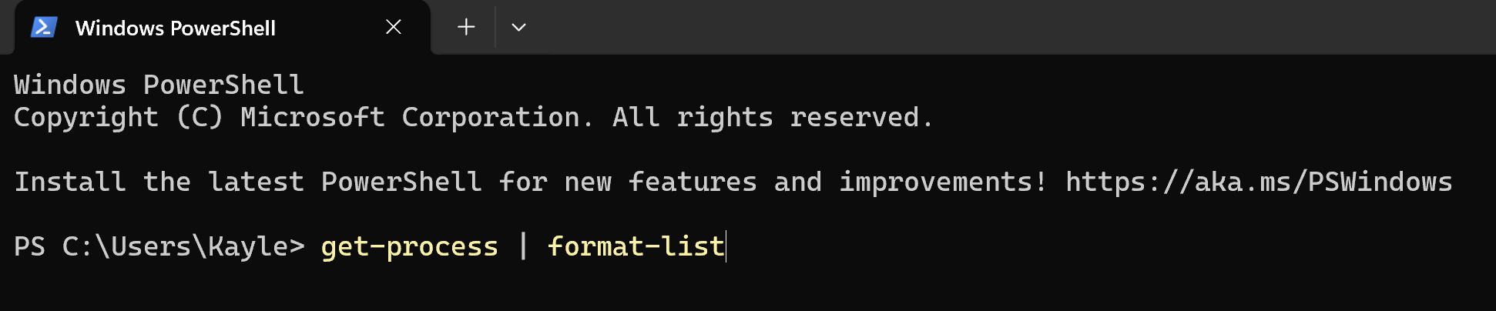
In the image below, it shows information about the processes on my laptop in a list format rather than a table format. This is useful as it allows the user to choose a format that they find easier to read.
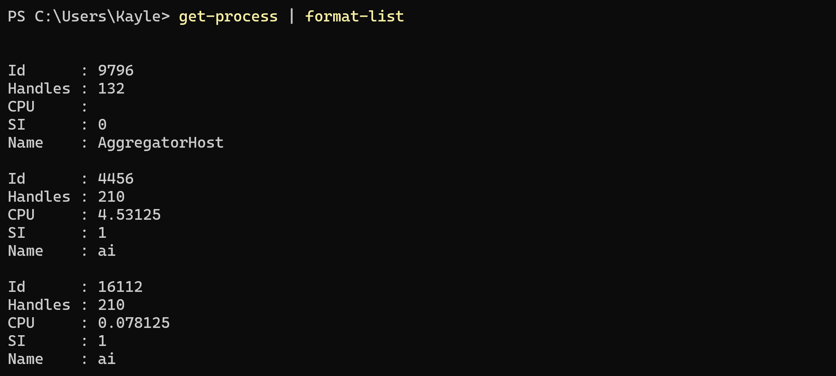

Using Linux OS CLI Commands
For this section of the report, I have tested some Linux CLI Commands using Bash Commands. To do this I connected to a virtual machine.
Echo Command
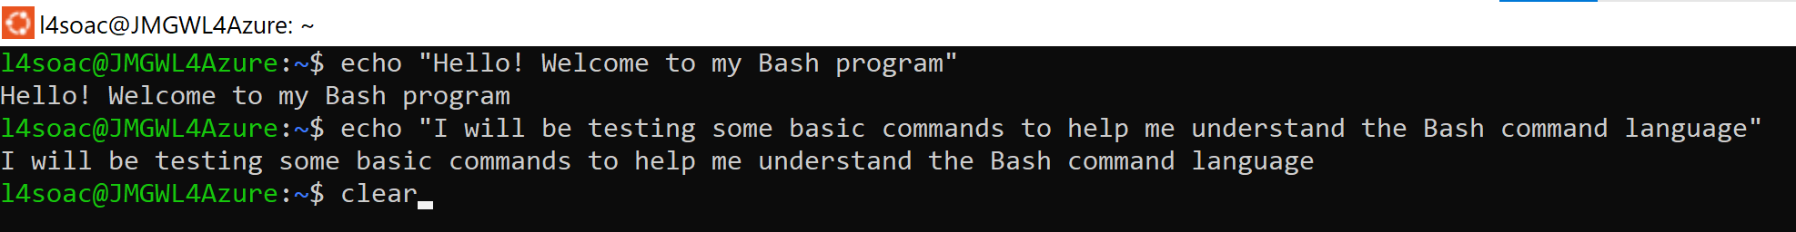
I have used the echo command to test and display messages in the Ubuntu command prompt.
Pwd Command
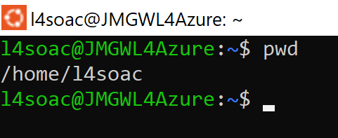
The pwd command is used to show the current working directory that the user is in by printing the full path to that directory.

ls Command
Using the ls command will show the user a list of all the subdirectories and the files in their directory. When using this command, it shows that there is only one file in my current directory which is testfile.txt.
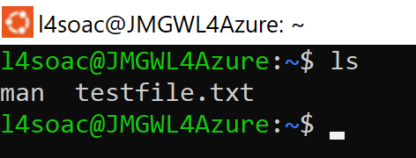

History Command
The history command can be used to display all the previous command that have been used in the current session. This will show what commands have been repeated or modified in an operating system.
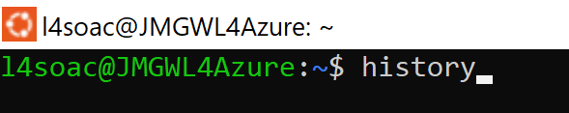

History Command Output
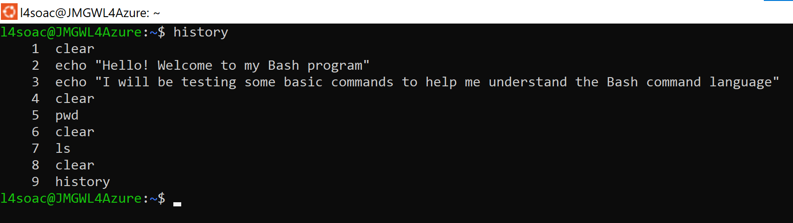

Above is a list of all the commands I have used while testing Linux Bash commands in Ubuntu. It also shows the order they have been used in.
History-C Command
The “history-c” command is used to clear all the command history from your current session. As you can see in the image below, I have tested serval commands in Ubuntu so far.
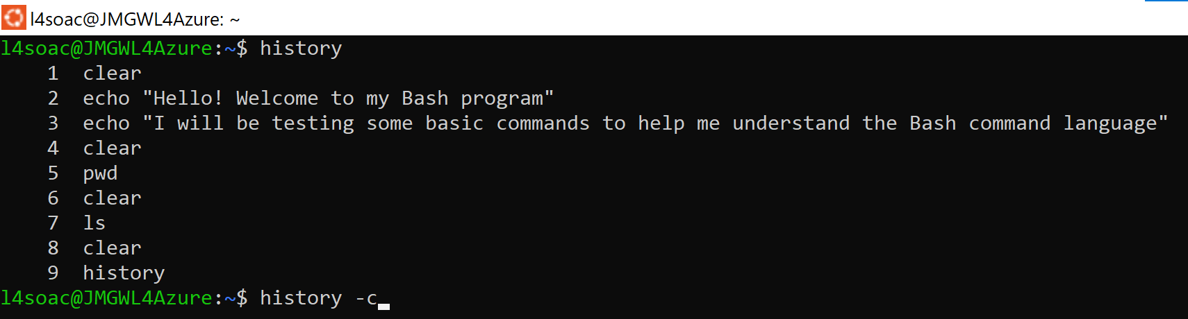

Command Output – History -C
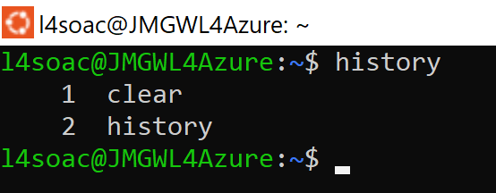
After running the clear history command, I decided to test the “history” command again to see if this was successful. The history of commands above shows that one command has been used since clearing the history.
Input Text Command
Here I have used some commands to put some text into a new text file. After running the command nothing seemed to have changed on screen. To test that this worked, I will use the nano command next.
Nano Command
Using the nano command allows me to view text files straight from the Ubuntu command prompt which would confirm if my previous commands worked.
In the image below, we can see that the command has opened the testfilenew.txt file that displays the messaged that was echoed in the previous command.
Rm-I command
This command is used for removing files from your working directory. Before the file is removed, a prompt will appear to confirm whether you want to delete the file. Here I will be testing this on the testfilenew.text file.
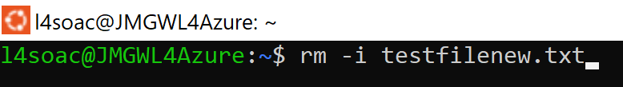
After entering the command, the prompt has appeared on my screen so that I can confirm If I want to continue and remove the file. I entered yes to allow Ubuntu to finish the command.
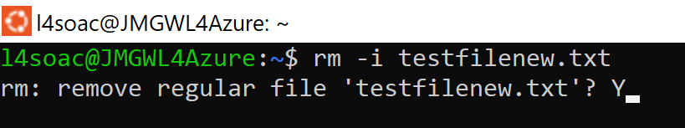
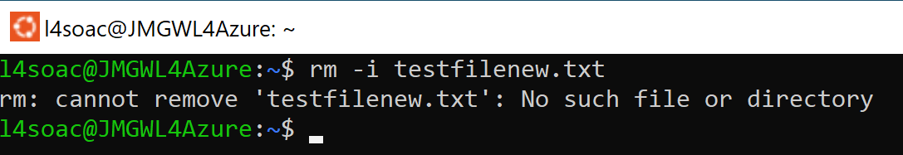
To test that these commands have worked, I repeated the same command to remove the testfilenew.txt to see if it was removed. As you can see in the image above, an error message has occurred as the file is no longer in our directory.
Help Command
The help command can be used to information about some of the commands and functions that can be used in Ubuntu. I have included the list of commands that are displayed in the output.
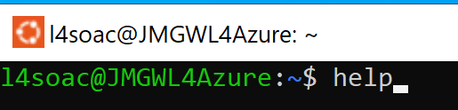
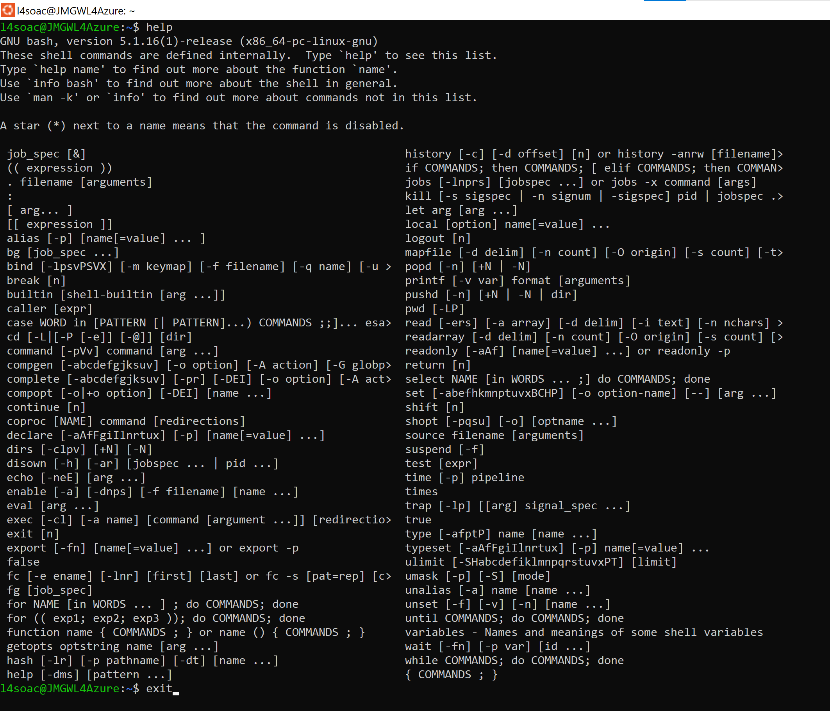
Compgen Command
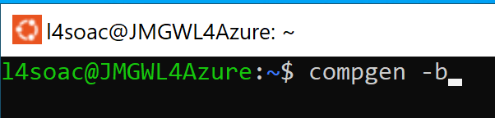
This command is used to display a list of all the commands, aliases and functions that are available to the user. These are shown in the image below.
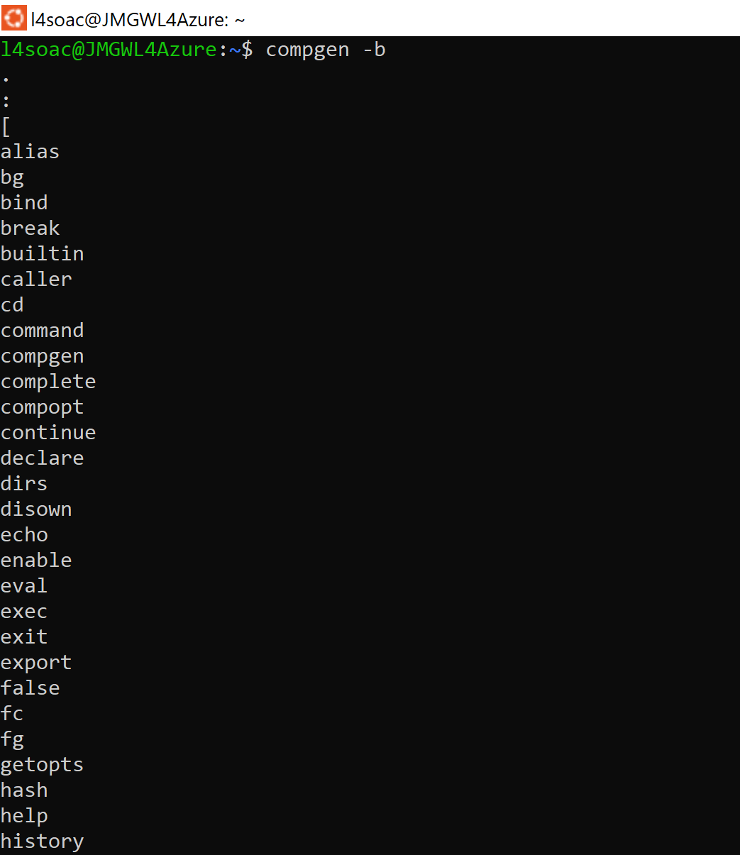

Using Windows OS Scripts
To develop some Windows OS Scripts, I have tested a range of commands to demonstrate the use of key features. This includes variables, loops, arrays and if statements. To do this, I have created batch scripts in notepad ++. Below I have included various screenshots to show the scripts and their outputs.

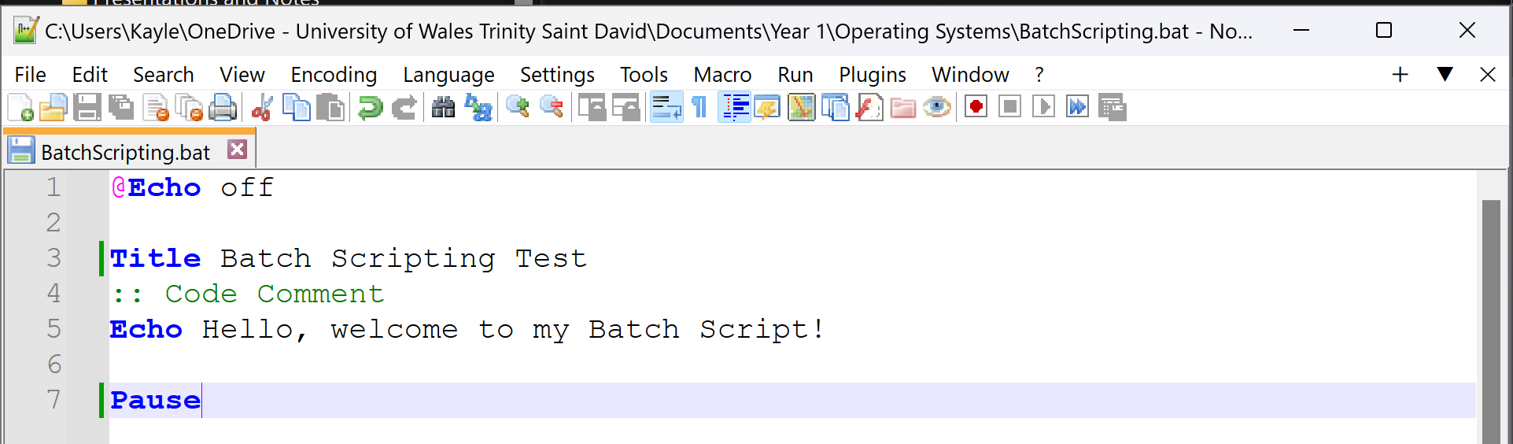
Batch Script 1

Batch Script 1 - Output

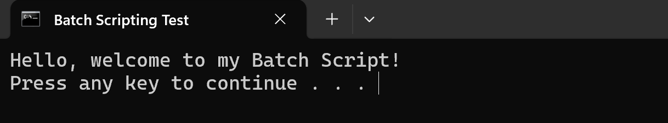
Batch Script 2
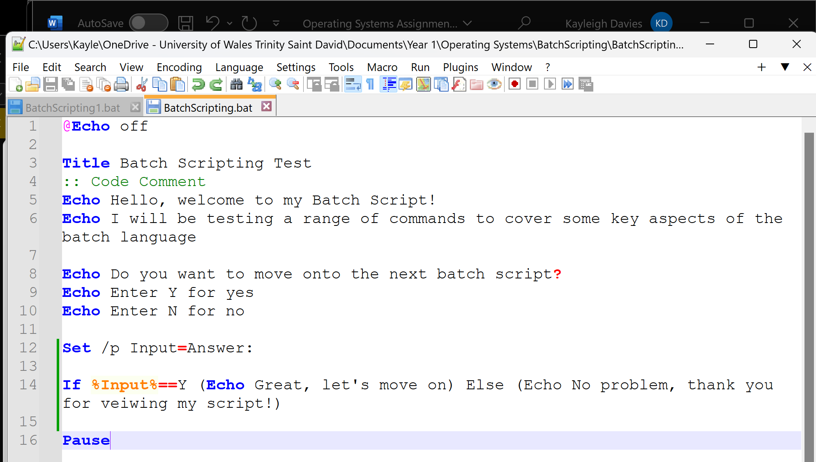

Batch Script 2 – Output
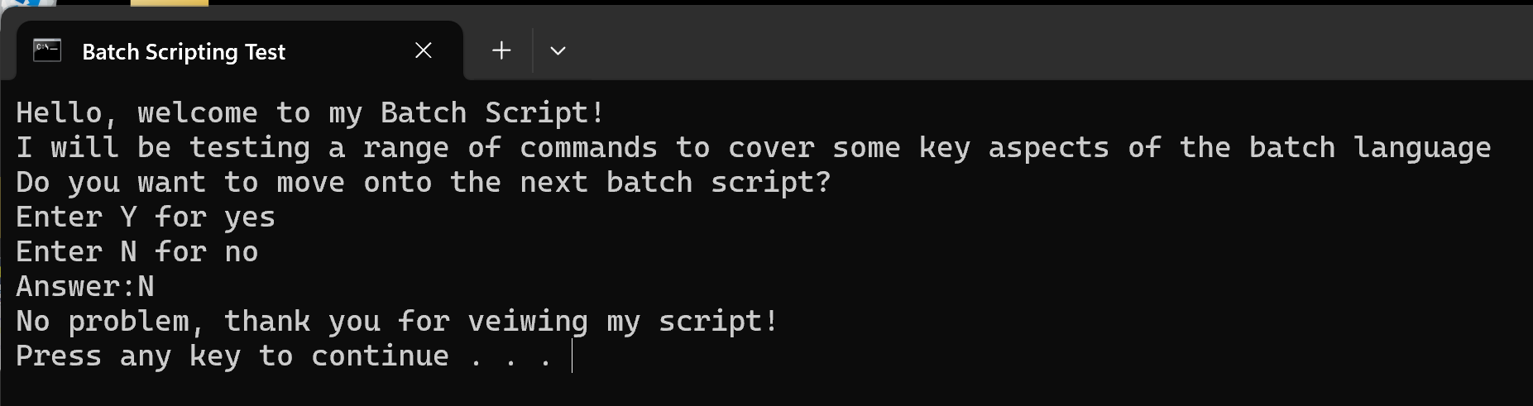
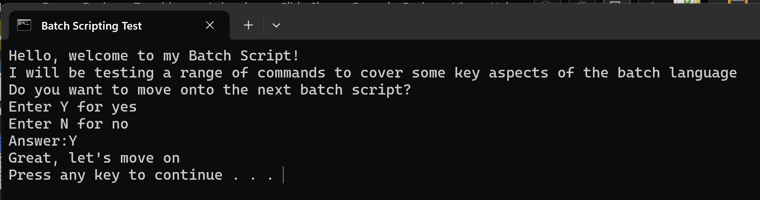

Batch Script 3
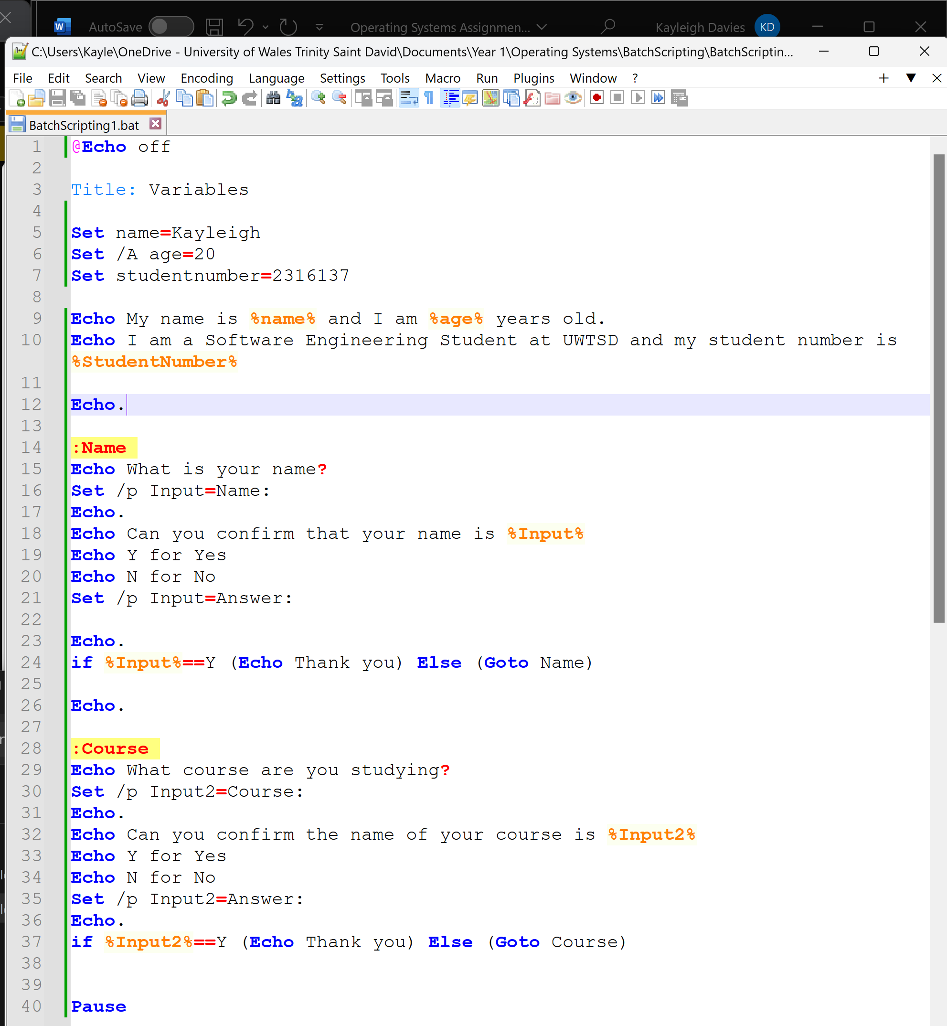

Batch Script 3 – Output
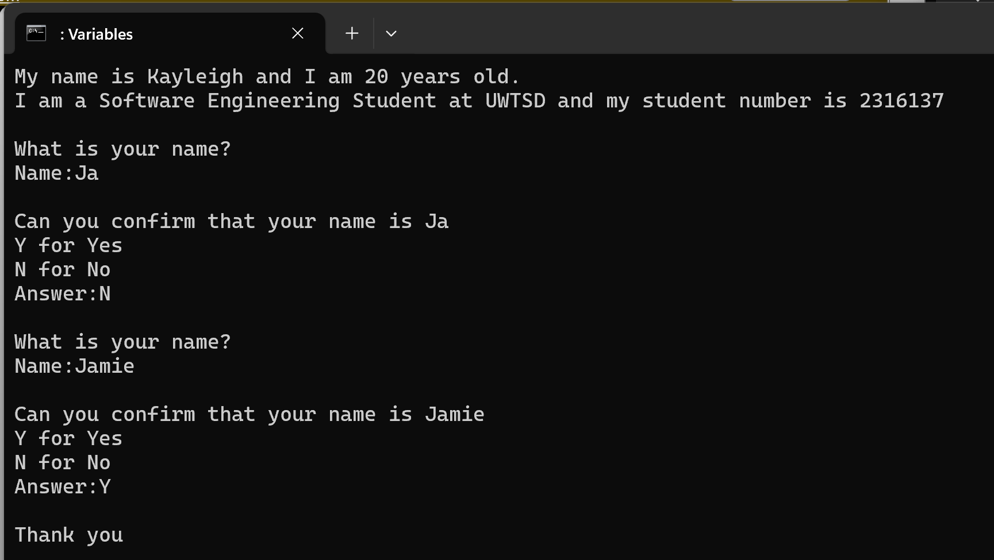
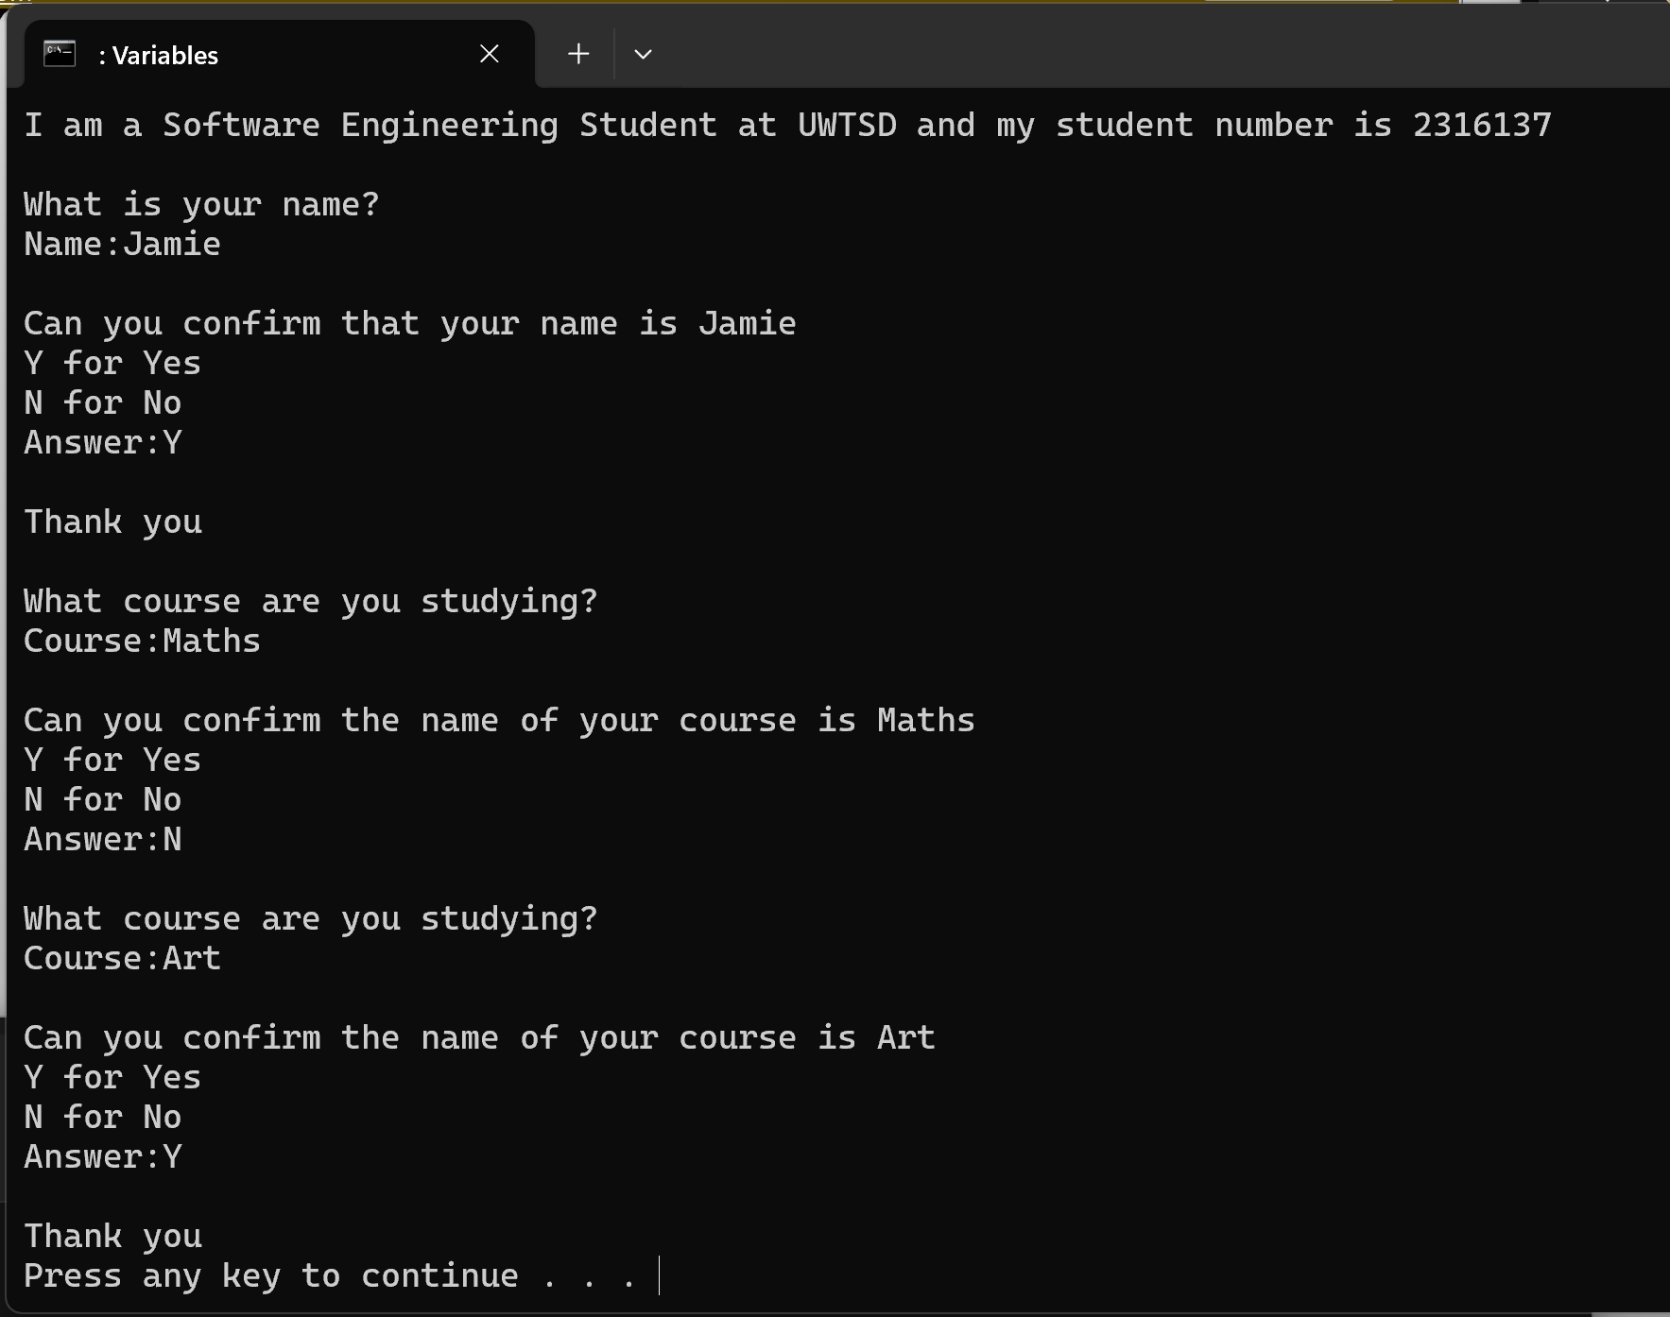

Batch Script 4
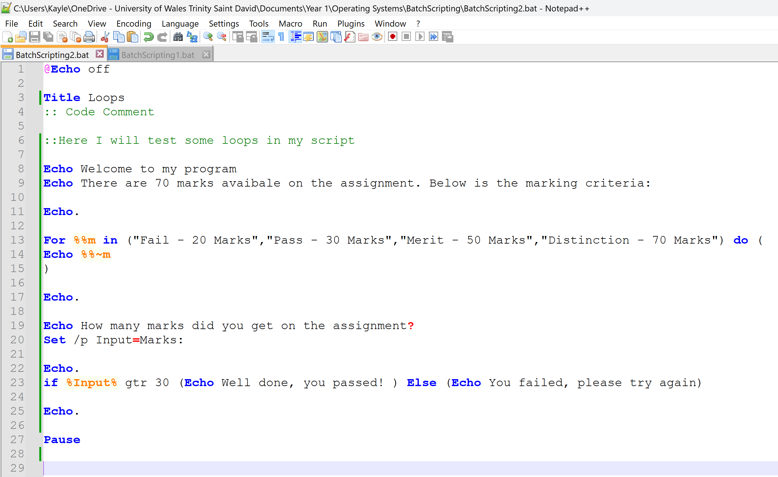
Batch Script 4 – Output
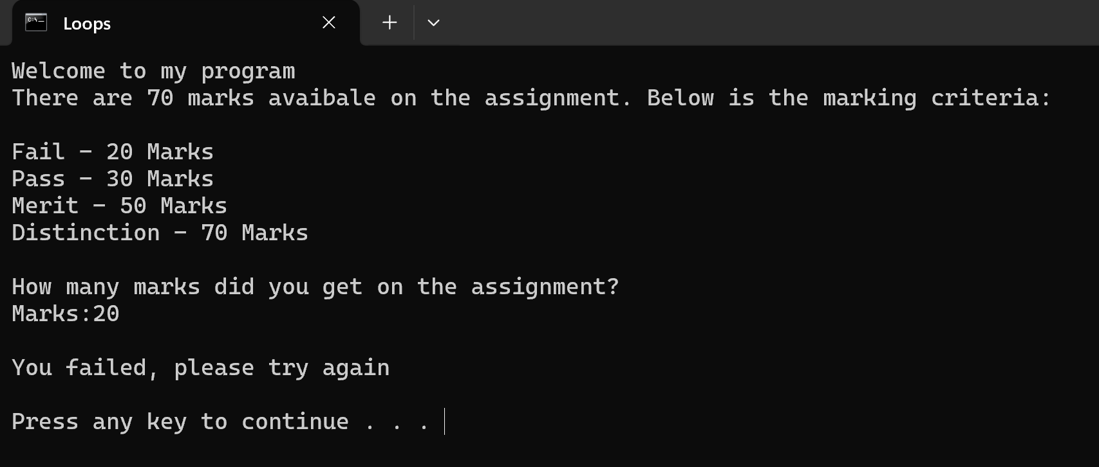
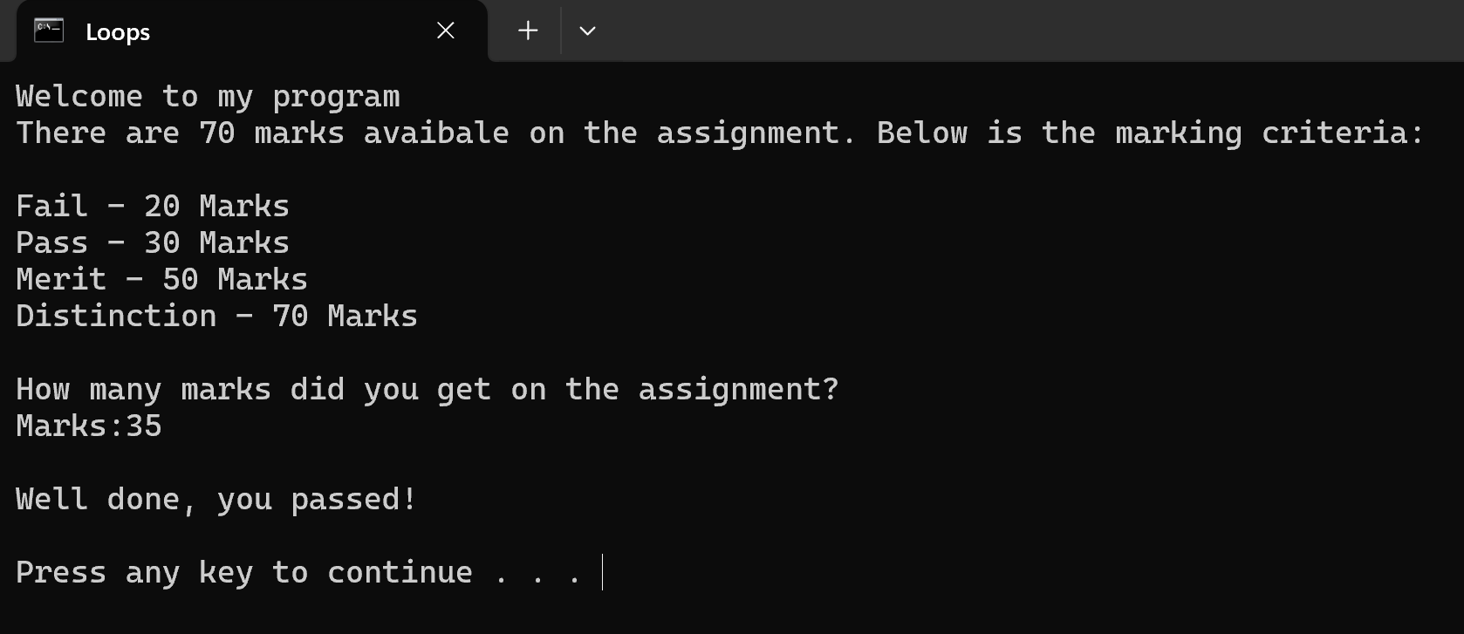

Batch Script 5
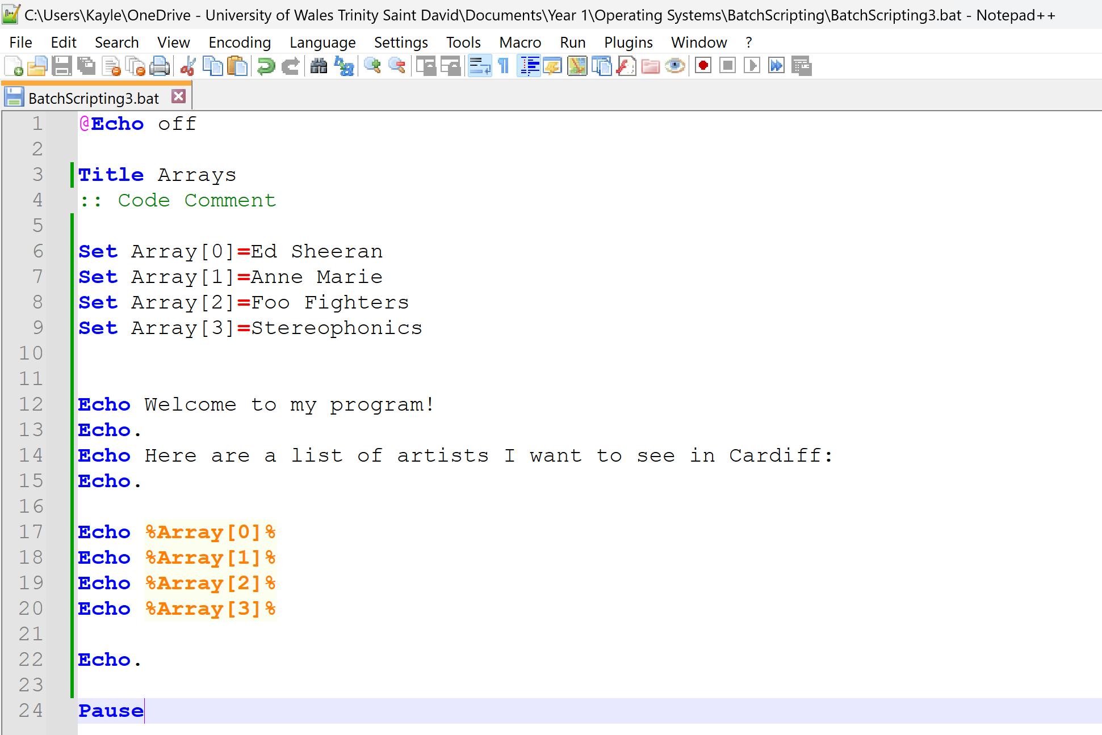

Batch Script 5 - Output
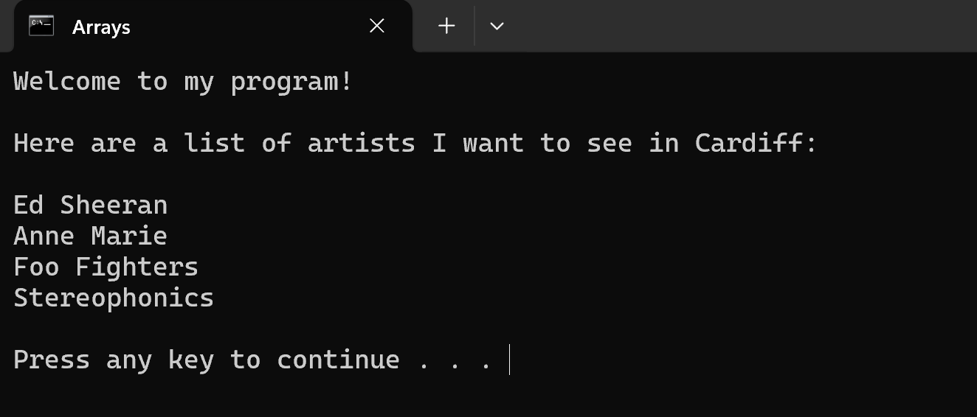
Batch Script 5 (Updated)
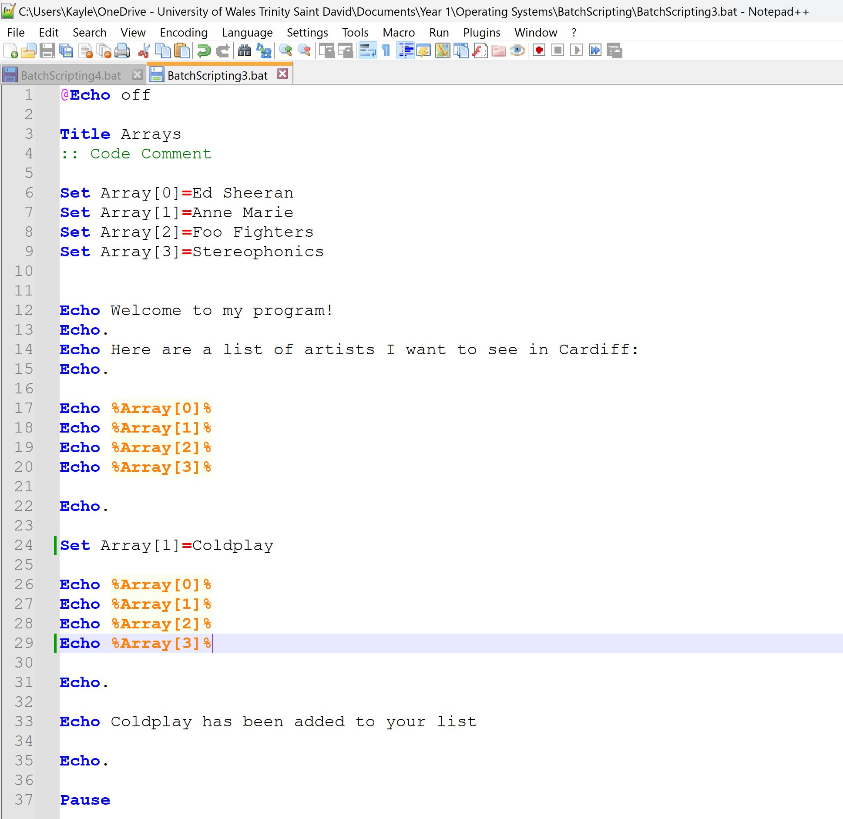
Batch Script 5 (Updated) - Output
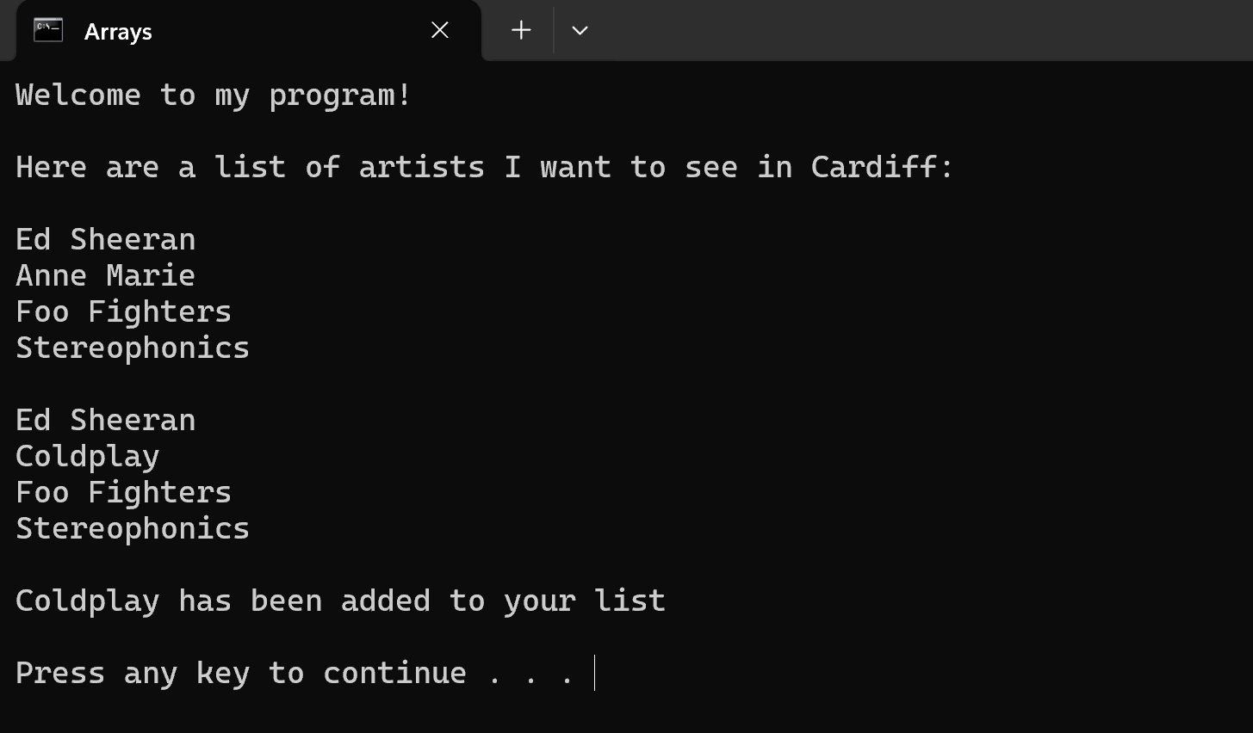
Batch Script 6
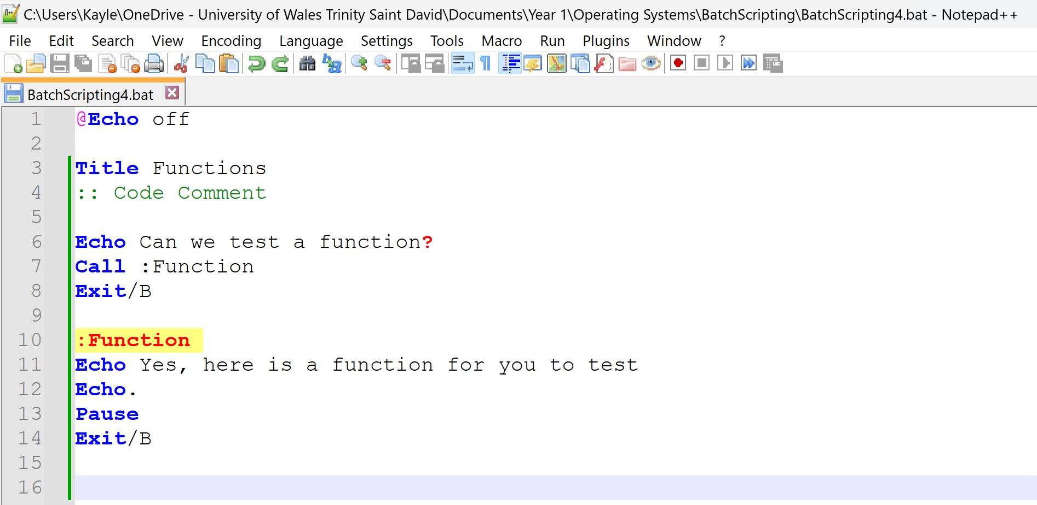

Batch Script 6 – Output
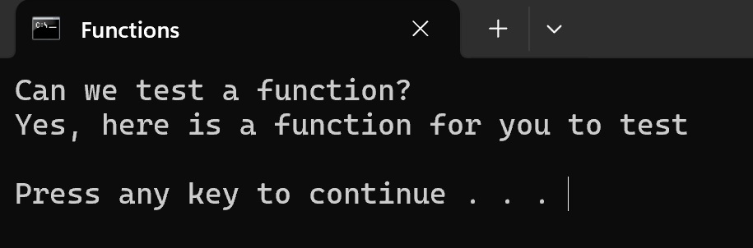

Using Linux OS Scripts
Throughout this section of the report, I have created various scripts to test key aspects of the Linux coding language. I have included the use of variables, if statements, case statements, loops, arrays, functions, and user input in my scripts. Below I have included screenshot of the scripts and their outputs.
Linux Script 1
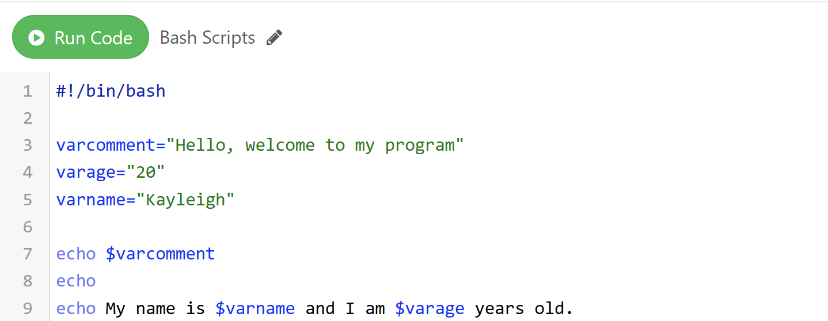

Linux Script 1 – Output
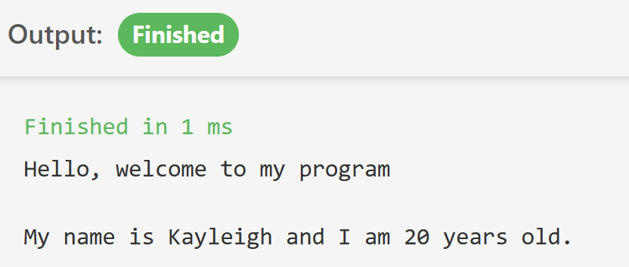
Linux Script 2
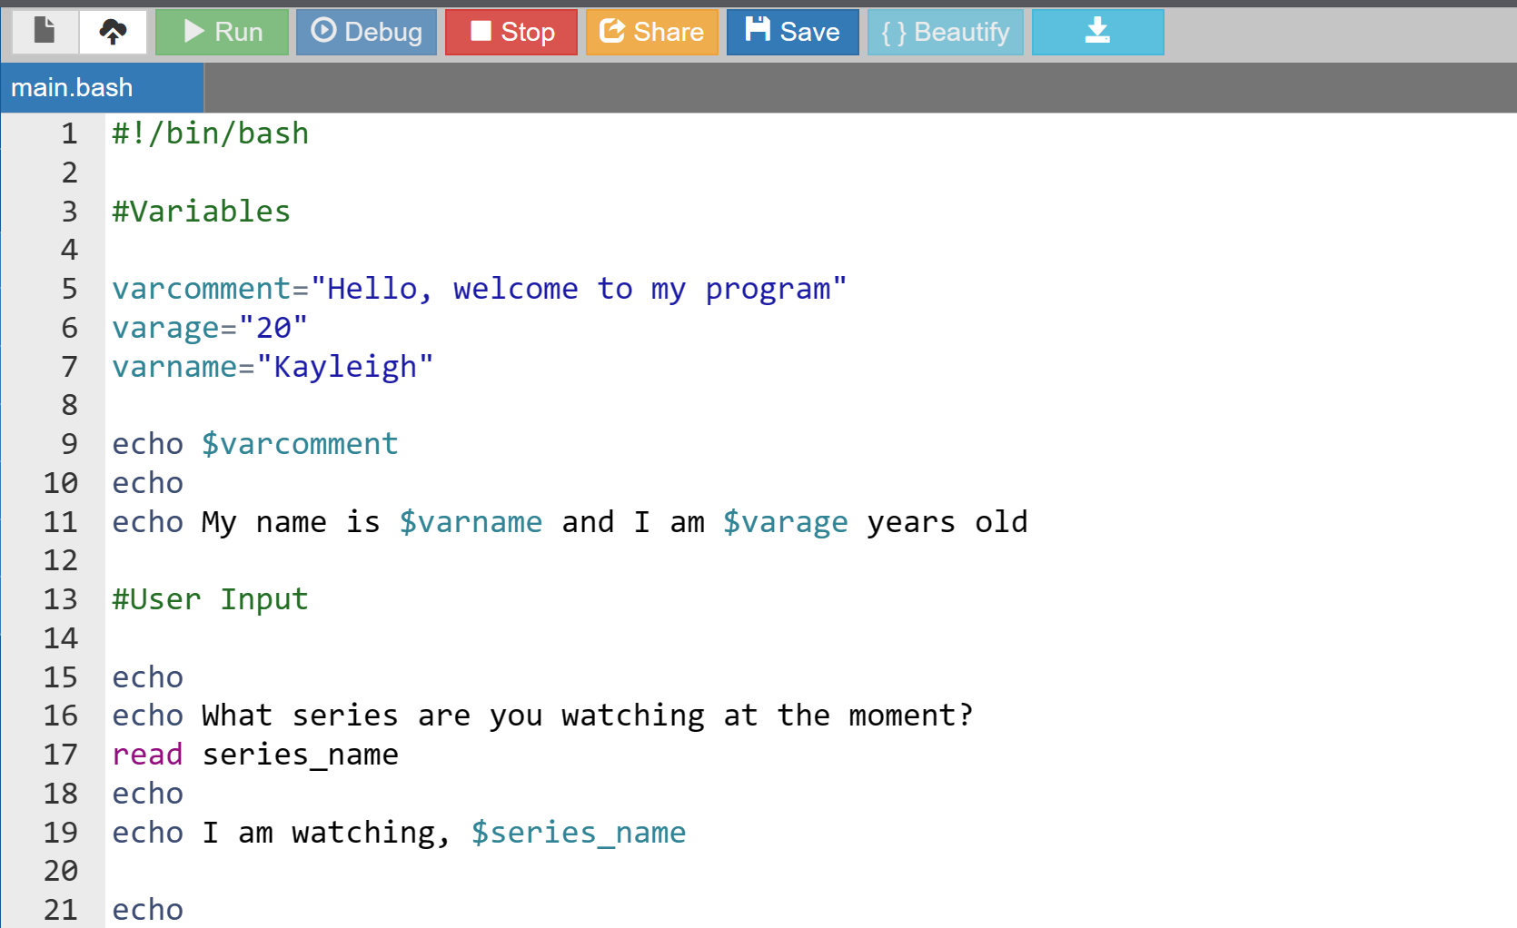

Linux Script 2 – Output
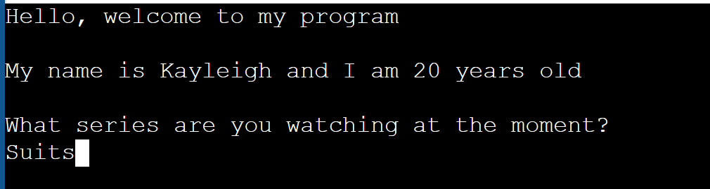
Linux Script 3
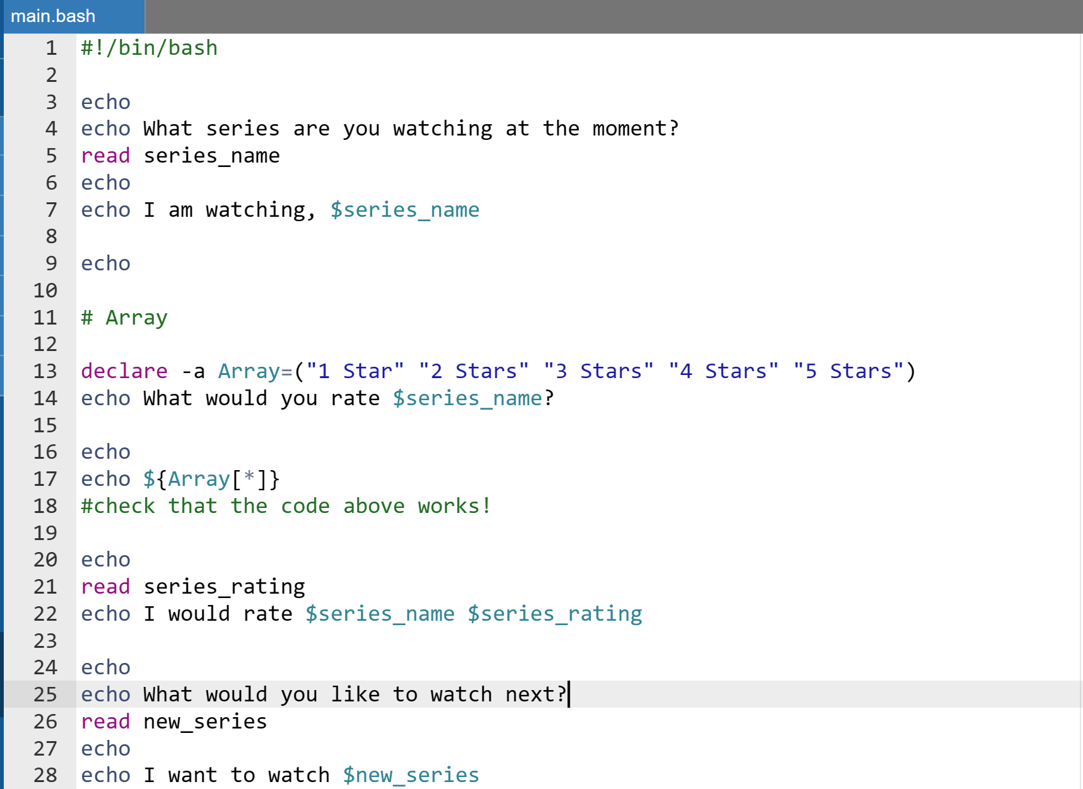

Linux Script 3 – Output
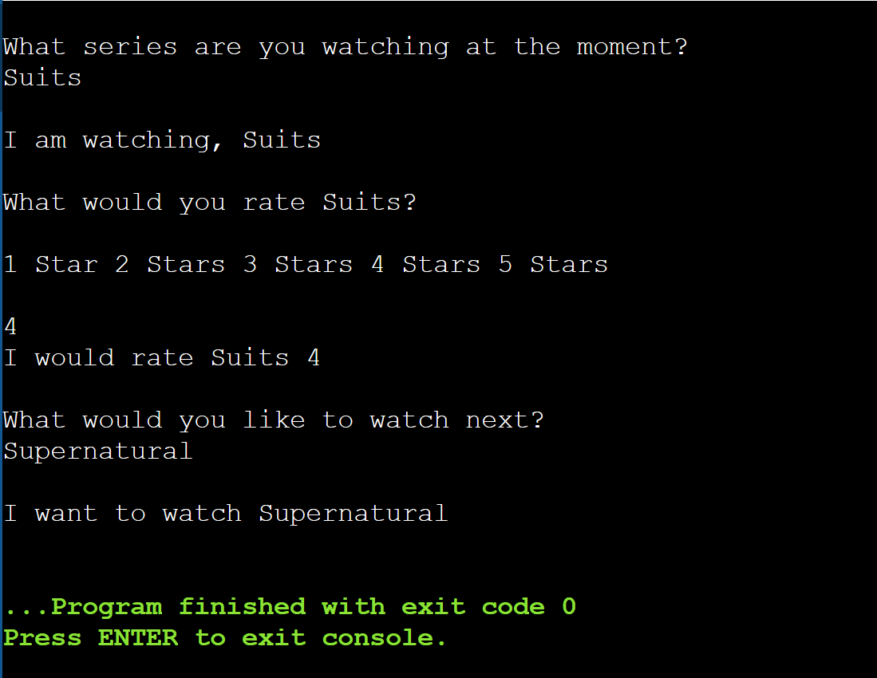
Linux Script 4
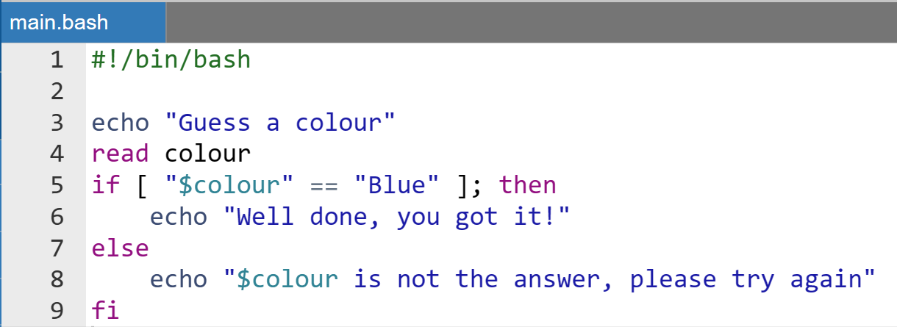

Linux Script 4 – Output
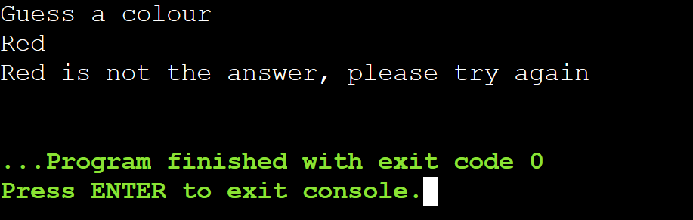
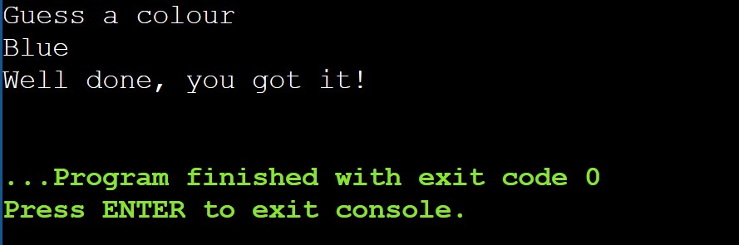
Linux Script 5
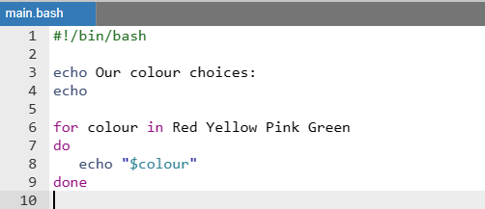

Linux Script 5 - Output
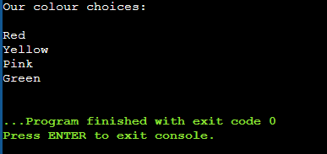
Linux Script 6
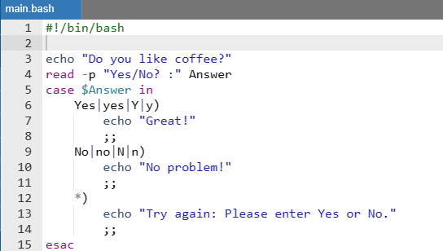

Linux Script 6 – Output

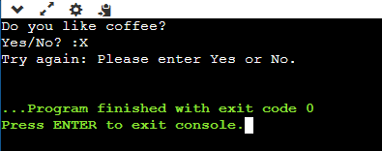
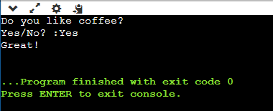
Linux Script 7
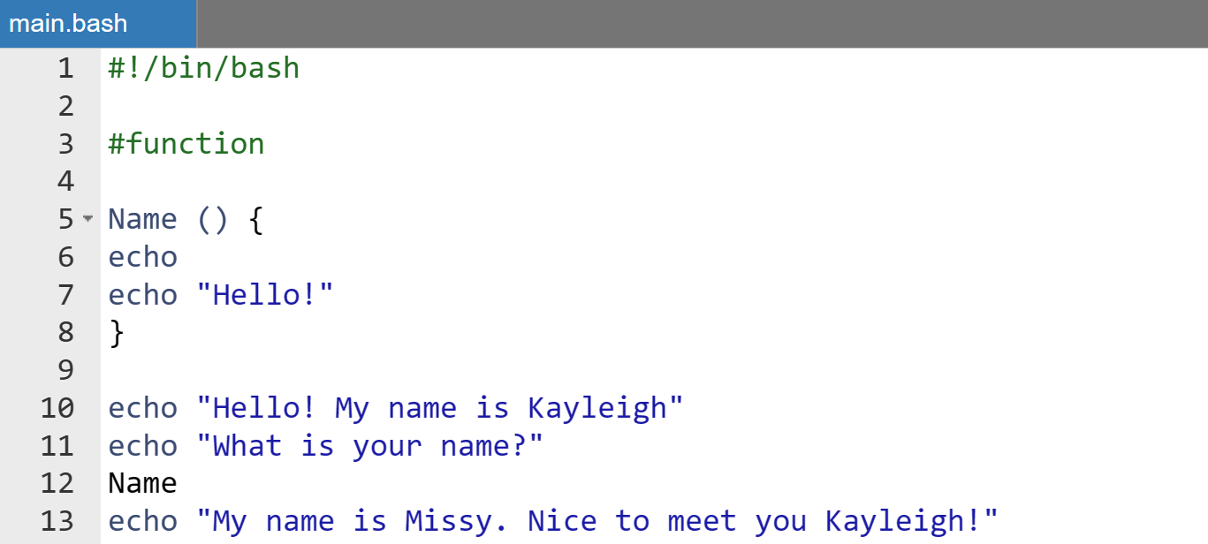

Linux Script 7 – Output
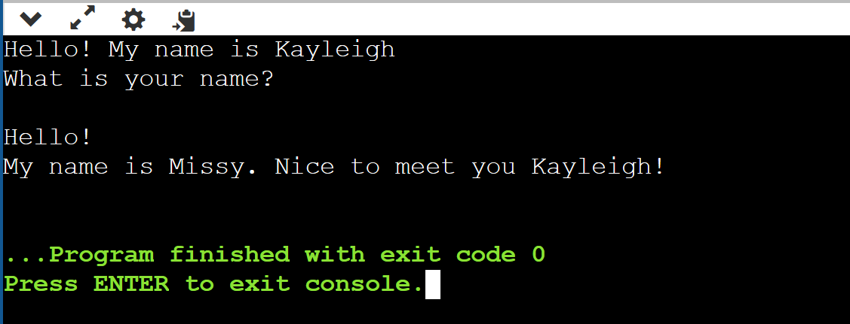

Conclusion
Throughout this report, I have researched the key functions of operating systems to understand their different purposes and how commands can be used to automate and speed up their processes. For example, using commands to run various applications to test and review the system performance or to navigate through the system files and folders.
I have tested various commands to familiarize myself with the scripting languages for Bash, Batch and PowerShell. This has allowed me to develop my skills and move on to creating small scripts to test other key aspects of these languages. In my scripts, I have included programming components such as Functions, If Statements, Loops and Variables.

References
[1] manjeetks007, “What is an Operating System?,” GeeksforGeeks, Jun. 11, 2021. https://www.geeksforgeeks.org/what-is-an-operating-system/ (accessed Apr. 19, 2024).
[2] “Functions of operating systems - Computer systems - AQA - GCSE Computer Science Revision - AQA - BBC Bitesize,” www.bbc.co.uk. https://www.bbc.co.uk/bitesize/guides/zkkkw6f/revision/5 (accessed Apr. 19, 2024).
[3] Indeed Editorial Team, “6 Types of Operating Systems (With Examples),” Indeed Career Guide, Apr. 28, 2023. https://www.indeed.com/career-advice/career-development/types-of-operating-systems (accessed Apr. 19, 2024).
[4] GeeksforGeeks, “Operating System Security,” GeeksforGeeks, Jan. 05, 2023. https://www.geeksforgeeks.org/operating-system-security/ (accessed Apr. 19, 2024).
[5] “Device Management in Operating System,” GeeksforGeeks, Jul. 23, 2023. https://www.geeksforgeeks.org/device-management-in-operating-system/ (accessed Apr. 19, 2024)
[6] “Operating systems - Computers - Edexcel - GCSE Computer Science Revision - Edexcel - BBC Bitesize,” www.bbc.co.uk. https://www.bbc.co.uk/bitesize/guides/zkrr97h/revision/10 (accessed Apr. 19, 2024).
[7] D. Grigoras, “The Impact of Operating Systems on Overall System Efficiency,” Stepofweb, May 10, 2023. https://stepofweb.com/how-operating-systems-help-manage-system-performance-monitoring-and-tuning/ (accessed Apr. 19, 2024).
[8] “Operating systems and user interfaces - Systems software - OCR - GCSE Computer Science Revision - OCR - BBC Bitesize,” www.bbc.co.uk. https://www.bbc.co.uk/bitesize/guides/zmqw7p3/revision/2 (accessed Apr. 19, 2024).
[9] “Batch File Commands (A-Z) | Explanation and Examples,” Online tutorials for c programming, cplusplus, Java, Python. https://www.trytoprogram.com/batch-file-commands/ (accessed Apr. 19, 2024).

[10]“Batch Script - Variables,” www.tutorialspoint.com. https://www.tutorialspoint.com/batch_script/batch_script_variables.htm (accessed Apr. 19, 2024).

[11] HOW TO MEDIA, “How to create For Loops In Batch File for loop in cmd windows 10,” YouTube. Jun. 13, 2023. Accessed: Apr. 19, 2024. [YouTube Video]. Available: https://www.youtube.com/watch?v=8vfGBgJYRlY

[12] “BATCH SCRIPTING// ARRAYS // Batch Scripting Part -13- ARRAYS,” www.youtube.com. https://www.youtube.com/watch?v=auxeOtUv02I (accessed Apr. 19, 2024).

[13] “How To Run Linux Code on Windows with WSL 2 & VS Code,” www.youtube.com. https://www.youtube.com/watch?v=bRW5r7TK6KM (accessed Apr. 19, 2024).

[14] “60 Linux Commands you NEED to know (in 10 minutes),” www.youtube.com. https://www.youtube.com/watch?v=gd7BXuUQ91w (accessed Apr. 19, 2024).

[15] “Online Bash Shell - online editor,” GDB online Debugger. https://www.onlinegdb.com/online_bash_shell (accessed Apr. 19, 2024).

[16] M. Hestor, “Welcome - PowerShell Video Tutorial | LinkedIn Learning, formerly Lynda.com,” LinkedIn, Feb. 14, 2020. https://www.linkedin.com/learning/learning-powershell/welcome-2?u=77966930 (accessed Apr. 19, 2024).

Appendices

Tutorial Activity - OS Types

Online Certified Course
To develop my understanding of PowerShell, its syntax, and its language, I have completed a LinkedIn Learning course. This course helped me to learn how to use the syntax and commands. Here are a few screenshots I have taken throughout the duration of the course.

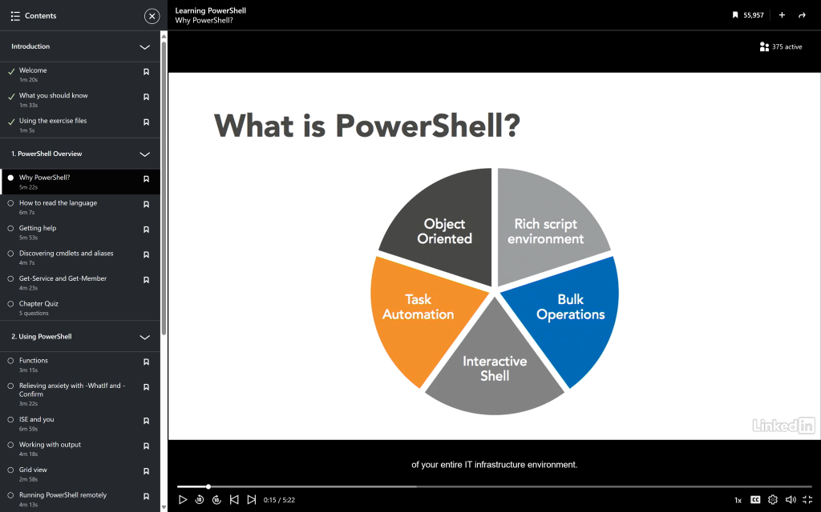

Evidence: What is Powershell
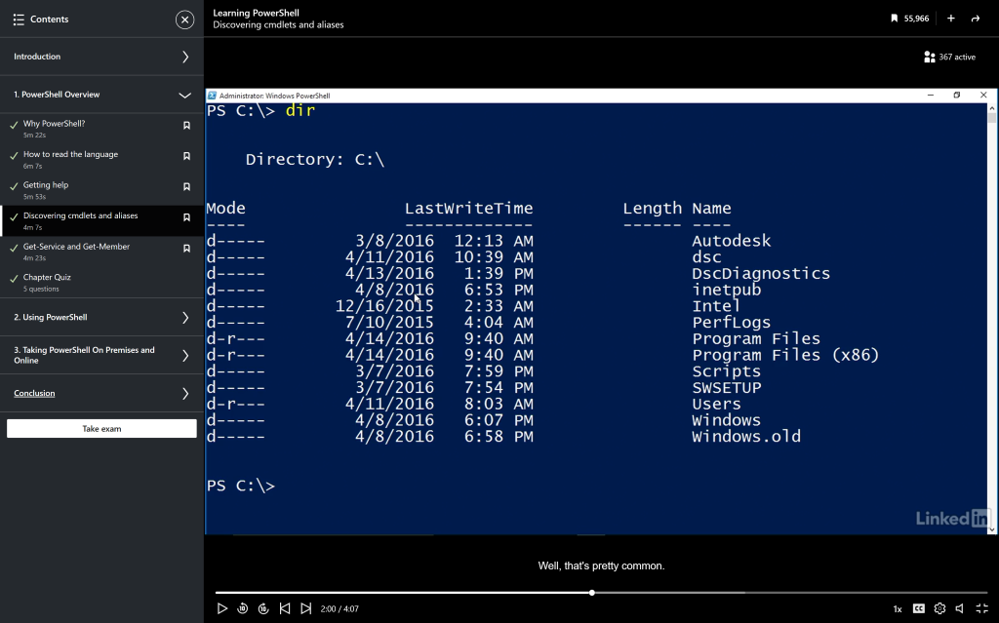
Evidence: Discovering cmdlets and aliases
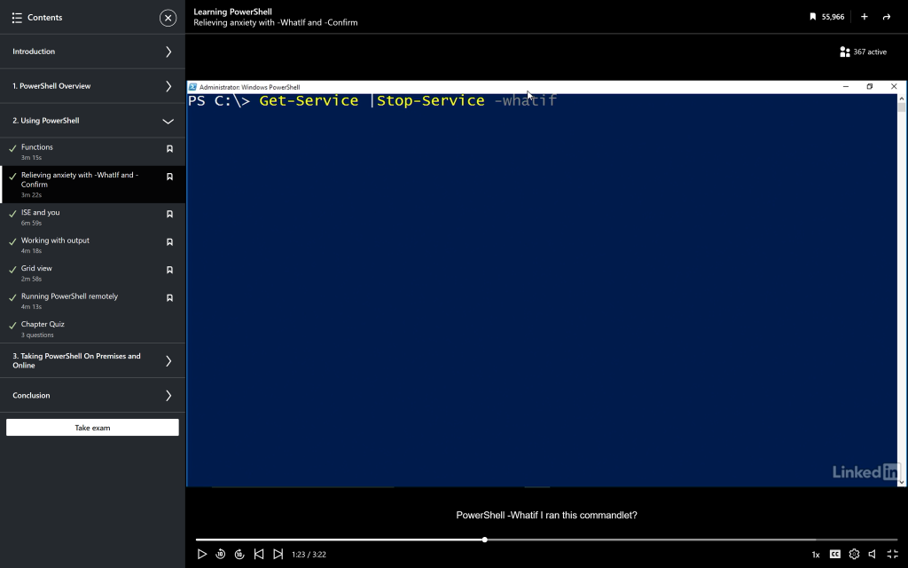

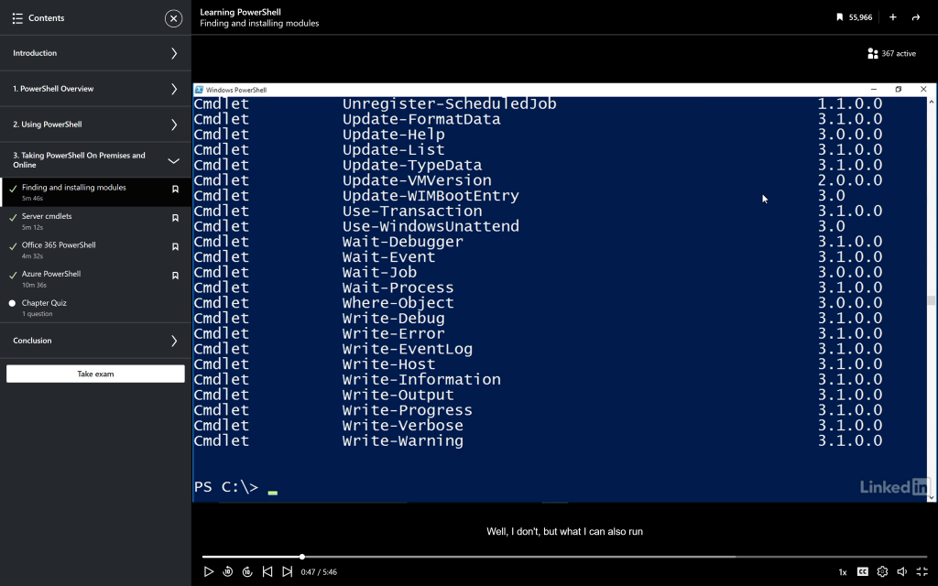
Evidence: What If and Confirm

Evidence: Finding and Installing Modules

Evidence: Course Completion Certificate

