Appendix 1- Observation Schedule: Lesson study 1

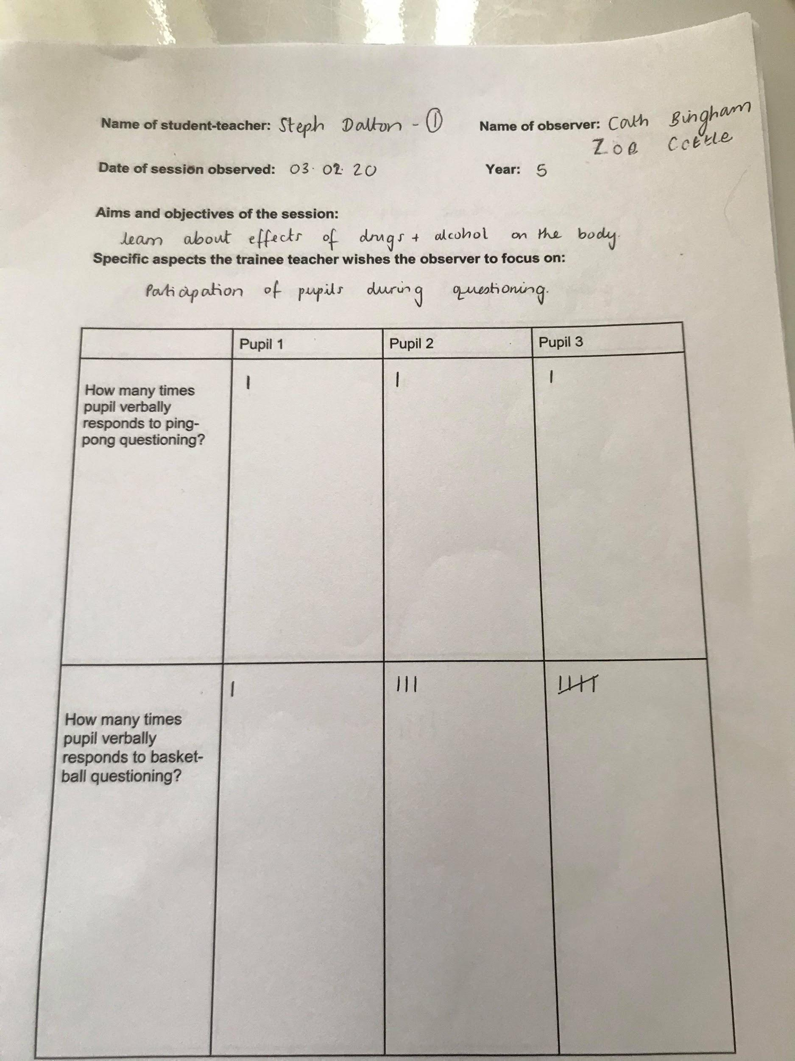

Appendix 2- Observation Schedule: Lesson study 2

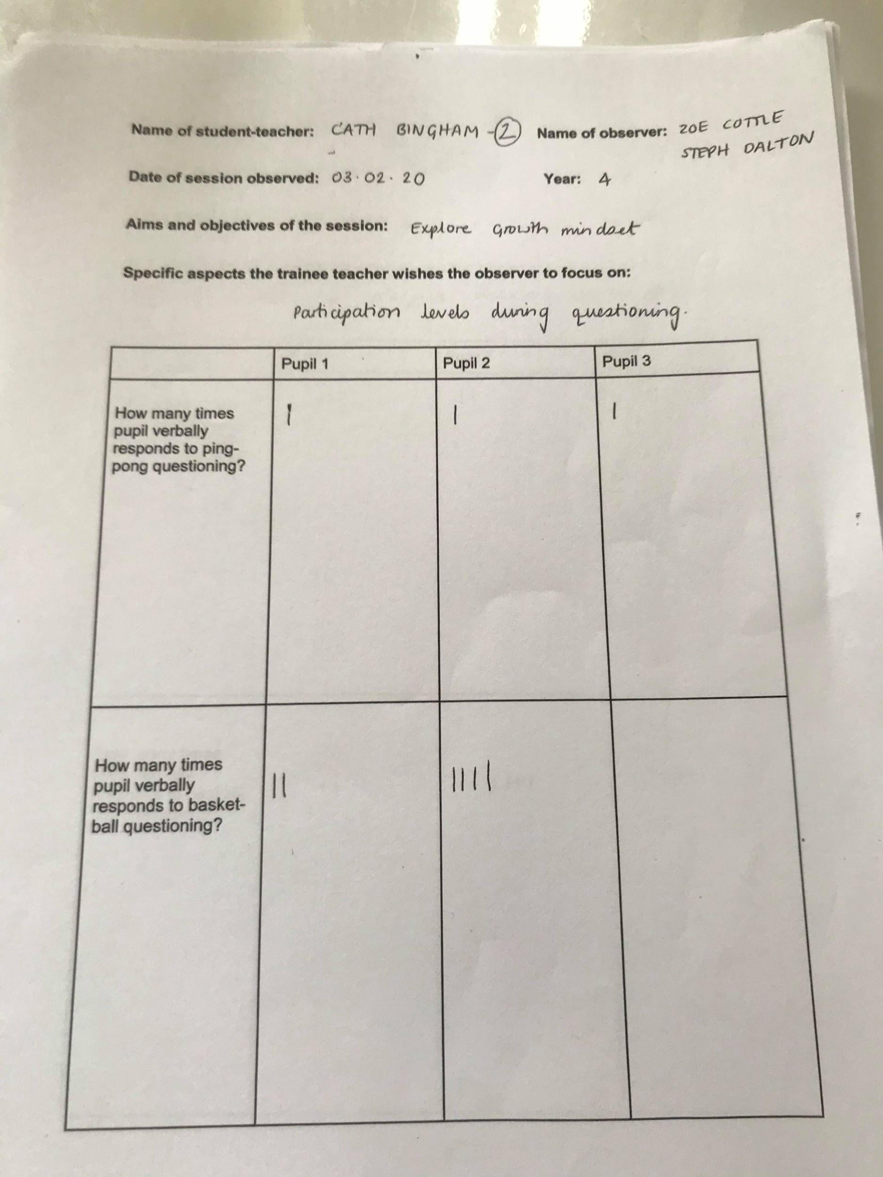

Appendix 3- Observation Schedule: Lesson study 3

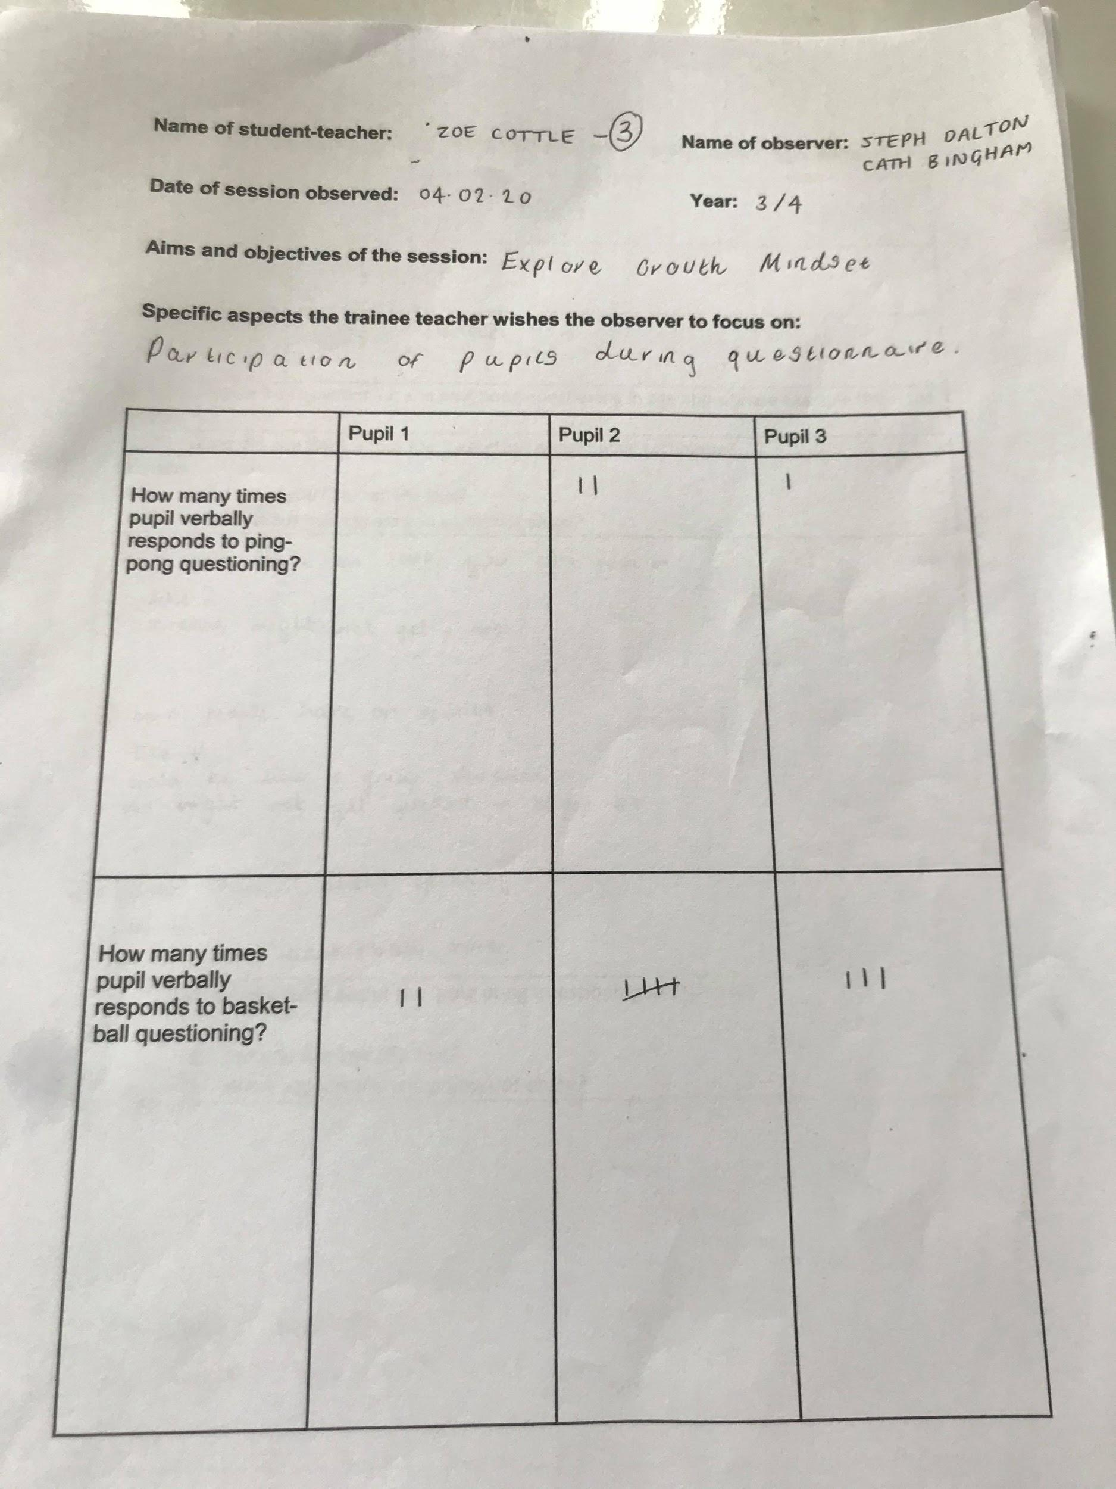

Appendix 4- Interview field notes: Lesson study 1

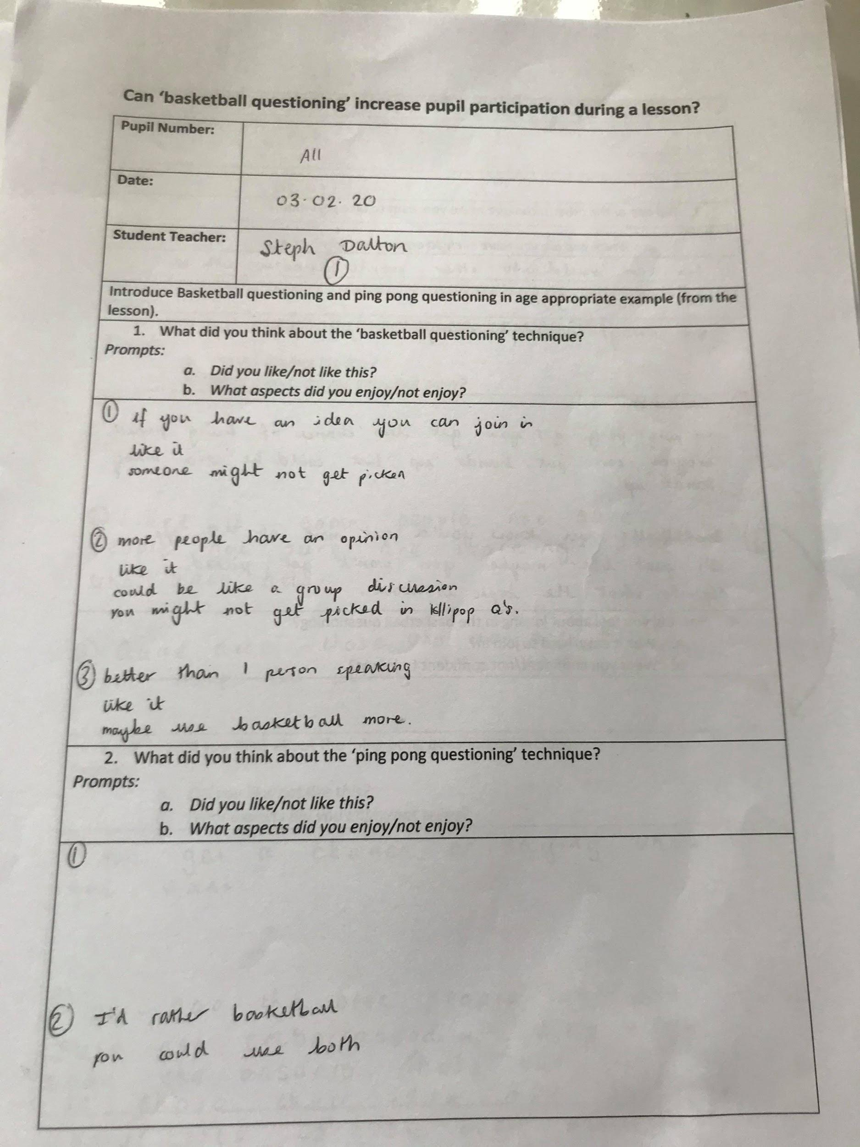

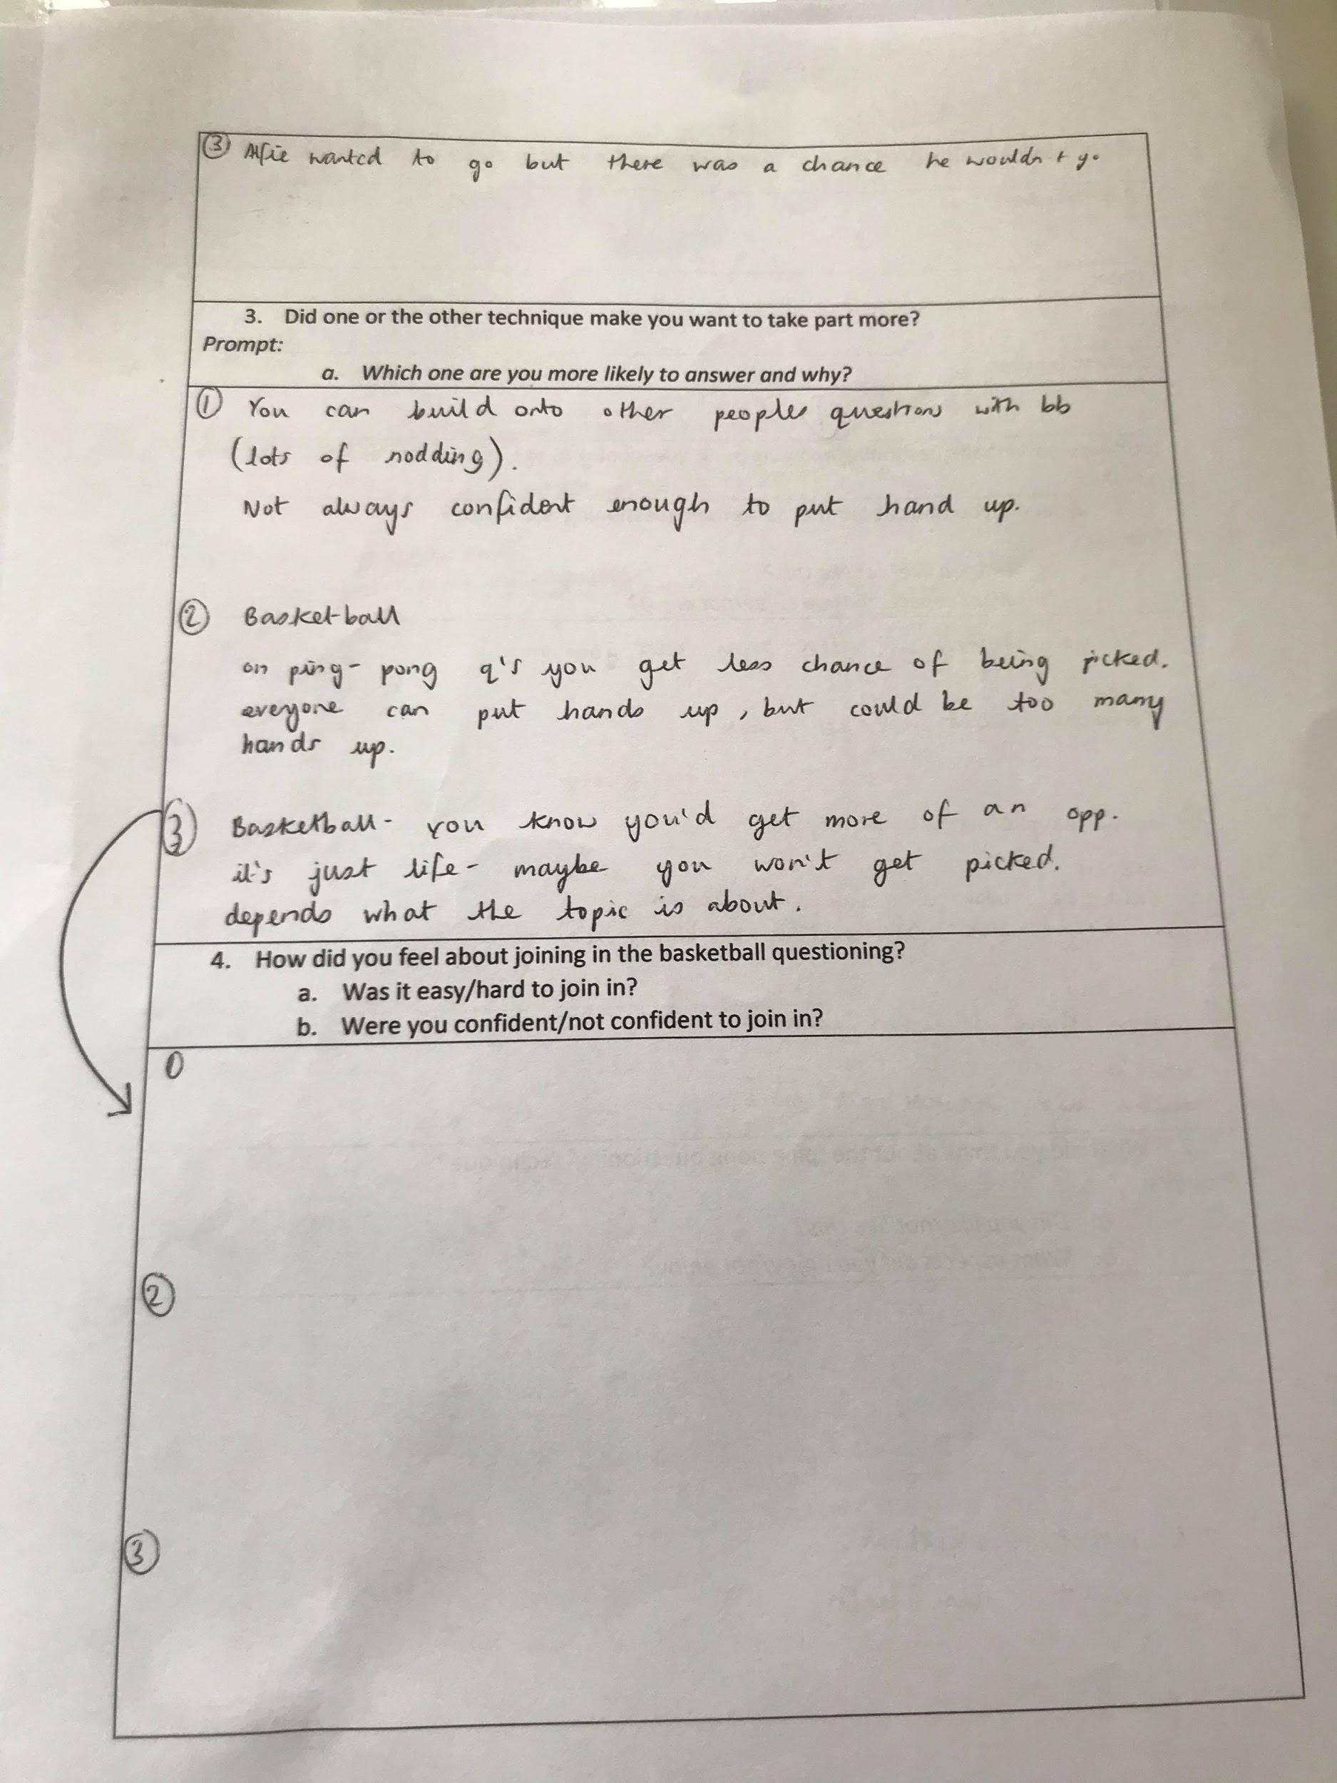

Appendix 5 - Interview field notes: Lesson study 2

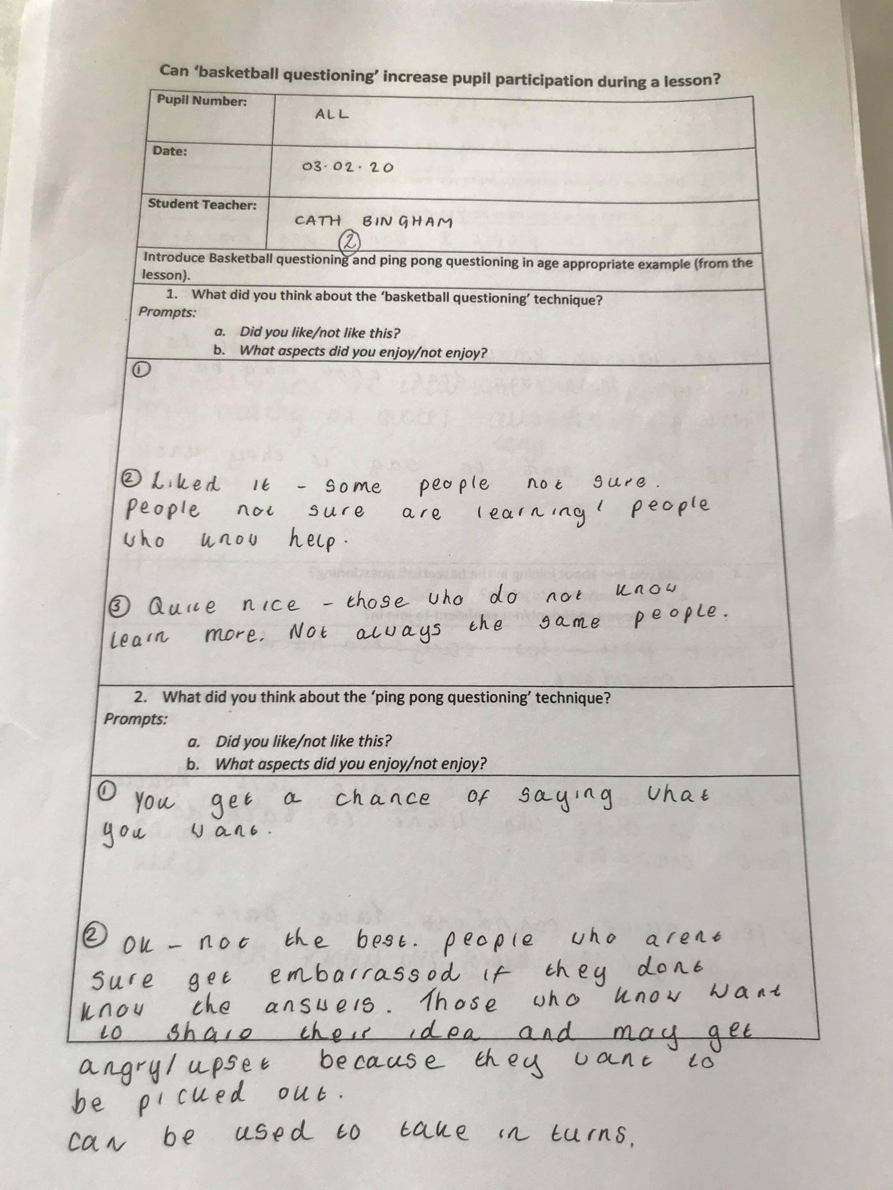

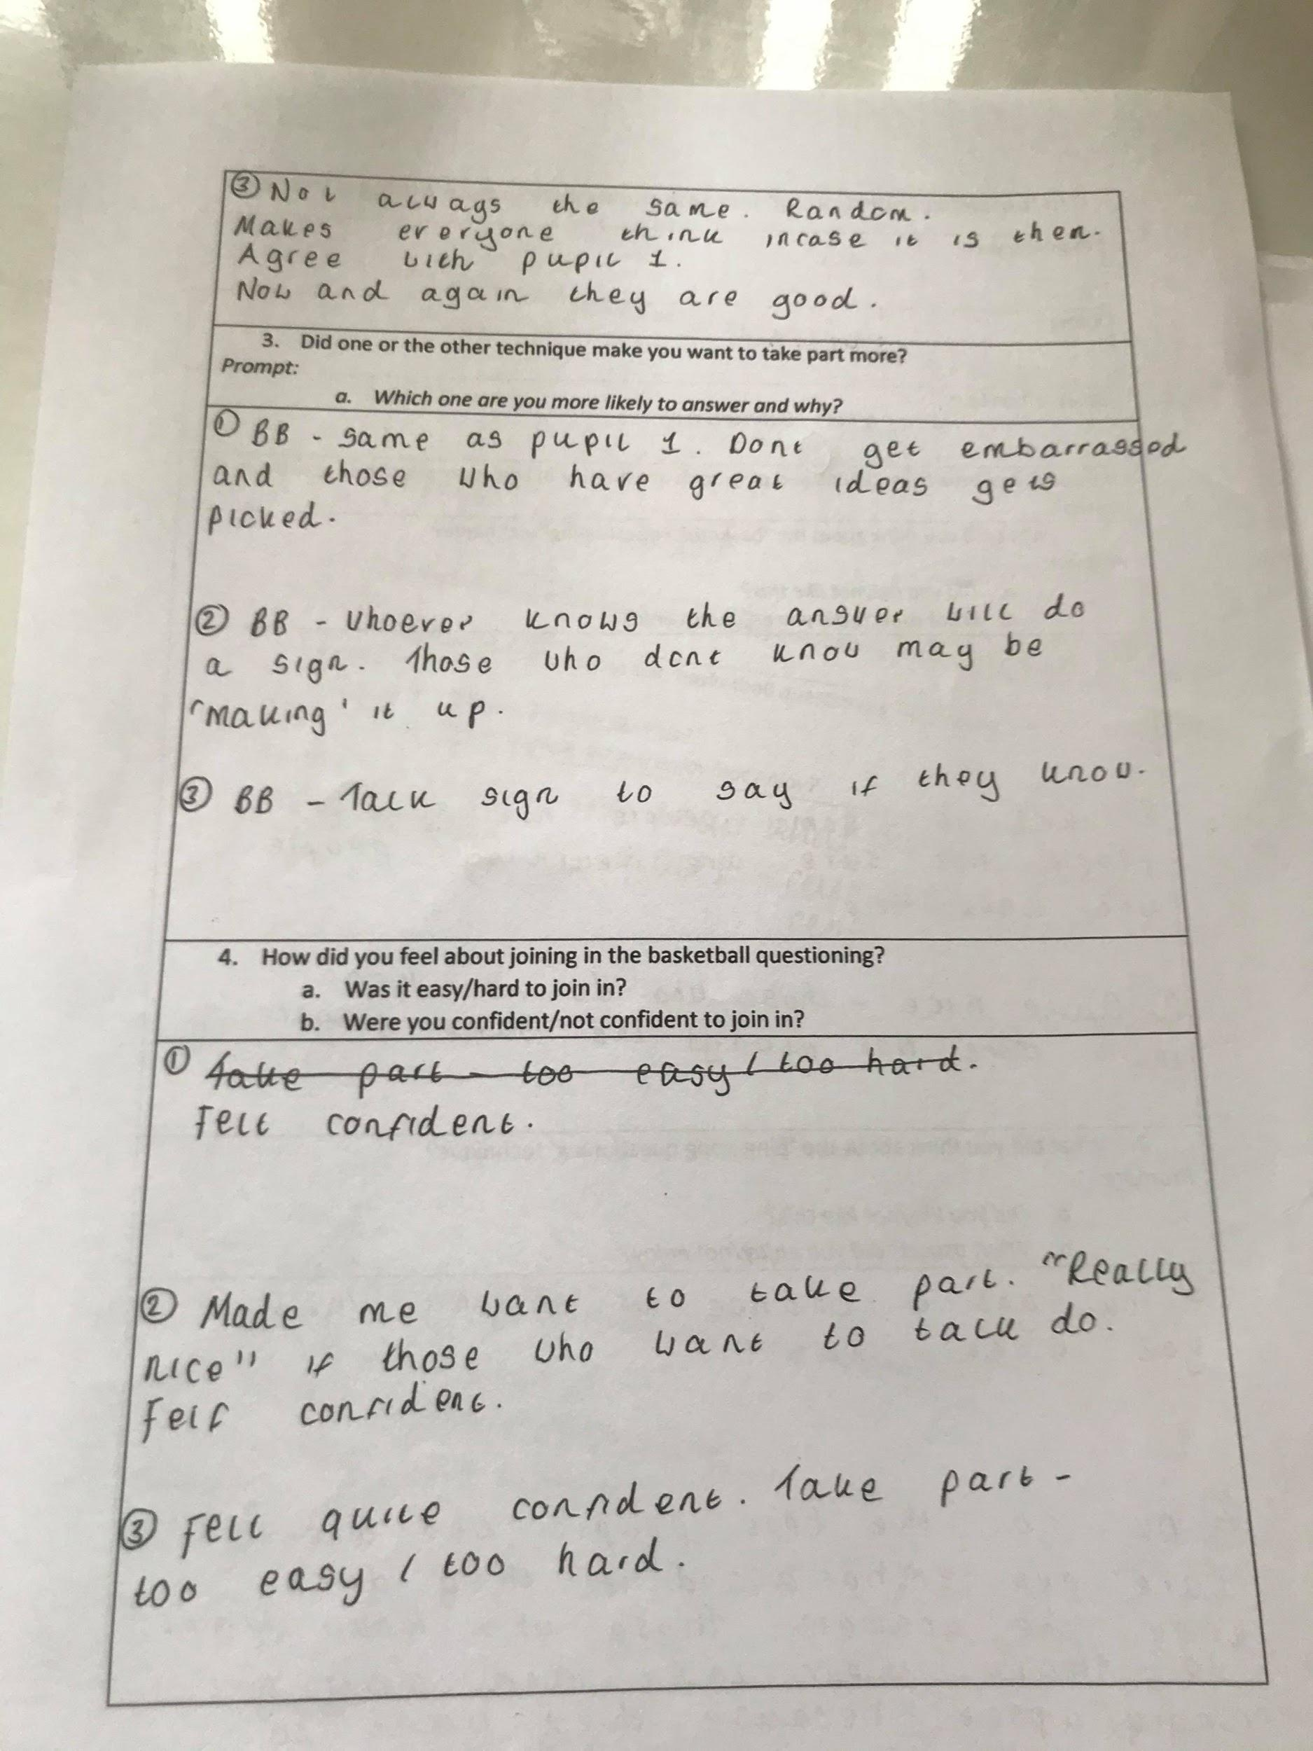

Appendix 6- Interview field notes: Lesson study 3

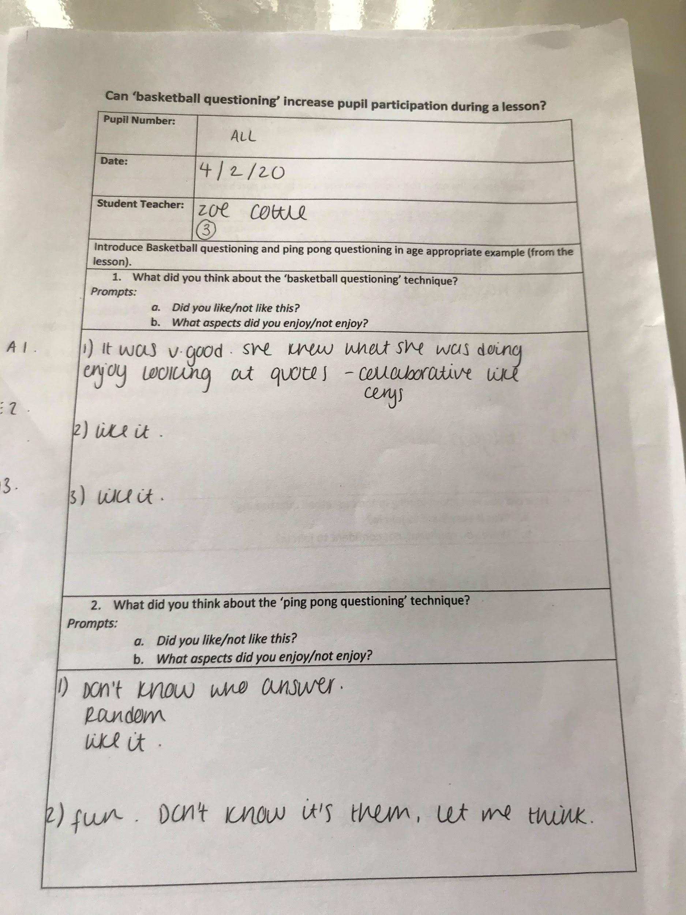

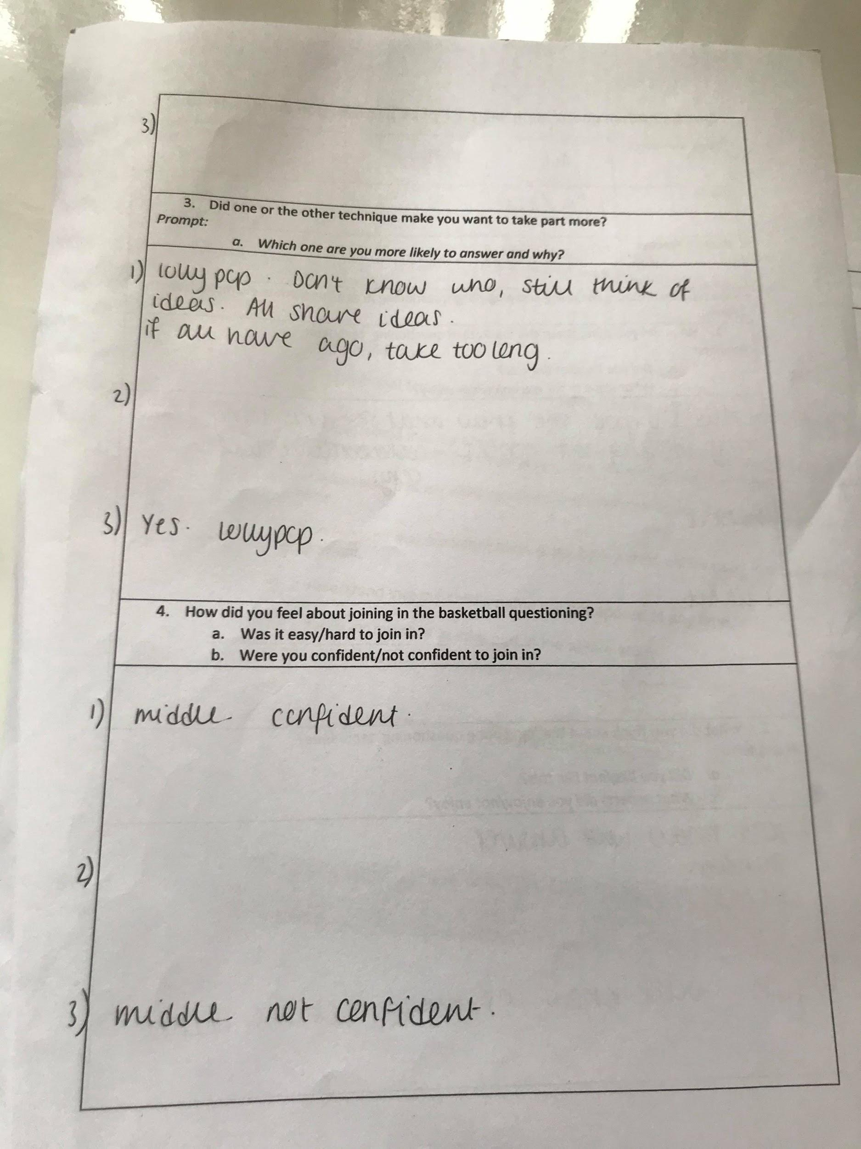

Appendix 7- Interview Transcription: Lesson study 1, 2 and 3

Transcript – Lesson 1 (Steph Dalton)
03/02/20
Miss Cottle: So we are going to ask you a couple of questions about the types of questions Miss Dalton used in the classroom. Is that okay?
All: Yes
Miss Cottle: Miss Dalton used the lollypop sticks as a form of ping pong questioning, whereby only one person could answer. Miss Dalton also used a form of basketball questioning, whereby all pupils could contribute if they wanted. One person may put their hand up, and then others can add on to their answer, so it’s like a discussion. Do you understand?
All: Yes
Miss Cottle: What did you think about the ‘basketball questioning’ technique?
Pupil 1: If you have an idea you can join in, which is similar, I like it.
Pupil 2: More people have an opinion. I like it because it could be like a group discussion.
Miss Cottle: Did you like it?
Pupil 3: It’s better than one person speaking. I like it. You’ve got more people to agree with.
Pupil 2: And you may not get picked in lollypop questioning.
Miss Cottle: Was there anything you didn’t like about it?
Pupil 3: May use basketball more. May not only lollypop sticks, maybe most of the thing was lollypop stick more.
Miss Cottle: Do you think it should be used more in class? Why?
All: Yes
Pupil 1: Yeah someone might not get picked.
Miss Cottle: Do you like basketball more?
All: Yes.
Miss Cottle: Why?
Pupil 2: If someone wants to say something in lollypop sticks, you probably won’t get picked. But in basketball questioning you can put your hand up and they’ll come to you.
Miss Cottle: We used the ping pong as the lollypop sticks. What do you think about the ping pong technique? Did you enjoy it?
Pupil 3: I particularly rathered the basketball questioning more.
Pupil 2: Like this morning, he really wanted a go.
Pupil 3: Yeah it was just lucky he got picked.
Pupil 1: Someone might not have an idea and they got picked.
Miss Cottle: Do you like lollypop sticks?
Pupil 3: I would rather basketball. But it doesn’t make a difference does it. You could use it.
Miss Cottle: Which type of technique made you want to participate more?
Pupil 3: Basketball ball because you’d get a go pretty much.
Pupil 2: Yeah basketball.
Miss Cottle: Which one are you more likely to answer in?
All: Basketball.
Miss Cottle: Why?
Pupil 2: Because you can put your hand up rather than having to get picked out of 21 people.
Pupil 3: And on the ping pong one you’ve got a less chance of being picked.
Miss Cottle: How did you feel about joining in the basketball questioning?
Pupil 3: Maybe a bit the same but a bit more, I’d rather the basketball.
Pupil 2: Yeah.
Pupil 1: You can build on other people’s questions.
Miss Cottle: Do you think its easier with the basketball to join in?
All: Yes.
Pupil 2: Definitely.
Miss Cottle: Or do you think its harder? What do you think?
All: Easier.
Miss Cottle: Because?
Pupil 2: Because everyone can put their hands up. And they’ll probably get picked.
Pupil 3: But maybe ping pong because you’ve got some people won’t get picked from basketball. Because there’s too many hands up, so you’ve got to play ping pong like.
Miss Cottle: Were you confident in the basketball questioning? Were you always confident enough to put your hand up?
Pupil 3: Yeah, just maybe you didn’t get picked, so its just life init.
Miss Cottle: Do you think you were confident in putting your hands up? Or do you think sometimes you think oh I have something to say but I’m a little bit nervous.
All: Yes.
Pupil 3: It matters what the topic is about though. If you don’t wanna say, then don’t say.
Miss Cottle: Was there ever a point in the lesson when you thought I have an idea, but didn’t get picked on the lollypop sticks.
All: Yeah.
Miss Cottle: Are there any other questions?
Miss Dalton: I don’t think so.

Transcript – Lesson 2 (Cath Bingham)
03/02/20
Miss Dalton: We are going to ask you about the sorts of questions that Miss Bingham using, she was using lolly pop sticks, asking one person a question, and then she also sometimes she was asking if you could build on it, doing your hand signals, or she was asking a question and asking someone else. We are calling this basketball questioning.
Miss Dalton: What did you think of the basketball questioning technique?
Pupil 2: I liked it, some people are like desperate and some people are not too sure. Then they’re just like they people that aren’t sure are like awh yeah, and then like the people that are bursting with ideas are also helping the people that aren’t sure. Their answers.
Miss Dalton: Ok. What do you two think?
Pupil 3: Um I thought it was quite nice because, quite similar to Pupil 2, because those who don’t know learn more, and its not always the same people.
Miss Dalton: Do you have anything to add? Was there anything you didn’t like about it?
Miss Dalton: What about the lolly pop sticks? What do you think about them?
Pupil 3: Not always the same people, it can be random and it makes them, think more then it could be me, and it might not be.
Miss Dalton: Do you know it when Miss Bingham uses the lollypop sticks?
Pupil 1: You do get a chance of saying of what you want. And even if you don’t get picked out, you still know the answer.
Pupil 2: I find it like ok, its not the best because some people are like, bursting with ideas and some are not sure, and the people that aren’t sure feel embarrassed when they get picked out and they don’t know an answer. The people that are bursting with ideas, when they get picked out, they don’t get picked out they ugh, sometimes it can like get them feeling like annoyed. They just want to share their idea and wanted to just share their idea, and they just get like ugh, I wish I was picked out, and some people aren’t always picked out and um they’ve got great ideas, and stuff. So, yeah they’re not always picked out, and they can get like upset because they like awh I want to be picked out, I’m never picked out of the lollypop sticks.
Miss Dalton: Okay what do you think about that?
Pupil 3: I agree with Pupil 2, like they pick someone they don’t know, the person who doesn’t know gets embarrassed, and people will burst with ideas why couldn’t it have been me. Just a waste of a turn.
Miss Dalton: Do you think lollypop sticks are good?
Pupil 3: Now and again they are.
Pupil 2: Yeah, like when loads of people want to do something at once, they can just put their names like in the sticks, and then whoever gets pulled out can do that thing. And then they can just take it in turns really.
Miss Dalton: Out of the lollypop sticks, and basketball, which one do you like the most?
Pupil 2: Basketball.
Pupil 1: Basketball.
Miss Dalton: Why was that?
Pupil 2: Because whoever knows the answer will do a sign, and those who don’t actually want a go, just making stuff up as they go along, when they’re doing that the other people are like awh they’re just making it up. And I’ve got like really good ideas, so they can just put their thumb up, and do the signs and they’ve got more of a chance.
Miss Dalton: Why do you two think basketball?
Pupil 3: Same as Pupil 2 really. Because its better for like, if people don’t have an idea they do get embarrassed, they may not get picked then. And the people who do have ideas do get picked, and then they don’t feel like awh pick me I had a great idea.
Miss Dalton: Do you have anything to add to that?
Pupil 2: If you don’t have an idea, um some people just use a talk sign and can pass it on to them, and they can say their idea.
Miss Dalton: Last question, how did you feel about joining in when we were doing the basketball questioning? Was it easy or hard? Did it make you want to take part?
Pupil 2: It made me want to take part.
Pupil 3: Yeah it definitely made me want to take part. There wasn’t like too hard or too easy. If it too easy you get bored, and if its too hard you get a bit annoyed.
Pupil 2: Yeah its like in the middle. It’s really nice, people that want to say the answers can say them and people that don’t don’t, so its just nice.
Miss Dalton: Did you feel confident to take part? Or were you a bit unsure?
Pupil 2: I felt confident.
Miss Dalton: What about you two?
Pupil 1: I felt quite confident.
Miss Dalton: Ok were there any other questions?
Miss Bingham: No.

Transcript – Lesson 3 (Zoe Cottle)
04/02/20
Miss Bingham: I just need to ask you some questions about Miss Cottle’s lesson. You might have noticed she was using the lollypop sticks sometimes and other times she was letting one of you answer, and then some of you added on your thoughts to those answers. So, the first method is called lollypop stick questioning, or ping pong questioning. The second one we call basketball questioning, its like its bouncing around the class. Ok, so, with those terms in mind, what did you think about the basketball questioning from Miss Cottle?
Pupil 1: It was good. Very good. She knew what she was doing, we could see that she had been planning.
Pupil 2: Yeah.
Miss Bingham: Did you like it? Not like it?
Pupil 1: I liked it.
Pupil 3: I liked it.
Pupil 1: It was a lot of fun.
Miss Bingham: What did you particularly enjoy?
Pupil 1: I enjoyed when we looked at some of the quotes, when we were ordering them, when we worked in a team and we were being collaborative like Cerys.
Miss Bingham: Anything to add?
Pupil 2: About the same as Pupil 1.
Miss Bingham: Have a think, what do you think about the ping pong style questioning? Which was the lolly pop questions.
Pupil 1: Yeah I thought it was very fun.
Pupil 3: Yeah it was fun because.
Pupil 2: We didn’t know who was going to answer it.
Miss Bingham: What did you like? What didn’t you like about it?
Pupil 1: I liked how it was just random, so she wasn’t picking herself.
Pupil 2: And I like how you don’t know whose going to do it, so someone didn’t know it was going to them, like, so if someone got it they’d like oh it’s me, now let me think how to do it.
Miss Bingham: Ok, lovely, anything to add? No? Happy? Ok? Did one or the other type of questions make you want to take part more?
Pupil 3: Yeah.
Miss Bingham: Which one?
Pupil 1: The lolly pop.
Pupil 3: Yeah the lolly pop.
Miss Bingham: So is that the one you’re more likely to answer?
Pupil 3: Yeah.
Pupil 1: Yeah, probably.
Miss Bingham: Can you explain why?
Pupil 1: Because you don’t know whose going to get it. Even if its not you, you can still think of ideas, maybe share, if you can like tell the teacher and then we can all still share ideas, instead of not, everybody not having ago. And then if we did all have ago, it would be too long and it would just be chaotic.
Miss Bingham: What could that turn into?
Pupil 1: Basketball.
Miss Bingham: Ok, anything else to add?
Pupils: No.
Miss Bingham: How did you feel about joining in the basketball questioning? Was it easy or hard to join in?
Pupil 1: In the middle.
Pupil 2: Yeah in the middle.
Miss Bingham: Can you expand?
Pupil 2: No.
Miss Bingham: Were you confident? Or not confident to join in basketball questioning?
Pupil 1: I wasnt confident.
Pupil 3: I wasn’t confident.
Miss Bingham: Can you say anything else about that? You just weren’t confident, that’s ok. Anything else to add?
Pupil 1: No.
Miss Bingham: Are you happy? Thank you for answering our questions

Appendix 8- Consent form

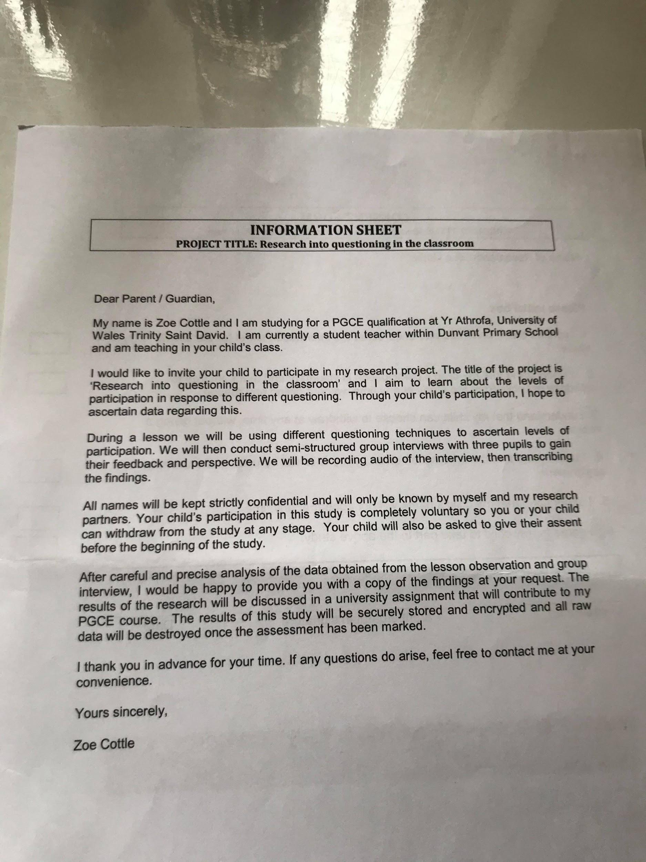

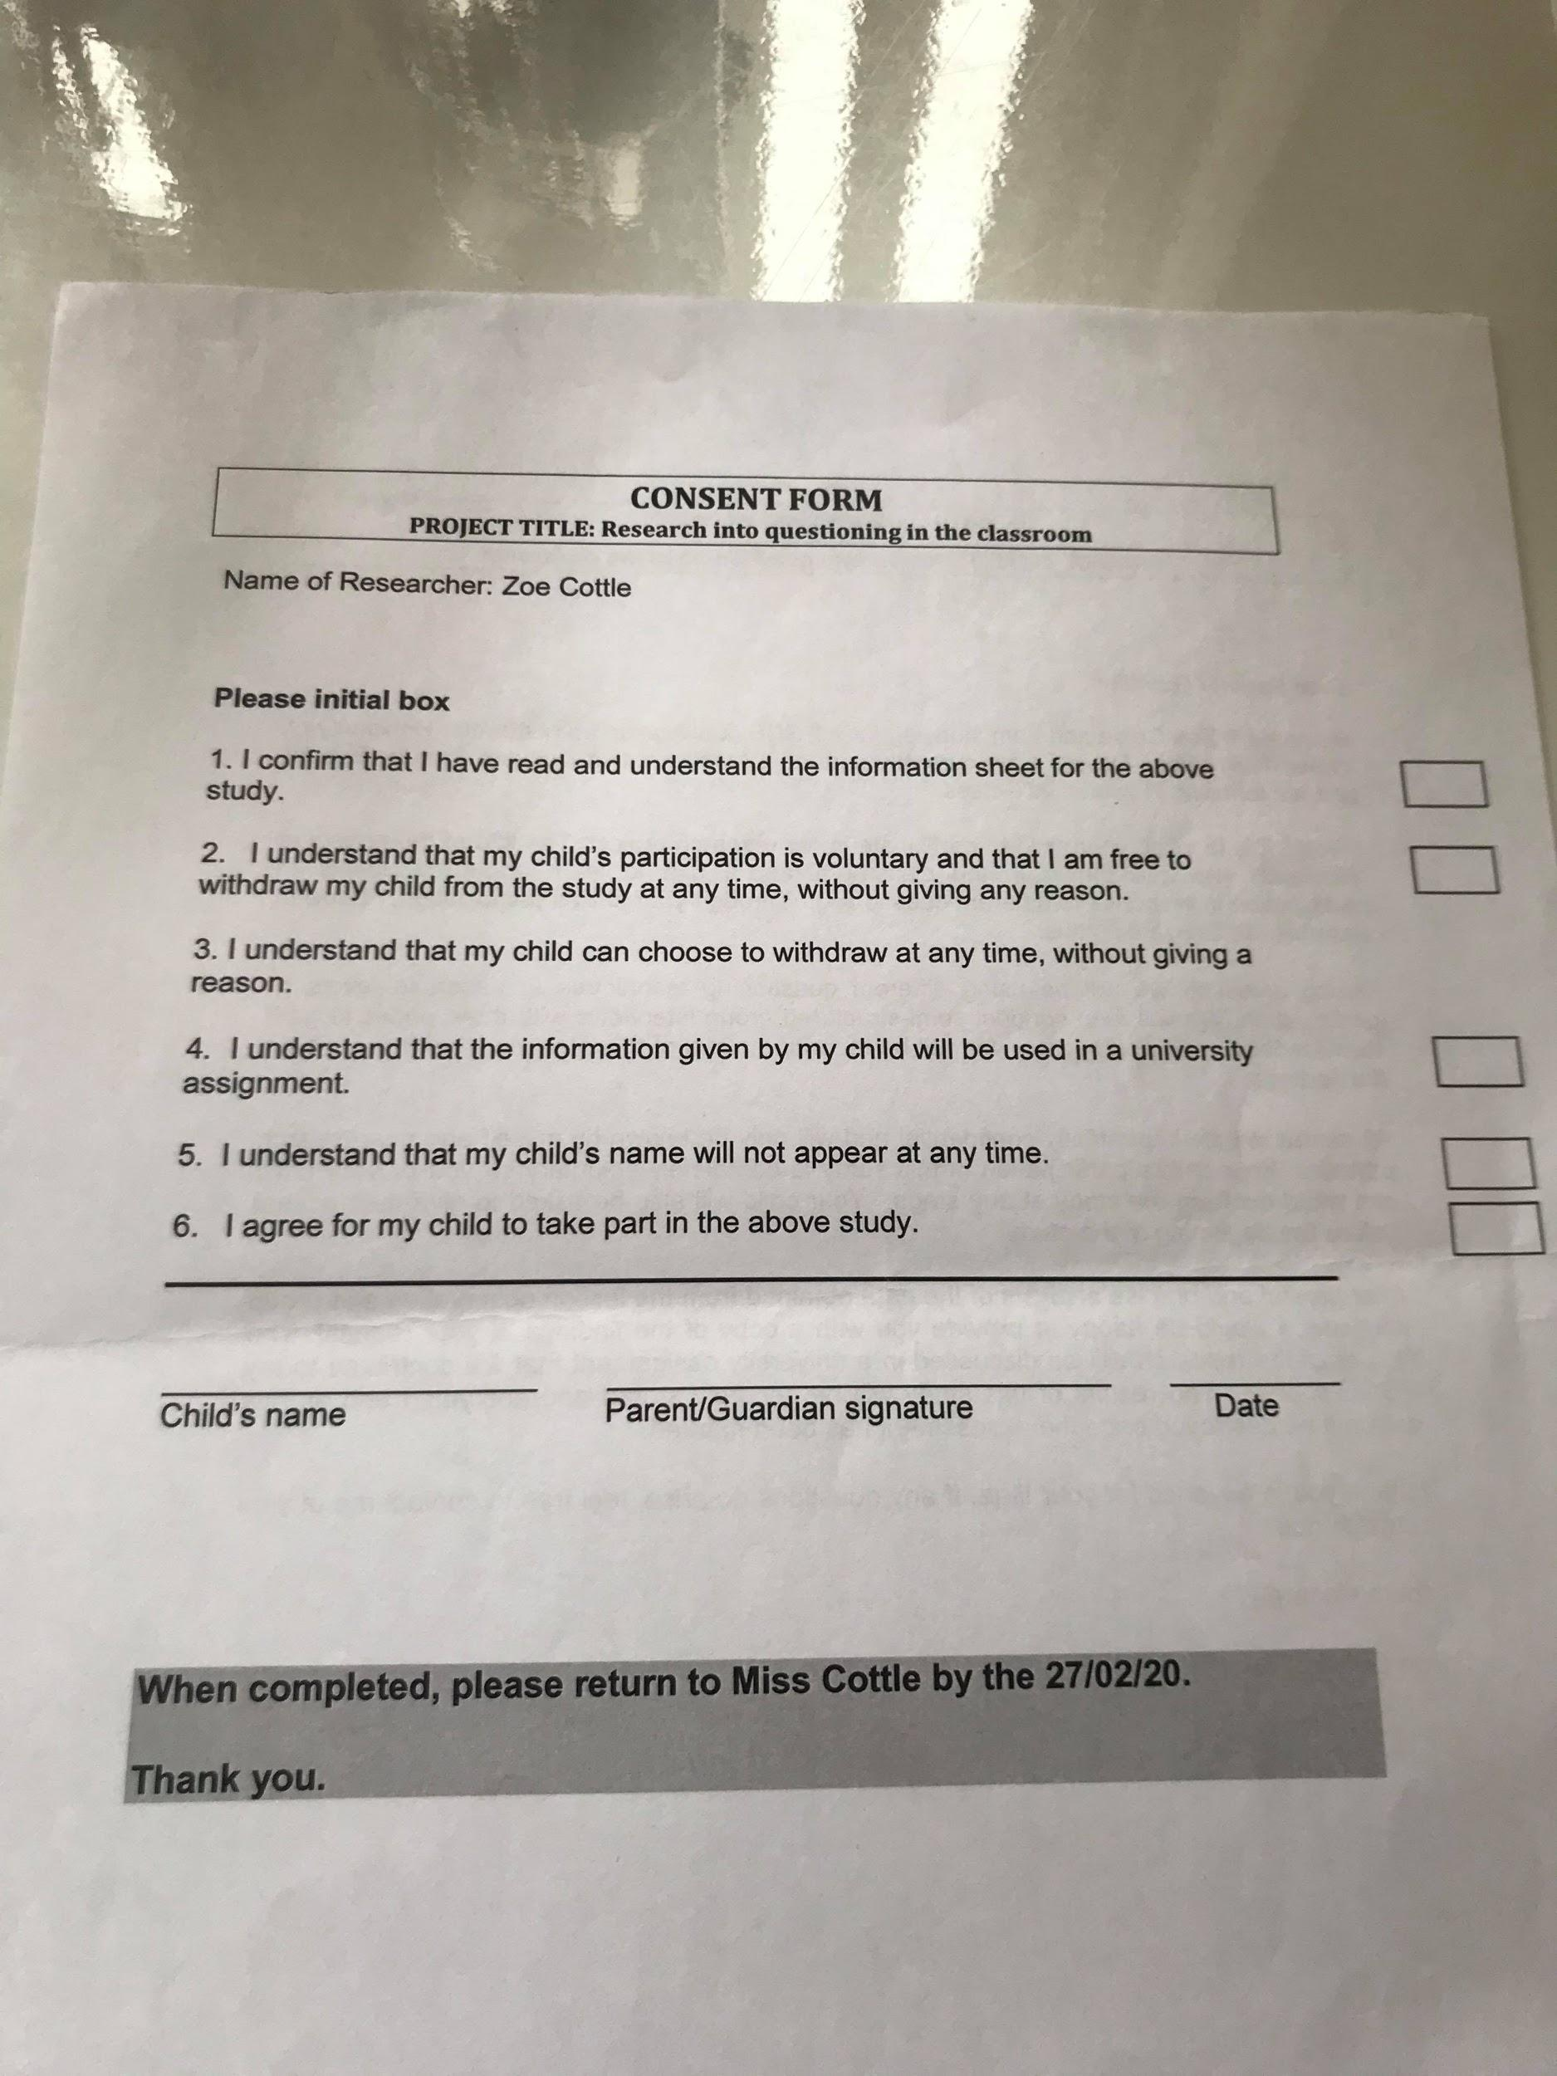

Appendix 9 - Gibbs reflective model

Description  What happened? | Feelings  What were you thinking and feeling? | Evaluation  What was good and bad about the experience?
During this action research lesson, I explored a lesson based around growth and fixed mindset. The lesson involved teaching 29 pupils in a mixed year 3/4 class. The purpose for the action research was to look at participation of pupils during different types of questions. In order to measure participation, my fellow student teachers aim was to record data on 3 different pupils focusing upon their levels of participation from the types of questions. Furthermore, there were two different types of questioning used throughout this lesson. One involved the use of basketball questioning whereby pupils bounced off each others ideas. The second type of questioning involved the use of lolly pop sticks whereby only the pupil who was picked out of the sticks had the opportunity to answer. Once the lesson had completed, myself and the other fellow student teachers participated in an interview with the 3 pupils who were focused upon during the lesson. | During this action research lesson, I was slightly disappointed in the level of participation from pupils. After making a conscious effort to use lolly pop sticks and the use of basketball technique through various types of questions, pupils did not seem to be engaging and were often replying to answers with 'I am not sure' or 'I do not know'. This therefore meant that the level of participation was a lot lower than I expected. In addition to this, the classroom environment was extremely fussy meaning that the level of participation from pupils was naturally lower. Despite this, I was pleased with the level of understanding from pupils during the lesson. I measured this analysis from the activities throughout the lesson. | I believe this action research lesson was beneficial in that it allowed myself and my fellow student teachers to explore the different types of questioning we can take forward in our future teaching practice. By this, I gained a better understanding in how pupils participation and level of engagement differed depending on the opportunity pupils had to answer questions. Looking at the negative aspects of this lesson, it could be argued that the use of lolly pop sticks may have been a disadvantage to those pupils whom in which may have had a contribution but did not have the opportunity to answer questions. Furthermore, after reflecting upon the interview with the 3 chosen pupils, some pupils may have felt embarrassed if they had been chosen but did not have the correct answer.
Analysis  What sense can you make of the situation? | Conclusion  What else could you have done? | Action Plan  What would you do next time?
Reflecting back upon my action research, I have now become aware of the importance of using different types of questioning throughout my future teaching practice. From looking at my evaluation, I will make a conscious effort to use different questions throughout. Despite this, I believe it is important to take into account that there are disadvantages to questioning and that each class needs to be personalised around the pupils needs. | Reflecting back upon my action research lesson, I could have given the opportunity to allow pupils to have a greater participation level by asking more questions. By this, I mean planning to ask more questions through the use of lolly pop sticks and basketball questioning. In addition to this, I could have put all the lolly pop sticks back into the pot once pupils names had been chosen. This would mean that pupils were all fully engaged throughout the lesson at all time as there was a probability that their name would be chosen to answer a question. | In my future teaching practice, I will ensure that I give the opportunity to allow pupils to increase their participation through using a wide range of questioning techniques. This could be through the example of lolly pop sticks whereby pupils who may feel nervous to put their hands up all had the opportunity to participate. Another example which I could use is the use of 'think-pair-share' whereby pupils worked collaboratively to come up with an answer as a pair.

