

Assignment 1
Student ID:2237335
Module:HRM
Lecturer:Gladius David Kulothungun

Contents
Introduction 4
Task 1: Current State of the Labor Market in the UK 5
1.1 Current Trends, Challenges, and Opportunities 5
Trends 5
Challenges 6
Opportunities 7
1.2 The Effect of Covid- 19 on the Labor Market 7
Immediate Impact 8
Sectoral Disparities 8
Remote Work Acceleration 8
Changing Nature of Work 8
Up skilling and Reskilling 9
Long-Term Structural Changes 9
1.3 The Effect of Brexit on the Labor Market 10
Changes in Immigration Policies 10
Impact on Industries 11
Challenges for SMEs 11
Opportunities for Domestic Workforce 11
Trade and Export Implications 11
Task 2: Emerging Human Resources Strategies 12
2.1 Emerging Human Resources Strategies 12
2.2 Human Resourcing Strategies Post Covid and Post Brexit 13
Conclusion 15
References 16

Introduction
The supply of workers and the demand for workers in different industries in the United Kingdom (UK) are always interacting with one another, making the labor market in the UK similar to a living ecosystem (Del Rio-Chanona et al., 2020). Over several decades, the employment market in the United Kingdom has changed due to several. The current situation of the British labor market, including the significant effects of the Covid-19 outbreak and the fallout from the Brexit decision, is the primary subject of this research. The dramatic changes that have occurred are the inspiration for this research into the new human resource management methods that have emerged (Alzoubi et al., 2022). The current status of the British employment market results from a confluence of domestic and international factors. Factors contributing to these tendencies include shifts in consumer behavior, advances in mechanisation and digitization, and the establishment of new business alliances.
The advantages and disadvantages of these changes will have far-reaching effects on job seekers and employers (Kaushik and Guleria, 2020). In this context, this research aims to examine the complexities of the current state of the British labor market by zeroing in on two major turning points: the effects of the Covid-19 pandemic and the environment's unique characteristics after Brexit (McCann and Vorley, 2021). Therefore, this research aims to identify the various channels via which the tendencies above have affected the British employment market. We examine how the sudden disruptions brought on by lockdowns, remote work arrangements, and changes in customer behavior have resonated through different industries as we delve into the effects of the Covid-19 pandemic. The research also analyses Brexit's effects, such as changes in immigration policy, trade dynamics, and the reorganisation of supply chains.

Task 1: Current State of the Labor Market in the UK

1.1 Current Trends, Challenges, and Opportunities
A myriad of trends, difficulties, and possibilities has transformed the landscape of the UK labor market. Klimkiewicz and Oltra (2017) stated job-seekers, businesses, and governments would all benefit greatly from a deeper comprehension of these relationships.

Trends
Several interesting developments are occurring in the UK work market. The nature of labor has changed as a result of automation and other technological developments (Andrejevic, 2019). About 7.4 per cent of professions are extremely vulnerable to automation, especially affecting normal and repetitive tasks, according to recent research by BBC London (2023).
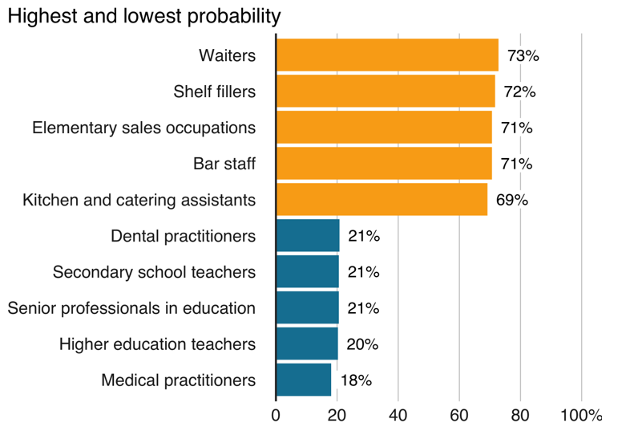
Figure 1: Jobs are at high risk of automation in the UK (Source: Office for National Statistics, 2023)
The Chartered Institute of Personnel and Development (CIPD) also reports that the gig economy is growing, with some 7.25 million people participating (Cheese, 2023). While this tendency does provide some leeway, it leads to questions about employment protections and guarantees.
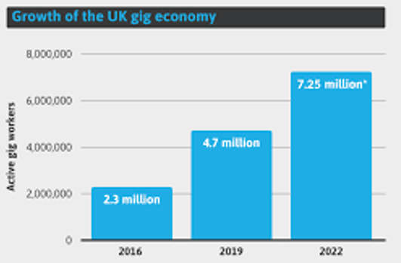
Figure 2: Growth of UK Gig Economy (Source: CIPD, 2022)

Challenges
Evident difficulties exist in the UK labor market (Bell, and Blanchflower, 2020). The Covid-19 epidemic has done significant damage. Joblessness rose from 3.9 per cent to 4.9 per cent due to the pandemic, according to the BBC (2020). Job losses in the hotel and retail industries disproportionately impacted vulnerable people due to lockdown measures.
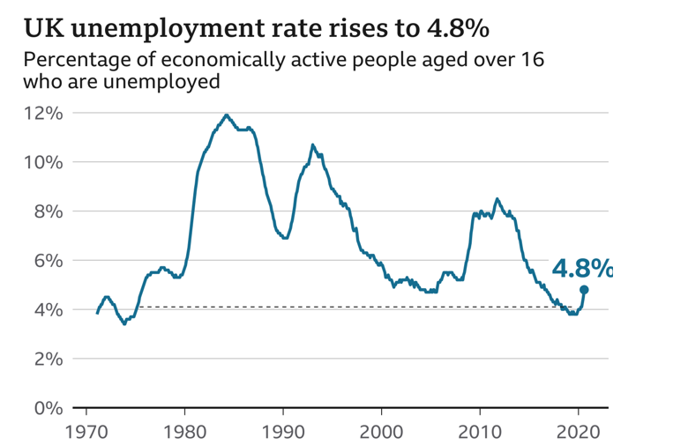
Figure 3: UK Unemployment Rate (Langella and Manning, 2022)
According to Buchholz et al. (2020), 5.3 million Adults in the UK have never used the internet, according to the UK Office of Communications (Ofcom), highlighting the necessity of digital literacy as the pandemic spread. This digital gap hinders people from taking advantage of online education and employment prospects.

Opportunities
Despite difficulties, there are openings in the UK job market. With the proliferation of remote work made possible by modern technology, businesses have access to more potential employees (Leonardi, 2021). The Office of National Statistics (2020) revealed that 38 percent of British workers performed their duties remotely throughout the pandemic.
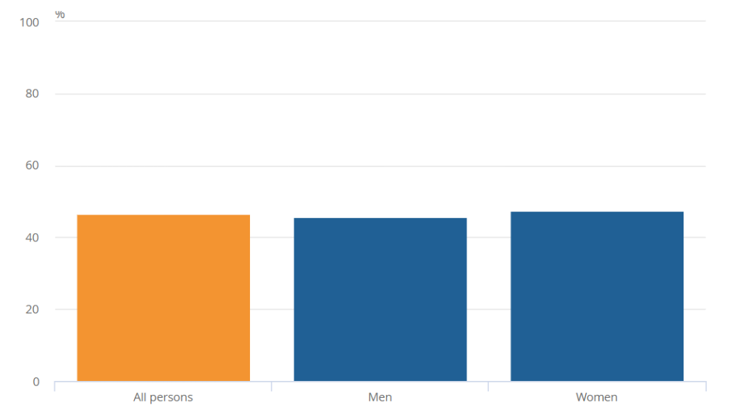
Figure 4: Gender working percentage from home (Source: Office for National Statistics, 2020)
Furthermore, green job growth has been observed since the UK government strives for zero emissions by 2050 (Chapungu et al., 2022). Two million green jobs are expected to be created by the Green Jobs Taskforce in fields including renewable energy and sustainable transportation.

1.2 The Effect of Covid- 19 on the Labor Market
The global economy, particularly the UK labor market, has seen the effects of the Covid-19 pandemic (Ando et al., 2022). Several areas of the United Kingdom's job market have been significantly influenced by the extraordinary nature of the epidemic and the subsequent actions adopted to control its spread.

Immediate Impact
According to Sahu and Kumar (2020), the government of the United Kingdom went into lockdown mode when the pandemic hit. Because of this, many establishments had to temporarily close their doors, resulting in a dramatic rise in the number of people out of work. According to the ONS, the unemployment rate will rise sharply from 3.9% to 4.9% by the end of 2020.

Sectoral Disparities
The consequences of the pandemic on the UK labor market varied widely between sectors. Breier et al. (2021) stated businesses in the hotel, tourist, and retail sectors were struck particularly severely because of their reliance on customer visits and road trips. According to ONS data, the number of people employed in the lodging and food services sector dropped by a shocking 43%. Workers in these fields saw widespread layoffs, reduced hours, and furloughs.

Remote Work Acceleration
On the other hand, the pandemic prompted a surge in telecommuting. To maintain efficiency, many businesses have implemented remote work policies (Baryshnikova et al., 2021). According to the ONS Labor Market Survey, 86 per cent of workers were telecommuting at the height of the pandemic. Worker adaptability to new technology and virtual collaboration tools became increasingly important, highlighting the significance of digital skills.

Changing Nature of Work
The epidemic has also hastened changes in the character of employment. As more people can work from home, the line between work and life has become increasingly porous. Parham and Rauf (2020) asserted work-life balance, mental health, and burnout are all issues raised in response to the benefits of remote work. Some jobs once considered indispensable and carried out in person also encountered difficulties. Frontline workers in healthcare, supermarket delivery, and food preparation continued to put themselves in harm's way.

Up skilling and Reskilling
The epidemic highlighted the significance of acquiring and practicing new skills. Due to the decline in manufacturing, many people lost their jobs. Because of this, many people have decided to change careers or upgrade their skill sets to keep up in the labor market (Costa Dias et al., 2020). According to many online education providers, courses in data analysis, programming, and digital literacy have seen a rise in popularity.

Long-Term Structural Changes
There will be lasting effects on the job market from the epidemic. Some ongoing structural shifts have been expedited as a result. For example, businesses increasingly turn to automation and AI tools to lessen their dependency on human workers in preparation for potential disruptions (Chen and Biswas, 2021). According to the Chartered Institute of Personnel and Development, there will be a rise in demand for highly trained workers in the United Kingdom.

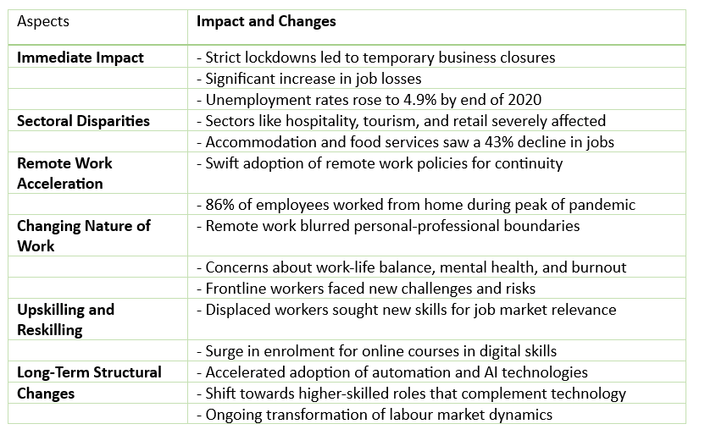
Figure 5: The effect of Covid- 19 on the labor market (Source: By Author)

1.3 The Effect of Brexit on the Labor Market
As a result of Britain's decision to leave the European Union (EU), the employment market has undergone significant transformations that have altered its dynamics and presented new opportunities and difficulties (Jagannathan et al., 2019). Economists, policymakers, and businesses in the United Kingdom are increasingly concerned about the effects of Brexit on the labor market as the country figures out its future relationship with the European Union.

Changes in Immigration Policies
Changing immigration policy is one of the most obvious and significant ways Brexit will affect the labor market. According to Portes (2021), after the UK and EU ended their free movement agreement, the UK instituted a points-based immigration system. Education, language skills, and job offers in shortage industries are prioritised in this approach. According to government reports, concerns concerning the loss of domestic employees have been addressed by designing a mechanism to attract highly skilled individuals.

Impact on Industries
Different sectors, especially those that rely significantly on EU employees, have felt different impacts from Brexit. Historically, industries including construction, agriculture, and healthcare have looked to the EU for workers, especially hard-to-fill positions (Foster et al., 2020). According to market research, the recent change in immigration policies has prompted worries about a scarcity of workers and the possibility of supply chain disruptions.

Challenges for SMEs
Brexit has presented unique difficulties for small and medium-sized businesses. These companies frequently lack the means to adapt to shifting international trade norms and ever-evolving regulations. According to Gherghina et al. (2020), customs checks and paperwork add extra costs and administrative hassles for small and medium-sized enterprises (SMEs) that export or import items to or from the European Union.

Opportunities for Domestic Workforce
The domestic workforce in the UK has also benefited from Brexit. Tovmasyan and Minasyan (2020) argued when companies are required to fill more positions with domestic workers, they have more incentive to provide career development opportunities for citizens. There is an opportunity to close skill gaps and provide more equal job opportunities to the people of the United Kingdom as firms attempt to minimise their reliance on foreign employees.

Trade and Export Implications
Although the trade relationship established after Brexit is not primarily a labor market concern, it does affect job opportunities and export-dependent industries (Du et al., 2023). New trade barriers may reduce the demand for specific products and services, which could affect the number of people employed in their production and distribution.

Task 2: Emerging Human Resources Strategies

2.1 Emerging Human Resources Strategies
Emerging HR solutions are helping organisations navigate the rapidly changing world driven by events like the COVID-19 epidemic and Brexit (David et al., 2023). These strategies use innovative methods to address disturbances and capitalise on development and resilience. Remote work and flexible arrangements are prominent HR trends. Work structures are changing to enable remote work, allowing employees to balance work and life. Fully remote work methods allow companies like Buffer to access a global talent pool and cut office overhead costs. Upskilling and reskilling have grown due to Covid-19 and Brexit. HR strategies now emphasise equipping workers for new tasks and responsibilities (Farndale and Vaiman, 2022). Amazon's "Upskilling 2025" programme offers machine learning and cloud computing training. HR methods also emphasise employee well-being and mental health support. Remote employment and Brexit, and pandemic uncertainty have increased stress (Crasii and Nawar, 2022). Mental health resources, flexible work hours, and wellness programs are being implemented to address these issues. Unilever's "Wellbeing Zone" shows how companies support employees' mental and physical health.
Emerging HR practices promote diverse, equitable, and inclusive workplaces as social issues gain attention (Shore et al., 2018). Companies are taking action to combat systematic prejudices and inequality. Microsoft's Chief Diversity Officer Job and other DEI initiatives demonstrate the company's commitment to inclusive cultures that empower all employees. Agile workforce planning is also needed due to Brexit and pandemic concerns. By matching worker demands with business goals, emerging HR strategies allow organisations to react quickly to changing market conditions (Subramanian and Suresh, 2022). Procter & Gamble uses agile methods to change employee size and skills to change business requirements.
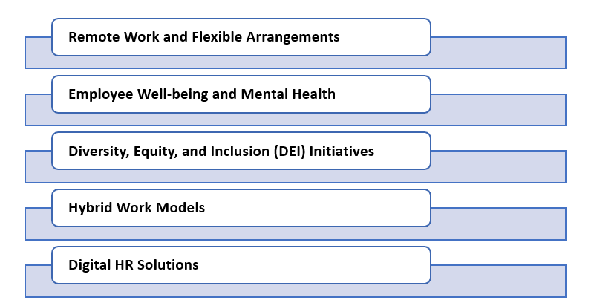
Figure 6: Emerging HR Strategies (Source: By Author)
Many companies are considering hybrid work models that combine remote and on-site employment as workplaces evolve. This technique mixes remote work with in-person workplace collaboration and socialisation. According to Cappelli (2021), HSBC's hybrid work patterns and office space reduction show companies adapting their workspaces to flexible arrangements. Finally, these HR practices heavily rely on technology. Digital platforms are used for talent recruiting, onboarding, performance management, and employee engagement (Malik et al., 2022). The use of AI and analytics for predictive workforce planning is growing, helping organisations make employment decisions.

2.2 Human Resourcing Strategies Post-Covid and Post Brexit
Blum and Neumärker (2021) asserted organisations have rethought and returned to their human resourcing strategies after the Covid-19 epidemic and Brexit. In response to skill shortages brought on by changes in immigration regulations due to Brexit, some companies are investing in locally tailored workforce development programs. They're teaming up with schools and training facilities in the area to offer students courses designed specifically to meet the regional labour market demands (Leigh et al., 2020). For instance, Airbus in the United Kingdom has partnered with local educational institutions to establish apprenticeship programs that teach students in-demand aeronautical expertise. Companies have formed adaptation-focused employee resource groups in response to Covid-19 and Brexit. These communities provide outlets for workers to talk to one another about the challenges they're facing and brainstorm ways to overcome them. Lucas et al. (2017) highlighted when adapting to new legislation, working remotely, or a shifting job market, the ERGs provide more than simply moral support.
Some companies have implemented resilience training programs to help their staff deal with the unpredictability caused by the pandemic and Brexit (Brown et al., 2020). These courses help participants develop the psychological and emotional fortitude necessary to deal effectively with uncertainty, stress, and transition. Businesses like Deloitte have used mindfulness training and stress reduction seminars to help their workers. Organisations are giving workers more leeway in spending their time off in response to Covid-19 and Brexit (Castro-Conde, 2021). Benefits, including health insurance, retirement savings plans, and flexible work schedules, are available for employees. For example, Unilever's "Wellbeing Choices" programme lets workers tailor their benefits to support their personal health and wellness objectives better. Organisations are moving towards outcome-based performance management as remote work increases in popularity. They are shifting their emphasis from purely quantitative measures, such as hours worked, to qualitative ones, such as the value employees provide to the company. According to Borgonovi et al. (2019), companies like GitLab have adopted a remote workforce and use outcome-based performance management, which emphasises actual output more than the number of hours an employee spends in an office. Remote employment allows some businesses access to a wider pool of qualified candidates worldwide (Adisa et al., 2023). To have access to a wider range of expertise and viewpoints, they are actively recruiting internationally. The WordPress development team at Automatic uses a fully dispersed model, bringing together specialists worldwide.
Organisations are promoting the development of cross-functional skills to increase employees' versatility and adaptability (Ahmed et al., 2021). The company encourages its workers to broaden their horizons by taking on tasks outside their normal duties. The "Job Swap" programme at Adobe allows workers to take on different responsibilities inside the company temporarily. After Covid-19 and Brexit, the landscape has changed, and these novel approaches reflect that. Borgonovi et al. (2018) stated organisations can improve their chances of thriving in times of change and uncertainty by implementing localised staff development, resilience training, and outcome-based performance management.

Conclusion
Human resource management is undergoing a paradigm shift due to the confluence of the Covid-19 pandemic and Brexit. In response, businesses have become more agile and creative in their talent acquisition, cultivation, and retention approaches. Central to these approaches is the rise of the remote worker, flexibility in workforce planning, and a relentless focus on employees' health and happiness. Companies are adjusting to the challenges brought on by disruptions and making the most of the opportunities that have arisen due to them. These innovative approaches to human resource management will be crucial in building adaptable, innovative, and people-focused businesses that can survive and prosper in today's volatile business environment.

References
Adisa, T.A., Ogbonnaya, C. and Adekoya, O.D., 2023. Remote working and employee engagement: a qualitative study of British workers during the pandemic. Information Technology & People, 36(5), pp.1835-1850.
Ahmed, R., Rafique, A. and Philbin, S.P., 2021. Cross-functional integration between organizational structure and the new product development process. Organization Development Institute, 39(4), pp.63-78.
Alzoubi, H.M., Ghazal, T.M., Sahawneh, N. and Al-kassem, A.H., 2022. Fuzzy assisted human resource management for supply chain management issues. Annals of Operations Research.
Ando, M.S., Balakrishnan, M.R., Gruss, B., Hallaert, M.J.J., Jirasavetakul, L.B.F., Kirabaeva, K., Klein, N., Lariau, A., Liu, L.Q., Malacrino, D. and Qu, M.H., 2022. European labor markets and the COVID-19 pandemic: Fallout and the path ahead. International Monetary Fund.
Andrejevic, M., 2019. Automating surveillance. Surveillance & society, 17(1/2), pp.7-13.
Baryshnikova, N., Kiriliuk, O. and Klimecka-Tatar, D., 2021. Enterprises’ strategies transformation in the real sector of the economy in the context of the COVID-19 pandemic. Production Engineering Archives, 27.
BBC. 2020. UK unemployment rate continues to surge. Available from: https://www.bbc.com/news/business-54884592
BBC. 2023. Automation could replace 1.5 million jobs. Available from: https://www.bbc.com/news/business-47691078
Bell, D.N. and Blanchflower, D.G., 2020. US and UK labour markets before and during the Covid-19 crash. National Institute Economic Review, 252, pp.R52-R69.
Blum, B. and Neumärker, B.K., 2021. Lessons from globalization and the COVID-19 pandemic for economic, environmental and social policy. World, 2(2), pp.308-333.
Borgonovi, E., Anessi-Pessina, E. and Bianchi, C. eds., 2018. Outcome-based performance management in the public sector. Cham: Springer International Publishing.
Borgonovi, E., Bianchi, C. and Rivenbark, W.C., 2019. Pursuing community resilience through outcome-based public policies: Challenges and opportunities for the design of performance management systems. Public Organization Review, 19, pp.153-158.
Breier, M., Kallmuenzer, A., Clauss, T., Gast, J., Kraus, S. and Tiberius, V., 2021. The role of business model innovation in the hospitality industry during the COVID-19 crisis. International Journal of Hospitality Management, 92, p.102723.
Brown, R., Kalafsky, R.V., Mawson, S. and Davies, L., 2020. Shocks, uncertainty and regional resilience: The case of Brexit and Scottish SMEs. Local Economy, 35(7), pp.655-675.
Buchholz, B.A., DeHart, J. and Moorman, G., 2020. Digital citizenship during a global pandemic: Moving beyond digital literacy. Journal of Adolescent & Adult Literacy, 64(1), pp.11-17.
Cappelli, P., 2021. The future of the office: Work from home, remote work, and the hard choices we all face. Wharton School Press.
Castro-Conde, C.A., 2021. The common response to COVID-19: The EU on the road toward de-crisisification?. In Federalism and the Response to COVID-19 (pp. 250-261). Routledge India.
Chapungu, L., Nhamo, G., Chikodzi, D. and Maoela, M.A., 2022. BRICS and the Race to Net-Zero Emissions by 2050: Is COVID-19 a Barrier or an Opportunity?. Journal of Open Innovation: Technology, Market, and Complexity, 8(4), p.172.
Cheese, P., 2023. CIPD. In Encyclopedia of Human Resource Management (pp. 44-45). Edward Elgar Publishing.
Chen, Y. and Biswas, M.I., 2021. Turning crisis into opportunities: how a firm can enrich its business operations using artificial intelligence and big data during COVID-19. Sustainability, 13(22), p.12656.
CIPD. 2022. To gig or not to gig? Stories from the modern economy. Available from: https://www.cipd.org/uk/knowledge/reports/gig-economy-report/
Costa Dias, M., Joyce, R., Postel‐Vinay, F. and Xu, X., 2020. The challenges for labour market policy during the Covid‐19 pandemic. Fiscal Studies, 41(2), pp.371-382.
Crasii, O. and Nawar, Y.S., 2022. Exploring the Effect of Business Strategy on Employees’ Retention During Pandemic and After Brexit: The case Home Care Sector in UK. The Business & Management Review, 13(2), pp.134-144.
David, A., Terstriep, J. and Zbierowski, P., 2023. 11. Riding the wave: resilient Polish migrant entrepreneurs navigating Brexit and COVID-19 in the UK. Research Handbook on Transnational Diaspora Entrepreneurship, p.220.
Del Rio-Chanona, R.M., Mealy, P., Pichler, A., Lafond, F. and Farmer, J.D., 2020. Supply and demand shocks in the COVID-19 pandemic: An industry and occupation perspective. Oxford Review of Economic Policy, 36(Supplement_1), pp.S94-S137.
Du, J., Shepotylo, O. and Beyza, E., 2023. Brexit Uncertainty and Trade in Services: Evidence from the UK Creative Industries 2014–2019.
Farndale, E. and Vaiman, V., 2022. HR professionals and talent management: Navigating the dynamic macro context. In Talent Management: A Decade of Developments (pp. 107-125). Emerald Publishing Limited.
Foster, J., Hodder, S.G., Goodwin, J. and Havenith, G., 2020. Occupational heat stress and practical cooling solutions for healthcare and industry workers during the COVID-19 pandemic. Annals of work exposures and health, 64(9), pp.915-922.
Gherghina, Ș.C., Botezatu, M.A., Hosszu, A. and Simionescu, L.N., 2020. Small and medium-sized enterprises (SMEs): The engine of economic growth through investments and innovation. Sustainability, 12(1), p.347.
Jagannathan, S., Ra, S. and Maclean, R., 2019. Dominant recent trends impacting on jobs and labor markets-An Overview. International Journal of Training Research, 17(sup1), pp.1-11.
Kaushik, M. and Guleria, N., 2020. The impact of pandemic COVID-19 in workplace. European Journal of Business and Management, 12(15), pp.1-10.
Klimkiewicz, K. and Oltra, V., 2017. Does CSR enhance employer attractiveness? The role of millennial job seekers' attitudes. Corporate Social Responsibility and Environmental Management, 24(5), pp.449-463.
Langella, M. and Manning, A., 2022. Residential Mobility and Unemployment in the UK. Labour Economics, 75, p.102104.
Leigh, N.G., Kraft, B. and Lee, H., 2020. Robots, skill demand and manufacturing in US regional labour markets. Cambridge Journal of Regions, Economy and Society, 13(1), pp.77-97.
Leonardi, P.M., 2021. COVID‐19 and the new technologies of organizing: digital exhaust, digital footprints, and artificial intelligence in the wake of remote work. Journal of Management Studies, 58(1), p.249.
Lucas, J., Gora, E. and Alonso, A., 2017. A view of the global conservation job market and how to succeed in it. Conservation Biology, 31(6), pp.1223-1231.
Malik, A., Thevisuthan, P. and De Sliva, T., 2022. Artificial Intelligence, Employee Engagement, Experience, and HRM. In Strategic human resource management and employment relations: An international perspective (pp. 171-184). Cham: Springer International Publishing.
McCann, P. and Vorley, T. eds., 2021. Productivity and the pandemic: challenges and insights from Covid-19. Edward Elgar Publishing.
Office For National Statistics. 2020. Coronavirus and homeworking in the UK: April 2020. Available from: https://www.ons.gov.uk/employmentandlabourmarket/peopleinwork/employmentandemployeetypes/bulletins/coronavirusandhomeworkingintheuk/april2020
Parham, S. and Rauf, M.A., 2020. COVID-19 and obligatory remote working in HEIs: An exploratory study of faculties’ work-life balance, well-being and productivity during the pandemic. International Journal of Economics, Commerce and Management, 8(12), pp.384-400.
Portes, J., 2021. Between the Lines: Immigration to the UK between the Referendum and Brexit. Brexit Institute, WP, (12-2020).
Sahu, K.K. and Kumar, R., 2020. Current perspective on pandemic of COVID-19 in the United States. Journal of family medicine and primary care, 9(4), p.1784.
Shore, L.M., Cleveland, J.N. and Sanchez, D., 2018. Inclusive workplaces: A review and model. Human Resource Management Review, 28(2), pp.176-189.
Subramanian, N. and Suresh, M., 2022. Assessment framework for agile HRM practices. Global Journal of Flexible Systems Management, 23(1), pp.135-149.
Tovmasyan, G. and Minasyan, D., 2020. The Impact of Motivation on Work Efficiency for Both Employers. Business Ethics and Leadership, 4(3).

