

Student Name: Mahabubur Rahman Rahat
Student ID: 2436043

Module Name: Strategic Management
Module Code: LCMB7003

Assignment Title: Assessment component: Individual report
Lecturer’s Name: Jean Wang

Work Count: 5101

Submission date: 15/12/2025


Strategic Market Expansion of Adidas: A Comprehensive Analysis of Entry into Nigeria

Executive summary
In this report, the researcher advises Adidas AG to adopt a step-by-step, omni-channel plan for entering into Nigeria. The analysis is developed on Porter's Five Forces, PESTEL, VRIO/RBV, value chain and portfolio tools (Ansoff, BCG). The entry will consist of instant online presence through Adidas e-commerce and marketplaces, limited flagship stores and shop-in-shops in Lagos and Abuja within 18-24 months, and broader coverage with the local distribution through wholesale and franchising.
The priorities include product and price adjustment to local demand (football & lifestyle), local supply and returns logistics, and sports partnerships to enhance brand awareness and ESG and compliance risk management.
The use of a Balanced Scorecard (financial, customer, process, learning and sustainability KPIs) will be used to track success. The strategy applies the powerful brand and resources of Adidas and mitigates potential risks such as inflation, FX, and regulations using hedging and local alliances.
Table of Contents
1. Introduction & company overview 4
1.1 Brief history, mission and core values 4
1.2 Main products, services and business model 4
1.3 Recent financial performance (five-year summary; key ratios) 5
1.4 Why Adidas is relevant for strategic analysis; the 2025 strategic challenge 6
2. External environment analysis & competitive positioning 7
2.1 Porter’s Five Forces Nigerian sportswear / athleisure 7
2.2 Tailored PESTEL focus on 2–3 critical macro factors 9
2.3 Strategic threats and opportunities (synthesis) 10
2.4 Strategic-group map & key competitors 11
2.5 Critical evaluation of frameworks 12
3. Internal Analysis 12
3.1 Resource-Based View (RBV) and VRIO Assessment 12
3.2 Value Chain Analysis 15
3.3 Business-Level Strategy (Porter’s Generic Strategies) 16
3.4 Comparative Competitive Advantage vs Rivals 17
4. Strategic Options and Decision-Making 18
4.1 Applying Ansoff’s Matrix to Adidas’ Growth Strategy 18
4.2 Corporate-Level Strategies: M&A, Alliances, and International Expansion 20
4.3 Portfolio Analysis Using BCG Matrix / GE Matrix 21
4.4 Key Strategic Decisions in the Last Five Years 22
5. Data Analysis, Strategic Implementation, and Recommendations 23
5.1 Financial Data Analysis to Support Strategic Recommendations 24
5.2 Scenario Planning for Strategic Options 25
5.3 Strategic Recommendations 26
5.4 Implementation Challenges 27
Conclusion 28
References 29
Appendices 31
Appendix A: Gantt Chart – Market Entry Timeline (36 Months) 31
Appendix B: Financial Summary Tables (Adidas & Nigerian Market) 31
Appendix C: Balanced Scorecard for Adidas Nigeria 32
Appendix D: Strategic Group Map – Nigeria Sportswear Market 33
Appendix E: Risk Register and Mitigation Plan 33

1. Introduction & company overview

1.1 Brief history, mission and core values
Adidas AG was founded in 1949 in Herzogenaurach, Germany, and has since evolved into one of the world’s leading sporting-goods companies, operating globally across footwear, apparel and accessories. The company’s stated purpose is to “be the best sports brand in the world” and its corporate narrative emphasises sport’s power to change lives; core corporate values include performance, authenticity, innovation and sustainability (Adidas, 2024).
Figure 1: Historical view of Adidas headquarters in Herzogenaurach, Germany.

Source: Adidas AG Corporate Archives, Herzogenaurach
The 2024 Annual Report highlights the firm’s “You Got This” brand campaign, a renewed focus on product franchises (Samba, Gazelle, Adizero) and a strategic emphasis on consumers, product, retail and athlete partnerships as pillars for growth (Adidas AG Annual Report, 2024).

1.2 Main products, services and business model
Adidas gives shoes, apparel and accessories through two primary categories: overall performance (jogging, football, education) and way of life/authentic. It sells products in 3 methods: direct to purchaser (very own shops and online), wholesale (dealer partners and vendors) and licensing. Most of the production is performed with the aid of outside suppliers, at the same time as design, advertising and shop operations stay in-house (Adidas, 2024). This model focuses on innovation and branding, even as it keeps production charges low through a handy technique and multi-channel distribution (adidas AG annual file, 2024).
Figure 2: Adidas Operating Model and Distribution Channels
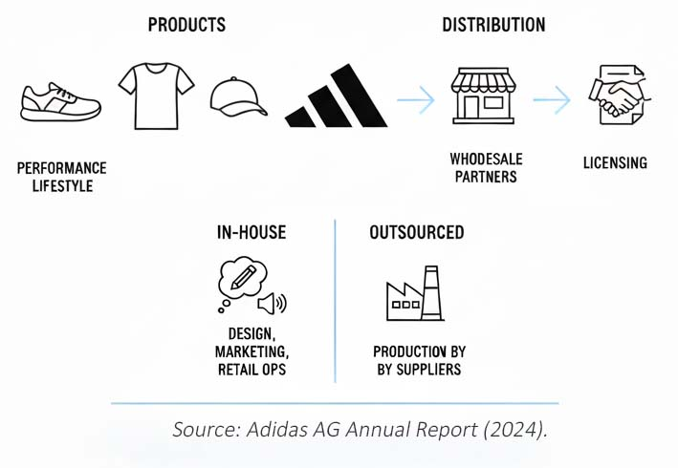

1.3 Recent financial performance (five-year summary; key ratios)
Adidas reported a strong financial recovery in the 2024 reporting year. Consolidated net sales increased to €23,683 million in 2024 (2023: €21,427m), an 11% increase in euro terms and double-digit growth on a currency-neutral basis; gross profit increased to €12,026m and operating profit rose markedly to €1,337m in 2024 (2023: €268m) (Adidas, 2024). Key performance indicators for 2024 included a gross margin of 50.8%, operating margin of 5.6%, and improved leverage. The company reported recovery of net income attributable to shareholders and signaled guidance for continued currency-neutral sales growth in 2025 and higher operating profit (Adidas, 2024). The Group’s ten-year overview shows cyclical volatility but an overall resilient top-line and improving profitability metrics during 2023–2024.
Figure 3: Adidas Financial Performance Highlights
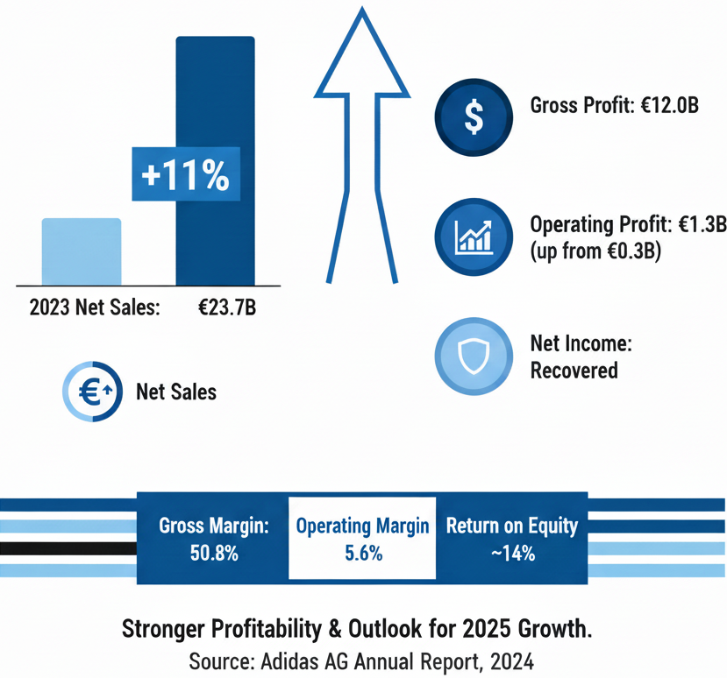
Selected financial ratios (2024): gross margin 50.8%; operating margin 5.6%; return on equity improved to c.14% (Adidas, 2024). These metrics demonstrate stronger profitability and balance-sheet capacity to fund selective expansion initiatives (Adidas AG Annual Report, 2024).

1.4 Why Adidas is relevant for strategic analysis; the 2025 strategic challenge
Adidas provides a compelling case for strategic analysis because it is a major global player that in 2024 completed a commercial and brand turnaround: management reset the product portfolio, resolved legacy inventory issues following the Yeezy termination, and generated improved margins through better product mix and reduced discounting (Adidas, 2024).
This strategic repositioning creates both the capability and imperative for measured international expansion into high-potential emerging markets. A specific strategic challenge for Adidas in 2025 is translating global brand momentum into profitable growth across heterogeneous emerging markets while managing supply-chain, ESG and macroeconomic risks, for example, balancing premium brand positioning with local price sensitivity, protecting margins in the face of currency volatility, and ensuring supplier compliance across diverse jurisdictions.
Figure 4: Adidas 2025 Strategic Challenge: Framework for Emerging Market Expansion
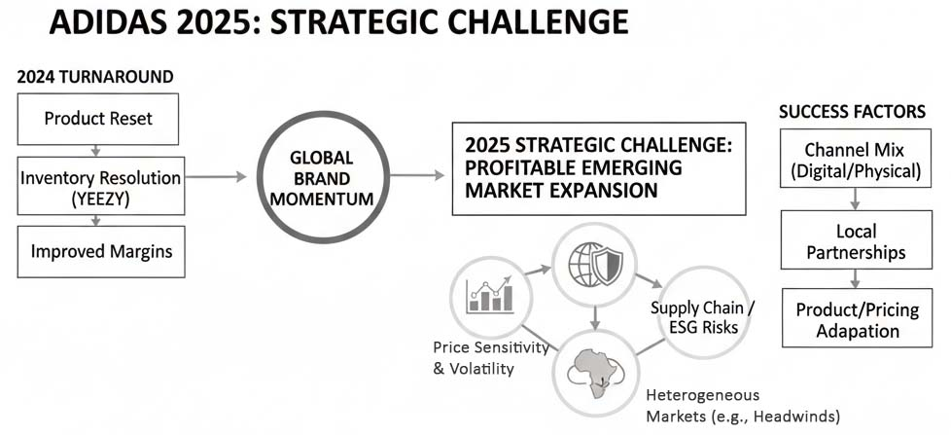
Source: Adidas Annual Report 2024
How Adidas configures its channel mix (digital vs physical retail), forms local partnerships, and adapts product assortments and pricing will determine success in markets such as Nigeria. The firm’s 2025 outlook explicitly targets high-single-digit currency-neutral sales growth but also recognizes industry risks from inflation and geopolitical headwinds making the strategic question of where and how to expand both timely and academically relevant.

2. External environment analysis & competitive positioning
It uses Porter's five forces and a customized PESTEL on the Nigerian sportswear / athleisure market and pinpoints the key strategic threats and opportunities of Adidas and develops a strategic-group map to display the key players. It ends with a critical assessment of the tools of analysis employed.

2.1 Porter’s Five Forces Nigerian sportswear / athleisure
Figure 5: Porter’s Five Forces Analysis: Nigerian Sportswear / Athleisure Market
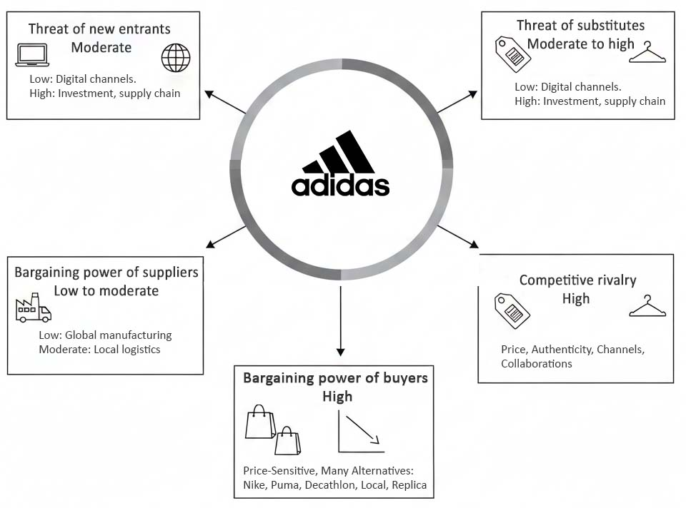
Source: Mordor Intelligence, Euromonitor, Jumia, World Bank, TechSci Research, 6WResearch.
Threat of new entrants — Moderate: The reduced capital needed to enter the market and the possibility of nimble brands trailing the market through digital channels and marketplaces make the number of potential entrants larger (Mordor Intelligence, 2025). Nevertheless, plausible international brands require substantial investment in marketing and consistent supply chains and customs knowledge to grow; this increases the cost of entry to create any competitive imperative (Euromonitor, 2024).
Bargaining power of suppliers — Low to moderate: Adidas sources have been sourcing manufacturing services from well-known international suppliers, and therefore, its purchasing size diminishes supplier bargaining power at the production phase. In Nigeria, distribution and fulfilment logistics suppliers and last-mile and payments services can charge more, which increases operational supplier power (Jumia, 2025).
Bargaining power of buyers — High: The erosion of the disposable incomes due to high inflation and currency depreciation has resulted in the fact that the Nigerian consumers are price-sensitive and are not only limited to the urban affluent bracket. The buyers have the option of international (Nike, Puma) brands, value retailers (Decathlon), local brands, and informal/replica brands with rising buyer power relative to price and promotions (Euromonitor; World Bank, 2025).
Threat of substitutes — Moderate to high: The threat of substitution is because of lower-priced local brands, secondhand markets and counterfeits, which are already established in Nigeria. Social trade and unofficial retailers further increase availability of substitutes, particularly in situations where price is the most important buying force (TechSci Research).
Competitive rivalry — High: The existence of international players (Nike, Puma, Adidas), value (Decathlon) and local suppliers generate great competition. The focus of competition is based on brand authenticity, price, channel coverage, and collaborations with sports organisations (6WResearch). Since the market is heterogeneous, firms are competing both in price and in non-price competition.
Overall, The Five Forces analysis is that Nigeria is favorable to brands that have volume and strong brand recognition, but the success is conditional on channel flexibility (marketplaces, social commerce) that can control supplier power in logistics and counterfeits.

2.2 Tailored PESTEL focus on 2–3 critical macro factors
Figure 6: PESTEL Analysis and Strategic Response for Adidas in the Nigerian Market
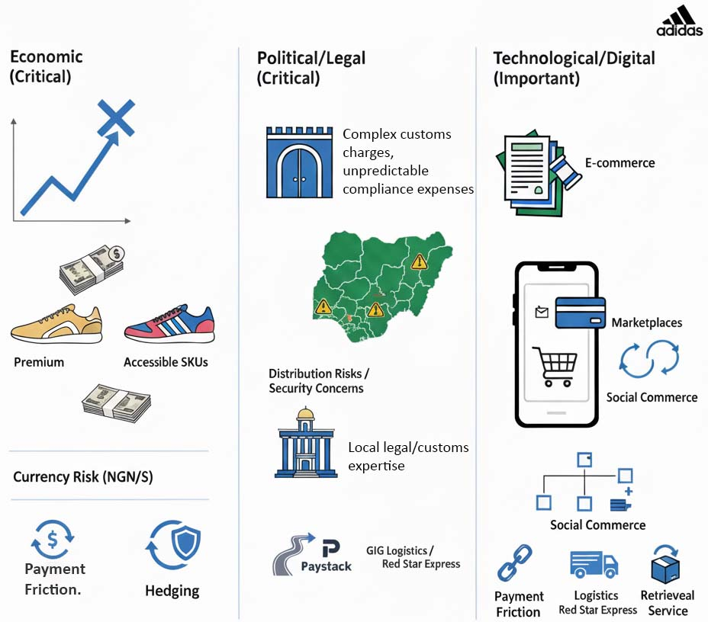
Economic (critical)
Nigeria has a high population (approximately 237 million), which provides a high size of addressable market; however, macro volatility is a limitation. The IMF and World Bank statistics indicate the growth of the real GDP with consumer prices/inflation levels still high (2024-25), and this puts pressure on discretionary spending and increases currency risk to importers (IMF; World Bank). In the case of Adidas, this translates into premium positioning and accessible SKUs, pricing it with NGN, and hedging and local partnerships to reduce the effect of FX exposure (IMF, 2025).
Political / Legal (critical)
Traditions, customs charges and unpredictability of the regulating controls add to the compliance expenses and cause operational constrictions. Some of the macro variables have been stabilized by recent reforms, but this has come at the cost of transitional volatility; local legal advice and customs experience are required. The addition of distribution risks is the political-security concerns of certain areas (Reuters, 2025).
Technological / Digital (important)
The adoption and expansion of smartphones and mobile commerce are the basis of an expanding e-commerce opportunity (the e-commerce market in 2025 is US $99.5bn with higher than double-digit CAGR forecasts). The significant discovery and fulfilment channels are marketplaces and social commerce. Nonetheless, the issue of payment friction, controlling logistics gaps and returns still remains a limitation that will need local fintech partners and logistics partners (Mordor Intelligence, 2025).

2.3 Strategic threats and opportunities (synthesis)
Opportunities
- Big demographic trend: the population of young people and football culture is supportive of sportswear (6WResearch).
- Access to the digital market: marketplaces and social commerce allow market capex entry and experimentation (Jumia, 2023).
- Premium segmentation: urban middle/upper classes are looking to have an authentic global brand to introduce to Adidas performance and lifestyle franchises (World Bank, 2025).
Threats
- Macro/FX pressure: Elevated inflation rates and naira fluctuations squeeze margins and increase price elasticity.
- Distribution and counterfeit risk: lack of trustworthy logistics, complexity of customs and a high informal market contribute to the operational and reputational risk.
- High level of rivalry and price competition: world competitors and low-cost substitutes will struggle with the share (Euromonitor, 2024).

2.4 Strategic-group map & key competitors
A strategic-group map in which the vertical axis is the price/positioning (premium = value) and the horizontal axis is the channel focus (DTC/flagship = wholesale/marketplaces) places the below brands:
Brand / Group | Strategic-Group Positioning
Nike | Premium, and it pays a lot of attention to both DTC and partner retail channels, supported by a high level of brand investment (Ken Research, 2024).
Adidas | Full-line differentiation based on a moderate combination of DTC and wholesale channels, which follows the omni-channel strategy (Adidas AG Annual Report, 2024).
Puma | Mid-premium, where the focus is put on strong lifestyle and football associations (Ken Research, 2024).
Decathlon | Decathlon is value-based, with big store formats, and a price leader (Decathlon, 2024).
Local players & informal market | Value-driven; using marketplaces and informal channels with a high threat of substitution (Ken Research, 2024).
Adidas must aim at the premium/aspirational quadrant and make use of marketplaces in an attempt to access larger and price-sensitive segments.

2.5 Critical evaluation of frameworks
Strengths: PESTEL and the Five Forces approach of Porter provide a systematic way of uncovering competition pressure and macro forces that can be used to develop practical entry strategies. The strategic-group map explains the positioning of competitors and makes channel/price decisions.
Limitations: These frameworks are mostly frozen in time and may even be underestimating the fast digital disruptiveness and informality in the market common to emerging economies. PESTEL is general, and it is dangerous to concentrate on a small number of macro factors and ignore micro-institutional realities. Porter's model underestimates internal capabilities and dynamic capabilities required to adjust pricing and supply in real time. Thus, such tools must be implemented with real-time market tests, partner due diligence and focused scenario planning (Euromonitor, 2024).

3. Internal Analysis
The internal analysis requires a strong footing in developing a market entry strategy into Nigeria that is consistent with the global strategic agenda of Adidas. It uses the Resource-Based View (RBV) and the VRIO framework to analyse the strategic resources and capabilities held by Adidas, a value chain analysis to determine the place where value is created, and the business-level strategy of the firm, as well as a comparison of the competitive advantages against its competitors like Nike and Puma.

3.1 Resource-Based View (RBV) and VRIO Assessment
The resource-based view focuses on the fact that resource-based sustainable competitive advantage comes as a result of valuable, rare, inimitable, and organised resources (Barney, 1991). Adidas has a number of strategic resources that achieve these criteria.
Figure 7: Adidas VRIO Assessment of Strategic Resources
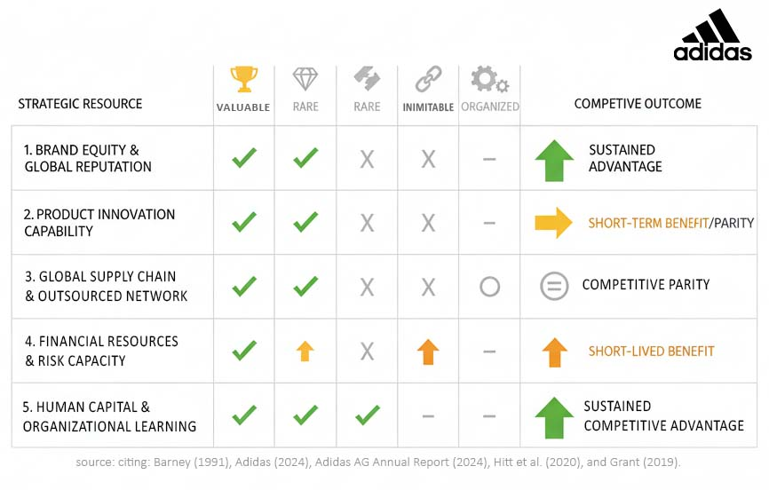
Brand equity and global reputation
Adidas is a brand with a long history of innovation and collaboration with top athletes and football clubs, which contributes to the recognition of the brand as one of the most recognizable brands in the global sportswear market. Brand strength is based on the fact that the company had continued to attract consumer demand in its iconic brands like Samba, Gazelle and Predator that saw the company expand tremendously in 2024 (Adidas, 2024). Brand equity is a valuable and rare asset that is hard to replicate because Adidas has long-term athlete relationships, design archives and cultural relevance, and the organisation is organised to capitalize on this strength through global marketing teams that give it a sustained competitive advantage (Adidas AG Annual Report, 2024).
Product innovation capability
Adidas spends a lot on R&D, especially in performance technologies, like Light strike, BOOST and advanced football boot engineering. These features are of use and to some extents are unique, despite competitors (Flynet by Nike, Nitro by Puma) also displaying comparable capability of innovation.
Though it gives a major short-term benefit, innovation cannot be wholly imitable because design talent is mobile and quick to spread across the industry (Hitt et al., 2020).
Global supply chain and outsourced manufacturing network
Adidas has an asset-light production model that has set suppliers in Asia and in the emerging markets. The flexibility and cost-effectiveness of outsourced manufacturing is a resource that cannot be neglected, and it is not unique and can be copied by the rivals. however, designed in a way that the organisation can utilises this capability effectively by having good compliance systems and supplier controls (Adidas, 2024). This resource will give only a competitive level, not a sustained advantage.
Financial resources and risk capacity
One of the advantages of going into 2025 is that Adidas has better financial results, as its sales and operating profit stand at €23.6 billion and 1.3 billion in 2024, respectively, compared to the previous year's losses (Adidas, 2024). Large cash flow improves the capacity to invest in international operations, marketing campaigns, supply chains and channel partnerships. Financial strength is not an absolute value because many other companies have equal and stronger financial capabilities, and Nike has even more. Nevertheless, it offers a short-lived yet significant benefit to the new-market expansion (Adidas AG Annual Report, 2024).
Human capital and organisational learning
The designers and marketing specialists are the global leadership teams of Adidas; this is a vital source of knowledge. Adidas is not like fast-fashion competitors because cultural capability in the implementation of global/local brand activations is a competitive advantage. This competence is uncommon and can be very expensive to replicate, especially in those emerging markets where localisation competencies are important (Grant, 2019).
General VRIO summary: Brand equity is the best VRIO-qualified resource of Adidas, along with marketing capability and design heritage. It should focus its entry strategy to the Nigerian market on these capabilities.

3.2 Value Chain Analysis
The internal processes of Adidas may be evaluated in the framework of the value chain proposed by Porter (1985) to understand the point of the competitive value creation.
Figure 8: Conceptual Value Chain Analysis for Adidas's Nigeria Entry Strategy.
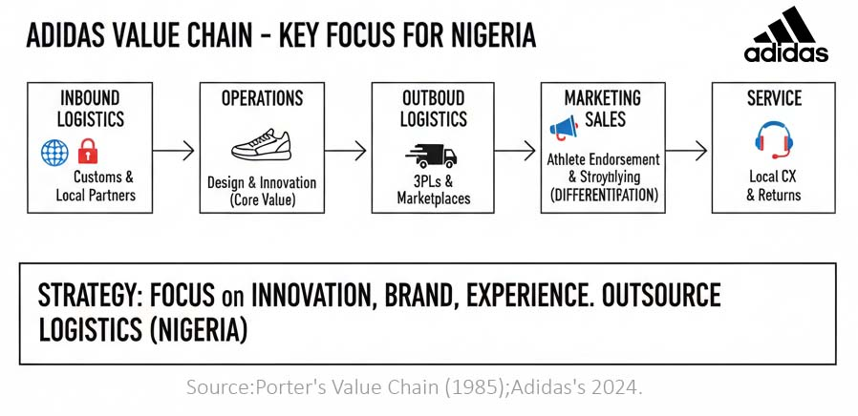
Inbound logistics: The upstream supply chain used by Adidas is international and has stringent auditing and sustainability procedures. The scale of it promotes bargaining power and guarantees efficient economic sourcing (Adidas, 2024). Nevertheless, in the case of entry of Nigeria, inbound efficiency will rely on the customs clearance and logistic collaboration.
Operations The most important operational value held by Adidas is the advanced design, prototyping and performance engineering, and not production. Its multiple product development centres in Germany, the U.S. and Asia help it to go through product iterations fast, which gives its products performance and lifestyle relevance (Adidas, 2024).
Outbound logistics and distribution: Adidas employs digital integration and centralized distribution centres to serve DTC and wholesale channels in order to provide services to the global market. In the case of Nigeria, third-party logistics companies and marketplace alliances will form the basis of outbound logistics, which implies that effective coordination will be essential.
Marketing and Sales: Marketing is a value-generative core activity that involves athlete endorsement, influencer campaigns, retail activation and product storytelling. The campaigns launched by Adidas, like the You Got This campaign, have been effective in bringing consumers back to the brand in 2024 (Adidas, 2024). A significant source of differentiation is marketing strength.
Service: Adidas spends on customer experience, warranty support and online customer experience. Those capabilities have to be adjusted to Nigeria using the local returns processes and service channels.
Value Chain Conclusion: the greatest value generated by Adidas is in product development, marketing, and brand experience, implying that the Nigeria strategy has to build on them and outsource low-value operations like logistics and last-mile fulfilment.

3.3 Business-Level Strategy (Porter’s Generic Strategies)
Porter's version describes 3 strategies on the commercial enterprise degree: price leadership, differentiation and cognizance. Adidas mainly follows a differentiation approach; this means that they compete by offering unique and high-quality products as opposed to low costs (Porter, 1985).
Figure 9: Porter’s Generic Competitive Strategies Matrix
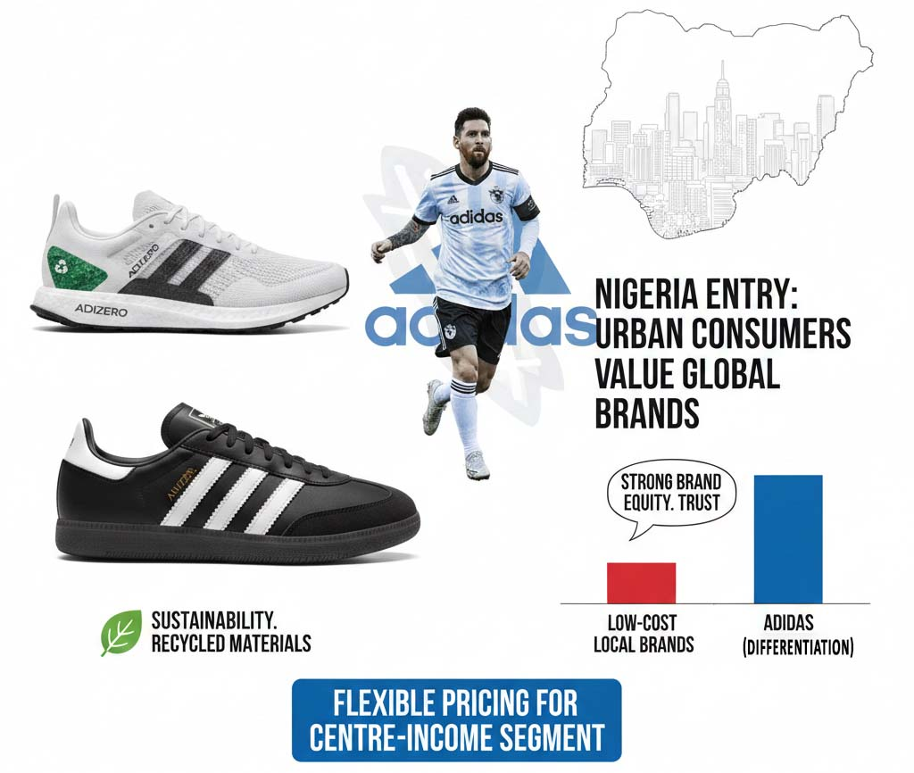
This may be visible in its performance shoes, inclusive of Adizero; its lifestyle lines, along with Samba; its partnerships with pinnacle athletes; and its sturdy awareness of sustainability by using recycled and coffee carbon materials.
The entry into Nigeria supports this method, as city clients fee worldwide manufacturers, and the low-fee section is already filled with local dealers. Adidas also benefits from strong emblem equity, which increases customer trust (Keller, 2013). Still, flexible pricing is needed to reach Centre-income customers at the same time as shielding the emblem fee.

3.4 Comparative Competitive Advantage vs Rivals
Adidas vs Nike
Nike is the chief within the worldwide sports clothing market, makes a good deal more money than Adidas (approximately $51 billion in 2024 as compared to Adidas's €23.6 billion) and has bigger marketing budgets and more potent athlete deals (Statista, 2025). However, Adidas has tremendous strengths in bringing back soccer history and the European way of life via Originals and famous product lines (Adidas, 2024). Nike is strong in basketball and North America, at the same time as Adidas plays higher in Europe, Africa and football-associated markets.
Figure 10: Comparative Competitive Advantage and Market Positioning
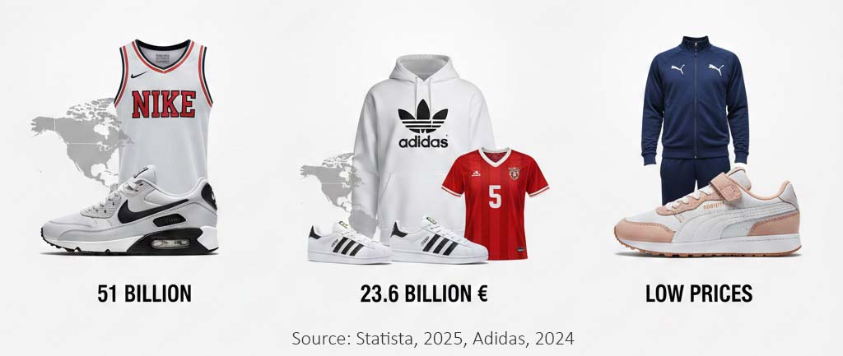
Adidas vs Puma
PUMA is smaller and focuses more on children and way of life. Adidas remains robust on new merchandise, overall performance technology, worldwide sponsorships and monetary energy. The foremost benefit of PUMA is low prices, which can entice extra value-aware markets like Nigeria.
Overall: Competitive advantages, brand equity, Adidas product franchises and marketing capability are in tandem with the Nigerian consumer preferences, in particular, the segments of football and youth culture.

4. Strategic Options and Decision-Making
To develop a successful market expansion strategy to enter Nigeria, Adidas needs to assess growth options, corporate-level options, and the portfolio of strategic business units of the company. The Matrix created by Ansoff, the BCG/GE portfolio frameworks, and a retrospective view of the main choices that Adidas has made over the past five years offer a systematic basis of strategic choice.

4.1 Applying Ansoff’s Matrix to Adidas’ Growth Strategy
The four strategic growth options as described by the Ansoff Matrix include market penetration, market development, product development, and diversification (Ansoff, 1957).
Figure 11: Adidas Nigeria Growth Strategy – Ansoff Analysis
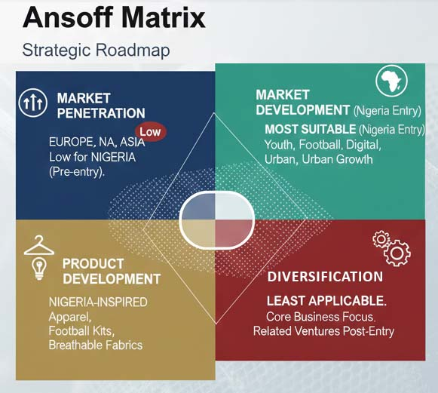
Market Penetration
This plan aims at expanding market share in the current markets. Adidas has employed penetration marketing in Europe, North America and Asia by using it via strong marketing, resale of well-known franchises (Samba, Gazelle) and digital direct-to-consumer (DTC) development. Its core markets are densely penetrated, as recent promotional discounts and retail execution efforts in 2024 have proven (Adidas, 2024).
Applicability to Nigeria: Low, since Adidas has a low direct presence. Market penetration is only applicable once it has entered the market.
Market Development (Nigeria Entry Strategy)
This is the most suitable strategic alternative to Adidas's expansion to Nigeria. Market development entails introducing a new geographical location with existing products. Nigeria offers:
- a large, youthful population,
- strong football culture,
- increased digital/marketplace retail infrastructure,
- increasing city middle income (World Bank, 2025).
The performance and lifestyle products that Adidas has developed can be deployed with minimal requirements in terms of product redesign. A phased market development strategy, digital entry, retail partnerships, and flagship stores mitigate the capital risk and are consistent with the brand-based differentiation strategy of the company.
Product Development
Product improvement refers back to the manner of introducing new merchandise to each new and gift market. In relation to Nigeria, Adidas can also, don't forget, grow a pill collection inspired by neighborhood subculture, grow Nigerian football apparel and use breathable fabric suitable for decent weather situations. While product development is generally taken into consideration secondary to market improvement, it remains a crucial technique for growing a brand's cultural relevance and constructing brand fairness (Grant, 2019).
Diversification
At first, diversification is least applicable. Adidas has not been involved in other diversifications which are irrelevant to its business and instead concentrates on enhancing its primary sporting goods business. Related diversification, sports events, athlete-training programmes or youth development programmes, could help brand-building, but only once the market has been successfully entered.

4.2 Corporate-Level Strategies: M&A, Alliances, and International Expansion
The corporate strategy defines the way Adidas competes in various business units and geographies.
Figure 12: Key Elements of Adidas' Corporate Strategy for Nigerian Market Entry
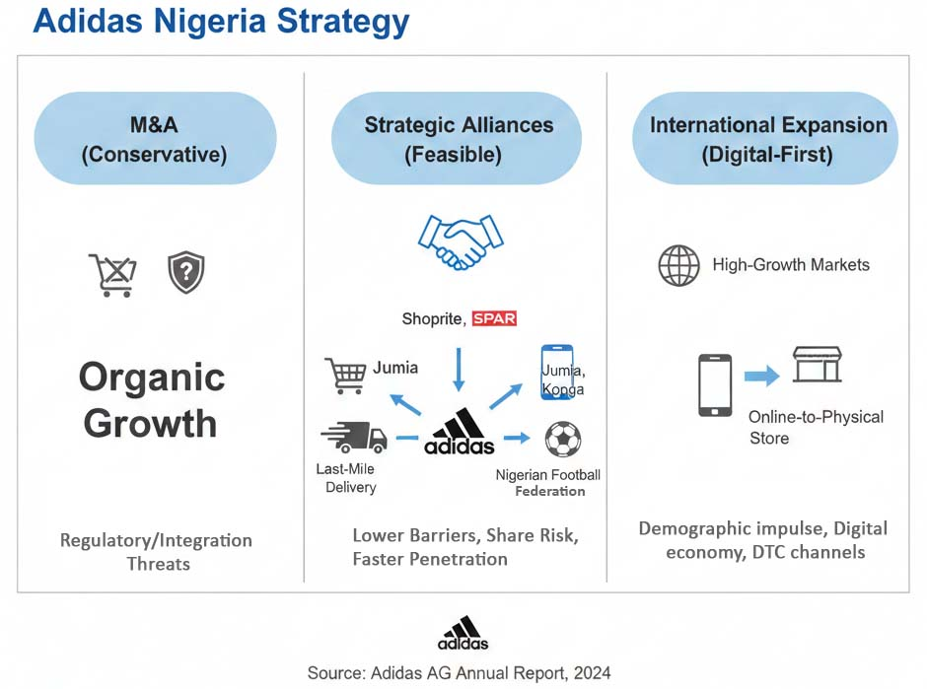
Mergers and Acquisitions (M&A)
Since the sale of Reebok in 2021, Adidas has been conservative in its M&A strategy. According to the annual report, there is still an emphasis on organic expansion and brand-building instead of massive acquisitions (Adidas, 2024). M&A would also present regulatory and integration threats in the emerging markets such as Nigeria. Therefore, the entry mode is not advisable to be through acquisitions (Adidas AG Annual Report, 2024).
Strategic Alliances and Partnerships
The most feasible strategy at the corporate level is strategic alliances. In the case of Nigeria, Adidas would have an advantage in:
- Sports World, SPAR or Shoprite retail partnerships.
- E-commerce collaboration with e-commerce websites like Jumia and Konga.
- Logistic partnerships with service providers with good last-mile delivery.
- Sports agreed with the Nigerian Football Federation or local clubs.
Such partnerships lower barriers to entry, spread risk, and help penetrate brands faster in line with Adidas's established partnership success track record in its international athlete and federation sponsorship model (Adidas, 2024).
International Expansion Strategy
The corporate strategy of Adidas focuses on the reinforcement of DTC channels and the growth of brand presence within the high-growth markets. Nigeria suits the mentioned model, as it has a demographic impulse and a developing digital economy. An online-to-physical-store entry strategy will fit into the global move of Adidas to digital-first approaches.

4.3 Portfolio Analysis Using BCG Matrix / GE Matrix
Figure 13: Portfolio Analysis of Adidas in Nigeria (BCG & GE Matrices)
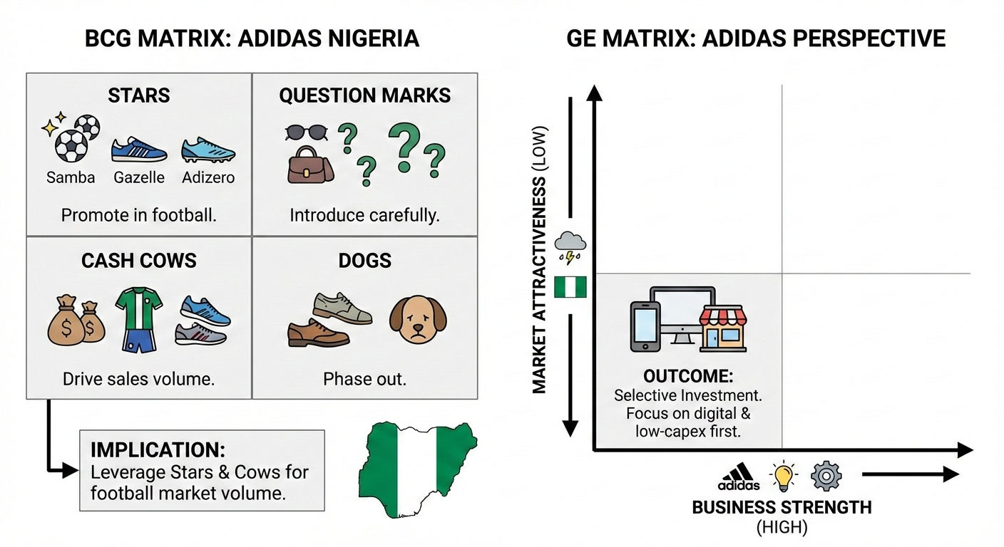
BCG Matrix Application
The portfolio of Adidas is made up of the following categories: footwear, apparel, and accessories, with sub-franchises in each. The BCG Matrix divides the products into Stars, Cash Cows, Question Marks and Dogs (Henderson, 1970).
Category | Implication for Nigeria
Stars | Samba, Gazelle, and Adizero are popular products in high demand. Focus on promoting these inside the Nigerian football markets.
Cash Cows | Football kits and running shoes: reliable merchandise that generates regular profits. Use these to increase your sales in Nigeria.
Question Marks | Accessories, stability merchandise: new merchandise with uncertain ability. Be careful while introducing these in Nigeria.
Dogs | Older products: less demand. Phase those out and focus on merchandise with higher effects in Nigeria.
Implication for Nigeria: Adidas must use Stars as it has strong brand pull with Cash Cows as a strategy to push volume in markets whose football is the Centre of attention.
GE/McKinsey Matrix Perspective
According to the GE Matrix, Adidas has high business strength in brand, marketing, and product innovation and low market attractiveness in Nigeria because of economic volatility.
Outcome: Discriminatory investment strategy, investing initially in digital and low-capex approaches and expanding to physical retail.

4.4 Key Strategic Decisions in the Last Five Years
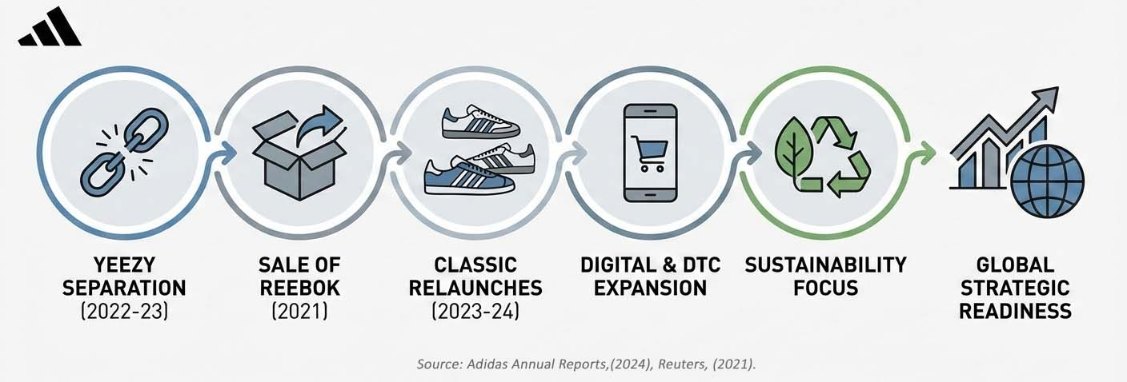
Figure 14: Key Strategic Decisions and Outcomes for Adidas (2021–2024)
- Scottie and Yeezy separation (2022-2023): It was an emergency move after the reputational and operational risks. Adidas also incurred financial losses that were recouped within the short term by selling the remaining inventory in 2023–2024, which restored part of the value and brand positioning (Adidas, 2024). The decision increased long-term integrity and risk management.
- Sale of Reebok (2021): Adidas sold Reebok so as to concentrate its portfolio on core performance and lifestyle products. This enhanced strategic focus and redistributed resources towards more growth franchises (Reuters, 2021). It enhanced the competitiveness of Adidas compared to Nike and Puma.
- Classic franchise relaunches (2023–2024): The reintroduction of such models as Samba, Gazelle and Campus gave the brand a strong forward momentum. These have been instrumental in the well-performing 2024 results of the company, and they made Adidas stronger to differentiate itself.
- Digital Growth and Direct-to-Consumer (DTC) Expansion: Adidas is investing more in digital technology to make the process of shopping online more convenient and ensure everything complements each other. This is aligned with the intention of Nigeria to work on the digital-first concepts and to make it easier to contact the customers with their products (Adidas, 2024).
- Sustainability and Ethical Supply Chain Practices: Adidas is playing more by the rules and becoming greener as well as fairer, such as using recyclable materials and ensuring that their suppliers are responsible. All these measures will assist Adidas in creating a positive image and fulfilling the desires of its customers worldwide (Adidas, 2024).
Overall, over five years, Adidas's strategic decisions have resulted in enhanced profits, enhanced brand authenticity, a less complex portfolio and alignment with the global trends. All these decisions make Adidas better prepared to enter the international market in emerging economies like Nigeria.

5. Data Analysis, Strategic Implementation, and Recommendations
This block is a synthesis of the financial performance, competitive strength, and internal strengths of Adidas to develop a data-driven plan to expand to Nigeria. Scenario planning is used to reflect on alternative strategic futures, with an evaluation of implementation difficulties in terms of structure, leadership, governance and risk management.

5.1 Financial Data Analysis to Support Strategic Recommendations
The latest financial performance of Adidas gives more reasons to make an international expansion. In 2024, the firm posted net sales of €23.683 billion, which is an 11% increase compared to the previous year, and its operating profit increased significantly to 1.337 billion (Adidas, 2024). This is a positive change due to an increase in full-price sell-through, reduced promotional activity and high performance of lifestyle and football franchises. Gross margin increased to 50.8, which indicates better product mix and inventory management. The operating activities cash flow rose substantially, which strengthened liquidity to invest (Adidas, 2024).
Figure 15: Adidas Financial Strength and Strategic Alignment for International Expansion (Nigeria Focus)
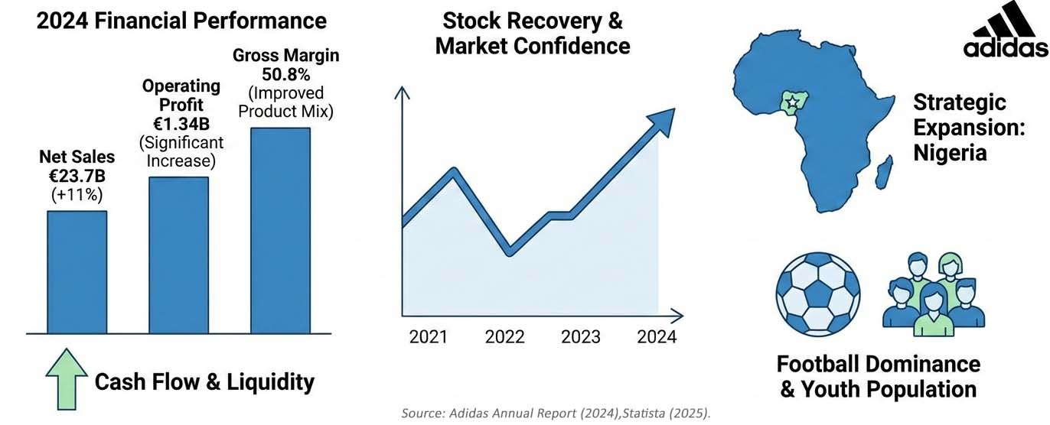
Performance of stocks has also been used to depict recovery. Although the stock of Adidas shares dropped in 2022 because of the break-up with the Yeezy brand and disruptions of the global supply chains, the stock recovered in 2023–2024 on the back of strategic resets (Reuters, 2024). This investor confidence signifies that the market is very optimistic about the possibility of any further geographical expansion.
This trend in market share also justifies entering new markets that have high potential. In 2024, Adidas is poised to recover market share in the football and lifestyle market segments worldwide, closing the divide with Nike in the major performance categories (Statista, 2025). Nigeria, where football is the most followed sport, presents a natural opportunity to capitalize on the global dominance of Adidas in the field of football attire and shoes.
Money data hence show that Adidas has the financial resources, profitability and investor trust to fund a gradual internationalisation process. Nigeria has one of the highest youth populations and emerging organised sportswear industries in Africa, thereby presenting a good growth frontier as per the 2025 strategy of Adidas.

5.2 Scenario Planning for Strategic Options
Since Nigeria is a volatile macroeconomic destination, scenario-based planning is necessary to predict the future directions and adjust the strategy (Schoemaker, 1995). Three situations are suggested:
Figure 16: Adidas Strategic Scenario Planning for Entry into the Nigerian Market
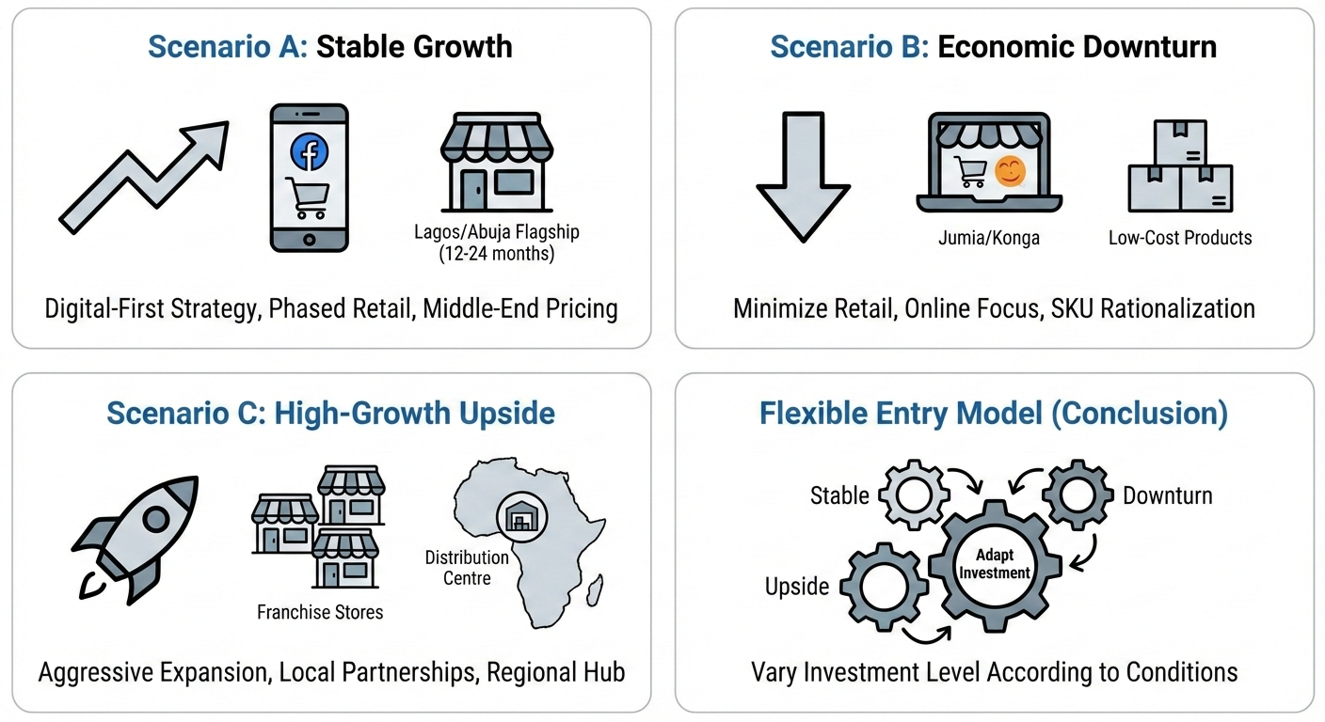
Scenario A: Stable Growth (Most Likely)
Constant growth in GDP (3-4%), stabilization of inflation, and better FX liquidity provide favorable conditions for the growth of Adidas. It is suggested to adopt a digital-first strategy, which makes use of marketplaces and social commerce. Lagos and Abuja flagship stores can be viable in 12-24 months, and the middle-end pricing will attract upwardly mobile customers, which will justify the slow pace of retail development and domestic advertising efforts.
Scenario B: Economic Downturn (Downside)
A decline in the economy characterized by devaluation of currency and inflation makes the purchasing and importation of goods more expensive. Adidas will have to minimize physical retail investment and concentrate on online stores like Jumia and Konga. SKU rationalization is required to control risk on inventory and with more focus on low-cost products. A streamlined and flexible model will allow us to retain the margins and retain brand identity.
Scenario C: High-Growth Upside
The high growth rate in the market due to the adoption of e-commerce, better logistics and high consumer demand presents Adidas with a chance to grow aggressively. To make it more culturally appealing, it is possible to establish several franchise stores and also make partnerships with designers in Nigeria. Also, Nigeria would act as a distribution Centre of West Africa. Scenario planning highlights the importance of the flexible entry model that varies the level of investment according to the economic conditions.

5.3 Strategic Recommendations
Following the studies on the topic of Sections 1 and 4, the following suggestions can be offered:
Figure 17: Core Strategic Pillars for Nigerian Market Entry
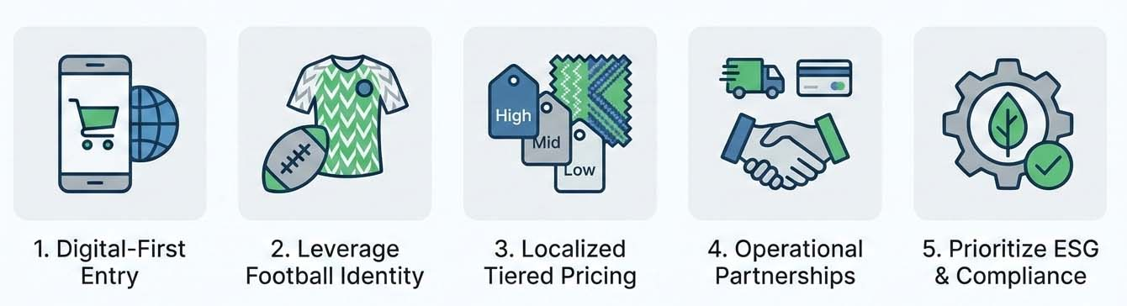
- Adopt a Phased Market-Development Strategy (Digital-First): Digital First is a strategy that Adidas should start with to reduce the level of capital intensity and test the demand promptly. Integration in the marketplace and a dedicated e-commerce site in Nigeria will attract the early adopters and mitigate the operation risk. This is in line with the global strategy of DTC and the financial capabilities of Adidas (Adidas, 2024).
- Leverage Football Heritage to Build Brand Identity: Nigeria has the most important culture sport, which is football. Adidas must make partnerships with local clubs, partnerships with the Nigerian Football Federation and partnerships with grassroots academies. The nature of sponsorships will make the brand stand out among its rivals and enhance the football leadership of Adidas.
- Implement Tiered Pricing and Localized Product Strategy: Since income distribution in Nigeria is diversified, Adidas needs to mix high-end flagships with middle-range products in the markets. Capsule collections which are inspired by the local can enhance cultural relevance.
- Collaborate with Other Parties to Shatter Down Fences: Adidas ought to cooperate with local delivery firms, payment providers, and retailers to simplify the process of dealing with customs, payments, and delivery. Through a partnership, they are able to save on expenses and expand their markets.
- Establish Good ESG and Compliance Rules: Africans are more interested in knowing the origin of the products, their sustainability, and selling ethically. As a way of creating trust and preventing reputation issues, Adidas ought to use its global environmental and social policies to run its business in Nigeria (Adidas, 2024).

5.4 Implementation Challenges
Area | Details
Organization Structure | Nigeria's function in emerging markets. Key positions encompass:
 | - Country supervisor
 | - Head of Retail Partnerships
 | - Head of virtual and e-commerce
 | - Compliance and regulatory manager
Leadership & Talent | Employ local Nigerians with experience:
 | - Retail, digital and supply chains.
 | - Helps with cultural match and better client expertise.
Corporate Governance | Ensure:
 | - Open purchase strategies
 | - Anti-corruption practices (especially in customs)
 | - Frequent financial and functional audits.
Risk Management | Major dangers and solutions:
 | - conversion of currency: apply hedging and flexible purchasing.
 | - Latent delay of deliveries: Cooperation with local warehouses.
 | - Fake products: investigate online and educate customers.
 | - Rule trade: Collaborate with law experts and business agencies.
Through proactive control of those dangers, Adidas will have the possibility to end up flexible in its operations and construct belief amongst its stakeholders.

Conclusion
This report has assessed the strategic preparedness of Adidas to go global and has offered Nigeria as a high-potential but complex emerging market. Based on extensive external and internal analyses, the report proved that the demographic strengths, robust football culture, and growing digital ecosystem in Nigeria present good prospects for the Adidas market-development strategy. Porter's Five Forces and PESTEL indicated that the environment was competitive and opportunity-rich, but RBV and VRIO evaluated the assets that Adidas possessed; its most vital assets were its global brand equity, ability to innovate, and its marketing capabilities as the key sources of competitive advantage.
The strategic alternatives reviewed via the Matrix of Ansoff, corporate-level analysis and portfolio tools suggest that the most appropriate strategy is the stepwise, digital-focused market growth strategy, bolstered by partnerships with local players. The scenario planning also emphasized the necessity of flexibility due to the macroeconomic volatility of Nigeria. Suggestions were aimed at building upon the Adidas football heritage, tiered pricing, local operations and entrenching solid governance and risk-management models.
Generally, Adidas is financially and strategically stable to execute controlled growth into Nigeria. Disciplined implementation, cultural localisation, effective partnerships and constant monitoring of performance will be the keys to success. The growth provides Adidas with the good chance to establish itself in another, developing global market and seize its prospective development.

References
- Adidas AG (2024) Annual Report 2024. Herzogenaurach: Adidas AG.
- Ansoff, H.I. (1957) ‘Strategies for diversification’, Harvard Business Review, 35(5), pp. 113–124.
- Barney, J. (1991) ‘Firm resources and sustained competitive advantage’, Journal of Management, 17(1), pp. 99–120.
- Barney, J. and Hesterly, W. (2019) Strategic Management and Competitive Advantage: Concepts and Cases. 7th edn. Harlow: Pearson.
- BCG (1970) The Product Portfolio. Boston: Boston Consulting Group.
- Bryson, J. (2018) Strategic Planning for Public and Nonprofit Organizations. 5th edn. San Francisco: Jossey-Bass.
- Deloitte (2024) Global Powers of Retailing 2024. Deloitte Insights.
- Euromonitor International (2024) Sportswear in Nigeria. London: Euromonitor.
- Euromonitor International (2024) Footwear: Global Industry Overview. London: Euromonitor.
- Grant, R. (2019) Contemporary Strategy Analysis. 10th edn. Chichester: Wiley.
- Henderson, B. (1979) Understanding the BCG Matrix. Boston: Boston Consulting Group.
- Hill, C. and Jones, G. (2018) Strategic Management: An Integrated Approach. 12th edn. Boston: Cengage.
- Hitt, M., Ireland, R. and Huskisson, R. (2020) Strategic Management: Competitiveness and Globalization. 13th edn. Boston: Cengage.
- IMF (2025) Nigeria Country Data and Economic Outlook. Washington, DC: International Monetary Fund.
- Jumia Group (2024) Nigeria E-commerce Market Trends. Lagos: Jumia Insights.
- Kotler, P. and Keller, K. (2022) Marketing Management. 16th edn. Harlow: Pearson.
- Lynch, R. (2021) Corporate Strategy. 9th edn. Harlow: Pearson.
- McKinsey & Company (2023) Africa Consumer Market Report. New York: McKinsey Global Institute.
- Mordor Intelligence (2024) Nigeria Sports Apparel Market – Industry Overview. Hyderabad: Mordor Intelligence.
- OECD (2024) Anti-Corruption and Integrity in Emerging Markets. Paris: OECD Publishing.
- Porter, M.E. (1980) Competitive Strategy: Techniques for Analyzing Industries and Competitors. New York: Free Press.
- Porter, M.E. (1985) Competitive Advantage: Creating and Sustaining Superior Performance. New York: Free Press.
- PwC (2023) Nigeria Economic Outlook. Lagos: PwC Nigeria.
- Reuters (2024) ‘Adidas sees continued recovery as sales strengthen’, Reuters Business News, 21 January.
- Schoemaker, P. (1995) ‘Scenario planning: A tool for strategic thinking’, Sloan Management Review, 36(2), pp. 25–40.
- Statista (2025) Global Sportswear Market Share – Adidas vs Nike. Hamburg: Statista Research Department.
- TechSci Research (2024) Africa Sports Equipment and Apparel Market Forecast. New Delhi: TechSci.
- Trading Economics (2025) Nigeria Inflation, GDP and FX Indicators. New York: Trading Economics.
- UNCTAD (2023) African E-commerce Development Report. Geneva: United Nations.
- World Bank (2025) Nigeria Country Overview. Washington, DC: World Bank Group.
- World Economic Forum (2024) Global Competitiveness Report. Geneva: WEF.

Appendices

Appendix A: Gantt Chart – Market Entry Timeline (36 Months)
Phase | 1–3 Months | 4–6 Months | 7–12 Months | 13–18 Months | 19–24 Months | 25–36 Months
Market Research & Regulatory Due Diligence | ●●●● | – | – | – | – | –
Partnership Negotiations | ●●● | ●●● | – | – | – | –
Launch of Adidas Nigeria E-Commerce Site | – | ●●● | ●●● | – | – | –
Marketplace Integration (Jumia/Konga) | – | ●●● | ●●● | – | – | –
Digital Marketing & Brand Activation | – | ●●● | ●●●●●●●● | ●●● | – | –
Retail Partner Onboarding (Shop-in-Shop) | – | – | ●●● | ●●●●● | – | –
Flagship Store Setup (Lagos, Abuja) | – | – | – | ●●●●● | ●●● | –
Product Localisation / Design Collaborations | – | – | – | ●●● | ●●● | ●●●
Monitoring & KPI Reporting | ●●●●●●●●●●  ●●(continuous) | – | – | – | – | –

Appendix B: Financial Summary Tables (Adidas & Nigerian Market)
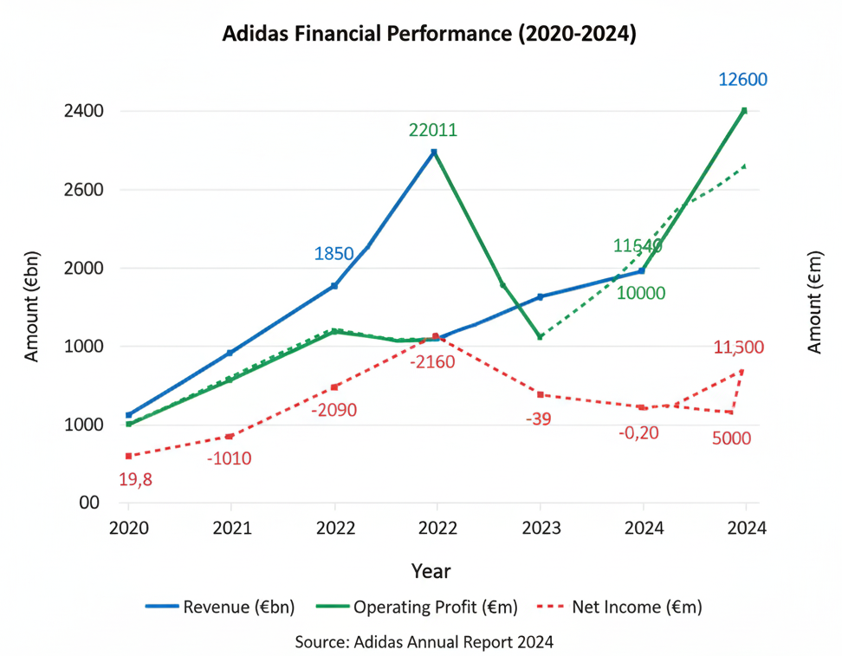
B1: Adidas Global Financial Performance (2020–2024)

B2: Nigeria Sportswear Market Snapshot (2024–2030)
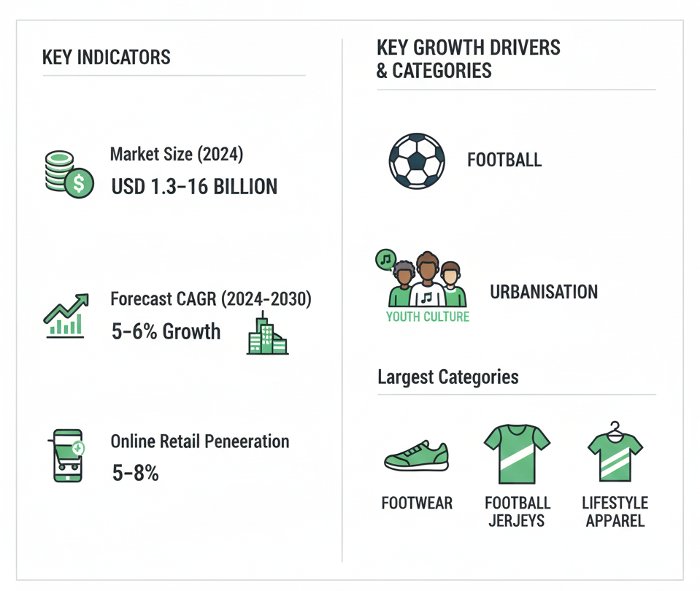

Appendix C: Balanced Scorecard for Adidas Nigeria
Area | Goal | KPIs | Target (Year 3)
Financial | Grow profit in Nigeria | Revenue, Profit margin, Payback period | €40m revenue, >40% margin, Break-even in 3 years
Customer | Build brand loyalty | NPS, Brand awareness, Market share | NPS >60, +20% awareness, 8% market share
Operations | Improve local operations | Delivery speed, Fulfillment, Counterfeits | <5 days delivery, >90% on-time, <1% counterfeit
Learning & Growth | Develop local talent and sustainability | Local hires, ESG compliance, Training | 50% local managers, 100% ESG, 20 hrs. training per employee

Appendix D: Strategic Group Map – Nigeria Sportswear Market
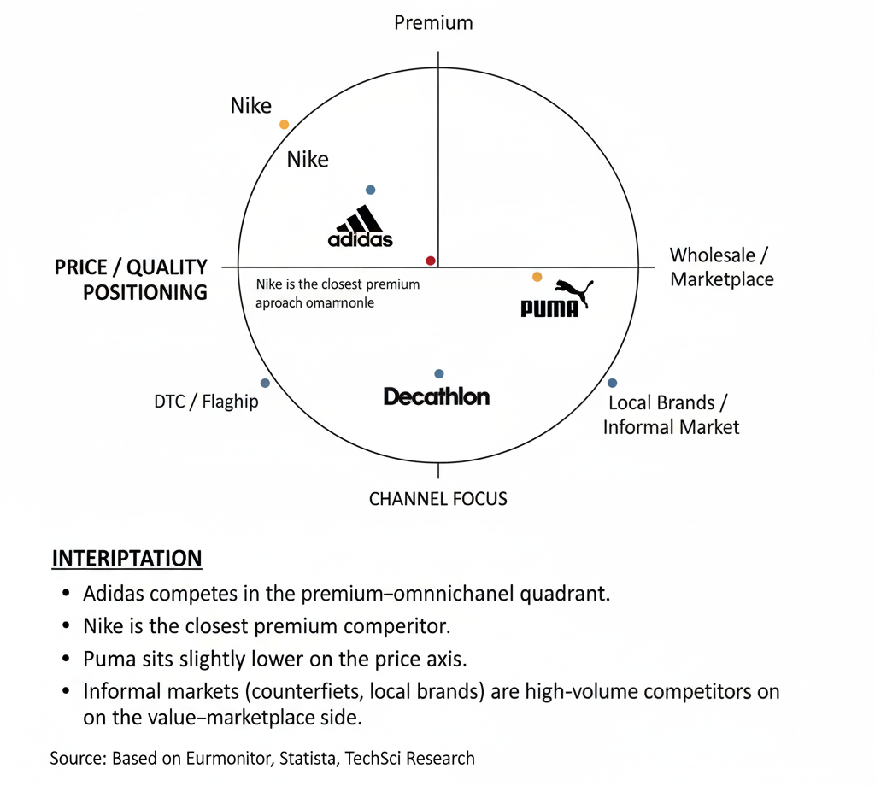

Appendix E: Risk Register and Mitigation Plan
Risk | What It Is | Impact | Chance | How to Handle It
Currency/FX Volatility | Naira falling in value, affecting imports | High | High | Use FX hedging; adjust prices regularly
Regulatory Issues | Customs delays, extra duties | High | Medium | Work with local legal advisors; clear goods early
Counterfeits | Fake products hurting brand | High | High | Use tech for product authentication; educate customers
Logistics Failures | Bad delivery service | Medium | High | Partner with reliable logistics companies
Security Risks | Theft during delivery or storage | Medium | Medium | Use secure warehouses; get insurance
Reputation Risk | Not following ESG standards | High | Low | Follow Adidas' global ESG rules strictly

