University of Wales Saint David
Wales Institute of Science & Art

Material Selection Report
Module code: ACHA4001
Module: Engineering Design and Materials

Name: Odysseas Androutsos
Student No: 2005263

March – 2022
Contents
1 Introduction 3
2 Material Properties 3
2 Material Selection 4
2.1 Material accessment for Steel 5
2.2 Material assessment for aluminium 5
2.3 Material assessment for titanium 6
2.4 Sustainability assessment 8
2.5 Cost assessment 8
3 Manufacturing Processes 9
3.1 Process for making aluminium forgued pistons 9
4 Conclusions 10
5 References 11

List of figures
Figure 1 – Stress Strain curves for various metals and alloys (Cobden, 1994) 6
Figure 2 – Effect of Alloying Element on Tensile Strenght, Hardness, Impact Sensitivity and ductility (Cobden, 1994) 6
Figure 3 – Defference in fatigue behaviour between Mild steel and Aluminuum Alloys (Cobden, 1994) 7
Figure 4 – S-N curve for annealed and cold rolled pure titanium(Fatigue Properties of Unalloyed Titanium, no date) 8
Figure 5 – Strength Vs temperature for various alloys (Leyens and Manfred, 2003) 9

List of Tables
Table 1– Properties of proposed materials for pistons 5

Introduction
The selection of the suitable material for a product is an important process and affects the behaviour of the product and also its success in the market. This report will be focussed on the material selection for a piston. The environment under which the piston will be functioning will be investigated and the required properties of the material that will be used will be set. Then the properties of the available materials will be identified in an attempt to select the best material for the purpose. The manufacturing process of the pistons will be described and finally conclusions will be made as far as what is the best material for the pistons.

Material Properties
Before deciding which material to consider for the manufacturing a piston it is important to identify under which conditions the piston operates.
During the power stroke the highest temperature of the piston is created because the fuel air mixture is ignited and heat is created. As the RPMs of the engine increases the temperature of the piston increases because the more heat is created. Considering that the engines have cooling systems it is expected that the pistons work at about 200 to 450 ºC depending on the thermal conductivity of the material of the pistons (Saif, 2021). If the cooling system fails, rabid increase of the temperature is created which this results in rabid deterioration of the piston, engine seizure.
The movement of the pistons in the cylinder creates friction and therefore heat. This friction has to be reduced by selecting a material with high hardness.
The weight of the pistons should be as minimum as possible and this can be achieved by selecting lightweight materials. The heavier the piston the higher the inertia force due to the motion of the piston.
The melting point of the material which will be use for the piston should be match higher than the temperatures which will be created when the engine is running.
The yield strength and the modulus of elasticity are also factors that need to be taken into account when designing the pistons because these will determine the thickness of various surfaces of the pistons in order to withstand the forces/pressure which will be created during the operation of the pistons.
The fatigue strength of the materials which will be considered for the piston is another important property that has to be considered because the pistons undergo cycling loading due to the operation of the piston and also due to changes in temperature.
The thermal conductivity and the coefficient of thermal expansion are also properties that need to be obtains because affect the cooling of the pistons and the clearance between the pistons and the cylinder.

Material Selection
Even though there is infinite number of materials that can be considered in the selection of the proper material for the pistons this report will concentrate to three basic materials. Steel, Aluminium and Titanium. These is because these materials are the basic materials which already used for manufacturing pistons. After research the properties of these materials were obtained and are summarized in Table 1. These materials come in various grades and their properties deviate from the values shown in table 1. As a start this report will be focused on the properties of the basic materials.
Table 1– Properties of proposed materials for pistons
Material Property | Aluminium | Steel | Titanium
Yield Tensile strength (MPa) | See Fig. 1 | See Fig. 1 | See Fig. 1
Modules of Elasticity (GPa) | 70* | 211* | 116*
Fatigue Strength | See Fig. 3 | See Fig. 3 | See Fig.4
Mohs Hardness | 2.75* | 4* | 6*
Melting point | 660.32* | 1535* | 1660*
Thermal conductivity (W/m.K) | 237* | 80.40* | 21.90*
Thermal Expansion coefficient (μm/(mK)) | 23.10* | 11.80* | 8.60*
Chemical Properties | Does not rust | oxidation | Does not rust
Density (kg/m³) | 2700* | 7870* | 4510*
Material Index (Tensile strength/density) | 0.0148 | 0.1398 | 0.0962
Price (USD/ton) | 3493 | 785 | 4800
* (Compare Metals, 2022)
NOTE: The material indexes listed above were calculated using the yield tensile strengths and the density of these metals from (Compare Metals, 2022)

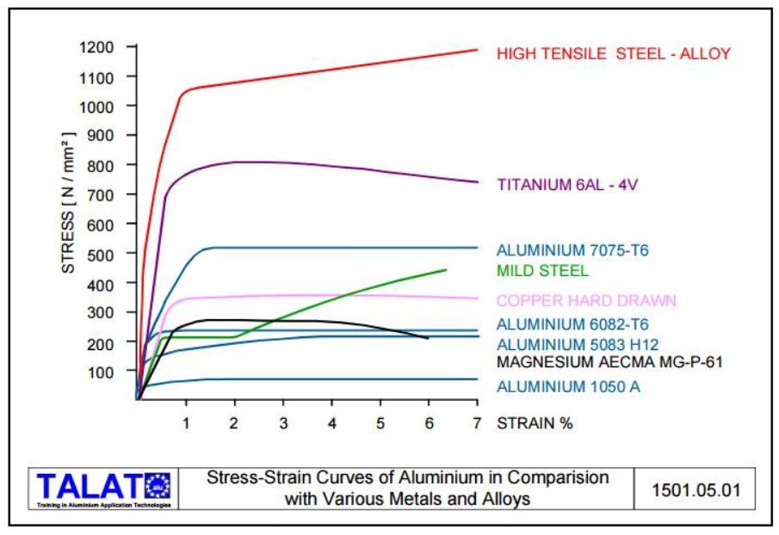
Figure 1 – Stress Strain curves for various metals and alloys (Cobden, 1994)

Material assessment for Steel
As it can be seen from table 1 and Fig 1. Steel has the highest yield tensile strength and fatigue strength (if it is assumed that the fatigue strength is a percentage of the yield tensile strength). Even though its density is high, the ratio of its yield tensile strength is relation to its density, has the highest value in relation to the other materials. This means that is the best material for pistons for this point of view. The fact that it thermal conductivity is conductivity not as high as that one of aluminium and its hardness is not as high as that one of magnesium these are the factors that result in the working temperatures of the pistons to be between 400 to 450 ºC (Saif, 2021). Considering that the melting point of steel is at 1535 ºC, this is something the steel can handle. Steel suffers from oxidation but this is not of a concerned as long as the engine is running.

Material assessment for aluminium
Aluminium is the lightest material from the materials which were considered in this report and it has also the lowest yield tensile strength, young modules and therefore fatigue strength.
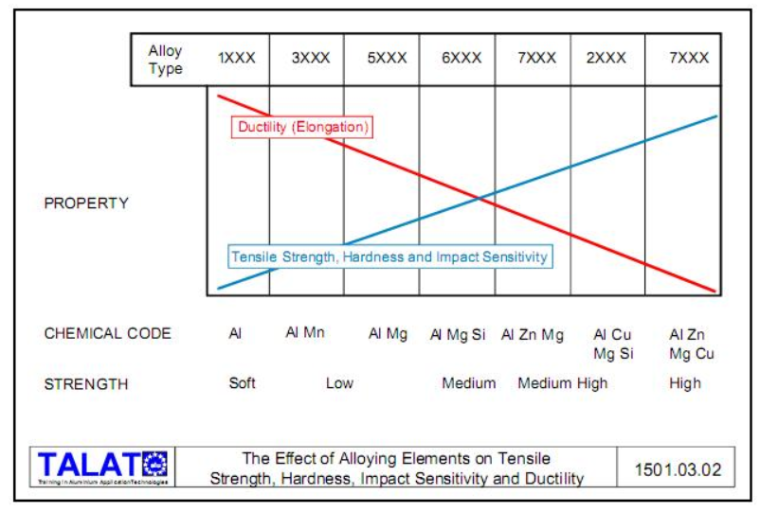 Figure 2 – Effect of Alloying Element on Tensile Strength, Hardness, Impact Sensitivity and ductility (Cobden, 1994)
As it can be seen from figure 2, the aluminium properties can drastically improve and its yield tensile strength from 40MPa (for Aluminium 1050A) can go up to 500MPa (for Aluminium 7075-T6) This changes the material index (Yield tensile strength to density) from 0.0148 which is listed on table 1, to 0.185. Considering the revised material index, Aluminium 7075-T6, comes now the first choice in the selection of the proper material for the pistons. The fact that its thermal contactivity is higher than the other metals, which were considered in this report, helps in cooling of the pistons. This has as a consequence, the piston working temperatures to be between 200-250 ºC (Saif, 2021) . These temperatures are not so far away from the melting point of aluminium which is 660 ºC and therefore the cooling of the engine and the lubrications of the pistons are impost art factors that need consideration.
There are are two weak points associated with aluminium pistons. The first one is that the hardness of the aluminium pistons is 2.75 (mohs Harness) in relation to steel and titanium which are 4 and 6 respectively. This hardness can be improved by applying special coating to the pistons skirt during manufacturing (Motoservice Group, 2016) and by introducing Mg, Zn and Cu in the aluminium alloy (see figure 2, (Cobden, 1994))
The second weak point of aluminium it that it has high thermal coefficient of expansion. This can to be considered in the design because this affects the clearance that has to be considered between the piston and the cylinder. (Saif, 2021)

Material assessment for titanium
As it can be seen from table 1 the strong point of titanium is its hardness. It has a Mohs hardness of 6 and aluminium and steel have 2.75 and 4 respectively. Its yield tensile it can reach up to about 700MPa as it can be seen from Figure 1 for titanium alloy 6Al-4V. This changes the material index (Yield tensile strength to density) from 0.0962 which is listed on the table 1, to 0.155. This change brings the material index of titanium closer to the material index of aluminium.
Comparing though the fatigue strength of titanium with the fatigue strength of the steel and aluminium as it can be seen from figures 3 and 4, that the fatigue strength of titanium is higher.
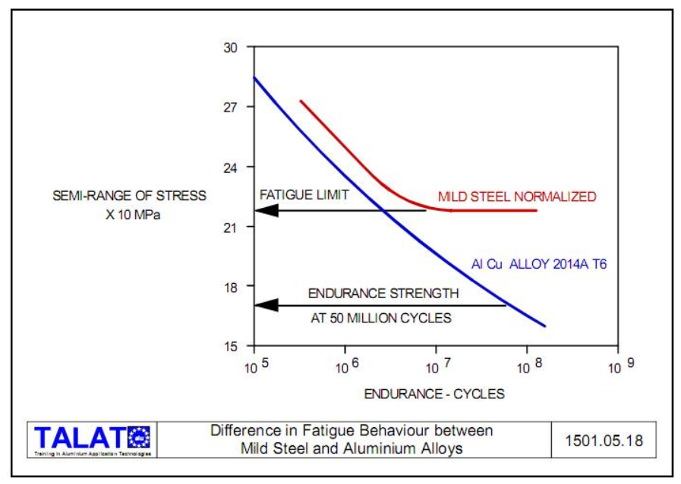
Figure 3 – Difference in fatigue behavior between Mild steel and Aluminum Alloys (Cobden, 1994)

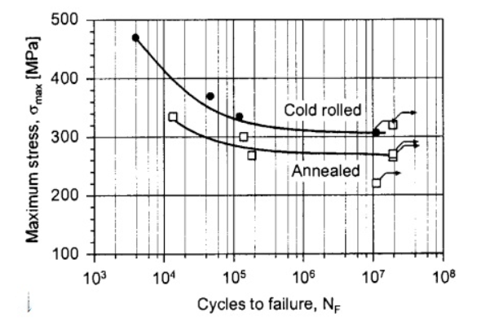
Figure 4 – S-N curve for annealed and cold rolled pure titanium(Fatigue Properties of Unalloyed Titanium, no date)

From figures 3 and 4 it can be observed that the fatigue strengths of aluminium, Steel and titanium are 170 MPa, 220MPa and 300MPa respectively. Using these values, the material index for aluminium Steel and Titanium (cold rolled) are 0.063, 0.028 and 0.067 respectively. This property of titanium makes titanium more preferable in cases where performance is required regardless of the cost.
As it can be seen from table 1, the thermal conductivity of titanium is lower than the other metals considered in this report which this means the operating temperatures of the pistons will be higher than the other metals. The fact thought that the melting point of titanium is even higher that steel this does not create any concerns. This can be supported also by figure 5 where titanium alloys and titanium-aluminium alloys can be stronger than Aluminium and steel alloys as the temperatures rise.
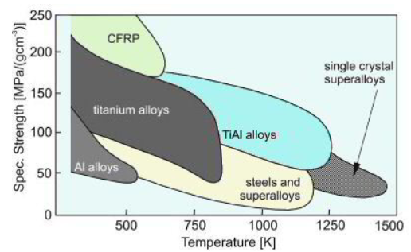
Figure 5 – Strength Vs temperature for various alloys (Leyens and Manfred, 2003)

Sustainability assessment
All the materials which were considered in this report are non-toxic and are recyclable. The pistons at the end of their design life and the waste materials during the manufacturing process can be recycled and do not leave any footprint on the environment apart from the emissions of the recycling factories which will process these materials. The recycling process of these materials will reduce the mining of these materials, the CO2 emissions associated with the mining and the waste to the environment. Due to recycling the cost of the materials might decrease or at least it should not rise as high if no recycling was done.

Cost assessment
The cost of the material which will be used for the manufacturing the pistons is also important factor in the material selection process. After research that was carried out it was observed that prices of the materials change by the minute. That is why the prices of the materials that are included in table 1 are just indicative in order to get a feeling of the cost differences between the materials which were considered in this report. The cheapest material is the steel which is approximately at 785 USD per ton and aluminium and titanium at 3493 and 4800 USD/ ton respectively. It is obvious that there is a large difference between the cost of these three materials but the material cost is not the only cost associated with the cost of the pistons. The manufacturing cost is also important because depending from the manufacturing process and the energy and the labour that is required for each process, the manufacturing cost and therefore the total cost of the pistons is affected. In order to obtain accurate figures about the cost detail analysis has to be carried outs considering the type of material which will be used the quantity of material required and the costing of the manufacturing process for the specific material.

Manufacturing Processes
The production of a piston involves various processes. The pistons can mainly be made with the casting process where the metal is melted and then is cast in to moulds and the forging process where the metal is heated and then is pressed in a dye. Both of these processes give different properties to the pistons even if the same metal/alloy is used. Usually, the forging process produce stronger materials because the metal is pressed and this makes the product denser and stronger. Below the process for making aluminium forged pistons will be described. Similar process is followed for the cast pistons. The only difference at the first steps of the process where in the casting process the material is melted and poured in to moulds.

Process for making aluminium forged pistons
The process of making forged aluminium pistons is as follows: (How It’s Made, 2016)
- First the raw material aluminium, which comes in long rods is cut at specified lengths depending of the size of the piston which will be manufactured, using a cutting machine.
- Then these pieces of aluminium, the punch press and dye are heated to 426 ºC.
- The aluminium pieces are then inserted in the press machine and 2000 tons of pressure is applied in order the initial shape of the piston to be formed.
- The pistons are then left to cool done for 1 hour and then are heated to high temperature to strengthen the metal and then to low temperature to stabilize it.
- When the pistons cool down are then inserted in a lath in order to give the required dimension to the piston.
- Using drilling machine various small holes are drilled to the side of the piston for lubrication when the piston is in operation.
- Using another lath, certain thickness of metal is removed around the piston and 3 grooves are formed to the side of the piston two for the compression rings and one for the oil ring.
- Using a drilling machine, a hole is drilled to the side of the piston for the piston pin.
- Using a milling machine 2cm of metal is removed to the sides of the piston where holes for the piston pin were created and the dome at the top of the piston is formed.
- Using a lath, the piston is shaved from outside to allow the piston to move up and down when the metal expands.
- Small drain holes are then drilled to allow lubrication of the piston pin.
- Engrave machine is then used to engrave production data on the piston.
- Finally sharp edges are removed from the piston manually and are sanded down using belt sander in order smooth surfaces to be produced.
This is generally the process of the forged pistons and modifications to this process can be made in producing other types of pistons like “Lo-Ex” Alloy pistons, Invar Strut pistons, Autothermic Pistons, Bi-Metal Pistons, Specialloid Pistons and Wellworthy pistons (Saif, 2021). The manufacturing processes of these pistons and the properties associated with these pistons will not be examined in this report.
Definity, the manufacturing processes and techniques that are used in making these pistons, affected the properties, the behaviour and the costing of the pistons and these are factors that need consideration as well in selecting the material(s) to be used for the pistons.

Conclusions
The selection of the right material for the piston is important because is one of the parts on the engine that undergoes extensive cycling loading at high temperatures. The basic materials that were considered in this report are all suitable materials for the manufacture of pistons even though none of these materials is perfect. Steel has the highest strength but its density is high which this results in higher inertia forces. Also, certain steel alloys can suffer from oxidation.
Aluminium is the lightest of the three metals which were considered and therefore the inertial forces which will be created due to the use of these materials will be the lower than steel. Its strength is very low but its strength and harness can be improved with the production of special aluminium alloys and the use of forging and heat treatment process.
Titanium is stronger that aluminium it has the higher hardness and it does not oxidise. Considering it fatigue strength has the higher material index which this the most favourable material for the pistons. The cost of titanium though is the most expensive of all three which this makes titanium pistons not so attractive choice.
Considering the above for engine with big pistons and especially diesel engines where higher compression is required in order the fuel to ignite and the fact that the revolutions of these engines is relatively low in comparison with other engines, steel pistons would be the best choice.
For small petrol engines where the engine performance is required to be improved by reducing the inertial force due to piston material, aluminium alloys pistons is the preferable choice.
In case where performance, fuel economy and reliability is required like in the case of racing and high performance engines and where the cost is not the important factor then titanium alloy pistons is an option that can be considered.(Faller, 2002)
Prior to any material selection for the pistons, details design, costing and testing has to be carried out for each option which will be considered.

5 References
Cobden, R. (1994) ‘Aluminium: Physical Properties, Characteristics and Alloys Contents’.
Compare Metals (2022). Available at: https://metals.comparenature.com/en/what-is-titanium/model-11-0 (Accessed: 19 March 2022).
Faller, K. (2002) Management Justification to Select Titanium Automotive Components. Available at: https://www.jstor.org/stable/44718640 (Accessed: 19 March 2022).
Fatigue Properties of Unalloyed Titanium (no date). Available at: http://www.metalspiping.com/fatigue-properties-of-unalloyed-titanium.html (Accessed: 20 March 2022).
How It’s Made (2016) How It`s Made Pistons [VIDEO]. Available at: https://www.youtube.com/watch?v=uVHP24k0J_A (Accessed: 20 March 2022).
Leyens, C. and Manfred, P. (2003) Titanium and Titanium Alloys: Fundamentals and Applications. John Wiley & Sons.
Motoservice Group (2016) How pistons work (3D animation) - [VIDEO]. Available at: https://www.youtube.com/watch?v=IKLPvxSXAXw (Accessed: 6 March 2022).
Saif, M. (2021) Engine Piston: Parts, Types of Pistons, Working Principle with (PDF). Available at: https://www.theengineerspost.com/types-of-pistons-working-principle/ (Accessed: 7 March 2022).

