Module Name: International Meetings Managements for the Hotel
Module Code: BMIH6007

Title: Planning and Delivering an International Meeting / Event

Lecturer’s name: Kathryn Flynn

Student name: Aniko Takacsne Feher
Student number: 2245369
Word count: 2629
Date: 13. June 2025.

AI Acknowledgement
I confirm that I have not used any AI tools in the research and creation of this assignment. I confirm that I have not presented any AI-generated materials as my own work. I confirm I have copies of my drafts, notes, and other resources I used, which I may be asked to provide in evidence.

Executive Summary

Cymru Connect offers a three-day international business retreat that combines professional networking opportunities with cultural experiences located in North Wales. The event which takes place during the final weekend of August 2025 aims to bolster Visit Wales’ “Year of Croeso” campaign by providing delegates worldwide with genuine exposure to Welsh culture and landscapes alongside community experiences.

The event spreads across Snowdonia National Park and Portmeirion and offers a carefully selected mix of activities such as guided nature walks and Welsh language workshops together with local storytelling and creative arts sessions alongside industry panel discussions. Participants will experience both professional advancement opportunities and personal connection time to recharge.

Cymru Connect focuses on 30 global delegates while embracing modern event planning trends including “bleisure” travel growth and sustainability along with intimate transformative experiences. The event budget totals £20,000 which will be fully financed by delegate payments and sponsorship contributions resulting in an expected £12,000 surplus. Essential management components consist of digital marketing initiatives, health and safety protocols, accessibility measures, and the implementation of the EMBOK model.

The report demonstrates Cymru Connect's achievement of strategic goals through comprehensive planning and risk management combined with cultural sensitivity techniques. The event seeks to boost Wales’ business tourism standing while providing participants with lasting memorable experiences.

Content
1. Introduction 5
2. The Event Cycle 5
3. Event Concept 6
4. Aim and Objectives of the Meeting / Event 9
5. Event Management 10
6. Event Budget 12
7. Industry Trends / Issues / Impacts 15
8. Situational and Cultural Considerations 15
Conclusion 16

1. Introduction
With two nights spent in Snowdonia and Portmeirion, Cymru Connect is a combined business event full of cultural experiences. Here, guests can get close to the rich culture, language and hospitality of Wales. Scheduled for the last weekend of August 2025, the retreat is part of the Year of Croeso 2025 initiative, which will celebrate Welsh culture whilst extending a warm welcome to all global travelers visiting Wales (Visit Wales, 2024).

The event has been deliberately scheduled to reflect the increasing trend in experiential tourism and to give participants an alternative to traditional business conferences. By blending personal development with authentic cultural engagement, Cymru Connect has in this way offered more than once a life-enhancing experience that one cannot obtain at home from purely professional training.

Snowdonia National Park is well known for its beautiful landscapes and peaceful surroundings (Ritchie & Crouch, 2022), whilst Portmeirion, with its extraordinary architecture and attractive environment, provides a unique location for accommodation and informal networking (Celtic Castles, 2025).

2. The Event Cycle
The Event Cycle, defined by Allen et al. (2010), has five key stages: Research, Design, Planning, Coordination and Evaluation, which often overlap and may change throughout the event's life (Harris & Allen, 2005). Human interaction and experiential value are at the heart of what is important in today's events.
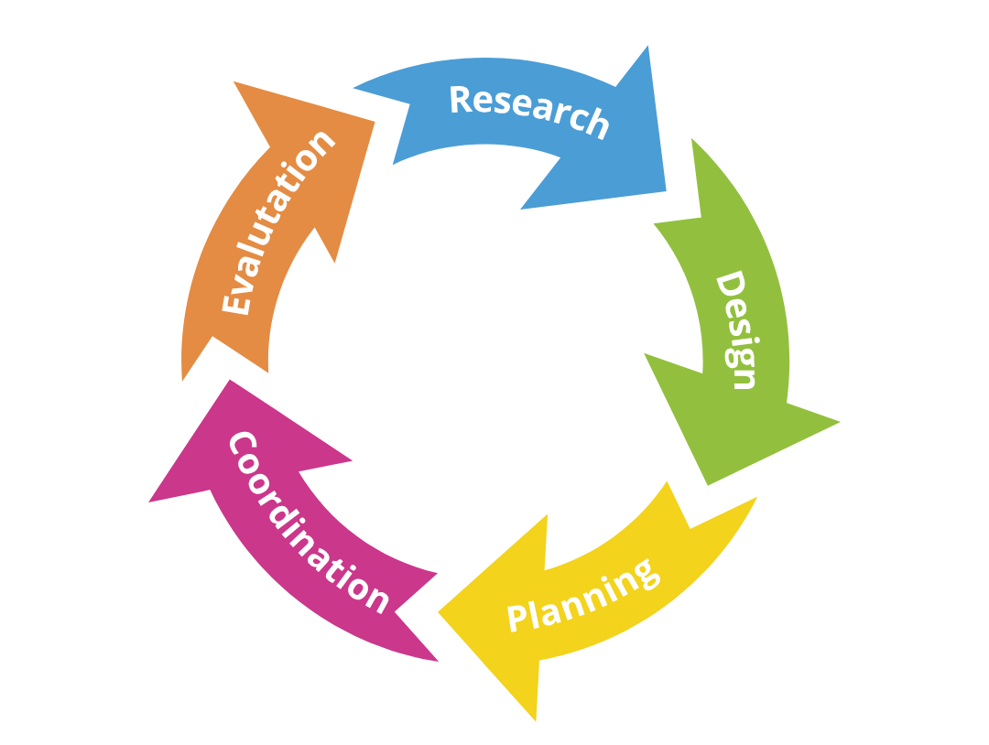
Figure 1. (self-made infographic)
Research
For Cymru Connect, the research phase involved understanding the needs of its target audience (international business professionals). The research into the needs of our target market, when delegate surveys returned and potential delegates were informally interviewed produced a message that was clear: people want meaningful experiences that combine work with pleasure (Prebensen & Foss, 2011).

Design
The event design centered on creating an itinerary that balances structured business sessions with cultural immersion. Delegates will attend Welsh language classes, storytelling sessions and nature hikes, which allow natural experiences. Culturally authentic events come standard at no extra charge alongside professional discussions (Pine & Gilmore, 2013).

Planning
In the planning stage, the logistics of venue selection, catering, transport and venue staff were all carefully arranged. Detailed timelines, roles and responsibilities were defined to ensure that the event would go smoothly (Getz 2008).

Coordination
On the day of the event, real-time coordination will ensure seamless transitions between business networking sessions and cultural events. All parts of this event will be managed by the event management team, ensuring that every component is executed as planned. Where unexpected challenges arise they will be addressed in a timely manner (Bowdin et al., 2006).

Evaluation
After the event, delegate comments will be used to evaluate the overall experience. This feedback will steer future iterations of Cymru Connect, ensuring that the event continually evolves to meet delegate expectations (Getz & Page, 2016).

3. Event Concept
Cymru Connect is a cultural and professional event, designed to meet the psychological, social and self-actualisation needs of international delegates. It is a concept aligned with Maslow’s hierarchy of needs.
This event idea was first introduced during the presentation bid pitch, particularly on Slide 3 (Purpose) and Slide 7 (Immersive Activities). In that pitch, we established the concept of “Connection through Culture” as the core theme. The final itinerary now reflects this by blending emotional resonance, cultural immersion, and reflective spaces—key elements that were highlighted during the pitch.

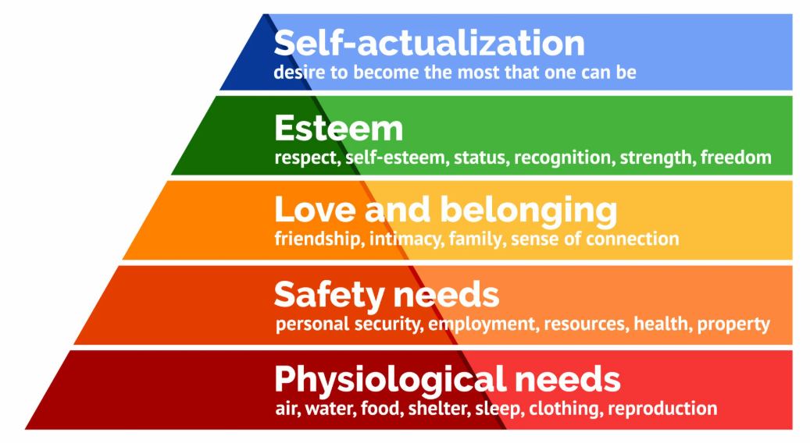
Figure 2. (source: https://www.simplypsychology.org/maslow.html)

As presented during the bid pitch, Cymru Connect integrates the principles of experience design (Pine & Gilmore, 2013), where every touchpoint is crafted to evoke emotion, connection and memory.

The design also mirrors post-COVID trends in the events industry, especially the rise of transformational retreats. Delegates are no longer looking for high-pressure, transactional conferences, but slow-paced, human-centred environments where deep reflection, well-being, and relational value are prioritised.

Over the next three days, the schedule is like this:

Day 1:
07:00–08:30: Slow breakfast with local Welsh food
08:30–10:00: Snowdonia National Park, guided walk
10:30–12:00: Welsh language workshop local guides
12:00–13:30: Lunch to divide among yourselves at one of the fanciest restaurants in the UK
14:00–16:00: Business Networking Sessions Invite all participants to be involved in business clinics with partners from their own industry
16:30–18:00: Story-telling circle about the myths and stories of Snowdonia led by a professional historian
19:00–21:00: Dinner and informal networking Portmeirion Dining Hall

Day 2:
07:00–08:30: Breakfast and time out for reflection
09:00–11:00: Outdoor group experiences such as hiking up a mountain or seeking out delicious local produce on a foraging trip
11:30–13:00: Collaborative group discussions on business and sustainability subjects in one or another of many small rooms available for private meetings
13:00–14:30: Lunch in the nearby village
15:00–17:00: Creative workshops concentrating on Welsh arts and crafts
18:00–20:00: Group dinner made from local ingredients followed by an evening campfire for those who wish to tell stories

Day 3:
07:00–08:30: Breakfast and time out for reflection
09:00–11:00: Panel discussion about Tourism in Culture and Business
11:30–13:00: Walk around the grounds and lunch
13:30–15:00: Parting thoughts & Presentation ceremony
15:30: Departure of guests

The table demonstrates how every essential function of Cymru Connect advances strategic goals while aligning with theoretical foundations including Maslow’s hierarchy of needs and Pine and Gilmore’s Experience Economy model.

Activity | Strategic Purpose | Maslow Tier | Experience Type (Pine & Gilmore)
Welsh language workshop | Deep cultural immersion, identity connection | Belonging / Self-actualisation | Education
Guided nature hike | Relaxation, mindfulness, informal networking | Safety / Self-actualisation | Aesthetic / Escapism
Storytelling circle | Emotional bonding, cultural memory | Belonging | Entertainment
Business networking clinics | Peer learning, knowledge exchange | Esteem / Self-actualisation | Education / Escapism
Arts and crafts workshop | Creative expression, local appreciation | Esteem / Self-actualisation | Education / Aesthetic
Campfire sharing session | Community building, emotional resonance | Belonging / Esteem | Entertainment / Escapism
Table 1. (Cymru Connect – Experiential Strategy Aligned with Theory)

Delegates will be encouraged to take part in both formal and informal networking throughout the conference, thus enabling them to make links with potential partners while engaging in cultural pursuits (Woodside & Martin, 2007).

4. Aim and Objectives of the Meeting / Event
Overarching Aim:
Comprehensive purpose :A new and influential cultural immersion retreat that combines ad cultural experiences with business networking, introducing the rugged beauty of North Wales to the international marketplace (Ritchie & Crouch, 2022), with aims to turn Wales into a top destination for overseas business tourism.

SMART Objectives:
- Specific: By the end of August 2025, we will have welcomed 30 international delegates each representing a different country.
- Measurable: By evaluating questionnaires completed after the event, our goal is to record an 85% delegate satisfaction level in terms of cultural immersion, networking and general environment (Harris & Allen, 2005). This is why we ask that you take some time before the conference closes to hand over your completed event survey form. We need the feedback from these forms (total of 1,000 questionnaires expected this year) if we want to make it even better next year.
- Time-bound: 70% of the materials and services for the event will be provided locally, so that the entire event will succeed in meeting its own survival targets from August 2025 onwards (Visit Wales, 2024).

5. Event Management
To launch Cymru Connect satisfactorily, a team is indispensable, it should be composed of individuals who have a wide range of skills and knowledge in several key areas.

Most importantly, of course, it is vital for the event to operate smoothly. Detailed planning and organization will be essential elements in handling all logistics for the event, including transportation, catering, accommodation and event logistics (Allen et al in 2010).

In the EMBOK model (O’Toole et al., 2010), effective event management is structured around five core knowledge domains: Administration, Design, Marketing, Operations, and Risk. Each of these is crucial to delivering a coherent and safe experience that meets both strategic objectives and participant expectations.
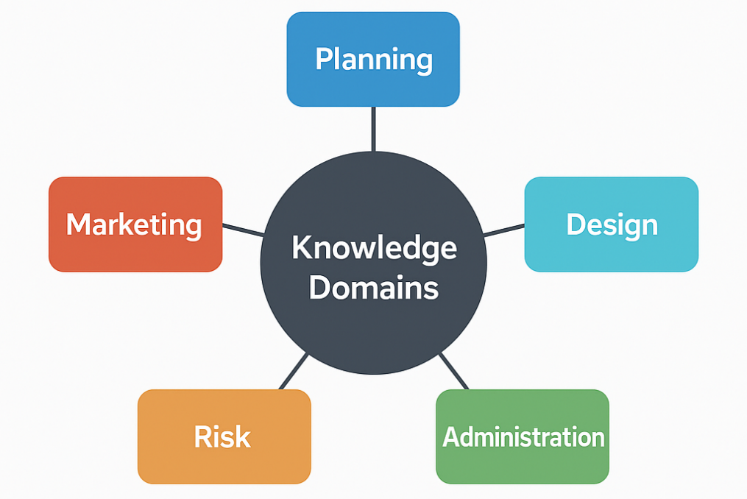
Figure 3. (self-made infographic)

Event Management Framework – EMBOK Model
EMBOK Domain | Application to Cymru Connect
Administration | Project planning, budgeting, legal compliance
Design | Experience design aligned with Pine & Gilmore model
Marketing | 7Ps strategy including digital promotion & influencer outreach
Operations | Venue setup, logistics, technology coordination
Risk | H&S planning, risk assessment, insurance cover
Table 2. EMBOK Model
For the planning phase, in particular, organizing an event will require expertise in design. This includes: scheduling; choosing the venue; and making meaningful experience for delegates (Bowdin et al in 2006).

The marketing teams need to use targeted campaigns on such easily accessible platforms as Instagram, LinkedIn or Visit Wales ’ own networks. Influencers and partnerships with cultural organizations will be the key to promoting the event (Prebensen & Foss in 2011).
We used McCarthy’s 7P framework for promotion:
- Product: a three-day cultural-business retreat,
- Price: a premium £900 package aligned with boutique retreat expectations,
- Place: the unique Welsh locations of Snowdonia and Portmeirion,
- Promotion: targeted campaigns through LinkedIn, Instagram, and Visit Wales’ channels,
- People: local guides, facilitators, and hospitality staff,
- Process: a seamless guest journey from registration to departure,
- Physical evidence: curated visuals, event branding, and digital materials.

Ensuring seamless communication with delegates and providing exceptional customer service throughout the event will also enhance delegate satisfaction (Pine & Gilmore, 2013).

The entire event will be managed by a dedicated team, made up of an event manager, logistics coordinator, marketing teams, and cultural workers and event staff.

Health and Safety Planning

Health and Safety planning for Cymru Connect follows UK HSE (Health and Safety Executive) guidelines.
Safety Measure | Implementation Detail
Risk Assessment | Conducted pre-event for all venues and outdoor spaces
Emergency Protocols | Shared with staff; includes evacuation points & local contacts
First-Aid Provision | Certified staff on-site throughout the event
Weather Contingency | Backup indoor venues reserved for key activities
Table 3.: Health and Safety Planning

Risk management has been part of every stage in the event planning process, drawing from the Risk domain of the EMBOK model (O'Toole et al., 2010). A risk matrix has been developed to evaluate and prioritise potential threats, including weather disruptions, transportation delays, medical emergencies, and technology failure.

Accessibility Considerations
Accessibility Element | Detail
Step-Free Access | Ensured for all major venues and accommodations
Inclusive Materials | Bilingual, large print, and digital options
Assistive Technologies | Hearing loops, captioning on request
Personalised Support | Mobility help and custom scheduling available on request
Table 4.: Accessibility Considerations

6. Event Budget
With Cymru Connect, the budget was established according to a variety of credible sources, including industry reports, event management best practices, and benchmarks for comparable events in Wales and broader industries.
Income:
Delegate fees were calculated by looking at similar boutique retreats and conferences in the UK (Getz & Page 2016). Events of this nature generally do charge premium rates in order to guarantee exclusivity make the customer feel they have value for money. £900 is a competitive price, which will cover a 3-day retreat with meals, workshops talks and (most importantly) networking.
For sponsorship the estimate of £5 000 was made in consultation with Visit Wales and local tourism organizations. This sum ties in with levels of sponsorship for smaller cultural events, partic-ularly those connected up to national marketing campaigns like the Year of Croeso 2025 (Visit Wales 2414).
Expenditure:
Venue (£6,000) is based upon the estimated cost of venue hire at Snowdonia and Portmeirion, UK venues used for similar-sized events (Celtic Castles 2025).

Picture 1. (source: https://www.musement.com/uk/snowdonia-national-park/snowdonia-national-park-v/)
Coverage for facilitators, local specialists, and the staff costs of £4,500. This amount is based on average prices in Wales for experienced facilitators and event coordinators. Culture workshop facilitators will charge £1,200–1,500/day for similar retreats, networking facilitators charge an additional fee (Harris & Allen, 2005)
£3,500 covers catering for high-quality, fresh local meals 30 delegates over three days (Ritchie & Crouch, 2022).
£2,000 has been estimated for technology. This estimate is based on the normal costs of providing such services to international audiences of small-scale events (Prebensen & Foss, 2011).
A budget of £1,500 for marketing festivals is based on norms in the industry for boutique event promotions, which emphasize digital. reach through organically-created material that will popularize your event (Pine & Gilmore, 2013).
£2,500 was budgeted for audiovisual equipment, insurance cover and general administration. This sum is based on typical AV and insurance requirements for events of this type and size (Bowdin et al., 2006).
Income
Delegate Fees (30 x £900) | £27,000
Sponsorship | £5,000
Total Income | £32,000

Expenditure
Venue Hire (Snowdonia & Portmeirion) | £6,000
Staffing and Facilitators | £4,500
Catering and Hospitality | £3,500
Technology and Hybrid Services | £2,000
Marketing and Promotion | £1,500
AV, Insurance, and Admin | £2,500
Total Expenditure | £20,000
Surplus: £12,000
The pie chart below visually represents how Cymru Connect’s budget of £20,000 is allocated across key expenditure areas:
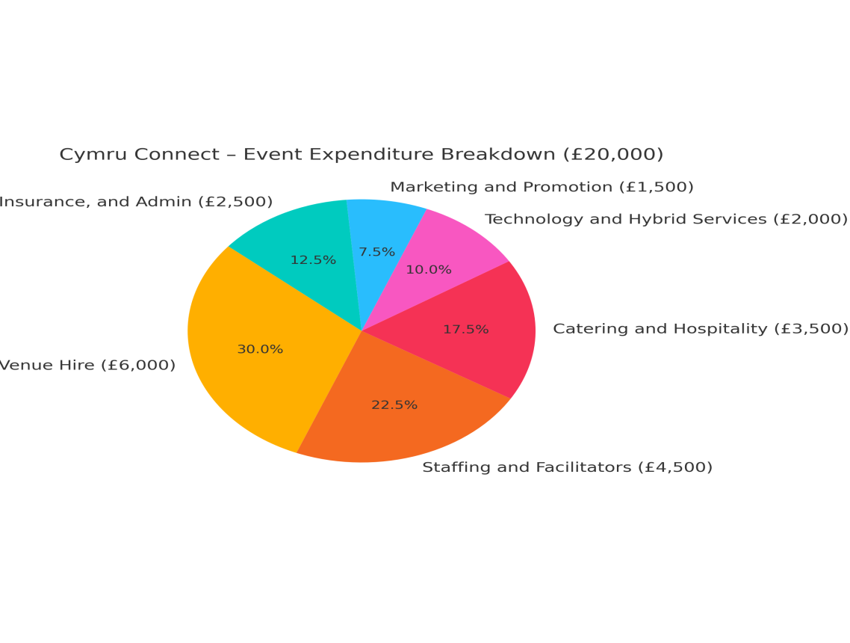
Figure 4.: Cymru Connect – Event Expenditure Breakdown (self-created)
This pie chart was self-created based on the event’s projected budget figures. All values are estimated.

7. Industry Trends / Issues / Impacts
In the modern meetings and events industry, events are hosted differently, prompted by a few key trends that are changing how conferences are run. Bleisure Travel is one of the biggest trends in recent years, and it entails incorporating leisure activities into business trips. This trend speaks to a growing yearning for the combining work and rest. Cymru Connect caters to this need by combining professional networking with down-time “activities” such as nature walks on historic parks, Welsh learning classes and story-telling done in Welsh. By catering to the need for mingling business with leisure (Getz, 2008), the retreat offers a more balanced and joyful experience for participants.

Another colossal trend in events hosting is the new passion for smaller, more intimate events. With the arrival of the pandemic, business has been pushed towards well-being and release. Now people want personally tailored events that relax them. Cymru Connect is in harmony with this trend. It creates a relaxing environment on behalf of delegates, but the weeks “offer plenty of quiet time and bonding events” that focus largely on mental well-being such as group self-reflection sessions or taking in some outdoor experience (Hall,2005).

Lastly, this is perhaps the most important trend for the events industry: green. As people continue to become more environmentally-conscious, the demand for sustainable events is growing rapidly. Cymru Connect ensures this by buying all materials locally or regionally, minimizing its waste and encouraging travellers to take package tours. Consequently, the event with its program of holistic activity not only provides participants a useful experience but also reduces impact on environment (Prebensen & Foss, 2011).

8. Situational and Cultural Considerations
Cymru Connect will belocated in a part of Wales that is rich in cultural tradition and history. If the event is to be a success, it is essential that all participants understand local customs, local traditions, and (from Welsh into English) the Welsh language. The event will offer language classes and local cultural activities that invite delegates to experience the essential Wales. After these experiences, everyone will leave knowing this region much better than ever before (Visit Wales, 2024).

A SWOT analysis will be useful to assess the internal and external factors that may impact the event:

Strengths | Weaknesses
Unique cultural experience aligned with Wales' tourism strategy | Potential language barriers (Welsh-English)
Strong partnership opportunities with Visit Wales and local communities | Limited tech infrastructure in rural locations
Authentic immersion through storytelling, food, nature, and language | May not appeal to traditional business travellers
Scheduled during national tourism campaign (Year of Croeso 2025) | Small scale limits immediate international reach

Opportunities | Threats
Growing demand for experiential and sustainable tourism | Weather disruptions affecting outdoor events
Potential to expand into an annual or scalable international event | Global economic issues may limit travel budgets
Enhances Wales’ image as a business + leisure destination | Transport delays, especially in rural areas
Table 5.: (SWOT analysis Cultural and Situational Considerations)
The insights drawn from this SWOT analysis inform critical planning decisions, such as building local partnerships, addressing logistical limitations, and preparing for environmental or cultural challenges to ensure event success.

Conclusion
In conclusion, Cymru Connect represents an elegant and innovative combination of business networking with an authentic cultural experience. It is the only such event in Wales which offers this kind of rich fusion where people can feel they belong the following year too- simply by being resident in Britain itself.

Cymru Connect is a retreat in the stunning natural landscapes of Wales. It maximizes Wales’s abundance of genuine culture and natural scenic beauty, along with its commitment to ecological sustainability, to provide visitors with very different and yet immersive experiences.

The careful application of the Event Cycle (Allen et al., 2010) in the planning and execution of the retreat ensures that each stage, from research and design to coordination and evaluation, is thoroughly considered to meet both the needs of the delegates and the overarching goals of the event. The well-structured itinerary offers delegates a balance of professional networking and cultural engagement, making Cymru Connect a truly transformative experience.

Furthermore the retreat sets SMART goals that will provide clear targets for success. In this way it becomes not just a wonderful experience for those who attend, but also an ongoing and profitable business. The event's connection with Visit Wales' Year of Croeso 2025 initiative and its emphasis on local sourcing, sustainability, and cultural authenticity also means it sets up precedents for future activities in this region.

By hopping on the trends of the times, such as increasingly spa resorts, Cymru Connect frames itself within an evolving landscape for events. (Prebensen & Foss, 2011), Cymru Connect is well-placed to thrive in the evolving events landscape. Its unique concept and focus on delivering genuine cultural immersion will set it apart from other international business events.
As Cymru Connect wants to leave both its delegates and the communities in which it is held with real and lasting impact, if successful it will not only raise Wales's profile as an important business-tourism destination but also provide a model that can be copied. The careful planning and turnkey operations ensure that it will be a satisfying experience for the delegates and also a sustainable event for Wales himself.

Finally, Cymru Connect underlines one way in which events can be found thriving outside traditional boundaries. It offers delegates an opportunity not only to grow professionally but to deepen their appreciation of Welsh culture. This event is not just a retreat. It is a festival celebrating community, culture and meaningful links.
References
- Allen, J., O'Toole, W., Harris, R. and McDonnell, I. (2010) Festival and Special Event Management. 5th edn. Milton: Wiley.
- Bowdin, G., Allen, J., O'Toole, W., Harris, R. and McDonnell, I. (2006) Events Management. 2nd edn. London: Routledge.
- Business News Wales (2024) Voco St David’s Cardiff wins Wales Best MICE Hotel 2024. Available at: https://businessnewswales.com (Accessed: 1 June 2025).
- Business Wales (2025) Visit Wales Marketing Webinar: Year of Croeso 2025. Available at: https://businesswales.gov.wales (Accessed: 1 June 2025).
- Carlisle, S., Zaki, K., Ahmed, M., Dixey, L. and McLoughlin, E. (2021) The Imperative to Address Sustainability Skills Gaps in Tourism in Wales. Available at: https://www.researchgate.net (Accessed: 2 June 2025).
- Celtic Castles (2025) Castle Corporate Event Venues in Wales. Available at: https://www.celticcastles.com (Accessed: 1 June 2025).
- Chaffey, D. (2024) How to use the 7Ps Marketing Mix. Smart Insights. Available at: https://www.smartinsights.com/marketing-planning/marketing-models/how-to-use-the-7ps-marketing-mix/ (Accessed: 9 June 2025).
- Edwards, D., Foley, C., Dwyer, L., Schlenker, K. and Hergesell, A. (2010) Evaluating the Economic Contribution of a Large Indoor Entertainment Venue: An Inscope Expenditure Study. Available at: https://www.researchgate.net (Accessed: 1 June 2025).
- FOCUS Wales (2025) International Music Festival. Available at: https://focuswales.com (Accessed: 2 June 2025).
- Getz, D. (2008) ‘Event Tourism: Definition, Evolution, and Research’, Tourism Management, 28(3), pp. 403–428.
- Getz, D. and Page, S.J. (2016) Event Studies: Theory, Research and Policy for Planned Events. 3rd edn. London: Routledge.
- Hall, C.M. (2005) Tourism: Rethinking the Social Science of Tourism. London: Pearson Education.
- Harris, R. and Allen, J. (2005) Event Management: A Professional and Developmental Approach. London: Routledge.
- McLeod, S. (2023) Maslow's Hierarchy of Needs. Simply Psychology. Available at: https://www.simplypsychology.org/maslow.html (Accessed: 9 June 2025).
- Musement (n.d.) Snowdonia National Park. Available at: https://www.musement.com/uk/snowdonia-national-park/snowdonia-national-park-v/ (Accessed: 9 June 2025).
- Pine, B.J. and Gilmore, J.H. (2013) The Experience Economy: Past, Present and Future. Updated edn. Boston: Harvard Business Review Press.
- Prebensen, N.K. and Foss, L. (2011) ‘Coping and Co-creating in Tourist Experiences’, International Journal of Tourism Research, 13(1), pp. 54–67. DOI: 10.1002/jtr.799.
- Ritchie, J.R.B. and Crouch, G.I. (2022) The Competitive Destination: A Sustainable Tourism Perspective. Wallingford: CABI Publishing.
- Travel Trade Wales (2025) Toolkit: Year of Croeso. Available at: https://traveltrade.visitwales.com (Accessed: 2 June 2025).
- UK Government (2024) Year of Croeso Weather-proofing Fund for Tourism Attractions. Available at: https://content.govdelivery.com (Accessed: 1 June 2025).
- University of Wales Trinity Saint David (2025) Events Feasibility and Development: From Strategy to Operations. Available at: https://librarysearch.uwtsd.ac.uk (Accessed: 1 June 2025).
- Visit Wales (2024) Figures on the Visitor Economy in Wales. Available at: https://industry.visitwales.com (Accessed: 1 June 2025).
- Visit Wales (2024) Overnight Visits to Wales by GB Visitors. Available at: https://industry.visitwales.com (Accessed: 9 June 2025).
- Visit Wales (2025) Tourism and Hospitality Industry Engagement Events. Available at: https://industry.visitwales.com (Accessed: 9 June 2025).
- Visit Wales (2025) Year of Croeso 2025 – Themed Year Campaigns. Available at: https://industry.visitwales.com (Accessed: 9 June 2025).
- Wales Tourism Alliance (2025) News Updates. Available at: https://www.wta.org.uk (Accessed: 9 June 2025).
- Welsh Government (2024) Wales Visitor Economy Profile: 2024. Available at: https://www.gov.wales (Accessed: 9 June 2025).
- Woodside, A.G. and Martin, D. (2007) Tourism Management: Analysis, Behaviour and Strategy. Boston College, University of South Carolina.

