Design and Implementation of a Relational Database System
  - MediLink Pharmacy Database Development Report

Student Name | Thazeb khan
Student ID | 2406900
Programme | CertHE Computing Skills for Workplace
Module | Introduction to Web and Database Concepts
Module Code | ACCA4023
Lecturer | Sadhana Jha
Date | April 06 2026

Table of Contents
Table of Contents 1
1. Introduction 1
2. Scenario Analysis and Database Design 1
2.1 Main entities and attributes 1
2.2 Relationships, cardinality and modality 1
2.3 ERD and implemented relationship structure 1
2.4 Normalisation to Third Normal Form (3NF) 1
3. Data Structure Development in Microsoft Access 1
3.1 Table Design, primary keys and data types 1
3.2 Referential integrity & constraint design 1
4. Implementation and Sample Data Population 1
4.1 Customer records 1
4.2 Medicine records and stock data 1
4.3 Prescription detail records 1
4.4 Prescription header records 1
4.5 Sale item records 1
4.6 Supplier records 1
5. Query Development and Report Outputs 1
5.1 Reorder-threshold query 1
5.2 Revenue summary query 1
6. Validation and testing 1
7. Decisions and Future Considerations 1
8. Conclusion 1
References 1

1. Introduction
MediLink Pharmacy is a growing community pharmacy chain that needs a more reliable way to manage medicine stock, prescriptions, supplier information, and customer records. The purpose of the database is to replace fragmented manual record keeping with a relational solution that improves data accuracy, reduces duplication and supports operational reporting for stock control and sales monitoring [1]-[4].
A relational database is suitable for this scenario because pharmacy operations contain repeated business events that share common data. Customers can receive multiple prescriptions over time, medicines can be supplied by the same supplier, and completed sale records need to be traced back to the related medicine and prescription information. Structuring that information across linked tables strengthens integrity and supports more dependable decision making than a flat spreadsheet approach [1]-[3], [5].
This report explains the scenario, identifies the main entities and attributes, documents the implemented relationships and cardinality, justifies the chosen queries, demonstrates normalization to Third Normal Form (3NF), presents the populated Access tables and evaluates the database against the functional requirements of the assignment brief [1]-[4].

2. Scenario Analysis and Database Design
The MediLink Pharmacy solution was designed around six core entities: Customers, Suppliers, Medicines, Prescriptions, Prescription Details, and Sale Items. This structure was selected because it separates descriptive master data from repeating transactional data and therefore supports both day-to-day data entry and management reporting. Current database design literature emphasizes clear entity boundaries, stable keys, relationship integrity and purposeful normalization as the basis of reliable implementations [1]-[4].

2.1 Main entities and attributes
Table 1 summarizes the main entities and the purpose of each table within the database. Together, these tables cover the required information flows for customer administration, medicine stock control, supplier management, prescription processing and sales recording.
Entity | Primary key | Main attributes | Purpose
Customers | CustomerID | CustomerName, Address, Phone, Email | Stores customer contact information.
Suppliers | SupplierID | CompanyName, ContactPerson, Phone, Email | Stores supplier records for medicine sourcing.
Medicines | MedicineID | MedicineName, Dosage, Category, StockQuantity, Price, ExpiryDate, SupplierID | Stores medicine stock records and the supplier link.
Prescriptions | PrescriptionID | CustomerID, PrescriptionDate, DoctorName, Status | Stores prescription header information for each customer prescription.
Prescription Details | DetailID | PrescriptionID, MedicineID, Quantity, Instructions | Stores the individual medicine rows for each prescription.
Sale Items | TransactionID | PrescriptionID, MedicineID, Quantity, SaleDate, TotalAmount | Stores transaction rows used for sales and revenue analysis.

This combination of entities reflects the scenario well because the design isolates who the customer is, who supplies the medicine, what the medicine is, what was prescribed, and what was sold. That separation is essential for consistent updates and more accurate queries [1]-[4].

2.2 Relationships, cardinality and modality
The implemented relationships are all one-to-many. A single customer may have multiple prescriptions, a single supplier may provide multiple medicines, one prescription may contain multiple prescription detail rows, and one medicine may appear in many prescription detail rows and sale rows. This structure supports the business rules of the scenario and allows Access to enforce referential integrity between parent and child tables [2], [3], [5].
Relationship | Cardinality | Meaning
Customers -> Prescriptions | 1:M | One customer may have many prescriptions.
Suppliers -> Medicines | 1:M | One supplier may supply many medicines.
Prescriptions -> Prescription Details | 1:M | One prescription may contain several medicine lines.
Medicines -> Prescription Details | 1:M | One medicine may appear in many prescription detail rows.
Prescriptions -> Sale Items | 1:M | One prescription may be linked to one or more sale rows.
Medicines -> Sale Items | 1:M | One medicine may appear in multiple sale transactions.

2.3 ERD and implemented relationship structure
Figure 1 shows the relationship window used in Microsoft Access. The diagram demonstrates the links between the main tables and shows the expected one-to-many cardinality markers. A well-labelled ERD is important because it makes the structural logic of the database visible and confirms how keys and foreign keys support business processes [1]-[3].
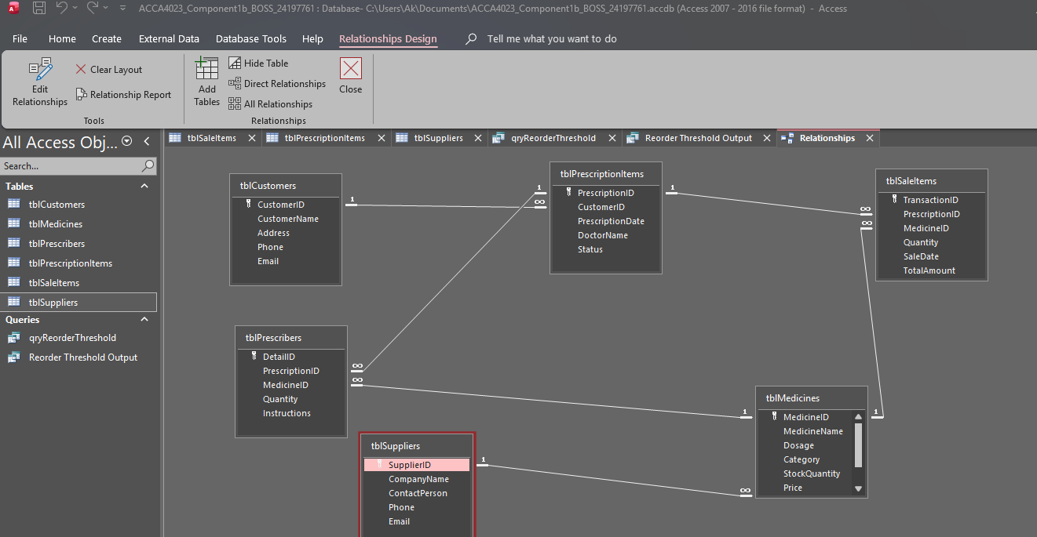
Figure 1. Relationship diagram showing table links, keys and one-to-many cardinality in the Access database.

2.4 Normalisation to Third Normal Form (3NF)
The database design complies with 3NF. First Normal Form is satisfied because each field contains a single atomic value. Second Normal Form is satisfied because repeating transaction data is separated from the master data tables. Third Normal Form is satisfied because non-key attributes are stored only in the table to which they logically belong, such as customer details in Customers and supplier details in Suppliers [1]-[3].
The separate Prescription Details table is particularly important because it resolves the many-to-many relationship between Prescriptions and Medicines. If this table were not present, the design would either have a single table with the same medicine data that appears in the Prescriptions table, or record multiple medicine values in the same field, and would not only violate normalization but have a lower query quality [1], [2].

3. Data Structure Development in Microsoft Access
After the conceptual design was finalized, the entity structure was implemented in Microsoft Access using AutoNumber primary keys, foreign keys, text fields, numeric fields, currency fields and date fields. Careful selection of field types is important because it influences validation, storage accuracy and the reliability of later query calculations [2]-[4].

3.1 Table Design, primary keys and data types
For the Customers table its CustomerID is the AutoNumber primary key and for each field the customer name, address, phone, email, are short text fields. For the Medicines table the MedicineID is the AutoNumber primary key to add dosage, category, stock quantity, price, expiry date and supplier ID. The implemented design views, for defining the table structure and key fields, are presented in Figure 2 and 3.
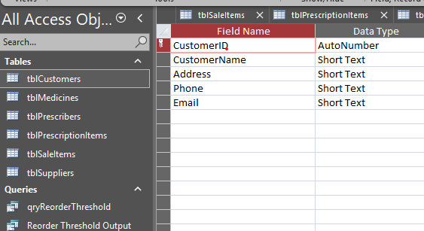
Figure 2. Customer table layout based on CustomerID in the form AutoNumber primary key.
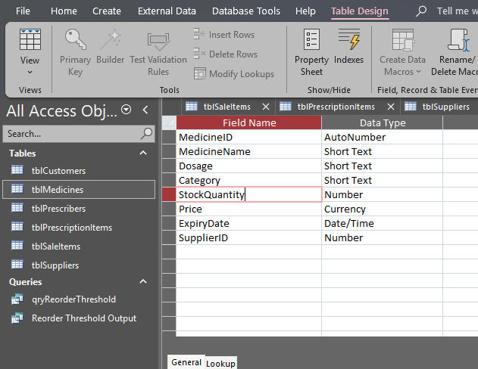
Figure 3. Medicine table design for stock, price and expiry date and supplier link to field types.

3.2 Referential integrity & constraint design
The relationship structure enables enforcement of parent-child links and ensures that prescription and sale along with medicine data maintains an even relationship. Referential integrity is an essential issue in healthcare-related systems because if the quality of data is poor, discrepancies can result in incorrect reporting, repeating records and also unreliable operational data [5]-[10].
The database is also designed with constraints because numeric fields will be the numbers, price fields are currency, and date fields will be date/time values. This enhances consistency, and facilitates accurate calculations for stock and revenue reporting [2], [4], [9], [10].

4. Implementation and Sample Data Population
The final dataset was populated with at least five realistic records in each main table. This meets the population condition of the assignment and shows that the design can provide realistic use cases, not empty structures. The relation structure working and suitable query-oriented, the linked IDs across tables also indicate that the schema is functional [1], [2], [4].

4.1 Customer records
Figure 4 contains the populated Customers table. Records are customer names, addresses, phone and email numbers etc, a base of contact information to make the database user testing feasible for operational testing.
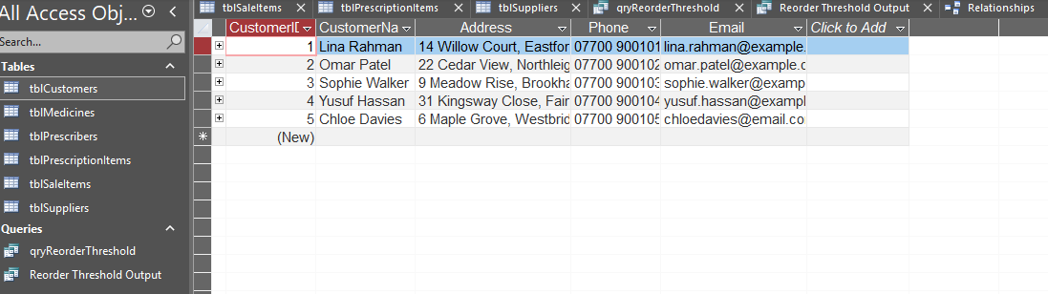
Figure 4. Customer records entered into this database.

4.2 Medicine records and stock data
In Figure 5, we see the Medicines table. These records house the medicine name, dosages, category, quantity-in-stock and price of the product, expiry date, and supplier ID. It allows for both stock management and query monitoring of low-stock medicines.
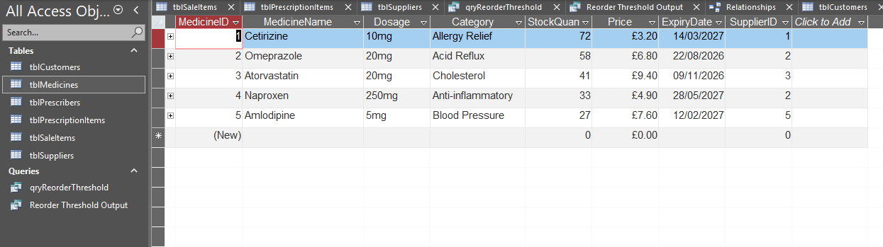
Figure 5. Medicine stock records with category, stock quantity, price, expiry date and link to supplier.

4.3 Prescription detail records
Prescription detail rows that relate each prescription to some medicine are shown in Figure 6. Every row has a prescription ID, medicine ID, quantity value and dosage directions. This structure supports a normalized storage of many prescription lines of different prescriptions.
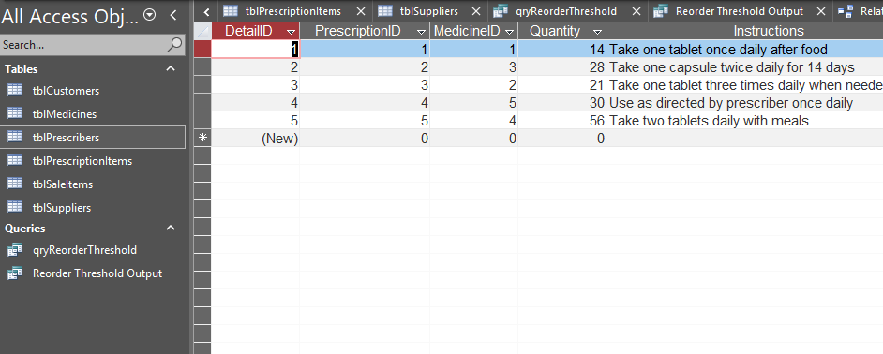
Figure 6. Prescription detail records linking prescriptions to medicines, quantities and instructions.

4.4 Prescription header records
The prescription header table in Figure 7 shows the customer ID, prescription date, doctor name and prescription status. This table holds the primary prescription event, while the linked detail table holds the medicines prescribed against that event.
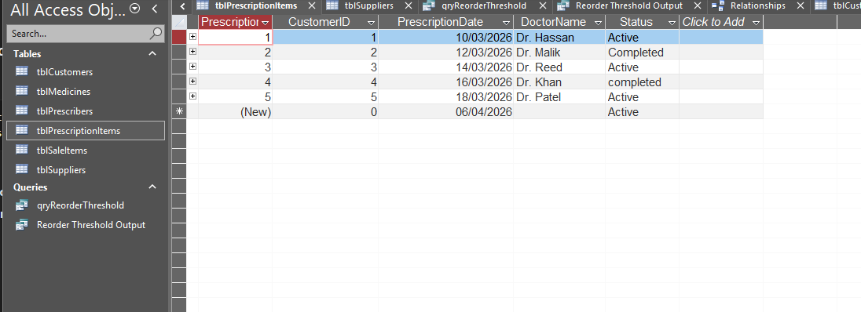
Figure 7. Prescription header records of customers, date, prescriber & status.

4.5 Sale item records
Figure 8 depicts the sale records for quantity and revenue sales analysis. The prescriptions were logged in individual rows and this is done by recording a prescription ID, a medicine ID, a quantity sold, a date of sale and a sum monetary value which is possible to aggregate later for reporting purposes [2], [4].
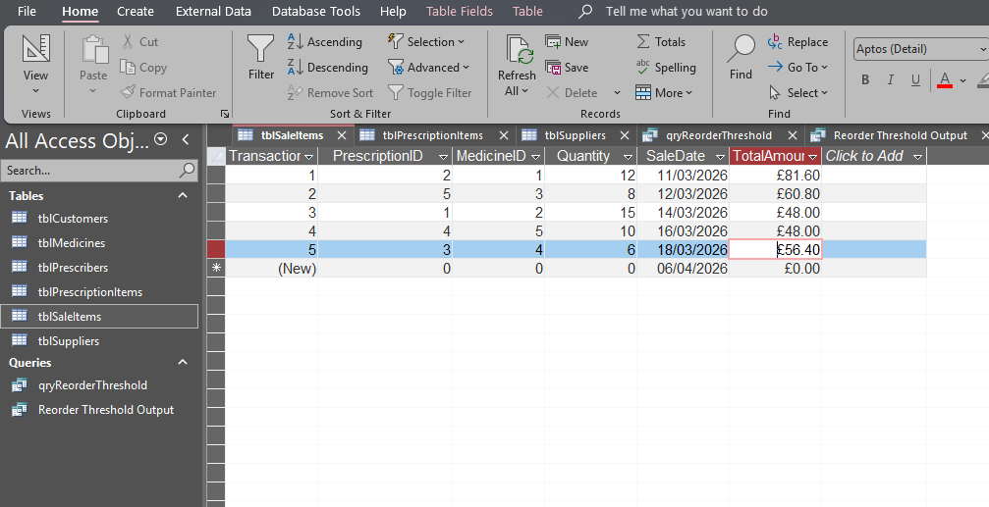
Figure 8. Sale item records used for quantity and revenue analysis.

4.6 Supplier records
Figure 9 shows the supplier records, all linked via SupplierID and Medicines table. This enables each medicine row to be linked to a source vendor for purchase and stock management.
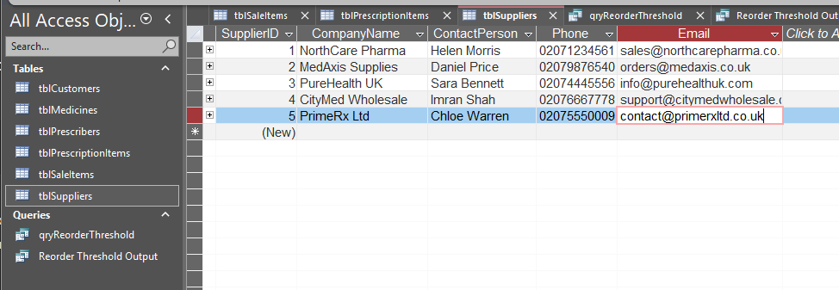
Figure 9. Supplier records linked to medicines through SupplierID.

5. Query Development and Report Outputs
Two concrete queries were drafted that show how the database can inform management decisions. The first query targets medicines below the reorder threshold.The second query will give an aggregate revenue summary when examining the sale records for that query. These are the two queries that were selected as they are directly related to the assignment requirement where we need practical, purposeful queries based on user requirements in stock control and sales monitoring [1], [2], [4], [6]-[8].

5.1 Reorder-threshold query
The reorder-threshold query selects MedicineName, Dosage, StockQuantity and Category from the Medicines table and returns only rows that have StockQuantity below 36. From the lowest stock quantity to the highest, this renders better visibility into medicines needing further procurement [1], [2].
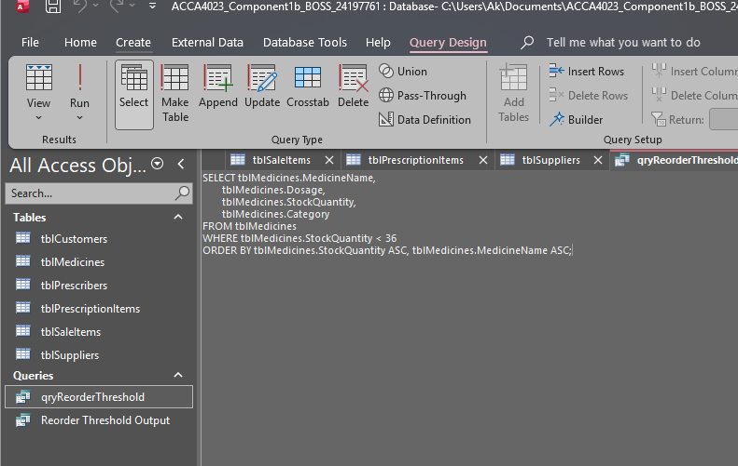
Figure 10. SQL visualisation of Reorder-threshold query.
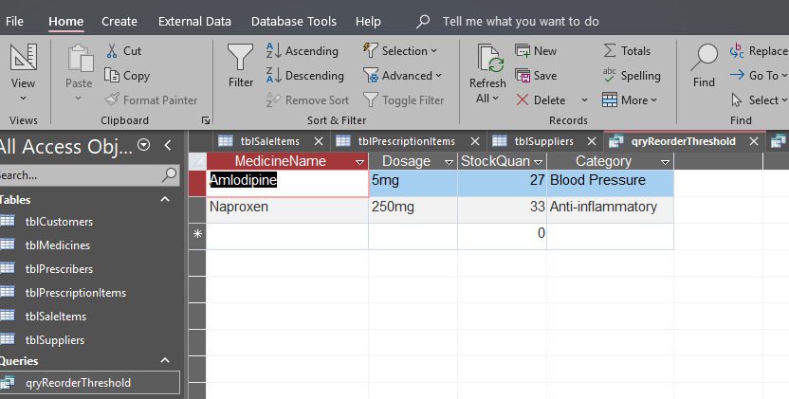
Figure 11. Reorder-threshold query output (medicines below threshold set)
The output of the query indicates that right now Amlodipine and Naproxen are below the specified threshold. This validates that the query is working as expected and also reflects Access on turning stored stock into management information for inventory review [1], [2], [7].

5.2 Revenue summary query
For revenue summary query, the Sum function of the Quantity and TotalAmount fields is used in the Sale Items table. Rather than listing each of these rows individually, the query returns the total number of units sold and total revenue value. Aggregate queries like this are helpful since they obtain compact management outputs obtained from more complex transaction data [2], [4], [8].
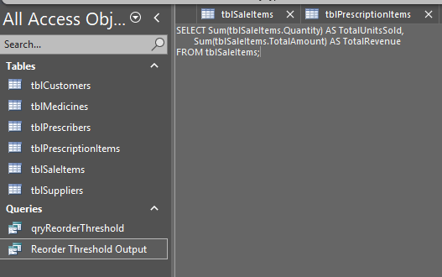
Figure 12. SQL Visualisation of Revenue Summary Query.
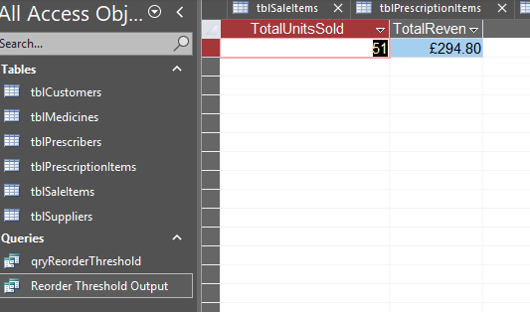
Figure 13. Revenue summary query output demonstrating total units sold and total revenue.
The output from the query is TotalUnitsSold = 51 and TotalRevenue = £294.80. A manual comparison with the sale rows from Figure 8 supports the same total. This substantiates the accuracy of the stored numbers and the general query logic [2], [4].

6. Validation and testing
The database was validated against the main functional requirements of the brief. Testing focused on such issues as structure, data integrity, sample data quality and accuracy of query output. The aim was to confirm that the database behaves as a coherent system and not as a set of unrelated tables [1], [3], [4].
Test area | Expected result | Outcome
Primary keys | Each primary table should have its own unique identifier. | As the major keys, Fields of AutoNumber were effectively assigned (used correctly) as primary key.
Relationships | Child rows should only refer to valid parent rows of 1:M in nature. | The graph illustrates our anticipated one to many connections.
Sample data population | Each table should contains realistic data for querying. | Five or more realistic data were filled in the main tables.
Reorder-threshold query | Only medicines falling under the specified threshold will appear. | The query returned Amlodipine and Naproxen.
Revenue summary query | The combined totals should match the registered sales rows. | No doubt the query returned 51 units and £294.80 in accordance with a manual verification.
Field types and constraints | Numeric, currency and date fields should be properly stored and computed. | Table designs allow for correct quantity type, price set, and date value set.

Results of testing proved that the database fulfills functional needs of the scenario. They are linked, sample data is meaningful and query outputs are user need driven. These are valuable signs of a well designed Access implementation [2], [4], [9]-[11].

7. Decisions and Future Considerations
The most critical design decision was to decompartmentalize the database into six linked tables which would not keep everything all in one unit so, now we have six linked tables. This choice tightened the integrity of the database and reduced redundancy and simplified query logic immensely. It also implemented the design that fulfilled 3NF by compartmentalizing customer data, supplier data, medicine stock, prescriptions, prescription detail rows and sales transactions [1]-[4].
The queries that were chosen were also intentional. The reorder-threshold query tackles stock control as it picks medicines to focus on, the revenue summary query handles sales monitoring by merging the transaction rows and returning a specific financial value. Thus, these query results act as management reporting views in Access [2], [6]-[8].
This current version of the database would likely expand further in the future with dedicated Access forms for customer entry, prescription entry, and transaction processing, as well as report objects for expiry tracking, supplier-based stock analysis, and date-filtered sales analysis. If databases were scaled further, the Prescriber table can be added separately to provide a more extensible model [2], [4], [8], [10].

8. Conclusion
The integrated database for MediLink Pharmacy offers a consistent relational model in Microsoft Access for storing customer information, suppliers, medicines, prescriptions, and transactions. The architecture allows for proper entity identification, primary and foreign keys usage, 3NF processing, realistic sample data populate, and practical queries to control stock at the right spot and analyze revenue. Combined, these features fulfil the principal requirements of the assignment, and demonstrate how a structured database can potentially enhance the quality and consistency of operational information and its utility [1]-[4], [6]-[11].

References
[1] M. J. Hernandez, Database Design for Mere Mortals: 25th Anniversary Edition. 4th ed. Pearson, 2021.
[2] R. Elmasri and S. B. Navathe, Fundamentals of Database Systems, 7th ed. Pearson, 2021.
[3] C. Coronel and S. Morris, Database Systems: Design, Implementation, and Management, 14th ed. Boston, MA, USA: Cengage, 2022.
[4] J. Korol, Access 2021 / Microsoft 365 Programming by Example. Dulles, VA, USA: Mercury Learning and Information, 2022.
[5] A. Gamal, S. Barakat, and A. Rezk, "Standardized electronic health record data modeling and persistence: a comparative review," Journal of Biomedical Informatics, vol. 114, art. no. 103670, 2021.
[6] A. Ogundipe, T. F. Sim, and L. Emmerton, "Development of an evaluation framework for health information communication technology in contemporary pharmacy practice," Exploratory Research in Clinical and Social Pharmacy, vol. 9, art. no. 100252, 2023.
[7] J. Frestel, S. W. K. Teoh, C. Broderick, A. Dao, and M. Sajogo, "A health integrated platform for pharmacy clinical intervention data management and intelligent visual analytics and reporting," Exploratory Research in Clinical and Social Pharmacy, vol. 12, art. no. 100332, 2023.
[8] K. N. Hettinger, O. A. Adeoye-Olatunde, A. L. Russ-Jara, E. G. Riley, K. L. Kepley, and M. E. Snyder, "Preparing community pharmacy teams for health information exchange (HIE)," Journal of the American Pharmacists Association, vol. 64, no. 2, pp. 429-436.e2, 2024.
[9] R. D. Thantilage, N.-A. Le-Khac, and M.-T. Kechadi, "Healthcare data security and privacy in Data Warehouse architectures," Informatics in Medicine Unlocked, vol. 39, art. no. 101270, 2023.
[10] S. Oktaviana R, P. W. Handayani, A. N. Hidayanto, and B. B. Siswanto, "Healthcare data governance assessment based on hospital management perspectives," International Journal of Information Management Data Insights, vol. 5, no. 1, art. no. 100342, 2025.
[11] M. Javaid, A. Haleem, and R. P. Singh, "Health informatics to enhance the healthcare industry's culture: An in-depth analysis of its features, contributions, applications and limitations," Informatics and Health, vol. 1, no. 2, pp. 123-148, 2024.

