

Assessment 1 – Reading Task Template
PART 1: Upload your photo of your A3 in-class notes here:
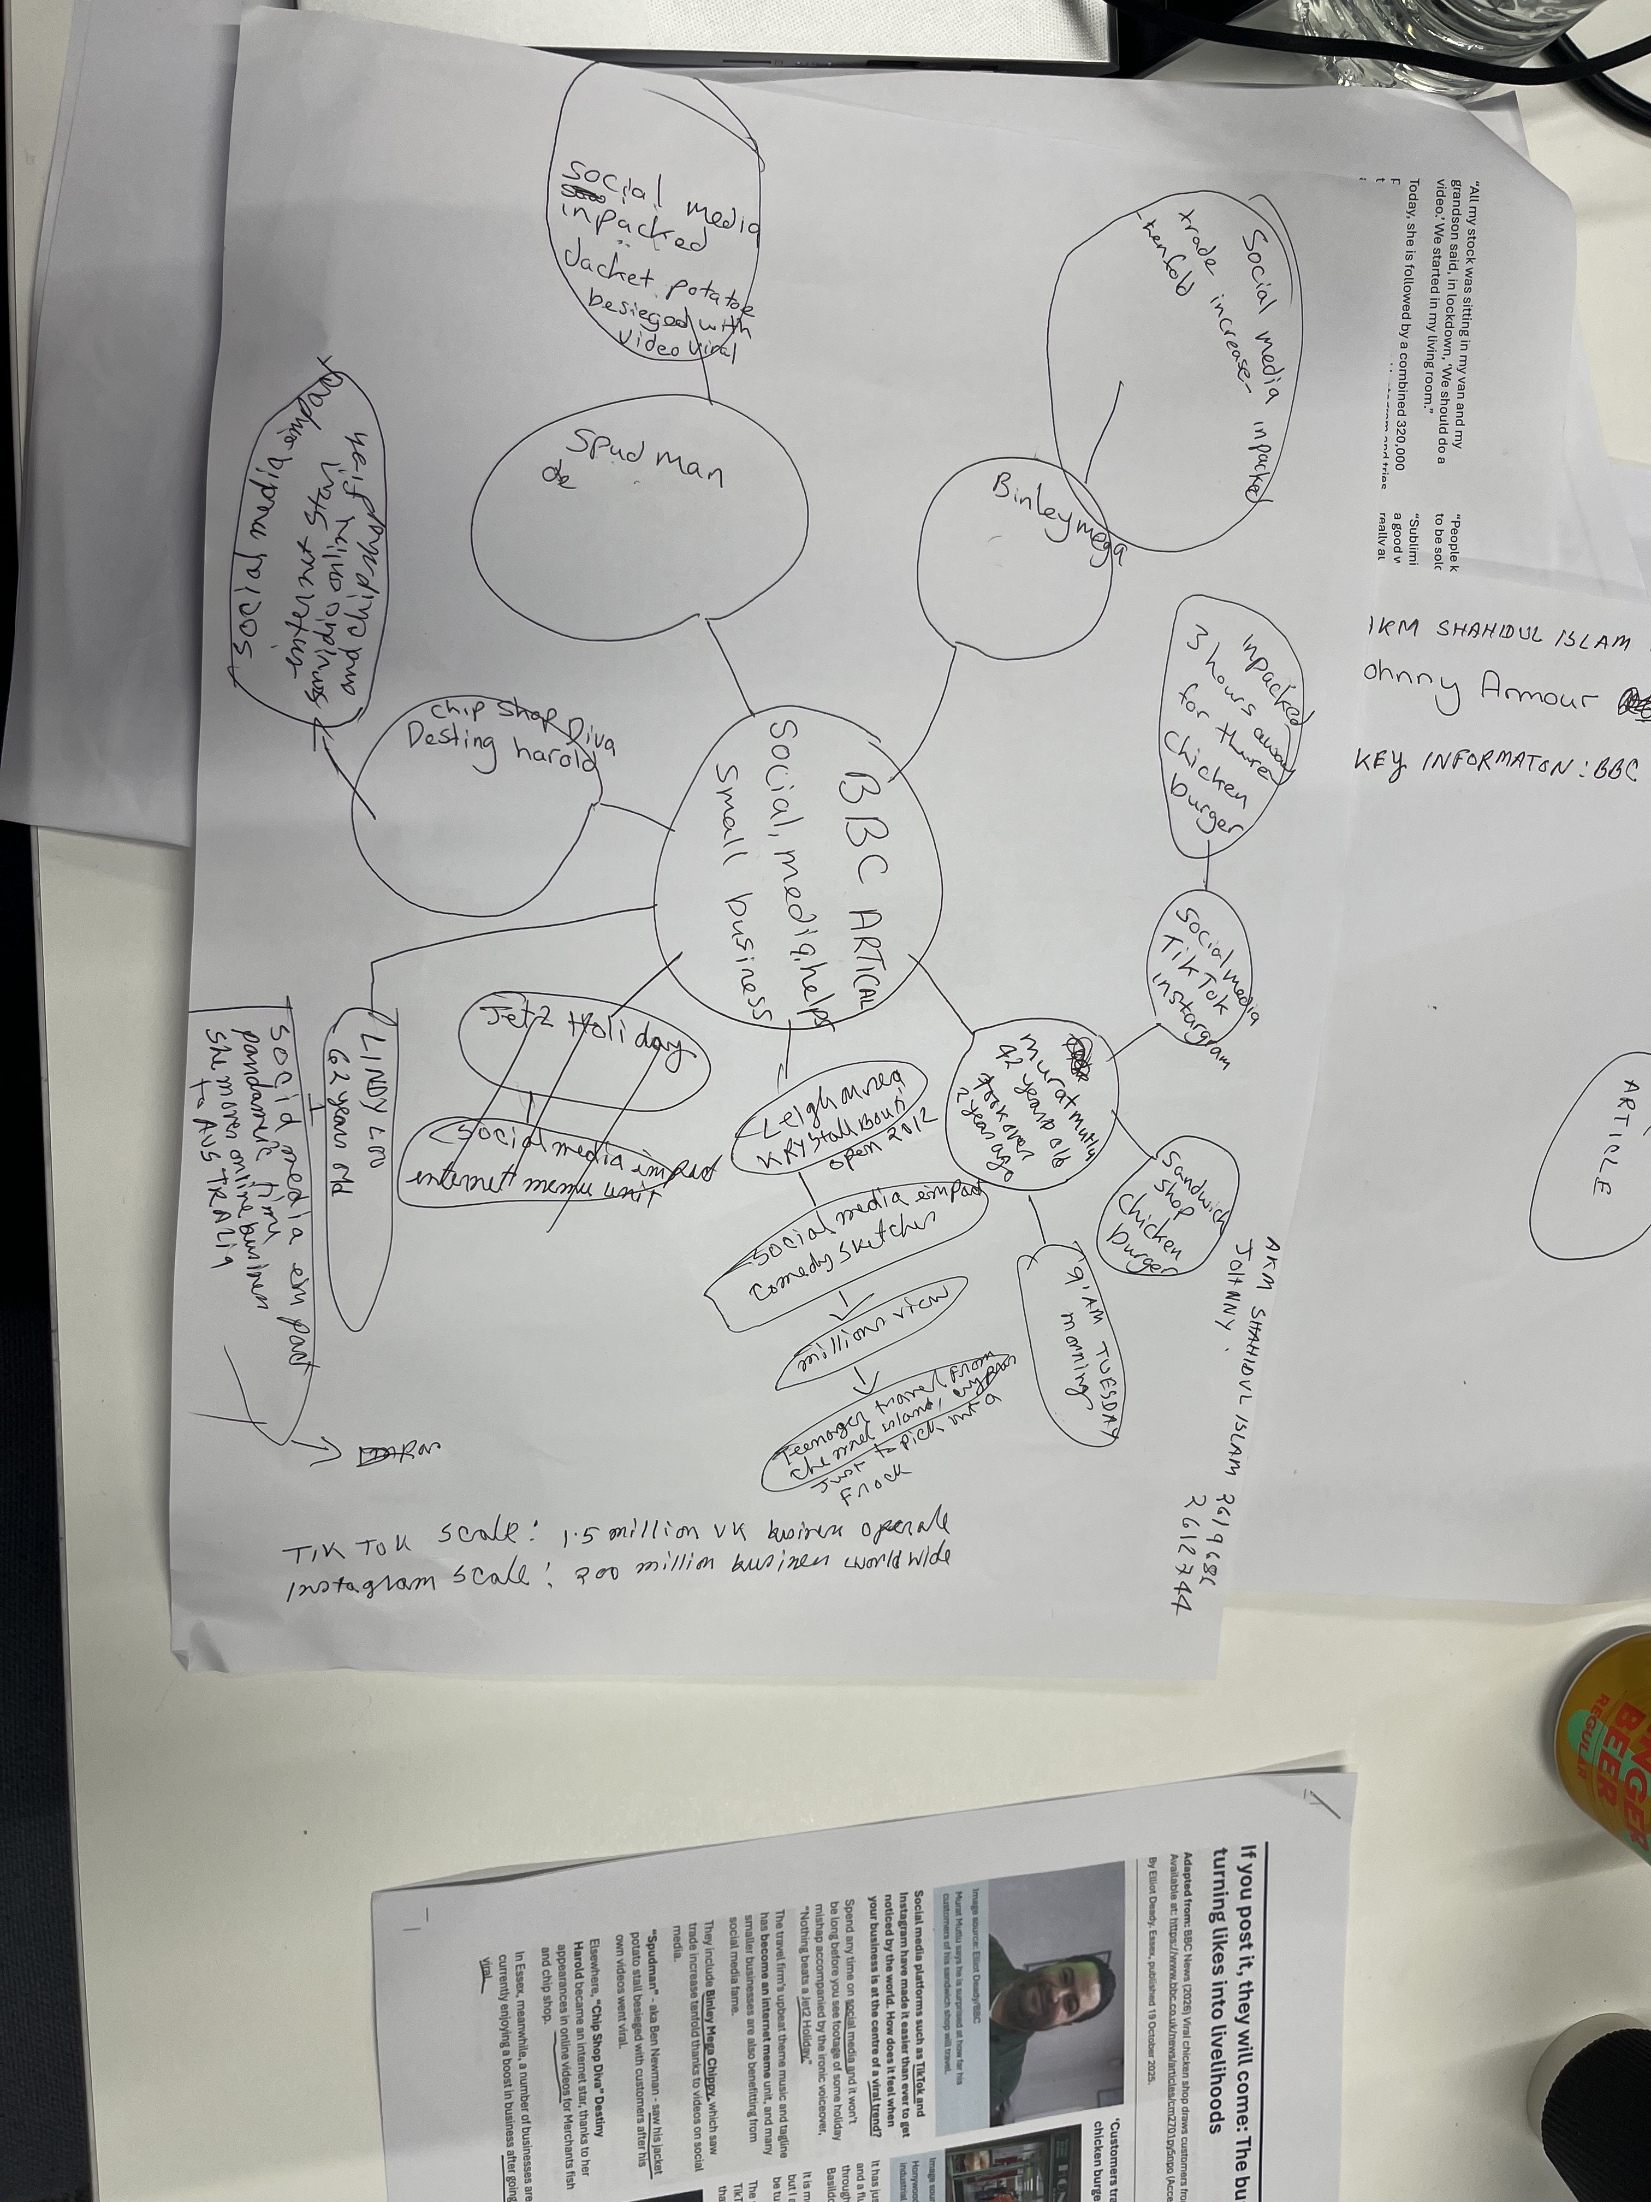

PART 2:
- Answer every question below in 1-3 full sentences.
- Use your own words. Do not use generative AI to answer these questions.
- Include a specific detail from the text when asked.
REMINDER
- The main idea is the overall message of the whole text.
- A key point helps to explain the main idea.
- A specific detail or example from the text shows that the key point is true.

1. What is the main idea of the whole text?
Answer: Social media platforms like TikTok, Instagram and Facebook are really helpful for small local businesses. When they share real content that gets popular, they can reach people all over the country — and turn that online attention into actual sales to support their business.
2. What is one key point that supports the main idea, and which specific example from the text shows this?
Answer: Social media helps businesses reach people who live far away. For example, customers travelled up to three hours to visit Honywood Sandwich Shop in Basildon just because they saw it online.
3. What is a different key point that supports the main idea, and which specific example from the text shows this?
Answer: Real posts from customers work better than the business’s own ads. Honywood Sandwich Shop grew mostly because customers shared videos about it, not because the shop paid for advertising.
4. Which part of the text do you think is most important, and why?
Answer: I think the most important part is that genuine content works better than traditional advertising. It’s the most important because it shows that small businesses don’t need lots of money — they just need real people talking about them online.
5. What did you find difficult in this task, and why was it difficult?
Answer: I found it a bit hard to tell the difference between the main idea and the key points. It was tricky because they felt similar at first, and I had to read carefully to separate them.
6. What helped you with this difficulty, and how did it help you?
Answer: Reading the text one section at a time really helped. It made it easier to see what the main message was, what the reasons were, and what examples were used to prove them.

