Strategic Analysis Frameworks (cascade, 2024)

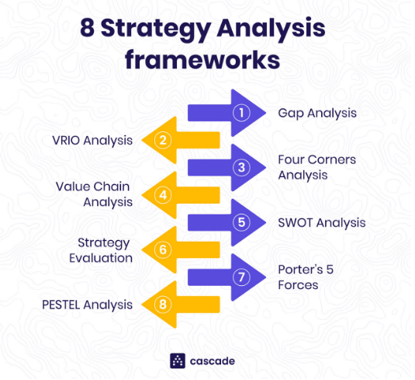

Gap Analysis
The Gap Analysis is a great internal analysis tool that helps you identify the gaps in your organization, impeding your progress towards your objectives and vision.
The analysis gives you a process for comparing your organization's current state to its desired future state to draw out the current gaps, which you can then create a series of actions that will bridge the identified gap.
The gap analysis approach to strategic planning is one of the best ways to start thinking about your goals in a structured and meaningful way and focuses on improving a specific process.

VRIO Analysis
The VRIO Analysis is an internal analysis tool for evaluating your resources.
It identifies organizational resources that may potentially create sustainable competitive advantages for the organization. This analysis framework gives you a process for categorizing the resources in your organization based on whether they hold certain traits: Valuable, Rare, Inimitable, and Organized.
The framework then encourages you to begin thinking about moving those resources to the “next step'' to ultimately develop those resources into competitive advantages.

Four Corners Analysis
The Four Corners Analysis framework is another internal analysis tool that focuses on your organization's core competencies.
However, what differentiates this tool from the others is its long-term focus. To clarify, most of the other tools evaluate the current state of an entity, but the Four Corners Analysis assesses the company’s future strategy, which is more precise because it makes the corporation one step ahead of its competitors.
By using the Four Corners, you will know your competitors’ motivation and their current strategies powered by their capabilities. This analysis will aid you in formulating the company’s trend or predictive course of action.

Value Chain Analysis
Similar to VRIO, the Value Chain Analysis is a great tool to identify and help establish a competitive advantage for your organization.
The Value Chain framework achieves this by examining the range of activities in the business to understand the value each brings to the final product or service.
The concept of this strategy tool is that each activity should directly or indirectly add value to the final product or service. If you are operating efficiently, you should be able to charge more than the total cost of adding that value.

SWOT
A SWOT analysis is a simple yet ridiculously effective way of conducting a strategic analysis.
It covers both the internal and external perspectives of a business.
When using SWOT, one thing to keep in mind is the importance of using specific and verifiable statements. Otherwise, you won’t be able to use that information to inform strategic decisions.

Strategy Evaluation
Generally, every company will have a previous strategy that needs to be taken into consideration during a strategic analysis.
Unless you're a brand new start-up, there will be some form of strategy in the company, whether explicit or implicit. This is where a strategy evaluation comes into play.
The previous strategy shouldn't be disregarded or abandoned, even if you feel like it wasn't the right direction or course of action. Analyzing why a certain direction or course of action was decided upon will inform your choice of direction.
A Strategic Evaluation looks into the strategy previously or currently implemented throughout the organization and identifies what went well, what didn't go so well, what should not have been there, and what could be improved upon.

Porter's Five Forces
Complementing an internal analysis should always be an analysis of the external environment, and Porter's Five Forces is a great tool to help you achieve this.
Porter's Five Forces framework performs an external scan and helps you get a picture of the current market your organization is playing in by answering questions such as:
- Why does my industry look the way it does today?
- What forces beyond competition shape my industry?
- How can I find a position among my competitors that ensures profitability?
- What strategies can I implement to make this position challenging for them to replicate?
With the answer to the above questions, you'll be able to start drafting a strategy to ensure your organization can find a profitable position in the industry.

PESTEL Analysis
We might sound repetitive, but external analysis tools are critical to your strategic analysis.
The environment your organization operates in will heavily impact your organization's success. PESTEL analysis is one of the best external analysis tools you can use due to its broad nature.
The name PESTEL is an acronym for the elements that make up the framework:
- Political
- Economic
- Social
- Technological
- Environmental
- Legal
Basically, the premise of the analysis is to scan each of the elements above to understand the current status and how they can potentially impact your industry and, thus, your organization.
PESTEL gives you extra focus on certain elements that may have a wide-ranging impact, and a birds-eye view of the macro-environmental factors.

