Research Project Proposal
Can holistic vocal coaching help individuals to understand and discover their personal identity?
Context, organisation and setting of the research project
The research project will be conducted with the participation of students from The Robin’s Voice Holistic Vocal Academy, a holistic vocal coaching establishment based in Manchester since 2014.The organisation provides voice coaching as singing lessons, public speaking practice and singing therapy to people of all ages and abilities. The term holistic can be defined as a whole-body approach to working with individuals. It is particularly employed within medical, social, psychological, and spiritual domains. It implies the acknowledgement and engagement of the mind (psychological element), the body (physical element), the soul (social and nuanced essence of self) and the spirit (the spiritual element of a being). This holistic pedagogic approach encourages the discovery of individuals’ authentic voices, as well as their vocal identities. (O’Bryan, 2015).
Project justification
As a holistic voice practitioner, the importance of understanding the individual as a ‘whole’ is fundamental to their overall development, both vocal and personal (Thiel, 2011). Identity as a construct of human nature, personality and behaviour has been confirmed through time as research and observation in social science, psychology and medicine continue to grow (Leary, M, 2012). Reflecting upon my career as a voice coach and singer I have observed the influence that emotional wellbeing, mental health, social and cultural circumstances and historical background all have on an individual’s idea or definition of self (Chong, 2001). I would like to explore the implications of voice pedagogy in understanding these concepts and how they contribute to the framework of personal identity.
The intended impact of the research project
The principal aim of this project is to analyse the benefits of holistic vocal coaching in helping individuals to explore their physical, emotional and psychological characteristics with a view to better understanding themselves and their personal identity (Papageorgi, 2022). The acknowledgement of these benefits, through the proposed research, would further highlight the advantages of adopting a comprehensive approach to voice pedagogy in order to facilitate vocal and personal development simultaneously, as well as reinforcing the important relationship between the two. It would be significant to my research path to contribute to existing literature in this field with more depth through a stronger unification of all the holistic elements.
Potential wider ramifications of the project
In the domain of psychology and medicine, creativity and the arts could be considered to be an unjustified method of physical, mental and emotional assessment, despite the strong positive attachment they hold. The exploration and visitation of emotional and cognitive states in research participants may begin to reveal the benefits of introducing a holistic approach to voice pedagogy as voice practitioners, in order to create a stronger affiliation between medical, social, mental, and creative wellbeing.
Project outline
The research will be conducted with three participants. Two will take part in live face to face vocal coaching sessions at The Robin’s Voice Holistic Vocal Academy and one participant will have sessions online via the Zoom platform. The sessions will take place over a period of 3 weeks and each participant will have a total of 5 sessions each. Voice coaching sessions will follow a typical pedagogic structure and participants will be asked to reflect upon a set of questions during each session which they will be guided to answer and discuss at the end of each session. The discussions at the end of each session will be audio recorded. Participants will also be asked to keep a diary in order to log any observations, thoughts, feelings or questions at any time during the research study.
Proposed research methods
Due to the subjective method of the research project, my proposed research methods will adopt an ontological and hermeneutic research design, therefore addressing the individuals perceptions, emotions and attitudes during research, as well as understanding the cultural and social aspect of the study of being and reasoning.
The research methods are as follows:
- Open-ended Questionnaire
- Participant Observation
- Participant and Researcher diaries
- Semi-structured Interview

Expected Timeline
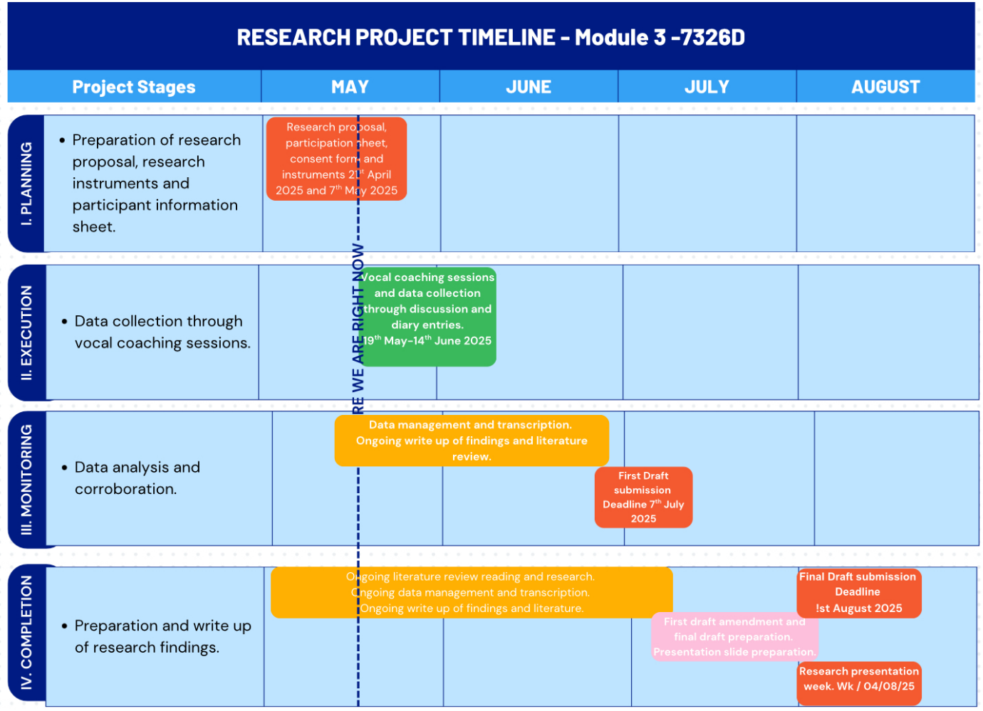
Ethical Implications
Due to the vulnerable nature of the research topic, signposting and support for the participant will be implemented to anticipate any instances of emotional overwhelm which may arise from a prolonged and close focus on potentially adverse emotions. As an insider researcher and vocal coach to the participants I recognise the influence our relationship could have on the feedback given. I understand the importance of having an objective and neutral approach during the research study, notably with semi-structured interviews. In order to prevent bias during research it will be important that I use inclusive language, language that is clear and accessible to all in questions and data collection and analysis. In light of these sensitivities the project has been reviewed and approved by the University of Wales Trinity St David.
Personal learning outcomes
- To gain a deeper understanding of the concept following this research project.
- Enhancing my skills as a holistic voice practitioner through with a view to conducting further study and research.
- Further study to reinforce my skills as a holistic vocal practitioner with a related mental health support qualification.

Project Report
Introduction
The project research was conducted at The Robin’s Voice Holistic Vocal Academy where, as voice practitioner, I provide vocal coaching in singing, public speaking and singing therapy. The participants taking part in the research study are students at The Robin’s Voice. The purpose of this study is to explore the ways in which holistic vocal coaching can support the understanding and discovery of an individual’s identity. My experience and observations as a holistic voice coach have inspired the focus of this research, supported by student reports of positive changes to personal development and self-discovery.
Defining the term ‘holistic’ at this point, is important to the comprehensive framework of the study. It can be explained as a whole person approach to a practice whereby physical, psychological, emotional and spiritual aspects of the self are taken into consideration (Chapman, 2017). The aim of the study is to demonstrate that the vulnerability that is experienced by certain individuals while singing and learning to sing is connected to the holistic self (mind, body and soul) and the past experiences and emotions associated with it. The desired outcome of the study is to confirm that understanding and processing challenging and limiting feelings, in parallel with achieving goals and overcoming obstacles in voice coaching could alleviate emotional difficulties and help individuals discover their authentic (Mruk, 2006). The complex composition of identity as a construct is entwined within such sentiments and sets the foundation for the phenomenological approach to this research. The schools of thought surrounding the subject of identity, what constitutes an identity, and where the self and the ego feature in the construction of an identity, are both contrasting and conflicting (James, 2000). The relationship between identity and singing, or more importantly, holistic voice pedagogy, reveals the importance of the connection between self and personal experience in defining identity (Chong, 2011). My primary objective will be to create a core reference for the definition of identity within the myriad of existing literature, against which my research data can be measured. The data has been collected through qualitative research methods and adopts the interpretivist paradigm. This creates the foundation for the thematic structure of this study. It is here, through existing literature, that the strength of the relationship between identity and he self, can be observed. We will also discover that there are many versions of the self within each individual, in conjunction with the various roles they play in their lives and how experiences have shaped their beliefs (Gallagher, 2011). I believe that the elements of the self which contribute to a positive understanding of an individual’s personal identity are accessible through their intrinsic sentiments, the emotional, psychological and spiritual core which constitutes the essence of an individual or rather, their authentic self. I hypothesise that the physical and mental challenges, emotions, thoughts, and feelings that arise or are uncovered during the pedagogic process of holistic voice coaching, contribute to the discovery of self and subsequently to an individual’s discovery of their personal identity.
Literature Review
The chosen topic of this research project sits between two focal points in academic literature. The first point of focus is that of identity, and equally, the self, which both exist as concepts in parallel with each other. They dominate the fields of psychology, mental health, behavioural science, philosophy, and metaphysics. Literature in this domain dates back as early as 429 BCE when Socrates raised the thought of the soul as a part of a principal and unifying element of the self. This is thought to have influenced Plato’s idea of the immaterial soul as the core of one’s authentic self (Gallagher, 2011). Transitioning into the 1700’s, John Locke’s theories on personal identity laid the groundwork for a thinking self, a self built of memory and consciousness (Dicker, 2019). Understanding the meaning of consciousness at this point is important to the study in general. In its most simple description, it is the awareness of, or understanding of, something; the nature of being alert and knowing what is taking place around you. At a deeper level, consciousness can be related to intrinsic self-awareness, through the understanding of those holistic elements of self, the mind, body and soul. Locke believed that thought and consciousness always worked together and formed the essence of self and personal identity. He suggested that this created consistency in the rational individual that was, in fact, their personal identity. Locke’s definition appeals to my own theories for my project. Notably that the intrinsic awareness of self can support a consistent identity despite the external influences and that holistic voice coaching can facilitate this. Moving into the twentieth century, psychologist William James, pioneered literature on the subject of the mind, emotion, empiricism, human experience, the self, and identity (Klein, 2018). He offered the idea of ‘the empirical self’ or the feeling self and was among the first psychologists to present the notion of humans being made up of many parts and having more than one version of self. He highlighted the importance of recognising the ego in personal identity (Syed, 2015) and brought focus to the ‘empirical self’ which recognises other components as part of an individual’s identity, for example, the influence of society, family, the physical body, material possessions and spiritual beliefs (Fontinell, 2000).. He published his first work in 1890 and continued writing and teaching until his death in 1910 (Klein, 2018). James’s concepts also contribute to the foundation of my research study. I agree with the concept of identity having many components and observe how they influence the actions of individuals’ daily lives. However, the notion of using a comprehensive approach to voice pedagogy to encourage the processing of emotions and the discovery of an individual's personal identity takes a more internal focus. Since the work of William James and his peers, there has been further consensus and development of the idea of a multifaceted identity (Fontinell, 2000).
The progression from understanding the core self, to understanding the self in the context of voice pedagogy and singing, brings us to the topic of self-esteem. Here it becomes apparent to what extent an individual’s self-perception and self-belief can positively or negatively influence their behaviour, thoughts and actions. As the one of the earliest leaders in psychology, it was, once again, William James who first wrote about self-esteem in his first book, The Principles of Psychology (James, 1890). The vast importance of the concept has continued to expand over many years since James and beyond. I believe that the reason for this stems from an evolution into a greater understanding of the elements that affect human behaviour.

Methodology
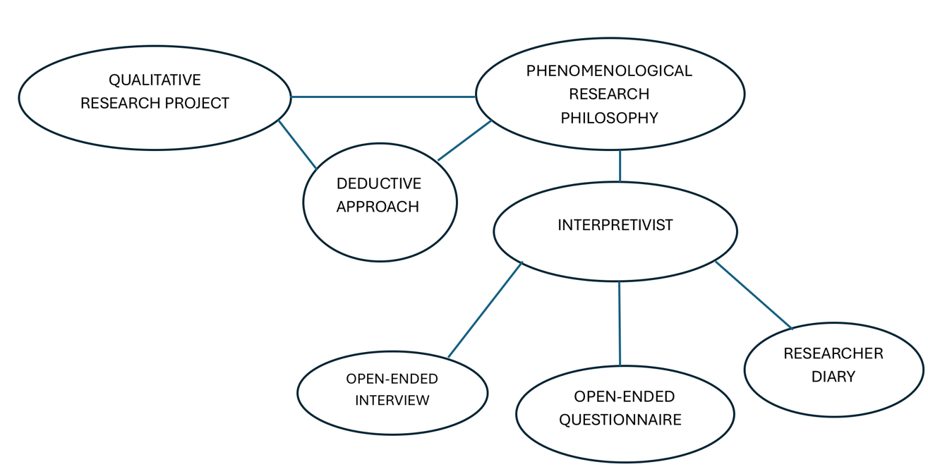

This research study was designed to assess the thoughts, feelings and emotions of four participants over the course of four weekly vocal coaching lessons. The research design is founded in a phenomenological philosophy with an interpretivist paradigm, which the supports the subjective nature of study and allows for an in depth evaluation of the participant experience. The psychological nature of the study and its focus on the experience and behaviour of its participants justifies the choice of research paradigm and the qualitative approach. It was important to be able to capture vivid and authentic descriptions of participant emotions and experiences. The qualitative research methods facilitated the gathering of such detailed information from participants.
The participants were singing students at The Robin’s Voice Holistic Vocal Academy in Manchester. They were selected by invitation to take part in the study. The criteria for participant selection were twofold. Considering the sensitive nature of the study in terms of emotion and susceptibility, I was keen to select adults over 18 who could take part in the study independently, in order to eliminate any risk of perceived manipulation or encouragement as an inside researcher. Secondly, I felt that it was important to have both male and female individuals, to achieve a varied data sample in this initial study.
Each of the four participants took part in a holistic vocal coaching session once weekly for one month. The sessions focused on voice pedagogy in a singing capacity as it is from observations within this practice that the research topic was created.
Upon completion of the four voice coaching sessions each participant took part in an interview with open-ended questions related to their experience and emotions over the course of their lessons. They were also asked to complete an open-ended questionnaire after their third session in order to help them reflect upon their experience and related emotions before the final interview. I equally entered relevant observations into a diary, throughout the data collection period.
The interview was the most effective research method. The interview questions were thorough in covering all related aspects of the topic and followed a structure that sketched out the pattern of instances as I have traditionally seen them take place over the course of singing lessons throughout my career as a voice practitioner. This structure was instrumental in assisting the deductive approach to the data analysis and inspired the thematic analysis of the information.
The questionnaire was a useful tool for reinforcing the data collected during the interviews, as it reiterated the participants thoughts and feedback following the vocal coaching experience. Participants were asked to complete the questionnaire either manually or electronically which, I believe, suggested a consolidation of their descriptions which the interview questions did not imply. This created a succinct reverberation of information which was useful during data analysis and theme creation. Time permitting, another method of research which could have been useful in providing valuable data, is that of the focus group. As a collective sharing experience, the focus group may have prompted further discussion and revelation of a more spontaneous nature.
The assessment of ethical considerations, although an integral component of the entire research project, was magnified as research instruments were defined, notably when the drafting of the open-ended questions was underway. It was important that the questions were not leading or directive in anyway, due to their sensitive nature, but still encouraged elaborated responses. The activation of emotions, thoughts and feelings, not previously acknowledged, may provoke an ascension of sentiments that participants may not be prepared for. In order to anticipate this, each participant was presented with a participant consent form which included the project requirements and the implications. Signposting towards the help of a mental health practitioner was chosen as the best assistance for participants if needed.
Thematic Analysis
The research data was analysed and coded following the structure of the interview questions which showed a progressive timeline of cause and effect with participant feedback.
The themes adopted within the research data have been crafted in order to highlight a pattern of negatively influenced thoughts, beliefs and emotions, all of which find their catalyst in the tasks and the general demands of the voice coaching settings undertaken by the participants. The research participants took part in a series of vocal coaching sessions which followed a typical lesson structure of The Robin’s Voice Holistic Vocal Academy, where the four chosen participants are currently students. The participants were asked to complete a questionnaire in their own time over the course of their four vocal coaching sessions, and they took part in a short, recorded interview at the end of the research study. As the researcher, I logged any further observations into a research diary. Each voice coaching session began with a vocal warm-up in the form of vowel scales ascending from a low to high vocal register depending on each individual's vocal ability and range.
Findings
Each participant chose a song to work on during the four research sessions for which they were asked to perform specific technical tasks and vocal enhancement exercises. The tasks were designed to help achieve the following: address and improve breath control and breath management; explore and expand vocal range; strengthen and understand chest voice and head voice; locate, understand and alleviate restrictive muscle tension; enhance vocal projection; improve vocal tone; understand and incorporate prosody and vocal dynamics; master vocal cord articulation; as well as gain proficiency in other elements of vocal technique, such as trills and vibrato. These tasks were chosen in relation to each participant and the techniques they were aiming to master at the time, not all tasks were performed collectively during a single lesson. The choice of song and the participant in session, largely determined which of the technical elements would be encountered and in what way.
Figure 1 below shows the thematic analysis of the research data with themes generated by a coding process.
Identity is shaped by an array of elements which relate to an individual’ s personal life experience. The feelings, perceptions and beliefs that are attached to each aspect of their experience will contribute to determining the individual’s identity and what they perceive it to be. Highlighting the significance of emotions, thoughts and beliefs in holistic voice pedagogy and their connection to self and identity, creates the framework for the thematic structure of this study. We have observed, through existing literature, the affiliation between identity, the self, emotion, belief and perception (Mruk, 2006). We equally recognise the familial, social, cultural, racial, spiritual, aesthetic and gender influences within the concept of identity (Wells, 1976). We will also learn from this study the significance of the rapport between identity and confidence. The format of the thematic analysis is based on the progressive advancement of research participants from the first vocal coaching session (Braun, 2006). It follows the transition through emotional and psychological alignment, towards positive change and transformation.

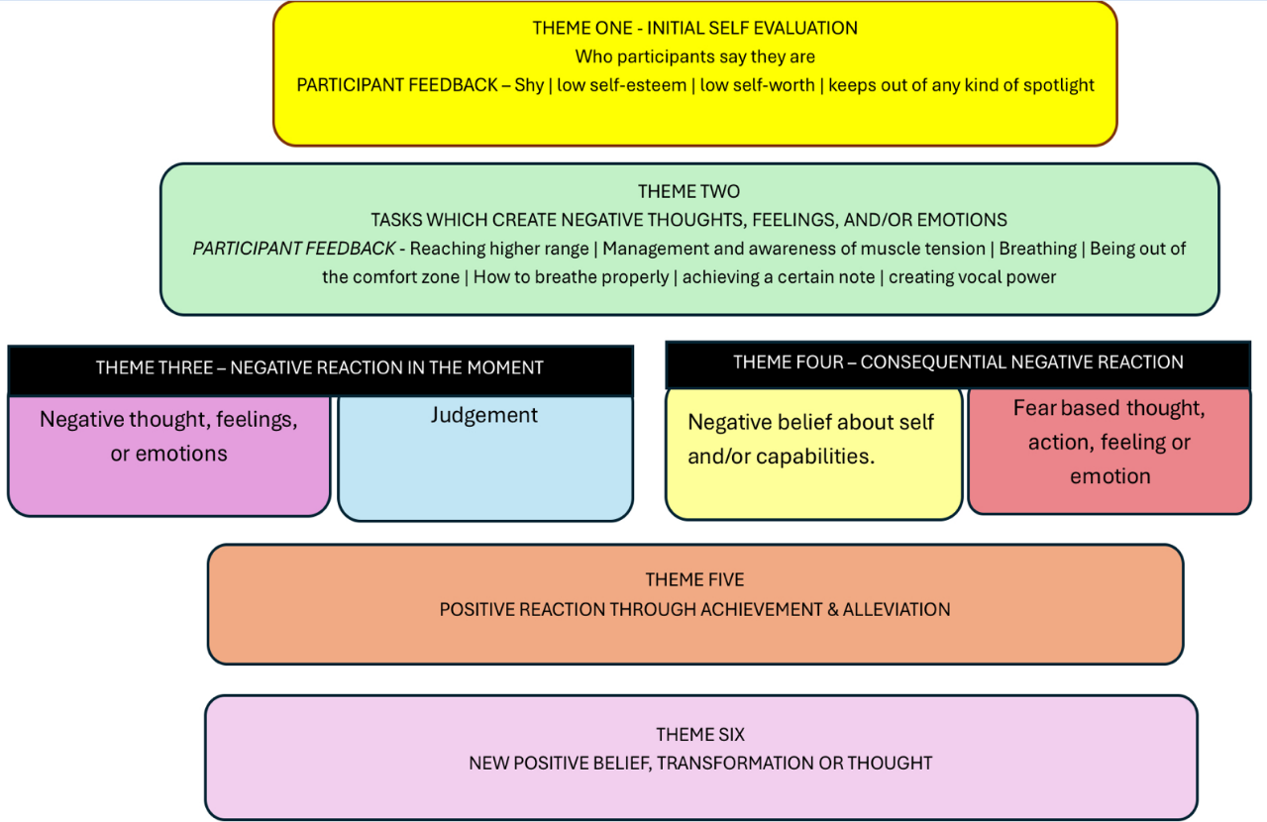
FIGURE 1 – THEMATIC DATA ANALYSIS

Themes
Theme One represents the introduction of each participant in terms of their self-perception at the time of the study. Participants two and three described themselves as shy individuals who would naturally keep themselves out of any kind of spotlight. Participant one explained that she would tend to prefer remaining quiet and unseen and participant four shared that she would shy away from singing in front of anyone and would describe herself as having low self-esteem and low self-worth. All participants shared their initial discomfort with singing in public settings. The introductory personality traits of each participant create the primary theme of ‘initial and relevant knowledge of self (who the participants ‘know’ they are)’. They could be described as introductory characteristics which maintain protection from situations involving communicative self-expression. This is pertinent to the core themes of the study and the challenging moments encountered by participants.
Figure 1 shows theme one to create negative thoughts, feelings or emotions, by research participants. These are, reaching a higher range or achieving a certain note in a higher register; awareness and management of muscle tension; breathing correctly; achieving vocal projection and being out of the comfort zone. They also expressed their fear of what other people would hear and how their voice would sound to others. This was largely related to their own perception of their voice and the unknown voice that they were discovering, but not yet acceptant of or comfortable with. (Whidden, 2015)
The introductory personality traits of each participant create the primary theme of ‘initial and relevant knowledge of self (who the participants ‘know’ they are)’. They could be described as introductory characteristics which maintain protection from situations involving communicative self-expression. This is pertinent to the core themes of the study and the challenging moments encountered by participants. The second theme, ‘negative reactions in the moment’, focuses on the initial impact the tasks have on the participants. This theme constitutes two principal outcomes reported by research participants 1) negative, thoughts, feelings, emotions and actions and 2) judgement. They initiate what could be described as a domino effect of adverse reactions which we will see find their roots in the criteria of the theme one, primarily the participants self - evaluation based on their level of self-esteem.
While working through an ascending scale warm-up participant three reported feeling challenged, stuck and tense, while participant one spoke of having ‘top note fear’ and getting ‘caught up in her breathing’. The experience underlined by participant two describes a ‘barrier that stops me from pushing myself out there, in case it's not right or you know? I don't do it how I perceive it should be done’. My observations during the study aligned with the participant experiences and expressed the challenges to self-esteem that accompanied vocal expression, notably singing. The act of doing something incorrectly or something unknown shared an affinity with the participants need for safety and control in an unknown or challenging situation. It is important, at this point, to emphasise the relationship between engagement in fearful situations, self-esteem and the body’s nervous system. According to contemporary research, an individual with high self-esteem may be better equipped to manage the body’s response to situations which create stress (Wells,1976)). In the case of singing and performance, the reactions caused by fear, uncertainty and lack of control which some individuals experience are akin to the fight or flight response induced by hormonal changes to the brain. This neurological response generates an array of stress reactions within the body including, muscle tension, perspiration, heart palpitations and breathing challenges. This helps us to understand the negative reactions of participants described in theme two and how they could be linked to low self-esteem.
The fundamental factors of theme one, negative self-perception and negative self-evaluation, equally hold a connection to the concept of low self-esteem. Their importance in this study is shared with the second element of theme two, judgement. Participants spoke of feeling judged by others while performing singing tasks during sessions, as well as judging themselves. The thematic analysis diagram has been designed to display the timeline of thoughts and emotions as they typically took place during a voice coaching session. Once a conflicting emotion arose, a judgemental thought would be initiated. In response to the question ‘Did you experience any thoughts or emotions, positive or negative, during your sessions which could be related to your sense of self?’ Participant one shared yeah ‘there was definitely a negative thread to it, I was kind of getting a little bit exacerbated with myself for not being able to it’. Participant two was posed a similar question related to performing any specific task. He acknowledged, ‘Yes, specific moment when I got to higher notes and I didn't feel like I was doing them correctly’. He elaborated with, ‘Yes, I think the range. Obviously I said I was frustrated, but then the thoughts that come in of why can't I do it because I've done it before and then I think the breathing that's more a feeling of why aren't you doing it? It should be easy to breathe, but I don’t seem to do it. Participant four spoke about specific feelings or emotions during the course of her vocal coaching sessions, ‘I think just the release of being able to just sing in front of somebody and not feel like I was going to get judged, because I think I'm probably like that myself, I think people are going to judge me’. Figure 1 shows the cumulative effect of emotions from theme three to theme four. A participant has negative thoughts or emotions, they subsequently judge their achievement and progress to a ‘consequential negative reaction’ (theme four).
Here we can identify the feelings and emotions that follow the judgemental thoughts of participants. The negative and judgemental thinking activates negative beliefs about the participant and/or their capabilities. The shift into fear of not being to reset the balance in the moment, or achieve the task at all rise to the surface. It is highly probable that themes three and four are interchangeable in the way they experienced. One student may begin with fear, as I know many of them do, which in turn creates the negative thoughts and emotions, because of negative self-belief and judgement. The structure displayed in figure 1 follows the themes as the relate to the four research sessions and the research instruments which largely shaped the research design. The relationship theme three and four hold with self-esteem and identity, however, remains positively significant. It is important observe some of the motivations for the negative self-belief and fear highlighted in theme four. Each participant expressed how negative past experiences or beliefs had affected to their self-evaluation and their self-expression. Participants were asked to describe any thoughts or memories of positive or negative past experiences that may have arisen during their research sessions. Participant two contributed ‘Yeah I think, I think they’re probably linked more to negative experiences as you know with that trying something different and doing something different where I am, I guess the centre of attention is tricky and it does bring up thoughts of, you know, when I was younger, I got bullied at secondary school and I think those thoughts came up of don't push yourself out there, because when you do, you get knocked down for it’. Participant one reported, ‘So, yeah, definitely think back to like, just past relationship, I don't know about if it wasn’t not expressing myself or just not being listened to actually, the communication loop not joining, but that same person sort of brought my attention to that as well, so very like complex dynamic, so it definitely sort of flipped me back there a little bit and to think of this awareness I've had for a long time’. It is accepted that our past experiences can shape our future. They also impact our identity and sense of self. Negative experiences can engender low self-esteem whereas positive experiences may create the contrary.
The literature review for this study refers to Maslow’s hierarchy of needs as an effective way to understand the framework of the self, the essence of an individual’s core self and their influences in the creation of identity. Research participants were aware of the self as a multifaceted concept and shared examples of the different versions of self that would dominate in different moments or situations.
Participants were asked to describe their ‘overall sense of self’ and whether they considered ‘self and identity to be the same’. Participant three highlighted ‘on a personal level, it's the charge that cooperates with whatever situation I'm in in the moment, do you know different environments? So I’ll be a different person, so I have a sense of my teaching self, for example when I'm a teacher, I'm in class and I know who that is and I know that's not me now, I'm maybe, my student self is operating here, so there's different parts of us. So I guess, depending on the song, depending on the emotions of the song or the range that I'm reaching whether I'm comfortable there or not will determine who, shows up in the moment I guess’.
Participant two shared ‘I think there’s some, they are similar in terms of you know self and identity. I think you know it's worth mentioning I’m LGBTQ and I think that kind of self shies away because of that identity, for fear of putting myself out there again linked to past experiences I think. Participant four noticed, ‘I'd say before, I'd say there were separate, but now I'm finding my identity through what I can achieve. Yeah, here. So, yeah, I put them, they’re moving, they’re moving together now, whereas before I didn't know who I was I don't think’.
In a world where each individual increasingly has the capacity to create their own stage and with it, their own identity, it can be difficult for the true authentic self to safely exist. Especially when challenges such as low self-esteem and low self-worth may negatively influence an individual’s lifestyle. Maslow’s hierarchy of needs validates our wish to belong and have a sense of connection, this could also be described as a desire for acceptance. It is here that individuals create different identities to fit into their social, familial and professional situations. An individual observing people and society with a need for acceptance which is based on low self-esteem may compare themselves to others in aesthetic, materialistic, creative, social and personal domains. This comparison can hinder an individual’s sense of their authentic self. My career as a holistic voice practitioner has provided me with many examples of comparison in students. It is often attached to an individual’s negative self-belief, in conjunction with the observation or example of someone who expresses themselves with greater ease, power, freedom and efficiency. Research the song they had chosen to sing, to myself as their voice coach or to their ‘more competent self’ from an earlier coaching session. Participant one shared her experience, ‘Yeah, I'm always comparing myself to other people in terms of how they kind of go about life with a bit more participants shared their experience of moments of self- judgement. In some sessions they would compare themselves to the original artist of an air of confidence than I do.’ In my estimation, many forms of self-judgement originate from a version of comparison to others or comparison to a negative experience or judgement from the past.
How can holistic vocal coaching help? Theme five, Positive reaction through achievement and alleviation, focuses on the positive impact that voice coaching sessions can have on individuals. It is widely believed that singing can positively affect physical, emotional and mental well-being. Many studies in this domain concentrate chiefly on the benefits singing has on the brain, notably through the production of calming and mood enhancing hormones. In consideration of the physiological process involved, it could be expected that this type of affirmative change would take place each time an individual engaged in singing. However, the participants of this research study collectively expressed feeling negative emotions attached to singing despite the typical joyful side effects. They also commented on their desire to sing with freedom and their desire to enjoy singing, nonetheless. Participant two, ‘we found a song that I like and like doing and I think I wanna go for it and sing it really well and give myself to the song, but there's a barrier that stops me from pushing myself out there.’ It is with the participants aspiration to sing that change can begin to take place.
The process of achievement and alleviation described in theme four consisted of identifying and changing the participant’s negative thoughts, feelings or emotions; locating their origin; inviting the participant to reflect upon and discuss their sentiments; processing the sentiments with the individual through motivation and positive encouragement; repeating the challenging task with a focus on refining vocal technique, liberating and renewing the mindset surrounding the vocal exercise or song; encouraging authentic feeling by removing judgement and connecting to natural enjoyment. The creation of a nurturing and reassuring space where participants can make mistakes and be vulnerable without judgement is paramount. The time frame for the positive outcome of this process is largely bespoke, however positive changes were noticed within the research period. Participant one described, ‘I was feeling quite frustrated with myself today for feeling so restricted and not just not being able to just kind of break through it today, but I've even found just the conversation around it helps because you start to locate it, then you start to kind of think, well, yeah, that makes sense, actually, given what I've got going on at the minute.’ Participant two expressed, ‘Yeah, I think I'm learning to deal with some of those physical and emotional things and actually since the first session. I'm extremely comfortable with you and I feel more relaxed with you. I think I'm becoming more relaxed in myself, starting to realise it doesn't matter as much. I wouldn't say I'm 100% there yet, but that's in terms of my sense of self. I think that's where it is.’ Participant three explains his positive experience, ‘So as I've developed my technique and obviously you've been coaching me through those challenging moments, I am finding that I'm able to now hit certain notes without any, any of the internal dialogue going on or even the body responding as fiercely it's like, the more I attune to that, the more I get comfortable with it, the more it allows me to produce from there, so growth, growth is always happening.’
Participant four describes changes to her overall confidence, ‘I think relating it to having more confidence in myself, in life in general, because I know I can, I can sing and I've been told that now and that sort of confidence that it's given me, gives me confidence to go out and know I can do other things, that I don't feel confident about.’
The overall outcome of the study was extremely positive in fulfilling the research objectives and aims.

References
Leary, M & Tangney, J (2012): Handbook of Self and Identity. The Guilford Press
Chong, Hyun Ju, (2001): Relationships between vocal characteristics and self-esteem: Quantitive and qualitative studies.
Thiel, Udo (2011): The ontological view of the self: Scholastic and Cartesian conceptions. https://doi.org/10.1093/acprof:oso/9780199542499.003.0002
O’Bryan, Jessica (2015): “We ARE our instrument!” Forming a singer identity. Research Studies in Music Education, 2015, Vol.37(1) 123-137. DOI:10.1177/1321103X15592831
Papageorgi, L, Saunders, J, Himonides, E and Welch, G (2022): Singing and Social Identity in Young Children. DOI: 10.3389/fpsyg.2022.823229
Gallagher, S. (Ed.). (2011). The Oxford handbook of the self. Oxford University Press.
Barresi, John, and Raymond Martin, ' History as Prologue: Western Theories of the Self', in Shaun Gallagher (ed.), The Oxford Handbook of the Self (2011; online edn, Oxford Academic, 2 May 2011), https://doi.org/10.1093/oxfordhb/9780199548019.003.0002, accessed 15 Aug. 2025.

McLean, K. C., & Syed, M. (2015). The Oxford Handbook of Identity Development (1st ed.). Oxford University Press.https://doi.org/10.1093/oxfordhb/9780199936564.001.0001

Whidden, C., 2015. The Creation of Singing Identity in Our Music Classrooms. The Canadian Music Educator, 57(1), pp. 38-41.

Brinkman, Svend, 2008: Identity as Self-Interpretation, Sage Publications
doi/pdf/10.1177/0959354308089792

Understanding the Self, Edited by Richard Stevens - The Open University, February 1996 | 384 pages | SAGE Publications Ltd
Gallagher, Shaun (ed.), The Oxford Handbook of the Self (2011; online edn, Oxford Academic, 2 May 2011), https://doi.org/10.1093/oxfordhb/9780199548019.001.0001, accessed 4 Aug. 2025.

Klein, A. M. (Ed.). (2018). The Oxford handbook of William James. Oxford University Press.
https://doi.org/10.1093/oxfordhb/9780199395699.001.0001

Fontinell, E. (2000). James: Personal Identity. In Self, God and Immortality: A Jamesian Investigation (pp. 81–100). Fordham University Press. https://doi.org/10.2307/j.ctvh4zh07.10

Wells, L. E., & Marwell, G. Self-esteem : its conceptualization and measurement, 1976

Mruk, Christopher, 2006, Self-esteem, research theory and practice:Toward a positive psychology of self-esteem, Springer Publishing Company
Dicker, Georges, 2019: Locke on Knowledge and reality: A commentary on an essay concerning human understanding. Oxford University Press
Chapman, J. L. (2017). Singing and teaching singing : a holistic approach to classical voice (Third edition.). Plural Publishing.

o

