Exercises: Using Date()

- Print out the full date and time on the screen using the Date() methods.

Your output should look something like this:

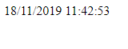

- Print out the full date with the day as a text day of the week, and the month as a text month of the year.

Your output should look something like this:

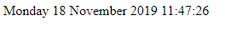

- In a seemingly small variation to 2) above, print the appropriate contraction:

Your output should look something like this:

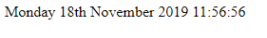

(Note the th , but it could be st, rd, or nd depending on the current date.)

Hint: you could use an if statement or a case statement. Test the different possibilities by temporarily hard-coding a value for day.

- Greet the user depending on the time of day. We have already done Good Morning, add the rest of the times as well.

Your output might look something like this:

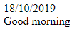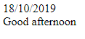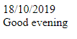

Note: hard-code the hour value for testing purposes.

- (Harder) Using Javascript, change an image to a different one at an appropriate time (eg a penguin in November and December). Feel free to use my images tulips.jpg and penguin.jpg from Moodle.

- Set up your initial page something like the following:

<html>
<head>
<style>
body{
background-image: url("tulips.jpg");
background-repeat:no-repeat;
}
</style>

<script type="text/javascript">

</script>
</head>
<body>
<h1>Welcome to my page</h1>

</body>
</html>

It should look something like this:



- Use an onLoad event to check the current date to see if it is November or December, and change the background image if required.

Hint: To change the background image, you need to access the body tag via document.getElementById() . The syntax to access the background image is something like the following:

xxxxx.style.background = "url('penguins.jpg')";

It should then look something like this:



- Extend the above to have a different image appear for each season.

