
Global challenges re-sit(bmmb7006)
IKEA Report

April 19, 2024
student: dan Brown (1905439) tutor: anthony burns
UNIVERSITY OF WALES TRINITY SAINT DAVID

Executive Summary

The purpose of this report is to analyse and to critically assess the conditions of business environment in which IKEA operates, investigating and analysing the actual and potential implications of different factors on the organisation for the decision making and business strategy stages.
This report analysed the competitive business environment of IKEA using three analysis tools and models such as PESTEL Analysis, which investigated the macro environment, SWOT Analysis which investigated the microenvironment, and Porter`s Five Forces, that identified the forces within the furniture retail industry where IKEA operates.
Following the main findings such as the international market position where IKEA actually sits, internal and external factors that influenced the decision making and strategies followed to present, there was identified strengths and concerns related to the present action taken by the Company.
Conclusions were drawn and recommendations were made for the future action to maintain the global market position and to improve the Company`s performance.

TABLE OF CONTENTS
Executive Summary ……………………………………………………………………. 1
- Introduction ………………………………………………………….……………… 4
  - Analysis tools, Theories, and Concepts ……………………………… 4
  - IKEA – A brief history …………………………………………………… 5
- PESTEL Analysis ………………………………………………………………..… 6
  - Political …………………………………………………………………… 6
  - Economic ………………………………………………………………… 8
  - Social …………………………………………………………………..… 10
  - Technological …………………………………………………….……… 11
  - Legal ……………………………………………………………………... 13
  - Environmental …………………………………………………………... 14
- SWOT Analysis ……………………………………………………………………. 14
  - Strengths ………………………………………………………………… 14
  - Weaknesses …………………………………………………………….. 17
  - Opportunities ……………………………………………………………. 19
  - Threats ………………………………………………………………..…. 22
- Porter`s Five Forces ………………………………………………………………. 23
  - Threat of New Entrants …………………………………………..…….. 24
  - Bargaining Power of Suppliers ……………………………………….... 24
  - Bargaining Power of Buyers ……………………………………………. 25
  - Threat of Substitutes ……………………………………………………. 25
  - Competitive Rivalry Among Existing Competitors …………………… 25

- Conclusions ………………………………………………………………………. 26
- Recommendations ……………………………………………………………….. 27
- References List …………………………………………………………………… 28

- Introduction
This report will critically assess the conditions of business environment in which IKEA operates, investigating and analysing the actual and potential implications of different factors on the organisation for the decision making and business strategy stages.
  - Analysis tools, Theories, and Concepts
It will be analysed the competitive business environment of Ikea using analysis tools and models such as PESTEL, SWOT, Porter`s Five Forces to critically evaluate the micro and macro environment, and the market position, in the context of competitive markets, internationalization and globalization trends.
PESTEL Analysis, also known as PESTLE, is a key tool and framework that analyses the macro-environment, highlighting six environmental factors, out of the company direct control, such as Political, Economic, Social, Technological, Environmental, and Legal (Whittington et al., 2020)
SWOT is a major strategic tool utilised for planning purposes, analysing the micro-environment of a company, factors which are under direct control of an organisation (Coman and Ronen, 2009), like a results-oriented framework, upon four internal factors: strengths, weaknesses, opportunities, and threats, as suggested by Helms and Nixon (2010).
Porter`s Five Forces it is a strategic model developed in 1979 by the Harvard Business School professor Michel E. Porter (Danao, 2024). In his book Competitive Advantage, Professor Michael E. Porter “describes the way a firm can choose and implement a generic strategy to achieve and sustain competitive advantage” (Porter, 2004, p.26). Furthermore, Porter identified five forces which influence the position of a company as follow: competitive rivalry, supplier power, buyer power, threat of substitution and the threat of new entrants (Danao, 2024).
In addition, Brujil (2018) argues that the Porter`s Five Forces framework is still widely used today even when the managers are looking for changes and innovation to step out from the company`s current position. This model looks not only of a single organisation like SWOT analysis, but to several organisations which might influence decision-making and positioning.
This report will investigate the business environment of IKEA upon theories and concepts that governs the global economy, international trade theories, and other frameworks and models.
From the analyses above, a comprehensive conclusion will be drawn to evaluate the current position of Ikea and what are the future decisions for business growth, ending with final recommendations of the way forward for the organisation.
  - IKEA - A brief history
As stated on the company website, IKEA was founded in 1943 by a young entrepreneur aged 17, in Almhult, a small village in Sweeden, namely Ingvar Kamprad, and started as small mail order company selling goods like pens and wallets, having the vision statement of “to create a better life for the many people” (IKEA, 2024). Furthermore, the company`s name IKEA is an acronym that stands for its founder initials, IK, “E” the initial of the Elmtaryd farm on which the founder grew up, and lastly, “A” the initial of the nearby village Agunnaryd.
From its inception, the company culture and identity are “determined to offer the best possible prices but not at the expense of quality” (IKEA, 2024). The same company website confirm that IKEA expanded its operations in Sweeden between 1950 – 1959, with new stores opened in Denmark and Norway between 1960 – 1969, and continued its expansion after the 1970s Australia, Canada, Japan, Kuwait, Singapore and other countries in Europe, outside Scandinavia. Furthermore, from the early 1980s, IKEA started to operate “under a franchise system”.
During the 80 years of its existence, IKEA succeeded to become a global brand operating in a 12 franchisees system, totalling 471 stores in 63 markets, (IKEA, 2024), bringing the company 44.6 billion euros in 2022, the highest in the last two decades, as Faria (2023) illustrates in an analyses report for the period of 2016 – 2023.

- PESTEL Analysis
  - Political
In a PESTEL analysis, Political factors refers to the influence of governmental policies, regulations, and political stability where the Company operates. This is also reflected in the Trade Policies and Tariffs, which many countries imposed in the recent years (Josephs, 2021). Chatzky and Siripurapu (2021) suggests that governments impose tariffs to the imports of foreign goods from other countries, as a form of tax, in the scope of protecting the local economy against the lower prices of products coming from outside the country, to stimulate local production and protecting jobs retention.
Woo and Liu (2018) illustrate that a Trade War was launched between USA and China, initiate by the former US president, Donald Trump, where both countries have been affected, losing 27 billion dollars of agricultural exports. S&P Global (2019) argues that the US – China Trade War impacted IKEA`s imports in furniture shipments with a drop of 9.8% per years as beautifully illustrated in the Figure 1. below.
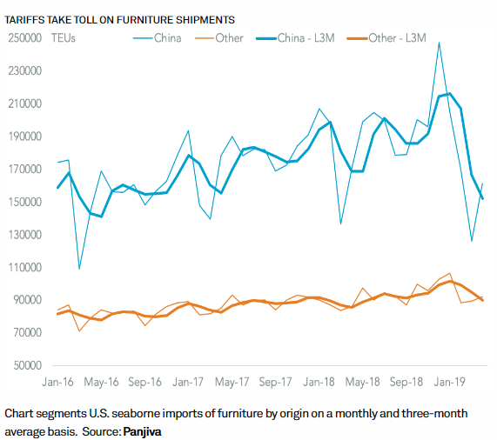
Figure 1, Source: S&P Global
Another political factor is regulatory compliance, where IKEA must adhere to regulations and standards set by governments in different countries, as well to adhere to labour law and employment practices, and taxation.
Nevertheless, diplomatic relations between Home Country (Sweden) and other countries where IKEA operates it is key for decision-making strategy in which the company consider its profitability according to corporate tax policies.
However, Alberti (2022) argues that IKEA have been involved in a scandal in which the Company’s suppliers “allegedly used Belarus prisoners under forced labour conditions”, furthermore, other allegations and lawsuits were handed to Courts, that involves the brand. These will be investigated in the next chapter of this report, under SWOT Analysis.
Worldwide political unrest such as Red Sea Conflict, Ukrainian war, Israel`s war impacted the IKEA`s Strategy, and other political unrest in the countries where IKEA is looking for raw materials, or where it has stores. This was reflected in a loss of revenue in these countries, like a profit fall of 45% in Russia, due to higher material and transport costs, as well as due to closure of its factories (Reuters, 2022). Furthermore, Marrow (2023) argues that IKEA sold its Russian factory to a local firm.
  - Economic
The economic factor of PESTEL analysis is focusing to macroeconomic conditions, trends and policies such as several relevant economic factors as follows.
The overall economic growth and consumer spending in the countries where IKEA operates are significantly important.
International Monetary Fund (2024) illustrates that globally, the economic map ranges from -3% to over 6% of real Gross Domestic Product (GDP), which is composed of “goods and services produced for sale in the market”.
Morrison (2011, p.45) suggests that there are differences between countries as it depends on the type of production, such as primary production, usually raw materials, secondary production, industrial production, and tertiary production in services. According to IKEA (2024) website, the company use raw materials from countries like Vietnam, Indonesia and China, amongst others, however, these countries are a consumer markets as well, according to their economy level and GDP per capita which highlights the purchase power of consumers.
The Central Intelligence Agency (CIA, 2024) has a powerful tool, The World Factbook, which analyses and compares all countries in the world upon several criteria such as geography, economy, energy, transportation, government, and most important, upon its GDP., in this case scenario, for reference, the GDP for Sweden is 55,300 USD in comparison to United Kingdom 47,600 USD.
The exchange rates and currency fluctuations are another factor of Economic section for PESTEL analysis.
Mehtiev, Magda and Vasa (2021, p. 13) suggest that the “existence of foreign exchange control system is crucial for trade activity modelling”. The same authors illustrate that the inflation increases when a devaluation of a currency occurs, resulting in more expensive imports. Moreover, Ramasamy and Abar (2015, p. 276) reiterate the crucial role of Currency Exchange (XR) that also extrapolates to “the investments, banking, insurance, education, tourism”.
Currency exchange rates are influenced by several factors such as inflation rates, government debts, current account deficits, recession, economic performance, speculation (Instarem, 2024). In addition, inflation is a key aspect as well, as it is defined as an increase of prices in a given period of time, which may refer to basic products such as food, or to services, such as finances, as illustrated by Oner (2024).
In addition to the actual currencies, Dorofeyev et al. (2018, p. 431) suggests the advantages of new blockchain technologies in adopting cryptocurrencies, such as “divisibility, portability, durability, recognizability and standardization”. Moreover, Beyer (2024) argues that in 2021, El Salvador adopted the cryptocurrency Bitcoin as legal tender.
Housing Market trends and Unemployment rates are essential to consider, as IKEA depends directly on these factors. Stanilov (2007, p. 174) suggests that after the crash of socialist systems throughout Central and Eastern Europe, the housing sector known a boom in trade and the “housing and residential industry began to recover”. Furthermore, Statista (2024) argues that the Real Estate market is moreover anticipated to grow at an annual rate of 3.41% by 2028, therefore, an emerging market on the rise worldwide, and IKEA should consider its expansion
  - Social
The social component of PESTLE analysis refers to cultural, demographic, and societal factors. For IKEA, the relevant factors are cultural diversity and globalization, demographic trends, lifestyle changes, health and wellness awareness, ethical and social responsibility, and changes in family structure.
Golombok (2020, p. 306) argues that starting the 1980`s, family structure moved towards different aspects than traditional family, considering the rise of sexual orientation awareness. Sharma (2013) argues that “definitions of family varied from country to country, and also within the country”; therefore it could be distinguished several types of family structure such as nuclear as also known ‘traditional family’, single-parent, extended family that involves partnerships, same sex families, childless, stepfamilies, foster, and grandparent families (Trying Together, 2024).
Baghaei et al. (2011) illustrates that in the context of economic circumstances, the lifestyle of families varies upon their affordability to satisfy the basic needs towards self-actualisation, as shown by Maslow`s Hierarchy of Needs (Gambrel and Cianci, 2003). The Department of Economic and Social Affairs of The United Nations (2022) offers a comprehensive data base as families are structured in each country, and for this report purpose it will be exemplified the case study of United Kingdom, beautilully illustrated in the Figure 2 – Household, below.
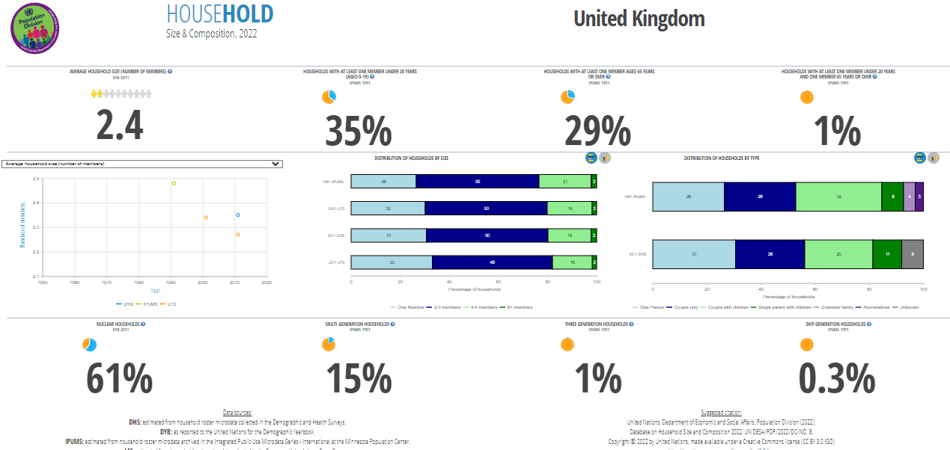

Figure 2 – Household, Source: The Department of Economic and Social Affairs of The United Nations (2022).
The above data, corroborated with the economic statistics of each country, offers a clear image for IKEA to better know their demographic target. As well, these data are enhanced with the primary research in collecting customers data using technology and social media platforms, to establish the trends and the needs and wants of the target population.
  - Technological
The technological component of IKEA`s PESTLE analysis focuses on the influence of technology advancements, innovation, and automatization in manufacturing furniture. It has been identified the relevant factors which refers to E-commerce and online retailing, digital tools for marketing, smart home technologies, supply chain optimisation, and customer relationship management.
In a modern age of technology, the E-commerce is one of the most significant activities on the internet. As having the power to reach out to a diversified range of customers, online retailing is growing in a tremendous fast pace, and with a significant reduced cost as for digital marketing (Seetharam et al., 2017). Snyder (2024) reiterated that “20.1% of retail purchases are expected to take place online in 2024”, from 5.3 trillion USD in 2022 to 7.9 trillion USD predicted for 2027, with a growth of 8.8% X, totalling 6.3 trillion USD globally in 2024. The same Forbes analyst suggests that 52% of online shoppers have done international purchases using the E-commerce platforms, however, 25% of customers abandoned their online carts. Furthermore, Statista (2023) argues that 27% of online shopping are made on social media platform Facebook, respectively 20% on Instagram, followed by Tik Tok and YouTube with 8% each.
Analysing the Media Marketing Strategies of IKEA, Zhou (2024) illustrates that it was revealed the fact that global furniture retail industry intensified in the last decade, therefore IKEA intensified data collection and analysis through their platform, on the Data Collection section (IKEA 2024).
The automation technologies relevant for furniture manufacturing are Robotics, Artificial Intelligence, Internet of Things, and Data Analytics (Praxie, 2024). These techniques help manufacturers during the hole process of furniture manufacturing, from the inception with design to 3D prototypes and precision cutting and assembly. The same author reiterates the advantages of utilising the cutting-edge technologies such as increased efficiency and flexibility, improved quality, sustainability, and increased safety for workers.
All the data and the information collected from customers, suppliers, payments for purchases, and vendors, must adhere to strict rules and regulations regard data protection.
  - Legal
The Legal component of PESTLE analysis refers to compliance with the laws and regulations that mainly focuses on Labour Laws, Environmental Regulations, Product Safety Regulations, Trade Policies, Tax Laws, Competition Laws, and Data Protection Laws, as in general.
In addition to general laws and regulations, Khiatani (2022) suggests that there are more regulations for compliance within the UK, such as those referring to UK Fire Safety, Children`s Furniture Safety Standards, General Product Safety Regulations.
The legislative component is essential for decision makers to ensure compliance and to adjust the strategies to reduce the risks and capitalize the opportunities in different markets that may anticipate the changes in legislation in various markets.
The Environmental component of PESTLE analysis is referring to environmental factors, focusing on sustainable sourcing, energy efficiency, waste management, product design for sustainability, and carbon footprint reduction.
“Concern for the environment is widespread”, as argued by Belshaw (2001, p. 1), especially when in the present, the climate change effects caused by gas emissions from natural systems and human activity has emerged (Fawzy and Osman, 2020), therefore, “the tension between economy and environment is not inevitable” as illustrated by Cato (2011, p. 4).
  - Environment
To protect the environment and to compensate for the damages inevitably occurred, IKEA Sustainability Report FY 2023 (2024) highlights the steps took forward towards sustainability. These steps aimed to reduce the carbon footprint with 12% since the previous financial year, and promoted the healthy and sustainable living, reducing air pollution by using renewable energy while enhanced the waste collection for biogas production. The company`s strategy aims to transform the IKEA value chain by making it circular and reutilising and recycling materials, in order to send zero waste on landfills.

- SWOT analysis

  - Strengths
The following strengths are relevant for IKEA: clear vision, brand reputation, large market share, cost-saving techniques, strong financial position, diversified product portfolio, successful franchise system, innovative design concepts on its easy to assemble products, strong understanding of its target demographics and customer knowledge, successful acquisitions and partnerships.
As mentioned in the previous chapter, IKEA has a strong vision for its strategy as wel as for its products and services, that led to a strong brand reputation. Danziger (2018) argues that The Reputation Institute ranked IKEA on the 58th place of 100 among the most reputable brands in 2017. Nevertheless, Statista (2024) suggest that in 2023, IKEA was ranked on the seventh place worldwide, with over 800 million customers which they visited all 471 stores around the word, bringing revenues from 10.4 billion euros in 2001 to 47.6 billion euros in 2023, this effect can be clearly demonstrated in the revenues Figure 3 - Annual revenue of IKEA Group worldwide from 2001 to 2023, bellow, which reiterates the continuous and consequent business growth.
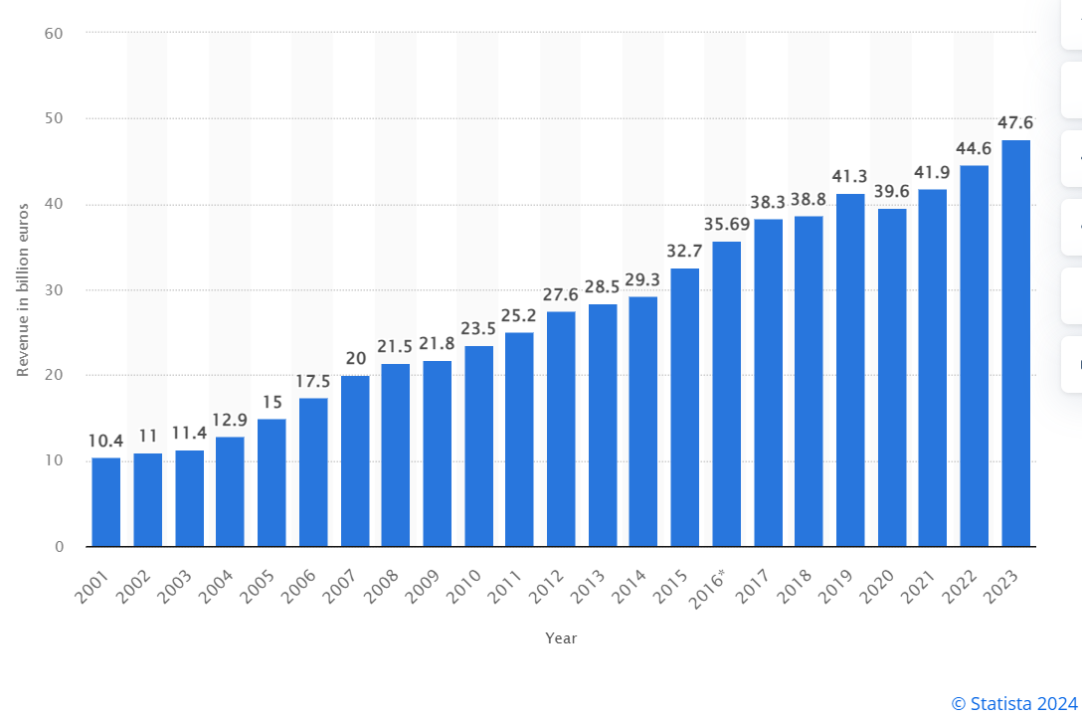
Figure 3 – Annual revenue of IKEA Group worldwide from 2001 to 2023, Source: Statista (2024).
The above figure it is also mirrored in the Inter IKEA Group Financial Summary FY23 which demonstrated the strong financial position IKEA (2024), with an increase of 6.6% compared to FY22, or with 7.3% when adjusted to the currency impact.
According to the same financial summary (p.3), the successful franchise system comprises the diverse portfolio and the large market share worldwide, as demonstrated in the Figure 4 - IKEA franchise system and value chain, below
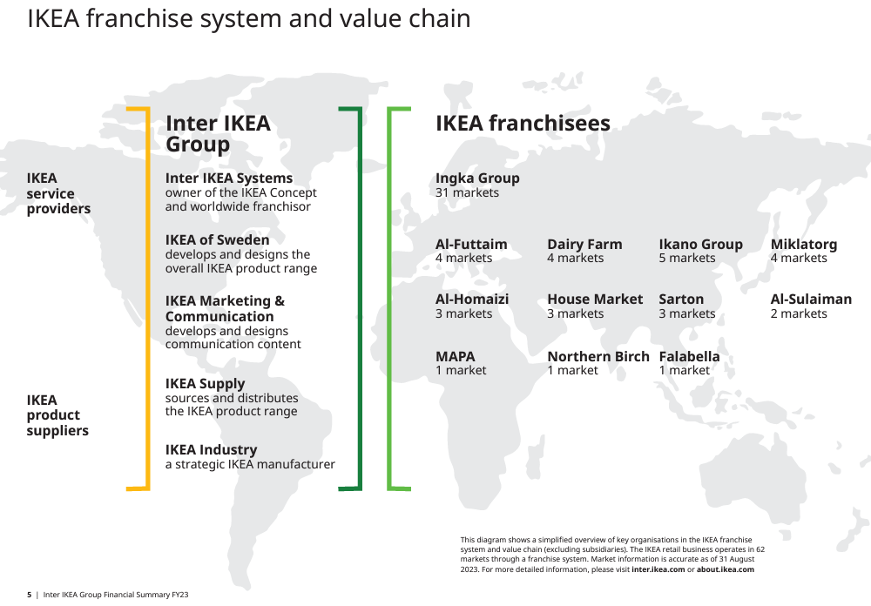
Figure 4 – IKEA franchise system and value chain, Source: Inter IKEA Group Financial Summary FY23.
This continuous growth would not be possible without a significant knowledge of the target market and customer preferences. Dyte (2024) argues that IKEA utilised the integrated experiences, maintaining its products and services relevant to customers by enhancing the human interaction store experience with the online and social media platforms, using the geolocated digital media for relevant advertising. Furthermore, IKEA succeeded to maintain brand loyalty offering customer support after purchases and second chance to return and to replace the faulty products.
In addition, Edvardsson and Enquist (2011) argues that service innovation consists not only in adding some economic value into the value chain, but also that the IKEA value model is “co-created with customers” (p.543) on both pre-purchase and post-purchase, as it called the experience rooms. Furthermore, IKEA Museum (2024) illustrate that this innovative approach was developed since 2006, especially when IKEA entered the Japanese market changing the status-quo adapting to Japanese culture. The customers can use all their senses, and test the products, prior the purchase.
  - Weaknesses
The following relevant weaknesses were identified for IKEA: decreasing products quality, decreasing net income, negative publicity from multiple scandals and accusations of poor working conditions, poor adaptation to the local cultures, self-assembly model is controversial on some products, negative customer perception on brand.
According to Dalheim (2023) IKEA is sourcing most of its wood from Europe (80%) followed by Poland (28%) and Lithuania (10%) as per Financial Year Report 2022, As previously sourced a significant percent of wood from Russia, after the Ukrainian war with Russia that started in 2022, Acosta (2023) argues that Russia was imposed sanctions on timber trade, therefore timber companies based in Turkey imported wood from Russia and resell it under a Turkish origin certificate to the European Union.
Leaven and Levinohn (1995) argues that the international trade theory upon Ricardian and the Ricardo-Viner models, to maintain the competitive advantage companies needs more input like in the Ricardo-Viner model such as raw materials and production technology, not only one factor, labour, which is assumed to be mobile and common for both models, like in Ricardo model.
Therefore, in order to maintain low prices, IKEA also lowered the quality of materials, that led to poor customer reviews about IKEA products, as illustrated by Johnson (2020). The similar negative reviews and low brand loyalty has been reiterated by review websites like Trust Pilot, Quora and Reddit.
In a report Employment Relationships and Working Conditions in an IKEA Rattan Supply Chain, International Labour Organisation (2015) illustrates the framework in which the labour in Indonesia and neighbour countries in Asia are contracted, highlighting some concerns in the workplace environment. In addition, Andersen and Skjoett-Larsen (2009) reiterates that IKEA is asking its suppliers in the chain to make adjustments in regard to working conditions and to not have child labour.
In the mid 1990`s, as IKEA`s success known a significant growth, a child slavery in Pakistan rug factories occurred and kept the first page of newspapers, as argued by IKEA Museum (2024). In response, IKEA acknowledged the situation and terminated the supply contracts with these manufacturers in Pakistan and started to cooperate with UNICEF – Save The Children. Furthermore, new provisions have been put in place to tackle child slavery to its existing suppliers and for the new ones.
According to Business & Human Rights Resource Centre (2024), IKEA faced an international lawsuit in United States in 2019, where “representatives from 35 countries in seven regions set out demands for social equity, cultural integrity, inclusivity”. Egan – Wyer et al. (2014) consider that IKEA raise ethical concerns as in their strategy to build a global brand, the ethicalness and sustainability displayed on IKEA (2024) is not completely mirrored in Company`s day-to-day operations. The Company faced repeated accusations related to age discrimination and for repeated pay discrimination. Furthermore, Ethical Consumer (2024) suggests that IKEA avoided to pay 1.1 billion USD corporation tax during 2009 and 2014, as in an investigation report in European Parliament which highlighted the usage of offshore European tax heavens. The same author reiterates concerns on using animal leather for its products and animal meat for its in-store restaurants, as not complying with the Animal Rights Regulations.
As opposed to its service excellence and innovation model, as illustrated by Edvardsson and Enquist (2011) being a lesson to learn for other companies in the industry, the self-assembly furniture being a key signature for IKEA brand as with its flat packaging as well (Kime, 2019), there are some controversial reasons for the poor consumer satisfaction. Myers (2016) argues that the self-assembly furniture has its cons as well, not only pros. Some customers are facing struggles on understanding the instructions; however, these instructions seem to be easy to understand to most customers, therefore some damages may occur during the assembly, and the customer perception might form around on low product quality. Nevertheless, IKEA is offering home assembly services, and shown transparency relate to its sources (IKEA, 2024).

  - Opportunities
The relevant opportunities were identified, such as: expansion on developing and emergent economies, E-commerce capabilities, expanding grocery services, investing in sustainability, diversifying the business model, further acquisitions and partnerships.
IKEA`s growth opportunities are vast and multifaceted especially in the emergent markets, as global furniture industry is projected to grow at a rate of 5.02% annually, based on the Compound Annual Growth Rate from 2024 to 2028, as illustrated by Statista (2024) in the Figure 5, below.

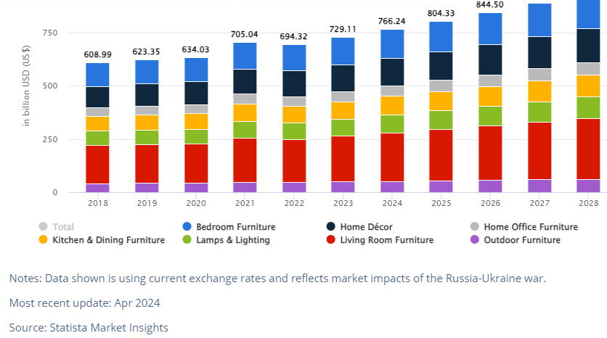
Figure 5, Source: Statista (2024).

According to the same statistics data base, China experiences a surge in demand for furniture as per increased disposable income in the context of rapidly urbanisation.
In addition, Fortune Business Insights (2023) argues that Covid 19 Pandemic had a significant impact on furniture production, decreasing revenues, however, the post pandemic projects 5.36% increase annually, especially in Asia Pacific market.
Driving factors for expansion are the implementation of new manufacturing techniques and new designs that made furniture industry in high demand on both sectors, low cost and luxurious furniture. However, the restraining factors might be considered the customer preference for second-hand furniture. The driving and the restraining forces are key drivers that moves the industry or companies into a direction for change, as changing the status quo. This model is known as Lewin`s Force Field Analysis, as illustrated by Swanson and Creed (2013), who reiterates that internal and external factors of a company are essential for managers and decision-making boards.
As considered a strategic expansion, IKEA (2024) aim to reduce greenhouse by using recyclable materials by 2023. Positioning itself as a global market leader, IKEA has the opportunity to diversify its products to attract a larger scale of home and appliances consumers. Investing in sustainability, renewable energy, and promoting the circular economy model, seems to be a significantly positive strategy to attract environmentally conscious customers. George, Chi-an Lin and Chen (2015) argues that environmental quality improvements cannot be achieved via economic growth only. Furthermore, Ludeke-Freund, Gold and Bocken (2018, p. 37) argues that the Circular Economy model comprises a regenerative system where “long-lasting design, repair and maintenance and recycling” are essential in a supply chain management.
As Warnaby (1999) suggests, IKEA`s acquisition of Habitat in 1992 opposed some issues relating the market segmentation and positioning with IKEA`s global strategic framework, as not being a real success. Therefore, Ikea was considering selling Habitat in 2002 as Campaign (2002) suggested, however, Habitat continues to provide mattresses for IKEA. According to their website, Ikea partnered with local communities for handmade art crafts, as well as with local brands and suppliers, helping and improving the life of local community. This partnership trend continues in the present, developing social enterprises as well in Indonesia, Mexico, and East Africa.

  - Threats
The following threats were identified for IKEA: an increased competition from other brands, changes in consumer preferences, changes in in macroeconomic conditions, the supply chain shocks and logistic disruptions, legal allegations.
In a fierce competition to a dynamic market, Abbott (2022) illustrates that the key competitors for IKEA are Wayfair, Amazon, Ashley Home Store, Walmart, Home Depot, and many others. Wayfair offers over ten million products from over 10,000 suppliers, while IKEA has a few over 1600 suppliers and 275 transport suppliers, however, they have 2000 new products yearly (Ikea, 2024). The bargaining power of suppliers will be analysed in the next chapter of this report.
Another threat might be considered the changes in consumer behaviour in the furniture industry. Khojasteh – Kshoro, Shalbafan and Thoemen (2022) argues that consumers are orienting their furniture purchases to those made from eco-friendly materials such as wood. Environmental conscious consumers are switching to lightweight panels, light density wood, that makes durable furniture at affordable prices. The same authors suggests that criteria on which consumers choose furniture in the present are the design, wight, natural aspect and price comparison with similar products. This aspect is one of the forces reiterated by Porter`s Five Forces, namely the Bargaining Power of consumers, as well as the Threat of Substitutes, which will be investigated in the next chapter in this report.
Morrison (2011, p. 43) argues that Globalisation can be defined as a system in which “products, people, companies, money and information are able to move quickly around the world”. Therefore, Mangan, Lalwani and Butcher (2008) suggest that companies might be oriented to outsource their manufacturing and labour facilities, usually in a suitable economic environment, according to the country’s employment law, tax law, political environment as highlighted in the previous chapter on this report in relation to PESTEL Analysis.
In this globalization context, suppliers chain shock could occur, and disruptions in the logistic chain, not only due to economic and political unrest, but also from environmental factors such as pandemics.
Chowdhury (2024) argues that despite the Red Sea disruptions, which led to a supply shock that put the prices up globally, IKEA is keen to not increase prices and the contrary to lower their prices in 2024, as said by IKEA`s CEO.

- Porter`s Five Forces

This framework it is utilised to analyse the level of competition within a certain industry, particularly the furniture industry within IKEA operates (de Bruin, 2016) and follows the forces described in the Figure 6 - Porter`s Five Forces, below.

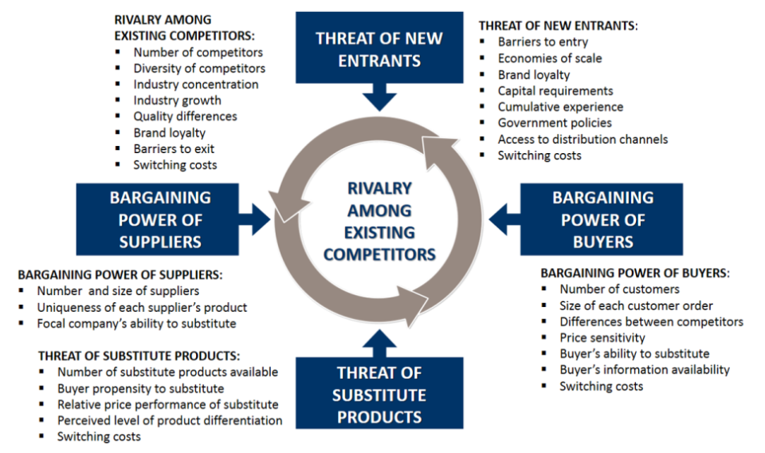
Figure 6 – Porter`s Five Forces, Source: de Bruin (2016)

  - Threat of New Entrants
The treats of new entrants’ level is Low to Moderate as IKEA benefits from economies on large scale in furniture manufacturing as ranked by Statista (2024) on first place, making “the world`s largest furnishing retailer”. Moreover, IKEA`s strong brand recognition and customer loyalty might be perceived as a strong barrier for entry in the industry, as well as a strong barrier to exit due to high costs. However, the main competitor in Asia, a Japanese firm, announced its expansion on Vietnam, Indonesia, and Taiwan as Sakamoto and Omiki (2023) suggests.
  - Bargaining Power of Suppliers
Also known as market inputs, the bargaining power of suppliers is force that analyse the power and control that suppliers have on businesses, and this level is Moderate for IKEA. The company have over 1600 suppliers worldwide, therefore their power it is to be considerate as Moderate. The financial status offers to IKEA the power to negotiate as it also has low prices for its products.
  - Bargaining Power of Buyers
This force analyses the power on the hands of customers, and as the competition is high, that gives the buyers access to a wide choice of alternative options from competitors.
  - Threat of Substitutes
In a fast-paced industry, the treat of substitutes level is to be considered low to moderate, as although there is a wide range of similar products within the furniture industry, the over 8 million customers seem to remain loyal to the brand. The replacement of wooden furniture with other material made furniture like artificial wood or plastic it is not desired, however, the threat of substitutes resides also on affordability (Adamkasi, 2019).
  - Competitive Rivalry Among Existing Competitors
The furniture and home goods industry are highly competitive; therefore, the level of competition is High. Despite the growth on online platforms, IKEA face the competition from traditional furniture retailers as well as from new designs, new products, and innovations. It might be considered a fierce battleground, to maintain the product quality at an affordable price.
Sakamoto and Omiki (2023) argues that Ikea known a strong competitor in Japan`s developing market where Nitori retailer took over the IKEA`s market by opening stores in Thailand`s capital city, Bangkok, as well in Vietnam.
- Conclusions
As from the main findings above, relevant conclusions cand be drawn further.
IKEA faces challenges from various forces in the industry, as illustrated in Porter`s Five Forces model, furthermore, it is a strong and powerful brand, positioning at top rankings upon brand recognition, customer footfall customer loyalty to the brand, product quality and sustainability.
PESTLE Analysis revealed that globalisation have a significant impact on multinational enterprises like IKEA, usually out of their direct control, that reflects the macro-environment scale. Constantly monitoring these six factors of analysis, positioned the Company at the top of most compliant enterprise, however, they were identified issues regard to employment and discrimination among the employees, tax avoidance schemes and hiding the real profits. There also concerns on diversity and cultural influence, and environmental issues, as IKEA partially failed to fulfil, despite the Company statements as working towards mitigating them. It was also concluded that cryptocurrencies are the new trend in globalization.
SWOT analysis revealed the strength and opportunities, making IKEA a strong brand, as well as the treats and weaknesses, influential factors that are part of microenvironment, under direct control of the Company. Nevertheless, there were identified concerns regards to scandals and lawsuits which influenced the brand position on the market and questioning the ethics of its strategy, as well as a decrease in products quality.
Porter`s Five Forces mirrored the findings in both PESTLE and SWOT analysis, reiterating the strong connection between these three analysis tools.

- Recommendations

After drawing the conclusions, few recommendations are to be made to improve the overall IKEA`s performance, as follows:
- To continue to invest cutting edge technologies, especially Artificial Intelligence, as well as to consider adopting cryptocurrencies as payments. This will significantly create a competitor advantage in a new digital era.
- To reconsider the quality of its products to maintain the leading position in the market.
- To invest more in renewable energy and to improve working conditions for the employees, to not only consider the profitability in disregard to wellbeing and the environment.
- IKEA is recommended to focus more on ethical aspects of its strategies, to avoid lawsuits.

- References List
Abbott, A (2022) Top 15 IKEA competitors & alternatives. Available at: https://bstrategyhub.com/ikea-competitors-alternatives/ (Accessed: 17 April 2024).
According to Business & Human Rights Resource Centre (2024) Indigenous Peoples call for respect for their rights, participation and shared prosperity in clean energy transition. Available at: https://www.business-humanrights.org/en/ (Accessed: 16 April 2024).
Acosta, C.M. (2023) How Russia`s timber trade is sidestepping the EU`s Ukraine war sanctions. Available at: https://www.icij.org/investigations/deforestation-inc/how-russias-timber-trade-is-sidestepping-the-eus-ukraine-war-sanctions/ (Accessed: 16 April 2024).
Adamkasi (2019) Poerter`s Five Forces Analysis of IKEA. Available at: https://www.porteranalysis.com/porters-five-forces-analysis-of-ikea/ (Accessed: 19 April 2024).
Alberti, M. (2022) IKEA suppliers allegedly used Belarus prisoners under forced labor conditions, report says. Available at: https://edition.cnn.com/2022/11/18/business/ikea-suppliers-belarus-labor-allegations/index.html (Accessed: 19 April 2024).
Andersen, M. and Skjoett-Larsen, T. (2009) “Corporate social responsibility in global supply chais”, Supply Chain Management, 14(2), pp.75-86. Available at: https://www.emerald.com/insight/content/doi/10.1108/13598540910941948/full/html?casa_token=Dz2FwuEvBooAAAAA:nvxLuBBLfh_EOPeAntNCDQEPXm0_6473BIPilDlZjEHgFsOr242RuorP-FcYPA6DZRMWOGo3ZAOmHXtjuw93UQKBLkvlVslE9bcmpdkBHqw3nTv46vA (Accessed: 16 April 2024).
Baghaei, N. Kimani, S., Freyne, J. Brindal, E and Smith, G. (2011) ‘Engaging families in lifestyle changes trough social networking’, International Journal of Human-Computer Interaction, 27(10), pp. 971-990. Available at: https://www.tandfonline.com/doi/full/10.1080/10447318.2011.555315?casa_token=biALGSK-35gAAAAA%3AWuke64jdJjUUpzAmq5xtSdU9l18BZGXi4Y9wbg1lV662UMcMmJ2fnvdMZ15xhoS0CEpoa7eIar5L (Accessed: 19 April 2024).
Belshaw, C. (2001) Environmental Philosophy. Chesham: Acumen publishing Limited.
Beyer, R. (2024) El Salvador Adopted Bitcoin as an Official Currency; Salvadorans Mostly Shrugged. Available at: https://insights.som.yale.edu/insights/el-salvador-adopted-bitcoin-as-an-official-currency-salvadorans-mostly-shrugged#:~:text=El%20Salvador%20took%20a%20different,Bitcoin%20as%20a%20legal%20tender. (Accessed: 19 April 2024).
Brujil, G.H.Th. (2018) “The Relevance of Porter`s Five Forces in Today`s Innovative and Changing Business Environment”, Bizchange Consulting, pp.1-22. Available at: https://papers.ssrn.com/sol3/papers.cfm?abstract_id=3192207 (Accessed: 13 April 2024).
Campaign (2022) Habitat could be sold by Ikea. Available at: https://www.campaignlive.co.uk/article/habitat-sold-ikea/155418 (Accessed: 17 April 2024).
Cato, M.S. (2011) Environment and Economy. Oxon: Routledge.
Chatzky, A and Siripurapu, A. (2021) The truth about tariffs. Available at: https://www.cfr.org/backgrounder/truth-about-tariffs (Accessed: 16 April 2024).
Chowdhury, D. (2024) Davos 2024: IKEA prices to fall despite Red Sea disruptions, CEO says. Available at: https://www.reuters.com/business/retail-consumer/ikea-prices-fall-despite-red-sea-disruptions-group-ceo-says-davos-2024-01-15/ (Accessed: 18 April 2024).
Coman, A. and Ronen, B. (2009) “Focused SWOT: diagnosing critical strengths and weaknesses”, International Journal of Production Research, 47(20), pp. 5677-5689. Available at: https://www.tandfonline.com/doi/full/10.1080/00207540802146130 (Accessed: 13 April 2024).
Dalheim, B. (2023) Without Russia, where is Ikea getting its wood?. Available at: https://www.furnituretoday.com/wood-furniture/without-russia-where-is-ikea-getting-its-wood/#:~:text=Ikea's%20main%20suppliers%20in%20fiscal,an%20effort%20to%20increase%20transparency. (Accessed: 16 April 2024).
Danao, M. (2024) Porter`s Five Forces: Definition & How To Use The Model. Available at: https://www.forbes.com/advisor/business/porters-five-forces/ (Accessed: 13 April 2024).
Danziger, P.N. (2018) Ikea Gets No Respect, But It Should. Available at: https://www.forbes.com/sites/pamdanziger/2018/01/17/ikea-gets-no-respect-but-it-should/#:~:text=Consumers%20also%20know%20Ikea%20and,Ikea%2C%20the%20stronger%20its%20reputation. (Accessed: 13 April 2024).
de Bruin, L. (2016) Porter`s Five Forces Model [image]. Available at: https://www.business-to-you.com/porters-five-forces/ (Accessed: 19 April 2024).
Dorofeyev, M., Kosov, M., Ponkratov, V., Masterov, A, Karaev, A. and Vasynina, M. (2018) ‘Trends and Prospects for the Development of Blockchain and Cryptocurencies in the Digital Economy’, European Research Studies Journal, XXI(3), pp. 429-445. Available at: www.researchgate.net/profile/Margarita-Vasyunina/publication/328552413_Trends_and_Prospects_for_the_Development_of_Blockchain_and_Cryptocurrencies_in_the_Digital_Economy/links/62386e5472d413197a39780c/Trends-and-Prospects-for-the-Development-of-Blockchain-and-Cryptocurrencies-in-the-Digital-Economy.pdf (Accessed: 19 April 2024).
Dyte, P. (2024) How IKEA evolved its consumer experience by integrating online and offline. Available at: https://www.iprospect.com/news-and-insights/news/how-ikea-evolved-its-consumer-experience-by-integrating-online-and-offline/ (Accessed: 13 April 2024).
Edvardsson, B. and Enquist, B. (2011) “The service excellence and innovation model: Lessons from IKEA and other service frontiers”, Total Quality Management & Business Excellence, 22(5), pp. 535-551. Available at: https://www.tandfonline.com/doi/full/10.1080/14783363.2011.568242 (Accessed: 13 April 2024).
Egan-Wyer, C, Muhr, S.L., Pfeiffer, A and Svensson, P. (2014) “The ethics of the brand”, Ephemera Theory & politics in organization, 14(1), pp. 1-166. Available at: https://ephemerajournal.org/sites/default/files/pdfs/issue/14-1ephemera-feb14%20copy.pdf (Accessed: 16 April 2024).
Ethical Consumer (2024) IKEA Ltd. Available at: https://www.ethicalconsumer.org/company-profile/ikea-ltd (Accessed: 16 April 2024).
Faria, J. (2023) IKEA`s brand value worldwide from 2016 to 2023. Available at: https://www.statista.com/statistics/980112/brand-value-of-ikea-worldwide/ (Accessed: 13 April 2024).
Fawzy, S. and Osman, A.I. (2020) ‘Strategies for mitigation of climate change: a review’, Environmental Chemistry Letters, 18, pp. 2069-2094. Available at: https://link.springer.com/article/10.1007/s10311-020-01059-w (Accessed: 18 April 2024).
Gambrel, P.A. and Cianci, R. (2003) ‘Maslow`s Hierarchy of Needs: Does it apply in a collectivist culture’, Journal of Applied Management and Entrepreneurship, 8(2), pp. 143-161. Available at: https://www.proquest.com/docview/203916225?pq-origsite=gscholar&fromopenview=true&sourcetype=Scholarly%20Journals (Accessed: 19 April 2024).
George, D.A.R., Chi-an Lin, B. and Chen Y. (2015) “A circular economy model of economic growth”, Environmental Modelling & Software, 73, pp. 60-63. Available at: https://www.sciencedirect.com/science/article/pii/S1364815215300050?casa_token=3U0FtVSYfRoAAAAA:7tW88NmlqniRisWx98fITG6s293SQbWx8IC-3XLZq-bL8A5Ypba4MIAslwPAdkBTygrQgb2qE4E (Accessed: 17 April 2024).
Golombok, S. (2020) How our understanding of family began to change in 1978. Available at: https://www.thebritishacademy.ac.uk/blog/how-our-understanding-family-began-change-1978/ (Accessed: 19 April 20240).
Helms, M.M. and Nixon, J. (2010) “Exploring SWOT analysis – where are we now? A review of academic research from the last decade”, Journal of Strategy and Management, 3(3), pp. 215-251, Available at: https://www.emerald.com/insight/content/doi/10.1108/17554251011064837/full/html (Accessed: 13 April 2024).
IKEA (2023) IKEA Sustainability Report FY 2023. Available at: www.ikea.com/global/en/images/IKEA_SUSTAINABILITY_Report_FY_23_20240125_1b190c008f.pdf (Accessed: 18 April 2024).
IKEA (2024) About IKEA UK. Available at: https://www.ikea.com/gb/en/this-is-ikea/about-us/about-ikea-market-pub3c09f721 (Accessed: 13 April 2024).
IKEA (2024) Data Collection. Available at: https://www.ikea.com/nl/en/customer-service/privacy-policy/data-collection-pubee56cc4a (Accessed: 19 April 2024).
IKEA (2024) Ethics and Integrity. Available at: https://www.inter.ikea.com/en/how-we-do-business/ethics-and-integrity (Accessed: 16 April 2024).
IKEA (2024) From humble orogins to global brand – a brief history of IKEA. Available at: https://www.ikea.com/gb/en/this-is-ikea/about-us/our-heritage-pubad29a981 (Accessed: 13 April 2024).
IKEA (2024) IKEA franchise system and value chain [image]. Available at: https://www.inter.ikea.com/-/media/interikea/igi/financial-reports/inter_ikea_group_financial_summary_fy23_31-10-2023_.pdf?rev=ec30b988178e4c0989d0f8d80ee2278d&sc_lang=en (Accessed: 13 April 2024).
IKEA (2024) Inter IKEA Goup Financial Summary FY23. Available at: https://www.inter.ikea.com/-/media/interikea/igi/financial-reports/inter_ikea_group_financial_summary_fy23_31-10-2023_.pdf?rev=ec30b988178e4c0989d0f8d80ee2278d&sc_lang=en (Accessed: 13 April 2024).
IKEA (2024) Our circular agenda. Available at: https://www.ikea.com/global/en/our-business/people-planet/our-circular-agenda/ (Accessed: 17 April 2024).
IKEA How we work. Available at: https://www.ikea.com/global/en/our-business/how-we-work/#:~:text=Together%2C%20all%20over%20the%20world&text=The%20retail%20business%20is%20organised,is%20a%20challenge%20we%20love. (Accessed: 13 April 2024).
IKEA Museum (2024) A new compass. Available at: https://ikeamuseum.com/en/explore/the-story-of-ikea/a-new-compass/#:~:text=In%20the%20mid%2D1990s%2C%20IKEA,too%20did%20the%20media's%20scrutiny. (Accessed: 16 April 2024).
IKEA Museum (2024) Retail revival in Japan. Available at: https://ikeamuseum.com/en/explore/the-story-of-ikea/retail-revival-in-japan/#:~:text=2021%20IKEA%20opened%20in%20Shinjuku,and%2020%20pop%2Dup%20stores. (Accessed: 13 April 2024).
Instarem (2024) 7 Key factors that influence foreign exchange rates. Available at: https://www.instarem.com/blog/7-key-factors-that-influence-foreign-exchange-rates/ (Accessed: 19 April 2024).
International Labour Organisation (2015) Employment Relationships and Working Conditions in an IKEA Rattan Supply Chain. Available at: https://www.ilo.org/wcmsp5/groups/public/---asia/---ro-bangkok/---ilo-jakarta/documents/publication/wcms_436863.pdf (Accessed: 16 April 2024).
International Monetary Fund (2024) Gross Domestic Product: An economy`s all. Available to: https://www.imf.org/en/Publications/fandd/issues/Series/Back-to-Basics/gross-domestic-product-GDP (Accessed: 18 April 2024).
Johnson, H. (2020) Gimme Gimme Gimme My Delivery. Available at: https://www.dailymail.co.uk/femail/article-9010793/IKEA-hit-90-cent-negative-reviews-customers.html (Accessed: 16 April 2024).
Josephs, J. (2021) IKEA boss warns tariffs will lead to higher prices, Available at: https://www.bbc.co.uk/news/business-56296028 (Accessed: 17 April 2024).
Khiatani, J.V. (2022) Furniture Regulations and Standards in the United Kingdom. Available at: https://www.compliancegate.com/furniture-regulations-united-kingdom/ (Accessed: 19 April 2024).
Khojasteh – Kshoro, S., Shalbafan, A. and Thoemen, H. (2022) “Consumer behaviour assessment regarding lightweight furniture as an environmentally-friendly product” Wood Material Science & Engineering, 17(3), pp192-201. Available at: https://www.tandfonline.com/doi/full/10.1080/17480272.2020.1847187?casa_token=9D25nlXrGFkAAAAA%3ABpS_8kCg3H717xQJccjqfxvI3clu-cMizYy-7n8iMsHYtOgKq53KClONhcAxlDXTCaIovuFVimDI (Accessed: 17 April 2024).
Kime, E. (2019) Dis-assembling IKEA. Available at: https://www.ft.com/content/714fa4c0-6922-3858-a3eb-54ab73a57c5c (Accessed: 16 April 2024).
Leamer, E. and Levinsohn, J. (1995) “International trade theory: The evidence”, Handbook of International Economics, 3, pp. 1339-1394. Available at: https://www.sciencedirect.com/science/article/abs/pii/S1573440405800061 (Accessed: 16 April 2024).
Ludeke-Freund, F., Gold, S. and Bocken, N.M.P. (2018) “A review and typology of circular economy business model patterns”, Journal of Industrial Ecology, 23(1), pp.36-61. Available at: https://onlinelibrary.wiley.com/doi/epdf/10.1111/jiec.12763 (Accessed: 17 April 2024).
Mangan, J., Lalwani, C. and Butcher, T. (2008) Global Logistics and Supply Chain Management, Hoboken: John Wiley & Sons Inc..
Marrow, A. (2023) IKEA completes sale of Russian factory to local firm. Available at: https://www.reuters.com/markets/deals/russian-firm-says-it-closes-deal-buy-ikea-factory-2023-03-27/ (Accessed: 19 April 2024).
Mehtiev, J., Magda, R. and Vasa, L. (2021) “Exchange rate impacts on international trade”, Economic Annals – XXI, 190(5-6(2)), pp. 12-22. Available at: https://ea21journal.world/wp-content/uploads/2022/01/ea-V190-02.pdf (Accessed: 19 April 2024).
Morrison, J. (2011) The Global Business Environment: Meeting the Challenges, 3rd edn., New York: Palgrave Macmillan.
Myer, C. (2016) What Assembling Ikea Furniture Taught Me About User Experience. Available at: https://www.forbes.com/sites/chrismyers/2016/02/17/what-assembling-ikea-furniture-taught-me-about-user-experience/ (Accessed: 16 April 2024).
Oner, C. (2024) Inflation: prices on the rise. Available at: https://www.imf.org/en/Publications/fandd/issues/Series/Back-to-Basics/Inflation (Accessed: 19 April 2024).
Porter, E.M. (2004) Competitive Advantage, New York: Free Press.
Praxie (2024) The future is here: Embracing Automation in Future Manufacturing. Available at: https://praxie.com/automation-in-furniture-manufacturing/#:~:text=In%20the%20context%20of%20furniture,pieces%20at%20a%20faster%20rate. (Accessed: 19 April 2024).
Ramasamy, R. and Abar, S.K. (2015) “Influence of Macroeconomic Variables on Exchange Rates”, Journal of Economics, Business and Management, 3(2), pp. 276-281. Available at: https://www.researchgate.net/profile/Ravindran-Ramasamy-2/publication/272908793_Influence_of_Macroeconomic_Variables_on_Exchange_Rates/links/5b73bbc492851ca6505f0ebb/Influence-of-Macroeconomic-Variables-on-Exchange-Rates.pdf (Accessed: 19 April 2024).
Reuters (2022) Inter IKEA posts 45% fall on costs, Russia. Available at: https://www.reuters.com/business/retail-consumer/inter-ikea-posts-45-profit-fall-costs-russia-2022-11-03/ (Accessed: 19 April 2024).
Sakamoto, K. and Omichi, K. (2023) Japan`s Nitori takes on IKEA in Asia with new Thailand, Vietnam stores. Available at: https://asia.nikkei.com/Business/Retail/Japan-s-Nitori-takes-on-Ikea-in-Asia-with-new-Thailand-Vietnam-stores (Accessed: 19 April 2024).
Seetharam, A., Niranjan, I, Saravanan, A.S. and Balaji, D. (2017) ‘A study of the moderate growth of online retailing (ecommerce) in the UAE’, The Journal of Developing Areas, 51(4), pp. 397-412. Available at: https://www.jstor.org/stable/26416983?seq=1 (Accessed: 18 April 2024).
Sharma, R. (2013) ‘The family and family structure classification redefined for the current times’, J Family Med Prim Care, 2(4), pp. 306-310. Available at: https://www.ncbi.nlm.nih.gov/pmc/articles/PMC4649868/ (Accessed: 19 April 2024).
Snyder, K. (2024) 35 E-commerce Statistics of 2024. Available at: https://www.forbes.com/advisor/business/ecommerce-statistics/ (Accessed: 19 April 2024).
Stanilov, K. ‘Housing trends in Central and eastern Europe cities during and after the period of transition’, in Stanilov, K. (eds) The post-socialist city, pp.173-190. Dordecht: Springer
Statista (2024) Annual revenue of IKEA Group worldwide from 2001 to 2023, [image]. Available at: https://www.statista.com/statistics/264433/annual-sales-of-ikea-worldwide/ (Accessed: 13 April 2024).
Statista (2024) Furniture – Worldwide. Available at: https://www.statista.com/outlook/cmo/furniture/worldwide (Accessed: 16 April 2024).
Statista (2024) IKEA – Statistics and Facts. Available at: https://www.statista.com/topics/1961/ikea/#topicOverview (Accessed: 13 April 2024).
Statista (2024) IKEA – Statistics and Facts. Available at: https://www.statista.com/topics/1961/ikea/#topicOverview (Accessed: 19 April 2024).
Statista (2024) Real Estate – Worldwide. Available at: https://www.statista.com/outlook/fmo/real-estate/worldwide (Accessed: 19 April 2024).
Swanson, D.J. and Creed, A.S. (2013) “Sharpening the Focus of Force Field Analysis”, Journal of Change Management, 14(1), pp. 28-47. Available at: https://www.tandfonline.com/doi/full/10.1080/14697017.2013.788052?casa_token=q4n8mw8ZWE4AAAAA%3Al3Qzh5DQ4HQVTVlTGobBVo_XfK1nYq_3KzkmYfwwk5LO50pwDHQb_N4yhNH-g1BIACvMQgSSBsEI (Accessed: 16 April 2024).
The Central Intelligence Agency (2024) Real GDP per capita. Available at: https://www.cia.gov/the-world-factbook/field/real-gdp-per-capita/country-comparison/ (Accessed: 19 April 2024).
The Department of Economic and Social Affairs of The United Nations (2022) Household size & composition, 2022 [image]. Available at: https://population.un.org/household/#/countries/840 (Accessed: 19 April 2024).
Trying Together (2024) Types of Family Structures. Available at: https://tryingtogether.org/dap/types-of-family-structures/ (Accessed: 19 April 2024).
Warnaby, G. (1999) “Strategic consequences of retail acquisition: IKEA and Habitat”, International Merketing Review, 16(4/5), pp. 406-417. Available at: https://www.emerald.com/insight/content/doi/10.1108/02651339910282027/full/html (Accessed: 17 April 2024).
Whittington, R., Regner, P., Angwin, D., Johnson, G., Scholes, K. (2020) Exploring Strategy, 12th ed, Harlow: Pearson Education Ltd.
Woo, W.T. and Liu, T (2018) “Understanding the U.S. – China Trade War”, China Economic Journal, 11(3), pp. 319-340. Available at: https://www.tandfonline.com/doi/full/10.1080/17538963.2018.1516256?casa_token=PcBeW0mjnX4AAAAA%3AqtfKy0azIhjnh5z4o3V_9e457odsncW4gweZyHY51TT-oUKqEq7BLJF2xbjTEe5RayuVjbY2IWUs (Accessed: 16 April 2024).
Zhou, S. (2024) ‘Analysing IKEA Brand`s Media Marketing Strategies and Improving Customer Experience Trough Inductive Reasoning Approach’, Journal of Education, Humanities and Social Sciences, 27, pp. 392-399. Available at: https://drpress.org/ojs/index.php/EHSS/article/view/18243 (Accessed: 19 April 2024).

