IMAGINED EXHIBITION Lola Preston : Femininity and the Representation of the Female Body

In day-to-day life we are exposed to various depictions of the female body, weather that be over sexualised models in perfume advertisements, or that of a celebrity being criticised in a tabloid magazine; the female body is ‘surveyed’ (Berger, 1972, pg.69). Throughout history women have been portrayed in certain ways in order to satisfy ‘The Male Gaze’ (Mulvey, 1973), this is evident in many gender stereotypes, for example typically the male would go to work while the female stayed home, amplifying the sense of power that the male has in the relationship. The need to conform to the male gaze is also very much visible throughout art history, particularly apparent in imagery that contains a female nude. Within this exhibition I wish to highlight how artists are beginning to disconnect the concept of a naked female with pleasing a male observer and changing the narrative that comes along with femininity within the world of art.
Males and females have often been viewed very differently throughout history, with differing roles and expectations within society, ‘the social presence of a woman is different in kind from that of a man’ (Berger, 1972, pg.63). Here, Berger states that the presence of a male is based on the power that they possess and how that might affect an individual, whereas the presence of a female is more so defined by what one decides they would be able to do to her, highlighting the opposing social views of each gender, ultimately portraying the woman as submissive to the overriding power of the man. Due to the fact that a female can impact how she is treated by others, she is more likely to adapt herself to fit the idealised version of a woman crafted by men, linking back to the concept of the ‘Male gaze’ (Mulvey, 1973) as ‘ultimately how she appears to men is of crucial importance for what is normally thought of as the success of her life’ (Berger, 1972, pg.70). How femininity is portrayed therefore has been greatly restricted as femininity itself has been constructed in order to satisfy the male gender. In western art, the female nude has been something that is generally seen to be very sexual and often thought to feed into the male desire, this concept was captured a painting by Johann Zoffany (see figure. 1)
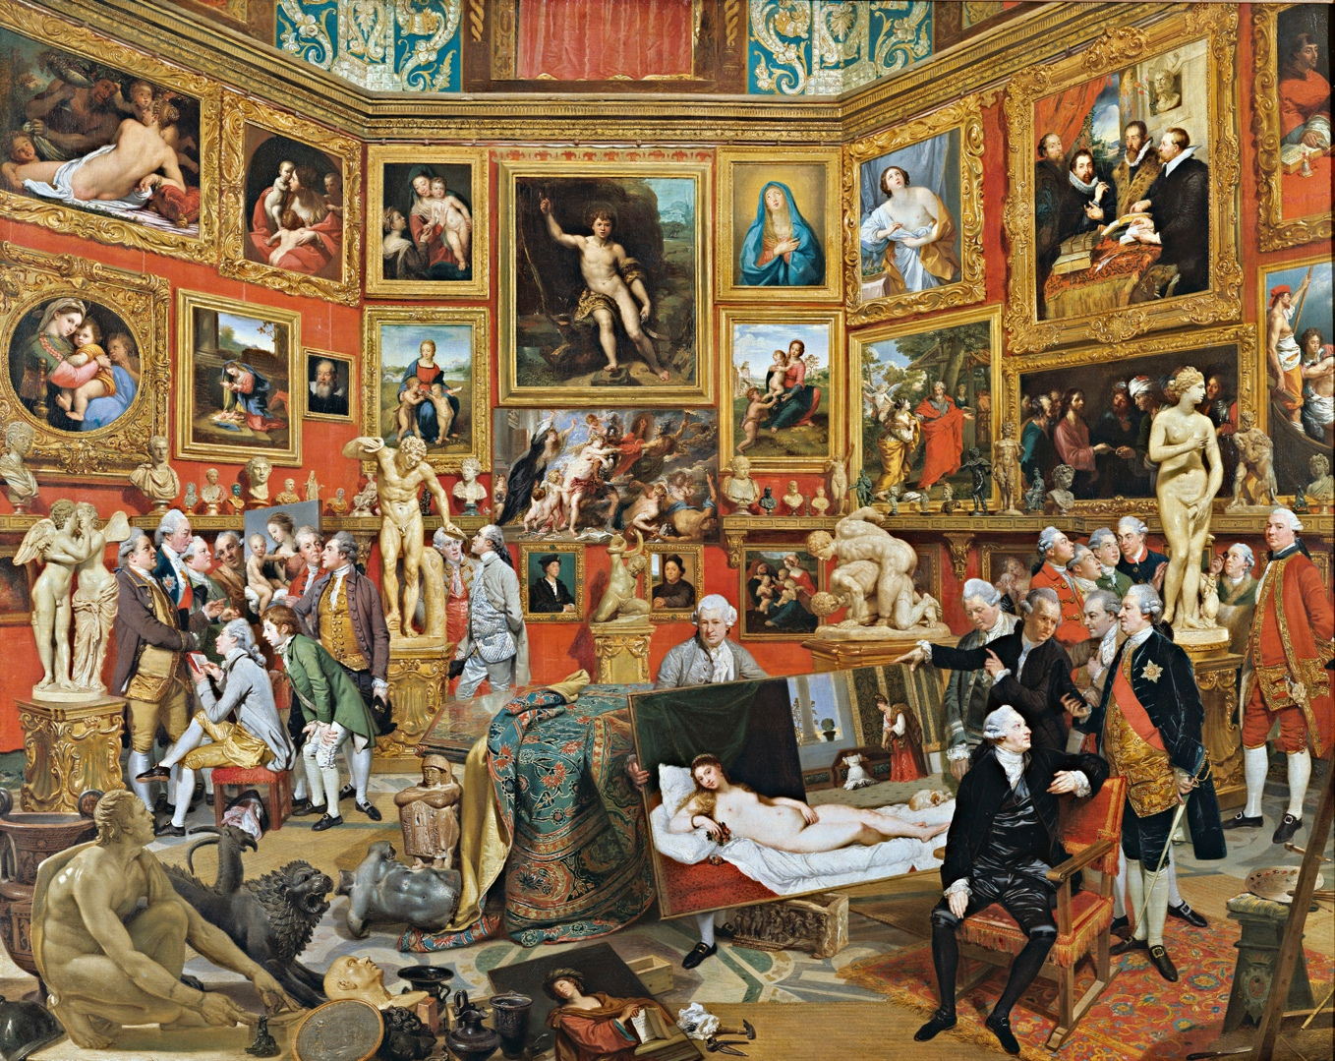
Figure. 1 – Tribuna of the Uffizi by Johan Zoffany (1772-1777)

This painting depicts a scene set in a gallery filled with lots of men who, seeming to be of a certain class as suggested by their grand clothing, are gathering round the many nude paintings and sculptures that fill the space. The sheer quantity of men in the space highlights that the nude may provoke pleasure for them and that the artists may exploit this knowledge when creating their version of the nude. Prior to this, another nude depiction of a female that has been seen to provoke sexual desire within males is The Aphrodite of Knidos (see figure.2
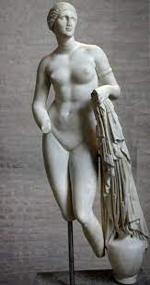
Figure. 2 The Aphrodite of Knidos by Praxiteles (4th century BC)
This links to the idea that lots of female nudes created in western culture were not accurate representations of women but were representations of what people believed the ideal woman should be like as ‘she is not naked as she is. She is naked as the spectator sees her’ (Berger, 1972, pg.77). The presentation of the nude has often been restricted, as Lynda Nead states ‘The obscene body is the body without boundaries and restrictions’ (Nead, 1992, pg.2), suggesting that without an artist restricting the elements of the female that the viewers see, the body is less likely to be desired and will be seen as crude, shattering the ideal image of the woman. ‘One of the principle goals of the female nude has been the containment and regulation of the female sexual body’ (Nead, 1992, pg.6), however this is beginning to change as more female artists are beginning to express their own femininity and present bodies that differ from those crafted by the male gaze, as I wish to show in this exhibition.
The exhibition starts with Albrecht Dürer’s, Draughtsman Drawing a Nude (1538) which is a woodcut that depicts a nude female draped in fabric lying opposite a draughtsman, a screen separating the two figures (figure. 3)
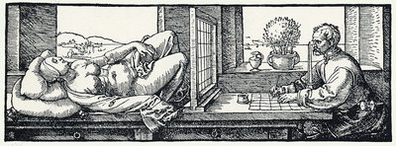
Figure 3 – Draughtsman drawing a nude by Albrecht Dürer (1535)
In this image the female is being analysed, not as a whole but section by section through the screen, her body being scrutinised by the artist in order to create something to visually please others, the ‘woman offers herself to the controlling discipline of illusionistic art’ (Nead, 1992, pg.11). The composition of this piece is striking as it creates a direct visual contrast between the male surveyor and ‘the surveyed female’ (Berger, 1972, pg.71), the artists intense gaze upon the female creating a sense of discomfort within the piece almost objectifying her for the purpose of the image; ‘a naked body has to be seen as an object in order to become a nude’ (Berger, 1972, pg.85). Starting the exhibition with this woodcut, will inform the viewer of the process behind constructing a nude and how it removes the reality from the body, it also gives an example of a literal male gaze upon a female body.
The second piece I wish to have in my exhibition is Édouard Manet’s Olympia (shown in figure. 4) which is an oil painting of a woman lying down being handed a bouquet of flowers.
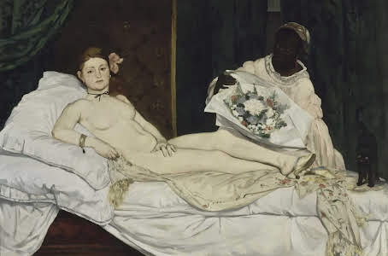
Figure. 4 – Olympia by Èdouard Manet (1863)
At the time this painting was extremely controversial as the nude model was a prostitute and in 19th century France, this was frowned upon, especially in the art world as most nudes were of deities or the perceived ideal woman. T.J. Clark stated that a nude ‘is a picture for men to look at, in which woman is constructed as an object of somebody else’s desire’ (1984, pg.131) suggesting that the subject must be desired for someone else to want to see it or for it to constitute as art, however critics named Manet’s Olympia to be ‘improper’ and ‘dirty’. By creating this painting, Manet began to change the narrative of the female nude by using a model that was unconventional for a nude the time, removing the idea of the male gaze and the female ideal from the nude, he ‘disobeys, crucially, the conventions of the nude’ (Clark, 1980, pg.25). Having this painting in the exhibition will highlight the changes that started to happen surrounding the female nude as it shows an artist moving away from tradition.
The next piece in the exhibition will be Yoko Ono’s Cut Piece (see figure. 5) which began with Ono sitting on the stage in her favourite suit and a pair of scissors in front of her, the audience were instructed to go up to Ono and use the scissors to cut away pieces of her clothing as she remains silent.
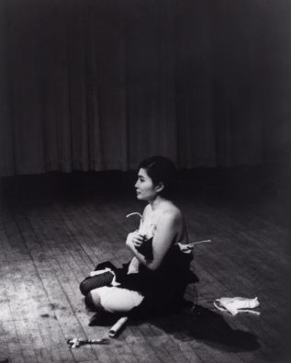
Figure. 5 – Photograph documentation of the performance Cut piece by Yoko Ono (1964)
This performance highlights the objectification of the female body as members of the audience begin to reveal Ono’s form as she sits silently throughout, suggesting that women themselves aren’t in control of how their bodies are portrayed or viewed by others in society. The contrast between the active audience and passive Ono highlights the vulnerability of the female in the hands of those who wish to objectify them. As she becomes more and more exposed, the audience observe and scrutinise Ono in this isolated state, creating a scene that almost mirrors Dürer’s Draughtsman drawing a nude as the female in both pieces is being objectified by other humans. Ono’s Cut Piece is important in making the viewer aware of the objectification of the female body and as the audience can take away the pieces of clothing they cut off it could provide lasting impact of the message for the exhibition.
The fourth piece in the exhibition is Valie Exports Action Pants: Genital Panic (see figure. 6) which is a set of six identical posters depicting a performance carried out by Export where she walked into a film-house wearing crotchless trousers.
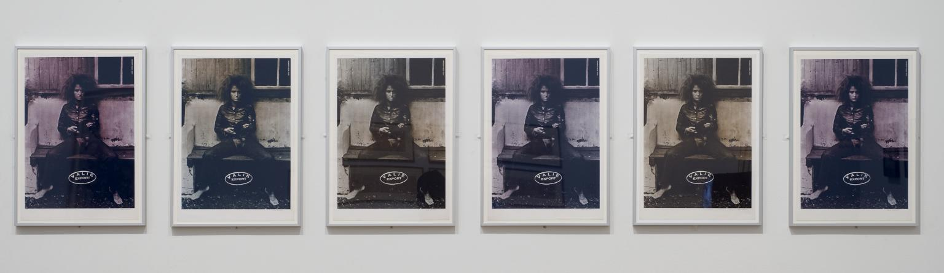
Figure. 6 – Action Pants: Genital Panic by Valie Export (1969)
Exports work mainly centres around the female body and for this piece she wanted to push people to be exposed to parts of the female body that aren’t usually highlighted, so by carrying out her performance in a cinema, her bare crotch was at eye level with everyone in there forcing them to look. This contradicts most depictions of the female body in culture as their genitals are usually covered, so here Export is challenging society’s view of the female nude and its representation in culture at the time. Export hung up the image of her in the crotchless trousers, holding a gun in the streets of Vienna where they were torn down immediately and this work also got rejected from exhibitions, showing how clouded societies view of the female body is if they can have nudes filling gallery walls yet are unable to present an image of a female with only her crotch exposed. This piece is important in highlighting to the viewers how society’s views on the female nude need to change.
The final piece in the exhibition is Terribly Wrong by Tracey Emin (shown in figure. 7) which is a monoprint depicting a figure with her legs spread wide and something pouring out from between them, the figure is surrounded by text saying ‘something wrong’ and ‘terribly wrong’ written backwards above.
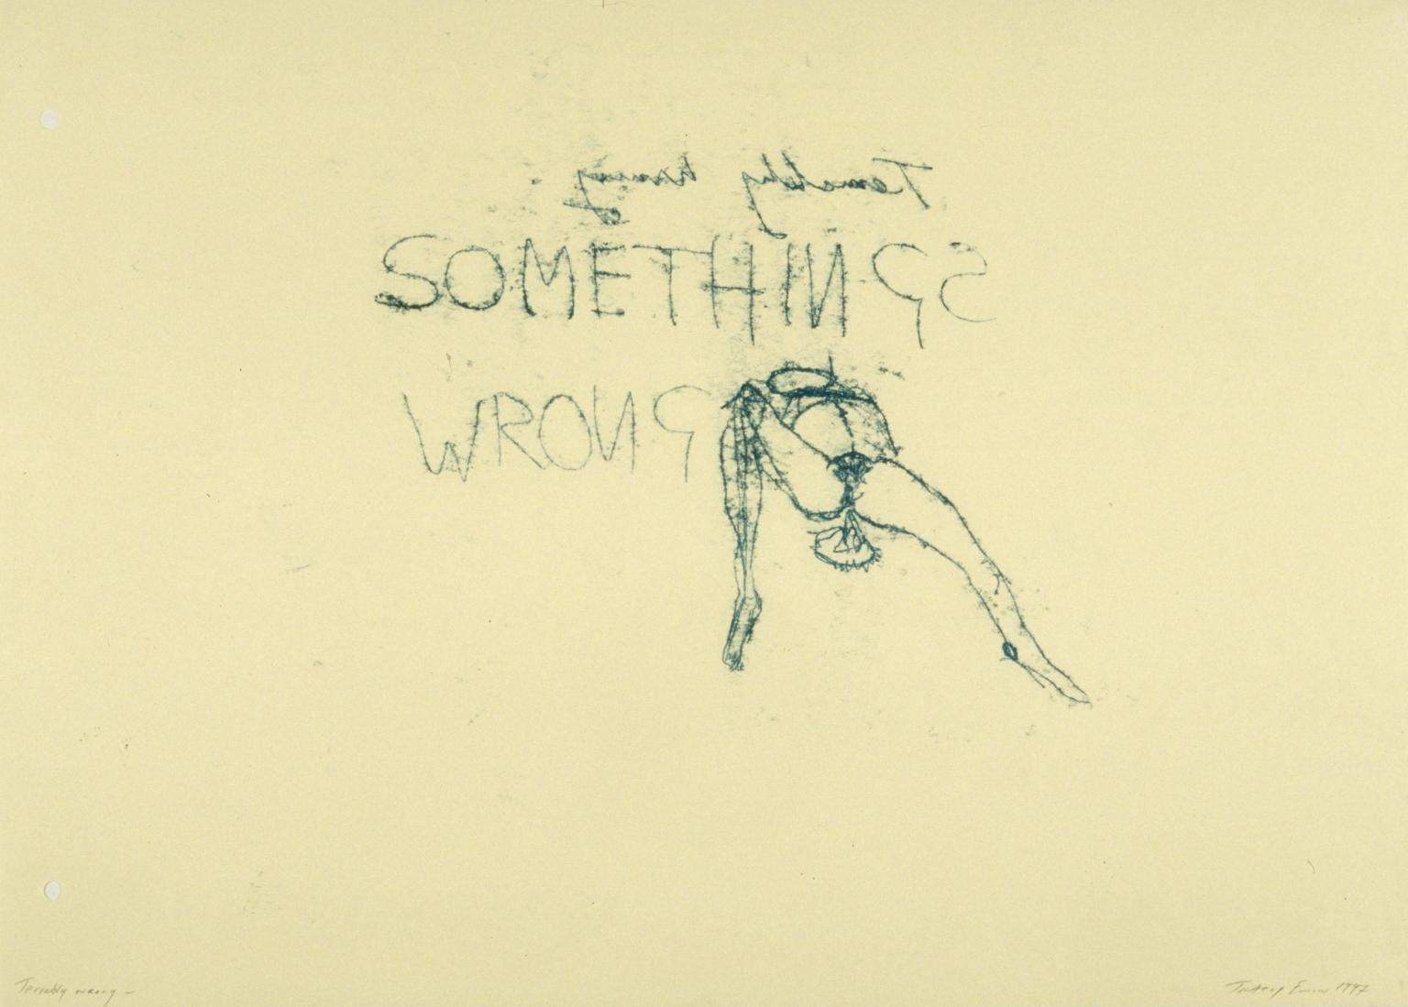
Figure.7 – Terribly Wrong by Tracey Emin (1999)
This piece completely contradicts the expectations of a female nude as it is a visual representation of Emin’s personal experience with abortion. Although the nude figure may be laying in a way that echo’s that of conventional nudes or has sexual connotations (for example, the spread legs and arched back), it is far from those as Emin created this piece as a way to get out her emotions, contrasting those that are created only to satisfy the male gaze and fit society’s ideals. Emin here shows how the female body doesn’t have to fit any expectations or be just an object to provoke sexual pleasure but can be a way of expressing one’s emotions. To end the exhibition, this piece shows how femininity can be presented and the female body can be just a body allowing the viewer to compare this piece to the first one they saw.
Overall, in this exhibition I want the viewers to challenge their views on the female body and and preconceptions of femininity, especially in relation to art. By showing pieces that differ greatly in how they present these aspects I think it highlights the changes that have been made and also any changes that still need to happen, as more female artist begin to get rid of the limitations set of the female body, more mindsets will shift. As Lynda Nead states ‘if nothing is allowed in or out then the female body remains a disturbing container for both the ideal and polluted’.

For the setting I chose the Mission Gallery as I wanted to put more contemporary nudes in a gallery space that would usually see more traditional depictions of the female body .

1 – Draughtsman drawing a nude by Albrecht Dürer (1938)
2 – Olympia by Édouard Manet (1863)
3 – Cut Piece by Yoko Ono (1964)
4 – Action Pants: Genital Panic by Valie Export (1969)
5 – Terribly Wrong by Tracey Emin (1999)

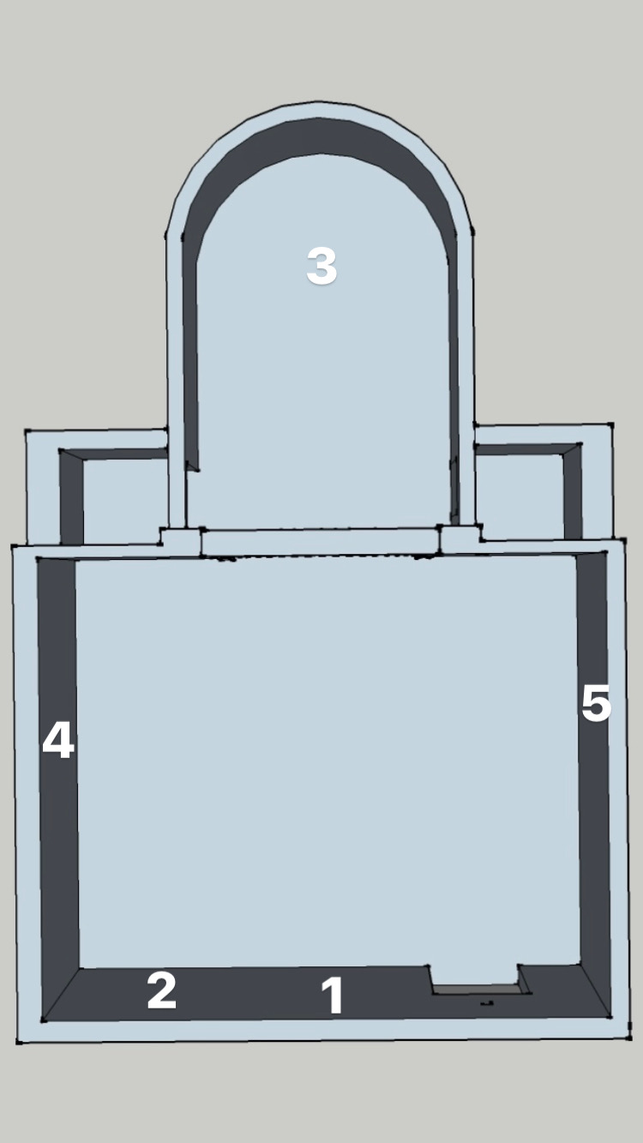
BIBLIOGRAPHY
BOOKS:
Berger, J. (1972) ways of seeing, Penguin Books
Mulvey, L. (1973) Visual Pleasure and Narrative Cinema
Clark, T.J. (1984) The Painting of Modern Life, Princeton University Press
Clark, T.J. (1980) Preliminaries to a Possible Treatment of ‘Olympia’ in 1865, The MIT Press
WEBSITES:
https://networks.h-net.org/node/24029/reviews/30048/read-garb-body-time-figures-femininity-late-nineteenth-century-france

https://www.nybooks.com/articles/1996/04/18/degas-women/

https://impressionistarts.com/impressionism-and-prostitution

https://www.artsy.net/article/artsy-editorial-history-female-rage-art

https://core.ac.uk/download/pdf/37374962.pdf

https://medium.com/thinksheet/the-misogynist-artist-who-was-obsessed-with-women-3bacb9003a0a

https://www.youtube.com/watch?v=11a2pCtznOY

https://www.youtube.com/watch?v=uzTGN5mQ_Hc

https://bigthink.com/high-culture/ways-of-seeing-berger/

https://www.tandfonline.com/doi/abs/10.1080/17400309.2017.1377937?journalCode=rfts20

https://www.historyextra.com/period/modern/mary-beard-nude-western-art-history-historian-janina-ramirez-bbc-show-podcast-shock-naked/

https://museum.classics.cam.ac.uk/collections/casts/aphrodite-knidos

https://kallosgallery.com/blog/32-women-therefore-inspire-love-even-when-made-of-aphrodite-and-the-male-gaze/

https://artincontext.org/olympia-manet/

https://www.tate.org.uk/art/artists/valie-export-6411/valie-export-artist-interview

https://www.tate.org.uk/art/artworks/export-action-pants-genital-panic-p79233

PODCASTS:

The bitesize feminine podcast (2022), The Sexualisation of the Female Nude

History Extra Podcast (2020), Mary Beard on the Nude in Western Art

