A Critical evaluation of Tesla’s Marketing Activity
Marketing Management BMMB7012
Davina Evan
Amelia McNally 28000537

Executive Summary
This report incorporates an analysis of Tesla, Inc. The investigation in this report has concentrated on how the marketing department within Tesla will outline its future development and the associated marketing plan to address the cobalt element currently present in its batteries and an essential component to making its vehicles as reliable and efficient as they currently are and are expected to remain (Bloomberg, 2022).
In 2021 Tesla produced 930,000 cars with over 100,000 of these in Europe. Tesla accounted for 11% of all car sales in the UK in 2021 (Electrek 2022).
This report has been conducted through the support of a micro and macroenvironmental analysis. Teslas’s segmentation, targeting and positioning alongside a full marketing mix to understand the company’s current target markets, brand audit and its position within the EV field. An investigation into its use of different types of media and advertising as well as an analysis of its success has been undertaken.
This report will has explored how Tesla can start disassociating itself from suppliers who are known exploiters of child labour, taking a more ethical stance within the automotive industry, and thereby removing the associated negative press around the topic (Forbes, 2022).
This report will provide recommendations to work towards disassociating itself from Panasonic and other supply chain elements that exploit child labour.
The development of a new battery, which does not include cobalt, provides the market with evidence of Tesla acting and responsibility for its previous environmental damages.
The marketing team has also concentrated on how the firm can reduce its carbon footprint within its supply chain and logistics and therefore become less reliant on fossil fuels and differentiate itself further from its competitors.
Table of Contents
Executive summary
- Introduction
- Main Findings
  - The Marketing Concept
  - The Micro and Macro environments
    - Microenvironment
    - Macroenvironment
    - Linking
  - Target Market
    - Segmentation
    - Targeting
    - Positioning
  - Marketing Mix
  - Marketing Media
  - Measuring Success
- Conclusion
- Recommendations

- Introduction

In this report, an analysis will be undertaken on Tesla, Inc. The investigation within this report will concentrate on how the marketing department within Tesla will outline its future development and the associated marketing plan to address the cobalt element currently present in its batteries and essential component to making the vehicles as reliable and efficient as they currently are (Bloomberg, 2022).
Tesla is an automotive company founded in 2003 with the ambition of creating fully electric vehicles. The vision was to merge modern automotive engineering with state-of-the-art technology to create vehicles that were faster and more environmentally friendly than the traditional fossil fuel equivalent. The company expanded in 2017 to include infrastructure and building-related products such as solar panels and the associated energy storage power walls. In 2021 Tesla produced 930,000 cars with over 100,000 of these in Europe. Tesla accounted for 11% of all car sales in the UK in 2021 (Electrek 2022).
This report will also be exploring how Tesla can start disassociating itself from suppliers who are known exploiters of child labour, taking a more ethical stance within the automotive industry, and thereby removing the associated negative press around the topic (Forbes, 2022). This report will also be investigating the development of a new battery, which does not include cobalt, providing the market with evidence of Tesla acting and responsibility for its previous environmental damages. The marketing team will also concentrate on how the firm can reduce its carbon footprint within its supply chain and logistics and therefore become less reliant on fossil fuels and differentiate itself further from its competitors.

- Main Findings

  - The Marketing Concept
Marketing is how an organisation tells its story to attract individuals and groups of people to interact with its products and investment opportunities. Marketing is the foundation that helps these individuals or groups to decide if they would like to be associated with the company and invest their attention, resource, and disposable income into it, to drive up profitable revenue. Marketing is the process of getting a product or service from a company to its end consumers from product development through to final sale as well as support thereafter. Therefore, the marketing strategy needs to involve business goals, marketing tactics, relatable metrics, and target customers. As a function, marketing spans the entire product life cycle from research, engagement, purchases, and post-purchase aftercare. In Tesla’s case of CSR currently being the challenge, this report will be concentrating on, it is up to the marketing department to make adequate changes and suggestions that will aid the company drive up its profits and be more in line morally with what consumers expect of companies today (Fahy & Jobber, 2015).
To be able to address the identified challenges, Tesla will need to undergo an audit of the current resources available within the organisation to identify if these changes are currently viable. As Tesla is currently worth $724.64 Billion and exceeded stock exchange expectations in 2022, Tesla is in a very favourable financial position to invest in further innovation compared to its competitors such as Rivian and Lucid, which could drive future growth even further (London Stock Exchange, 2022).
Tesla currently employs 99,000 people, the company has already invested in six Giga factories worldwide, reducing their supply chain and reliance on the logistics industry drastically as well as Elon Musk as CEO, concentrating and investing heavily into technology innovation (The Telegraph, 2022). These elements combined put Tesla in a positive position to address the challenges identified around its corporate social responsibility around the cobalt mining industry and the negative impact this could have on the company’s reputation, even more, important for Tesla, as its current marketing strategy relies heavily on its reputation as innovative and modern within the luxury car industry.

  - The Macro and Microenvironments

    - Microenvironment
Tesla’s Microenvironment has been assessed through the help of a SWOT analysis as seen in appendix 1. The company’s current strengths include its innovation and being the most valuable car manufacturer worldwide (Statista, 2021). The company’s weaknesses lie within its supply chain such as chip component shortages (BBC, 2022) but also with Elon Musk being its sole representative (Ferris, 2016), which poses a threat as Musk is known for his unpredictable behaviour. The opportunities for Tesla lie within manufacturing its batteries without the use of cobalt and the current heavy reliance on Panasonic (Smith, 2021). However, Lithium-ion batteries are extremely combustible and come with a product safety issue (Kleinman, 2016). Further threats are other big established car manufacturers entering the EV market (Porter, 1979).

    - Macroenvironment
Tesla Macro environment has been analysed through the help of a PESTLE analysis as seen in appendix 2. Looking at the political and legal elements of this analysis, trade deals could have a detrimental impact on import tax changes, tariffs, and the associated quotas (Radcliff, 20022). Current Political tensions such as the US and Russia introducing sanctions on each other will hurt Tesla expanding into that market (Borger, 2022). The potential of an upcoming global recession and a banking collapse could be catastrophic to global businesses, even those with enormous wealth (Economist, 2013). Such events will have negative impacts on customer buying habits and make consumers more aware of the sustainability of their purchases (Oberseder et al, 2013). In addition, Tesla needs to spend large percentages of its overall wealth on retaining its competitive advantage through research and development (Carlier, 2022). A five forces analysis as seen in appendix 3 has also been undertaken, concentrating on the threat of substitution by existing competitors as well as the threat of new entrants such as EV start-ups and big traditional automotive companies investing heavily into alternative lithium-based batteries, to replace the industry-wide challenge of cobalt use and mining (Perkins, 2021).
The importance of using these two models together can be seen in appendix 4.
The Tesla Model 3 has been the number one selling EV in the UK since 2014, with Tesla’s biggest competitors being Nissan, Renault and KIA (Department for Transport, 2022). All of which still use cobalt in their batteries (Griffiths, 2018).
It is important to assess both the micro and macroenvironment together to gather a well-rounded understanding of Tesla’s internal and external position. Which elements are within the company’s control, and which are not? This will enable the marketing team to make sound and well-justified recommendations for change (Singh, 2021). Most importantly concentrating on its CSR and the impact cobalt mining is having on the Congo and its citizens and what Tesla can change and improve not only the ethical issues they are facing but also its reputation.

  - Target Market
Segmentation, Targeting and Positioning are the basis of an effective marketing strategy. Concentrating on the customer’s wants and needs and breaking them down into profitable segments (Camilleri, 2017). An extensive STP can be seen in appendix 5.

    - Segmentation
Tesla segmentation can be distributed between behaviour, psychographics and consumer profiles.
The benefits sought are that Tesla is environmentally friendly, provides luxury quality coupled with high technological standards and lifestyle attributes such as high-status symbol, successful, aspirational, and environmentally cautious. Tesla so far has concentrated mostly on the demographic of people falling into the 40s and above age bracket, mainly male in management or other professional roles who are interested in environmentally friendly and sustainable transport, most tesla customers are high-income professionals from the upper-middle class. Geographically Tesla and other EV market inhabitants are in countries with well-established and developed infrastructures. The US and China combined hold 71% of Tesla’s revenue (Wilhelm, 2022).

    - Targeting
Looking at the strengths and weaknesses within tesla’s targeting segments. The benefits sought are environmentally friendly and the absence of fossil fuel consumption is high on the consumer’s priority list and can be seen as a strength while the weaknesses of these priorities are how un-environmentally friendly and morally problematic the supply chain can be with elements such as cobalt needed in the production of all of Tesla’s batteries. Geographically, the US and China, Tesla’s biggest markets have good infrastructure and thriving markets lead to higher wages and more disposable income. However, Large supply chains face challenges with higher fuel costs and the current political situations that surround this (McKinsey & Company, 2019).

    - Positioning
The positioning is where the marketing team position the product within the market with great emphasis on what the consumer is looking for and in need of. Tesla consumers are seeking vehicles with low emissions to reduce their carbon footprint and reduce the negative impact on the environment. As Tesla positions itself as a company providing zero-emissions vehicles with the highest ranges of models within the electric vehicle market as well as the best performing batteries, allowing drivers to go further between charges (Tesla, 2020).

  - Marketing Mix
The Marketing Mix now consists of seven Ps as expanded from McCarthy’s original 4 Ps in 1960, product, promotion, price, place, people and participant, process, and physical evidence (Booms and Bitner, 1981).
The product in question is an electric vehicle, which satisfies the consumer’s need for eco-friendly vehicles that do not require fossil fuels to run. Tesla currently promotes itself mainly online through viral marketing, privately owned garages and personal selling, sales promotions, referrals and the reliance on Elon Musk’s Twitter feed and outrageous opinions (Musk, 2020). The prices for its vehicles are set at the top end of EVs, positioning themselves as a premium product. Vehicles are placed in company-owned showrooms or available as online purchases only. The people involved are a high-profile CEO, Elon Musk, and subject matter experts in all aspects of the business. Tesla’s present processes include purchasing companies that align with their ethos and the aim for technological advancements as well as product components beneficial and necessary to all of Tesla’s products. In this case, outsourcing battery production, a vital element for electric vehicles and solar power storage walls, is hurting the company’s image. By providing the physical evidence in high-tech gigafactories and luxury showrooms the company can combat the supply chain issue and produce an alternative battery in-house, Tesla would address several of its current challenges, while improving its public image and supply chain issues.

  - Marketing Media
The key channels used by Tesla to communicate with its existing and future customers are public relations, online marketing, personal selling, sales promotion, and traditional advertising.
Tesla communicates with its current customer base through email, maintaining a positive customer relationship with frequent updates on new products and allowing customers to update their vehicles, conveniently online. Although this method is reliable and cost-effective, it is not free of charge and therefore customer buy-in is necessary for Tesla’s success (Bowden, 2010). This way of advertising and purchasing falls in line with the post covid convenience of online purchases very well, with the added benefit of seeing Tesla vehicles frequently to take a closer look.
The company’s online marketing consists of a highly effective website (Tesla, 2022). Twitter and Facebook page to keep customers updated on the latest developments in innovative technology and product (Tynan and McKechnie, 2008). A lot of traction is also brought through Elon Musk and his outspoken and widespread opinions on his Twitter feed. Customers have grown to associate Elon with Tesla, therefore this method is low-cost and very effective (Musk, 2022).
Tesla uses a variety of different personal approaches to selling its products, using the product, beneficial and referral approaches (Cheverton, 2013). Displaying its latest developments regarding bodywork design and innovative engineering of its products, testimonies from customers, in the hope of building generational rapport such as traditional manufacturers like Mercedes and BMW. Tesla also provides personal account managers for individual customers to enable the continuation of a customized service approach. All these approaches, although more traditional are still very effective.
Regarding sales promotion, customers’ perception of a brand is vital to its success, the associations consumers make with brands are multidimensional and emotionally instigated (Bowden, 2010). Tesla offers free test drives, and discounts for multi purchases, making it attractive to businesses and free services for vehicles with up to 50,000 miles on the clock (Tesla Motors, 2015).
Tesla also advertises in a more traditional sense in displays in privately owned showrooms but mainly on social media. Tesla very successfully advertise with a certain image aimed at a specific target group. Through timely appeal and emotions as well as self-prejudice, its advertisements skew the mind into believing that it needs this product (Tynan and McKechnie, 2008).

  - Measuring Success
Tesla’s marketing strategy goes against the traditional trends of TV advertising and high-cost social media campaigns. The company also Markets its sustainability through consistencies throughout the company, innovations being tweeted about through Elon Musk. Tesla spent $58.3 million on marketing costs in 2015, compared to BMA which spent $195 million. Tesla highly relies on word of mouth and referrals, trusting in its brand completely and having it speak for itself once on the road.
The success of Tesla’s marketing strategy so far can be evidenced in the company’s growth and associated sales and although these slumped in 2019 by almost 31% (Forbes, 2022). These have recovered greatly throughout and post pandemics. Tesla has demonstrated that by focusing on customer experience, media attention about its products as well as its eccentric CEO and its sustainability, Tesla has successfully generated interest in its products while delivering on quality. These elements seem to be enough to continue dominating the EV market.
Although Tesla has led a sustainable revolution within the automotive industry and appealing to an environmentally conscious customer base, tesla has utilized the opportunity to use its customer base as marketers by appealing to them in significant ways. With media attention, such as Polestar and EV6 ads airing during the Super Bowl and by proxy benefitting Tesla (Cleantechnca, 2022) and good use of social media, tesla has not needed to invest in traditional tv advertising. Although this model works for Tesla, tesla still has some production and supply chain issues regarding CSR that need to be addressed. Tesla has shown that with the right product, the right target market, and a company mission that consumers are in alignment with, a company can thrive without expensive marketing materials and campaigns.

- Conclusion
This report has incorporated an analysis of Tesla, Inc. The investigation in this report has concentrated on how the marketing department within Tesla will outline its future development and the associated marketing plan to address the cobalt element currently present in its batteries and an essential component to making its vehicles as reliable and efficient as they currently are and are expected to remain (Bloomberg, 2022).
In 2021 Tesla produced 930,000 cars with over 100,000 of these in Europe. Tesla accounted for 11% of all car sales in the UK in 2021 (Electrek 2022).
This report has been conducted through the support of a micro and macroenvironmental analysis. Teslas’s segmentation, targeting and positioning alongside a full marketing mix to understand the company’s current target markets, brand audit and its position within the EV field. An investigation into its use of different types of media and advertising as well as an analysis of its success has been undertaken.
This report will has explored how Tesla can start disassociating itself from suppliers who are known exploiters of child labour, taking a more ethical stance within the automotive industry, and thereby removing the associated negative press around the topic (Forbes, 2022). This report has also investigated the development of a new battery, which does not include cobalt, providing the market with evidence of Tesla acting and responsibility for its previous environmental damages. The marketing team has also concentrated on how the firm can reduce its carbon footprint within its supply chain and logistics and therefore become less reliant on fossil fuels and differentiate itself further from its competitors.

- Recommendations

  - Tesla should not associate themselves with suppliers who are known exploiters of child labour.
Situation
Panasonic currently provides Tesla with its batteries, utilised in its cars and power storage walls. The cobalt mineral used within these batteries is extracted from mines in the Democratic Republic of Congo (DCR). The extraction itself hurts the environment as the use of big fossil fuel machinery is needed to extract the mineral. The occurrence of Child labour and the associated injuries are morally corrupt and work against corporate social responsibility (CSR) (Amnesty, 2016).
Objectives
Tesla needs to reposition itself to become disassociated with companies working in DCR and exploiting child labour.
Strategy
Tesla needs to position itself in the cobalt market such that it can work with smaller suppliers, rather than China Molybdenum, the biggest mine owners in the Congo. By working with smaller companies, Tesla would have the bargaining power to produce processes and policies to avoid child labour in those mines (The New York Times, 2022). Working with more stringent rules on Child labour Tesla would be seen as an ethical stakeholder with a positive brand image. It would provide evidence of a built-in CSR approach and would differentiate itself from competitors.
Tactics
Tesla will need to sever its ties with Panasonic by buying itself out of its contract. As well as sourcing a new company to work with.
Actions
The role of severing these contracts will need to be undertaken by senior management, the CEO and company lawyers. The contracts should be dissolvable within 6 months. As Tesla is a high-profile company, finding and creating new contracts with smaller providers should not be challenging and should not be time consuming. Writing up new CSR-friendly contracts and policies for smaller companies to work with will be the bigger challenge.
Control
Success can be measured once new contracts have been signed with smaller companies and all contracts have been severed with Panasonic.

  - Tesla should develop a battery that is not reliant on cobalt as an essential component.

Situation
As explained n 4.1 Tesla’s current batteries rely on batteries containing cobalt. The company is now dealing with negative press surrounding CSR due to the negative impact cobalt mining has on human rights and the environment.
Objectives
Tesla needs to create an alternative battery to the traditional cobalt batteries used in EV.
Strategy
Tesla currently finds itself in a position where they could learn from its competitor Nissan on how to produce lithium-ion batteries that do not use cobalt (Nissan, 2022). Alternatively sourcing lithium-ion batteries and trialing them in specific models in the US or China, as these are Tesla’s biggest markets could be beneficial
Tactics
Innovative technology, qualified engineers and scientist and an adequate supply chain will need to be put in place.
Actions
Senior Management will need to recruit adequate staff and undergo risk assessment on which models to trial the batteries in and in which market to target first. Quality checks on battery life and performance will also need to be assessed.
Control
Rolling out new batteries across the board will take time and successes will need to be measured in phases. Incorporating the new battery in certain models in certain markets will be the first measure of success. Receiving positive consumer feedback will be the next.

- Bibliography
Anonymous2022, -06-07T10:00:18.818Z. Electric Vehicle Outlook Is Even Brighter If the World Bikes and Takes the Bus. Bloomberg.com.
BBC. (2022). Tesla expects 50% growth despite supply chain woes. Available: https://www.bbc.co.uk/news/business-60149374. Last accessed 5th May 2022. ​
Booms, B.H. & Bitner, M.J. (1981) Marketing Strategies and Organization Structures for Service Firms. In: Marketing of Services, American Marketing Association, Chicago, 47-51.​
Borger, J. (2022). The US unveils new sanctions on Russia, targeting services, media and defence industry. Available: https://www.theguardian.com/us-news/2022/may/08/us-unveils-new-sanctions-on-russia. Last accessed 5th May 2022. ​
Bowden, John. “The Process of Customer Engagement: A Conceptual Framework.” Journal of Marketing Theory & Practice, 17.1 (2010): 63-74. Print.
Camilleri MA (2017) Corporate sustainability, social responsibility and environmental management: an introduction to theory and practise with case studies. Springer, Heidelberg, Germany
Carlier, M. (2022). Tesla's research and development expenses from FY 2010 to FY 2021. Available: https://www.statista.com/statistics/314863/research-and-development-expenses-of-tesla/. Last accessed 5th May 2022.
Cheverton, Philip. Key Marketing Skills: Strategies, Tools, and Techniques for Marketing Success, London, UK: Kogan Page, 2013. Print.
COHAN, P., Tesla Stock Down 46% As Q2 Deliveries Fall Short. Available: https://www.forbes.com/sites/petercohan/2022/07/05/tesla-stock-down-46-as-q2-deliveries-fall-short/ [Jul 6, 2022].
Department for Transport. (2022). Vehicle licensing statistics data tables. Available: https://assets.publishing.service.gov.uk/government/uploads/system/uploads/attachment_data/file/1077492/veh0181.ods. Last accessed 25th May 2022.
Economist. (2013). The origins of the financial crisis. Available: https://www.economist.com/schools-brief/2013/09/07/crash-course. Last accessed 6th May 2022. ​
Electric Cars, Solar & Clean Energy. Available: https://www.tesla.com/ [Jul 6, 2022].
Electric vehicle lithium-ion battery | Innovation | Nissan Motor Corporation Global Website. Available: https://www.nissan-global.com/EN/INNOVATION/TECHNOLOGY/ARCHIVE/LI_ION_EV/ [Jul 6, 2022].
Ferris, R. (2016). Musk is Tesla’s greatest strength and weakness says, a valuation expert. Available: https://www.cnbc.com/2016/07/13/musk-is-teslas-greatest-strength-and-weakness-says-valuation-expert.html. Last accessed 5th May 2022. ​
Griffiths, H. (2018). Is cobalt the electric car’s dirty secret?. [Online] Available: https://www.autoexpress.co.uk/car-news/105573/is-cobalt-the-electric-car-s-dirty-secret. Last accessed 25th May 2022.​
INTERNATIONAL, A., -01-19T13:57:29+00:00, 2016-last update, Exposed: Child labour behind smart phone and electric car batteries. Available: https://www.amnesty.org/en/latest/news/2016/01/child-labour-behind-smart-phone-and-electric-car-batteries/ [Jul 6, 2022].
Kleinman, Z. (2016). Why do lithium batteries explode? Available: https://www.bbc.co.uk/news/technology-37255127. Last accessed 5th May 2022.
LAMBERT, F., 2021. Tesla boosts UK's electric car sales to a record 11% market share, the same as diesel.
Market Stock. Available: https://www.londonstockexchange.com/live-markets/market-data-dashboard/price-explorer [Jul 6, 2022].
MUSK, E., 2022-last update, Elon Musk Twitter feed. Available: https://twitter.com/elonmusk?ref_src=twsrc%5Egoogle%7Ctwcamp%5Eserp%7Ctwgr%5Eauthor [06/07/, 2022].
Öberseder, M., Schlegelmilch, B.B., Murphy, P.E., (2013). CSR practices and consumer perceptions Journal of Business Research, 66 (2013), pp. 1839-1851. ​ Fahy, J., and Jobber, D., (2015), Foundations of Marketing, 5th edition, London: McGraw-Hill
PENG, B.E.A., 2019. Winning the race:
China’s auto market
shifts gears. McKinsey China Auto CEO Quarterly,
Perkins, T., -11-27T07:00:50.000Z, 2021-last update, Will Rivian’s electric vehicles end Detroit’s reign over the US auto industry?. Available: https://www.theguardian.com/environment/2021/nov/26/will-rivians-electric-vehicles-end-detroits-reign-over-the-us-auto-industry [May 21, 2022]. ​
Porter. M. (1979). How Competitive Forces Shape Strategy. Harvard Business Review 57, no. 2 (March–April 1979): 137–145. ​
Radcliffe, B. (2022). The Basics of Tariffs and Trade Barriers. Available: https://www.investopedia.com/articles/economics/08/tariff-trade-barrier-basics.asp. Last accessed 5th May 2022. ​

ROJAS, F., a-last update, Council Post: Eight Digital Marketing Lessons We Can Learn From Tesla. Available: https://www.forbes.com/sites/forbesagencycouncil/2020/12/10/eight-digital-marketing-lessons-we-can-learn-from-tesla/ [Jul 6, 2022].

SINGH, R., SARANGAL, R.K. and SINGH, G., 2022. The Impact of Micro and Macro Environment on Entrepreneurial Success: Case of J&K MSMEs. FIIB Business Review, 11(1), pp. 94-106.

Smith, A. (2021). Panasonic’s new Tesla battery lasts five times longer and costs half as much. Available: https://www.independent.co.uk/tech/panasonic-tesla-battery-electric-car-b1958785.html. Last accessed 5th May 2022. ​
Statista. (2021). Most valuable brands within the automotive sector worldwide as of 2021, by brand value. Available: https://www.statista.com/statistics/267830/brand-values-of-the-top-10-most-valuable-car-brands/. Last accessed 5th May 2022.
Tesla closes 2021 on a high note by beating expectations in Q4.
​Tesla. (2022). About Tesla. Available: https://www.tesla.com/about#:~:text=Tesla%20was%20founded%20in%202003,to%20drive%20than%20gasoline%20cars.. Last accessed 5th May 2022.
Tesla Motors. Abu Dhabi Market. 2015. Web.
TITCOMB, J., 2022, -07-03. Tesla loses $440m as Elon Musk's Bitcoin bet sours. The Telegraph. ISSN 0307-1235.
Tynan, Caroline and Sandra McKechnie. “Experience Marketing: A Review and Reassessment.” Journal of Marketing Management 25.6 (2008): 501-527. Print.
​

- Appendices
Appendix 1. Swot Analysis
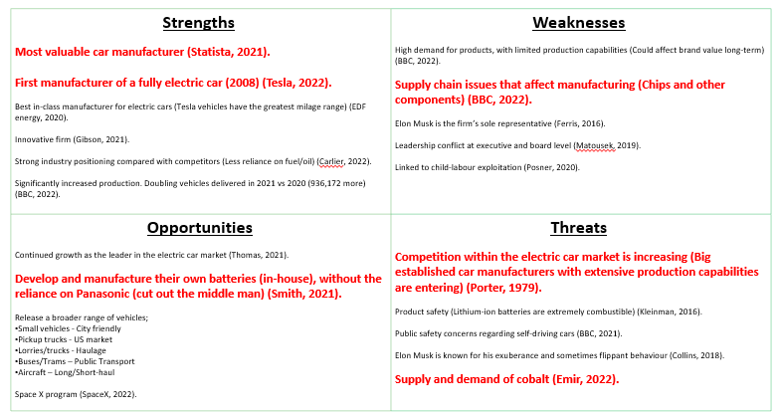
Appendix 2. Pestel analysis
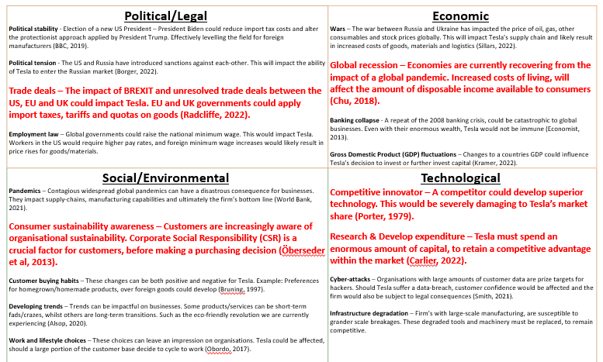

Appendix 3. 5 forces
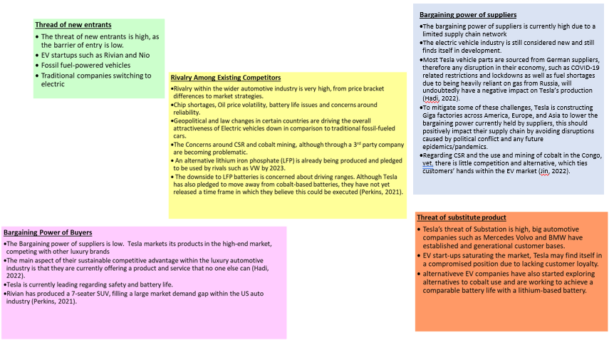

Appendix 4. Pestel and five forces link
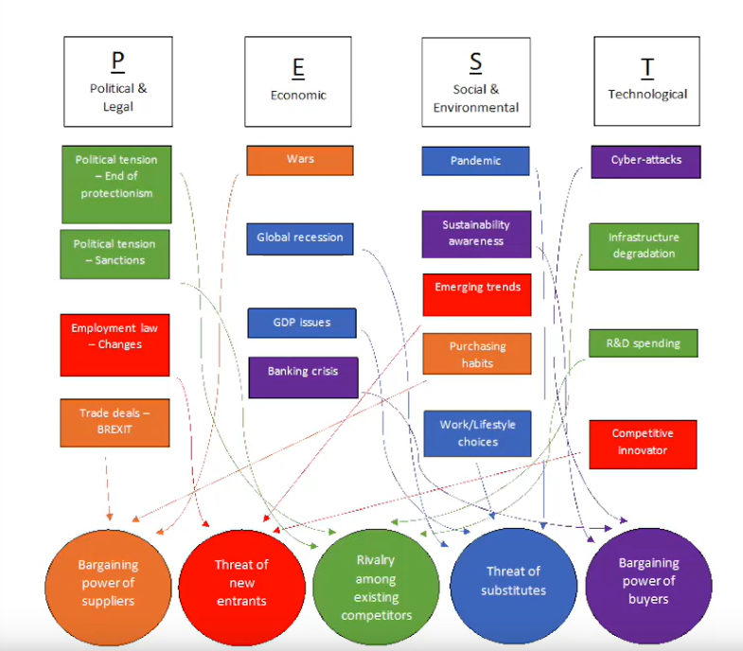
Appendix 5. STP
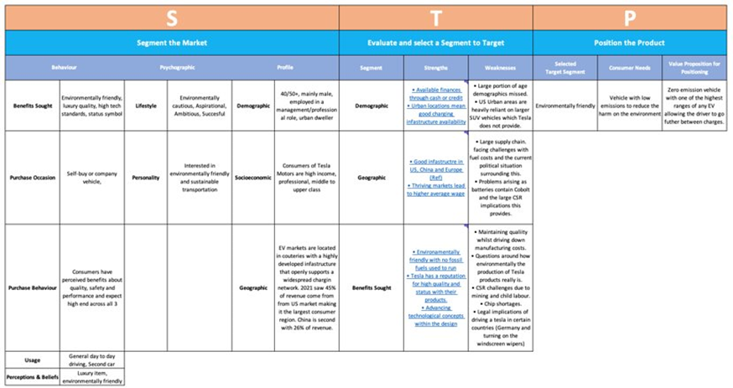

Appendix 5. Marketing Mix


