EcoRevive Business Plan – Smart Electric Vehicle Refurbishment and Leasing Startup
Module: Enterprise and Entrepreneurship (LCLM4006)
Programme: Certificate in Higher Education Business Skills for the Workplace
Assignment: Individual Written Business Plan (Component 1)
Student Name:
Student ID:

Table of Contents
1. Overview of the Business Idea 2
2. Legal Format and Management Structure 3
3. PESTEL Analysis 4
4. Marketing Strategy 6
4.1. Target Market Segmentation 6
4.2. Marketing Mix (4Ps) 6
4.3. Customer Relationship Management (CRM) 7
5. Funding and Startup Expenses 7
6. References 8

Overview of the Business Idea
EcoRevive is a green business that is located in the fast-growing used electric vehicle (EV) market in the United Kingdom. It specializes in obtaining used electric and hybrid vehicles and refurbishing them with the help of artificial intelligence (AI) diagnostics to check and optimize the battery condition and sells them to individual consumers and small-to-medium enterprises (SMEs) via flexible and cost-effective leasing solutions. This model is a direct reaction to the growing need of affordable, low-carbon mobility and corresponds to the UK Governmental intentions to reach the same net-zero carbon emissions by 2050 (Department for Energy Security and Net Zero., 2024).
The used EV sector has demonstrated exceptional growth. According to the Society of Motor Manufacturers and Traders (n.d.), transactions of used battery electric vehicles increased by 57.4 to almost 190,000 units. Nevertheless, the average cost of a new EV is over 35,000 pounds, leaving a large number of customers unable to afford the cars (Auto Trader., 2024). EcoRevive will fill this affordability gap with its refurbished and AI-certified vehicles that will provide not only quality assurance but also a flexible leasing option that will be economical and beneficial to the environment. The customers targeted by the business would include people who are environmentally friendly, urban professionals who would want to have easy mobility, delivery drivers, as well as SMEs that would want to have fleet operations at affordable costs.
The main idea behind EcoRevive is to ensure that sustainable transportation is affordable and that vehicles can have extended lifecycle to limit industrial waste production, as per the concept of a circular economy (Ellen MacArthur Foundation., 2023). Its Unique Selling Point (USP) is the use of the AI-based diagnostics allowing prediction of maintenance, increasing battery performance and reliability and reducing operational costs. The company refurbishes data-driven vehicles of high safety and efficiency standards to guarantee consumer confidence in sustainable mobility.
With EV adoption expected to keep rising throughout the UK, the scalable business model at EcoRevive will help it expand in the region, especially in major demand hubs in London, Birmingham and Manchester to help the economy become more resilient and the country achieve its decarbonization goals.

Legal Format and Management Structure
EcoRevive shall be a Private Limited Company (Ltd) incorporated in the United Kingdom under the Companies Act 2006. This legal structure offers limited liability, where the personal wealth of shareholders is not at risk due to company liabilities, and this is necessary in the initial stages of the venture in capital-intensive sectors. It is also important that the Ltd structure increases the investor confidence, as it implies formal governance, accountability and clear financial reporting, all of which play a major role in the investment choice in the sustainable transport market (Burns, 2022). It gives EcoRevive room to scale operations, investor attraction and growth of the EV market (Department for Business and Trade, 2025).
EcoRevive’s leadership structure fosters efficiency and innovation, with the Founder leading strategy and the Technical Manager overseeing refurbishment and AI diagnostics. The Marketing Manager will do the digital outreach and branding, and the Finance Officer will do the budgeting and funding. A cooperative hierarchy assures openness, sustainability and ongoing operational enhancement.

Figure 1: EcoRevive Organisational Structure

PESTEL Analysis
PESTEL analysis examines the external forces that influence the performance of EcoRevive in the UK electric vehicle (EV) market. Since EcoRevive is a business that refurbishes and rents used electric cars, it functions within a highly dynamic market influenced by government policy, economic trends, and heightened environmental sensitivity (Whittington et al., n.d.).
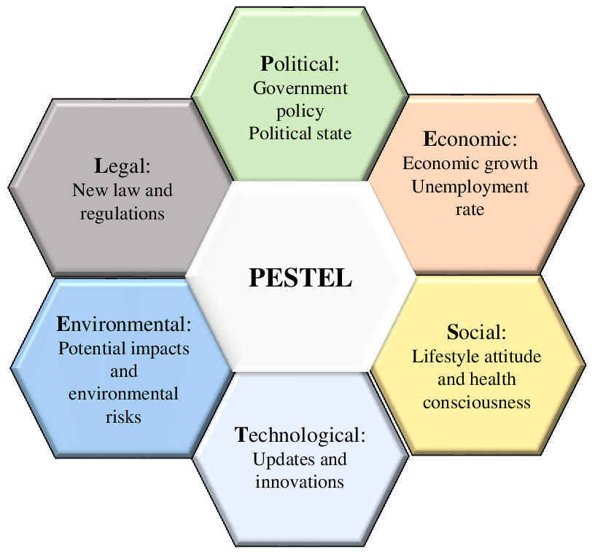

The PESTEL analysis framework (Sansa, 2020)
Political Factors
The UK Government’s Net Zero Strategy and Road to Zero initiatives strongly promote electric mobility by offering grants, tax exemptions, and business incentives for sustainable transport ventures (Department for Transport, 2024). Other policies like the Extended Producer Responsibility policy promote recycling and circular management of resources, which directly correlate with the mission of the EcoRevive of refurbishing and reusing EV components. The long-term existence of green business as a result of continued government support of low-emission transportation will guarantee political stability and will be a long-term support to green entrepreneurs.

Economic Factors
The electric vehicles have become more attractive to consumers with low incomes due to the high fuel prices and inflation. The Society of Motor Manufacturers and Traders report revealed that used EV sales in the UK were up by 57% in 2024, which means that it has shifted to a better market. Green financing of sustainable ventures is supported by organizations such as the British Business Bank which gives EcoRevive an opportunity to capitalize on this trend.

Social Factors
Climate change remains an issue of concern to the people and this puts a restructuring effect on consumer preference. Studies indicate that younger groups of people especially in cities embrace cheaper, convenient, and sustainable means of transport (Ipsos MORI., 2024). This cultural shift towards shared and leased mobility rather than owning a car enhances the demand of the EcoRevive services offered and also, brand alignment with ethical and environmental ethics.

Technological Factors
The fast solutions of artificial intelligence, telematics, and predictive maintenance enable EcoRevive to become more precise with refurbishing, increase the safety of vehicles, and decrease downtime. A further rise in accessibility and consumer confidence is supported by the growth of the EV charging system in the UK that is supported by more than 380 million dollars in government funding.

Environmental Factors
EcoRevive supports circular economy principles by extending EV lifespans, minimizing electronic waste, and reducing carbon emissions from new vehicle production (Ellen MacArthur Foundation, 2023).

Legal Factors
EcoRevive adheres to the Consumer Rights Act 2015, Vehicle Leasing Regulations 2020, and the UK GDPR data protection regulations, making its operation ethical, trusting customers and transparent to the regulations (Jones et al., 2023).

Marketing Strategy
The marketing plan of the brand EcoRevive is to become a leader in the segment of affordable and sustainable transport in the UK electric vehicle (EV) leasing market, which is still developing. The company is addressed to environmentally conscious consumers, young professional people, and small to medium enterprises (SMEs) driven by environmental consciousness and financial effectiveness. The issues of market segmentation rely on demographic, psychographic and behavioral issues in accordance with the developing national interest in green mobility solutions.

Target Market Segmentation
Segment | Description | Motivation
Eco-conscious individuals | Aged 25–45, middle-income professionals in urban areas | Sustainability and reduced carbon footprint
SMEs and delivery services | Local businesses seeking affordable fleet options | Cost efficiency and CSR enhancement
Young professionals | Aged 22–35, tech-savvy users | Flexibility, convenience, affordability

Marketing Mix (4Ps)
The marketing mix outlines EcoRevive’s strategic approach through product, price, place, and promotion elements.
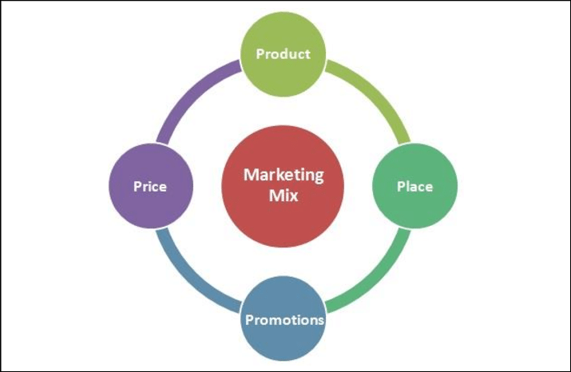

Marketing Mix 4Ps (Surtawijaya and Soegoto, 2020)
Product  EcoRevive is a company that sells refurbished electric and hybrid cars with the added benefit of AI-based diagnostics, as well as predictive maintenance through telematics. Leasing packages are free insurance and servicing guaranteeing customer confidence and reliability in its operation (Miskolczi et al., 2021). | Price  The pricing plan will be based on the monthly lease levels (flexible, between £250 and 600), which is adequate to match the income of consumers in the middle-income segment in the city, influencing them to use EVs in conditions of economic uncertainty (“UK New Car Registration Data - Latest Figures & Statistics"). Subscription-based pricing reduces upfront financial barriers (Burns, 2022).
Place  An online-first platform with an integrated booking app ensures accessibility, complemented by a Birmingham-based refurbishment center for inspection and distribution. This hybrid approach combines convenience and trust (Department for Transport, 2024). | Promotion  EcoRevive employs a digital-first promotional mix using Instagram, TikTok, and LinkedIn to engage sustainability-oriented audiences. Collaborations with EV charging stations and other environmentally-friendly projects improve brand authenticity. Google Ads performance and regional targeting are optimized with the help of data analytics and SEO tools (2024 Global Automotive Consumer Study | Deloitte Global).

Customer Relationship Management (CRM)
Consumer behavior analysis, satisfaction tracking and feedback will be registered by a central CRM system. The understanding of the insights of engagement metrics will inform ongoing service enhancement and loyalty-related efforts.

Funding and Startup Expenses
EcoRevive will require about60,000 start-up capital to open a business in Birmingham including vehicle acquisition, installation of a workshop, and IT. Early marketing efforts to create brand awareness, attract customers and build a solid market position will also be financed in the investment.
Category | Estimated Cost (£)
Purchase of used electric cars | 25,000
Workshop rental and tools | 10,000
AI diagnostic equipment | 8,000
App/website development | 7,000
Marketing and branding | 5,000
Insurance, licensing, and administration | 5,000
Total Estimated Funding | 60,000

The funding will be secured via the mix of UK start-up loans by financial institutions like Barclays and NatWest, with the help of the Start Up Loans Scheme by the British Business Bank which offers start-up entrepreneurs a fixed interest loan and advice on starting and running a business. EcoRevive will also seek Green Business Grants provided by the Department for Energy Security and Net Zero (2024), focused on promoting clean mobility programs. Moreover, the private investors and angel funders who show interest in sustainable ventures will be approached to make the venture financially stable.
The average revenue per vehicle per month is around 400 pounds per contract due to leasing contracts, which will secure the sustainability and profitability of the operations and allow reinvesting into AI technologies and expanding the fleet within the initial year of operation (Burns, 2022).

References
2024 Global Automotive Consumer Study | Deloitte Global (no date). Available at: https://www.deloitte.com/nl/en/Industries/automotive/perspectives/global-automotive-consumer-study.html (Accessed: October 20, 2025).
AutoTrader. (2024). Electric Vehicle Market Report 2024. - Google Search (no date). Available at: https://www.google.com/search?q=AutoTrader.+(2024).+Electric+Vehicle+Market+Report+2024.&oq=AutoTrader.+(2024).+Electric+Vehicle+Market+Report+2024.&gs_lcrp=EgZjaHJvbWUyBggAEEUYOTIHCAEQIRigATIHCAIQIRigATIGCAMQIRgV0gEHNTg0ajBqNKgCALACAQ&sourceid=chrome&ie=UTF-8 (Accessed: October 20, 2025).
Burns, P. (2022) Entrepreneurship and small business. Bloomsbury Publishing.
Department for Business and Trade (2025) GOV.UK. Available at: https://www.gov.uk/government/organisations/department-for-business-and-trade (Accessed: October 20, 2025).
Department for Energy Security and Net Zero. (2024). Electric Vehicle Infrastructure Strategy. - Google Search (no date). Available at: https://www.google.com/search?q=Department+for+Energy+Security+and+Net+Zero.+(2024).+Electric+Vehicle+Infrastructure+Strategy.&oq=Department+for+Energy+Security+and+Net+Zero.+(2024).+Electric+Vehicle+Infrastructure+Strategy.+&gs_lcrp=EgZjaHJvbWUqBggAEEUYOzIGCAAQRRg70gEIMjYyNmowajSoAgCwAgE&sourceid=chrome&ie=UTF-8 (Accessed: October 20, 2025).
Department for Transport. (2024). Road to Zero: Delivering a Sustainable Transport System. - Google Search (no date). Available at: https://www.google.com/search?q=Department+for+Transport.+(2024).+Road+to+Zero%3A+Delivering+a+Sustainable+Transport+System.&oq=Department+for+Transport.+(2024).+Road+to+Zero%3A+Delivering+a+Sustainable+Transport+System.&gs_lcrp=EgZjaHJvbWUyBggAEEUYOTIHCAEQIRiPAjIHCAIQIRiPAjIHCAMQIRiPAtIBBzYwNWowajSoAgCwAgE&sourceid=chrome&ie=UTF-8 (Accessed: October 20, 2025).
Ellen MacArthur Foundation. (2023). Circular Economy in Mobility. - Google Search (no date). Available at: https://www.google.com/search?q=Ellen+MacArthur+Foundation.+(2023).+Circular+Economy+in+Mobility.&oq=Ellen+MacArthur+Foundation.+(2023).+Circular+Economy+in+Mobility.&gs_lcrp=EgZjaHJvbWUyBggAEEUYOTIGCAEQRRg80gEHNTMwajBqNKgCALACAQ&sourceid=chrome&ie=UTF-8 (Accessed: October 20, 2025).
Ipsos MORI. (2024). Public Attitudes to Climate Change in the UK. - Google Search (no date). Available at: https://www.google.com/search?q=Ipsos+MORI.+(2024).+Public+Attitudes+to+Climate+Change+in+the+UK.&oq=Ipsos+MORI.+(2024).+Public+Attitudes+to+Climate+Change+in+the+UK.&gs_lcrp=EgZjaHJvbWUyBggAEEUYOdIBBzQwNWowajmoAgawAgHxBVm44I-gqUij&sourceid=chrome&ie=UTF-8 (Accessed: October 20, 2025).
Jones, M.C. et al. (2023) “Navigating data governance associated with real-world data for public benefit: an overview in the UK and future considerations,” BMJ open, 13(10), p. e069925. Available at: https://bmjopen.bmj.com/content/13/10/e069925.abstract (Accessed: October 20, 2025).
Miskolczi, M. et al. (2021) “Urban mobility scenarios until the 2030s,” Sustainable Cities and Society, 72, p. 103029. Available at: https://www.sciencedirect.com/science/article/pii/S2210670721003139 (Accessed: October 20, 2025).
Sansa, M. (2020) A new model to improve the life cycle of products since early design phase. PhD Thesis. Institut National des Sciences Appliquées et de Technologie (Tunisie). Available at: https://hal.science/tel-03313747/ (Accessed: October 20, 2025).
Surtawijaya, A.A.A. and Soegoto, D.S. (2020) “Developing Strategic Marketing Plan for Artificial Flower Bouquet Business in Bandung,” in International Conference on Business, Economic, Social Science, and Humanities–Economics, Business and Management Track (ICOBEST-EBM 2019). Atlantis Press, pp. 29–31. Available at: https://www.atlantis-press.com/proceedings/icobest-ebm-19/125931963 (Accessed: October 20, 2025).
“UK New Car Registration Data - Latest Figures & Statistics” (no date) SMMT. Available at: https://www.smmt.co.uk/vehicle-data/car-registrations/ (Accessed: October 20, 2025).
Whittington, R. et al. (no date) “Welcome to Exploring Strategy.” Available at: https://www.pearson.com/en-au/media/g10dyvte/9781292428741_sample.pdf (Accessed: October 20, 2025).

