

Programme: Master of Business Administration
Module: International Business Concepts
Module code: LCMB7034
Assignment Name: Report
Assignment Title: International Business Strategies and Cultural Adaptation of Reckitt
Lecturer’s Name: Akshay Narayanan
Student Name: MD MEHEDI HASAN JIHAD
Student ID:2436052
Word Count: 5450
Submission Date:13th December 2025
Table of Contents
1. Introduction 4
2. Benefits and challenges of International operations 4
2.1 Justification as an MNC/TNC 4
2.2 Reckitt’s Global Value Chain 7
2.3 Entry modes used by Reckitt 8
2.4 Key Benefits of Internationalisation 9
2.5 Challenges of Internationalisation 11
3. OLI Eclectic Paradigm Analysis 11
3.1 Ownership Advantages (O) 11
3.2 Location Advantages (L) 12
3.3 Healthcare industry in Bangladesh 13
3.4 GDP of the last five years of Bangladesh (In Million Taka) 14
3.5 Internalisation Advantages (I) 15
3.6 Resulting Entry Mode Decision 16
4. Cultural Distance & Its Implications 17
4.1 Cultural Profile Comparison 17
4.2 Language and Religion Differences in the UK and Bangladesh 19
4.3 Impact on Entry Strategy 20
4.4 Impact on Success Potential 21
5. Recommendations and Strategic Adjustments for Bangladesh 21
Adjustment 1: Operational / HR / Management SOP Revision 21
Adjustment 2: Market and Product SOP Revision 23
Adjustment 3: Compliance & Governance SOP Revision 25
6. Conclusion 26
7. References 28

1. Introduction
Reckitt is a British multinational consumer goods organisation concentrated on health, hygiene, and nutrition products. It is also known for a portfolio of reputed brands such as Dettol, Lysol, Harpic, and Veet. Reckitt’s products are sold globally, with over 30 million products sold daily (Reckitt, 2025). The organisation’s purpose is to provide innovative solutions for healthier lives and happier homes. Reckitt maintained its outlook for 2025, which anticipates more than 4% like-for-like revenue growth in its core operations and between 3% and 4% for the group as a whole (Investing, 2025).
Reckitt also spans over six continents and 68 countries (Reckitt, 2024). This organisation employs around 40,000 employees working across health, hygiene, and nutrition, delivering diverse roles from R&D to sales (Reckitt, 2025). This consultancy report focuses on assessing how Reckitt tackles its global operations and how these tactics can be used while navigating its activity in the UK and Bangladesh. The benefits and challenges,OLI (Ownership-location-internalisation) factors,Hofstede dimensions, and SOP integration have been highlighted here through using various frameworks. This report focuses on assessing Reckitt’s competitiveness in the UK and Bangladesh and providing operational understanding to support sustainable development.

2. Benefits and challenges of International operations

2.1 Justification as an MNC/TNC
Reckitt can be considered a multinational and transactional corporation for the scale, scope, and global aspect of its operations. As it is a UK-based customer health, hygiene, and nutrition organisation, it maintains a robust international presence in around 68 countries (Reckitt, 2024). This aspect is also assisted by a wider distribution network that reaches over 200 markets (Reckitt, 2024). Its portfolio includes globally recognised brands such as Dettol, Lysol, Nurofen, Veet, which present Reckitt’s capability to build products that balance persistent quality standards along with adapting with different cultural and regulatory settings. The global presence is the preferred indicator of an MNC that operates beyond domestic boundaries and uses cross-border efficiencies (Odinaka et al., 2023). Although Reckitt’s organisational structure presented transactional characteristics through the integration of global scale and local responsiveness which is also incorporates operations across numerous countries while maintaining main strategic control (Odinaka et al., 2023). Its strategic decisions, such as brand positioning, international research and development centre and supply chain optimisation, are the epicentre that enable the organisation to use the economies of scale and technology expertise (Reckitt, 2024).
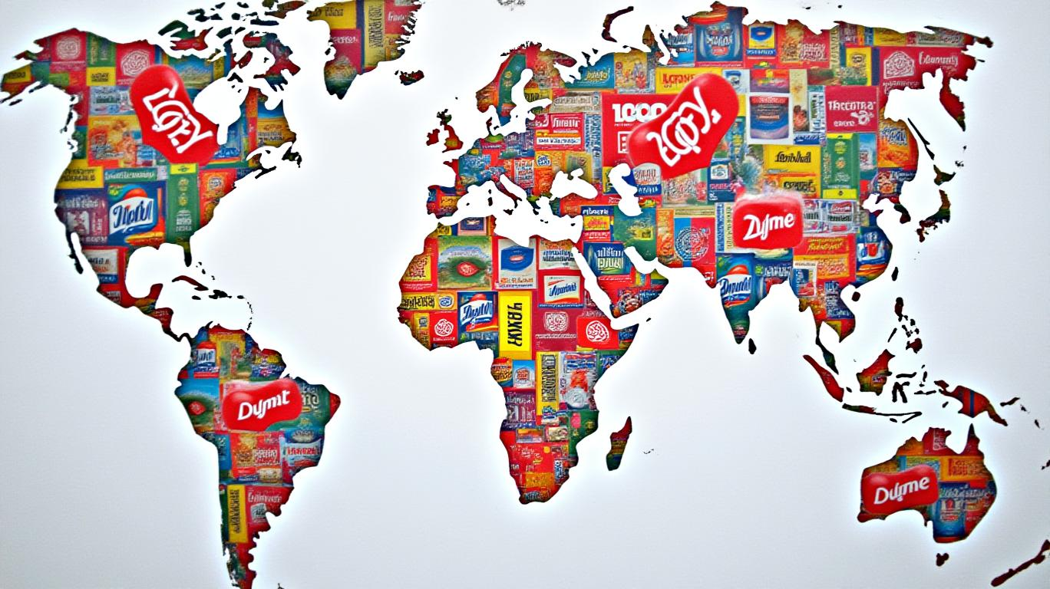
(AInvest, 2025)
Simultaneously, operational decisions, marketing communication, and product adaptation are customised to incorporate with local consumer culture, which allows adaptability in diverse markets (Rachwal-Mueller and Fedotova, 2024). This combination effectively aligns with the main prospect of TNC by tackling global efficiency with local market requirements. Moreover, Reckitt consists of strategic control over intangible resources such as robust brand image, proprietary technology, and global standardised manufacturing procedure with a sophisticated integration system. This ability enables the organisation to maintain consistent value while reducing opportunity across borders. Its economic strength, cross-market learning, and integrated global talent force also promoted the company as a transnational player. Dettol Hygiene Quest behaviour change program, which is being expanded to Uganda after success (Reckitt, 2024b).
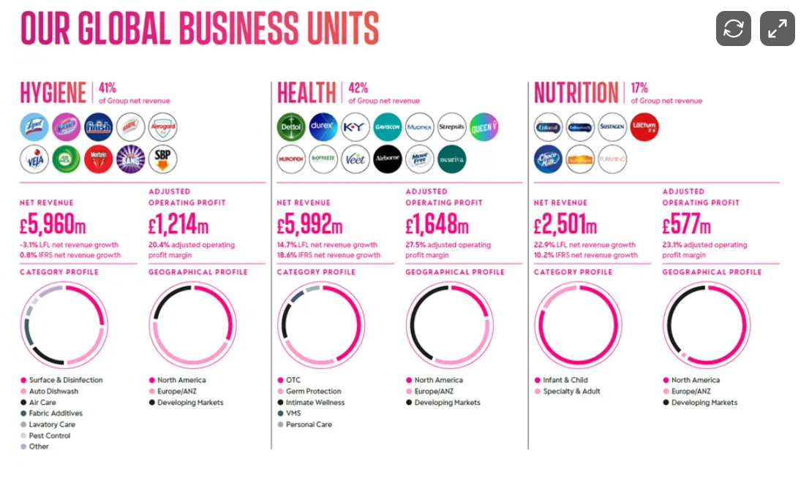
(StockOpine, 2023)
Meanwhile, Bangladesh demonstrated the extension of this brand's global strategy due to the market's rapid urbanization, increasing disposable income, and demand for hygiene and health solutions, which properly incorporate Reckitt's mission of protecting, healing, and nurturing. From that, it can be highlighted that Reckitt is not only a multinational organisation but also a transnational organisation that effectively manages global networks while remaining sensitive to cultural factors, which provides structural and strategic ability to successfully operate and expand in Bangladesh (Reckitt, 2025b).

2.2 Reckitt’s Global Value Chain
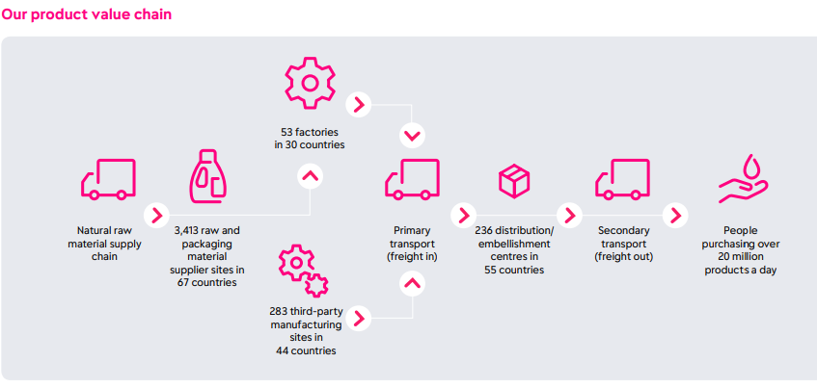
Figure: Product value chain
Source: (Reckitt, 2025a)
Reckitt’s global value chain is developed based on incorporating research, manufacturing, distribution, and marketing activities over multiple intertwined locations for obtaining cost efficiency, innovation, and global reach. Its global R&D is located in key regions such as the UK, the US, Europe, and Asia, with the new major hub in Shanghai, which concentrates on health & hygiene innovation for brands such as Dettol, Durex, and Nurofen, using customer data, digital tech and collaborations to make customised solutions. It has 238 third-party manufacturing sites in 44 countries (Reckitt, 2025a). Reckitt’s manufacturing is tactically distributed over established and emerging economies. Reckitt can mitigate operational expenses while balancing strict global quality standards by locating production facilities in regions with suitable labour costs, logistics benefits and global quality standards. Its supply chain is effectively collaborated using advanced prediction, demand planning, and procurement systems for managing raw materials and assuring efficient distribution. On the other hand, it uses a hybrid distribution model that includes both direct distribution and strategic local collaboration. Its focus on sustainability, human rights, and environmental influence. In 2022, this organisation focused on the human rights impacts of Durex and Enfa value chains in Thailand (Reckitt, 2025b). Their global distribution network connects regional warehouses to retail networks, e-commerce platforms, and health sector distributors. Its global distribution network includes 144 distribution points (Media, 2025). Marketing is conducted through a dual global-local strategy, focusing on promotional messaging to resonate with the local cultural standards and health behaviours. Lastly, Reckitt’s global value chain consistently improves value creation through using cross-border effectiveness, centralized R&D excellence, and market-specific adaptations. This structure enables Reckitt to introduce products into Bangladesh with robust supply reliability, brand reputation, and integration to international safety norms (Reckitt, 2024).

2.3 Entry modes used by Reckitt
Reckitt (formerly Reckitt Benckiser) primarily operates in Bangladesh through a wholly-owned subsidiary known as Reckitt Benckiser Bangladesh PLC. This allows the company full control over its operations and strategy within the country (Doha, 2024). The Key aspects of its operations and entry mode in Bangladesh may include:
The entry mode of Reckitt in Bangladesh is “Wholly-Owned Subsidiary” which establishes a local subsidiary that provides complete ownership and control over all the business functions by including manufacturing, marketing, sales, and distribution. Reckitt emphasizes the hiring of local talent to gain an advantage from the government policies by building a positive local market image while bringing in international employees when it is needed. This company also uses an extensive local distribution channel, which involves a network of wholesalers, retailers, and distributors by making its products widely available in the marketplace of Bangladesh. It also manages marketing strategies, which include brand positioning, pricing, and product life cycles. The local entity adapts to the local market conditions to expand its business across the whole of Bangladesh. The Bangladesh unit of this company manages a sophisticated local supply chain by including two “Cost and Freight (C&F)” agents, which ensure efficient distribution from raw materials to finished goods (Rafi, 2025).
Other entry modes for this brand in Bangladesh may involve exporting, licensing, franchising, and joint ventures, which are common international business strategies. Reckitt's main approach in Bangladesh is considered a “wholly-owned subsidiary”. The structure of this company enables the "Powerbrands" like Dettol, Harpic, and Durex to be managed with complete autonomy in the local market (Reckitt, 2025a).
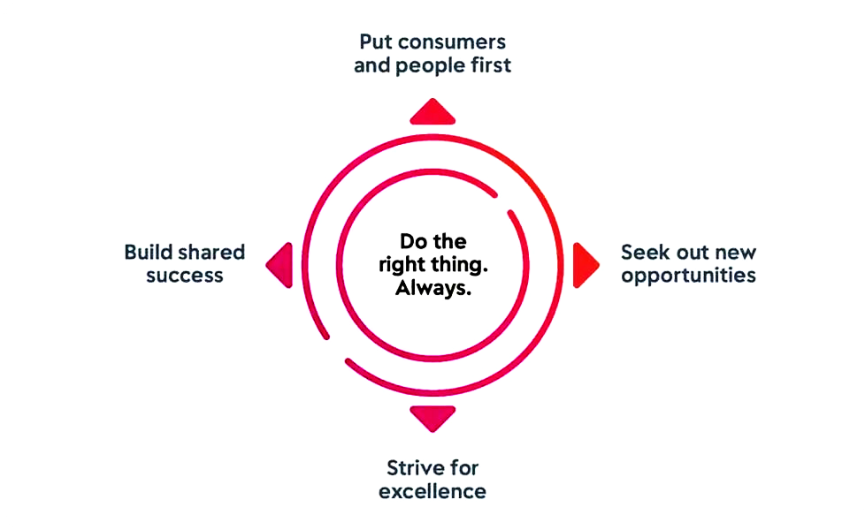
Figure: Purpose of Reckitt
(Source: Reckitt, 2025b)

2.4 Key Benefits of Internationalisation
The key benefits of Reckitt's internationalization in Bangladesh include market dominance in its product categories, enhanced brand recognition through localized products, and contributing to public well-being through social initiatives like distributing hygiene products. The company also benefits from a large and active consumer base and generates significant revenue and profit from this market (Ani, 2024). The benefits can be highlighted for the company for the public, and the community.
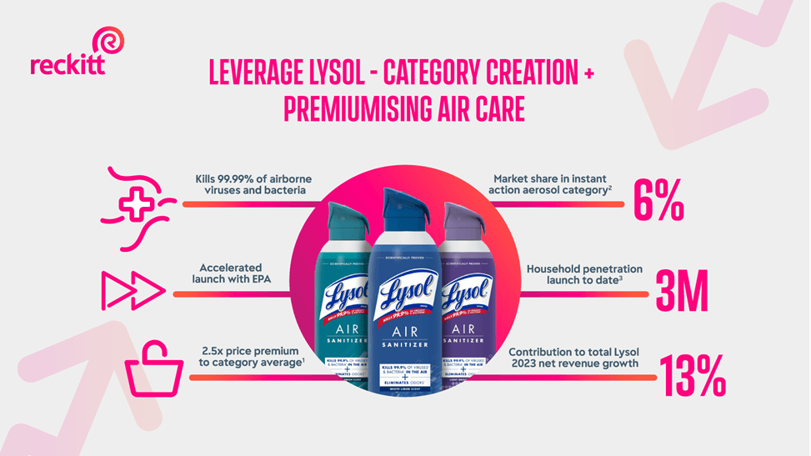
(Reckitt, 2024)
Benefits for the company may include market dominance, revenue and profit, local brand recognition and global product portfolio. Reckitt has a significant market share in the certain product categories which anchor Bangladesh's large population and various consumer behaviours. This brand operates in Bangladesh with a key source of revenue and profit for the company by allowing for high cash inflows and dividends to shareholders. The company highlights its high brand recognition and trust for its products from “health” “hygiene”, and “household” segments such as “Dettol”, “Veet”, and “Lizol”. The ability of this company to bring its globally renowned brands and products to a new market which help to allow for the growth and market expansion of Reckitt in Bangladesh (The Business Standard, 2025).
Benefits for the public and community makes its hygiene and health products available in hospitals and health centers. Reckitt supports public health initiatives of the government of Bangladesh. This company engages in social work, like distributing hygiene products during occasions like the “Bengali New Year” by promoting public well-being. It also uses a "global local" strategy to adapt its marketing and products which suit Bangladeshi consumers’ needs and lifestyles (Bhowmick, 2022).
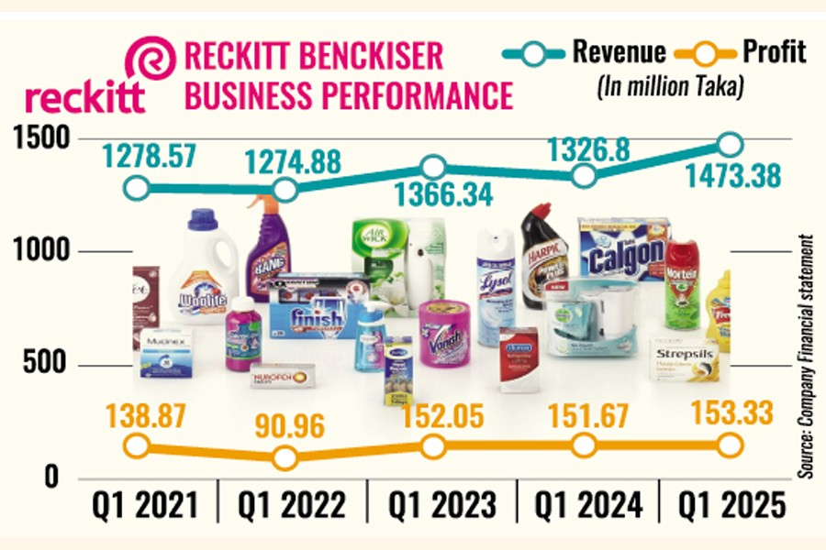
Figure: Revenue and Profit of Reckitt in Bangladesh
(Source: The Financial Express, 2025)

2.5 Challenges of Internationalisation
The main challenges for Reckitt in Bangladesh include foreign currency shortages, which can increase the raw material costs. This can affect the exchange rates by affecting the profit margins. Other significant challenges may include supply chain disruptions, intense competition from local and new brands, by navigating the local infrastructure and regulatory hurdles, which include high taxes (Track, 2023).
Economic and financial challenges may involve foreign currency shortages, volatile exchange rates, and high costs. A significant issue for Reckitt has been a shortage of foreign currency, which increases the cost of imported raw materials from the global market. The fluctuations in the exchange rate can directly affect the profit margins by making financial planning difficult. Increased costs for raw materials and shipment inflation caused by some global events, such as the “Russia-Ukraine conflict,” can create pressure on the profitability of this brand. Some competitive challenges may include intense competition and market dynamics. The operational and logistical challenges may include supply chain disruptions, infrastructure, and bureaucratic hurdles (Sarker, 2025). Lastly, the broader market and regulatory challenges include high taxes, a political and social environment with limited access to finance (Rahman, 2025).

3. OLI Eclectic Paradigm Analysis

3.1 Ownership Advantages (O)
Reckitt consists of effective ownership advantages which provide competitive advantages while expanding into Bangladesh. Around 50-55% of its employees have a share in this company, which is among the highest for a UK-listed public company. This makes a robust ownership culture which incorporates the sustaining interest of employees with those of external shareholders and assists the entrepreneurial aspect (Al Rawaf and Alfalih, 2023). Moreover, its strong brand portfolio, mainly Dettol and Harpic, delivers effective customer trust and recognition, which mitigates the challenges connected with obtaining market acceptance in the emerging economies. Brand loyalty in health and hygiene products is high, and this organisation's sustained reputation for safety and quality allows it to approach premium pricing while maintaining a strong market presence (Al Rawaf and Alfalih, 2023). Additionally, Reckitt's R&D resources and abilities are the core ownership advantage that delivers enduring competitive benefits by integrating consumer insights with trusted science to deliver superior and differentiated products. This organisation invests heavily in innovation, mainly for personal hygiene, sanitation, and medical products. These innovations depend on emerging technology and patent ingredients, which make intellectual property that cannot be easily recreated by local competitors (Reckitt, 2025a).
This technology benefits are important in the market like Bangladesh, where domestic organisations may lack comparable resource capacity. Additionally, it also benefits from comprehensive financial resources and global experience in directing complicated regulatory settings while using substantial revenue and a global footprint. Reckitt Benckiser’s global reach has expanded over the years and generated global net revenue of around 14.2 billion British pounds in 2024 (Statista, 2018). Its revenues are broken down into three main categories, including health, hygiene, and nutrition. Its financial scale in production, distribution, and procurement enables it to reduce costs and improve operational efficiency. Moreover, its global workforce includes 40,000 employees who are managerial experts in marketing and supply chain management, which delivers advantages. Collectively, these ownership resources, such as brand power, research and development resources, economic capability, and global managerial resources delivered this organisation the strategic benefit for competing with the local competitors in the Bangladeshi market (Statista, 2018).

3.2 Location Advantages (L)
Bangladesh delivers the emerging opportunities for Reckitt’s market entry due to its locational benefits. One of the main factors is its large and increasingly developing population over 171 million with the expanding middle class and rising awareness of health and hygiene (BBC, 2017).

3.3 Healthcare industry in Bangladesh
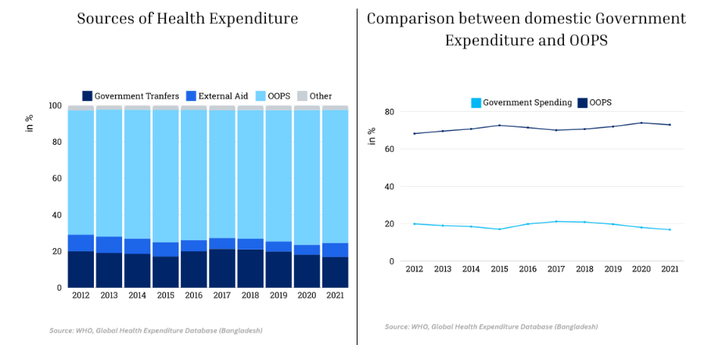
(Upturn, 2024)
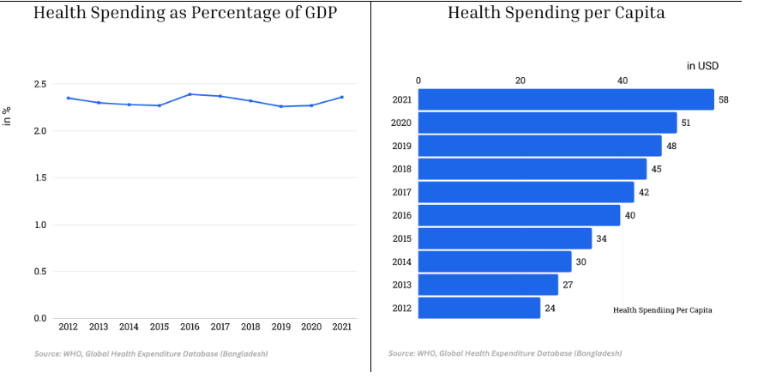
(Upturn, 2024)
Moreover, in Dhaka and Chittagong, urbanisation is also increasing, which is demanding packaged hygiene products, disinfectants, and household cleaning solutions, which are considered the main categories for Reckitt. One of the advantages includes labour cost, which assists in localisation. Bangladesh provides a young workforce with comparatively low wages, which allow cost-effective manufacturing and packaging operations. This prospect can be considered as an advantage for Reckitt’s unsegmented market products, which depend on high volume and cost-effective production for competitiveness (Al Rawaf and Alfalih, 2023).

3.4 GDP of the last five years of Bangladesh (In Million Taka)
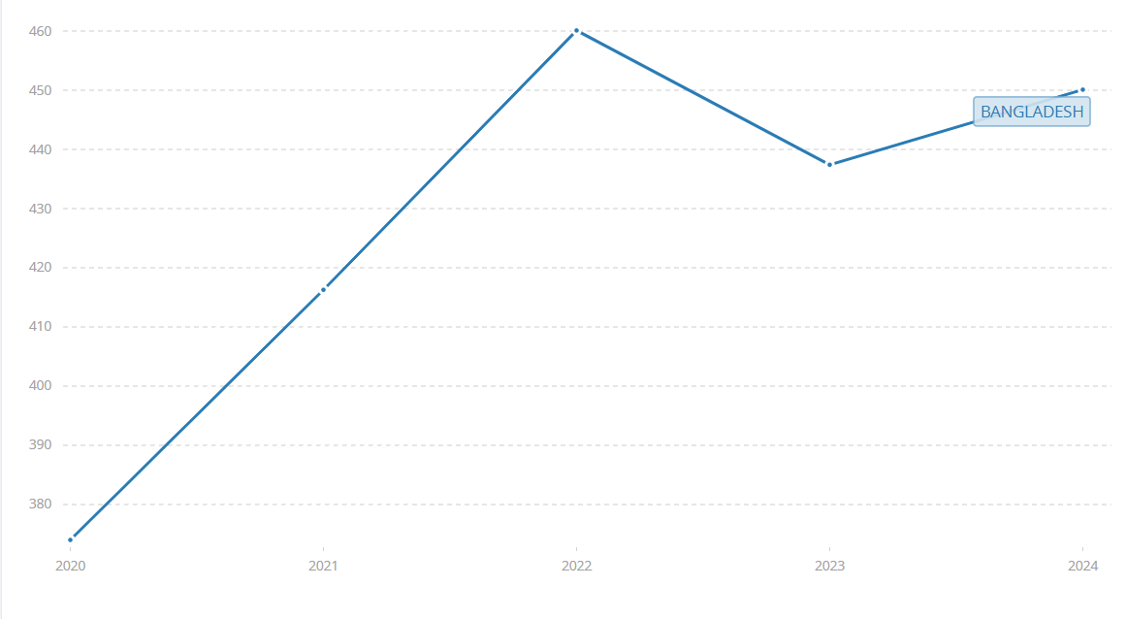
(World Bank, 2025)
Moreover, Bangladesh’s emerging business setting, which is assisted by government initiatives, tax incentives, and industrial zones, can deliver favourable conditions for this organisation. However, Bangladesh’s developing retail infrastructure, such as supermarkets, pharmacies, and retail structures, delivers wider distribution channels that can deliver opportunities (Al Rawaf and Alfalih, 2023).

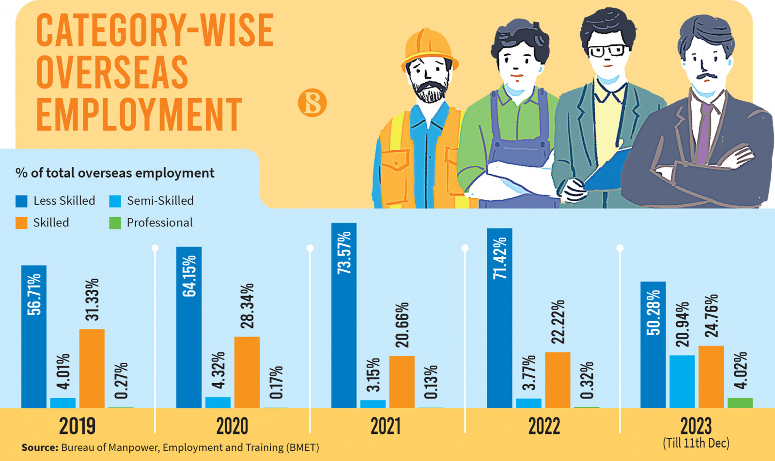
Figure: Category-wise Overseas Employment from Bangladesh
(Source: Siddiqui, 2023)3. OLI Eclectic Paradigm Analysis
Additionally, Bangladesh’s regional accessibility in South and Southeast Asian supply chain systems can enhance logistics effectiveness which allows Reckitt to incorporate the market into the existing value chain. Lastly, this locational factor, market size, customer demand and assistive policy setting can make Bangladesh as attractive tactical location for its expansion (Hasan et al., 2024).

3.5 Internalisation Advantages (I)
Reckitt has various reasons for internalise operations rather than depending on licening and outsourcing while entering Bangladesh. Initially, its products are robustly sensitive in the context of safety, quality, and regulatory integration. Internalisation can enable Reckitt to balance control over the manufacturing norms that ensure that its global safety and hygiene standards are consistently met. Moreover, outsourcing can enhance the risk relevant to quality inconsistencies or misuse of proprietary aspects (Alshurideh et al., 2022). Additionally, the internalisation safeguards Reckitt’s intellectual property.

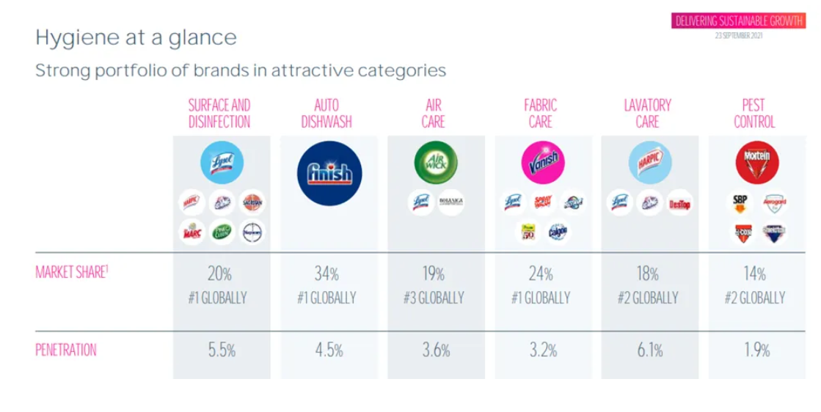
(StockOpine, 2023)
Reckitt’s competitive advantages proactively depend on patented technologies and innovative chemical compositions. In the Bangladesh market with weaker IP enforcement systems, internalising operations allows the organisation to protect its innovation and mitigate restrictions by the local organisation. Reckitt’s incorporated logistics, predicting and procurement systems are tailored for high efficiency, and balancing internal control assures that regional supply hubs, distribution centres, and local factories work effectively to mitigate costs and avoid disruptions. Moreover, internalisation improves Reckitt’s capability to implement branding, marketing, and product style aligning with local cultural preferences while assuring persistence with global brand recognition (Hasan et al., 2024). Collectively, it can be stated that Reckitt get advantages from internalising operations for the requirements for quality assurance, IP protection, supply chain effectiveness, and tactical alignment. These benefits can justify maintaining effective ownership and supervisory control when expanding into Bangladesh.

3.6 Resulting Entry Mode Decision
From the above OLI factor evaluation, it can be observed that the most suitable entry model for Reckitt in Bangladesh is wholly owned subsidiaries, which is assisted by the various local partnerships mainly in the distribution and retail. This organisation already has a significant presence in South Asia, mainly in India. Additionally, the wholly owned structure can enable it to use robust ownership benefits such as brand equity, global R&D, technical resources, and economic strengths (He and Pérez Estébanez, 2023). Full ownership in Bangladesh can allow Reckitt to develop proactive manufacturing procedures, assist quality control, and safeguard strategies, which are important in the context of products. The local production and manufacturing system under the Reckitt organisation can help in mitigating the reliance and enhance the accountability for market requirements in Bangladesh (Kais and Islam, 2020). Moreover, a particular partnership mainly with local distribution networks can enable Reckitt to get advantages from the domestic market knowledge without compromising control. Moreover, Bangladesh’s structured retail systems need robust local connections, which make the hybrid model efficient (Samun et al., 2025). Moreover, the wholly owned subsidiary can also assist in sustaining long-term tactical positioning by providing Reckitt autonomy in marketing decisions, supply chain incorporation and regulatory integration. It can assist persistent brand messaging while allowing product implementation to local cultural standards and hygiene practices (Hasan et al., 2024). Moreover, Reckitt’s efficient entry tactics into Bangladesh are an integration of full ownership for production and tactical functions, which can be complemented by the local collaboration for distribution and market excellence.

4. Cultural Distance & Its Implications

4.1 Cultural Profile Comparison
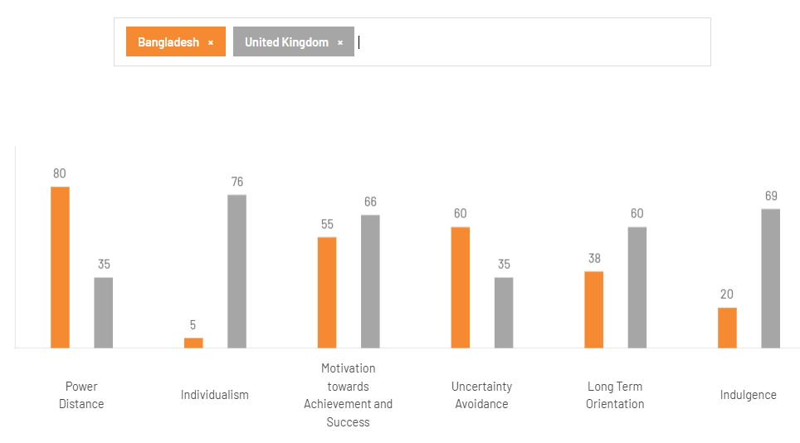
Figure: Hofstede’s cultural dimension model
Source: (Theculturefactor, 2020)
The comparison between the UK and Bangladesh has been conducted by using Hofstede’s cultural dimension model to understand the insights for Reckitt. This evaluation has demonstrated substantial cultural distance, which has tactical implications for the organisation's entry and operation in Bangladesh.
Power distance: Bangladesh scores high with 80, whereas the UK scores 35. These aspects are mirroring the culture of Bangladesh, where hierarchy, authority and social satisfaction are needed (Rabbani et al., 2024). The employees in Bangladesh mainly require clear direction, top-down communication and a visible leadership style. In comparison, UK employees value empowerment and open communication. This gap highlighted that Reckitt need to implement its management and workplace practices to align with the hierarchical demands of Bangladeshi individuals.
Individualism and collectivism: A high gap has been noticed. The UK is highly individualistic with a score 76 and Bangladesh scored 5. This prospect indicates the individualistic, personal choices and individual achievement preferences among UK people whereas Bangladesh is a collectivist society where they value loyalty towards family, community and workplace groups form behaviour (Islam, Shama and Jalil, 2024). They also believe that decision-making impacted by group collaboration, social standard and relational prospect. Here Reckitt need to understand the customer behaviour in Bangladesh by focusing on community-driven and workplace communication over direct conflict.
Motivation towards achievement and success: Both countries have moderately masculine cultural qualities; the UK scores a little higher than Bangladesh. A male society places a premium on accomplishment, victory, rivalry, and material advancement (Hofstede Insights, 2024). For Reckitt, this means that product communications that focus on performance, such as how well disinfectants work, how clean things look, or how good hygiene results are, will work in both situations.
Uncertainty avoidance: Bangladesh scored high 60 and UK scored low 35. It highlighted that people in Bangladesh requires transparent instructions, structured setting and anticipable procedures. Additionally, customers are mostly cautious in implementing new products until the safety, trust and reliability are communicated strongly (Michler, Decker and Stummer, 2020). Here, Reckitt’s robust brand reputation for quality and hygiene can be a proactive benefit in these regions.
Long-term orientation: The UK presented a high long-term orientation with a score of 60, and Bangladesh scored low with 38. This prospect mirrors future planning and strategic thinking. Bangladesh focus towards short-term orientation and prefers tradition and social obligation. While entering this region, Reckitt needs to effectively tackle the long-term brand-building tactics with a short-term promotional strategy that can deliver immediate advantages (Michler, Decker, and Stummer, 2020).
Indulgence: The UK has scored high with 69, and Bangladesh scored low with 20. These results indicate the UK prefers the circumstances that value leisure, enjoyment, and freedom. Whereas Bangladesh restrains and aligns with social standards. The marketing tactics need to avoid a liberal mindset and focus on social collaboration (Mejía et al., 2023). Lastly, the UK-Bangladesh cultural comparison has highlighted that this cultural distance need Reckitt to implement transparent communication, managerial style and employee involvement Strategies for assuring incorporation with Bangladeshi society standards.

4.2 Language and Religion Differences in the UK and Bangladesh
Language and religion are two major cultural and social distinctions between the UK and Bangladesh that have a big impact on Reckitt's plans for entering the market, how they communicate, and how they position their products. English is the main national language in the UK and the main language for business, school, and advertising. Communication is often direct, low-context, and focused on the individual, which is in line with British cultural norms (Hall, 1976). Bangladesh, on the other hand, is a Bengali-speaking country where Bangla is not only the official language but also a strong symbol of national identity, cultural legacy, and emotional affinity (Rahman, 2021). Because of this language difference, Reckitt has to thoroughly translate all of its packaging, product instructions, safety labels, and marketing communications into clear and culturally appropriate Bangla. If you don't do this, it could make it harder for people to understand, lower brand trust, and limit market penetration in rural areas, especially since Bangladesh has a lot of semi-literate people. In addition, advertising messages need to be changed to fit the high-context communication style that is common in Bangladesh. In Bangladesh, indirect, relational, and narrative-driven messaging works better than the direct and persuasive communication style utilised in the UK (Ahmed, 2020).

4.3 Impact on Entry Strategy
The above cultural competition between the UK and Bangladesh demonstrated that the differences in culture can effectively influence the entry strategy of this organisation. The high-power distance in Bangladesh highlighted that the local establishment of organisations needs an authoritative management system compared to the UK. The transparent hierarchical structure, visible leadership, and transfer and communication system can help in developing trust among the local employees in Bangladesh, which can improve the streamlining of internal coordination (Ahsan and Panday, 2023). Additionally, the collectivist culture of Bangladesh also influences how Reckitt needs to customise the marketing and stakeholder involvement tactics. Moreover, the product marketing strategies also need to be aligned with family welfare, community Health, and social collaboration rather than individual advantages. Moreover, Reckitt’s success with Dettol’s global positioning as a family protection brand effectively incorporates the collectivist value, which has made the cultural implementation efficient.
Moreover, based on the higher uncertainty avoidance, it can be stated that this organisation is required to highlight product safety, validity, and effectiveness in communication. The detailed structured instruction, reliable and visible certification, along with presentation of hygiene effectiveness, can help to mitigate customer resistance to adopting a new product (Rodriguez Sanchez, Williams, and Garcia Andreu, 2020). Moreover, the local cultural prospect of Bangladesh has a high focus on restraint and social resemblance. This context needs careful implementation of global brand messages, mainly for the sensitive categories such as Durex. Moreover, this organisation needs to incorporate the promotional activities with cultural standards by using a non-indulgent approach (Kim, 2020). Lastly can be highlighted that cultural differences promoted the requirement for a localised entry strategy with adaptations in leadership approach, marketing communication, product positioning, and stakeholder involvement, which assured the operational acceptance in the market.

4.4 Impact on Success Potential
The cultural competition and distance between the UK and Bangladesh highlighted both difficulties and advantages for the long-term success of Reckitt. However, the larger differences in power distance, collectivism, and uncertainty avoidance have highlighted that this organisation needs to implement the management practices and communication style for alignment with the local standards of Bangladesh. Additionally, failure to adapt to this prospect can result in misalignment with the employee demand, mitigating consumer trust and limited market acceptance (Tao et al., 2025). Moreover, the cultural features of Bangladesh also highlighted the robust chances for Reckitt’s health and hygiene product bands. However, the collectivist value needs to be incorporated with products which foster family and community protection in the prospect where this organisation has global strength. On the other hand, the high uncertainty avoidance in Bangladesh has enhanced customer choice is for trusted and reputed brands, making Reckitt’s validity and credibility a significant asset in this market. Moreover, it can be demonstrated that by proactively localizing the marketing strategy, adopting leadership styles and maintaining transparent communication, Reckitt can change the cultural distance into competitive benefits (Agu et al., 2024). Lastly, Reckitt's potential to incorporate worldwide expertise with local sensitivity standards can improve the overall success propensity in the Bangladeshi market landscape.

5. Recommendations and Strategic Adjustments for Bangladesh

Adjustment 1: Operational / HR / Management SOP Revision
Reckitt’s operational and HR Standard Operating Procedures (SOPs) in Bangladesh are updated with its continuous improvement and strategic reviews. It also focuses on operational efficiency and human capital. The key areas of revision involve the streaming processes of efficiency, which is shown in the company’s recent global strategy, which simplifies the organizational structure and the operations with its leadership strategies. In terms of the HR SOP revision, this company also adapts to the local context in Bangladesh. It includes some local context in Bangladesh by involving some specific challenges like leadership development and retention programs. It also aligns the global standards for recruitment, induction and compensation (Reckitt, 2024).
Operational SOP revision - The Reckitt’s operational SOP revision may include some strategic alignment, process optimization, and technology integration. This company’s global strategy is to emphasize its portfolio and organizations. Its brands foster the revision of local operational SOPs, which improve the performance and efficiency of the company. Reckitt should review and update the processes which are related to procurement, logistics, and C&F agent management. These help to ensure seamless operations and cost-effectiveness. The operations of the company should be updated to adopt the new and advanced technologies like ERP systems in the key areas like managing purchase entries and maintaining accurate records of the company (Amin, 2023).
HR SOP revision - The Reckitt’s HR SOP revision in Bangladesh may involve the strategic human resource management (SHRM), recruitment and selection, induction and training, talent management, compliance, and administration. HR SOPs Revision aligns with the company's strategic objectives, which involve the adaptation of a more streamlined organizational structure by refreshing leadership. This company’s SOP revision is also involved in terms of recruitment by improving efficiency, like strong, clear and effective communication for the group interviews of the candidates. Updating induction modules may also be involved in Reckitt's SOP, which ensures the new employees are integrated into the company, with a focus on specific departmental needs like production, quality, and logistics. This brand also adapts to the local challenges, which improves the internal training programs about leader development by implementing more effective retention programs. This company also ensures all the HR-based activities, from compensation and benefits to labor union relations and security, by complying with the local laws and international labor standards (Rafi, 2025).
Management SOP revision - The Reckitt’s management SOP revision in Bangladesh may involve leadership and governance, performance management, cross-functional collaboration, and ethical practices. The global strategy of this brand involves refreshing the leadership team and Board, which updates the management SOPs and governance structures in Bangladesh. Management SOPs revised to align with the new strategic priorities of the company by driving growth and value creation. Management SOPs facilitate the seamless collaboration between the departments in procurement, inventory, and quality control, which improve overall operational efficiency of the company. Revising SOPs reinforces the company's commitment in terms of the ethical business practices and social responsibility in Bangladesh (Miah, Sarah &Takahash, 2022).
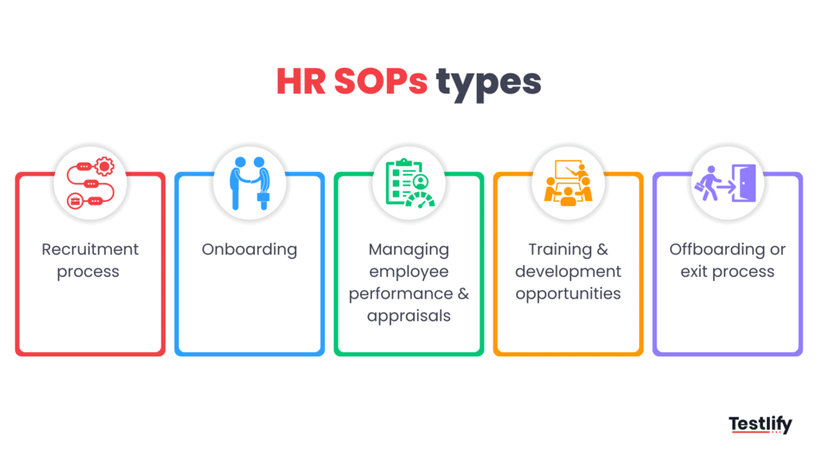
Figure: Types of HR SOPs
(Source: Testlify, 2024)

Adjustment 2: Market and Product SOP Revision
Reckitt in Bangladesh is revising its market and product strategies by taking various initiatives like the “Lizol Mosque Activation” and “Harpic - Toilet ki Doctor” campaigns, which help to connect with the local consumers. It also introduces its new products like “Harpic Toilet Sanitizer” by adapting the market demand. It also evaluates the outsourcing model to manage the supply chain risks by focusing on sales opportunities in growing areas (Khan, 2025).
Market strategy revisions - The Reckitt’s marketing strategy SOP revision in Bangladesh may involve local engagement, behavioural change, sales, and distribution. This company introduces global brands to the local cultural context of Bangladesh with its “Lizol Ramadan” campaign in mosques, which can enhance the relevance and connections with the consumers. It also uses its different marketing campaigns, like “Harpic -Toilet Ki Doctor” to educate consumers and influence them to embrace some positive habits about sanitation. Reckitt also focuses on its growth in the economic areas which increases the sales volume in high-margin products (Reckitt, 2024).
Product strategy revisions - The Reckitt’s product strategy SOP revision in Bangladesh may involve innovation in product, adaptation of portfolios and extension of the brands. It fosters new products on the basis of the market demand. “Harpic Toilet Sanitizer” is an example of product innovation. It should continue to build portfolios which can meet the diverse needs of the consumers with its various scent and format products for Lizol and Harpic. Brand extensions of Dettol can be highlighted from “soap” to “body washes” to expand the product line (Akther, 2024).
Operational and supply chain considerations - The operational and supply chain considerations include outsourcing review by re-evaluating the potential issues with the production deadlines and the risks of technological information leak to third parties. It also involves conducting the proper human resource with the planning to manage the risks which are associated with outsourcing and ensure the company about the supply chain efficiency (Rafi, 2025).
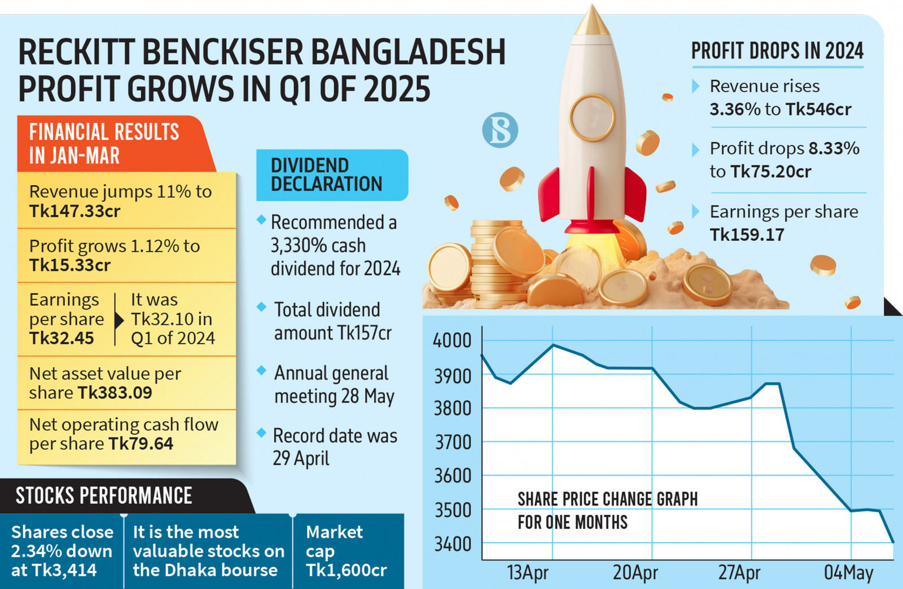
Figure: Profit Growth of Reckitt Benckiser in Bangladesh
(Source: The Business Standard, 2025)

Adjustment 3: Compliance & Governance SOP Revision
Reckitt's Compliance & Governance SOPs in Bangladesh are revised to align with the local laws and corporate governance guidelines of Bangladesh, like “Bangladesh Securities and Exchange Commission (BSEC)”. Some specific internal revision details are not public. Reckitt's commitment to corporate governance is demonstrated via its adherence to BSEC's rules on the board of directors and audit committees with the help of its ongoing efforts in sustainability and risk management (Reckitt, 2024).
Compliance & Governance SOP Revision - The Reckitt’s compliance and governance SOP revision in Bangladesh may involve alignment with BSEC regulations, board and committee structure, ongoing compliance and improvement, corporate governance framework, and internal policies. Reckitt Benckiser (Bangladesh) PLC complies with different conditions which are set by the BSEC. This includes some guidelines on the structure and independence of the Board of Directors and the establishment of an Audit Committee. The board and committee structure involves a board of directors and an audit committee. As per the BSEC guidelines, there should be five to twenty directors, and at least one-fifth of the board must be independent. The company should have an Audit Committee, which is a sub-committee of the Board, to ensure the accuracy of financial statements and a strong internal monitoring system of the company (Bhuiyan, 2020). Ongoing Compliance and Improvement also involves regular audits, sustainability, and risk management. The company analyzes regular audits and annual reports, which provide the details of its financial performance and compliance status. This company focuses on sustainability and risk management, which is a part of the company’s overall governance framework. This aligns with the global and local challenges and regulatory pressures. Reckitt's approach for governance includes sections on the Board's roles and responsibilities, governance frameworks, and various committee reports. These are subject to internal revision to maintain the high standards of the products. The revision of Standard Operating Procedures (SOPs) is considered an ongoing internal process that ensures compliance by upholding the high standards of integrity in the company's operations (Hawlader, 2024).
Management of the Revisions - The Corporate Responsibility, Sustainability, Ethics and Compliance (CRSEC) Committee and other management committees like the Compliance Management Committee (CMC) and Ethics Management Committee (EMC) play a pivotal role in overseeing the implementation of the updated policies of Bangladesh and the company itself. The revision process involves regular reporting on a compliance status. On the other hand, this process also involves updating SOPs to ensure the consistent and compliant engagement with stakeholders, which includes the board, management and the regulatory bodies.
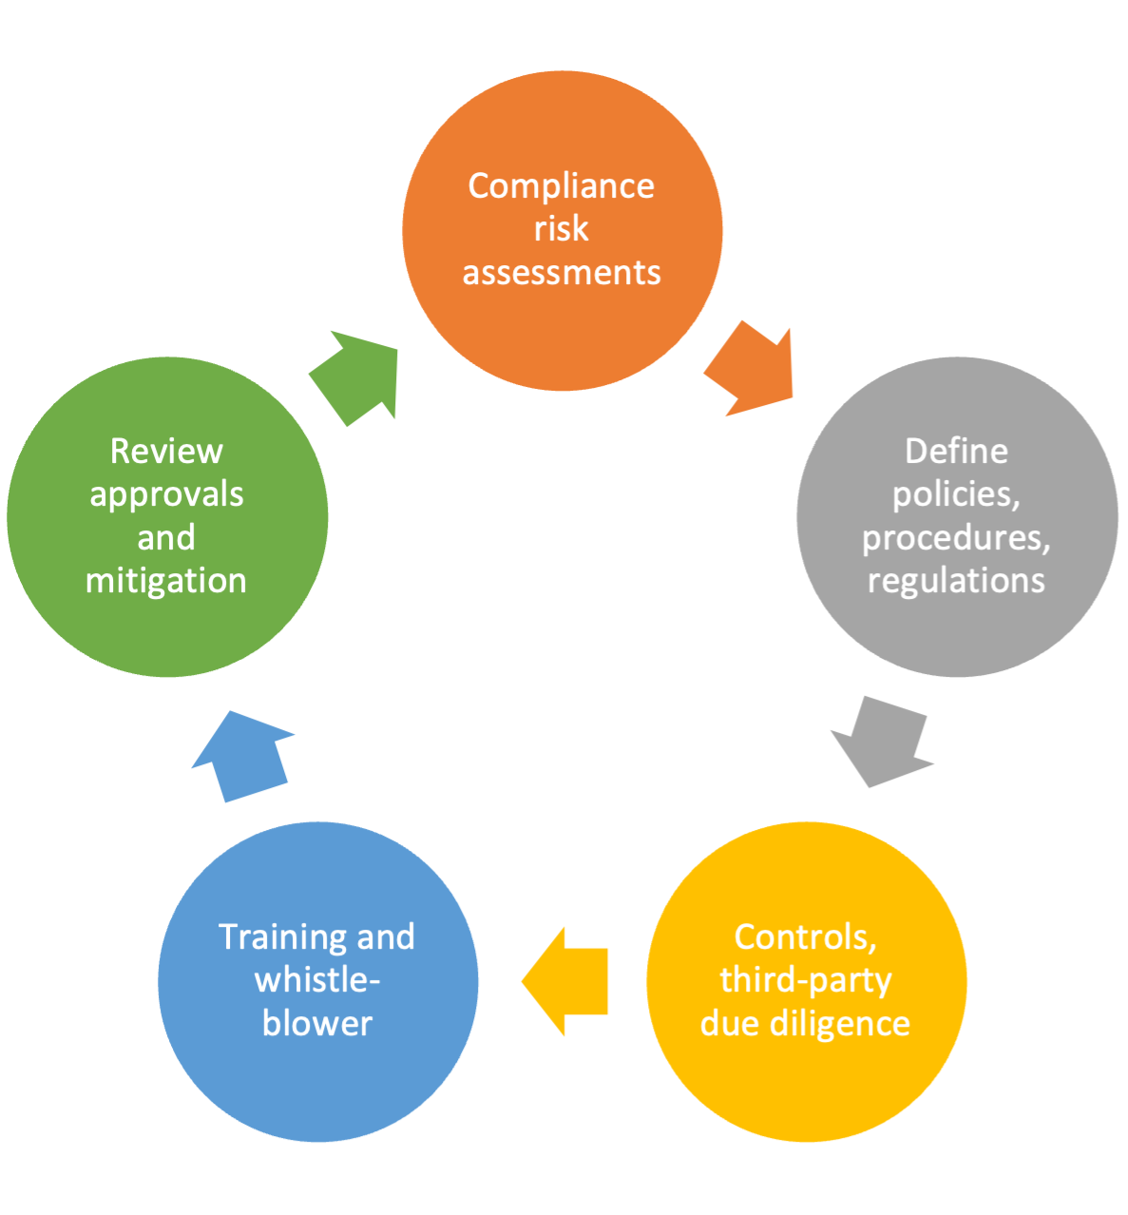
Figure: Navigating governance, risk management, and compliance in modern business
(Source: Pinnamraju, 2023)

6. Conclusion
The above evaluation has demonstrated that Reckitt's global business strategy has influenced by the robust ownership advantages, effective internalisation Strategies, and global value chain. This prospect has positioned the organisation successfully in Bangladesh. Additionally, the OLI paradigm presented that this brand's equity, research and development resources, and economic strength have integrated with the community and demographic of Bangladesh. This prospect has highlighted the chosen entry strategy, such as wholly own subsidiary structure. Moreover, these reports also demonstrate the cultural distance and differences between the UK and Bangladesh, which require effective implementation of leadership style, communication approaches, and stakeholder involvement. By including Hofstede's model, Reckitt is able to recognise the strategy for customizing its operation and integrating with local demand, mainly for the hierarchy, collectivism, and uncertainty avoidance. Moreover, the recommended SOP adjustment for operations, human resources, and product strategy and governance improved its ability to direct the local difficulties, which can reduce risk and improve competitiveness. Lastly, these strategies have effectively assisted the sustainable development and promoted the company's mission of protecting, healing, and nurturing in the Bangladeshi market landscape.

7. References
- Agu, E.E., Nwabekee, U.S., Ijomah, T.I. and Abdul-Azeez, O.Y., 2024. The role of strategic business leadership in driving product marketing success: Insights from emerging markets. International Journal of Frontline Research in Science and Technology, 3(02), pp.001-018.https://www.researchgate.net/profile/Tochukwu-Ijomah-2/publication/383848125_4_Independent_Researcher_USA/links/66dc4ce2f84dd1716cd4b2b3/4-Independent-Researcher-USA.pdf
- Ahsan, A.K. and Panday, P.K., 2023. Looking into inter-organizational coordination from a cultural perspective: A study on public organizations at the subnational level in Bangladesh. Local Development & Society, 4(1), pp.229-247.https://www.researchgate.net/profile/Pranab-Panday/publication/362542691_Looking_into_inter-organizational_coordination_from_a_cultural_perspective_A_study_on_public_organizations_at_the_subnational_level_in_Bangladesh/links/62f09fbd0b37cc34477c6bc8/Looking-into-inter-organizational-coordination-from-a-cultural-perspective-A-study-on-public-organizations-at-the-subnational-level-in-Bangladesh.pdf
- Akther, T. (2024). Report On A Comparative Financial Analysis of Health and Hygiene Products: Study on Reckitt Benckiser Bangladesh PLC. [online] Available at: https://dspace.bracu.ac.bd:8443/xmlui/bitstream/handle/10361/24922/20304048_BBS.pdf?sequence=1&isAllowed=y.
- Al Rawaf, R.A. and Alfalih, A.A., 2023. The role of governance in achieving sustainability in family-owned business: do responsible innovation and entrepreneurial culture matter?. Sustainability, 15(7), p.5647.https://www.mdpi.com/2071-1050/15/7/5647
- Alshurideh, M.T., Alzoubi, H.M., Sattar, O. and Kukunuru, S., 2022. An Experimental Evaluation on Resource Attribute Internal Risks and Regime Structure of R&D Association, Including Exploration of Moderating Effect of Association Management Capability Psychological. Journal for ReAttach Therapy and Developmental Diversities, 5(SpecialIssue2), pp.201-215.https://www.researchgate.net/profile/Mounir-El-Khatib/publication/366536131_An_Experimental_Evaluation_on_Resource_Attribute_Internal_Risks_and_Regime_Structure_of_RD_Association-Including_Exploration_of_Moderating_Effect_of_Association_Management_Capability_Psychological_Imp/links/63a5a1aaa03100368a2191bf/An-Experimental-Evaluation-on-Resource-Attribute-Internal-Risks-and-Regime-Structure-of-R-D-Association-Including-Exploration-of-Moderating-Effect-of-Association-Management-Capability-Psychological.pdf?origin=journalDetail&_tp=eyJwYWdlIjoiam91cm5hbERldGFpbCJ9
- Amin, S.S. (2023). Overview of Inventory Management for Reckitt Benckiser (Bangladesh) PLC. [online] Available at: https://dspace.bracu.ac.bd/xmlui/bitstream/handle/10361/25026/18104189_BBS.pdf?sequence=1&isAllowed=y [Accessed 19 Nov. 2025].
- Ani, S.F. (2024). Internship Report On Impact of MFS Integration for Incentive Disbursement to Distribution Representatives: A Study on Reckitt (Bangladesh) PLC. [online] Available at: https://dspace.bracu.ac.bd/xmlui/bitstream/handle/10361/24106/19104035_BBA.pdf?sequence=1&isAllowed=y [Accessed 19 Nov. 2025].
- BBC (2017). Export diversification in Bangladesh. [online] Bbc.com. Available at:https://www.bbc.com/storyworks/capital/bangladesh-a-vision-realised/economic-potential-bangladesh.
- Bhowmick, P. (2022). ‘Financial Performance and Financial Position Analysis of Reckitt Benckiser (Bangladesh) PLC’. [online] Available at: https://dspace.bracu.ac.bd/xmlui/bitstream/handle/10361/18831/18104037_BBA.pdf?sequence=1 [Accessed 19 Nov. 2025].
- Bhuiyan, N. (2020). RECKITT BENCKISER Audit Report Analysis. [online] Scribd. Available at: https://www.scribd.com/document/489231669/RECKITT-BENCKISER-Audit-Report-Analysis [Accessed 19 Nov. 2025].
- Doha, I. (2024). INB372 Case Study: Reckitt Benckiser’s Strategies in Bangladesh Market. [online] Studocu. Available at: https://www.studocu.com/row/document/north-south-university/international-business/inb372-case-study/112817991 [Accessed 19 Nov. 2025].
- Hasan, M.M., Rayhan, Z., Mukta, R.T. and Faruq, O., 2024. Research on adapting marketing techniques to different culture economics and regulatory environment to entering new international markets. Информатика. Экономика. Управление/Informatics. Economics. Management, 3(4), pp.0257-0277.https://cyberleninka.ru/article/n/research-on-adapting-marketing-techniques-to-different-culture-economics-and-regulatory-environment-to-entering-new-international
- Hasan, M.M., Rayhan, Z., Mukta, R.T. and Faruq, O., 2024. Research on adapting marketing techniques to different culture economics and regulatory environment to entering new international markets. Информатика. Экономика. Управление/Informatics. Economics. Management, 3(4), pp.0257-0277.https://cyberleninka.ru/article/n/research-on-adapting-marketing-techniques-to-different-culture-economics-and-regulatory-environment-to-entering-new-international
- Hawlader, Md. (2024). Corporate Governance Practices in Bangladesh: An Overview of Pharmaceutical, Chemical and Ceramic Industry. 4. 2024. https://www.researchgate.net/publication/388550098_Corporate_Governance_Practices_in_Bangladesh_An_Overview_of_Pharmaceutical_Chemical_and_Ceramic_Industry
- He, M. and Pérez Estébanez, R., 2023. Exploring the impact of R&D intensity, human capital, patents, and brand value on business performance in small and medium enterprises (SMEs). Economic research-Ekonomska istraživanja, 36(1).https://hrcak.srce.hr/file/442508
- investing (2025). Securly - Geolocation sharing. [online] Investing.com. Available at: https://in.investing.com/news/earnings/reckitt-maintains-2025-targets-after-betterthanexpected-q3-revenue-5056221 [Accessed 19 Nov. 2025].
- Islam, M.M., Shama, M.S. and Jalil, M.A., 2024. A Critical Examination of Bangladeshi Educational Institutions to Evaluate the Interaction of Moral Values between Servant Leadership and Power Distance. Asian Journal of Research in Education and Social Sciences, 6(3), pp.328-342.https://www.researchgate.net/profile/Mohammed-Jalil-4/publication/384561956_A_Critical_Examination_of_Bangladeshi's_Educational_Institutions_to_Evaluate_the_Interaction_of_Moral_Values_between_Servant_Leadership_and_Power_Distance/links/6704ee1ef540ba7e6e1f2823/A-Critical-Examination-of-Bangladeshis-Educational-Institutions-to-Evaluate-the-Interaction-of-Moral-Values-between-Servant-Leadership-and-Power-Distance.pdf
- Kais, S.M. and Islam, M.S., 2020. Resilience to climate change in industrial shrimping in Bangladesh: assessing the comparative role of the stakeholders. Sustainability, 13(1), p.307.https://www.mdpi.com/2071-1050/13/1/307
- Khan, S.A. (2025). Reckitt Benckiser (Bangladesh) PLC’s Lizol Ramadan Campaign: A Gender-Inclusive Approach. [online] Available at: https://dspace.bracu.ac.bd:8443/xmlui/bitstream/handle/10361/26506/20204002_BBS.pdf?sequence=1&isAllowed=y [Accessed 19 Nov. 2025].
- Kim, J.S., 2020. National culture and advertising sensitivity to business cycles: A reexamination. Journal of International Marketing, 28(4), pp.41-57.https://www.researchgate.net/profile/Jung-Kim-60/publication/341562612_National_Culture_and_Advertising_Sensitivity_to_Business_Cycles_A_Reexamination/links/5fb6094a458515b79750e311/National-Culture-and-Advertising-Sensitivity-to-Business-Cycles-A-Reexamination.pdf
- Media (2025). Like-for-like net revenue growth 1. [online] Available at: https://www.reckitt.com/media/vlxfyi3r/strategic-report.pdf.
- Mejía, G.M., Henriksen, D., Xie, Y., García-Topete, A., Malina, R.F. and Jung, K., 2023. From researching to making futures: a design mindset for transdisciplinary collaboration. Interdisciplinary Science Reviews, 48(1), pp.77-108.https://www.researchgate.net/profile/Yumeng-Xie-2/publication/365479819_From_researching_to_making_futures_a_design_mindset_for_transdisciplinary_collaboration/links/63d43cde64fc860638f128d0/From-researching-to-making-futures-a-design-mindset-for-transdisciplinary-collaboration.pdf?origin=journalDetail&_tp=eyJwYWdlIjoiam91cm5hbERldGFpbCJ9
- Miah, M.K., Sarah, M.K. and Takahash, Y. (2022). Human Resource Management Practices of Foreign Manufacturing Companies in Bangladesh: A Comparative Study. South Asian Journal of Human Resources Management, 9(2), p.232209372211255. doi:https://doi.org/10.1177/23220937221125552.
- Michler, O., Decker, R. and Stummer, C., 2020. To trust or not to trust smart consumer products: a literature review of trust-building factors. Management Review Quarterly, 70(3), pp.391-420.https://www.researchgate.net/profile/Christian-Stummer/publication/335596468_To_trust_or_not_to_trust_smart_consumer_products_a_literature_review_of_trust-building_factors/links/6263e95c1b747d19c2a1a43e/To-trust-or-not-to-trust-smart-consumer-products-a-literature-review-of-trust-building-factors.pdf
- Odinaka, N., Okolo, C.H., Chima, O.K. and Adeyelu, O.O., 2023. Cross-Border Financial Control Testing in Multinational Corporations: A Remote Team Model for US Compliance and Reporting Accuracy. International Journal of Scientific Research in Computer Science, Engineering and Information Technology, 9(6), pp.500-511.https://www.researchgate.net/profile/Nnadozie-Odinaka/publication/394517261_Cross-Border_Financial_Control_Testing_in_Multinational_Corporations_A_Remote_Team_Model_for_US_Compliance_and_Reporting_Accuracy/links/68a0de722c7d3e0029b125b5/Cross-Border-Financial-Control-Testing-in-Multinational-Corporations-A-Remote-Team-Model-for-US-Compliance-and-Reporting-Accuracy.pdf
- Pinnamraju, K.B. (2023). IBM Developer. [online] developer.ibm.com. Available at: https://developer.ibm.com/articles/navigating-governance-risk-compliance/.
- Rabbani, G.M.M.N., Fuad, M.N., Haque, T.A., Siam, S.A.J. and Mahbub, M.B., 2024. Exploring the influence of Bangladeshi organizational culture on internal communication practices. Cultural Communication and Socialization Journal, 5(1)pp.01-06.https://www.researchgate.net/profile/Md-Nafis-Fuad-2/publication/378794586_Exploring_the_Influence_of_Bangladeshi_Organizational_Culture_on_Internal_Communication_Practices/links/65ec1e58aaf8d548dcbc4f3c/Exploring-the-Influence-of-Bangladeshi-Organizational-Culture-on-Internal-Communication-Practices.pdf
- Rachwal-Mueller, A. and Fedotova, I., 2024. The impact of cultural factors on consumer behavior: a holistic model for adaptive marketing approaches. Економіка транспортного комплексу, (44), pp.165-184.http://www.irbis-nbuv.gov.ua/cgi-bin/irbis_nbuv/cgiirbis_64.exe?C21COM=2&I21DBN=UJRN&P21DBN=UJRN&IMAGE_FILE_DOWNLOAD=1&Image_file_name=PDF/ektk_2024_44_12.pdf
- Rafi, M. (2025). Reckitt Benckiser HRM Case Solution. [online] Scribd. Available at: https://www.scribd.com/doc/93100423/Reckitt-Benckiser-HRM-Case-Solution [Accessed 19 Nov. 2025].
- Rahman, M.F. (2025). The Financial Express. [online] The Financial Express. Available at: https://thefinancialexpress.com.bd/views/views/restructuring-banking-sector [Accessed 19 Nov. 2025].
- Reckitt (2024). Our locations. [online] Reckitt.com. Available at: https://www.reckitt.com/careers/our-locations/.
- Reckitt (2024). POWERBRANDS WITH IMPACT Annual Report and Accounts 2024 Annual Report and Accounts 2024 POWERBRANDS WITH IMPACT CONTENTS. [online] Available at: https://www.reckitt.com/media/3jaoa4dy/reckitt-annual-report-and-accounts-2024_accessible_format.pdf.
- Reckitt (2024b). Reckitt Catalyst. [online] Reckitt.com. Available at: https://www.reckitt.com/our-impact/fairer-society/social-impact/.
- Reckitt (2025). Careers. [online] www.reckitt.com. Available at: https://www.reckitt.com/careers/.
- Reckitt (2025). Reckitt | Protect, heal and nurture. [online] www.reckitt.com. Available at: https://www.reckitt.com/.
- Reckitt (2025a). A RESPONSIBLE APPROACH ACROSS OUR GLOBAL VALUE CHAIN. [online] Available at: https://www.reckitt.com/media/8618/global-value-chain-2020.pdf.
- Reckitt (2025a). Meet Our Powerbrands. [online] Reckitt.com. Available at: https://www.reckitt.com/our-stories/2025/meet-our-powerbrands/.
- Reckitt (2025b). HUMAN RIGHTS ACROSS OUR VALUE CHAIN Reckitt Sustainability Insights 2021. [online] Available at: https://www.reckitt.com/media/9987/human-rights-across-our-value-chain-2021.pdf [Accessed 19 Nov. 2025].
- Reckitt (2025b). Our purpose. [online] phxreckittdev.gatsbyjs.io. Available at: https://www.reckitt.com/our-company/our-purpose/.
- Rodriguez Sanchez, I., Williams, A.M. and Garcia Andreu, H., 2020. Customer resistance to tourism innovations: entrepreneurs’ understanding and management strategies. Journal of Travel Research, 59(3), pp.450-464.https://rua.ua.es/dspace/bitstream/10045/89472/1/2019_Isabel-Rodriguez_etal_Customer-resistance-to-tourism-innovations.pdf
- Samun, T.I., Mahmud, S., Rahman, M. and Ridoy, M.M.H., 2025. A hybrid distribution network model for cost, quality and distribution optimization in perishable goods supply chains. Malaysian Journal of Science and Advanced Technology, pp.1-11.https://mjsat.com.my/index.php/mjsat/article/download/462/205
- Sarker, Md.A. (2025). Universepg An Independent International Academic Publisher. [online] Universepg.com. Available at: https://www.universepg.com/cjbis/challenges-to-import-trade-practices-in-bangladesh [Accessed 19 Nov. 2025].
- Siddiqui, K. (2023). Skilled labour migration from Bangladesh rises. [online] The Business Standard. Available at: https://www.tbsnews.net/bangladesh/migration/skilled-labour-migration-bangladesh-rises-759570.
- Statista (2018). Topic: Reckitt Benckiser. [online] www.statista.com. Available at: https://www.statista.com/topics/2149/reckitt-benckiser/.
- Tao, J., Aamir, M., Shoaib, M., Yasir, N. and Babar, M., 2025. Bridging the Gap Between Supply Chain Risk and Organizational Performance Conditioning to Demand Uncertainty. Sustainability, 17(6), p.2462.https://www.mdpi.com/2071-1050/17/6/2462
- Testlify (2024). Testlify - Best Talent Assessment Platform - Pre-Employment Screening Software. [online] Testlify. Available at: https://testlify.com/hr-sops/.
- The Business Standard. (2025). Reckitt Benckiser Bangladesh sees Q1 revenue jump, profit growth slows. [online] Available at: https://www.tbsnews.net/economy/stocks/reckitt-benckiser-bangladesh-sees-q1-revenue-jump-profit-growth-slows-1136666 [Accessed 19 Nov. 2025].
- Theculturefactor (2020). Country comparison tool. [online] Theculturefactor.com. Available at: https://www.theculturefactor.com/country-comparison-tool?countries=bangladesh%2Cunited+kingdom.
- The Financial Express (2025). The Financial Express. [online] The Financial Express. Available at: https://today.thefinancialexpress.com.bd/stock-corporate/reckitt-benckisers-profit-rises-marginally-on-revenue-growth-1746641652 [Accessed 19 Nov. 2025].
- Track, B. (2023). Reckitt Adjusting To The Post Pandemic World As Its Profitability Declined | Markedium. [online] Markedium. Available at: https://markedium.com/reckitt-adjusting-to-the-post-pandemic-world-as-its-profitability-declined/ [Accessed 19 Nov. 2025].
- AInvest (2025) Reckitt Benckiser holds steady amid global challenges: FY2025 outlook unchanged. [online] Available at: https://www.ainvest.com/news/reckitt-benckiser-holds-steady-global-challenges-fy2025-outlook-unchanged-2504/ (Accessed: 4 December 2025).
- World Bank (2025) GDP (current US$), Indicator: NY.GDP.MKTP.CD. [online] Available at: https://data.worldbank.org/indicator/NY.GDP.MKTP.CD?end=2024&locations=BD&start=2020 (Accessed: 4 December 2025).
- Upturn (2024) Healthcare Industry. [online] Available at: https://www.upturn.com.bd/industry/healthcare (Accessed: 10 December 2025).
- StockOpine (2023) Reckitt: Brands, Transformation and Future Potential. [online] Available at: https://www.stockopine.com/p/reckitt-brands-transformation/ (Accessed: 10 December 2025).
- Hofstede Insights (2024) Country Comparison: United Kingdom and Bangladesh. Available at: https://www.hofstede-insights.com (Accessed: 10 November 2025).
- Ahmed, S. (2020) ‘Religion and consumer behaviour in Muslim-majority societies’, Journal of Islamic Marketing, 11(4), pp. 823–839.
- Hall, E.T. (1976) Beyond Culture. New York: Anchor Books.
- Rahman, M. (2021) Language, Culture and Identity in Bangladesh. Dhaka: University Press Limited.

