Raya salah Student no. 2026066 Lecturer: Muhammed Islam

EFFECTIVE TEAM WORKING AND COMMUNICATION (BMSW4002_BIRM)

Contents
Introduction 2
Model of teamwork 3
How can you develop a team based on the scenario? 3
Shaper 5
Shapers are group members who move the group forward. Being task, they push others and themselves to ignore any difficulties that come. 5
Project manager 5
Finisher finisher 5
Completer finishers are focused people who pay close attention to small details and work hard to achieve. 5
Plant 5
Monitor evaluator 5
Coordinator 5
Team worker 5
Resource investigator 5
Impact of effective teamwork on team success 5
Advantages of having an effective team would be, 5
The barriers to teamwork would be: 6
Ineffective leadership 6
Goal confusion 6
Communications Gap 6
Personal decision-making 6
Team size 6
Poor conflict resolution skills 6
Workflow mismanagement 7
Recommendation 7
Conclusion 8
Reference list 9

Introduction
In this report, we will discuss the importance of being a part of a team and how important teamwork is. The value of joining a team and the necessity of teamwork will be covered in this report. Teams are created when individuals with comparable preferences, attitudes, and inclinations band together to work toward a common objective. Teams play an important role in both our personal and professional life. Each employee depends on his co-workers to work together and successfully support the company. No employee can operate independently; they all need to communicate to get things done. The results are significantly better when employees work as a team as compared to individually since everyone can work together in the greatest way possible.

Model of teamwork

How can you develop a team based on the scenario?
With the team being unable to communicate during team meetings, it’s difficult for anything to progress or even come to conclusions. Lack of communication in this team has led to team conflict.
In order for me as a leading manager responsible of developing an effective team that would successfully launches the children’s wear, I would use the Tuckman’s model. The terms Forming, Storming, Norming, Performing, and Adjourning are used to describe these phases. According to Tuckman's model, relationships form as a team matures and gains skill, and the leadership style shifts to one that is more collaborative or shared.
When a new team first comes together, members will be unsure of the team's goals, how they fit in, and whether they will get along with one another, this stage is called forming. They can be apprehensive, intrigued, or eager to start. They will seek the team leader for guidance regardless of how they are feeling.
As people get to know their new co-workers and one another's working styles, this may take some time.
People begin to push against the established bounds during the storming stage. As team members' genuine personalities and preferred methods of working come to the surface and collide with those of others, tension or conflict can also develop between team members.
At this point, team members could contest your authority, your management approach, or even the group's goal.
The team enters the norming stage gradually. People begin to put aside their disagreements, respect one another, and recognise your leadership abilities.
Your team members will feel more at ease asking for assistance and providing helpful criticism now that they are more familiar with one another. They'll be more dedicated to the team's objectives as a whole, and they ought to move forward successfully, this istage is called performing.
Another way to develop an effective team lacking communication skills would be using the belbin's team theory, which is a suggestion that within a particular team, develop your strengths and weaknesses as a team and improve how each one of the team can contribute. Team roles can affect how people communicate, how they receive feedback, and not just what they say.
Simply by arguing from two opposing points of view, two persons with very diverse Team Roles and few shared strengths. Building connections and developing trust require an understanding of what motivates communication and how it differs for various people. In other words, it helps us communicate effectively."
In Belbin’s theory, interaction with others is really important, these roles are split into groups of three:
- Action
- Thinking
- Social roles
These three basic action schemes help allow communication to take place and get rid of any tension. The context issue must be addressed in addition to the traits of the Team Role (or collection of roles) For instance, team players are likely to be good at casual, one-on-one communication within the team but may find it difficult to speak up in meetings, especially when emotions are high. When discussing when describing their opinion of expertise, specialists and plants are most likely to communicate poorly with one another. Understanding your own and your co-workers’ communication preferences help enhance day-to-day interactions. It's possible that you already have some thoughts about how you and them. including when it goes well, when it can cause issues, and how it aligns with the Belbin Team Roles.
It's Difficult To remember that no ones can work alone. Each of us has a set of preferred, manageable, and least preferred Team Roles that define how we like to work, and the specific configuration of these determines how we connect with others
Sometimes we believe we can instantly recognise the team roles of our clients and co-workers.
In some situations, recognising a difference does not guarantee that our working relationships will improve.

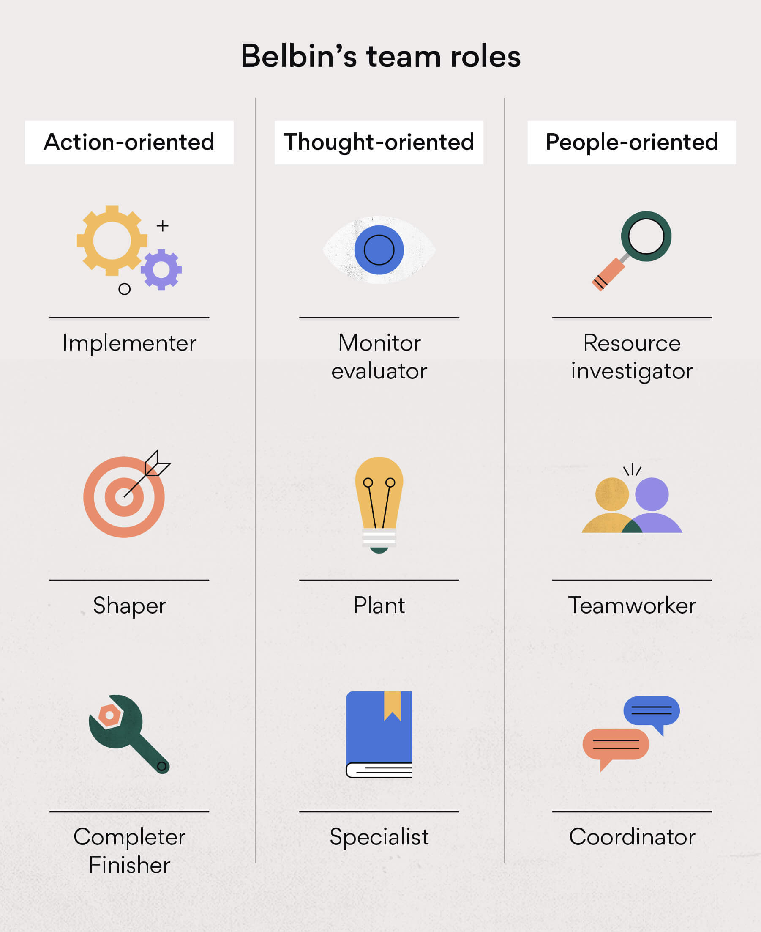

Shaper

Shapers are group members who move the group forward. Being task, they push others and themselves to ignore any difficulties that come.

Project manager

Developers keep order in their settings and are also activity group members. They are succesful at making ideas come true. Despite their preference for demanding activities, developers are far too restricted. These people can definitely support other group members, making them the core of the group.

Finisher finisher

Completer finishers are focused people who pay close attention to small details and work hard to achieve.

Plant

The plant can be a member of the group who is a new and original student. Although plants help the group to change, they prefer to plan and collect their own ideas before sharing them with more important group.

Monitor evaluator
The screen evaluator is another part of a workgroup. This kind may be a great student who can set feelings aside to understand a problem. Screen judges perform at their best when their tasks call for valuable data and important planning. They assess ideas to see whether they are realistic and reasonable, and if so, they take the necessary actions to forward those ideas.

Coordinator
the coordinator may be a group part with incredible communication aptitudes. Coordinators are often in administration positions since they promote collaboration and encourag the group to achieve their objectives.

Team worker
Their extroverted personalities help them function well with others and co-ordinate with their teammates.

Resource investigator
They are individuals that enjoys exploring new opportunities like finding potential marketing opportunities.

Impact of effective teamwork on team success

Advantages of having an effective team would be,
Strong relationship
Team work helps build strong bonds between team members
Flexibility
Working in team can help exchange skills and knowledge between team members and improve productivity.
Problem solving
Teams bring together different people with different ways of thinking varying levels of experience and different ideas
Conflict resolution skills
There is often the potential for clashes between individual team members but collaborating towards shared goal often enables members to work how best to resolve disagreements for the benefit of the team.
Increased productivity
Members contributing to help a team produce results will feel valued, supported and committed to each other. This can lead to happier, productive and more motivated staff.
New ideas and opportunities
Teamwork can spark creativity among your staff, which can lead to the development of innovative new ideas, products or services as well as identifying new business opportunities.

The barriers to teamwork would be:

Ineffective leadership
For teams to work together properly, they may need a leader who can direct them, offer their understanding and help collaboration on a reliable ground to stand on.

Goal confusion
Easy communication can start with the foundation of shared objectives that team individuals can work toward.

Communications Gap

Group members don't always understand each other's needs and goals if there are communication gaps. To close these gaps and communicate more successfully, groups can purposefully work to improve their communication skills.

Personal decision-making

In a group setting, it's common for one group member to take more responsibility than the others and make the rules for decision-making.

Team size
Small teams—those that consist of three to six professionals—often collaborate more efficiently than larger ones.

Poor conflict resolution skills

Teams may struggle as they work to achieve common goals, but it's important that professional know how to find answers and move forward as a team. Without the ability to continue under pressure, it will be a hard task.

Workflow mismanagement

Some teams find it difficult to move past the stage of defining the goals and understanding the tasks they must perform to achieve such goals. Teams need to know how their workflow will work and what role each person in the group can play in achieving the common goal in order to share information effectively. Teams may think about using tools like modeling or hiring a project supervisor to draw out a clear path to success in order to properly manage workflow.

Recommendation
Masterclass (no date) suggests high-performing groups don’t materialize out of the ether. They require cautious development from a group pioneer with a solid sense of group values, objectives, and code of morals. Without this administration from the beat, your representatives are essentially co-workers. It’s up to you to them an real group. Here are a few steps toward making that happen.
Establish expectations
New team members and new employees frequently come in as a little bit of a clean slate, open to different business cultures, but they soon start looking for hints on how to fit in. Make use of it to your benefit. Indicate the positive if the answer is yes. An excellent leader will set these rules early on, offering the group's existing members a clear understanding of what they are agreeing to.
Respect team members
Respect each team member and employee for who they are as people, regardless of their background.
Gain connections within the team.
While it is important that you respect and appreciate each individual team member, it is necessary that the team members show one another the same amount of respect, encourage others to see one another as business partners instead of just the person who sits at the desk next to them so they can work together to grow the company, achieve personal goals, and accomplish team objectives.
- Be more sensitive to your emotions. Realize the advantages of motivated ideas to succeed. Amazing leaders are aware that different people are driven by different things. Some team members succeed while working toward shared objectives. Others seek aggressive rivalry, whether it comes from an outside rival or from a rival deals team based in the same workplace. Understanding the interaction of different working styles and motivations allows a leader to see people's individual differences as a benefit rather than a burden.
- Encourage others with confidence. Positive thinking is more successful in shaping team members than negative behaviour, as great leaders are aware. Don't point out the errors of your teammates. Instead, promote positive team dynamics by pointing to actions and events.
- Communicate. Everyone values knowing where they stand in life. Are my co-workers happy with the work I'm producing? Do I have to act on something? Recognize that people need to be taught. If they notice you're upset but don't say anything, this could build up tension and even hate, which could lead to an empty argument. However, if they believe they are working brilliantly but you, their boss, are unhappy, this could result in unexpected shock when you tell them they have been failing. So brush up on your communication skills because effective communication may keep working connections strong for decades while keeping things to yourself can cause problems and unnecessary fights.
- Look for ways to reward good work. People love recognition of their hard work. Reward them.
- Diversify. Your group should be as diverse as possible in terms of backgrounds, experiences, and ages. surround yourself with people who will offer advice on the decisions you make and the information you give.
- Create a group you can trust. Find a decision-maker who can act on your behalf. By giving them the ability to choose their own leaders, you can encourage people to work together.

Conclusion
To lead great teams, needs extraordinary leadership. Leaders that aren't afraid to change course make the tough choices, develop goals that are continually being achieved and constantly getting better. Building groups requires a great understanding of people, their characteristics, and what drives them to work with others, whether in the business, in competitive sports, or in your community. For a group to form, egos and their ongoing, endless demands for respect and recognition must be managed. Group formation is an art, and a leader who can establish tall groups is valuable. History has demonstrated that it requires a particular type of leader with unique features.

Reference list

- (Advantages of effective teamwork | nibusinessinfo.co.uk, 2017)
(Belbin Team Role communication styles, 2022)
- (Forming, Storming, Norming, and Performing: Tuckman’s Model for Nurturing a Team to High Performance, 2017)
- (Belbin Team Role communication styles, 2022)
- Masterclass(no date) Available at: https://www.masterclass.com/articles/how-to-build-a-strong-team#how-to-build-a-strong-team-in-9-steps(Accessed: 09 July 2022).
- Forbes(no date) Available at: https://www.forbes.com/sites/glennllopis/2012/10/01/6-ways-successful-teams-are-built-to-last/?sh=3e5457822b55 (Accessed: 09 July 2022).
- Indeed(no date) available at: https://www.indeed.com/career-advice/career-development/barriers-to-teamwork (accessed: 10 July 2022)
- Nibusinessinfo (no date) Available at: https://www.nibusinessinfo.co.uk/content/advantages-effective-teamwork (accessed: 10 July 2022)
- Asana.com (no date) Available at: https://asana.com/resources/team-roles (accessed: 10 July 2022)

