Name: S. Hortense Assoh
Student Number: 2245799
Module Code and Title: BMHP6029 Psychological Classifications and Provisions
Assignment Title: Component 2: Written Assignment (Report)
Lecturer: Neale Haddon and Kennedy Obohwemu
Submission Date: Monday 20th July 2026

Table of Contents
1. Introduction 4
2. Classification and Diagnosis of Autism Spectrum Disorder 5
2.1 Classification of ASD in ICD-11 5
2.2 Diagnostic Criteria of ASD 5
2.3 Diagnostic Process and Assessment 5
3. Treatment and Rehabilitation of Autism Spectrum Disorder 6
3.1 Standard Treatment Approaches 6
3.2 Rehabilitation Measures in ICD-11 and Practice 7
3.3 Effectiveness and Limitations of Current Approaches 7
4. Current Debates and Emerging Issues in Autism Spectrum Disorder 8
4.1 Debates Surrounding Classification and Treatment 8
4.2 Neurodivergence and Reclassification Issues 8
4.3 Impact on Practice and Policy 9
5. Recommendations 9
5.1 Recommendations for Improving Classification and Diagnosis 9
5.2 Recommendations for Treatment and Rehabilitation 10
5.3 Implications for Practice, Policy and Future Research 10
6. Conclusion 11
7. References 12

List of Figures
Figure 1: Autism Spectrum Disorder 6
Figure 2: Applied Behaviour Analysis 9

1. Introduction
Mental health disorders refer to the conditions which influence the thoughts, feelings, behaviour and performance of a student in day-to-day life (Landrum, 2024). These disorders may affect the social relations, communication, learning and wellbeing. Autism Spectrum Disorder (ASD) is one such disorder, a neurodevelopmental disorder that is defined by the continued nature of difficulties in social communication and interactions, as well as restricted and monotonous behaviour patterns and interests. ASD does not allow everyone to develop in the same manner and, as a result, does not provide a standard set of strengths and supporting needs. This report will analyse the classification and diagnosis of ASD under the ICD-11, consider the recent treatment and rehabilitation strategies, discuss the current controversies and issues and give suggestions to enhance practice, policy and future research.

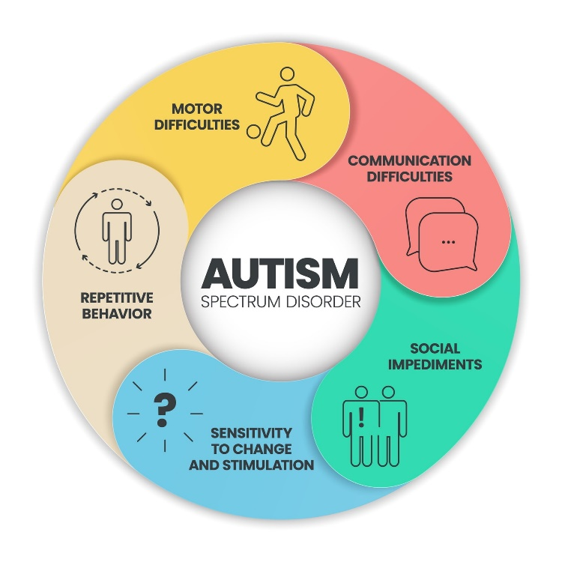
Figure 1: Autism Spectrum Disorder
(Source: Phoenix Autism Center, 2025)

2. Classification and Diagnosis of Autism Spectrum Disorder

2.1 Classification of ASD in ICD-11
In the Swedish system of classifications of diseases, the International Classification of Diseases, Eleventh Revision (ICD-11), autism spectrum disorder (ASD)s are classified under code 6A02 and are grouped under Neurodevelopmental Disorders. ICD-11 adopts the name autism spectrum disorder, which represents a medical and diagnostic model in which autism is considered as a disorder and not a condition or an illness. The fact that the term is being used in relation to disorder implies that there are clinically important impairments in functioning that might need to be assessed, supported or treated. ASD is a neurodevelopmental disorder according to ICD-11 and is defined by long-standing problems in social communication and interaction, as well as limited, repetitive patterns of behaviour, interest or activity (da Silva, 2023). The symptoms usually manifest at the developmental stage and may differ in degrees among individuals. ICD-11 moves towards a spectrum approach, which means that diagnoses previously treated separately in the system (e.g., Asperger syndrome and childhood autism) will be merged into a single diagnosis. It also has additional subcategories according to intellectual functioning and language abilities.

2.2 Diagnostic Criteria of ASD
The Autism Spectrum Disorder (ASD) diagnosis, according to the ICD-11, uses certain criteria. The main characteristic is enduring problems with social communication and interaction, such as problems in comprehending social cues, maintaining social contacts and exchanging emotions or interests (Kamp-Becker, 2024). The other qualification is recurrent, narrow, and rigid styles of behaviour, interests, or activities, e.g. repetitive movements, rigidity in following routines and atypical sensory reactions. The symptoms should result in substantial dysfunction in social, school, work, or personal functioning. Symptoms start off in the developmental period when they can be more apparent, but may develop more as the social needs exceed the capabilities of the individual.

2.3 Diagnostic Process and Assessment
ASD is usually recognised through an extensive clinical examination of a multidisciplinary team, which could consist of psychiatrists, scholars, speech and language experts, and others. As a rule, the assessment process incorporates behavioural observation, the developmental history, clinical interview, and data obtained by the family members, caregivers or teachers. Although some progress has been made in diagnosis techniques, there are still numerous problems. Symptoms may be highly different in people, causing challenges in identification (Hirota and King, 2023). Moreover, females and adults usually receive insufficient diagnosis because masking behaviours and variations in the manifestations of a symptom are common. The accuracy and timeliness of diagnosis could also be influenced by cultural factors and poor access to specialist services.

3. Treatment and Rehabilitation of Autism Spectrum Disorder

3.1 Standard Treatment Approaches
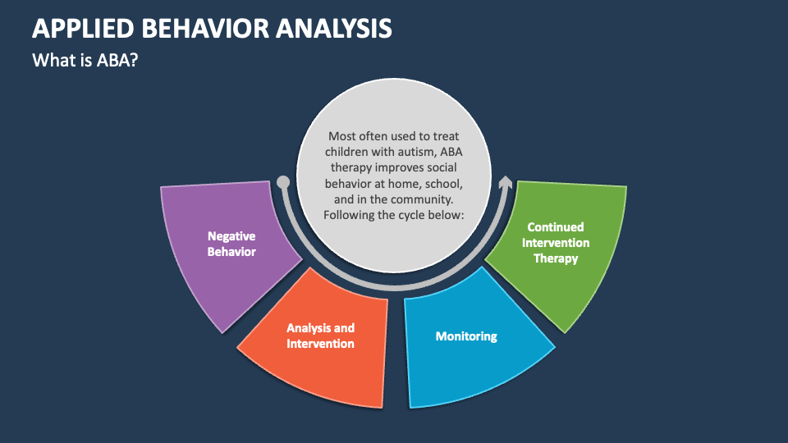
Figure 2: Applied Behaviour Analysis
(Source: Collidu, 2025)
There is no cure yet of autism spectrum disorder (ASD), and hence the treatment is calculated towards improving the communication, making autonomy, daily functioning and overall, the quality of life (Yu et.al. 2024). In the management of effective treatments, the individual strengths and support needs are properly outlined. The use of behavioural interventions is usually directed towards the improvement of communication, social interaction, and adaptive abilities. Among the most well-known methods is Applied Behaviour Analysis (ABA), which employs reinforcement strategies to stimulate good behaviour and mastery of skills. Although ABA has been linked to positive gains in communication and academic achievements, this practice attracts controversy due to the latter view that it tends to focus on behavioural conformity and not individual well-being.
The input of speech and language therapy cannot be underestimated in terms of exploring speech and non-speech communication and enables those concerned to present their requirements and use the rest of the world in a more effective manner. Older adults have goals of occupational therapy that focus on the improvement of self-care, sensory processing, and motor skills. Autistic people will be able to achieve their potential in education, with the help of educational interventions that incorporate a personalised learning plan and classroom modification (Hildebrand et.al. 2023).

3.2 Rehabilitation Measures in ICD-11 and Practice
Despite the fact that the main aim of ICD-11 is concerned with the domain of classification and diagnosis, rehabilitation is also an essential part of the practice of assisting individuals with ASD. Rehabilitation and care are supposed to maximise independence, engagement and quality of life and not to try to get rid of the autistic traits (White et.al. 2023). Skills development is a major aspect of rehabilitation. The programmes will be built to enhance communication, socialising, problem-solving and adaptive functioning. Support in communication can be provided through speech therapy, augmentative and alternative systems of communication and other assistive technologies that assist people to express themselves in a better manner. Rehabilitation is also aimed at the building of independent living skills (personal care, time management, financial literacy and vocational preparation). These abilities are able to facilitate higher independence in adulthood. Another significant objective is social participation, which is promoted using interventions that help in participating in education, employment, recreational activities, and community life. Capacity building based on community rehabilitation programmes even further enhances inclusiveness by offering support in a natural setting instead of just basing it on a clinical setting. These strategies aim at minimising obstacles and helping autistic individuals engage in society wholly.

3.3 Effectiveness and Limitations of Current Approaches
It has been shown that early treatment is able to enhance communication, adaptive behaviour, and social functioning of many individuals with autism. Speech and language support and educational therapies are usually used to help individuals acquire the important skills of life and attain improved independence (Anixt et.al. 2024). The efficacy of these strategies, however, differs since ASD is heterogeneous and thus, there is no single approach that is applicable to all individuals. There is also a problem of accessibility because many families experience a long wait, and the number of specialist services is small, and the geographical barrier is present. Access to support can also be curtailed due to financial costs, especially where partial funding of services is considered. Additionally, there are other therapies, especially Applied Behaviour Analysis (ABA), which have been charged to decrease autistic behaviours rather than promote acceptance and well-being.

4. Current Debates and Emerging Issues in Autism Spectrum Disorder

4.1 Debates Surrounding Classification and Treatment
Autism Spectrum Disorder (ASD) is a topic of continuous discussion about how it is to be classified and treated (Qin et.al. 2024). One of the points of debate is the medical model and the social model of disability. The medical model perceives autism as a disorder that needs diagnosis and treatment; the social model claims that problems of autism are the result of barriers and insufficient appropriate support of society, and not autism. The other controversy is on overdiagnosis and underdiagnosis. Although there has been increased awareness, creating more diagnoses, many professionals think that underdiagnosis is still prevalent, especially in females, adults, and minority populations whose symptoms may not correspond to classic diagnosis patterns. There is a dispute over the role of early intervention as well. In spite of the fact that early support has been related to better developmental outcomes, critics argue that the intervention should aim to develop a better quality of life rather than decreasing the autistic characteristics. Equally, certain behavioural therapies like Applied Behaviour Analysis (ABA) are also controversial in that the therapy may encourage conformity with the social world rather than personal identity and wellbeing.

4.2 Neurodivergence and Reclassification Issues
The concept of neurodivergence has been of increased importance in the context of autism spectrum disorder (ASD). It appreciates the fact that neurological differences like autism processes are not abnormalities but variations in how the human brain normally functions (Hirota et.al. 2023). This opinion is also highly justified by the neurodiversity movement which is fighting against the conventional interpretation, which is largely based on deficits and impairments. Whether to address autism either as a difference or a disorder is one of the most important controversies. The proponents of neurodiversity opinion insist that autism is merely an alternative way of thinking and viewing the world and that it is often defined by such positive attributes as creativity, honesty and attention to detail.
Nevertheless, it is argued by some that the issue of disorder should also be present since a large number of individuals with autism need clinical attention and special care. Criticism is also made on deficit-based language, whose key consideration is on limitations, which can lead to stigma. Moreover, the reclassification of autism in ICD-11 has brought about debate. A number of diagnostic conditions, such as Asperger's Syndrome, previously stand-alone diagnoses, have since been incorporated under a single Autism Spectrum Disorder diagnosis. Although this spectrum method enhances consistency in diagnosis and represents the general variety in autistic experiences, critics believe it represents a spectrum that might not capture key variations in individual identities and support requirements (Sclabassi et.al. 2025).

4.3 Impact on Practice and Policy
Such discussions have significant implications for professional practice and policy. With the increasing awareness of neurodiversity, the importance of inclusive education practices aimed at altering learning environments instead of forcing autistic learners to adapt to mainstream teaching methods in education has been promoted. Correspondingly, employment support, such as accommodations in the workplace and workplace initiatives, which identify the strengths of autistic persons, is receiving more focus. In the context of healthcare services, the focus is becoming more and more on person-centred and strength-based assistance. Meanwhile, the disability rights organisations and autistic self-advocacy groups have also been immensely useful to support equality, accessibility and social inclusion (Bindhani and Gopinath, 2024). Moving forward, the development of the policy in the future will centre around making access to diagnostics easier, cutting social challenges and factors, allowing autistic people to live on their own; furthermore, making sure that autistic individuals have a positive input in the formulation of the choices that will influence their lives. The changes could lead to better inclusion and provision of systems in society.

5. Recommendations

5.1 Recommendations for Improving Classification and Diagnosis
Autism Spectrum Disorder needs to be classified and diagnosed better, by identifying the disorder earlier, and through better assessment procedures. The rate of early diagnosis and consequent intervention can be enhanced with the help of increased awareness of healthcare professionals, educators and parents (Okoye et.al. 2023). Diagnostic instruments ought to be continuously revised according to the latest studies and manifestations of autism in various populations. Moreover, diagnostic procedures must be more culturally sensitive to minimise chances of misdiagnosis and provide everyone with equal opportunities to access assessment services despite their variety.

5.2 Recommendations for Treatment and Rehabilitation
The person-centred approach of treatment and rehabilitation services should be personalised and take into consideration the personal strengths, preferences and support needs of individuals. More funds should be allocated towards improving accessibility and availability of specialist services, mostly in underserved communities. Minimising waiting and financial access would enhance access to the necessary support (Hirota and King, 2023). It is also desirable that family involvement is encouraged during treatment and rehabilitation since parents and caregivers are instrumental in encouraging skill development, independence and a good long-term well-being.

5.3 Implications for Practice, Policy and Future Research
Subsequent professional education should be a focus of future practice to gain better knowledge of autism and neurodiversity. The policy reforms ought to be put in place to foster inclusive education, job opportunities, and affordable healthcare provisions (Gagné and Hewett, 2025). Moreover, longitudinal studies should also be done in the future to determine long-term effects and effective supporting strategies. The future developments should be informed by neurodiversity so that the support systems can be safe in respecting both the individual differences and human rights.

6. Conclusion
This report looked at autism spectrum disorder (ASD) as per the ICD-11 framework. It talked about the classification and diagnostic features of ASD and how it fits in the category of neurodevelopmental disorders, and the steps involved in diagnosing the condition. The current treatment and rehabilitation strategies were also compared in the report, which comprised the behavioural intervention, the communication support, as well as skills development programme. Besides this, it covered contemporary debates about autism, such as the idea of neurodiversity, reinstatement of the deficit paradigm, and using deficit language. Overall evidence has revealed that there should be balanced, person-centred, and inclusive type of support keeping in mind the weaknesses and the strengths of autistic people.

7. References
Anixt, J.S., Ehrhardt, J. and Duncan, A. (2024) Evidence-based interventions in autism. Pediatric Clinics, 71(2), pp.199-221. 10.1016/j.pcl.2024.01.001
Bindhani, S. and Gopinath, G. (2024) Inclusive education practices: A review of challenges and successes. International Journal for Multidisciplinary Research, 6(2), pp.1-9. https://pdfs.semanticscholar.org/ed8d/1d6726065046d80774fe5b27685b4e5d5c07.pdf
Collidu, (2025) Applied Behavior Analysis Available at: https://www.collidu.com/presentation-applied-behavior-analysis (Accessed on: 23rd June, 2026)
da Silva, N.I. (2023) autism spectrum disorder: history, concept and future perspective. Journal of Neurology Research Reviews & Reports. doi.org/10.47363/JNRRR/2023(5)173
Gagné, M. and Hewett, R. (2025) Assumptions about human motivation have consequences for practice. Journal of Management Studies, 62(5), pp.2098-2124. https://doi.org/10.1111/joms.13092
Hildebrand, M.W., Geller, D. and Proffitt, R. (2023) Occupational therapy practice guidelines for adults with stroke. The American Journal of Occupational Therapy, 77(5), p.7705397010. https://doi.org/10.5014/ajot.2023.077501
Hirota, T. and King, B.H. (2023) autism spectrum disorder: a review. Jama, 329(2), pp.157-168. 10.1001/jama.2022.23661
Kamp-Becker, I. (2024) autism spectrum disorder in ICD-11—a critical reflection of its possible impact on clinical practice and research. Molecular Psychiatry, 29(3), pp.633-638. https://doi.org/10.1038/s41380-023-02354-y
Landrum, T.J. (2024) Emotional and behavioral disorders. In Handbook of special education (pp. 301-326). Routledge. https://doi.org/10.4324/9781003302766-15
Okoye, C., Obialo-Ibeawuchi, C.M., Obajeun, O.A., Sarwar, S., Tawfik, C., Waleed, M.S., Wasim, A.U., Mohamoud, I., Afolayan, A.Y. and Mbaezue, R.N. (2023) Early diagnosis of autism spectrum disorder: a review and analysis of the risks and benefits. Cureus, 15(8). 10.7759/cureus.43226
Phoenix Autism Center, (2025) Understanding Autism Spectrum Disorder: Key Facts Every Parent Should Know Available at: https://phoenixautism.com/understanding-autism-spectrum-disorder-key-facts-every-parent-should-know/ (Accessed on: 23rd June)
Qin, L., Wang, H., Ning, W., Cui, M. and Wang, Q. (2024) New advances in the diagnosis and treatment of autism spectrum disorders. European Journal of Medical Research, 29(1), p.322. https://doi.org/10.1186/s40001-024-01916-2
Sclabassi, E., Peret, S., Qian, C. and Gao, Y. (2025) Pharmacological Interventions in Autism Spectrum Disorder: A Comprehensive Review of Mechanisms and Efficacy. Biomedicines, 13(12), p.3025. https://doi.org/10.3390/biomedicines13123025
White, S.W., Schall, C., Santos, J.D., Maddox, B.B., Hillier, A., Klinger, L. and Pugliese, C. (2023) Promoting quality of life: Suggestions for mental health care providers working with young autistic adults. Autism in Adulthood, 5(4), pp.347-355. https://journals.sagepub.com/doi/abs/10.1089/aut.2022.0106
Yu, Y., Ozonoff, S. and Miller, M. (2024) Assessment of autism spectrum disorder. Assessment, 31(1), pp.24-41. https://journals.sagepub.com/doi/abs/10.1177/10731911231173089

