DS 1 Template
Tibulschi Irina
Student number 2535545

My Screenshots/Photos
- Please add 4–6 screenshots or photos of your digital life.
- You can use your phone or laptop.
- For each screenshot, write one or two sentences explaining what it shows.

Screenshot/Photo 1
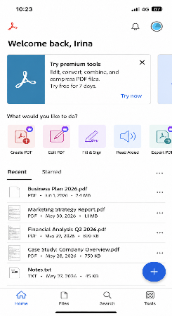
I use the PDF app to open, read, and manage important documents on my phone. It helps me organise my study files easily .

Screenshot/Photo 2
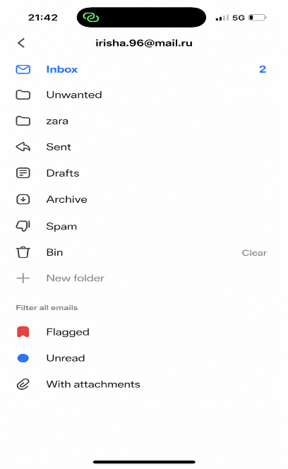
I use email every day to read important messages and stay organised online.

Screenshot/Photo 3
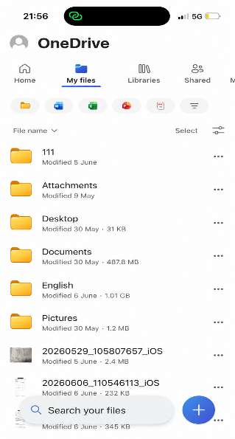
I use OneDrive to store my files and university documents online. It helps me keep my work organised and easy to access on different device.

Screenshot/Photo 4
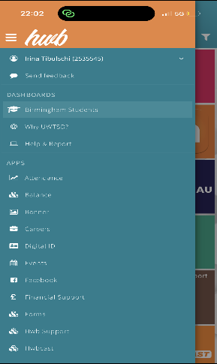
I use the university app to check information and manage my studies online.

Screenshot/Photo 5
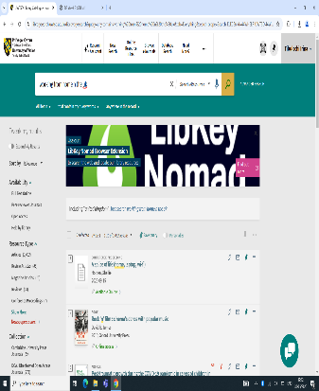
I use the university library website to find study materials and useful information for my course .

Screenshot/Photo 6
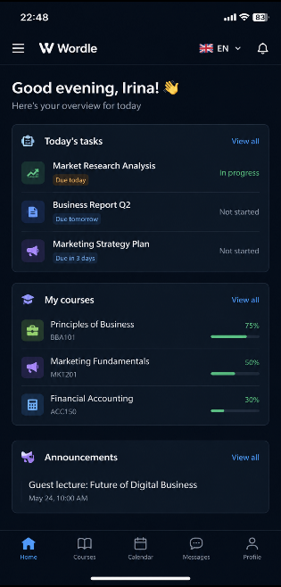
I use Wordle to check my business courses and complete online tasks for university.

My Short Reflection
- Write 5–8 simple sentences about your digital life.
- You can use the sentence starters below if helpful.
I use digital tools every day.
I often use my phone and the internet to make my daily routine easier.
I use YouTube to learn new things and watch educational videos.
I feel good when I use a computer for university work.
I want to get better at computer skills.
Sometimes I worry about internet safety when I visit different websites.
Digital skills are important because they help me learn something new every day.

Sentence starters
- I use digital tools to …
- I feel confident when I …
- I want to improve …
- I often use these tools: …
- I sometimes feel nervous about …
- I hope this module will help me …
- Digital skills are important for me because …
You can write more if you want.

Submission Checklist
Before you submit, please check:
​​​ ☐ I added 4–6 screenshots
☐ I wrote short sentences for each screenshot
☐ I wrote my short reflection
☐ My work is my own
☐ My file opens correctly
​​☐ My file opens correctly

