[Date]
Jomir Ullah 1708855
[company name]
Strategic Management SME
[Document subtitle]

Contents
1.0 Executive Summary 2
2.0 Introduction 3
3.1 The Business Environment 4
3.2 Environmental Analysis 5
3.2.1 TOWS Analysis 5
3.2.2 Pestle Analysis 6
3.2.3 Porters Forces 6
Generic Strategies 6
Best Cost Provider 6
Value Chain / Value in Information 6
4.0 Stakeholder Analysis 6
5.0 Sustainable Strategic Options 6
6.0 Recommendations 7
7.0 Conclusion 9
8.0 References 10

1.0 Introduction

This report will aim to critically appraise the current strategic direction of an Indian restaurant which is located in the heart of Warwickshire, in a rural town of Henley-in-Arden. The restaurant is strategically located on the Henley high street and has gained popularity from local residents and high-income earners who frequent the affluent town of Henley. This is a small restaurant employing twelve people. It has been trading for ten years and gained cumulative experience in the catering and hospitality industry.size turnover.
Ever since its opening in 2009 the restaurant has faced challenges in human resource management and internal logistics which has impacted on the firms competitive advantage. Naya Indian cuisine are also facing difficulty as the environment that they operate in has changed dramatically due to Covid-19. Customers eating preferences and changes in regulation and law are restricting customers and this causal effect has had a negative impact on the sales and growth prospects of the business, often limiting the business to a take-away service only.
The company at present does not have a mission or vision statement. The business objectives at present is survival and to maintain customer loyalty. Values in the business, although not written are communicated in the socialisation process of new recruits and reinforced by existing members of the workforce. This report will aim to formulate a vision and mission statement for Naya.
In order to understand the current business direction, this report will include an industry analysis with the aim of highlighting the strengths and weakness of the business, identify new opportunities and threats and determine which functional strategies can add value and competitive advantage. A PESTLE analysis will provide a holistic view of the broader ecosystem in which the business operates and also identify external factors/components that can limit the competitiveness of the business.
prior to formulating new strategy this report will include a stakeholder analysis and Identification of weakness will help to mitigate threats and plot strategies to circumnavigate around limitations the business is facing.
Porters -competition five forces
Porters generic strategies – low cost – differentiation- focus group
Stakeholder analysis-
Sustainable growth options- balance scorecard- objectives- measure.

environmental scanning tools to analyse the competitive landscape

Current Strategic Direction For Naya

Strategic planning is an important aspect for a business as it helps the business to match its objectives to the vision statement and establish what resources are required to reach their goals.
To establish the current strategic direction of the business this report will aim to use industry analysis techniques and benchmarking tools to measure how Naya compares with its competitors in the market. various other tools such as a SWOT analysis will help to identify internal strength and weaknesses of the business. The finding of the analysis can be used to understand the competitive strategies the busines is currently pursuing to remain in the number one position in the marketplace. by identifying the weakness, the report will make recommendation on how to formulate new strategies based on the internal operations of the business.
See pestle analysis below.
Further, researcher Michael porter framework to measure competition in the marketplace will help to identify the various threats and powerful influences which can also impact on the current strategy and help to identify what value the business is creating in its daily operation. Value can be created in the business process and in the way the busines functions in each category of the value chain analysis also proposed by porter.
MISSION STATEMENT: OUR MISSION IS TO PROVIDE OUR CUSTOMERS WITH A UNIQUE, HIGH QUALITY AND AUTHENTIC TASTE OF INDIAN AND BANGLADESHI CUISINE IN A COMFORTABLE AND RELAXING ENVIRONMENT. You will find Our team of experienced staff to be very polite professional and attentive TO YOUR CULINARY DESIRES. WE PROVIDE A COMPREHENSIVE TRAINING TO ALL OUT STAFF AND EMPOWER THEM. TEAMWORK AND GOOD COMMUNCATION IS VITAL FOR SUCCESS IN DELIVERING A QUALITY SERVICE TO ALL OUR GUESTS.
Customer employees
Statement of values and to show strategic intention.
Naya does not have a vision statement. NEW VISION STATEMENT: OUR VISION IS TO EXPAND INTO EVERY MAJOR CITY IN THE UK AND GAIN MICHELIN STAR STATUS.
According to Forbes mission statement should include value statement This is common amongst SME especially in the Indian restaurant sector. The restaurants main objective to make a profit by proving high quality food and excellent customer service to gain repeat business.
A memorable innovation moment for this sector is the use computer software such EPOS system to take customers orders more efficiently. This has revolutionized how the business operates, leaving behind the iconic pen and writing pad.
Researchers have stated that having a vision and mission statement provides multiple benefits to an organisation. it gives them a sense of purpose and a long-term direction. as a result, goals and objectives can be used by managers to measure performance in terms success and failures. It also helps the business to formulate strategies on business and operational levels to fulfil the vision of the company. Furthermore, having a vision statement will make the business more attractive to customers and potential investors as the vision also details other aspects such as ethical and sustainable approaches which the business may pursue for the future.
Researchers have stated that a good vision statement should include how the customers can benefit from the services as well the corporate social responsibility of the business to the environment in which they operate as well …..

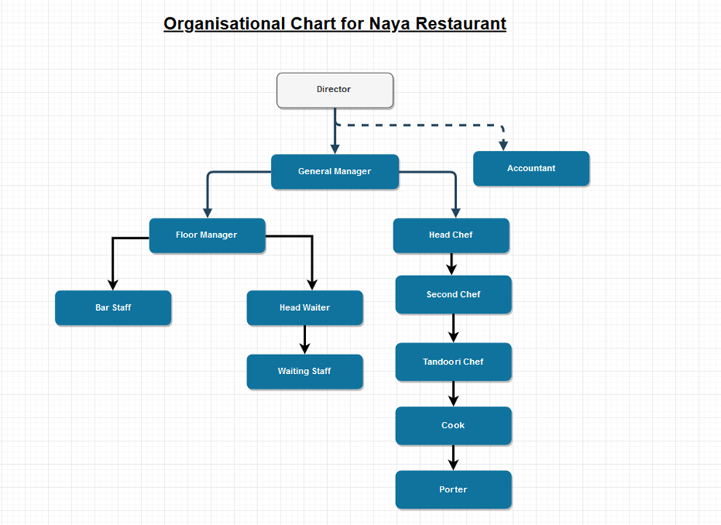
Accountant makes strategy link stakeholder. Need resistant to change- least important.
Discuss the hierarchy corporate level decisions, tactical level decision and operational , which is the processes that happen within the organisation.
the structure of the business, leadership style and culture within a business plays a key role in strategy formulation. reference beer!

3.2.3 Porters Forces
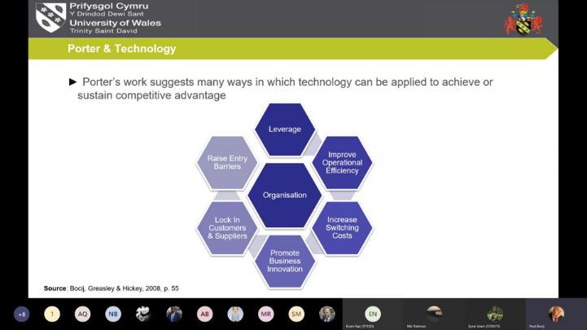
Bocij assert that business use technology to strategy to gain leverage

Critics of porter state it is not always possible to gather complete information. As environment is rapidly changing. Data used to plan ahead may be sufficient an uncertain outcome. https://core.ac.uk/reader/19187624
Porters forces looks at the level of competition in a particular industry and can help managers and leaders to identify and predict current and future opportunities and risks. The analysis of industry forces will encourage businesses to decide how to exert more influence and exploit certain industry characteristics. The main objective is to modify these competitive factors to increase profitability and market share.

Force | Risk H/L | Notes
Threat of new entrants | Medium | Barriers to entry are currently medium. There is a shortage of expert human resources such as Chefs in the Indian restaurant industry. The setup cost in a rural town is considerably high. Also the incumbents have an advantage as they have ten years cumulative experience in this sector.
Threat of substitutes | High | Substitutes are alternative products that fulfil the same need. There are various businesses such as Pubs, fast-food outlets and supermarkets in the business ecosystem that can attract customers as they are readily available.
Bargaining power of customers | Low | Customers at present can not force the prices down as it a rural town. Switching cost are relatively high as they need to go out of town to make a saving which in turn will increase fuel cost and time.
Bargaining power of suppliers | Low | Supplier for the industry are readily available and products are differentiated. So the business can choose to obtain resources from a variety of suppliers
Industry rivalry | High | rivals are trying to increase market share. Current pandemic has reduced sales and rivals are reacting strongly with competitive warfare tactics by reducing prices and aggressive marketing and promotion

Threat of new entrants: although the barrier to entry is currently medium. This can change dependent of other components of the business environ such as the macro environment.

Value Chain / Value in Information

Reduce Business cycle time cost of storage. Toyota JIT system. Planes landing in non commercial airports
- Rayport, J.F. and Sviokla, J.J., 1995. Exploiting the virtual value chain. Harvard Business Review, 73(6), p.75.
  - https://hbr.org/1995/11/exploiting-the-virtual-value-chain
- Short video on value chain
  - https://www.youtube.com/watch?v=g8p2H7EvoGM
- Article on value chain analysis
  - https://blog.hubspot.com/sales/value-chain-analysis
- Example of value chain analysis related to Starbucks
  - https://www.investopedia.com/articles/investing/103114/starbucks-example-value-chain-model.asp
- Harvard Business Review article on innovation and the value chain
  - https://hbr.org/2007/06/the-innovation-value-chain
- Detailed guide to value chain analysis with examples
  - https://www.smartsheet.com/everything-you-need-to-know-about-value-chain-analysis

This theory can be linked to the observation that we found in Porters Competition/forces.
New entrants – no delivery driver. New logistical company or rivals can introduce Uber they will gain more market. As COVID-19 people cannot get out. So need to be aware of future threats.
  - Critique of porters work! https://www.researchgate.net/publication/266967720_Supports_and_Critiques_on_Porter's_Competitive_Strategy_and_Competitive_Advantage
Give example how this can save money through process improvement. Gain competitive advantage.

3.2 External Environmental (Macro) Analysis
Conducting an environmental analysis allows the organisation to understand and anticipate current and potential future changes in the business environment. This provides input to make important strategic decisions for the business. It also facilitates and fosters strategic thinking, challenges current wisdom, and brings a fresh viewpoint to the organisation. the environment is dependent on the perception of the observer and so it is multifaced.
Characteristic of an environment? See below
E.g. Perception take rate increase- small sme outs, large ok and have less competition leading to more sales and profitability.
Objectives:
- Survival
- Stability
- Growth
- Efficiency
- Profitability
The business environment
Few problems exist when we look at the environment these are complexity: difficult to understand, uncertainty: keeps changing turbulent/unstable and diversity: too many factors to look at.
Four characteristics on the environment include: complex, multifaced, dynamic, far reaching impact on business decisions

At end mention what they are doing good and bad. Is it working for them?
Any gaps in mission statement. As it does not have one this is limited factor my analysis.

3.2.2 Pestle Analysis

A PESTLE audit looks into the various environmental forces at play in the outer boundaries of the organisation. this gives them a panoramic view of how the business. These factors are also known as external forces, they are inter-related and can have a long-lasting impact on the functions within the organisation. the organisation does not have direct control over these environmental forces.. however, any changes in these factors can disrupt the business and any strategy that the business may like to pursue or it can be an opportunity for this business. therefore, this tool can be used to scan, monitor, forecast and assess current and future patterns trends and changes and measure the critical success factor of strategies as the business can look for opportunities in the future and identify potential threats or risk.
the factors which can impact on strategic decision making for Naya are listed below:
Political:
- Brexit- price of goods will rise due to taxation. Logistical channel-transportation costs, health and safety at work, food safety laws. Employment regulations. Pensions scheme compulsory, migrant residents may leave.
- elections
- war and famine
- COVID-19 restrictions
Economical: :
- recessions and depression
- inflation
- rise in oil prices
- COVID-19 restrictions
Vat increase. Peer to peer lending. Ethical sourcing of goods, pollution, waste disposal. Carbon emissions. Weak economy, inflation is high, public spending is low. Cost of inputs has risen, gas, electric and telecommunications.
Socio-cultural:
- change in local demography
- changes in work patterns
- changes in preferences
customers tastes and preferences are changing, low fat , health-conscious option, vegetarians, customers no longer using cash.cite. societal value changes may add confusion to some facilities such as the restroom. Uk residents are not always willing to work unsociable hours in the industry.
Technological:
- automation
- mechanisation
- better telecommunication
- social media
new cooking equipment to maintain freshness, increase productivity and efficiency. Online ordering system. 5G , current networks are slow. Internet of things CCTV monitor, sensors for temperature control and record out of stock items. Epos system has helped. But need adequate training.
Environmental:
- pressure/focus groups
- sustainable and ethical sourcing of inputs
- unstable weather
pressure groups, focus groups, pandemics and poor unstable weather such as floods snow, hampered business and booking have been cancelled.
Legal:
- minimum wage increase
- food safety regulation
- changes in public health regulations
added cost to employer. Changes in health laws, tighter curfew on opening hours. Recent deaths from allergic reactions, staff need to more training, business has no female employees- this can be seen in a negative light by potential investors, not much diversity. Access to other workforce will be limited after workforce- business not able to attract new talent as Home office requirements are unfavourable to the industry.
how the forces can have a causal effect and how the business can impact on the environment.
Technological: advances in technology can be a source of competitive advantage as well as a threat. Technology makes it easier to perform business functions more accurately and can be used to monitor business activities. Also technology if not implemented in the right time can be difficult to adapt to, as processes need to change.
Social: demographics is key to success. Henley has baby boomers and is often referred to as ‘gods waiting room’. These customers have a high disposable income and are willing to pay for premium prices in return of good value in food and service. If there is a shift in the demographics then new strategies need to be formulated to take advantage of change. Show concern for social welfare- ethical in dealing.
Culture: cultural trends can impact on business as mentioned above wedding rings example: us men Germany women. Take advantage of this
Economic: the economic climate can have significant impact on the business cycle such as during depressions and recession, if customers have more money they are likely to spend, so business can target them with better services and quality products. In recession people are out of pocket and will look for cheaper options to satisfy their need. Again strategies need to be changed to take into account of this changes in economic climate.
Legal: laws which are enacted can also be a taken as good or bad. Such as minimum wage increases, this will eat into profits and the business may need to reduce the staff and organisational size. These laws can be different dependant on where in the world you are.
if they adapt to the changing nature of the external environment they can prosper. business that have taken advantage of such changes in the macro environment are now successful and making more profit with higher market share and growth. e.g. changes made by Ofcom on energy regulation has allowed smaller suppliers to compete in the energy sector making it more competitive and giving customers more choice- perfect competition. rather than price wars.
business that have failed to identify risks or responded to late have been forced to completely shut down e.g. blockbuster did not take action over changes in technology.
powerful industries can and will lobby to exert pressure on government to make the market more favourable for them e.g. American gun laws.

3.2.1 SWOT ANALYSIS

What is swot? How it help?
What are the limitations of this model
Briefly discuss the main concerns
The firm must identify it position relative to others in the market.
Comp adv. Comes from the firm ability to perform activities more efficiently than competition
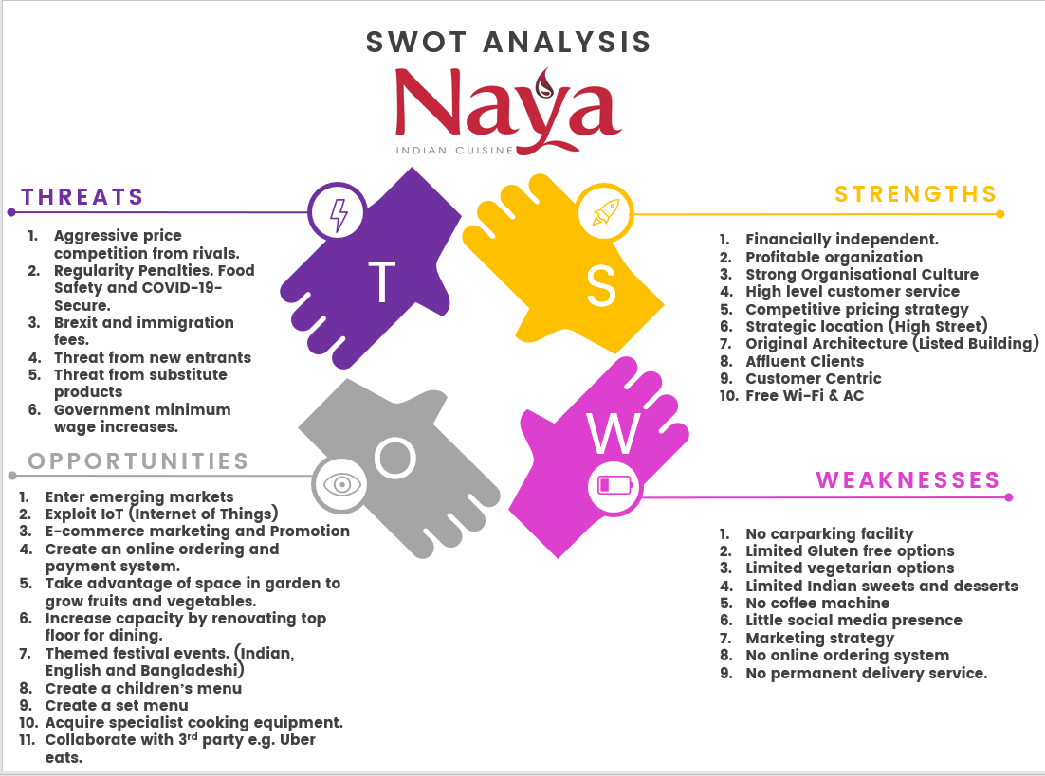
Figure 1 SWOT Analysis of Naya Restaurant ( own construct )

4.0 Stakeholder Analysis

what is a stakeholder? a stakeholder is a person or a group of people who have influence and power over the decisions an organisastin makes. they can be internal or external stakeholders. their influence in the decision making process a significant impact on the strategies that the business will carry out and thus the business will try to communicate these strategies to the stakeholders. the level of communication will depend upon the stakeholders engagement with the business and the power which the stakhoders can apply.
internal stakeholders: customers, employees, managers, shareholders
external stakeholders: parish council, local residents, competitors, government regulators, banks, it support.
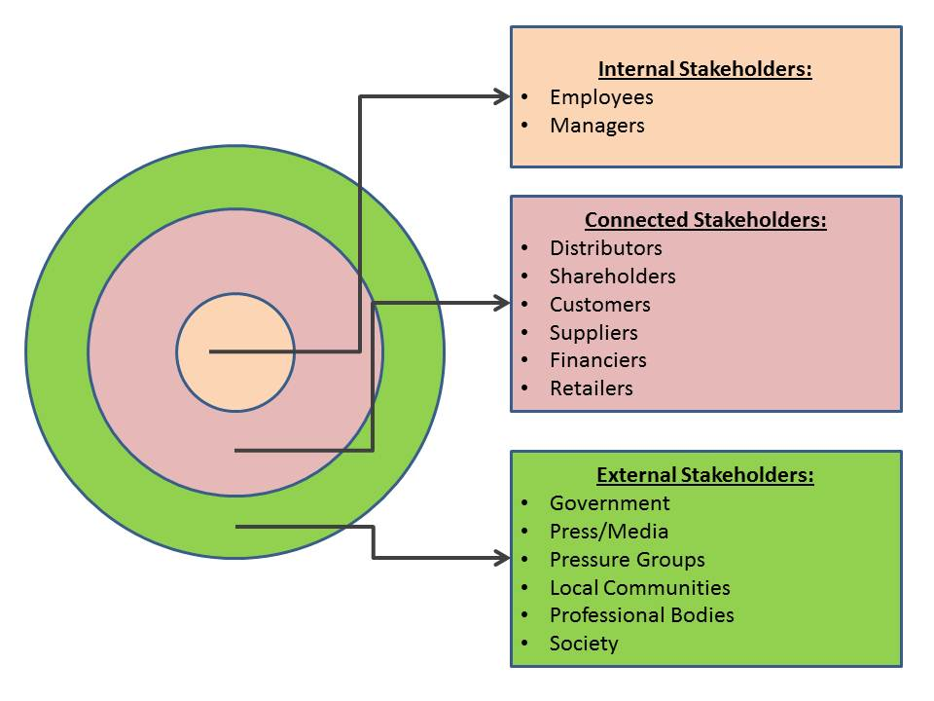
Figure 2 https://www.professionalacademy.com/blogs-and-advice/stakeholder-mapping---marketing-theories
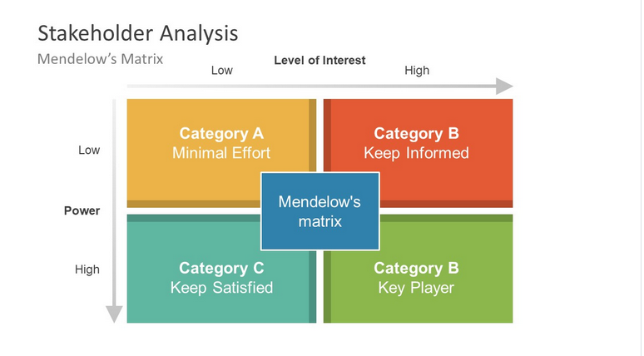
Naya tend to emphasis on quality and intangible metrics such as customer relationship management to add value to the business operations.
Power is direct. Influence is more subtle- influence to go on strike..
There are many potential stakeholders. However it is important to filter through an examine how much power or influence my strategic decision will influence the stakeholders.
Waste disposal
employees
Customers
Food safety hygiene rules
Suppliers- maintenance
Logistics
Media-advertising
Regulate g
Focus groups
Vegetarians interest. No financial.

5.0 Sustainable Strategic Options

Values: RESPECT, TEAMWORK, CUSTOMER
MISSION: BE THE NUMBER ONE CHOICE FOR INDIAN FOOD IN WARWICKSHIRE.- get their trough customer testimonial, enter competition such as British curry awards. Participate and invest in local causes.
Porters analysis reveals emphasis on niche market, so the business new strategy should be continued growth and tap into new customers preferences and create value through providing different dishes.

Balance Score Card

 | OBJECTIVES | MEASURES | TARGETS | INITIATIVES
CUSTOMER | - Increase loyalty  - Reduce complaints  - Increase customer satisfaction | number of repeat customer orders  reduce waiting time and food preparation times  number of touchpoint with customer
FINANCIAL | - Increase market share  - Increase sales revenue  - Reduce costs | new customers
BUSINESS PROCESS | - Reduce waste  - Improve quality of food  - Improve ambience | Use recycling bins. Number of general bins lower  Quality control  Customer surveys review ratings
GROWTH AND LEARNING | - Comply with food safety laws  - Improve teamwork  - Employee Job satisfaction  - Job enrichment enlargement | - Rate of absenteeism  - Employee turnover  - Staff surveys/feedback

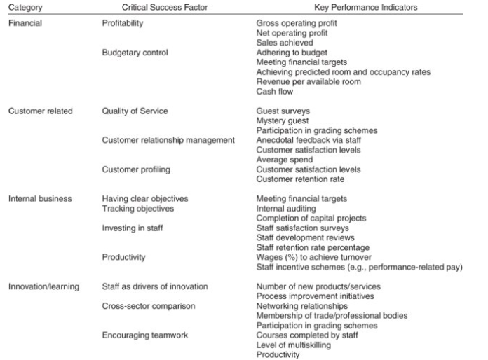
Sustainable what it means. Should have long lasting effects. Ethical management. Environment
Think about future threats and how to overcome them. Electric cars. Zero carbon energy efficient equipment.

6.0 Recommendations
You devised competitive strategy to accomplish business vision, how competitors may do same
What difficulty faced when implementing strategy? Finance Human Resources talent time consumption. Resist changes for fear of loosing position power. Deskilled need new training
Org culture, women staff diversity creativity innovation
Use available space in back of restaurant to cultivate and harvest fresh produce. Employ local people to maintain the garden. Reduce carbon footprint. Added value. Freshness, limited resources required to maintain garden
Increase capacity = renovate and make a top level available for dining. Although this will incur cost- it will increase the longevity of the business and meet the demands of the customers who want to dine in. at present COVID-19 restrictions limit maximum capacity.
Targeted marketing for vegetarians, Pescatarians and vegans. Also adopt a gluten free menu for customers with allergy, this will gain more market share and increase profitability.
Continue with current pricing strategy as customers have high disposable incomes. And the business can charge a premium price for superior quality of food and excellent customer service.
Issues: leadership style management not communicating effectively
Organisations culture. Beliefs. Selling pork. For customers.
Core competencies skills staff need training or replacement. As a result resistant to change
Use new technology
Finance

7.0 Conclusion

Businesses leaders and managers should be more proactive in how they operate and examine the economic forces, internal process to anticipate and future trends, identify the opportunities to gain competitive advantage as apposed to just reacting to events after they have taken place. When an external and internal analysis takes place the business is more alert and can predict changes in the environment and respond accordingly. Strategy is just about staying afloat on the business. Some business plan to leave an industry and other plan to merge or acquire new businesses. Without having prior knowledge they can not make the transition and may become bankrupt or the business might make a loss.
Why? strategic management? overall objectives are Two-fold 1. Create competitive advantage.

2. guide the business to navigate through the dynamic business environment. As changes are taking place constantly such as PESTLE.
Importance of Strategic management
- Proactive rather than reactive as markets are dynamic and unstable: ABLE TO ANALYSE AND TAKE ACTION AS OPPOSED TO BE A MERE SPECTATOR. UNEXPECTED CHANGES-TURBULANCE AND DISSONANCE. NOT GETTING CARRIED AWAY.
- Enhances the longevity of the business. STAY LONG IN THE MARKET AND FIGHT HARD.
- Corporate defence mechanism. SAFEGUARD INTEREST AND PRONE TO MORE RISKS. SM CAN ANTICIPATE CHANGES AND WITHSTAND SUCH BLOWS.CRORNOVIRUS.RECESSION/INFALTION/BEXIT.
- Framework for major decision: ALL BUSINESS PROUCTS. MARKET MANUFACTURING PROCESS AND ORGANISAITONAL STRUCTURE.
- Develop core competencies. UNIQUE CAPABILITIES. OF EMLPLOYEESS ASSSIT IN SURVIVAL AND GROWTH.—LEADING TO COMP ADVANTAGE.
- Define realistic objectives and goal for the business
- Helps to face future, pathfinder to various business opportunities.
BUSINESS THAT DO NOT FOLLOW A STRATEGIC MANAGEMENT CAN NOT BENEFIT FROM THE ABOVE.
Limitation: can be overcome.
- The business environment is highly complex(difficult to understand) and turbulent ( not stable and constantly changing)
- Time consuming process- create vision put it on paper- these activities may IMPEDE daily operations and negatively impact on routine business.
- Cost association: SM can be an expensive as different managers and experts required to take int account all possible scenarios. This will be difficult for an organisation with limited resources.
- Strategic estimation: it is difficult to clearly estimate the competitive responses to a firm strategic management. Implementation and Execution is critical!

Functional strategies 5
Marketing: delivering value to customer—marketing mix 4P !! 14 types of marketing-augmented, demarketing, person marketing, tourism, synchro marketing
Finance: how to raise funds/resources, budgets, evaluating business worth: net worth, sto
Human resources; hr manager: 7 points, core competencies competitive advantage, culture, achieves unique capabilities, ethical leadership.
Production
Inventory supply chain management: logistics-movement and storage of good- procurement , manufacturing, outsourcing, dales services and performance
Research and development: first firm to INNOVATE, intelligent imitation, mass production.

8.0 References
Type references here

