

Task 1 – Reading Task Template
Upload your photo of your A3 in-class notes here:
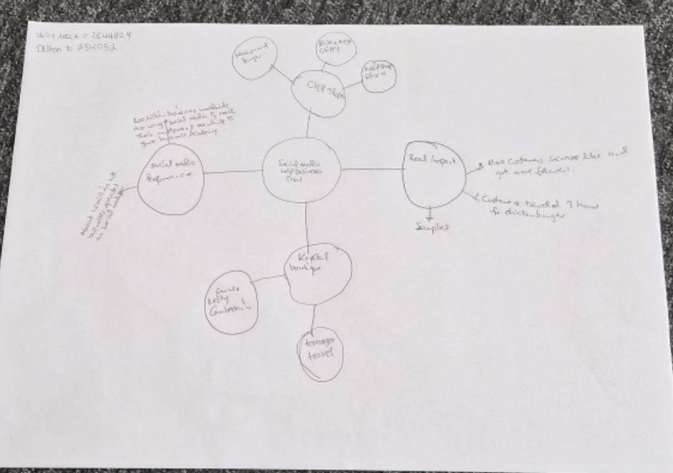

1. Answer these questions using the sentence starters below
a. What is the main idea of the text?
The main idea is that social media influence can turn small businesses around for success in a twinkle of an eye.
b. What are two key points?
One key point is that, with good customer reviews, videos and likes, social media platforms like TikTok and Instagram make businesses go viral.
Another key point is that any business videos that goes viral leads to increase in sales, number of followers as well as customers
c. What part of the text did you find most important? Why? The most important part is the example of the ‘Honeywood sandwich shop’ ‘’ customer travelled 3 hours for burger.
The most important because it shows the positive impact of social media.
d. Was anything unclear or difficult to understand?
I was not sure about any.
e. How did your group help you understand the text better?
My group helped me by all of us working as a team and putting ideas togethers.
3. One sentence reflection - The text shows how effective social media, by turning attention into business growth.
Question: What did you find challenging about this task?
The hardest part was that I find it challenging understanding the text in the first ten minutes of skimming through it.

