Assignment 1

You have been employed to provide a design solution for the construction of a square 16-storey building with three car-park underground floors at SA1 near the IQ building.

Civil Engineering Technology

ACBA5007

Prepared for
Dr Deborah Hughes

Completed by
Benjamin Davies (2012775)

Completed on
17/01/22

Table of contents

1.0 | Introduction | Page 3
2.0 | Excavations | Page 3 - 5
3.0 | Basement Construction | Page 6
4.0 | Drainage | Page 7
5.0 | Facades | Page 7- 8
6.0 | Conclusion | Page 8
7.0 | References | Page 9
8.0 | Appendices | Page 10-12

- Introduction

I have been employed by a construction company to provide a design solution for the construction of a square 16-foot building with three underground car parks at SA1 by the trinity university IQ building. In this assignment I will go through all of the excavation works that are going to be carried out, all of the drainage solutions that will be used, I will also go through the construction of the three basement car parks providing each stage of construction, I will also go through the vertical envelope where I will implement the type of façade that I will be using, insulations, and connections that will be needed while also providing how the facades can be deconstructed and replaced in the future.

2.0 Excavations

In construction, excavation is the process in which you remove earth to form a cavity in the ground, in small scale operations this is usually done with picks shovels and wheelbarrows, but as in our case with a large operation, it requires that bulldozers and more heavy machinery be used. (Holmes, 1994)

CDM Regulations 2015 requires that we must take all necessary steps to ensure the safety of all workers so we must have supports to safely ensure that the earth doesn’t collapse while excavating and cause major injuries or death. We will also be using vertical walls to support the earth. Due to the earth being excavated being a large amount which is around 20 meters due to 3 underground basements being built I have decided that we will be using bottom-up excavation

The bore holes have told us for the first 4 meters there is a layer of made ground, followed by 4 meters of dense sandy clay, followed by 10 meters of boulder clay, and finalised with grey mudstone for the next 10 meters.

Bottom-up excavation will be advantageous to us as it supports deep foundation construction, with this method the construction begins from the bottom to the top of the building, the process is that you first sink temporary diaphragm walls to the required 20m depth, then install temporary steel strutting to support the walls and then creating the hole with a concrete slab at the bottom which is open to the sky and the building then rises from the concrete base slab. Waterproofing can also be easily installed around the whole outside including the permanent walls.

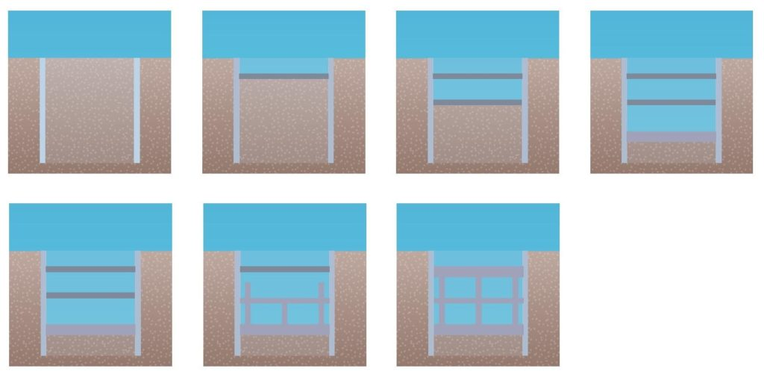
(Bottom-Up Excavation, Endicott)

It is necessary before construction that the ground is reasonably free from water, therefore the water must be blocked or carried away, for granular soils pumping methods are the most appropriate option, but for more medium to coarse gravels, the permeability of the material is too high for pumping so that’s where cement grouting may come into play, and at the lowest depth where clay sits, sumping is necessary because water seepage is then a problem. There are temporary and permanent options that we can consider, these are:
Temporary –
- Sheet piling
- Pumps
- Cofferdams
- Horizontal Drains
- Electro-Osmosis
- Ground Freezing
Permanent-
- Drainage
- Diaphragm Walls
- Slurry trench cut-off
- Thin grouted membrane
- Contiguous piling
- Pressure grouting
For this operation I have decided the best option is for the first 10m we will use Drainage systems, and for the 10m below that we will be using pressure grouting as it gets to thicker clay where nothing else would suffice due to the thickness of it
For this method of excavating, we will be using diaphragm walls to support the weight of the earth that’s putting pressure on it, diaphragm walls are excavated using rope hung on cranes and piling rigs, the jaws are mechanically operated, and the process is carried out under a support fluid which puts hydraulic pressure against the walls and prevents collapse on either side. The primary advantage of this is that it reduces the number of joints in the wall and improves water tightness, they are the best for deep excavations like ours because they take on high structural loads (Balfour Beatty, 2021)
They are constructed in a series of panels ranging from 3m to 7m and the width can vary between 600mm to 180mm which is perfect for what we need.

For safe removal of the soil, it would require that we acquire an earth moving plant that can transport the earth 5 miles away, we will need 3 of these for the high volume of earth that will be needed to move. We will be requiring highway dumper trucks which is the largest earth moving plant available and the capacities vary from 5 m 3 to 30 m3, this is the most suitable option for large sites like ours and they have the capability to dispatch earth over large distances which is ideal for what we need, the rear tipping is hydraulically operated, and the heaped capacity is normally 10 m3. (Chudley R., Greeno R, 2007)
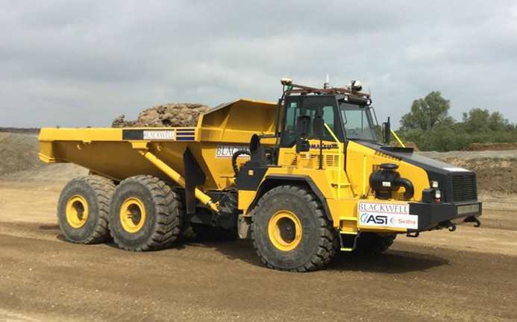

To ensure safety for workers, the excavation will be fenced off with a limited entrance to allow access and exiting the excavation, there will also be hazard signs, the excavation will be strictly examined at the start of every shift to ensure there is no water, cracks in the sides or collapsing risks. There will be a series of ramps going down to the lower depths upon scaffolding with barriers strong enough not to collapse if someone falls on them. There will be mandatory checks on the ground and retaining walls to make sure it doesn’t collapse. No plant or materials will be near the excavation edges to ensure it doesn’t collapse due to the heavy weight being applied to it, and finally there will also be mandatory site analysis after any significant event which affects the stability and at the end of every shift.
3.0 Basement Construction
For the construction of the three basements, you first must work out the types of basements they are. There are 3 types of waterproofing protection basements, that being type A, B, and C drainage. These types are suitable for different functions and require different specifications while being constructed. Type A, which includes car parks and plant rooms, allows some seepage and damp patches, Type B, which includes Housing, offices and leisure centres doesn’t allow water penetration, but water vapour can be present. Type C, which includes archives and controlled environment areas, allows no water to be present and must be a totally dry environment.

Due to the being car parks, I have worked out that they are Type A drainage Basements which allows some seepage and damp because there are no electrical components that could be damaged. Type A construction consists of a concrete slab and walls of reinforced concrete or blockwork with external, sandwiched or internal waterproofing. (Trotman, 2007)

The three basements will be stacked upon each other from the lowest depth, which is 20 meters, each basement will be 6.5 meters in length and 30 meters in width which allows an area of each basement to be 150m³. the first will be built upon the pre-existing concrete slab which allows for a raft foundation from excavation, with a ramp being built to allow access to the second basement, and then the second being built with access to the third and the third being built with ramp access to the street level and stairway access into the new building. There will be adequate ventilation to each basement with extract and jet fans being on the ceiling of each. There will also be drainage into sump pumps which access the sewage system to decrease water build-up on each basement level.

The basements will be built first in our construction because of the bottom-up system of construction, and will take around 20 weeks until completion, and will be a foundation for the 16-storey building to be built upon, it will be built with concrete and will be structurally integral enough to support the load being applied onto it by the building. The structural retaining walls will have external and internal waterproofing with a tanked protection and all joints will have water stops as seen in figure 1. The upper floors will act as roofing for the basements and will be reinforced concrete.

4.0 Drainage
The excavation will be drained with grouting method because of how thick the earth gets at the deep lower levels, and how the basements will have sump pumps built into the drainage system and how the walls will be waterproofed externally and internally. The building itself will have guttering on the roof, as required by Building Regulations Approved Document H, to capture water running down the roof to take it into vertical pipes that release it onto the street level discharging it into the water sewers, these are made of PVC plastic. They will have 2 drainage points on the roof to mitigate in case of blockage and water ways to connect to put the water into the sea as the sea is in very close proximity to the area. Each floor will be fitted with cast iron pipes to reduce noise due to the density of it and its ability to take on large loads of water and there will be 16 toilets with a one per floor basis, each will be set to join into the sewage pipe and the sinks will be fitted into water waste pipes.

5.0 Façades
The façade is basically the face of the building, and many would think that the only function of this is for appearance, but that’s just one part of it. Façades don’t bear any load beyond their own, they instead support the building, they are usually appreciated for their appearance but above everything they most importantly provide vertical and lateral resistance to wind and other elements. They play a massive role in the aid of enhancing weather, thermal, acoustic and fire resistance as they are the first thing these elements will encounter when put upon the building.

They eliminate water ingress through a water cladding system that prevents water seeping into the building structure which can cause damp,
Water damage, frost damage, rot, and potential building collapse, this can be prevented by water cladding which is basically putting a layer of material like wood, metal, brick etc over the insulation and a face sealed system which seals of any cracks and eliminates any holes that the water can potentially seep through.

It also can control air permeability as most buildings are designed to be airtight which can help control how much air comes in and out of the building and can stop heat and cooling losses

Wind resistant construction is also vital because a building must incorporate the right materials like brick, concrete etc to protect the building from being hit by large gusts of wind as it can cause damage or the building to topple over, which can cause severe injuries and death, so it is vital that a façade should be able to protect us from these conditions.

Thermal and Acoustic insulation is also very important due to fact that the building could potentially absorb heat on a hot day and heat up the interior of the building to a substantially large amount so there must be an air cavity to allow air to flow to cool it down and there must also be a layer of insulation so that on cold days the heat from inside doesn’t escape to the outside and cause the interior to be too cold. A ventilated façade will reflect the external noise and improve the occupant in the interiors comfort (GoSmartBricks, T. 2019)

For our building I have decided that the best option would be to have an outer envelope of brickwork with wall ties to provide stability and wind resistance to avoid building collapse, this is even more supported by the strength of foundation that runs deep in the ground with the basements, an inner air cavity for air flow, an insulation layer for thermal resistance and an inner layer of concrete, I have provided a cross section in the appendix (Figure 2) that I have hand drawn myself. There will also be 80 double glazed windows on each face with 5 on each of the 16 floors that will be tested thoroughly for water tightness, and each will each be sprayed by a jet powered hose for 30 seconds to make sure no water can seep through. Each floor will be sub divided by a concrete beam which is reinforced by steel to allow the façade to be capable to have the ability to be deconstructed and adapted safely because the materials can crack and break and cause major damage so we must do this to allow the building to have the capability to be deconstructed.

6.0 Conclusion
I have gone through carefully each stage of the construction of the building and I believe that I have done well to explain how we can remove water from construction, how to excavate the area to allow basements to be built, how we can build the basements in the excavation, and how to build a strong façade to facilitate the height and load the building is applying and how to tackle the many elements that can damage the building. I have also provided a hand drawing of the full building construction after completion in figure 3.

7.0 References

(Holmes, 1994) 'Introduction to Civil Engineering Construction' (3rd ed.), HOLMES, R., College of Estate Management (1994)

(Endicott) Endicott, J. (n.d.). Digging deeper and smarter. [online] Without Limits. Available at: https://aecom.com/without-limits/article/digging-deeper-smarter/.

(Balfour Beatty) https://www.balfourbeatty.com/media/29507/diaphragm-wall.pdf

(Chudley R., Greeno R, 2007) ‘Building Construction Handbook’ (6th ed.)

(Trotman, 2007) Basement construction and waterproofing: Site investigation and preparation. Trotman P. (2007)

(GoSmartBricks, T. 2019) What Is a Façade and Its Top 6 Functions? [online] Go Smart Bricks. Available at: https://gosmartbricks.com/what-is-a-facade-and-its-top-6-functions/ [Accessed 17 Jan. 2022].

8.0 Appendices
Figure 1
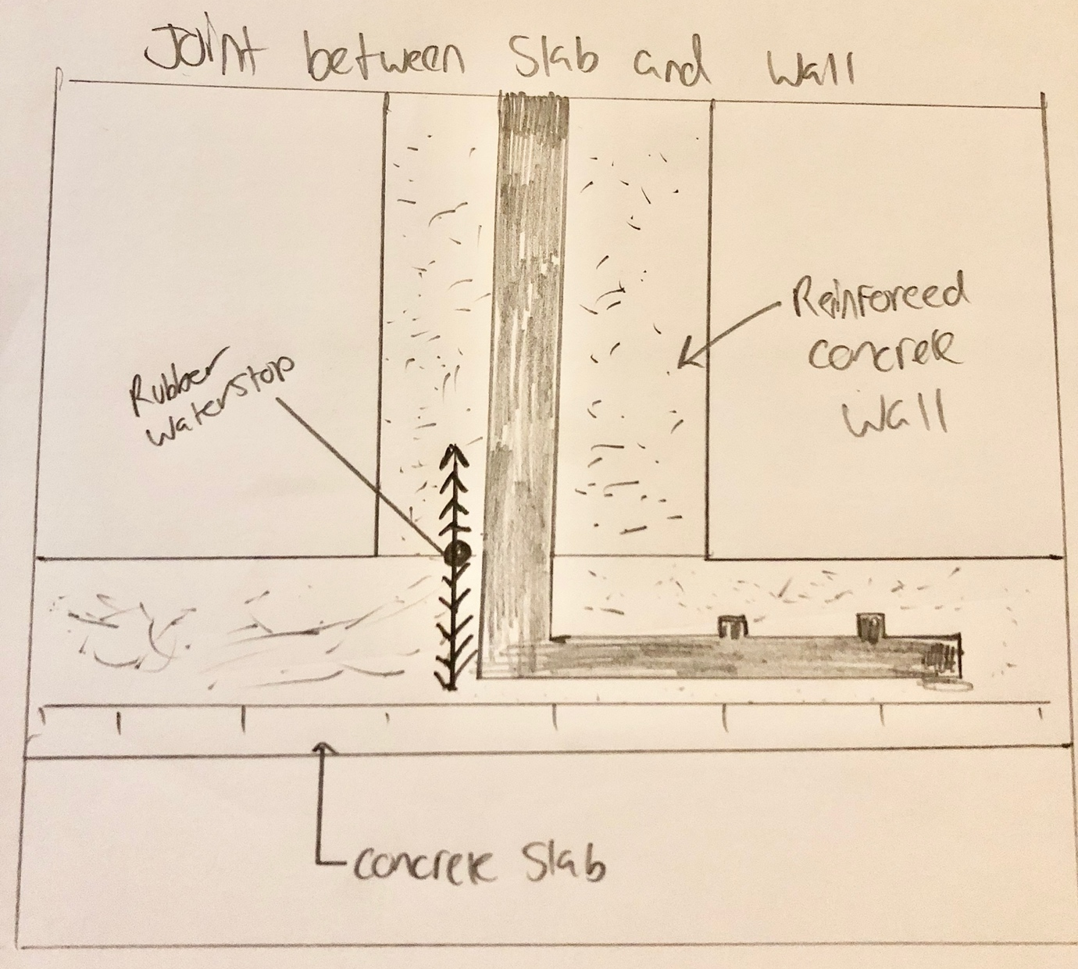

This is the cross section of a joint in the basement between the concrete slab and wall that shows the precautions we take by installing water stops in each one. This was hand drawn by me.

Figure 2
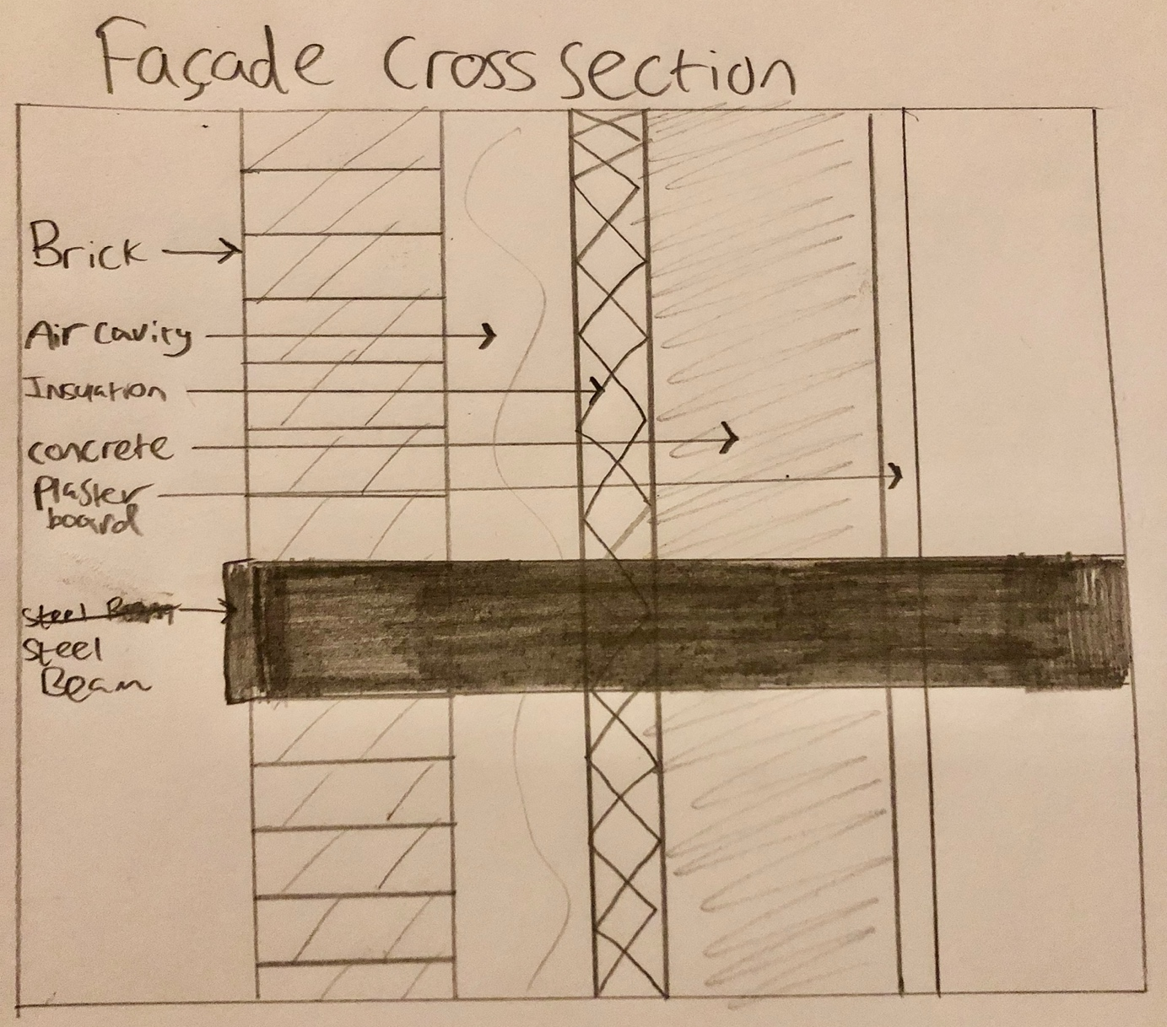

This is a cross section for the façade, it has an outer layer of brick, an inner air cavity, a layer of insulation, an inner concrete layer finished with plasterboard for the interior, this is personally hand drawn by me.

Figure 3
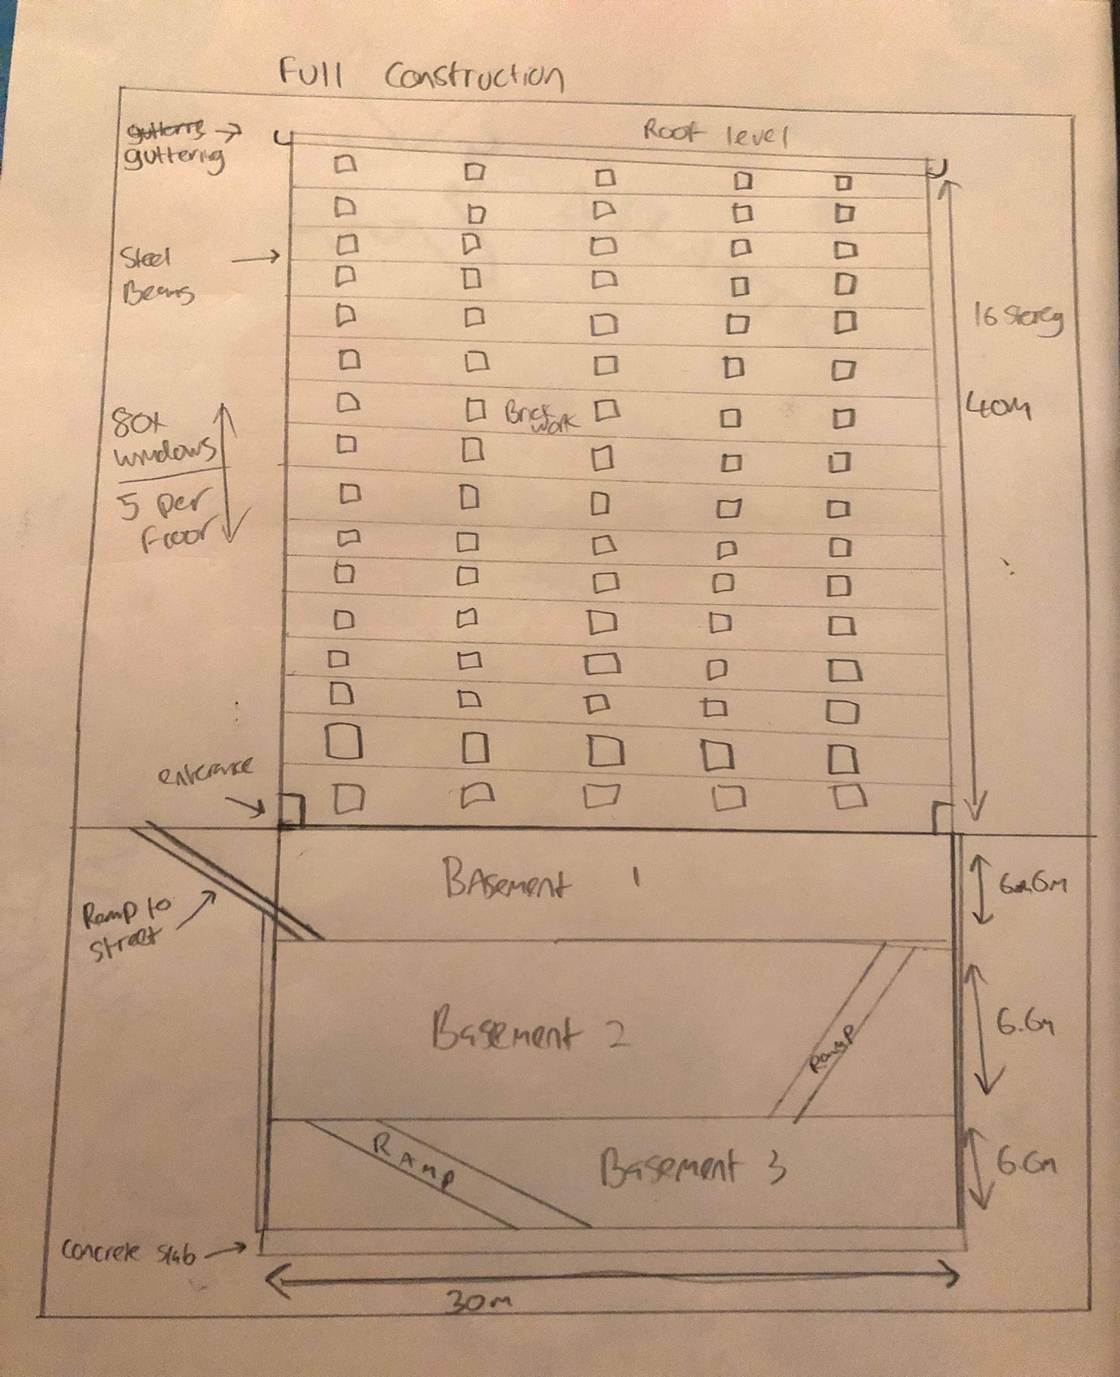

This is a hand drawn picture by myself of what I believe final construction will look like with the 3 basements being shown along with the 16-storey building completed with measurements

