Restaurant Management and Types of Services
Student Number: 2126978
Sayad Ahmed
Lecturer: Tristan Hawkins
Module Title: Food and Beverages

Introduction:
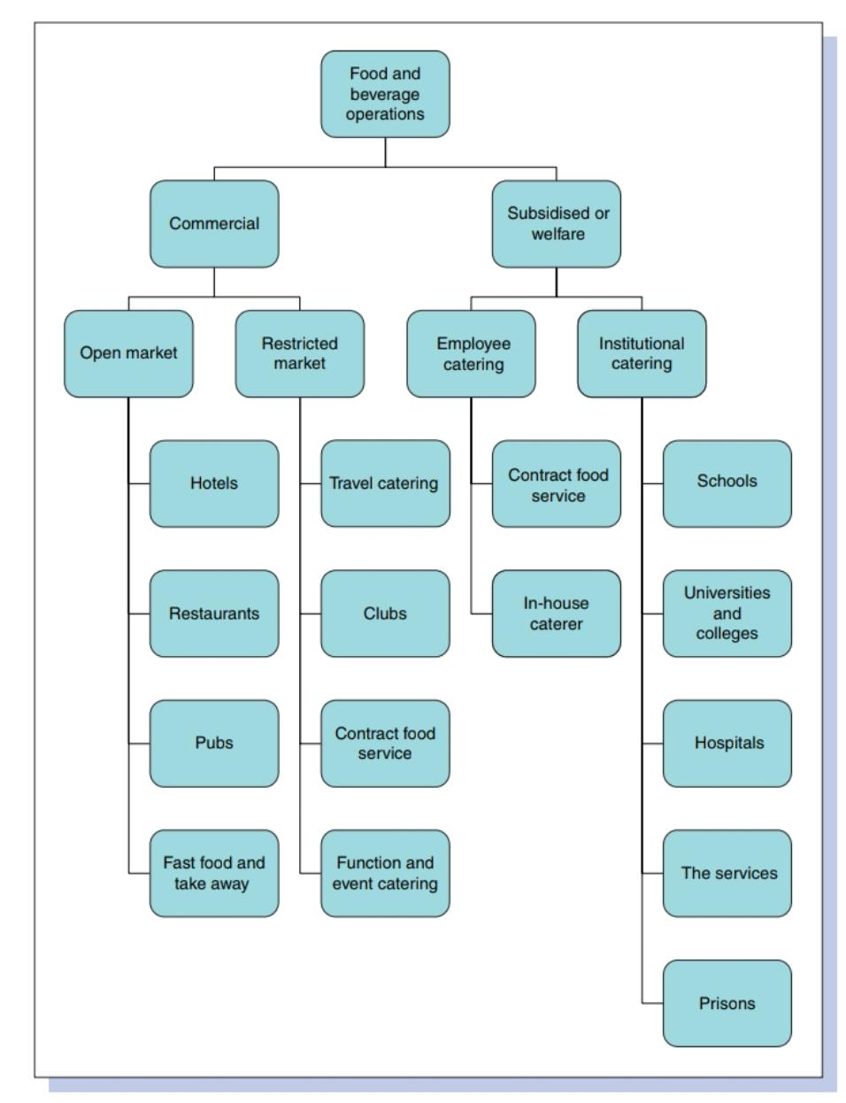
Whenever or wherever, there is a group of people there will be the provision of food, beverages, and residence away from home. That's called hospitality. Hospitality covers all sectors of hotels, catering, and food services (John & Suzzanne, 2018). There are two possible discrepancies between food and beverageoutlets. One is based on the operation such as commercial (such as Restaurants) and subsidized and the other is based on the market served (Bernard et. al., 2008).

Restaurant Management:
To lead a restaurant successfully and progressively it has to be supervised very efficiently, in which the roles and responsibility of manager should be well defined (Martjin & Suzanne, n.d).

Responsibilities of Restaurant Manager:
- To supervise daily functions effectively.
- To provide quality food to satisfy the customer.
- To listen to and remove customer’s complaints effectively.

Key Points for Restaurant Management:
- A manager has to manage in a way that causes profit and progress for the restaurant as well as his career too.
- Management is incomplete without its staff so one of the key responsibilities of a restaurant manager is to recruit, train and review the performance of its staff.
- Management runs effectively when it is working as one team so a manager has to make sure that its team is dispute or conflicts free.
- If the restaurant a 24/7 service, then ensure shifts and organize them properly. To motivate its staff to raise their morale and productivity. Also, to make sure availability of all resources. To make sure it complies with food and accommodation safety guidelines.
- To manage the good image, he has to work on cost-effectivenessand also promote marketing of the restaurant by providing schemes (discountsand offers) and managing events (like valentine’s day, Christmas, orany other special day)increase the number of customers.Keepimprovising policies to keep progressing in the market.
- Designing the menu in a way that attracts customers and brings innovation into it.
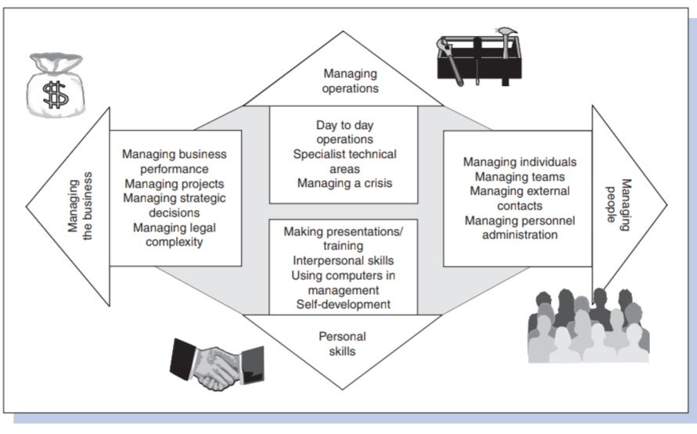
- It is also necessary to include your team while decision-making so they feel included.
- Prepare an annual review and have meetings to interact with teamto gain knowledge of their hurdles regarding work as it assists in managing operations efficiently.

Constraints during Restaurant management:
There is external and internal factors causes complexity in management. External factors could be government legislation that bounds the organization to a certain limit. Similarly, the raising cost and inflation causesan impact on budgeting and profit. Social impact on management like the diversity of food fashion in which takeaways and home deliveries are preferable than dine in. Increases in mechanical demands for food production raise the cost requirement for types of machinery (Stephanie, 2020).
Internal factors are those which originate within the organization and can be resolved by taking proper measures like depletion of food stock or wastage of excessive food. Similarly, shortage of staff due to any reason could be illness or any personal matters or inefficient staff.

Types of Services:
There are different types of food and beverage service.

- Dine-in services:
It is a service where people come in to have service which is provided by waitersthis includes everything from food to its payment.
Advantages and Risks: This service is more personalized as you can fulfill the special demands of customers. It limits food wastage as each plate is of the same size. Miscommunication is also reduced due to single table orders having to be dealt with.
But in this service, there is a chance of miscommunication between the kitchen and the orders placed which can impact on restaurant's reputation.

- Chinese Banquet Service:
In this service single waiter is assigned to 10 to 12 customers or groupsof tables and dishes are usually common.
Advantages and Risks:
Orders are given before coming to the restaurant makes it easy for waiters as it reduces the risk of making mistakes in receiving orders and also because dishes are common to eat.
If staff is not skilled it may cause customer dissatisfaction as multiple orders have to be served at a single time.

- Buffet Restaurants:
Buffet service is a service in which food is displayed on a table and the customer is served itself. There are several types of buffets like a buffet where beverages are provided by customers called station-type buffet similarly cutlery and beverages are served in modified deluxe buffet while in deluxe buffet appetizers are also served.

- Self Service/ Semi Self Service:
In this services cafe and fast-food chains are included where orders are given already and only collected at counters or inn semi service served by waiters.

References:
- Bernard D., Andrew L, Peter A, & Loannis S. Panteidis (2008). “Food and Beverage Management”. International Journal 4th edition Slovenia: Elsevier.
- Indeed for employees. (2022) Restaurant manager job description: Top duties and qualification URL: https://www.indeed.com/recruitment/job-description/restaurant-manager[Date Last Accessed: 23rd October, 2022]
- John C. & Suzanne W. (2018) Food and Beverage Service Level 2 London: Hodder Education
- Martjin B. & Suzanne W. (n.d) “Restaurant Management: Everything You need to know” URL: https://www.revfine.com/restaurant-management/ [Date Last Accessed: 23rd October, 2022]
- Resources for Employee. (n.d) Restaurant Manager job description URL: https://resources.workable.com/restaurant-manager-job-description[Date Last Accessed: 23rd October, 2022]
- Stephanie Schalow. (2020). “8 Critical Restaurant manager responsibilities” URL: https://sevenrooms.com/en/blog/8-critical-restaurant-manager-responsibilities/[Date Last Accessed: 23rd October, 2022]
- The Restaurant times. (No date) A complete Restaurant management guide for a smart Restaurateur URL: https://www.posist.com/restaurant-times/restro-gyaan/restaurateurs-guide-restaurant-management.html[Date Last Accessed: 23rd October, 2022]
- Unilever Food solutions. (n.d). “5 types of Food service”s URL: https://www.unileverfoodsolutions.com.ph/free-courses-academy/menu-planning/service-service-service/5-types-of-service.html[Date Last Accessed: 23rd October, 2022]
- Victor Delgadillo. (2021) Types of Restaurant Services: which style should you use URL: https://www.waiterio.com/blog/en/types-of-restaurant-services/[Date Last Accessed: 23rd October, 2022]

