Module NaMe: Introduction to Web and Database Concepts
Module Code: ACCA4023
Lecturer: Suneth Fernando
Trinity saint david University of Wales (London Campus)

11/12/2025
Assessment
PORTFOLIO REPORT ON INTRODUCTION TO WEB AND DATABASE CONCEPTS

Mohammed Hamid (2440293)
Student Name: Mohammed Hamid STUDENT ID:2440293


11/18

Table of Contents
Introduction 3
Task 1: Implementation Guide: 3
Scenario Analysis 3
Entity-Relationship Diagram (ERD) 3
Data structure Development 3
Normalization Compliance 3
Sample Data Population 3
Query Development 4
Validation and Testing 4
Conclusion 4
References 5
Appendices 6
Appendix 1: Draft work 6

Introduction
This document presents the design and implementation of a small relational database for Eco Ride, an electric bike rental scheme operated by a local authority. The database aims to replace paper forms and basic spreadsheets with a structured system that supports registering riders, maintaining bike records, recording rentals, and tracking staff involvement in maintenance and inspections.
The document covers scenario analysis, entity-relationship modelling, data structure development, normalisation to Third Normal Form (3NF), sample data, practical queries, and validation and testing of the implemented solution.

Task 1: Implementation Guide:

Scenario Analysis

EcoRide is a green transport initiative offering electric bike rentals at several public locations such as parks, train stations, and university campuses. Riders can scan their ID at a rental point, take a bike, and return it to any EcoRide station. The current system relies on paper forms and simple spreadsheets, which makes it difficult to track which bikes are available, in use, or under maintenance and to produce accurate reports.
Based on this scenario, the following main entities and attributes have been identified:]
- Rider
The Rider entity stores details of people who use the EcoRide bike rental service.
Entities: | Rider
Attributes: | - Rider ID (primary key)  - FirstName  - LastName  - Email  - Phone  - ID Number  - Date Registered  - Status
Fig 1

- Station
The Station entity represents each EcoRide location where bikes can be rented from or returned to.

Entities | Station
Attributes | - Station ID (primary key)  - Station Name  - Location Description  - Capacity
Fig 2

- Bike
The Bike entity stores information about each individual electric bike in the scheme.

Entities | Bike
Attributes | - Bike ID (Primary Key)  - Bike Type  - Serial Number  - Purchase Date  - Condition Status  - Current Station ID  - Is Active
Fig 3

- Staff
The Staff entity represents employees or technicians who work on the EcoRide system, especially those involved in maintenance and inspections.

Entities | Staff
Attributes | - Staff ID (Primary Key)  - FirstName  - LastName  - Role  - Email  - Phone
Fig 4

- Rental
The Rental entity records each individual bike rental transaction, from the moment a rider takes a bike until it is returned.

Entities | Rental
Attributes | - Rental ID (Primary Key)  - Rider ID  - Bike ID (Foreign Key)  - Start Station ID  - End Station ID  - Rental Start Date Time  - Rental End Date Time  - Duration Minutes  - Total Cost Payment Status
Fig 5
- Maintenance The Bike Maintenance entity records maintenance, repairs, and inspections carried out on bikes.

Entities | Bike Maintenance
Attributes | - Bike Maintenance ID (Primary Key)  - Bike ID  - Staff ID  - Maintenance Date  - Maintenance Type  - Description (text)  - Cost  - Next Service Due Date
Fig 6

Entity-Relationship Diagram (ERD)
The ERD diagram from MS access for this database includes entities: Rider, Station, Bike, Staff and Rental.
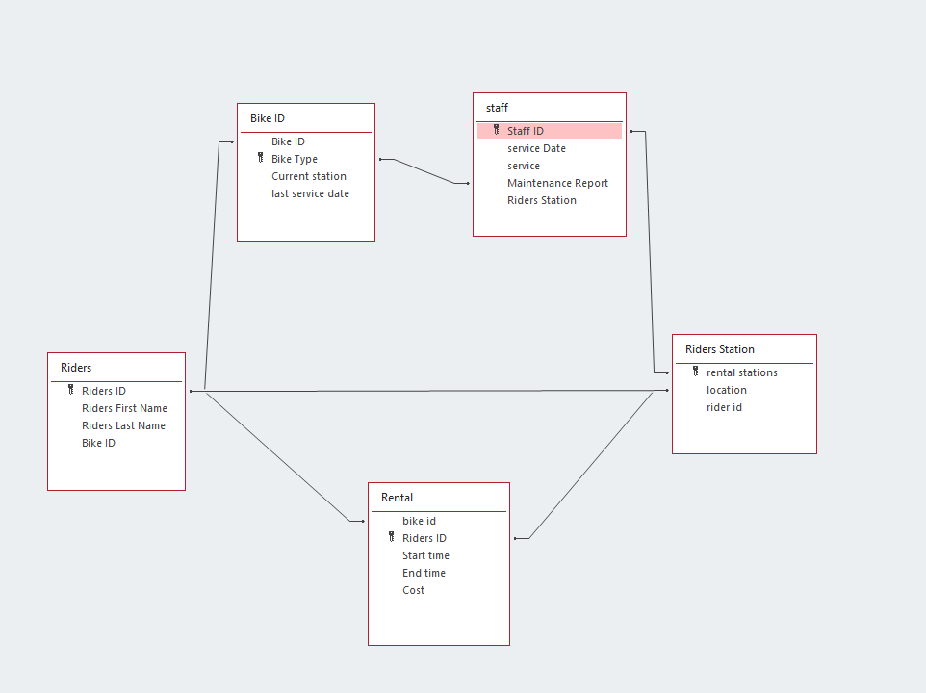
Fig 7
The primary keys and foreign keys are defined as follows:
Entities | Primary key | Foreign key
Rider | Rider ID | Rental ID
Station | Station ID | Location description
Bike | Bike ID | Current Station ID, Station ID
Staff | Staff ID | Maintenance Report
Rental | Rental ID | Rider ID, Bike ID, Start Station ID , End Station ID and Station ID
Bike Maintenance | Maintenance ID | Bike ID, Staff ID
Fig 8
The appropriate Cardinality and Relationships:
Entities | Cardinality
Rider | One Rider can have many Rentals (1: Many between Rider and Rental).
Station | One Station can be the start or end point for many Rentals (1: Many between Station and Rental via Start Station ID and End Station ID).
Bike | One Bike can appear in many Rentals over time (1: Many between Bike and Rental).
Staff | One Bike can have many Bike Maintenance records (1:Many between Bike and Bike Maintenance)
Rental | Many rentals can appear to one bike (many:1)
Bike Maintenance | Many maintenance records can appear to staff ID (Many: 1)
Fig 9

Data structure Development
Step 1 :The highlighted circle indicates when you create your field you’ll have an option for the type of data needed to ensure Data integrity.
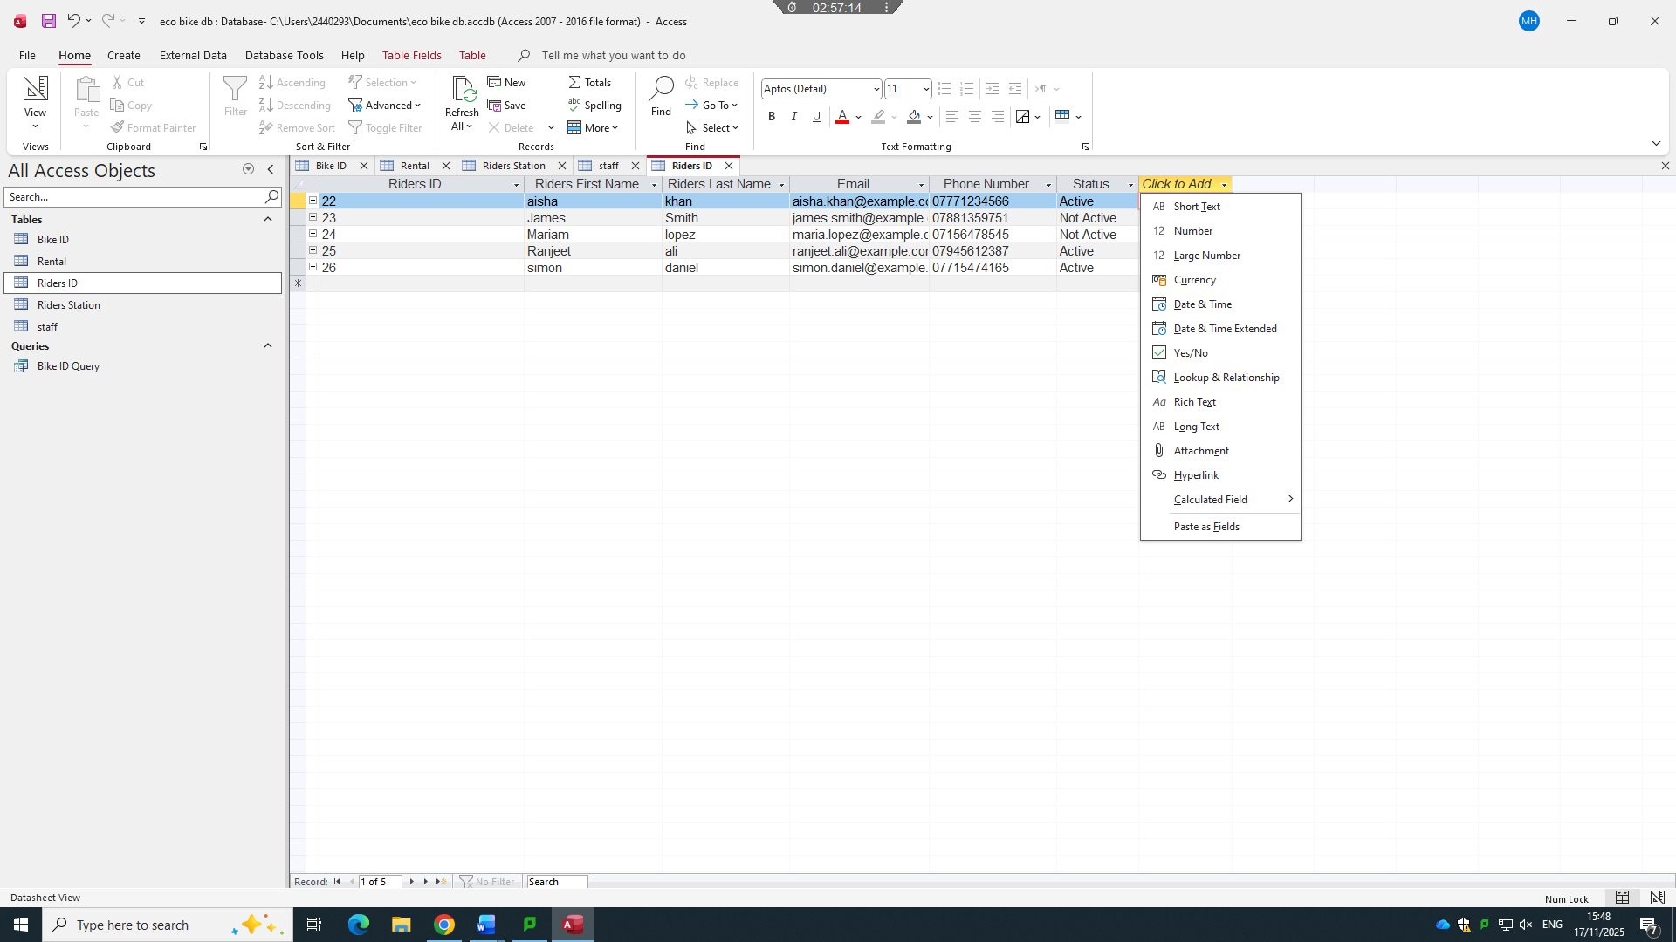
Fig 10
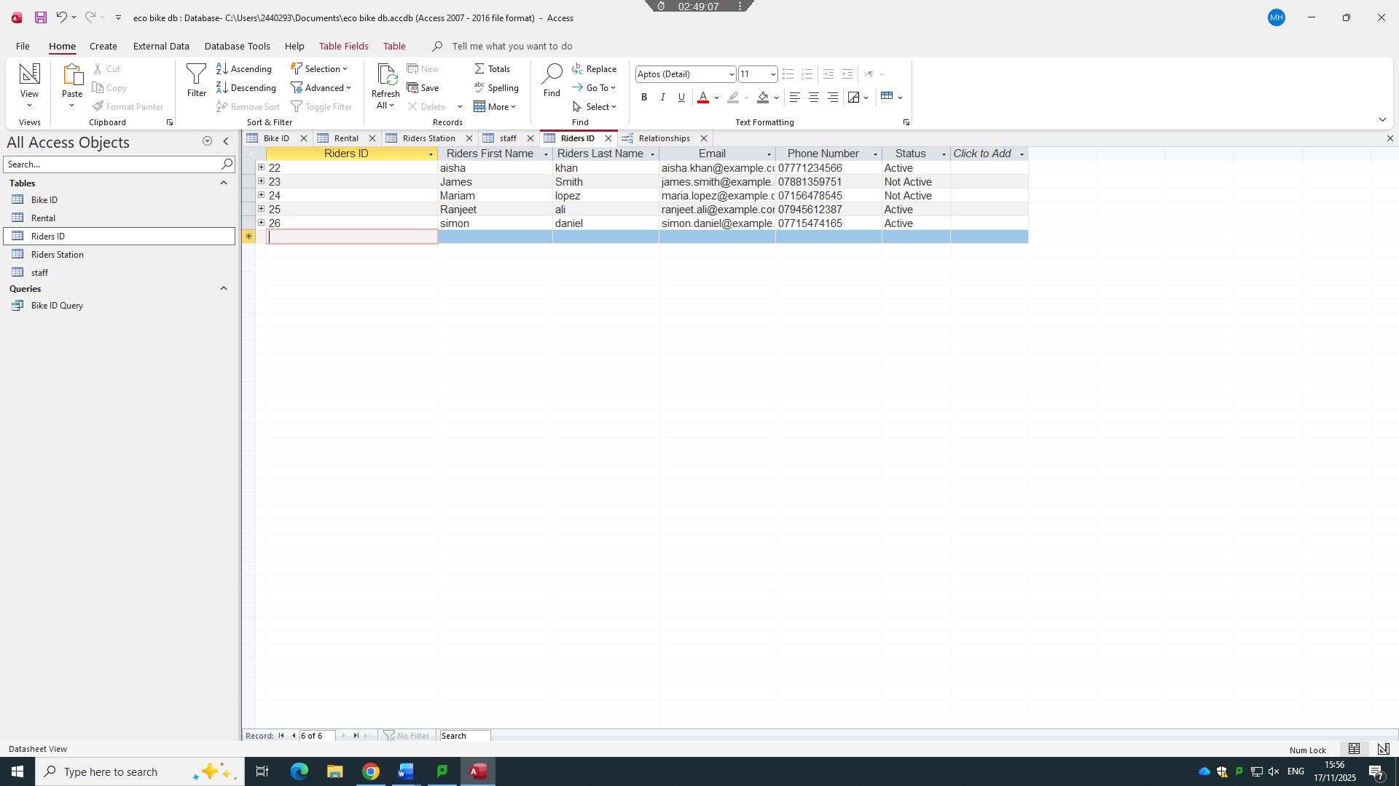
Step 2 :The highlighted circle on table one completed, here you can see Riders ID and their information, such as name, email address and status. The Riders ID will act as your Primary key information/ Records.
Fig 11
Step 3
The highlighted circle shows I have created five tables with different entities
Here you can now see Bike ID , bike type, Current station and last service Date. I have completed 5 table.
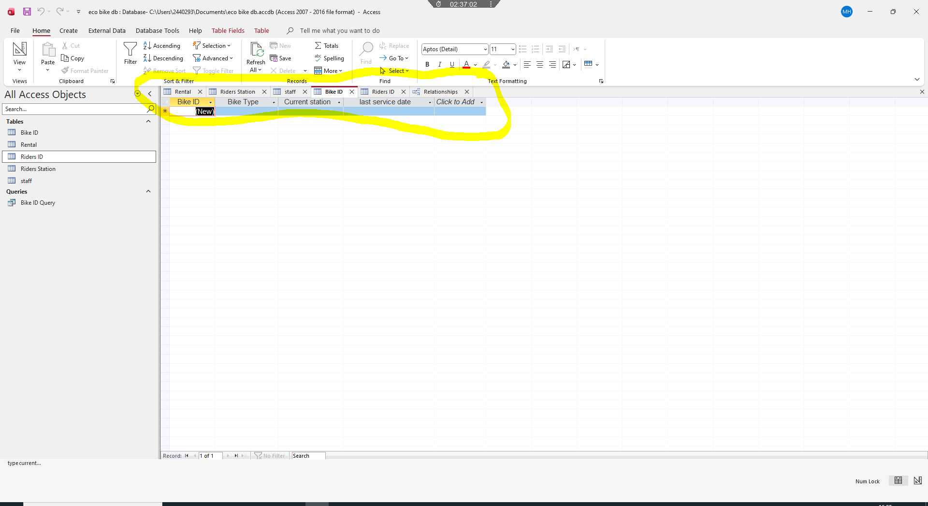
Fig 12

Normalization Compliance
Normalisation is used to reduce redundancy and improve data integrity. The final design of the EcoRide database has been structured to meet Third Normal Form (3NF). Normalization consequently eliminates potential data anomalies, while increasing the computational cost of read operations. Despite decades worth of applications of normalization theory, it remains largely unclear to what extent normalization affects database size and efficiency[1].

1. Unnormalized Form (UNF)

This is an unnormalized table displayed below :
Riders ID | Rider Name | Bike  Id | Bike Type | Station Location | Rental Start Date Time, | RentalEndDateTime | Total Cost | Maintenance Performed
X | x | x | x | x | x | x | x | x
X | x | x | x | x | x | x | x | x
X | x | x | x | x | x | x | x | x
X | x | x | x | x | x | x | x | x
Fig 13

In this table it will have rider details, bike details, station details and staff/maintenance information they are all repeated across multiple rows whenever a new rental is recorded.

- First Normal Form (1NF)

To achieve 1NF, repeating groups are removed and each attribute holds atomic (indivisible)
values. The Rental Form table is restructured so that each column stores a single value and
each row represents a single rental transaction.

Riders ID | Rider details | Bike ID, | Bike Type | Station Location | Rental Start Date Time, | Rental End Date Time | Total Cost | Maintenance Performed
x | x | x | x | x | x | x | x | x
x | x | x | x | x | x | x | x | x
x | x | x | x | x | x | x | x | x
x | x | x | x | x | x | x | x | x
Fig 14

Riders ID - Riders Details
Riders ID | Rider details
x | x
x | x
x | x
x | x
Fig 15 Riders ID - Bike ID
Riders ID | Bike ID, | Bike Type | Station Location | Rental Start Date Time, | Rental End Date Time | Total Cost | Maintenance Performed
x | x | x | x | x | x | x | x
x | x | x | x | x | x | x | x
x | x | x | x | x | x | x | x
x | x | x | x | x | x | x | x
Fig 16
This is the first step to breaking down the form I have made all riders details under the riders ID and put it in a separate table with the bike details and etc

3. Second Normal Form (2NF)
To achieve 2NF, the table must first be in 1NF and all non-key attributes must depend on the whole primary key, not just part of it. If a composite key were used, attributes such as Rider Name or Bike Type would depend only on part of the key. This leads to splitting the data into separate entities such as Rider, Bike, Station, Staff, Rental and Maintenance Log.

I have made a separate table for the Riders ID and Bike type with the transaction details
Riders ID Bike Type
Riders ID | Rider details
x | x
x | x
x | x
x | x
Bike Type | Station Location | Rental Start Date Time, | Rental End Date Time | Total Cost | Maintenance Performed
x | x | x | x | x | x
x | x | x | x | x | x
x | x | x | x | x | x
x | x | x | x | x | x

Fig 17 Fig 18
Now I have put them in another table which has the riders ID with the bike type for the rental
Riders ID | Bike Type | Station Location | Rental Start Date Time, | Rental End Date Time | Total Cost | Maintenance Performed
x | x | x | x | x | x | x
x | x | x | x | x | x | x
x | x | x | x | x | x | x
x | x | x | x | x | x | x
Fig 19

4. Third Normal Form (3NF)
To attain 3NF, the tables must be in 2NF and all non-key attributes must depend only on the primary key and not on other non-key attributes The final set of tables Rider, Station, Bike, Staff, Rental and Maintenance therefore
satisfies 3NF, with each non-key attribute depending solely on its table primary key.

For example,
- station location depends on Station ID so it is stored in the Station table
Station ID (PK) | Station location | Station Name

- Bike types details depends on Bike ID so it will be stored on Bike ID (Rental ID)
Bike ID (PK) | Bike type | Station location

- Staff details are stored in the Staff table and referenced from Maintenance they all depend on staff ID.
Staff ID(PK) | Staff name/last name | Maintenance log

Sample Data Population
The records include different rider names and contact details,
a mix of station locations, several bike types and conditions, and a set of rental and
maintenance events that reflect typical use.

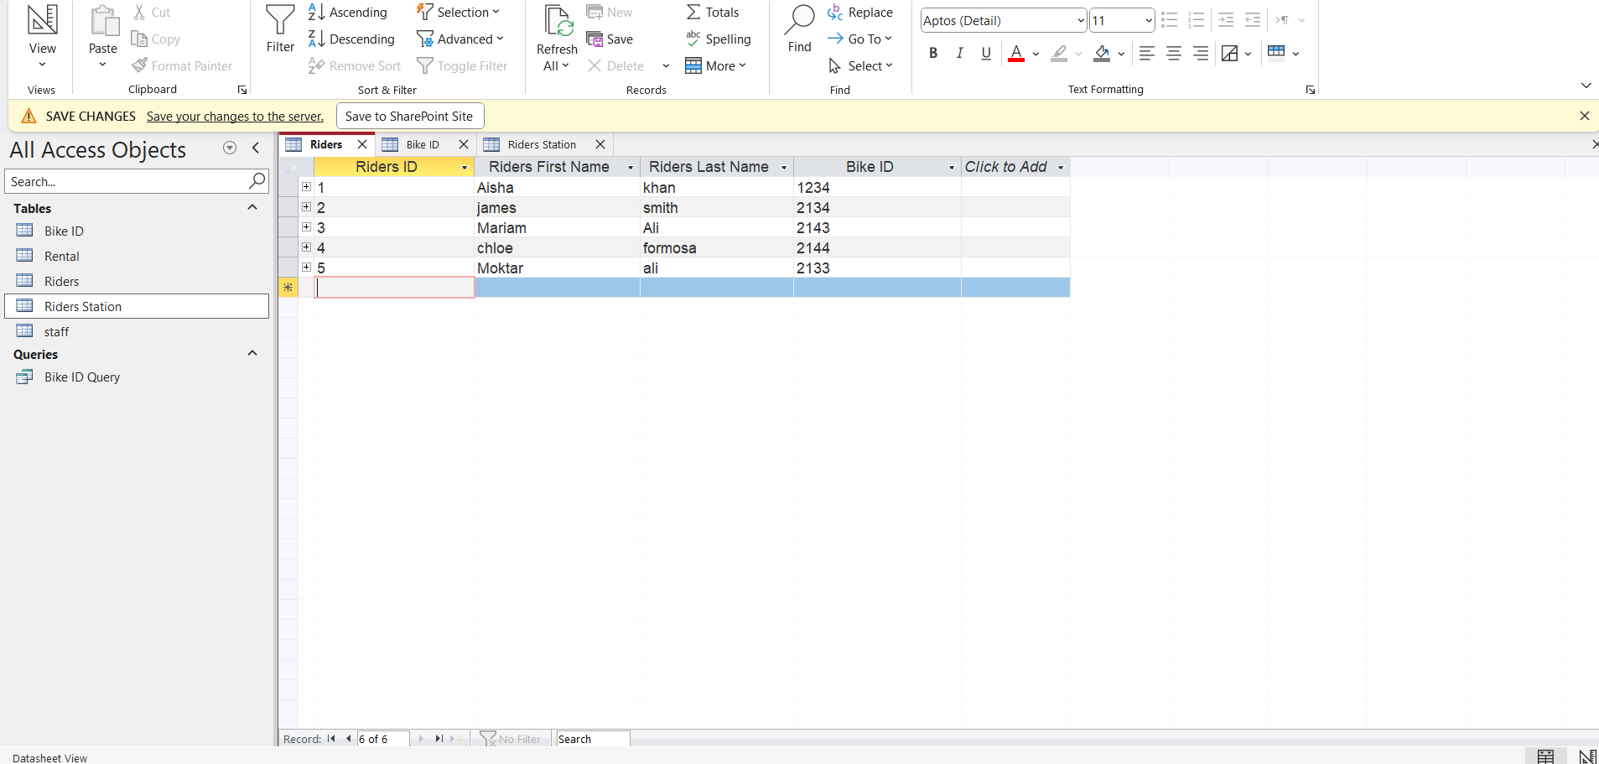
This screenshot below shows all Riders information
Fig 20

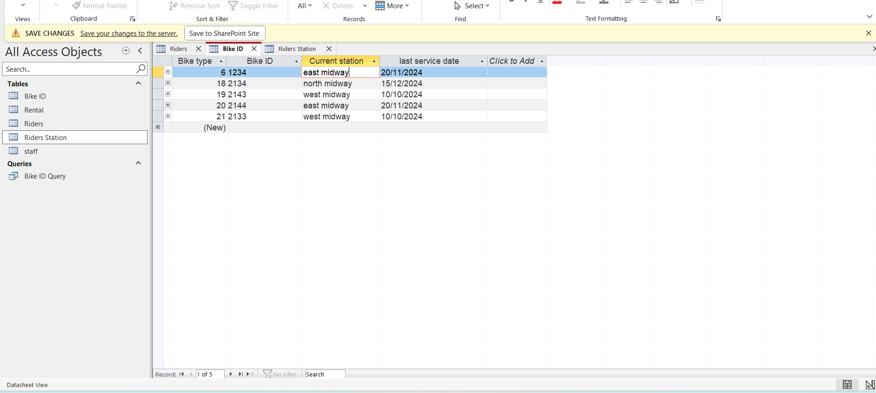
This screen shot below shows all bike information
Fig 21

This screen shot below shows all Station information
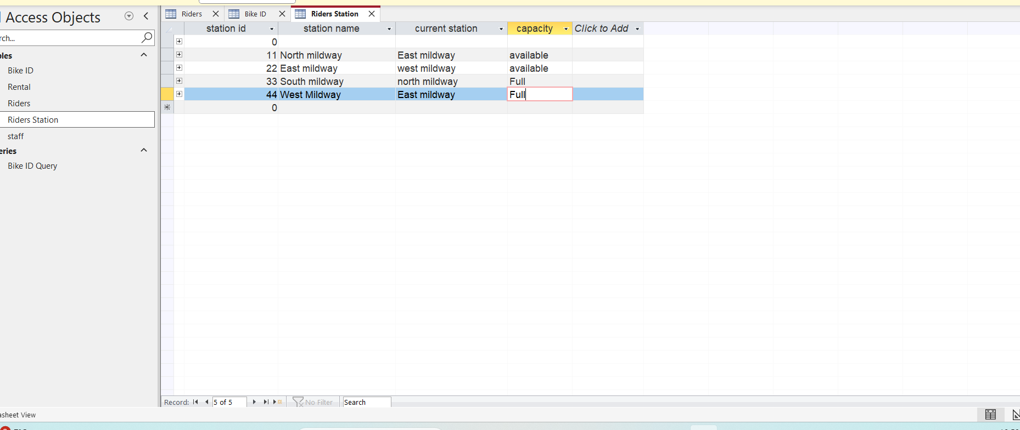
Fig 22

Query Development
This is step 1 for the development query I clicked on create then went to query design then I have inserted all the field to my query design at the bottom on the capacity column I have referenced on the criteria section to determined if any bikes are available or full at the current station
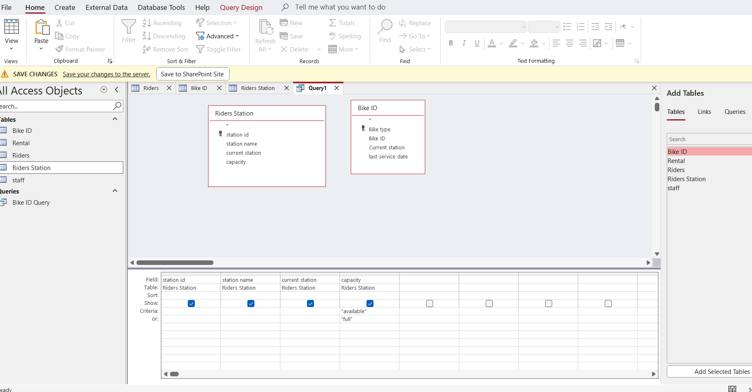
Step 2 has a list of the all the bikes that are available or full
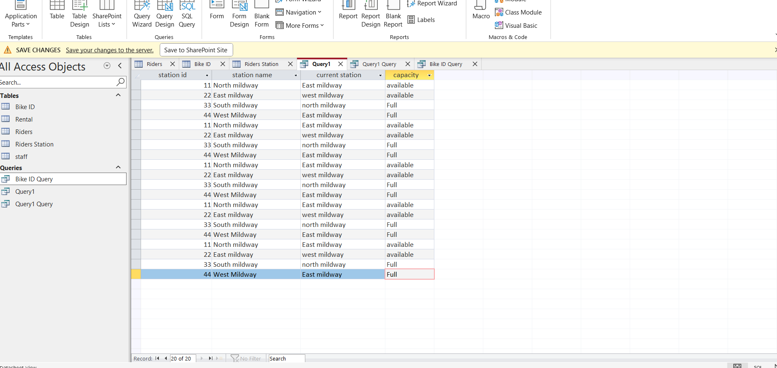

This practical query was developed to show how the database can be used to support
Eco Ride’s availability . These queries address typical information needs such as tracking bike availability, Bikes currently out on rental.

Validation and Testing

Entity | Field/Attribute | Validation Rule | Test Case | Expected Outcome
Bike | capacity | Values: "Available", "Full", "Under Maintenance | Setting a bike status to available when it’s not | 1. Should not allow availability without a rental record.
Station ID | Station ID | Must be unique, ID e.g. 11,22 | two stations with the same Station ID.  e.g. 22,22 | Should return an error for duplicate Station ID.
Riders ID | Rental ID | Must be unique, auto-generated | creating a rental record with an existing RentalID | Should return an error for  non-existent UserID.
Maintenance | Maintenance Status | Values: "Scheduled", "Completed", "Ongoing" | Set an invalid status (e.g., "Finished"). | Should reject invalid status values.

The completed EcoRide database has been validated and tested against the functional requirements to confirm that it meets user needs. Testing focused on three key areas: data integrity, functional behaviour and query correctness. While it is possible to succeed migrating a small and unsophisticated application design this kind of “shoot from the hip,” database migration projects of significant size and complexity are always better served by going through a rigorous series of data validation tests to ensure that all aspects of your data were migrated in a way that meets the organization’s expectations[2].

Conclusion

What I have learnt in this assignment will report the design and implementation of a relational database for the EcoRide electric bike rental scheme. Starting from the scenario, key entities and relationships were identified and modelled using an ERD. I also learnt about database structure which was implemented in a DBMS, normalised to Third Normal Form and populated with realistic sample data. Limitation I faced was the set of practical queries developed to support everyday operations such as checking
bike availability, identifying bikes due for service, reviewing frequently used bikes and
examining rider rental histories.
Validation and testing activities confirmed that the database meets the core functional requirements and maintains data integrity. This work demonstrates how a structured database solution can replace paper-based and spreadsheet-based processes and improve the management of a small transport scheme.

References

[1] [1] T. Taipalus, "On the effects of logical database design on database size, query complexity, query performance, and energy consumption," arXiv preprint arXiv:2501.07449, 2025.
[2] K. Kline, et al. , "Data Validation Testing," in Pro Database Migration to Azure: Data Modernization for the Enterprise, Springer, 2022, pp. 285–294.

