DS 1 Template

My Screenshots/Photos
- Please add 4–6 screenshots or photos of your digital life.
- You can use your phone or laptop.
- For each screenshot, write one or two sentences explaining what it shows.

Screenshot/Photo 1
[Insert Photo/Screenshot below]
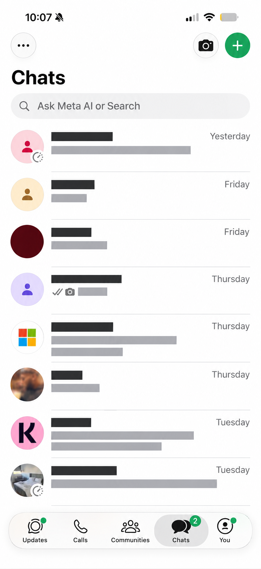
I use WhatsApp to communicate with family & friends. It can also be useful for businesses to communicate with customers and colleagues through its different features.

Screenshot/Photo 2
[Insert Photo/Screenshot below]
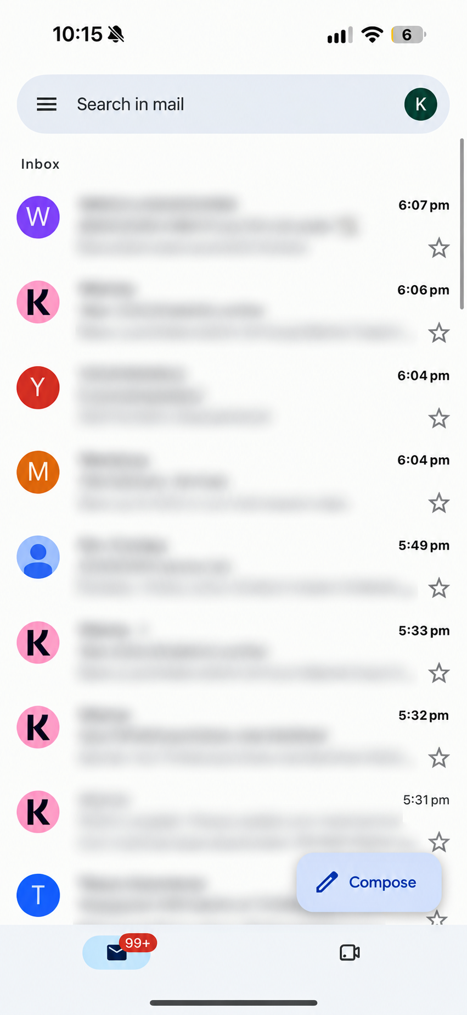
I use email, specifically Google Mail to receive important information & to communicate professionally if I have a enquiry/query. It can be useful to keep record of messages also.

Screenshot/Photo 3
[Insert Photo/Screenshot below]
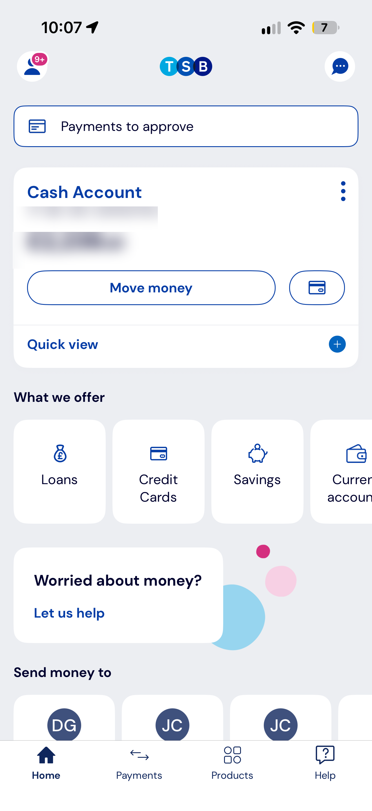
Online banking allows me to manage, check my account balance & make payments. It can also be useful to manage finances or any outgoings.

Screenshot/Photo 4
[Insert Photo/Screenshot below]
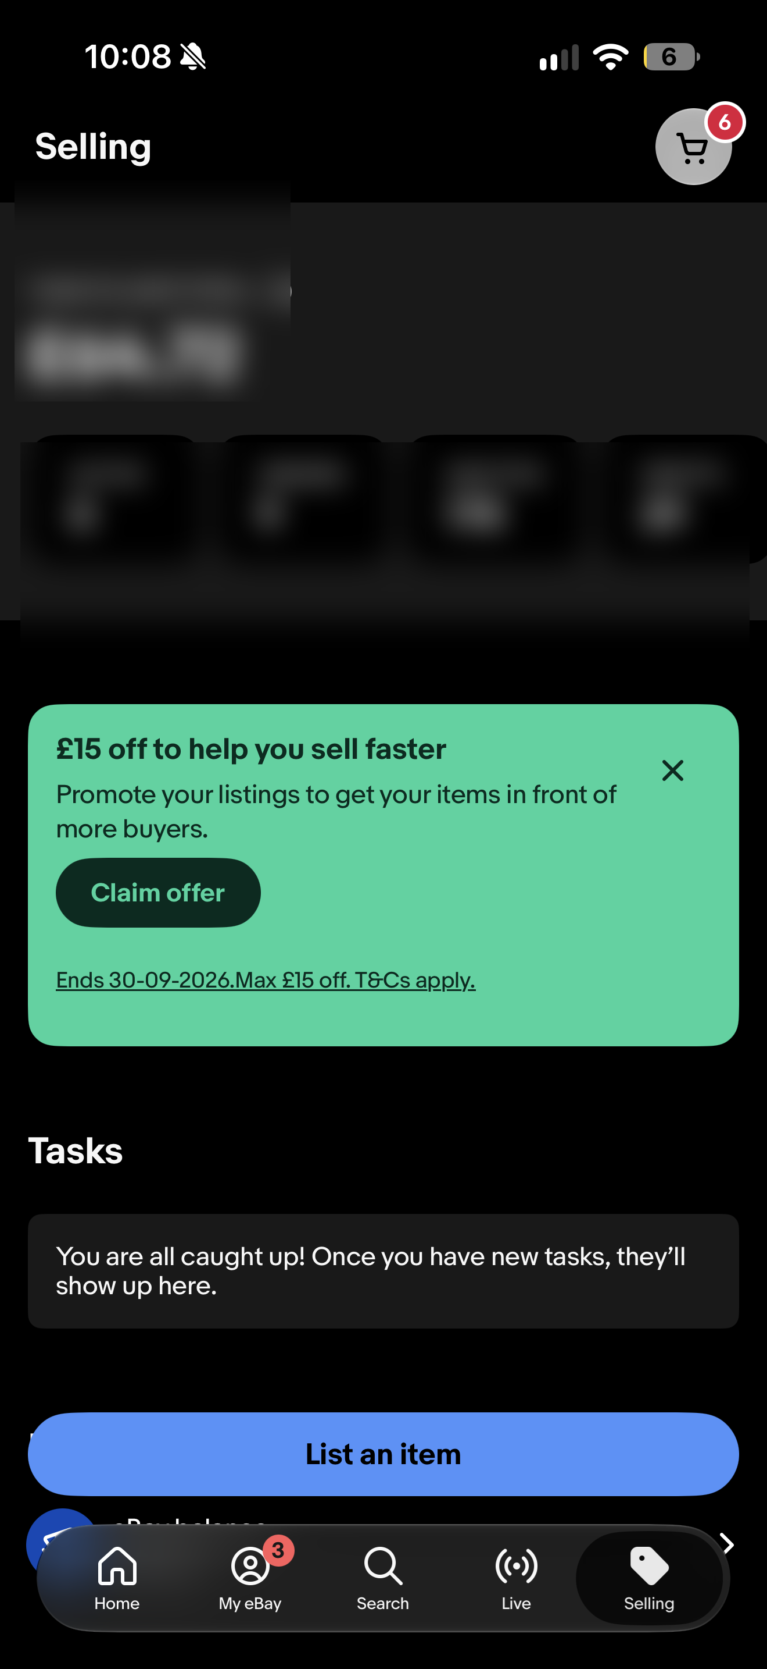
eBay is a platform I use for buying and selling items online. It has also helped me understand how online selling works, from finding the product itself to communicating with sellers & buyers.

Screenshot/Photo 5
[Insert Photo/Screenshot below]
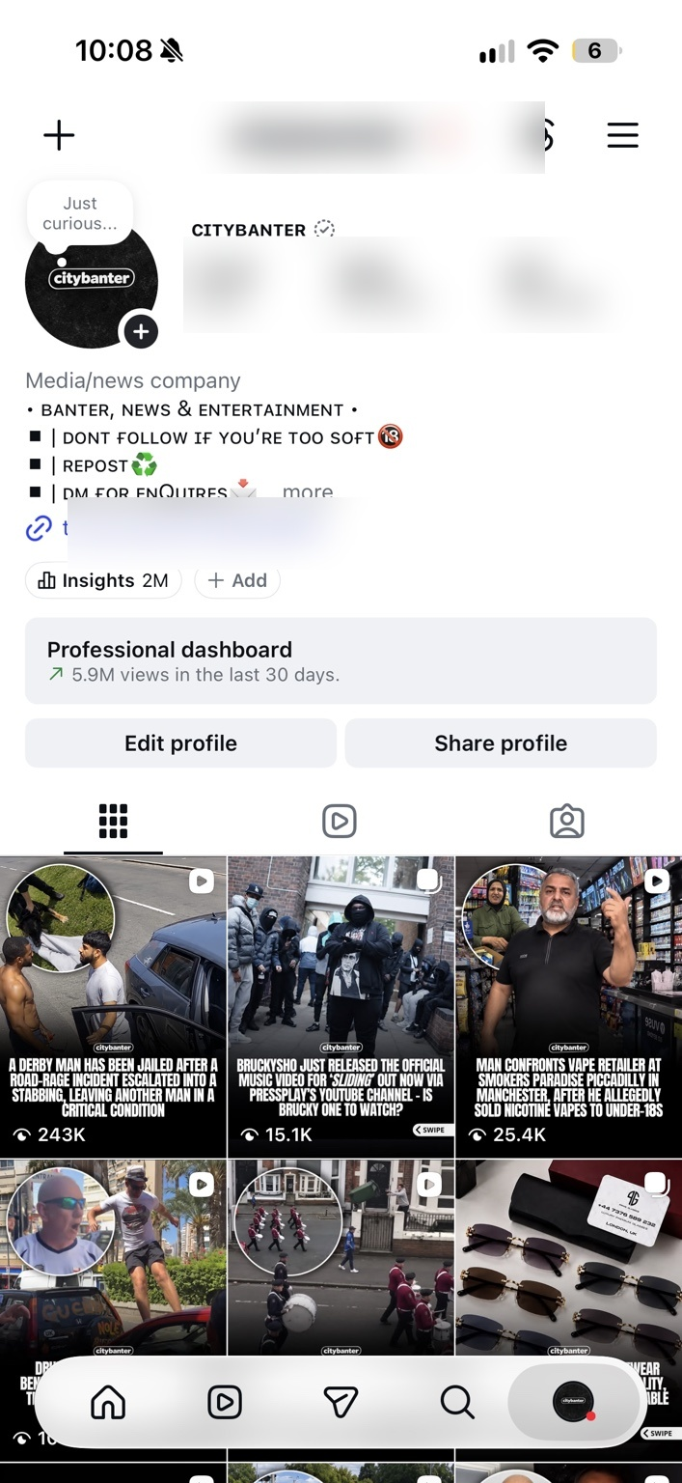
Instagram lets me share content, connect with people and promote products or companies. It can also help businesses advertise and reach new customers.

Screenshot/Photo 6
[Insert Photo/Screenshot below]
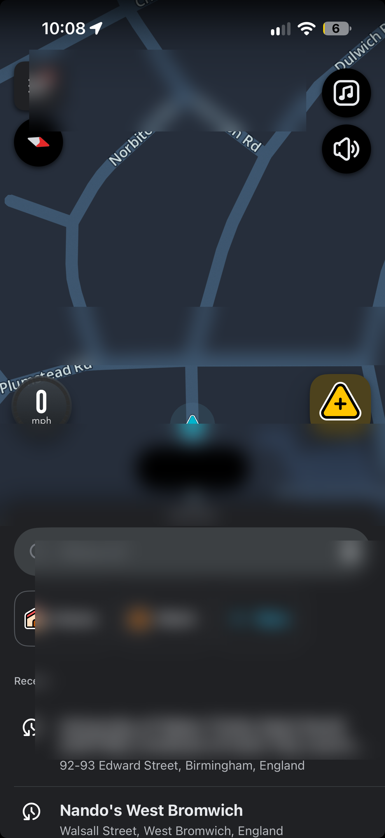
Waze is a part of my everyday travel, helping me plan journeys, find the quickest possible routes and avoid traffic. It can help businesses when travelling to customers or making deliveries.

My Short Reflection
- Write 5–8 simple sentences about your digital life.
- You can use the sentence starters below if helpful.
I use digital tools every day to talk to my friends and family.
I mainly use WhatsApp, email and Instagram.
I feel confident using technology because I’ve used it a lot since a kid.
I have always been interested in different apps and what they can do.
I often use online banking to check my balance and make payments.
I sometimes use social media to find new restaurants or locations I want to visit.
My phone makes everyday tasks easier for me, but sometimes I can spend too much time using it.
I want to improve my digital skills because technology is always advancing and I think it will help me in the future.

Sentence starters
- I use digital tools to …
- I feel confident when I …
- I want to improve …
- I often use these tools: …
- I sometimes feel nervous about …
- I hope this module will help me …
- Digital skills are important for me because …
You can write more if you want.

Submission Checklist
Before you submit, please check:
​​​ ☐ I added 4–6 screenshots
☐ I wrote short sentences for each screenshot
☐ I wrote my short reflection
☐ My work is my own
☐ My file opens correctly
​​☐ My file opens correctly

