

Enabling Smooth Transitions in the Early Years

A Good Practice Guide for Practitioners

Handbook

1003350 Alexis Bater
EAEE4003

Contents
- Introduction p3
- Transitions in the Early Years p4
- The Needs of the Child p5
- The Role of the Adult p6
- Interventions p8
- Transitions Timeline for Flying Start p11
- Proposed Outcomes p12
- Reference List p13

“Good practice emphasises the importance of transitions being managed and planned carefully with a consideration of children’s needs and respecting parents as partners in supporting children’s learning and transitions. Successful transitions are dependent on a commitment from all staff involved in the process to develop effective communication systems and information sharing protocols.”
(Welsh Government, 2017).


Introduction

(Image: Montessori Academy, no date)

The aim of this handbook is for Early Years Practitioners in the Flying Start playgroup setting to fully understand and be able to provide effective support for the children aged 2-3 years in their periods of transition. This handbook has been written in accordance with current Government legislation, UNCRC and Flying Start outcomes.

The child must be held central during the planning of any transitions. Transitions between Flying Start provisions should aim to be continuous and smooth. The process needs to be pro-active, with all parties involved demonstrating their dedication and care for each child. (Welsh Government, 2017).

This handbook will explore relevant theories in child development and look at how these theories are incorporated into learning frameworks. The handbook will act as a guide for the practitioner in reinforcing these valuable ideas in their everyday practice at the setting and enabling seamless transitions from home to playgroup aged 2, and then onto school aged 3.

Transition in the Early Years

Transitions are key points of change in life. Transitions during the early years should be viewed by Early Years Practitioners as a journey rather than just an event. Practitioners must therefore understand the importance of transitions and how they can be supported effectively. (Early Years Matters, 2020).
Transitions are immense for children. It is imperative that the professionals working with children learn all about every individual child. Between birth and five years old, children learn more than at any other point in their life. If children are valued and supported correctly during this time in accordance to their individual needs, then this will also support them through life. (DfE, 2020). Children who are provided with sufficient support during early transitions learn the necessary skills to cope with change as they get older. Early years transitions should ideally be an opportunity for enthusiasm to learn but also with the sense of feeling safe. (Buckinghamshire Council, 2020).

Transitions involves new environments, new routines, new people, new activities. Transitions therefore require lots of new skill adaptations. It is vital to recognize the child’s identity, that is before the change, during the change and after the change. (Te Kete Ipurangi, no date).

Dunn (2019) states that for the young child’s brain to grow and develop, they require an adult to focus upon them, to be ‘tuned-in’ to their needs and wants. Sriram (2020), affirms that between the ages of around two to seven years old the brain goes through its first developmental spurt known as a ‘critical period’. It is during this period that humans have more synapses in their brain than at any other time of life, and this therefore means that humans can learn the most at this time. What happens during this stage of life will have a long-lasting impact upon what happens later in life. To support brain development, children require support in developing a interest to learn and an understanding of effort will gain more knowledge. Children need the opportunities to experience a wide range of activities, rather than focusing upon a particular skill set. Adults need to recognize that learning in the early years is essential and should not be treated as a forerunner to real education and must put importance upon emotional intelligence. Skills that need to be learned at this critical period are skills such as being kind, empathy, and teamwork. (Sriram, 2020).

The Needs of the Child

Maslow’s Hierarchy of Needs

Maslow (1908-1970) developed the theory of a hierarchy of human needs. In the form of a pyramid, at the bottom it states the basic physiological needs for a human to survive and working up the pyramid it adds levels of needs based upon security and relationships to enable a human to thrive. (Pichẻre, 2015). Early Years Practitioners can apply this to the needs of the children within the setting. They require physical care of course; however, it is the relationships they develop and the support and opportunities they are given to enable the children to gain the most benefit from attending.

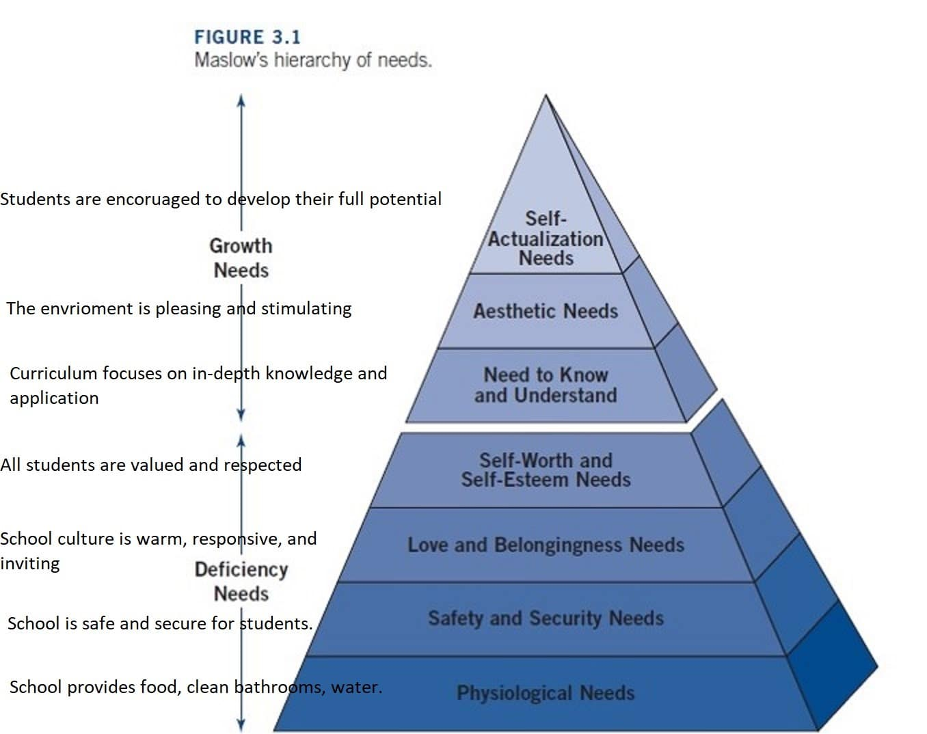

(Jones, 2017)

Attachment Theory

John Bowlby’s work (1969, cited in Johnston and Nahmad-Williams, 2009) focused on maternal attachment, and this led to the understanding of it’s importance not only for the mother and infant at the time but also for emotional development and mental health later in life. Bowlby identified in older babies, usually around the time they learn to walk and become more independent, that they often become clingy to their primary caregiver and become fretful meeting new people. Bowlby called this ‘separation and stranger anxiety’. An innate instinct to stay close to safety, to protect from predators and danger. (Zeedyk, 2013).

While Bowlby’s work focused upon the attachment between the primary caregiver (usually the mother), other theorists since expanded on the idea of attachment with secondary care givers. For example, Daly et al (2009) states that Tizzard for example identified that children can make attachments with ‘new mothers’, allowing for the recognition today of Key Workers within the childcare settings. Winnicott’s work highlighted the importance of comfort objects during transitions.

Play

According to Isaacs (1929), children have an innate need to be inquisitive. They have a need to learn and investigate through the medium of play, she says it is “the glory of the human child, his human heritage”. While children have the innate desire to want to learn through doing, the adult educator has a responsibility to support and plan opportunities for this growth of mind.

The Role of the Adult

The Early Years Practitioner has a responsibility to be highly responsive to the needs of all children in their care. This will empower the children to develop their confidence, skills and independence, laying the foundations needed to build the blocks for learning in later life. Practitioners will have a strong impact upon how children will feel about themselves and their abilities. (Daly et al, 2009). Allingham (2012) agrees, stressing the importance of practitioners supporting the emotional wellbeing of children always, but in particular during times of transition.

Bruce et al (2019) declares that play is an innate way in which children in the early years learn, however while play may be inbuilt it still requires social relationships and life experiences to enable it to thrive. Practitioners need to ensure their knowledge of the children is sound, using observations. These observations may demonstrate that the child is learning through certain schemas. The practitioner therefore can plan and facilitate holistic learning opportunities through providing an environment and continuous provision which supports these schemas.

Froebel, a pioneer of early years education emphasized the importance of allowing children to play, learning through their own inquisitions and the role of the educator is to guide and support the child in making choices and then reflecting upon these choices. Froebel believed that children are autonomous learners and that everything is connected in some way. He put forward the idea of children being individuals, and that learning and developing is whole, through firsthand experiences. (Tovey, 2020). This approach puts forward the importance of knowing the child’s needs through observations and reflection. Promoting independent learning through play is imperative, but also planning and guiding to promote certain learning outcomes. Stobbs (2019) however suggests that the best way to support children’s learning, particularly those who may be quiet or introverted, is to take advantage of spur of the moment learning opportunities during play. Both approaches however indicate the need for a trusting relationship with an adult who has the child’s individual needs at the forefront.

Davies et al (2020), state that practitioners and parents working well in partnership has a beneficial impact upon the child’s holistic development during the early years and still later in life. Louis (2020) supports this stating that early years practitioners need to engage with the children’s parents and carer’s as they are the most significant people in their lives. The quality of children’s early experiences has a long-lasting effect on their potential. This draws links to the Reggio Emilia schools, founded by Magaluzzi in 1963, who firmly believed that educators need to recognize that parents are the child’s first educators and that also the wider community has a responsibility too.

In practice today there is emphasis on the importance of multi-disciplinary teams working together. All professionals in Flying Start must establish positive working relationships, its vital that they work closely, understand the transitional process, and communicate effectively. (Welsh Government, 2017).

McMillan (1860-1931) first developed the idea of creating a ‘nurturing’ environment for children, placing importance on creativity and imagination but only possible if children’s safety and welfare were considered firstly. (Johnston and Nahmad-Willams, 2009). Montessori (1070-1952) developed her own approach of education based upon her years of research which is still used widely today. A significant part of her approach was to provide an environment for children with the freedom to learn independently, and a focus upon learning life skills. She emphasized the importance of furniture being the correct size in proportion to the children using them. Montessori promoted free flow play, particularly between the indoor and outdoor environment. (Hodgman, 2011). Isaacs (1929) led a focus upon educating children to use real life objects and tools. This not only sets up a learning of lifelong skills but also gives the child a home from home feel for their new learning environment.

Interventions

Effective Communication

Communication with children staff other professionals and parents is a key message throughout many theories frameworks and legislation that has been considered in this handbook.

Early Years Practitioners need to gain the trust of the parents to build a positive relationship which focuses on effective communication and partnership working. Parents need to be informed of how well their children are doing as well as certain areas they mind be finding difficult. This is particularly so for children who may have additional needs. (Lecont, cited in Rawstrone, 2018). Louis (2020) declares that practitioners need to demonstrate a sincere commitment to the relationship with the parents, understanding that it is of course the parents who has the most knowledge of their child and their best interests at heart.

Interventions used at Flying Start to support this are:

Home Visits

Link up sessions

Key Worker

Regular opportunities to visit and be involved

Allingham (2012) puts forward however, that it isn’t just the children who need to feel secure during the transition process, the team around the children are just as important. This is where the importance of effective communication within working partnerships becomes vital.

Interventions used at Flying Start to support this are:

Close working partnership between playgroup and the family Health Visitor

Team around the family (TAF) meetings

Transition Meetings

Transition to school paperwork

Inclusion

CIW National Minimum Standards declare that all children’s individual needs must be planned for during transitions. (Welsh Government, 2017). To support this at the Flying Start setting an ‘All About Me’ card is created. This card is available for professionals working with the child to look at and it enables them to gain an understanding of the child immediately.

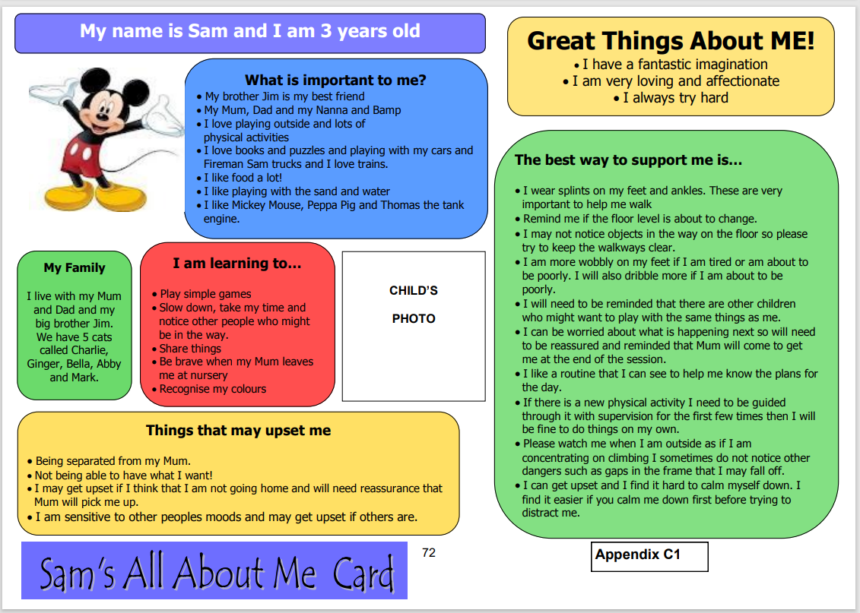

(Welsh Government, 2017)

It is essential that practitioners offer opportunities for a tailor-made transition process in accordance to their needs and personalities. Quieter children may settle better if they are given the opportunity to arrive slightly earlier than the rest of the group. Some children may find it easier for other children to join their space rather than them join in an already busy space. (Stobbs, 2019).

Creating and Enabling a Nurturing Environment

Stobbs (2019), recommends that children are given the opportunity to explore and take on their own learning to gain the most effective moments of learning. It is essential therefore that practitioners take a responsibility to ensure that the continuous provision within the setting can provide such opportunities. Stobbs continues to propose that there are quiet, secluded areas available to prevent the room and activities becoming too overwhelming. Quiet areas can give children the opportunity to recharge.

Establishing a daily routine allows for young children to feel a sense of security. Apprehension and distress can be reduced quickly as there are fewer surprises to face. Routines can support the attachment relationship and can actually aid the child in facing unexpected or new events or transitions, as they still have the familiar structure to reassure them. (Lentini and Fox, no date available).

How can we measure if the transition is effective?

Observations.

Key Worker assessments.

Communication with the family and the wider team.

Warning Signs

Poor attendance – include the support of the Health Visitor. Find out the reason for the poor attendance and work together to try to overcome any difficulties. Lower amount of sessions or shorter sessions can be offered to support the process.

Child continues to be distressed – shortening the sessions can be an option, making them less traumatic for the child. ‘Backward chaining’ is a good technique to use which allows the child to attend for the end of the session and participate in the end of session routine, the session times can be built up from that point with the child having a firm understanding that their parent will return.

Quiet, introverted behaviour – Key worker to support, offer the opportunity to fetch in a comfort object. Communicate with family the child’s likes and dislikes. Provide quiet spaces in the environment.

Transitions Timeline

At the Flying Start setting, we can break down the transition process for the children during their three eligible terms, as noted in this timetable below:

Term 1 | Term 2 | Term 3
Children are eligible for a Flying Start playgroup place the term after their second birthday.  Health Visitor will visit the family and inform them of the playgroup provision, discussing the options available to them. Information Sharing Form discussed, agreed and signed.  The Health Visitor will be in regular contact with the playgroup manager and other professionals involved. Transition meetings will take place and the needs of the children discussed and planned for. Multi-professional meetings with the family can take place if needed at the family home or at the setting.  ‘Link up sessions’ are arranged at the setting for the children to attend with their parents (usually three).  Each child will be allocated a Key Worker. Family introduced to the Key Worker, regular discussions to take place.  During the settling in period the playgroup manager will be in contact with the Health Visitor to support the transition.  Assessments made for the child’s holistic development using the Foundation Phase Profile and WellComm SAL tool. Multi-professional team made aware if any concerns are highlighted through assessments and observations at the setting, individual plans created.  Questionnaires given to the parents to ask their opinions on how they feel their children are settling in at playgroup. Opportunities for regular discussions are held. | Term 2 and Term 3 children given time to settle back in after the holiday break before the new Term 1 children begin. This will allow the practitioners to give the children the support they need while they adapt to the environment once more.  WellComm assessments and Foundation Phase Profile observations carried out once more by the child’s Key Worker. Any concerns discussed with parents.  Multi-professionals informed if there are any concerns or additional support required. Termly Health Visitor discussions and updates carried out.  Opportunities created for parents to visit the setting, keep up to date with their children’s learning and experiences and to work in partnership. | WellComm assessments and Foundation Phase Profile observations carried out by the Key Worker. With the parent’s permission, this information will be passed on to the child’s future school.  Local authority Transition Meetings take place, allowing prospective class teachers to meet with playgroup and nursery managers, Health Visitors and the wider multi-disciplinary team. Further Team Around the Family Meetings set up with the involvement of Children’s Services for those children who are considered at risk. Transition plans put in place to support the children moving on to school.  Dates set for visits to the school as a group and individually with their parents. Dates set for teachers to visit the playgroup setting to get to know the children.  Transition documents to be completed by the playgroup manager and then passed on to the class teacher.

Proposed Outcomes

According to Hutchin (2012), affirmative, supportive working relationships will aid the children in their transitions by providing them with confidence, preventing them from being disorientated with the change. Practitioners need to aim for all children to be recognized individually. Unique needs and personalities should be accounted for and this information passed on to the necessary adults who will also be supporting the transition. Hutchin (2012) goes on to say that if this is taken seriously, smooth transitions can take place successfully. Continuity is key. The Foundation Phase framework supports Hutchin’s opinion, highlighting the essential practice of observation and planning for challenging children in accordance to their individual stages of development. Progress for each child is unique and this must be considered and placed in high regard. (Welsh Government, 2008).

The Effective Provision of Pre-School Education in 2004 was a study of 3000 children aged three to seven years old in their homes and early years settings. The study discovered that the quality of the learning environment at home was very important to the child’s developmental outcomes. The research held in high position the engagement between the home and setting. Extending the communication between home and setting will lead to a common understanding and a higher learning. (Louis, 2020).

O’Connor (2020) proposes that placing attachment and functioning skills such as self-regulation, impulse control and persistence, at the centre of the early years curriculum. Positive attachments and relationships impact positively on the development of the brain and the skills it learns. Positive attachment in the early years, O’Connor declares, will support the children in becoming resilient adults and therefore a resilient society in the future.

Following the Donaldson Report in 2015, Welsh Government has recognized the importance of supporting the development of resilience in children for the future and has committed to the new curriculum for Wales in 2022. The Welsh Government aim for children to be resilient, ethical, confident and ready to play an active part in their community in preparation for the world of work. (Welsh Government, 2020).

Reference List

Allingham, S. (2012). Transitions in the Early Years: A Practical Guide to Supporting Children Between Early Years Settings and into Key Stage One. London: Practical Pre-school Books.

Bruce, T. Louis, S. Bloch, C. (2019) ‘All About Schematic Learning’, Nursery World, 4-17 February, pp25-30.

Buckinghamshire Council (2020). Effective Transitions. Available at: https://earlyyears.buckscc.gov.uk/eyfs-best-practice/effective-transitions/ (Accessed: 22/11/2020).

Daly, M. Byers, E. Taylor, W. (2009) Early Years Management in Practice. 2nd Edition. Essex: Heinemann, Pearson Education Limited.

Davies, C. Tracey, L. Grenier, J. (2020) ‘Close to Home’, Nursery World, November, p38.

Department for Education. (2020) Development Matters. Available at: http://development-matters.org.uk/ (Accessed: 22/11/2020).

Dunn, O. (2019) ‘Give Voice’, Nursery World, August, p20.

Early Years Matters (2020) Transitions. Available at: https://www.earlyyearsmatters.co.uk/eyfs/positive-relationships/transitions/ (Accessed: 23/11/2020).

Hutchin, V. (2012). Supporting Every Child’s Learning across the Early Years Foundation Stage. London: Hodder Education.

Hodgman, L. (2011). Enabling Environments in the Early Years. London: Practical Pre-School Books.

Johnston, J. Nahmad-Williams, L. (2009). Early Childhood Studies. Essex: Pearson Education Ltd.

Jones, D. (2017) Applying Maslow to School: A New Approach to School Equity. Available at: https://dey.org/applying-maslow-to-schools-a-new-approach-to-school-equity/ (Accessed: 24/11/2020).

Lentini, R. Fox, L. (no date). Family Routine Guide: Positive Solutions for Families. Available at: http://csefel.vanderbilt.edu/resources/parent/mod6/family_routine_guide.pdf (Accessed 26/11/2020).

Louis, S. (2020) ‘Close to Home’, Nursery World, 16-29th March, p26.

Montessori Academy (no date). Top Five Benefits of Montessori Education. Available at: https://montessoriacademy.com.au/top-five-benefits-montessori-education/ (Accessed 25/11/2020).

O’Connor, A. (2019), ‘Question of Responsibility’, Nursery World, 6-19th January, p14.

Pichẻre, P. (2015), Maslow’s Hierarchy of Needs: Understand the True Foundations of Human Motivation. https://www-vlebooks-com.ezproxy.uwtsd.ac.uk/Vleweb/Product/Index/744508?page=0 (Accessed: 20/11/2020).

Stobbs, N. (2019) ‘Time to Talk?’, Nursery World, 4-17th February, p21.

Sriram, R. (2020) Why Ages 2-7 Matter So Much For Brain Development. Available at: https://www.edutopia.org/article/why-ages-2-7-matter-so-much-brain-development (Accessed: 20/11/2020).

Te Kete Ipurungi (no date). Te Whariki: Pathways and Transitions. Available at: https://tewhariki.tki.org.nz/en/weaving-te-whariki/pathways-and-transitions/ (Accessed: 22/11/2020).

Tovey, H. (2020), Froebel’s Principles and Practice Today. Available at: https://www.froebel.org.uk/training-and-resources/pamphlets (Accessed: 25/11/2020).

Welsh Government (2008). Observing Children. Available at: https://hwb.gov.wales/api/storage/74f7c7cc-d337-4fd0-9604-27b3d1a5746d/observing-children.pdf (Accessed:20/11/2020).

Welsh Government (2017). Flying Start – Annex, Transitions Guidance. Available at: https://gov.wales/sites/default/files/publications/2019-07/flying-start-transition-guidance-for-professionals.pdf (Accessed: 24/11/2020).

Welsh Government (2020) Education is Changing. Available at: https://gov.wales/education-changing (Accessed: 27/11/2020).

Zeedyk, S. (2013). Sabre Tooth Tigers & Teddy Bears, The Connected Baby Guide to Attachment. Dundee: Suzanne Zeedyk Ltd.

