Daniel James Lewis
1702173
Fine Art: Studio, Site & Context

Changemakers: Building your Personal Brand for Sustainable Employment
Paul Duerinckx, Holly Slingsby
ADAA5001

Assignment title: Website

Word count: 777

Building an Artist Website
Link to Swansea.Art profile page: http://swansea.art/privateprofile/daniel-lewis

In this project, we were assigned to create our own artist websites, more specifically – an artist profile on the already existing Swansea College of Art’s Fine Art website, Swansea.Art (https://swansea.art).
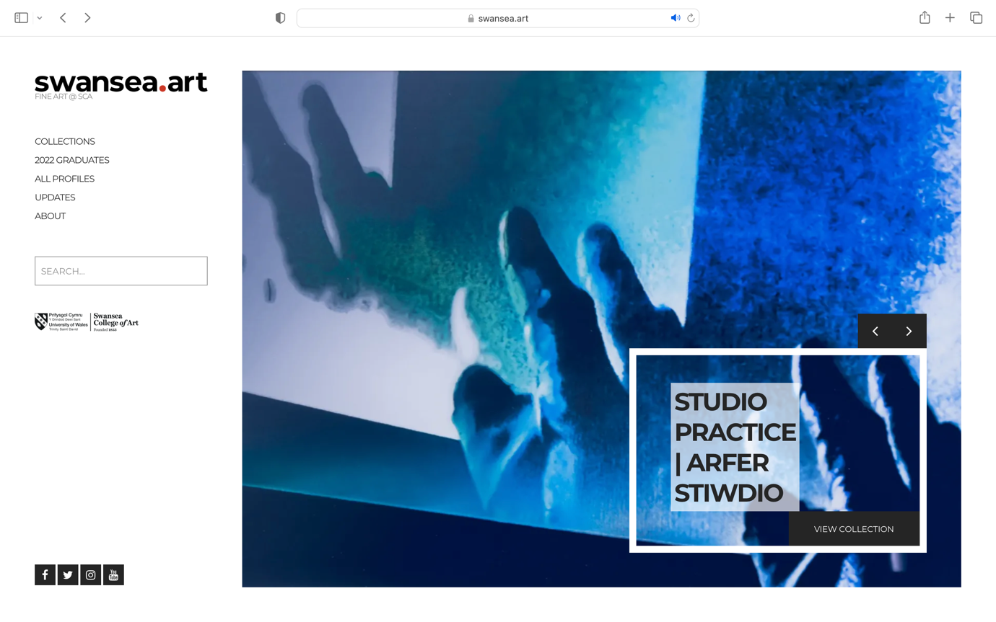
Fig. 1, swansea.art homepage, 2023
In preparation for the assignment, I decided to take advantage of my own personal research towards my art practice, where I’d develop an exploration of artists that are of interest to me, that may have similar visual aesthetics, topics and so forth. Through this medium of research, I could influence how I want my own art practice to be perceived through an online format, taking positive notes from other artist websites, and abandoning ideas that I believe didn’t work as well, nor suit my approach.

I felt there were pros and cons in utilising the Swansea.Art website as a home for my artist profile. Of course, one positive was that this was already a functional, sleek, established website, saving time in creating a website from scratch. But negatives of using an already established website was that customisation was limited, I had to fit into a set mould, creating an aesthetic/overall feel that I may not have originally intended. The only other aspect I wasn’t fond of in this circumstance was that this process involved several people to get from one point to another. As I don’t have access to editing the website, I had to consult/submit my plans to others that would then go on to create the website profile on my behalf, though I’m grateful in the sense of this benefitting me as I have little experience in website construction, but this also impacted on timeframe, personalised touches etc.
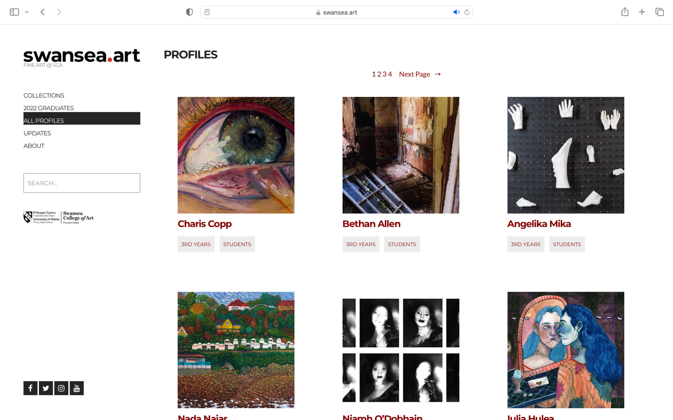
Fig. 2, Swansea.art Profiles section, 2023
One aspect of my practice that I find integral is a sense of process. I always feel that my work is ongoing, constantly developing, and I feel that my art and studio represent this. I find myself taking moments to process where I’m at, almost like reaching checkmarks in my development and would document this through photographing the art and space, sketching, and making small notes. I mention this as I wanted this to be visible in my artist profile. This is something I realised upon my research into other artists such as Duane Keiser.

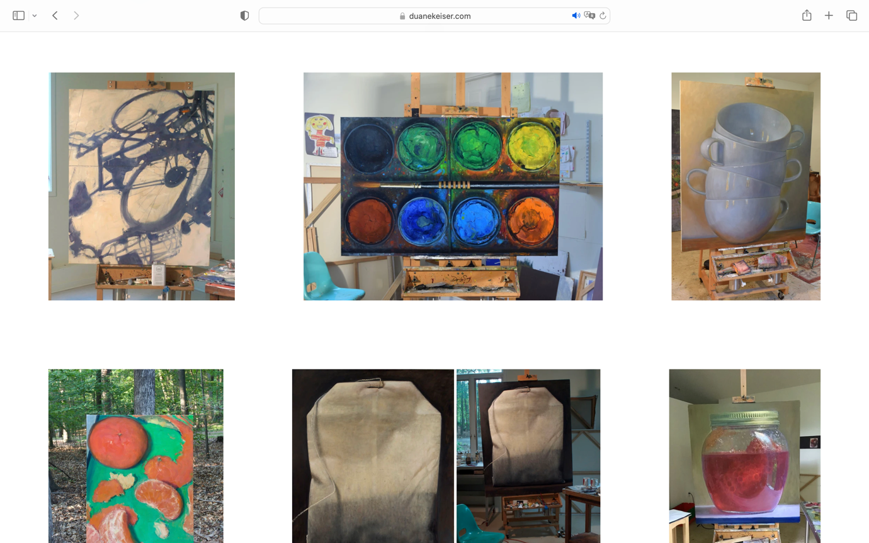
Fig. 3, Duane Keiser’s website, paintings section, 2023 https://www.duanekeiser.com/paintings

Upon exploring his website and browsing his artworks, I became aware of a difference in presentation of work in comparison to other artist websites I’d been exploring at that time. I find the ‘norm’ in presenting artworks is typically very clean cut, almost with an aesthetic quality of a typical gallery space. Although Keiser could go in this direction, he strays away, and presents his work in his workspace at the time, usually still on the easel, giving the impression that he may have only just finished the piece. I think there’s a charm in this style of presentation, and one that would work with the ‘constantly ongoing’ element to my practice. This almost acted as an affirmation in the way I wanted to document my work, submit my artworks as they were, a raw documentation rather than a polished outcome.

Following this theme of a continually developing practice, I decided I wanted to submit works completed throughout the academic year, to document the development and alternate directions that I’d explored. They don’t fall into the same visual aesthetic category nor medium, therefore would’ve likely divided these into separate sections, or curate the images into a layout that complements one another. I find most artists typically section their work depending on the medium or topic at hand, examples include Jonathan Todryk’s website (https://jonathantodryk.com) seen in figure 4, that categorises his work into different sections on his website.
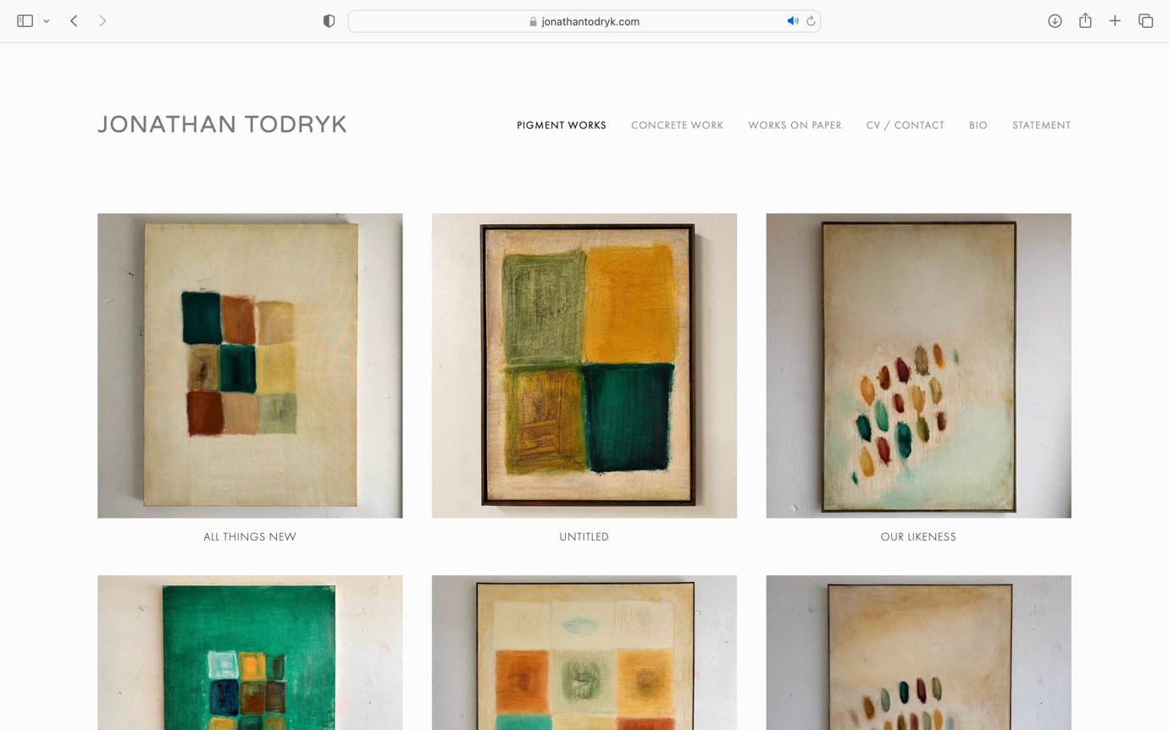
Fig. 4, Jonathan Todryk’s website, 2023

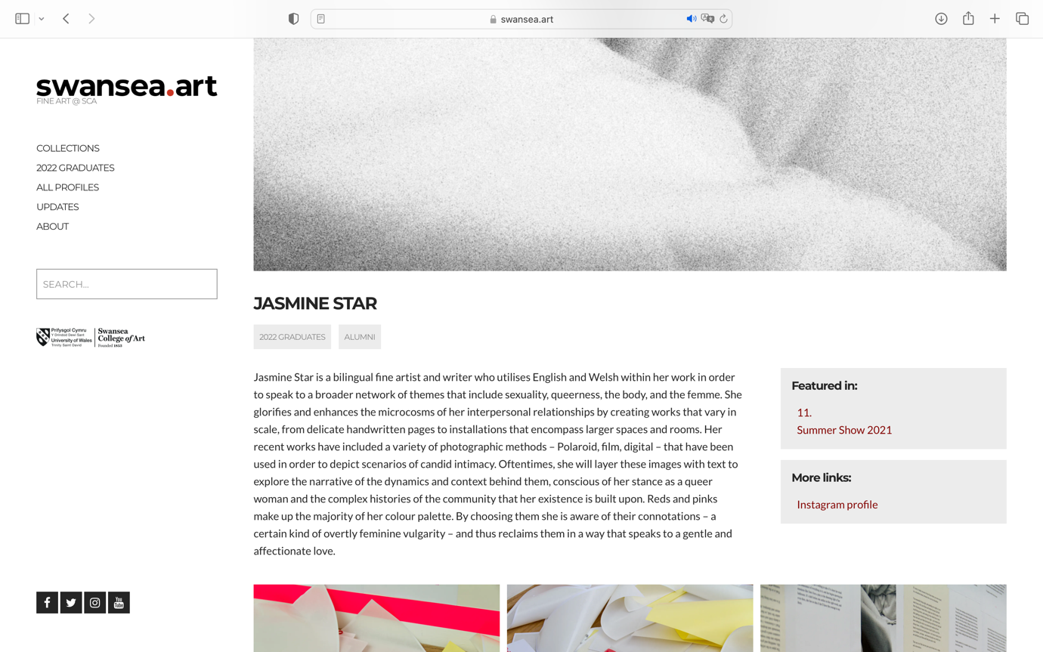
Fig. 5, Swansea.art profile, 2023
Another key area I made sure the research before submitting materials towards my Swansea.art profile, was obviously the already existing profiles on the websites itself. I browsed through many of the profiles to see what I could add to my own profile, and one part I noticed on most profiles was a link to their social medias, mostly art centred Instagram pages as can be seen in figure 5. As I have my own art Instagram page, I made sure this was included. I thought this would be important as the information on a website would be more fixed/permanent, whereas a social media would show more updates in my practice, therefore if someone had come across the website, this would allow them to go on and look further into my constantly updating social medias.

