ENTREPRENEURSHIP

Student name: Ana-Maria Budau
Student ID: 2030929

BUSINESS DESCRIPTION / MARKET OPPORTUNITY

The business description section provides a general description of the company. It should include your mission statement, description of the product or service with a focus on the innovative element that makes it relevant in a post-Covid 19 and customer demand, which may be in its design or delivery, need for the product and milestones achieved thus far. The ownership structure should also be laid out.

Power People is an online electronic supermarket company that operates its headquarters in the UK. The company has been aiming to provide laptops, mobiles, and electronic gadgets like radios, drones, cameras, etc, all electrical items at one online platform along with the availability of all electronic repair services and consultancy. The name Power People has been selected as the company aims to empower humanity with a digitization process and introduce the new era of a technology-driven society. The company will be adopting a partnership ownership structure as it will need funds and resources which is not easy in any other ownership structure like a sole proprietor (Awan, 2021). As the digitization process bloomed in the era of the pandemic and customers became more technologically driven the company decided to start this business and provide services to the customers according to their needs and demands.
Statement of intent (Vision): Bring creativity and inspiration to everyone on earth
Mission: We strive to provide our customers with the best selection, lowest prices, and greatest ease of use
The business had an opportunity to grow in this online electronic market as the demand for digitalization processes is increasing and businesses are adopting digital practices rapidly which enhances the demand for electronic products all across the globe. Thus, Power People have a huge opportunity to grow and develop their business operations in the market of UK.

INDUSTRY ANALYSIS

The threat of new entry

The company will be facing the threat of low brand loyalty in the current market situation where the consumer is getting many business options like Bermondsey Electronics Ltd, FNATIC, Emotech, etc (Bermondseyelectronics, 2023). The consumers will not be aware of the brand name and the company will be facing the challenge of low initial capital investment. The competition level in the market is also expected to be high as there are many new start-ups as well as big tech companies that are working in this field. Thus low barriers to entry will lead to a high threat of new entrants that will ultimately reduce the profit potential of Power People. Electronics and Media market is considered to be the third largest market segment in the UK. As the market is blooming there will be more new entrants in the market.

Figure 1: Revenue share of SMO markets- Worldwide
Source: (Statista. 2020)
Threat of substitutes

The online electronic market segment in the UK is having the threat of high substitutes as there will be more rivals in the market. As there will be more options available to the consumers they are likely to switch to other services or offerings. A major player in this market is Amazon, Apple, Currys, and Argos (Statista, 2021).
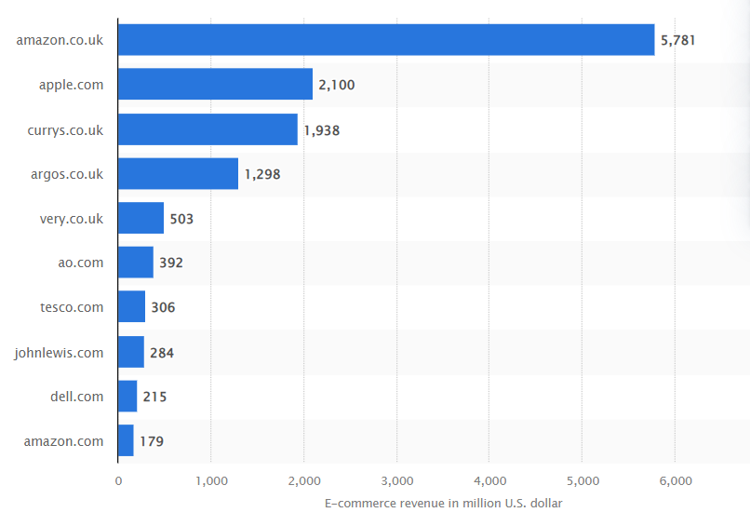
Figure 2: Top online stores in the consumer electronics segment in the UK in 2021, by e-commerce net sales
Source: (Statista, 2021)
Bargaining power of customers

According to International trade administrations, it can be observed that the population size of online consumers currently accounts for 30% of the total retail market in the year 2021 i.e. a 10% increase from the previous year 2020. According to the key digital figures for the UK, the population size that uses e-commerce platform is 68.05M. Out of this around 67.61M have access to mobile phone connection and a total of 65.32M are active users of the Internet. The ITA also highlights that the total active users of social media platforms are around 53M (Trade, 2023). This highlights that the bargaining power of the buyers is relatively low as there are many buyers of electronic gadgets in the market.

Bargaining power of suppliers

The Electronic market in the UK is rising and there are many suppliers available to the companies. Thus when the suppliers are more in the market then the bargaining power of suppliers is considered to be low which is good for a new start-up business. From the analysis, it has been forecasted that the consumer electronic market amounts to US$ 32.48bn in the year 2023. The market is expected to grow annually at 0.5% CAGR 2023-2027 (Statista, 2023).

Competitive Rivalry: Who are your main competitors and how can you differentiate yourself from them

Name of competitor | Differentiation
Amazon | Amazon is the leading brand in the online electronic supermarket and has a market share of 5,781 million for the year 2021. As the company has already set the bar by providing low friction, convenience, and self-service shipping, to the customers' Power People has to majorly focus on meeting those expectations of the customers (Hyken, 2023).
Newegg electronics | The company is known for providing quality customer service for computer parts, electronics, and laptops. To compete with Newegg, Power People will have to excel in its customer service (Newegg, 2023).
Rakuten | This company provides a broad range of offline as well as online services related to travel, fintech, digital content, etc. To compete with this brand Power People have to consider operating in the online as well as offline market (Rakuten, 2023).

OPERATIONS AND MANAGEMENT TEAM
OPERATIONS
What is your business process like? E.g., if it is a bakery – what are all the processes involved? Where will you get your supplies from? What supplies and equipment will you need? How will you transport them to your production site? Where will you make the cakes and scones? How will you get them to your customers? Will anyone else be involved in this process? Etc

The business process for Power People is as follows-
- Marketing- This process will aim to target potential consumers and attract them to visit the website.
- Customers- The business can distinguish between two types of customers that purchase goods being a business and the final consumers that pay the company through the use of credit cards.
- Visit website- The Company can track the users' profiles and access information about the customer to understand his needs and wants.
- View Product- The customer then provides a window to the customer to attract the customer and can make an individual its potential customer.
- Add to cart- The customer then selects the electric product and can observe the price, quantity, and attributes according to his choice. The company should aim to provide large options to the customers.
- Checkout- After the customer has selected the item he can check out by paying for the product. In this process, the customers will have to provide information like shipping addresses and billing.
- Transport fee- The Company will be charging the customer this fee to deliver the product. The company can also choose to provide some discount after the customer has selected to buy the membership of the company.
- Processing orders- After the payment has been received the company starts the order processing process and provides the customers to track their orders or the expected delivery date.
- Order fulfilment and shipping- The last process of the business structure is that the company delivers the item to the customers and with this, the business structure ends (Fuscaldo, 2022).
How would you generate revenue for your business? E.g., How would you prevent loss of revenue?

To generate revenue for the business the following management team will be required-

MANAGEMENT TEAM

Name | Skills | What do they bring to the firm
IT development team | Web engineers/ front-end & back-end developers. | He will manage the digital infrastructure of the company and create coherent e-commerce website architecture.
HR manager | Recruiter | This will bring quality and skilled employees to the company.
Marketing Director | Copywriter and content manager, graphic designer, and SEO skills. | This will generate authenticity and traffic to the company’s website. Through quality competitive analysis he can provide marketing services to the company.
Operations Team | Logistics and inventory specialist | This will provide operations support to the company and ensure that the company doesn’t face issues related to operations (Elogic, 2023).

MARKETING: The Four P’s must be used to describe your marketing strategy

Product: Brief description of your product

Power People is an online electronic supermarket company that will be providing electronic-related gadgets like laptops, mobile phones, computer parts, and other daily-use technologies. It has been predicted that the consumer electronic market is expected to experience about 45.9% of total revenue in the year 2023. The electronic market is expected to experience a volume growth of 1.5% in the year 2024 (Statista, 2023). As the online electronic market is expected to grow in the future the company has decided to enter this market segment and provide electronic-related products. The company will be also providing services like logistics and supply to make the products available for the customers and can provide some options like membership to the customer to provide them with offers and gift coupons that will attract the customers.
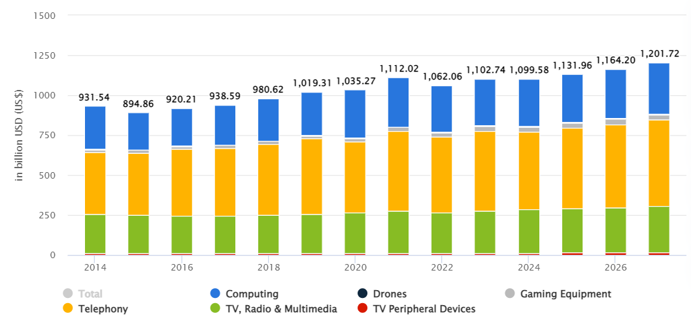
Figure 3: Average revenue per capita
Source: (Statista, 2023)

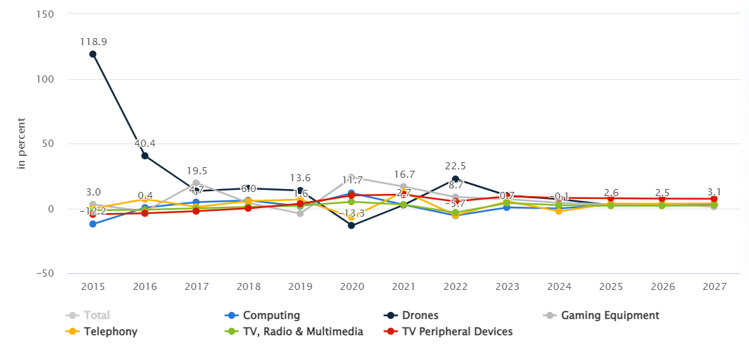
Figure 4: Revenue change by segment
Source: (Statista, 2023)

Price: How much would you charge for your product and what is the basis for the price chosen?
The company will be charging for the services that it is providing to the customers like logistics and supply services, installation services, warranty services, etc. To continue its business and services it will have to cover up costs like inventory, supply chain, depreciation and losses of offerings, etc. Thus the company will be charging for its products after considering all its services operations and costs. For different products, the company will be charging differently according to the technologies being used in the product, the logistics, and other related charges, etc.
Promotional Mix: What techniques would be used in promoting your product?
To promote the product the company will be using various digital marketing techniques as well as traditional marketing techniques. These techniques will be helping the company in attracting new customers and increasing the number of its target market (Sudari et al., 2019). Through promotional activities, the company will be able to increase its brand awareness which will help in creating its brand image in the market. To undertake promotional activities the company can use digital marketing techniques like social media marketing, content marketing, email marketing, search engine optimization SEO or search engine optimization, web advertising, video marketing, and other affiliate advertising. The company can also use some traditional marketing methods like newspaper ads, billboards, TV and radio advertisements, and mail advertisements.
Place (Distribution strategy): How would your product be distributed?
There are two major channels of the distribution process. These two channels are indirect and direct. The direct channel involves selling goods and services directly to the final consumers through the medium of online and brick-and-mortar stores (Sudari et al., 2019). The indirect channel to distribution includes offering products to middle-level businesses like wholesalers or retailers. These intermediaries then sell the product to the final consumers later on. As Power People are selling products through the online channel it will be majorly using direct channels of distribution strategy. The company will also be providing its services to other businesses and thus indirect channel of distribution will also be used.

FINANCIALS

Sources of funds: where would you be getting funds from?

The company will be attracting funds from different investors, bonds, loans, sales, etc. The company can attract the government of the UK to invest in its funds or it can get access to various public sources to meet its costs and expenses. After attracting funds it will have to use its funds in the right amount and areas so that the company can able to grow in long run. The company can also use angel investors, cloud funding and crowdfunding, self-finance, peer-to-peer lending, etc.

Use of funds

 | Month 1 | Month 2 | Month 3 | Month 4 | Month 5 | Month 6
Revenue (from your operations and marketing section) | Paying back loans and debentures in installments. | The company can purchase the necessary equipment to carry on with its operations. | The company can utilize its revenues by hiring a new and skilled workforce. | The company can use the revenue to upgrade its technologies and equipment. | The company utilizes its revenue for expansion and can repay its investors | The company uses the resources for research and findings activities.
Fixed Costs  (List out your fixed costs) | Rental cost and lease costs. | Utility bills | Insurance and loan repayment | Taxes like business licenses. | Maintenance and inventory cost | Operating cost.
Variable Costs  (List out your variable costs) | Labor costs | Cost of services and offerings | Production supplies | Delivery costs | Packaging supplies | Raw materials
Profit | Profit from sales | Selling advertising | Selling of customer data | Become an affiliate | The charge for sponsored posts | Increasing membership

REFERENCES

Awan, W. 2021 "What are the differences and similarities between a sole-proprietorship, partnership, corporation, and trust? Available at: https://kpu.pressbooks.pub/cdntax/chapter/__unknown__-2/#:~:text=A%20sole%2Dproprietorship%20has%20one,legal%20entity%20from%20its%20shareholders. (Accessed: 12 January 2023).

Bermondseyelectronics. 2023. Available at: https://www.bermondseyelectronics.com/ (Accessed: 12 January 2023).

Elogic 2022. Ecommerce Team Structure: Building an eCommerce Team. Available at: https://elogic.co/blog/how-to-build-an-ecommerce-team-a-best-practices-guide/ (Accessed: 12 January 2023).

Fuscaldo, D., 2022. What Is E-Commerce? Available at: https://www.businessnewsdaily.com/15858-what-is-e-commerce.html (Accessed: 12 January 2023).

Hyken, S., 2023. How Can You Compete With Amazon? Available at: https://www.forbes.com/sites/shephyken/2021/05/23/how-can-you-compete-with-amazon/?sh=3a2209e25671 (Accessed: 12 January 2023).

Newegg. 2023. Computer parts, laptops, electronics, and more. Available at: https://www.newegg.com/global/uk-en/ (Accessed: 12 January 2023).

Rakuten. 2023. About Us. Available at: https://www.rakuten.com/ (Accessed: 12 January 2023).

Statista. 2020. Digital Market Insights. Available at: https://www.statista.com/outlook/digital-markets#marketSegments (Accessed: 12 January 2023).

Statista. 2023. Consumer Electronics - Worldwide. Available at: https://www.statista.com/outlook/cmo/consumer-electronics/worldwide#revenue (Accessed: 12 January 2023).

Statista. 2023. Consumer Electronics - UK. Available at: https://www.statista.com/outlook/cmo/consumer-electronics/united-kingdom (Accessed: 12 January 2023).

Statista. 2021. Top Consumer Electronics online stores United Kingdom 2021. Available at: https://www.statista.com/forecasts/870870/top-online-stores-consumer-electronics-united-kingdom-ecommercedb#:~:text=Amazon.co.uk%20is%20leading,revenue%20of%20US%241%2C938%20million. (Accessed: 12 January 2023).
Sudari, S., Tarofder, A., Khatibi, A. and Tham, J., 2019. Measuring the critical effect of marketing mix on customer loyalty through customer satisfaction in food and beverage products. Management Science Letters, 9(9), pp.1385-1396. http://m.growingscience.com/msl/Vol9/msl_2019_125.pdf

Trade. 2023. United Kingdom - eCommerce (2023). Available at: https://www.trade.gov/country-commercial-guides/united-kingdom-ecommerce (Accessed: 12 January 2023).

