A marketing plan is written for
____________________(Sheraton)_____________________

Student Name
________________ Violeta -Ionela Necsoi ________________

Student ID number
_______________________2212736______________________

Marketing Essentials BMIH4005

Lecturer
____________________Ruth Taylor Davies_________________

Table of Contents
1 Introduction 3
2 Situation Analysis 3
2.1 Company: SWOT analysis 3
2.2 Customers: Segmentation and Targeting 4
2.3 Competitors: Porter’s five forces 4
2.4 Perceptual map 5
2.5 -Collaborators: Demonstrate an awareness of your organisation’s B2B Relationships, Partnerships, and Franchises. 6
2.6 -Climate: PESTLE 6
3 Objectives 6
4 Strategy 7
5 Tactics 7
5.1 Marketing mix: 7
6 Action 8
7 Control 8
8 Conclusion 9
9 References 10
10 Appendix: Presentation 12

Introduction
This report discusses the Sheraton hotel and its expansion plan in other selected countries; the aim is to expand the business globally and acquire more consumers. The marketing plan has been developed to acquire a large base of consumers. The micro and macro analysis of the Sheraton hotel has been conducted in order to evaluate the strengths and competitive advantage; along with that, it also formulated the strategies that can help to increase consumers. This highlight the Situational analysis that contains the 5C's; further, it discusses the marketing mix and the Gantt chart for managing the marketing plan.

Situation Analysis
5 'C's

Company: SWOT analysis
Strengths  - Sheraton hotel has a wide network of hotels, i.e. 400 plus  - Strong brand image  - Famous for its acquisition strategies  - Presence in 70 countries (Annual Report, 2022) | Weaknesses  - Sheraton hotel is also offering services that are replicable  - The Consumer's preferences are changing  - The financial planning in the organisation is not effective (Sheraton, 2022)
Opportunities  - The expansion Scope is increasing. Sheraton has the opportunity to maximise profit.  - The growth in the hospitality industry is an opportunity for the Sheraton  - Emerging technology is also an opportunity for the Hospitality industry | Threats  - The competition in the industry is increasing  - The hospitality industry is dependent on the economic condition  - The preferences of consumers are changing

Customers: Segmentation and Targeting
Segmentation | Targeting | Positioning
- Sheraton Hotel has been divided into two groups which are leisure and business travellers. | - The target consumers of the Sheraton hotel are business travellers and consumers who spend time on vacations  - Honeymoon couples | - Sheraton hotel has been positioned as a best-class customer service and comfort provider hotel.

Competitors: Porter’s five forces
Bargaining power of buyers  (High) | - The Consumer’s power in the hospitality industry is increasing due to increased awareness and knowledge of the market (Armstrong and Matters, 2016).
Bargaining power of supplier  (Low) | - The negotiation power of the suppliers in the industry is low because there are many suppliers present in the market that provide the same services and products for the hotels (Eissner and Gannon, 2018).
Threat of substitute  (High) | - The small and medium size hotel business and guesthouses provide bed and breakfast services. In addition to that, the competitors in the market also provide the same services (Cervellon and Galipienzo, 2015).
The threat of new entrance  (Moderate) | - The investment to start any five- or four-star hotel require high capital investment.
Competition  (High) | - The competition in the industry is increasing, and hotels are trying their best to acquire a major market share.

Perceptual map
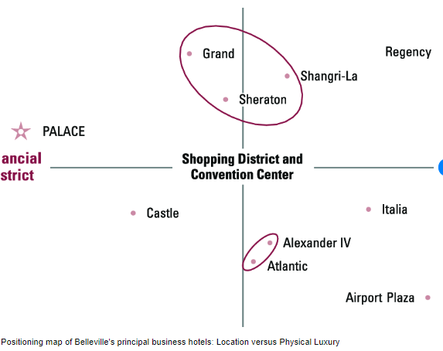
Figure 1:Perceptual Map
Source: (McDowall et al., 2017)

-Collaborators: Demonstrate an awareness of your organisation’s B2B Relationships, Partnerships, and Franchises.
The aim of Sheraton is to maintain a long-term relationship with the other franchises; it has a global business development team that manages effective relations with the franchises and their partners globally (Shurbaji and Furlan, 2017).

-Climate: PESTLE
Political  - The rules and regulations in the UK for businesses are favourable and low taxes (Lorusso and Pieroni, 2018). | Economic  - UK economy is stable as its GDP is increasing and unemployment is also decreasing (Besley, 2015)
Social  - Consumer preferences for the services in hotels are changing. They expect more luxury and technology (De Ayala et al., 2021) | Technological  - Technology is getting advanced, and the UK government supports the development of technology
Legal  - The UK has strong laws for consumers’ rights and safety in the hospitality industry. | Environmental  - The regulations for environmental factors are strict in the UK (Sun et al., 2017).

Objectives
- The aim of the strategy is to acquire the consumers and increase market share by 5% within 1 year by offering new club and guest rooms.
- The objective of Sheraton hotel is to invest in health and safety initiatives to attract a new consumer base and increase the profitability of the company by 15% within the next 2 months.
- The aim is to increase social media marketing and increase company sales by 5% in the first month of next year (2023).

Strategy
In the case of Sheraton, their current value proposition includes their innovatively designed guest rooms and their initiative of club lounges, which offer the customers a profound experience of complementary breakfasts, 24/7 available snacks, a vast array of beverages, both alcoholic and non-alcoholic, and lastly, free Wi-Fi service (Weinstein, 2018). At the same time, considering the after-effects of the COVID pandemic, the Sheraton hotel seeks to fulfil its value proposition which would ensure customer safety and health. Hence, the hotel would establish safety policies which would overlook the whole hotel's sanitisation and refinement. The post-pandemic era brought forth the general public concern about health and safety, which the hotel would be monitoring in their new value proposition. Such would aim to attract a new segment of customers since the hotel would focus more on sanitised spaces and disinfected food. It would aid Sheraton in getting the upper hand in the market in terms of post-pandemic cleanliness and safety.

Tactics

Marketing mix:
Product: Sheraton's current products are segmented into five categories, where all of them are sold under the brand's name with different product lines. Their products are noted to highly differ from their competitors, while also being available to the customers in a vast range of variety. Customers are inclined to pay for them due to their traditional touch, high quality and accessible use (Perenc, 2020). However, given the relevant strategy, Sheraton is likely to include sanitised product line in their range, which is obscured by the threat of COVID disease.
Place: Sheraton currently possesses two channels upon which they market their products and sell them accordingly. Firstly, they use their social media presence to sell their booked tickets, and secondly, they provide their tickets to wholesalers, who, in turn, sell the goods to retailers over the nation (Perenc, 2020). On the other hand, the renowned hotel chain is inclined to focus more on its social media product distribution because people during the post-pandemic era are more intended to book tickets through an online purchasing system on Instagram or Facebook.
Price: Sheraton's present pricing strategy highlights its competitive-based pricing tactic. Such is the reason due to high competition threat in the existing market. The rivals evidently possess similar data and products to Sheraton, which is why the hotel seeks to price their products high with excellent quality. Such excellence enables customers to buy their offerings (Perenc, 2020). Considering the high rise of hotel products after COVID, Sheraton would benefit by selling a 100-pound product at 99 pounds, which enables the customer to purchase it due to low cost.
Promotion: Presently, Sheraton promotes its offerings through multiple media channels, such as traditional or TV promotions. The hotel also reportedly utilises its social media apps to market itself and reach newer audiences (Perenc, 2020). Given the impact of COVID on the hotels, Sheraton would promote themselves by focusing more on their digital marketing and even would hire celebrity influencers with a massive audience for health promotion.

Action
The marketing teams will formulate marketing campaigns for Facebook and Instagram to communicate the new and innovative initiatives to the consumers
-Gannt chart of marketing activities:
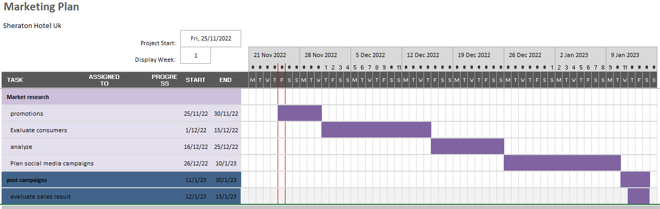
Based on market research, it has been identified that consumers spend the majority of their time on Facebook and Instagram (David, 2021). Research help to understand that social media tools are important and that consumers prefer luxury and innovative services in the hotel industry (Roy and Chowdhury, 2021)

Control
The competitive advantage of the company is its terrace-based room and pools along with bars. Its value proposition is to deliver luxury services for the consumers, and the terrace-based rooms are not offered by any other hotel, which makes it more effective. This unique selling point helps the companies in managing existing consumers and allows them to attract new consumers. The performance of the new strategy would be evaluated through the response and the number of sales for the rooftop bedrooms. Along with that, the responses from social media would be evaluated. The positive attitude of the consumers towards the hotel would be treated as a success for the company

Conclusion
In Order to promote the Sheraton’s new lounge and rooftop rooms, the major challenges that the Sheraton hotel can face are the changing preferences of the consumers and the inefficient marketing teams. So, to manage these factors, Sheraton hotel needs to invest in proper planning and market research to identify the most effective tools, as Sheraton hotel has been suggested to promote its new and innovatively designed guest rooms and lounges for consumers through the use of social media tools.

References
Annual Report, 2022. Investor relations, Marriott International. Available at: https://marriott.gcs-web.com/ (Accessed: November 25, 2022).
Armstrong, R. and Matters, R.T., 2016. Modern slavery: risks for the UK hospitality industry. Progress in Responsible Tourism, 5(1), pp.67-78.
Besley, T., 2015. Law, regulation, and the business climate: The nature and influence of the World Bank Doing Business project. Journal of Economic Perspectives, 29(3), pp.99-120.
Cervellon, M.C. and Galipienzo, D., 2015. Facebook pages content, does it really matter? Consumers’ responses to luxury hotel posts with emotional and informational content. Journal of Travel & Tourism Marketing, 32(4), pp.428-437.
David, J., 2021. PESTEL analysis of France (France country profile).
De Ayala, A., Foudi, S., Solà, M.D.M., López-Bernabé, E. and Galarraga, I., 2021. Consumers’ preferences regarding energy efficiency: a qualitative analysis based on the household and services sectors in Spain. Energy Efficiency, 14(1), pp.1-15.
Eissner, S. and Gannon, J., 2018. Experiences of mentoring in the UK hospitality sector. Journal of Human Resources in Hospitality & Tourism, 17(3), pp.296-313.
Lorusso, M. and Pieroni, L., 2018. Causes and consequences of oil price shocks on the UK economy. Economic Modelling, 72, pp.223-236.
McDowall, W., Geng, Y., Huang, B., Barteková, E., Bleischwitz, R., Türkeli, S., Kemp, R. and Doménech, T., 2017. Circular economy policies in China and Europe. Journal of Industrial Ecology, 21(3), pp.651-661.
Parents, J., 2020. Factors determining the improvement of hotel service quality as seen by customers of Sheraton Hotel in Warsaw. Studia Periegetica, 30, pp.125-136.
Roy, M. and Chowdhury, S., 2021. Ecotourism and hospitality in Bangladesh: the application of PESTEL analysis and determining the internal factors. In Tourism Products and Services in Bangladesh (pp. 181-215). Springer, Singapore.
Sheraton, 2022. About Us, Sheraton Hotels & Resorts. Available at: https://sheraton.marriott.com/about-us/ (Accessed: November 25, 2022).
Shurbaji, M. and Furlan, R., 2017. The Sheraton Park and Users’ Human Behaviour: Strategies for Implementation of the Public Realm in Doha.
Sun, S., Tong, K.T. and Law, R., 2017. Chinese hotel guest perception of international chain hotels under the same hotel brand in different travel destinations: The cases of intercontinental and Sheraton. Journal of Vacation Marketing, 23(2), pp.172-188.
Weinstein, A., 2018. Business Models and Customer Value Propositions. In Superior Customer Value (pp. 43-62). Routledge.

Appendix: Presentation
Slide1: Cover
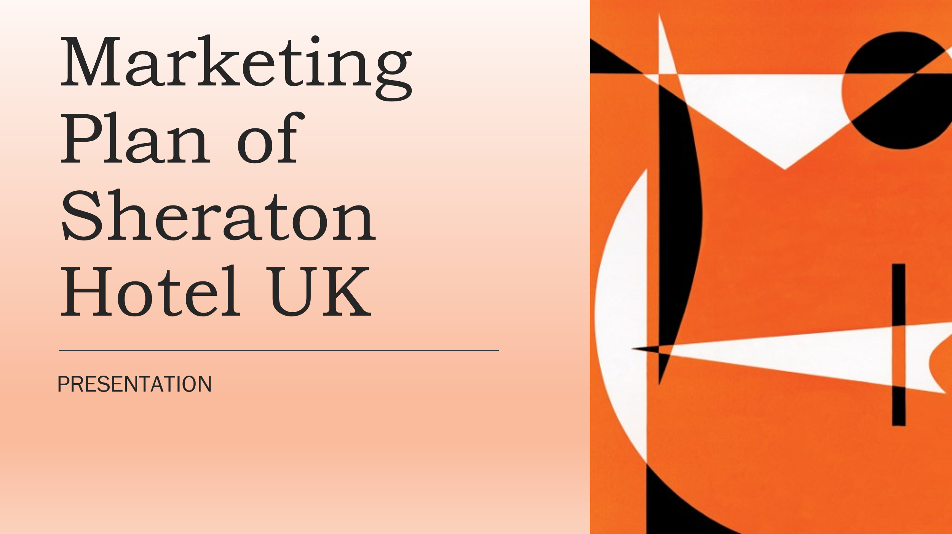
Slide 2: Table of content
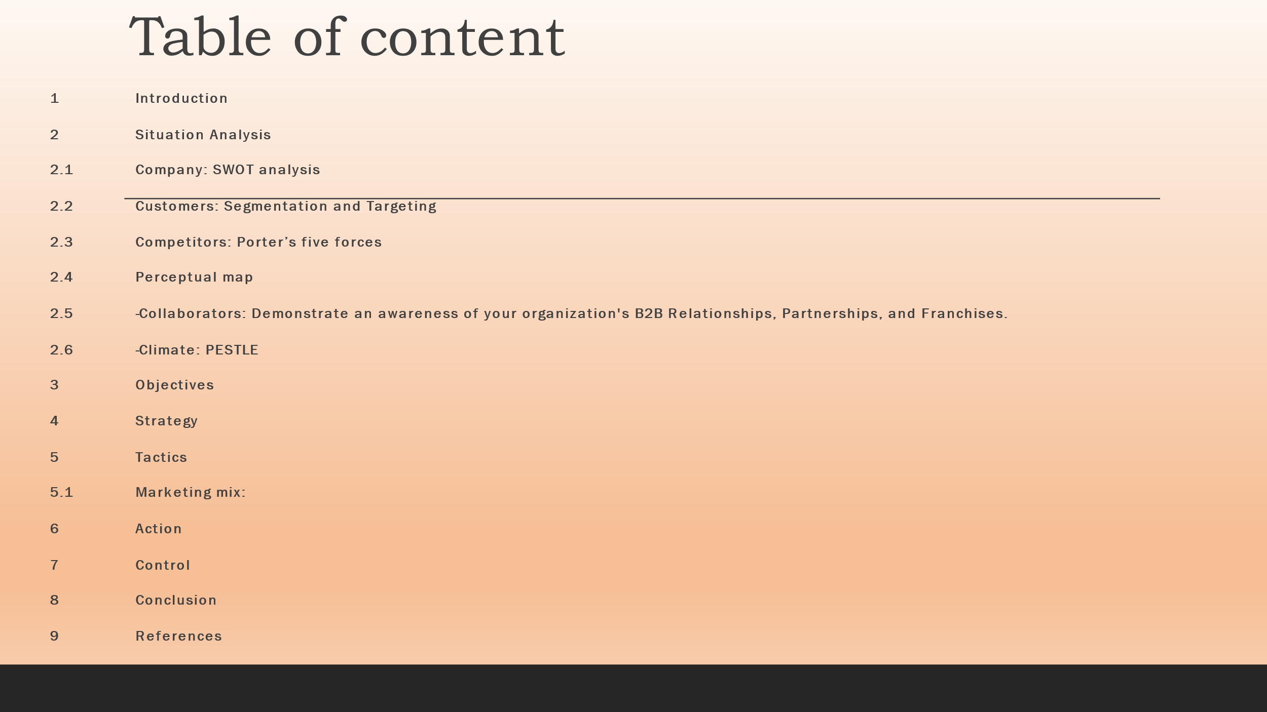
Slide 3: Introduction
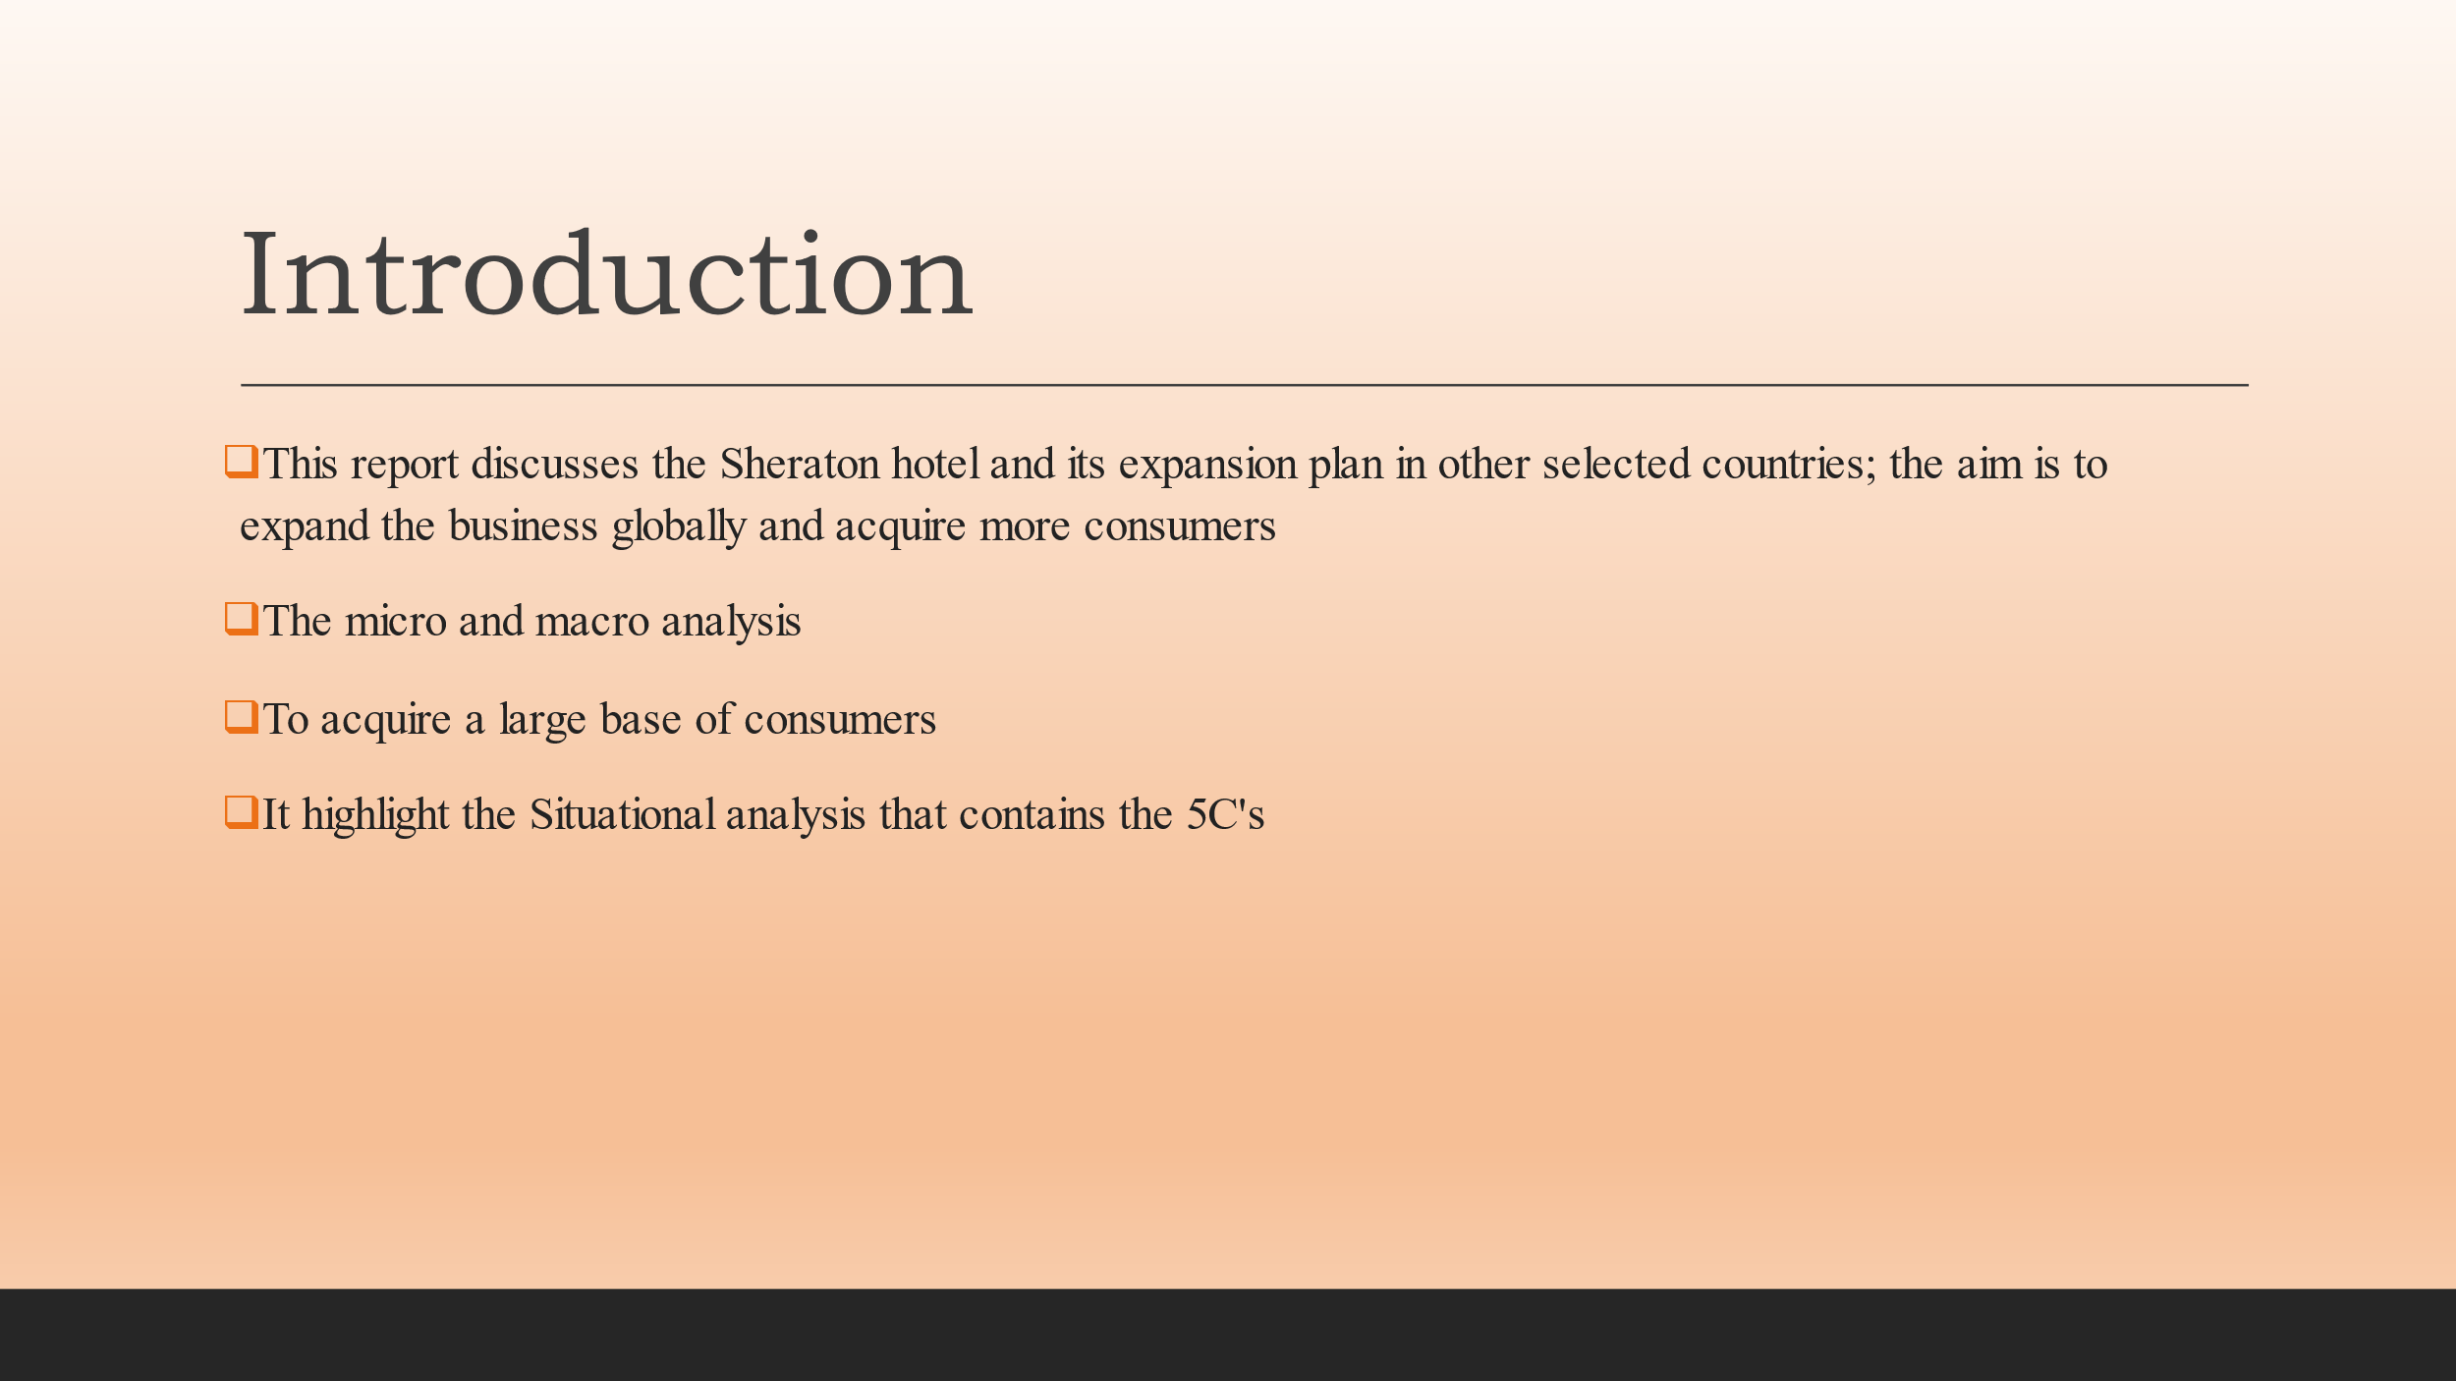
Slide 4: Situational Analysis
SWOT Analysis
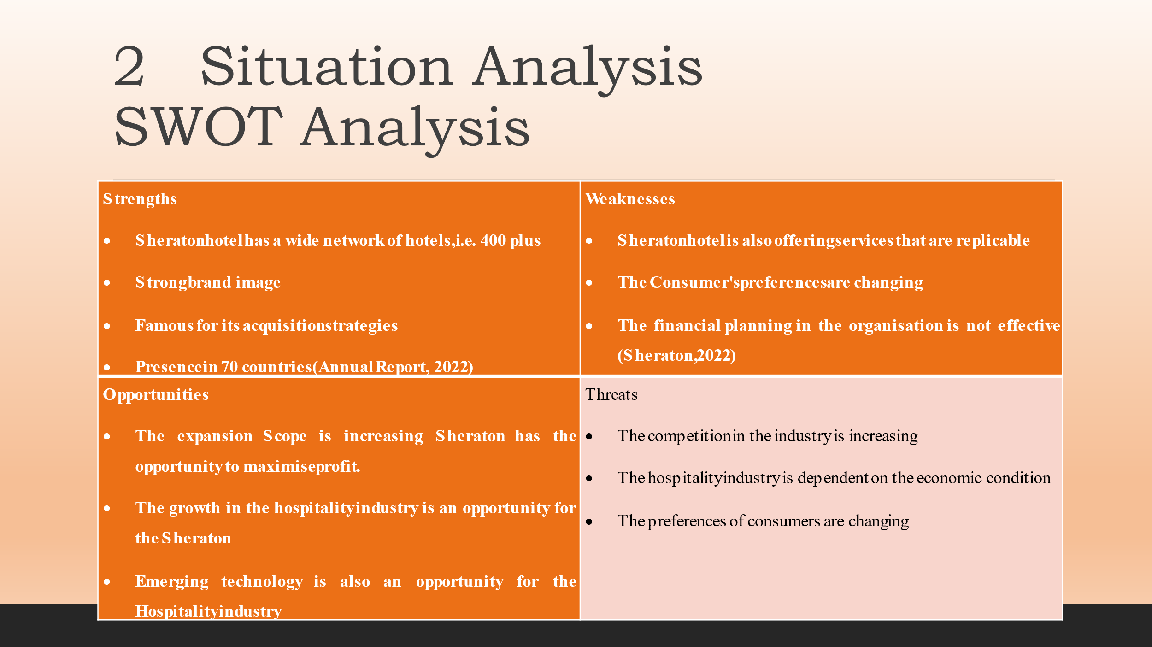
Slide:5 STP
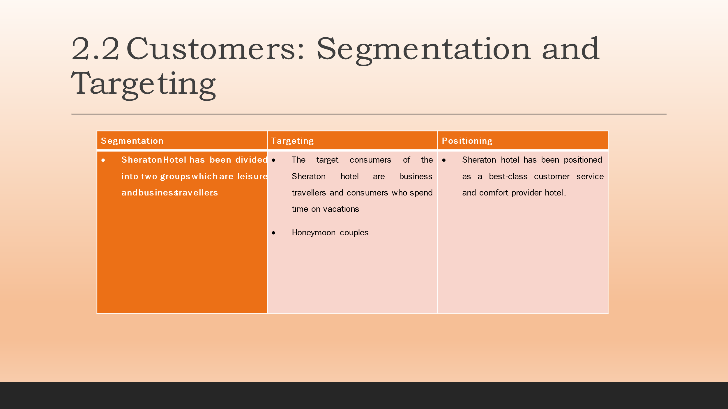

Slide 6: Porter’s Five forces
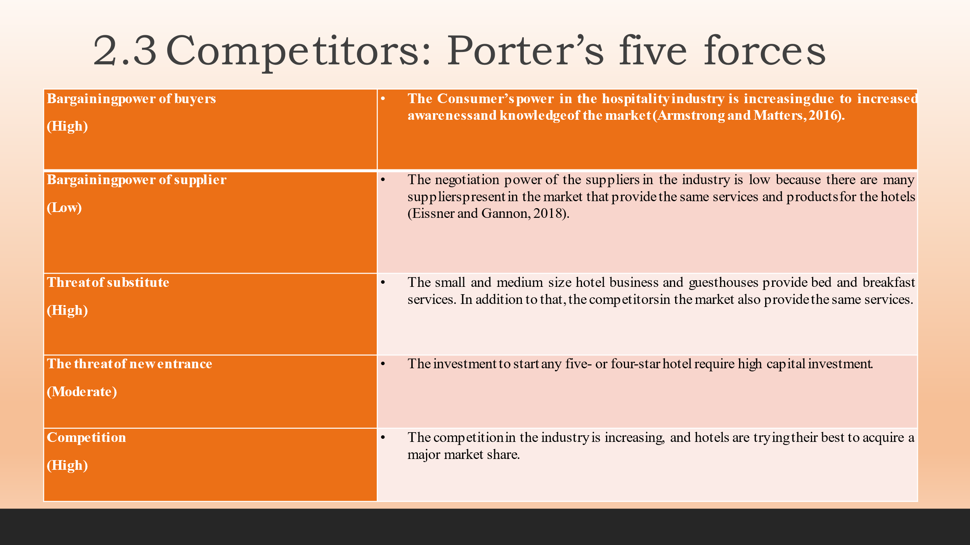
Slide 7: Perceptual Map
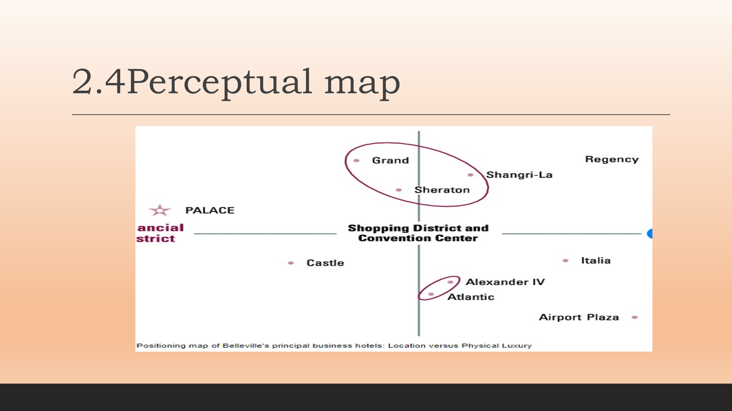
Slide 8: Collaborators
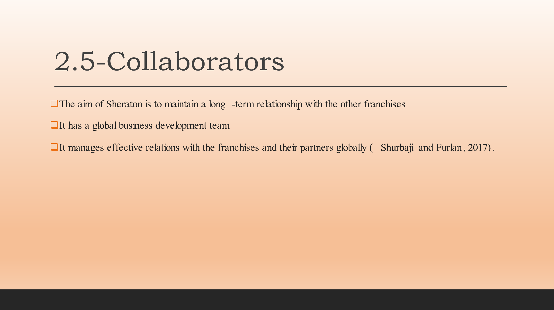
Slide 9: PESTLE
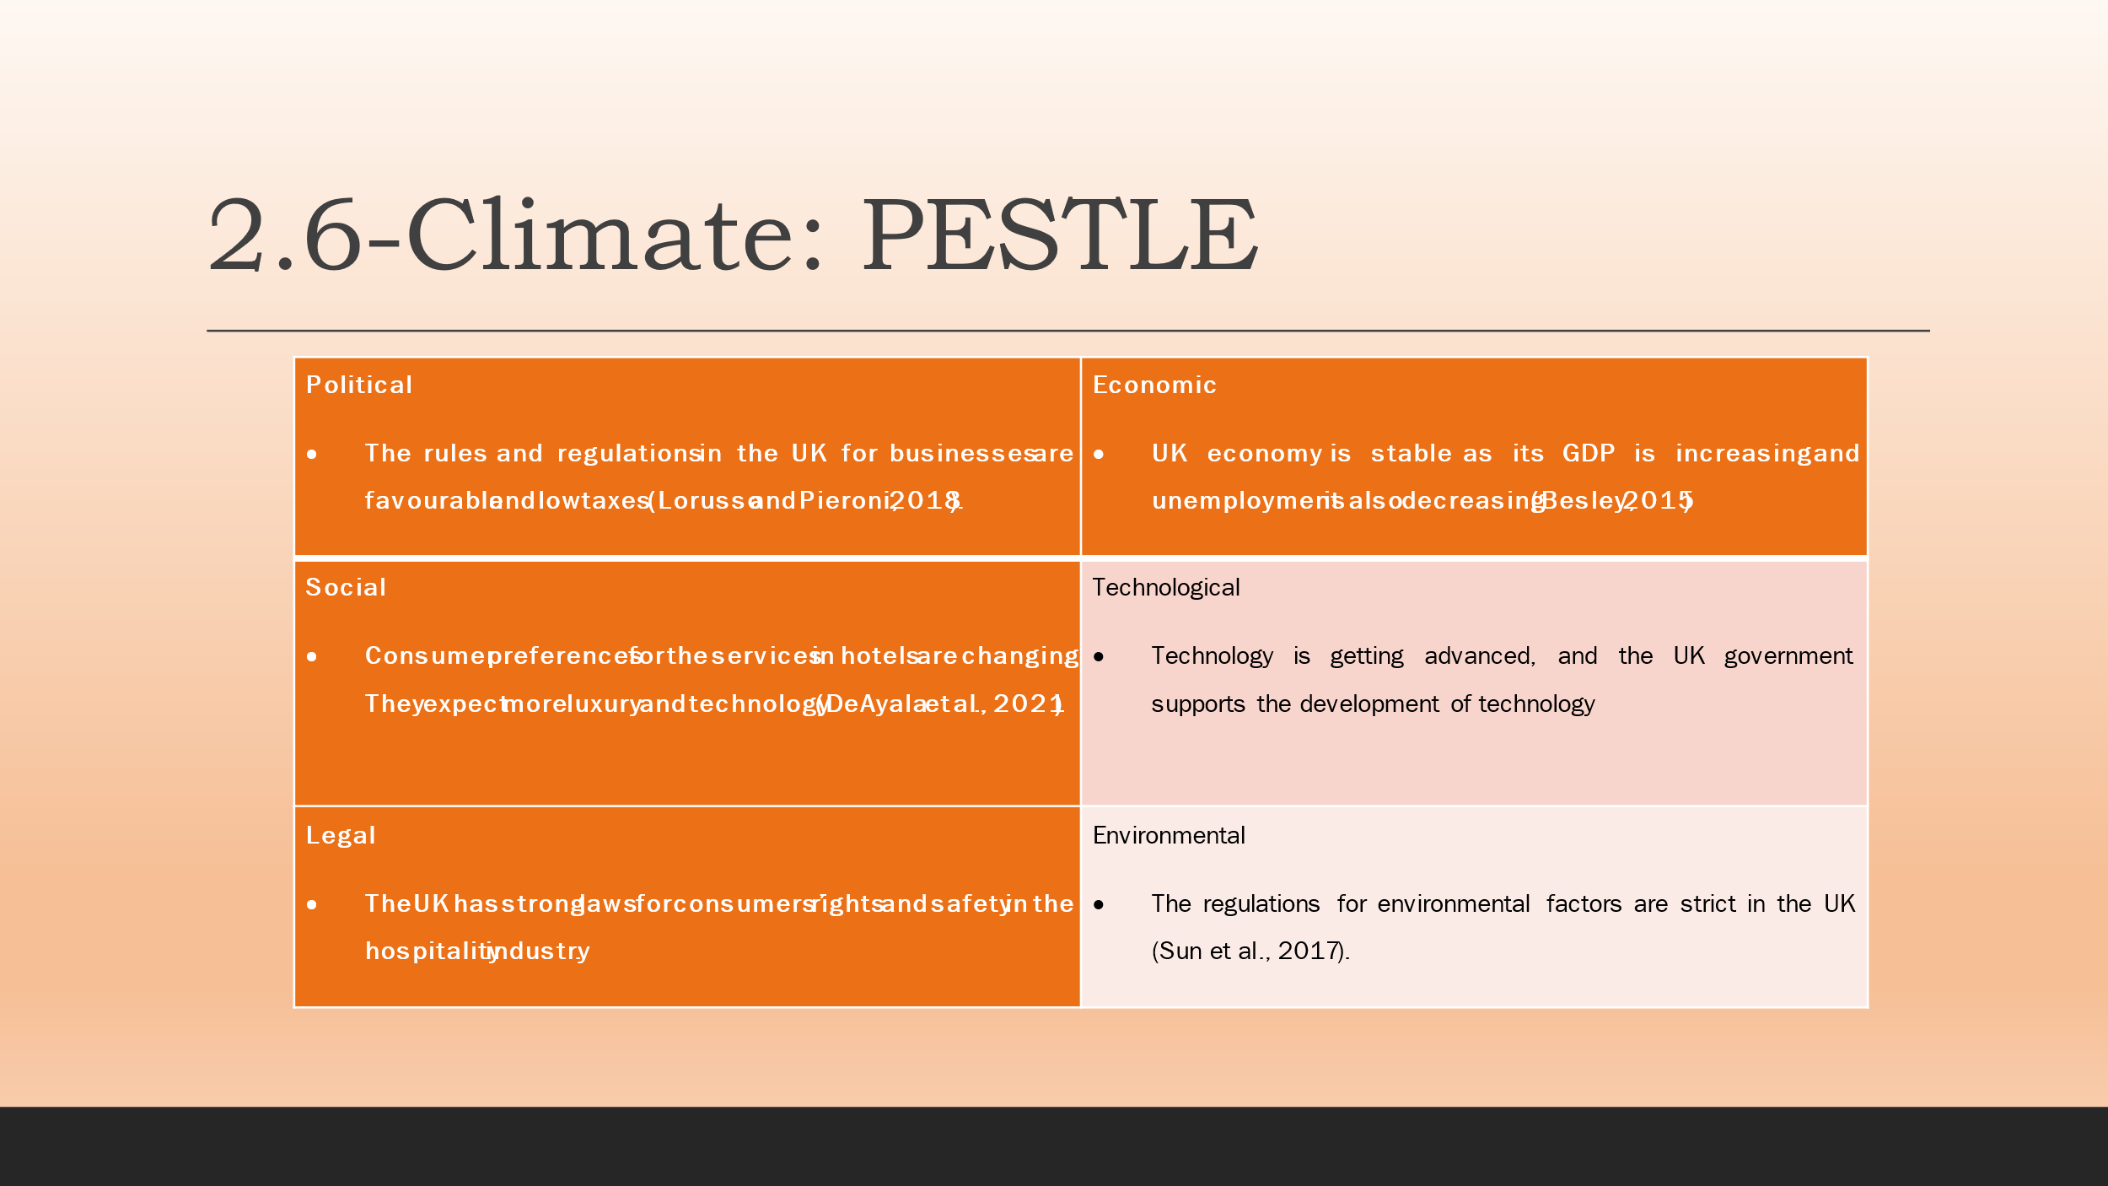
Slide 10: Objective
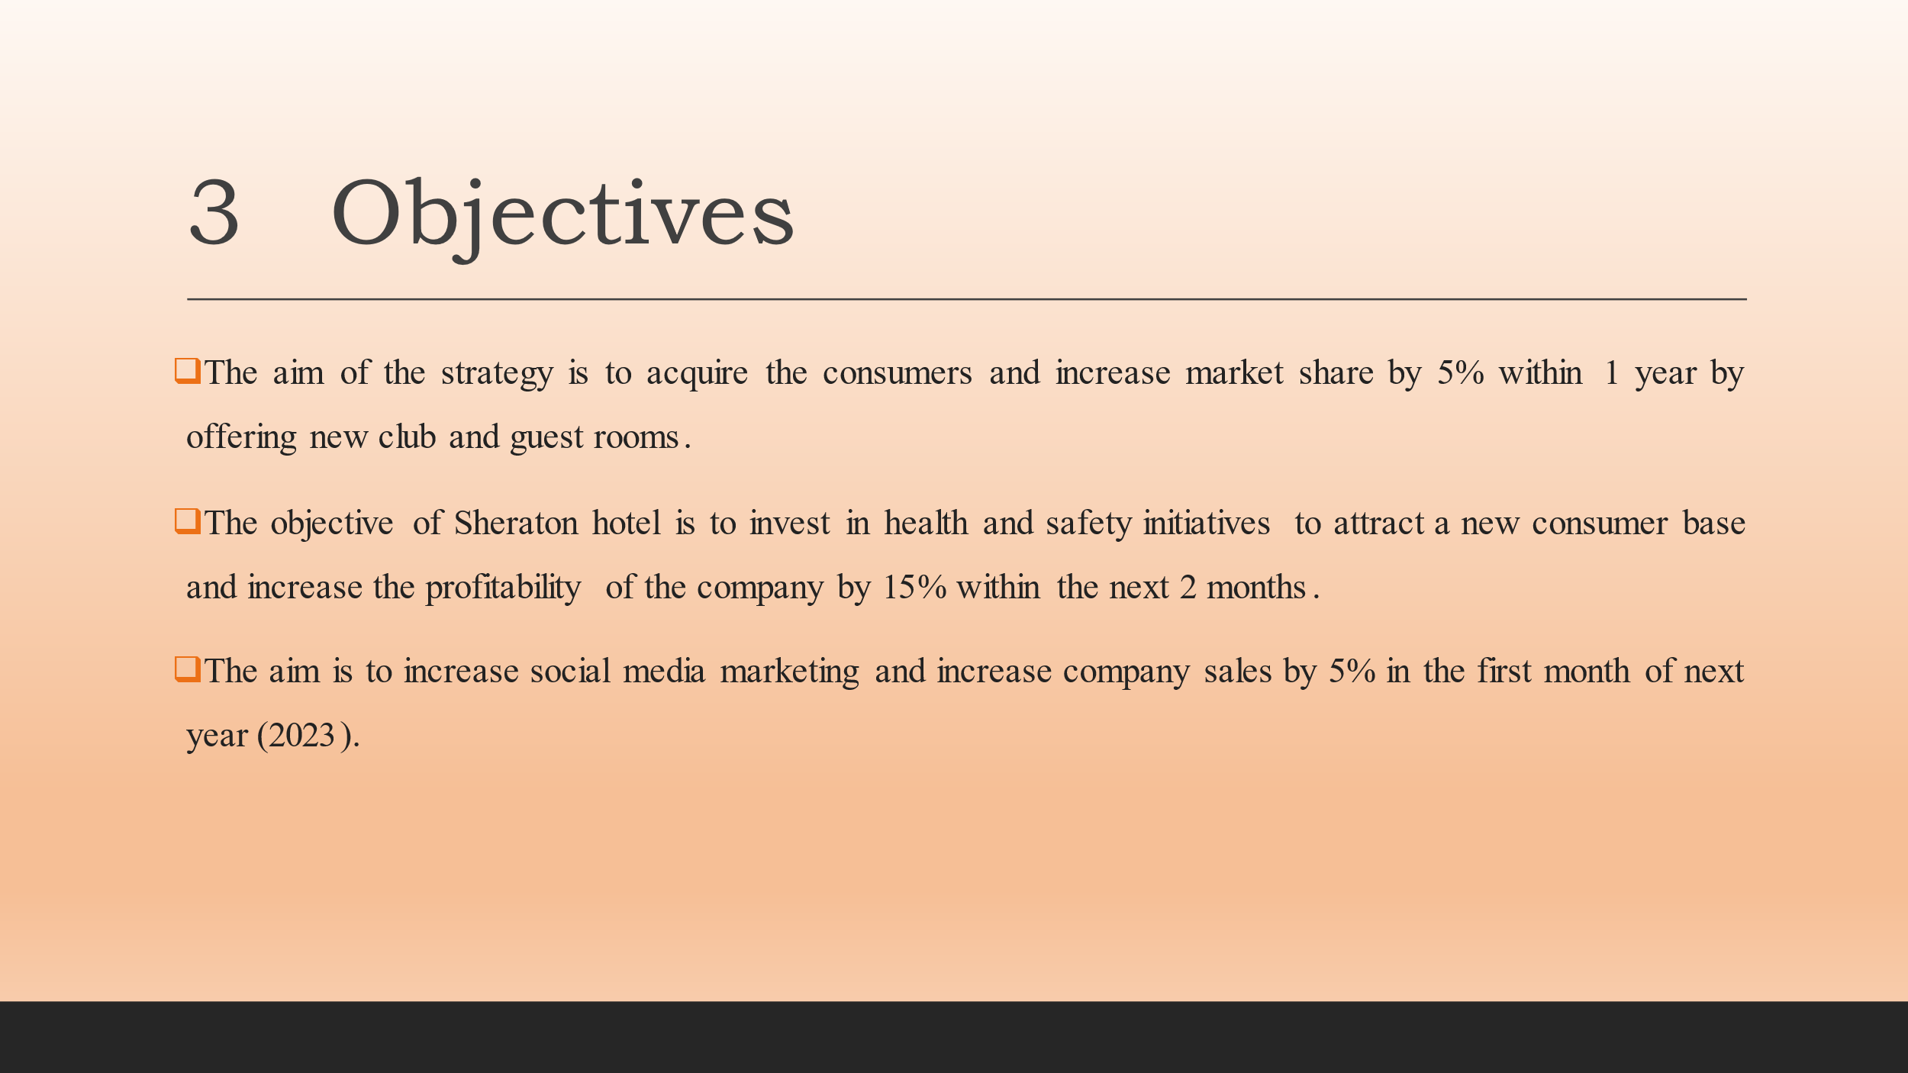
Slide 11: Strategy
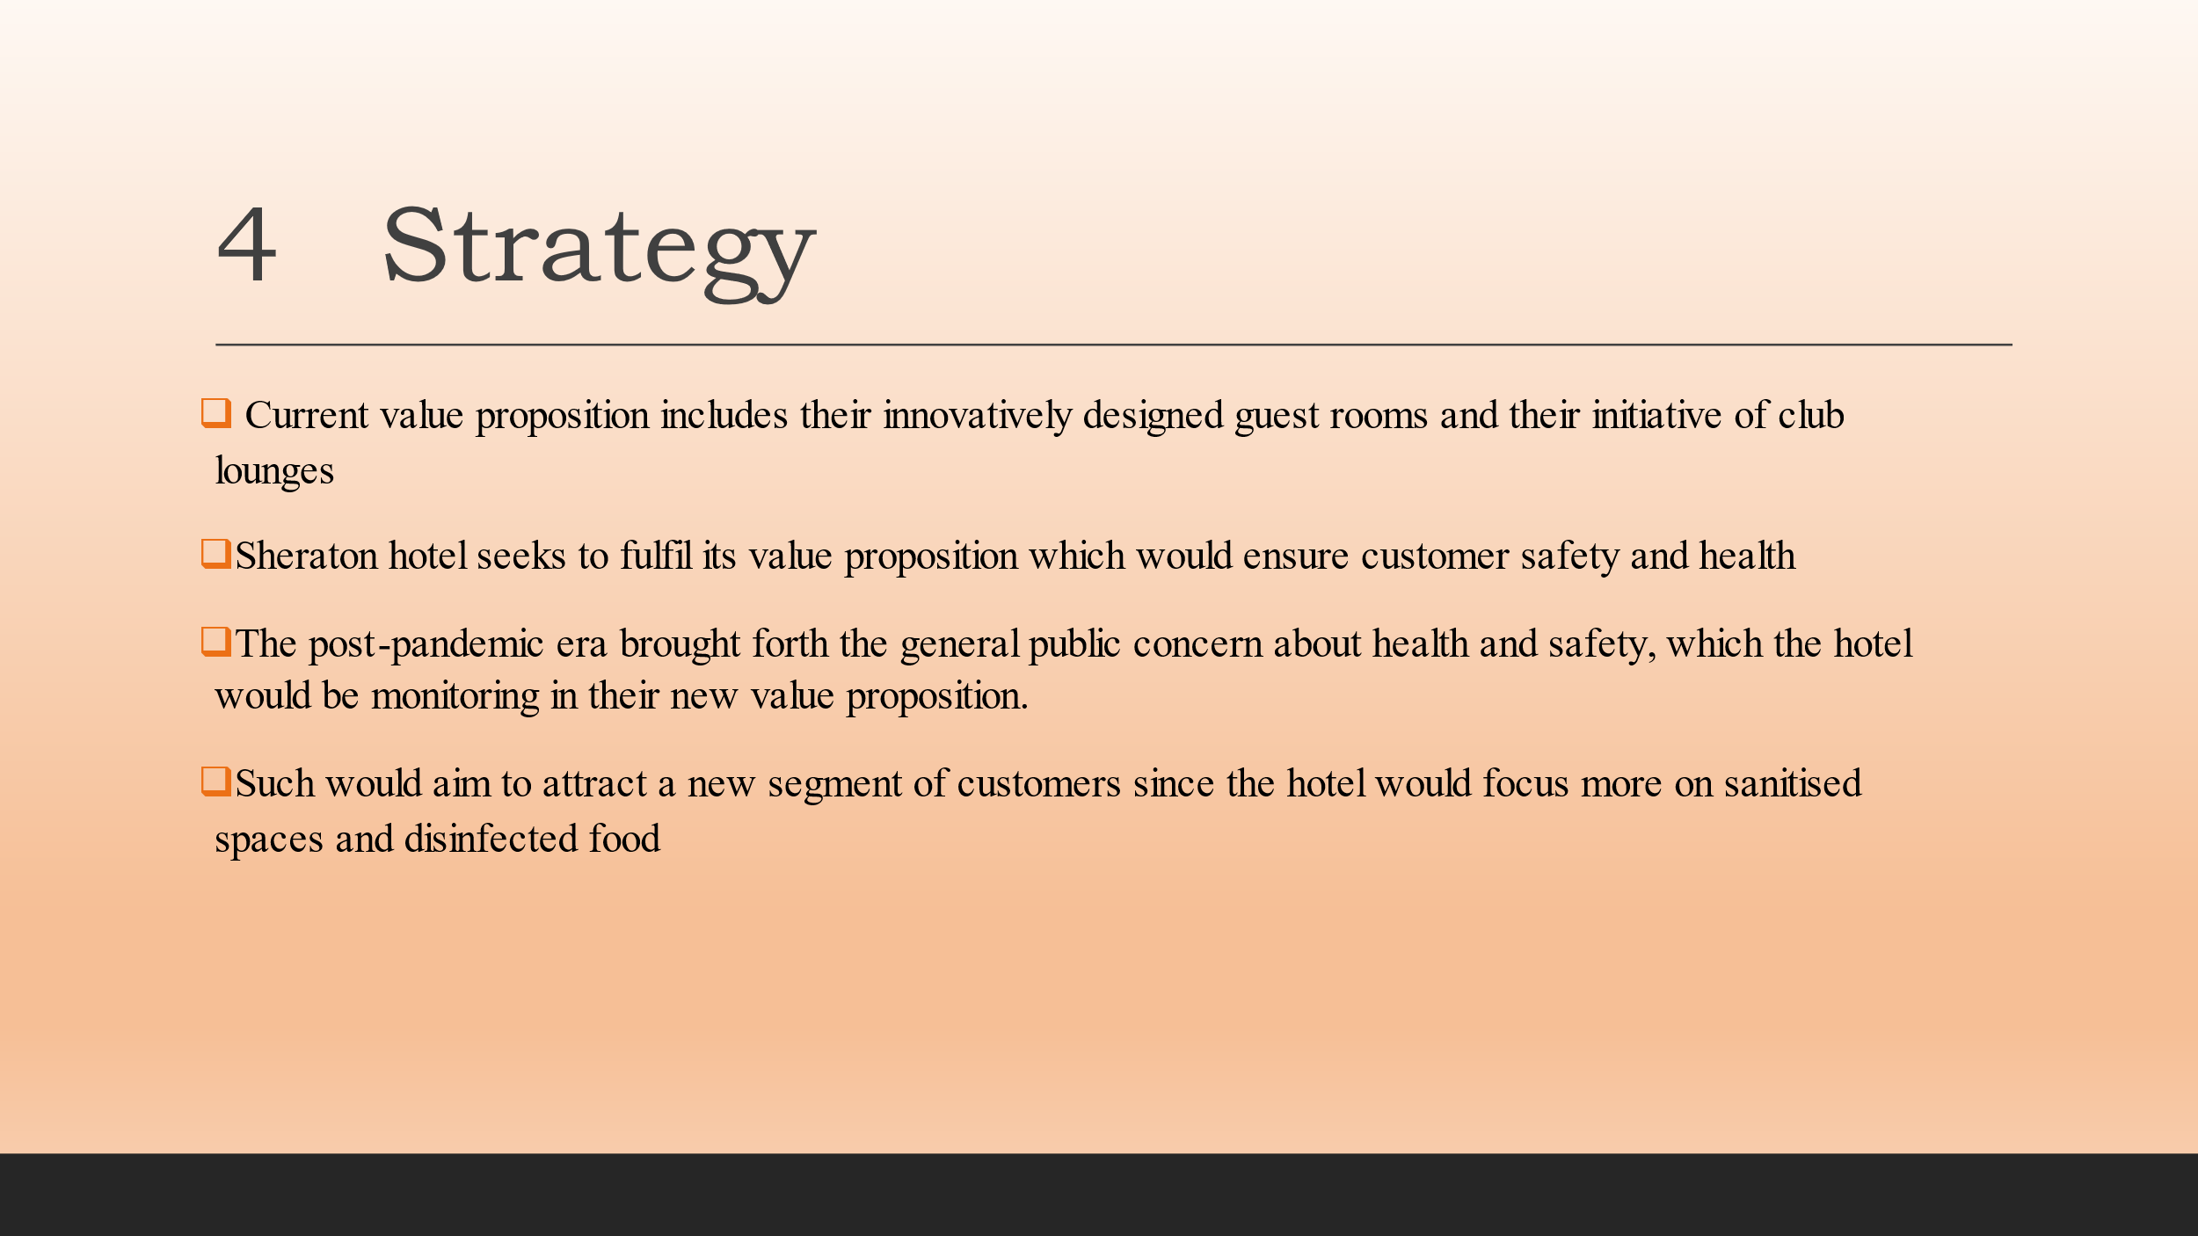
Slide 12: Tactics
Marketing Mix
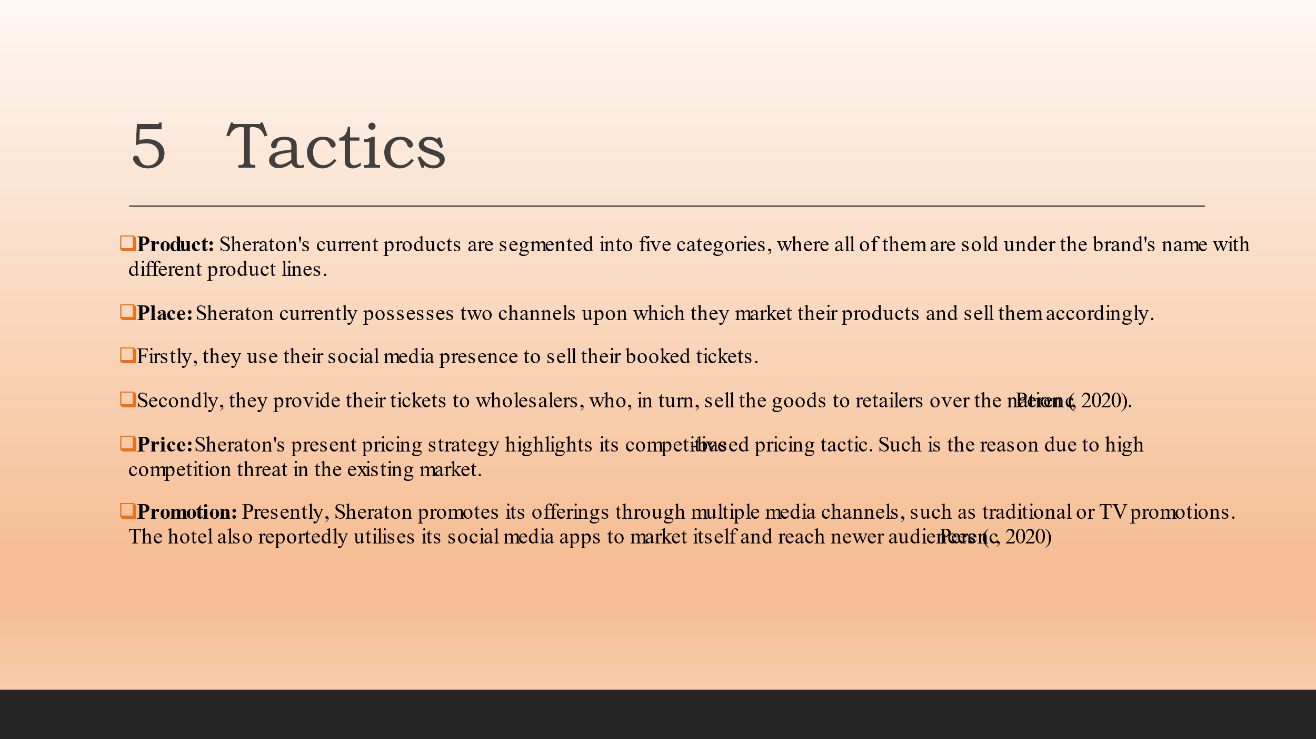
Slide13: Action
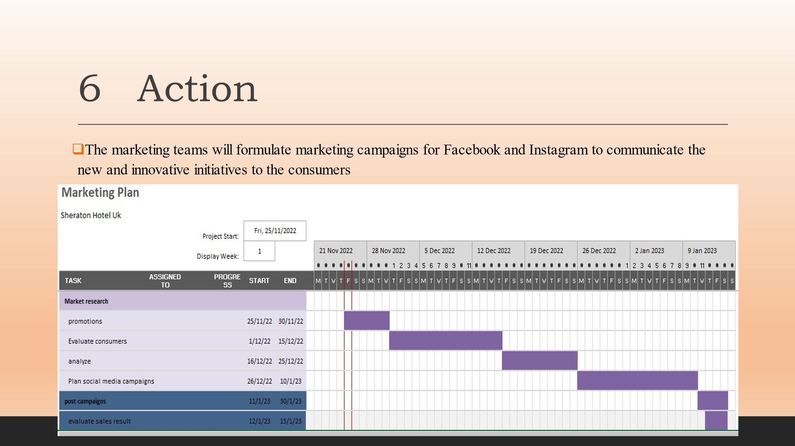
Slide 14: Control
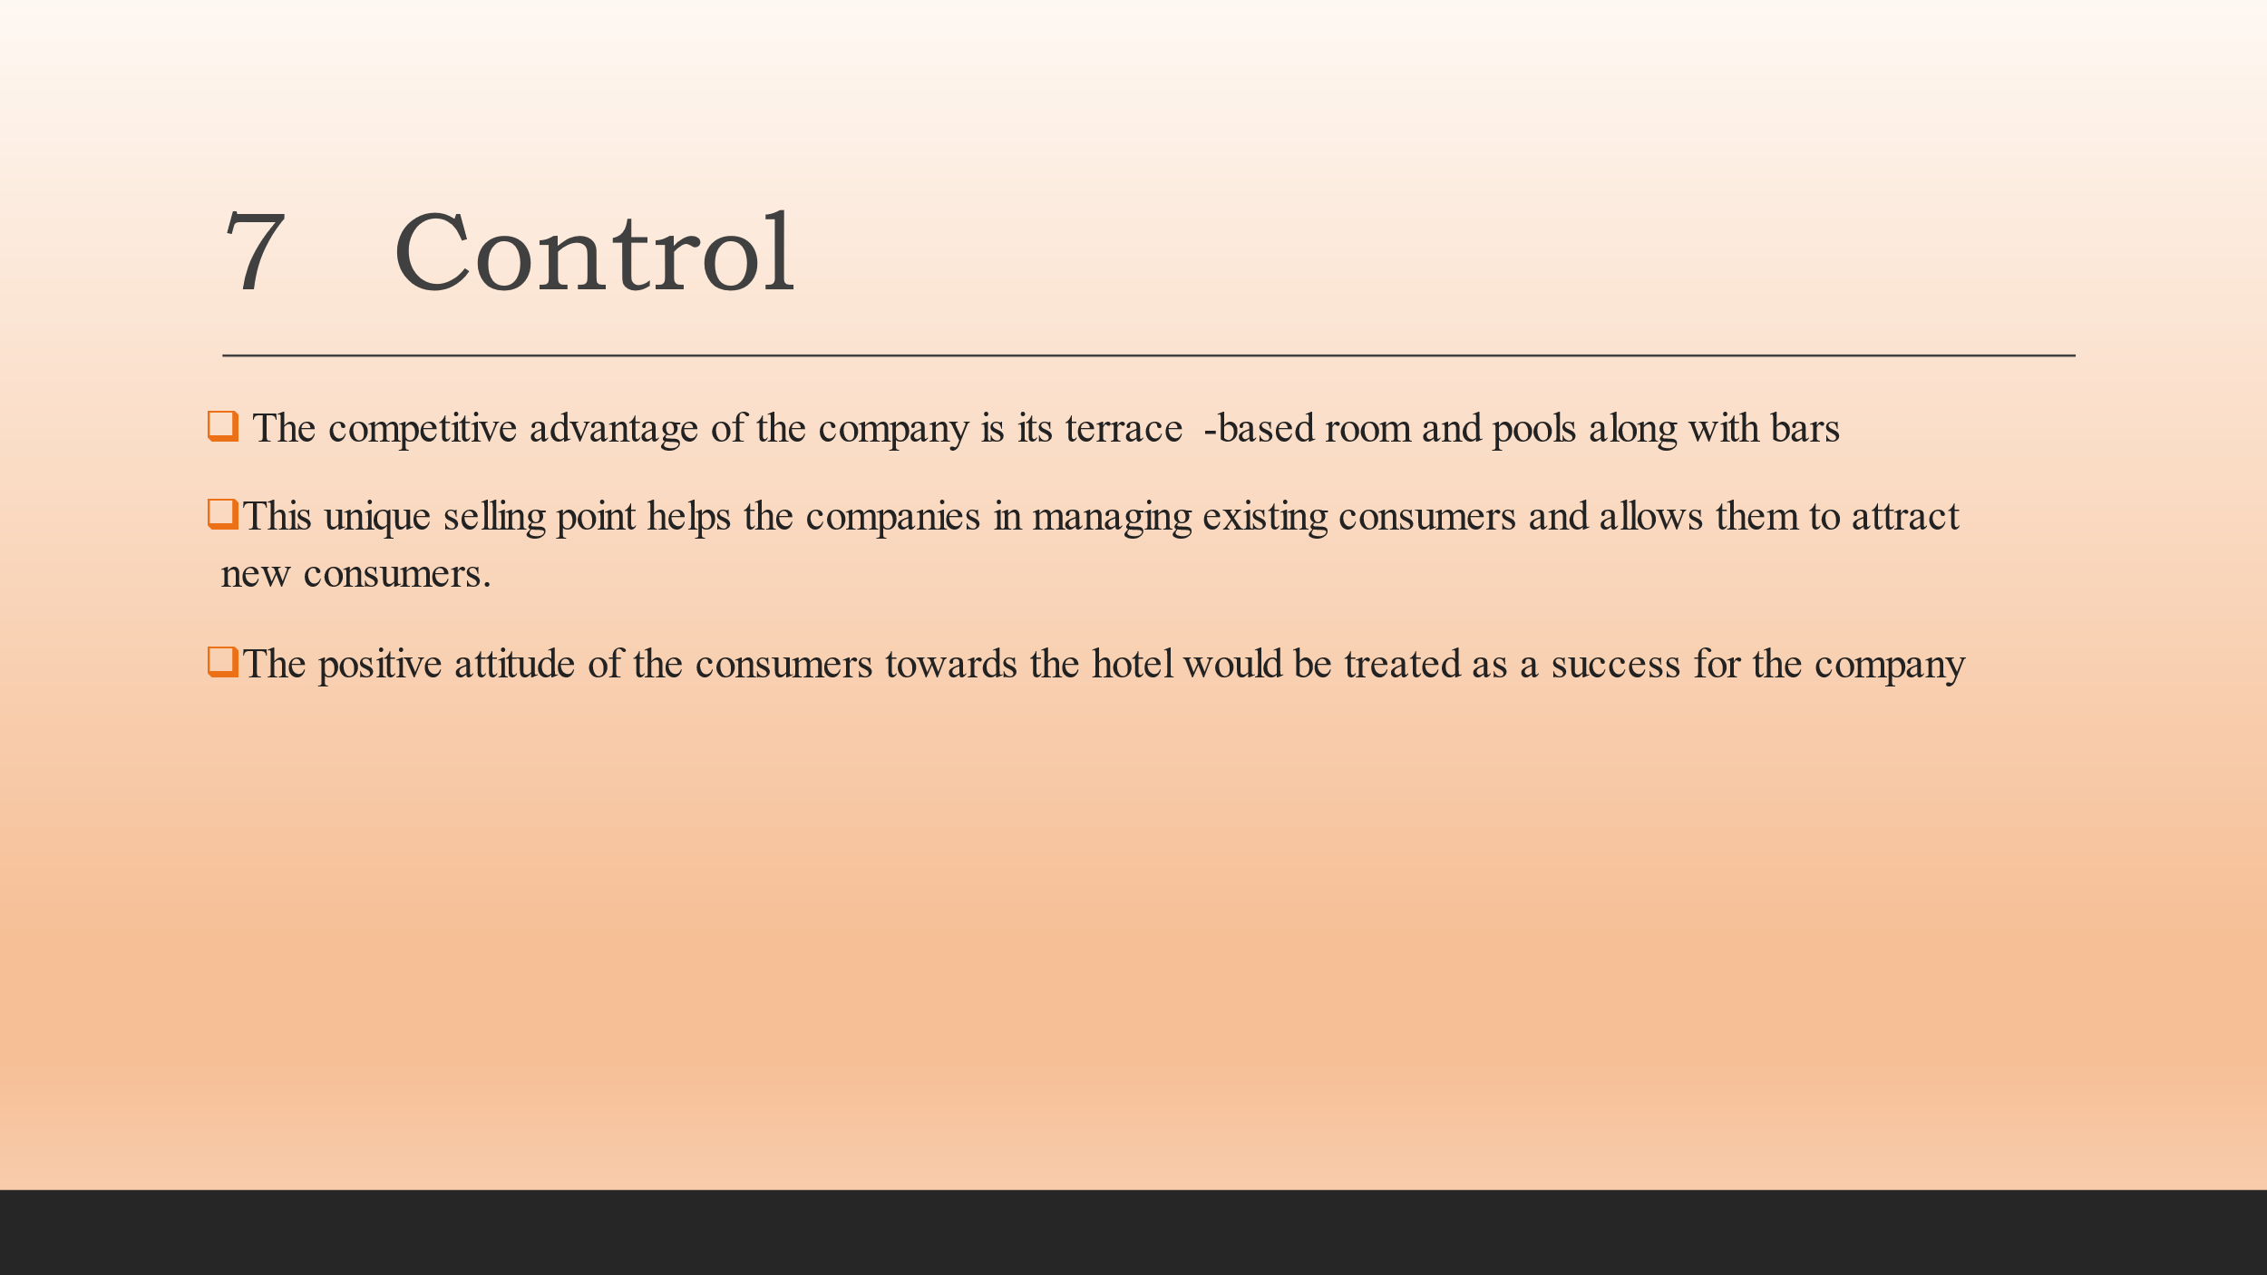
Slide 15: Conclusion
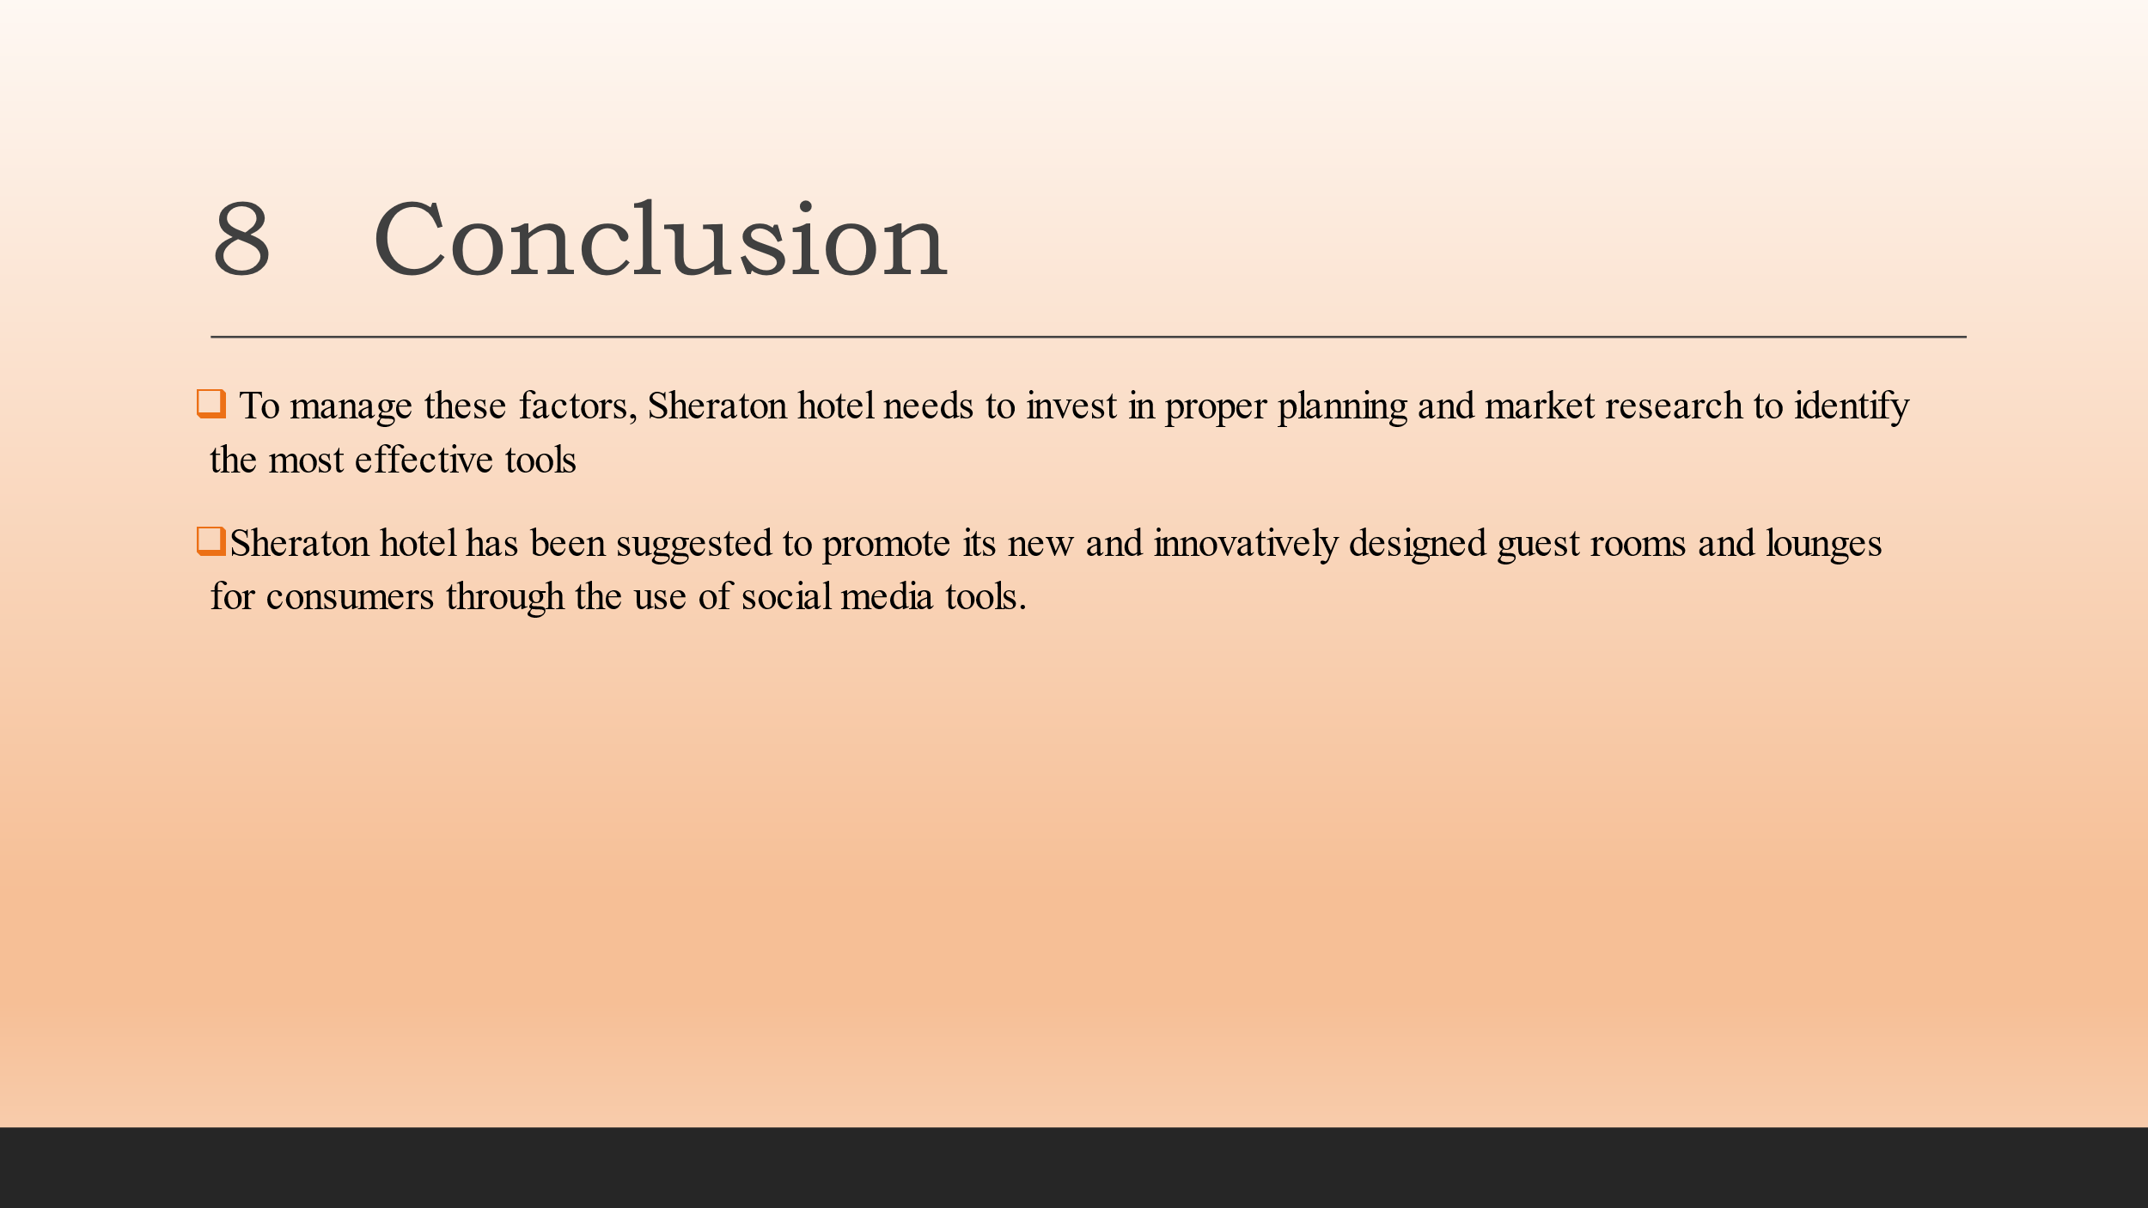
Slide 16: Thank you
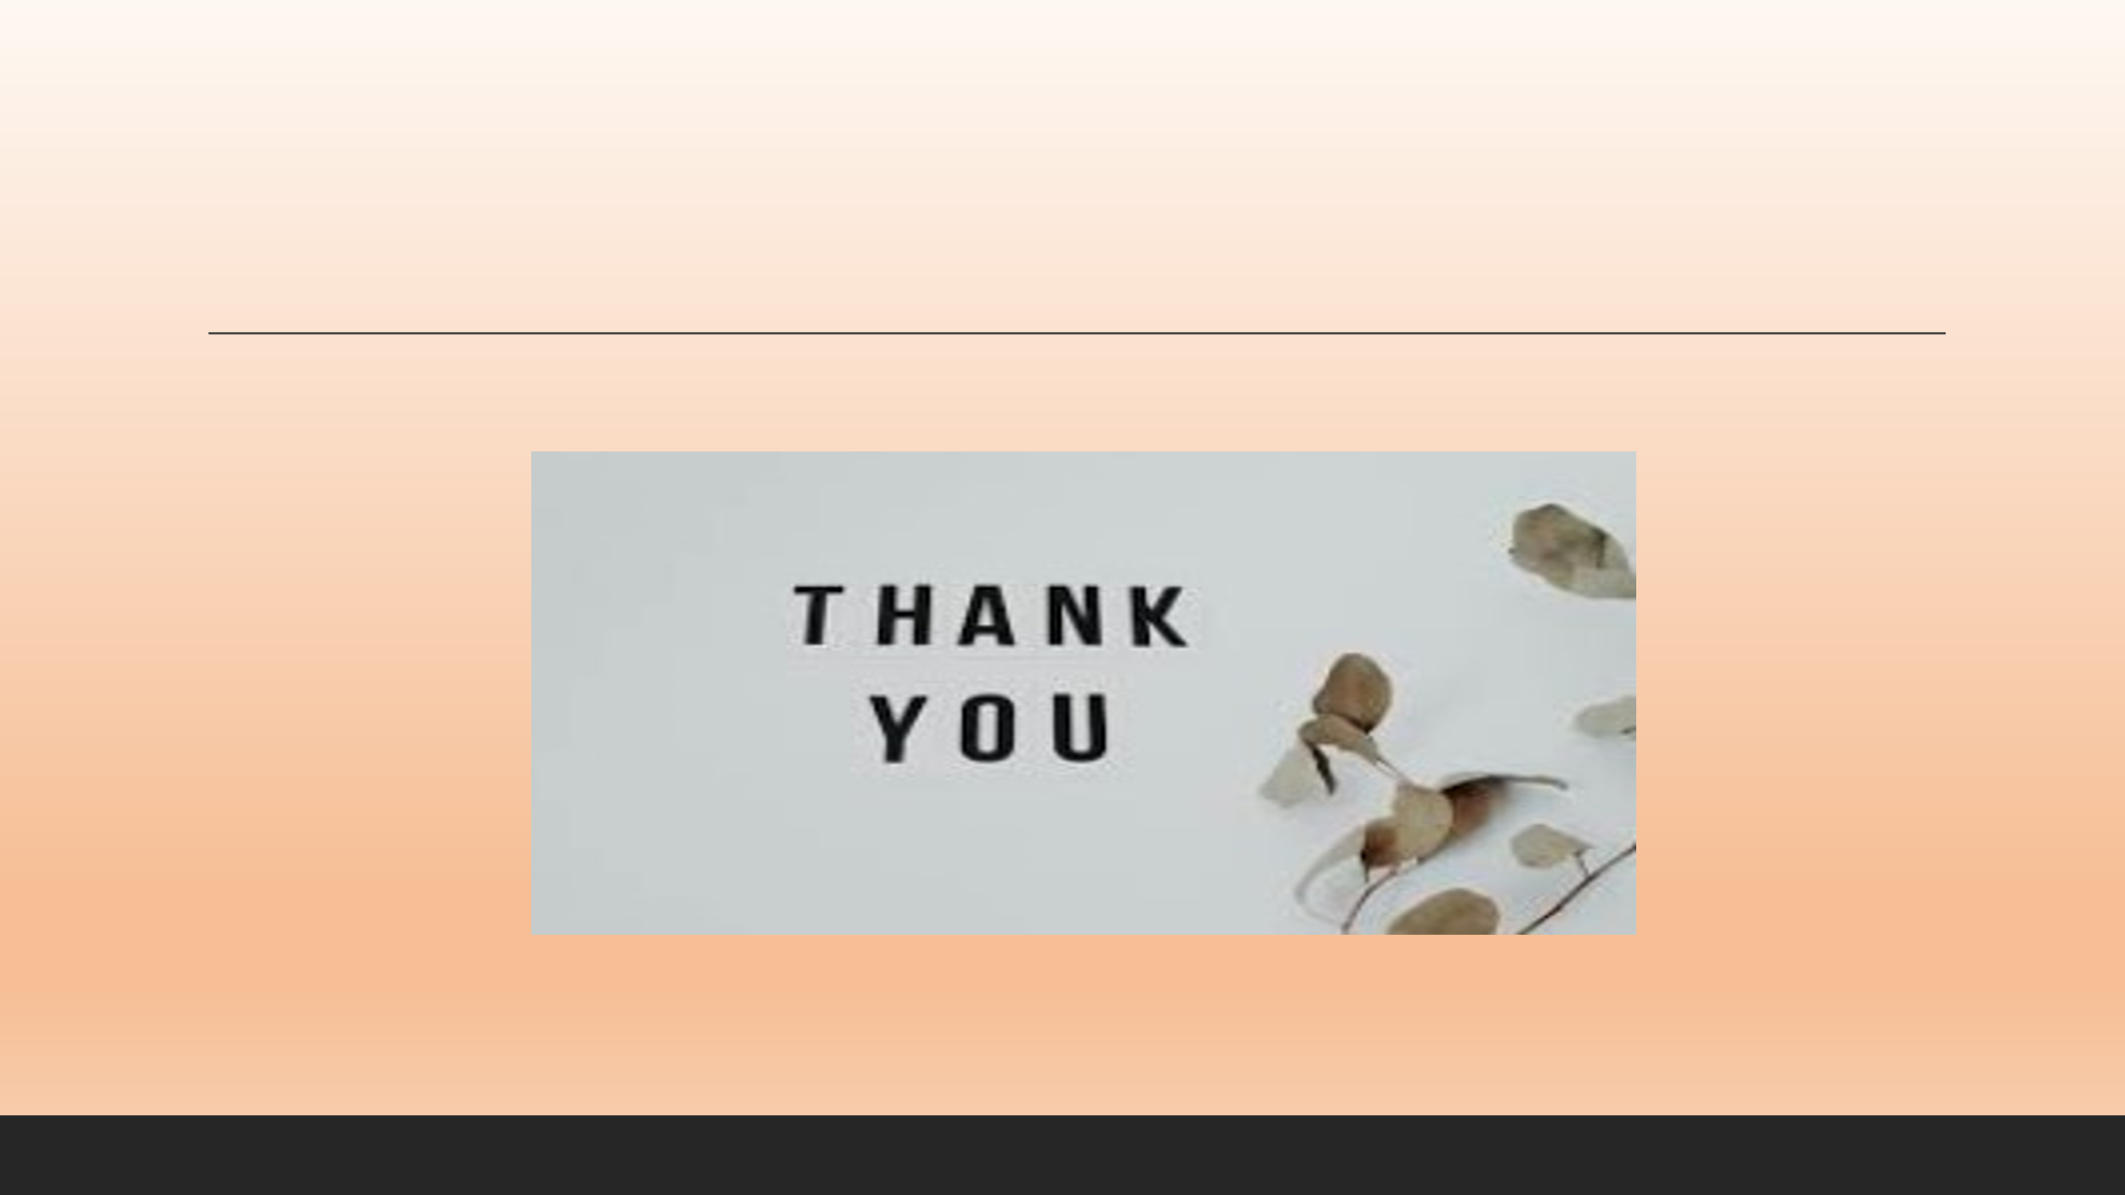
Slide 17: References


