
Data Manipulation
Level 5 Assessment

Statistical Programming
Student ID: 2311568
Nate Fox

Contents
Introductory Page 3
Explanation of Questions 1-4 4
Question 1: Generating the Fibonacci and Pell Sequences 4
Question 2: Building the Approximation Column 5
Question 3: Approximating the Square Root of Two and Calculating Differences 6
Question 4: Calculating Accuracy in Decimal Places 7
Programming Style and Presentation 8
Program Flow Chart 9
Testing and Validation 10
Reflection 11
References 12

Introductory Page

This report explains the design and purpose of the R script developed for task 1 of the Statistical Programming module (ADDB5021). The script generates the first 200 terms of the Fibonacci and Pell sequences, uses the Pell numbers to create a sequence of rational approximations that move towards one plus the square root of two, and then evaluates how well these values approximate the square root of two. Each question is addressed in turn, outlining how the loops, calculations, and data structures were implemented.
The report also discusses the accuracy of the approximations, the behaviour of the sequences, and the testing carried out to check the results. A flow chart is included to summarise the overall logic of the program.

Explanation of Questions 1-4

Question 1: Generating the Fibonacci and Pell Sequences

The first part of the task involved generating the first 200 terms of both the Fibonacci and Pell sequences. Two numeric vectors were created for this purpose, and the initial values for each sequence were set manually: zero and one for both Fibonacci and Pell. A loop was then used to calculate the remaining terms from position 3 to 200. Each Fibonacci term was found by adding the previous two values, while each Pell term was calculated by doubling the previous term and adding the one before it.

Once completed, the results were placed into a data frame called ‘pelldata’, containing the term number, Fibonacci values, and Pell values. This formed the basis for all later calculations.

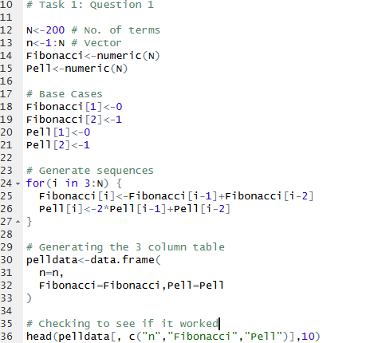
Figure 1: Task 1 Question 1 - Code Input
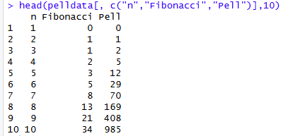
Figure 2: Task 1 Question 1 - Code Output

Question 2: Building the Approximation Column

The second part of the task involved creating a sequence of values that move closer to one plus the square root of two. A new vector called ‘Approximation’ was set up for this. The first two entries were marked as ‘not available’ because the recurrence cannot be applied there, and the third value was calculated as the Pell number in position three divided by the Pell number in position two.

From the fourth term onwards, each value was found by taking two and adding one divided by the previous approximation. This recurrence produces values that gradually approach the target number. Once completed, the vector was added to the data frame as a new column.

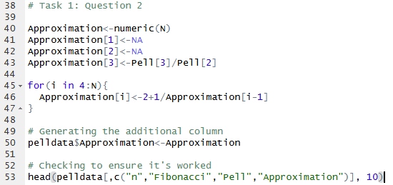
Figure 3: Task 1 Question 2 - Code Input

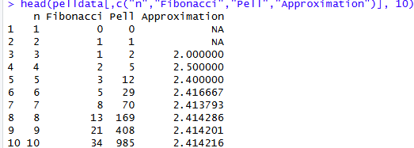
Figure 4:Task 1 Question 2 - Code Output

Question 3: Approximating the Square Root of Two and Calculating Differences

The approximations from Question 2 get close to one plus the square root of two, so the next step was to convert them into estimates of the square root of two itself. This was done by subtracting one from every value in the Approximation column and storing the results in a new vector called ‘ApproxSqrt2’.

To assess accuracy, each estimate was compared with the true value of the square root of two, calculated using sqrt(2). The difference between the two was stored in a separate vector called ‘Difference’, which was then rounded to five decimal places as required by the task.

Both the approximation values and the rounded differences were added to the data frame as a new column.

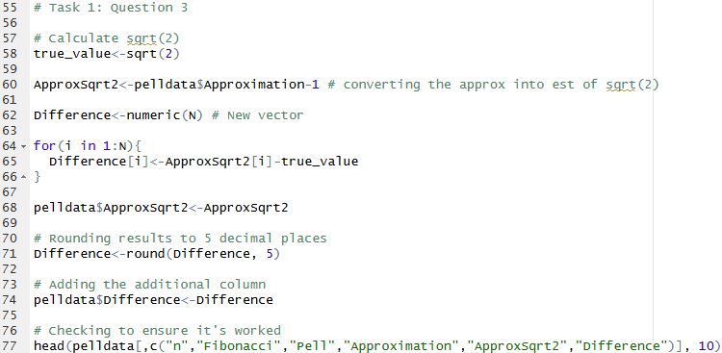
Figure 5: Task 1 Question 3 - Code Input
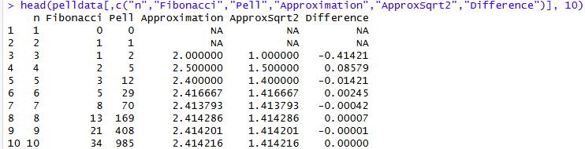
Figure 6: Task 1 Question 3 - Code Output

Question 4: Calculating Accuracy in Decimal Places

The final part of Task 1 involved calculating how many decimal places of accuracy each approximation had. This began by finding the absolute error for each term, which measures the size of the gap between the approximation and the true value, regardless of whether the estimate is above or below it.

A simple accuracy rule was then applied, using the size of the error to estimate how many decimal places match the true value. If the error could not be calculated, the accuracy was marked as ‘not available’. The resulting values were stored in a new column called ‘AccuracyDP’ and added to the data frame.

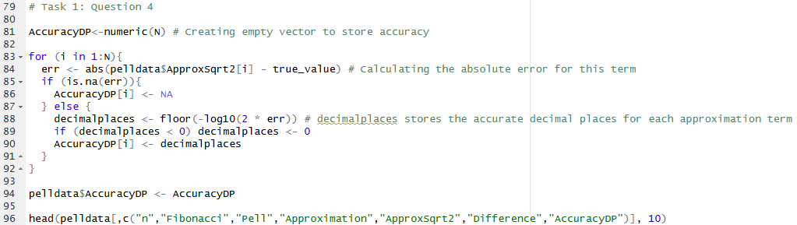
Figure 7: Task 1 Question 4 - Code Input
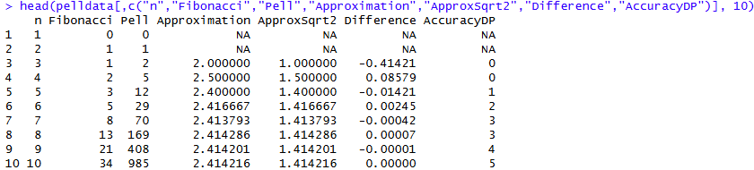
Figure 8: Task 1 Question 4 - Code Output

Programming Style and Presentation

Throughout the script, a clear and consistent programming style was used to make the code easy to read. Comments were added at the start of each section to explain its purpose, with short notes included where needed to clarify steps such as setting base values or describing what each loop calculated. Whitespace and simple indentation were used to separate logical sections and highlight the structure of the code.

Descriptive variable names, including ‘Approximation’, ‘ApproxSqrt2’, and ‘AccuracyDP’, helped show the role of each value. The script also follows the task requirements by using basic loops rather than functions or apply-type shortcuts, demonstrating the core principles of iterative programming.

Program Flow Chart

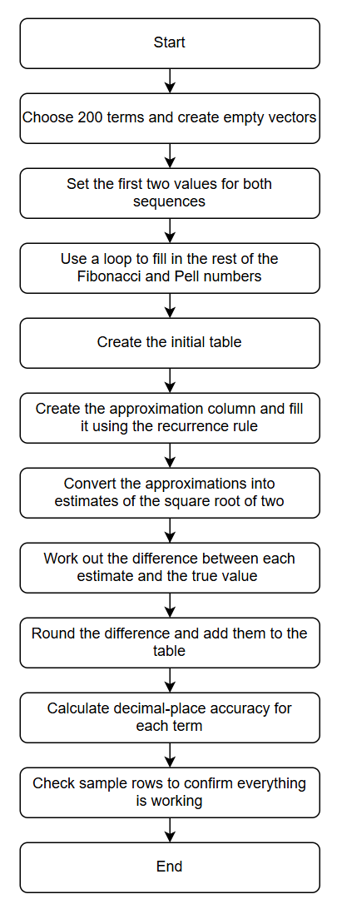
Figure 9: Assignment Task 1 Flow Diagram. Created through Draw.IO

Testing and Validation
Several checks were carried out to ensure the program was performing correctly:

-The first few Pell numbers were compared manually, and the ratios between them were checked. These ratios slowly approached the value ‘one plus the square root of two,’ which confirmed the sequence was behaving correctly.
-When one was subtracted from these ratios, the results moved closer to the real square root of two, which showed that the conversion was working.
-The ‘Difference’ values became smaller as the term number increased, which confirmed the approximations were improving.
-The ‘AccuracyDP’ column increased over time, which showed that more decimal places were becoming correct as the sequence progressed. Short periods where the accuracy stayed the same were also expected and normal.

These checks confirmed that every part of the program was functioning as intended.

Reflection

Working through this task gave me a clearer understanding of how loops, sequences, and numerical approximations work in R. I quickly realised how important it is to set up initial values correctly, as both the Fibonacci and Pell Sequences rely entirely on their base cases. Once they were in place, generating 200 terms using a simple loop showed me how effective iterative calculations can be. Creating the approximation column was one of the more challenging but interesting parts. At first, using a rule where each value depended on the previous one felt confusing, but once I recognised the pattern, the recurrence became much easier to follow. Watching the values gradually move closer to the target helped me understand how repeated calculations can approximate real numbers without relying on built-in functions.
Turning these approximations into estimates of the square root of two, and then comparing them with the true value, helped reinforce the importance of checking results. The accuracy task, where I calculated the number of correct decimal places, was new to me, but breaking the process into small steps made it manageable and easier to understand.
Throughout the task I carried out small checks, such as inspecting the first few rows of the data frame and observing how the error values changed, which helped me interpret the behaviour of the sequences. Overall, this task strengthened my understanding of loops, vectors, data frames, and iterative methods, and it has made me feel more confident about tackling similar problems in future assignments

Use of Generative AI
I used ChatGPT as a support tool for structuring my report and helping me explain certain concepts more clearly. I wrote the code myself and ensured that all explanations in this report reflect my own understanding. The AI support was used only for checking clarity and structure, in line with the assessment guidelines.

References

[1] N.Matloff, “The Art of R Programming”. San Franciso, CA: No Starch Press, 2011.
[2] Swansea University, “ADDB5021 / Statistical Programming – Lecture Slides,” Module Teaching Materials, 2025.

