Characterisation of Women and Men in the Four Branches of the Mabinogion
Characterisation in the Four Branches varies between that of the branches and the rest of the stories. Although there can be differences marked even between the male and female characters, varying from their attitudes to their situations and the types of punishments they are put to; there is great detail put into the difference between the branches and the other stories. These protagonists are typically shown to be conniving and offer a moral stance on some problem, that offer advice to the readers. The variation in characters gives a number of idols for readers to find solace in, and guidance from. The vary in characterisation can be found not only in the dichotomy between sexes, but also the alignment of animals in the four branches, and how the author uses animals as metaphors and to assist the moral dilemmas that characters find themselves in. The alignment with gender, the metaphor of animalistic behaviour and the moral dilemmas and hubris the characters all offer equally goes to teach the reader a moral lesson about following hubris and greed down a dark path.
First Branch
Looking at initially the protagonist from the First Branch of the Mabinogion, Pwyll, his introduction as a man and as a leader immediately places him in a stasis of overconfidence and greed. Pwyll is introduced as a king who was once hunting with his pack of dogs, and sees a stag taken down by a different pack of dogs, whom he chases away so his own dogs can feast. Writer Susan Garlick has written about the importance of animals in the Mabinogion – ‘Many animals in the Mabinogion occur and play roles in the recurrent activity of hunting […] in the form of horses and hounds’ The appearance of the stag and the dogs emphasises this act of hunting, whilst also making clear an action of hubris and greed – he appears to be a king who is not willing to work for what he has, and expects it to be handed to him. Comparing Pwyll to a woman introduced within the same part of the text, Rhiannon, we can see she is introduced as a mysterious rider who is strikingly attractive – ‘And then he thought that the face of every maiden and every woman he had ever seen was unattractive compared with her face.’ Her only devotion was to marry Pwyll – portraying women in the light of men, wherein which they only exist to offer themselves endlessly to men. Later, she is fought over by Pwyll and Gwawl, but since Pwyll is the only one she truly loves, she offers a conniving solution to their predicament – this offers an idea that in the First Branch, protagonists of both men and women are intelligent enough to do whatever they can to get their way. When Pwyll implicitly does this at the beginning, Rhiannon imitates this by pulling the trick with the bag – she suggests the only way to get rid of Gwawl and to live happily with her chosen husband is to trick him into falling into a bag, which they will then throw under hunting horsemen. This again references Garlick’s note about the horses used for hunting, and the connection to animals can also be marked in this first branch as a unique characterisation in the Mabinogi – the stag which is killed earlier in the chapter can suggests innocence, the killing of bravery, the overcoming of difficult tasks – whereas Pwyll and Rhiannon seem to align with a hunter and fighter who would slyly get their way no matter what.
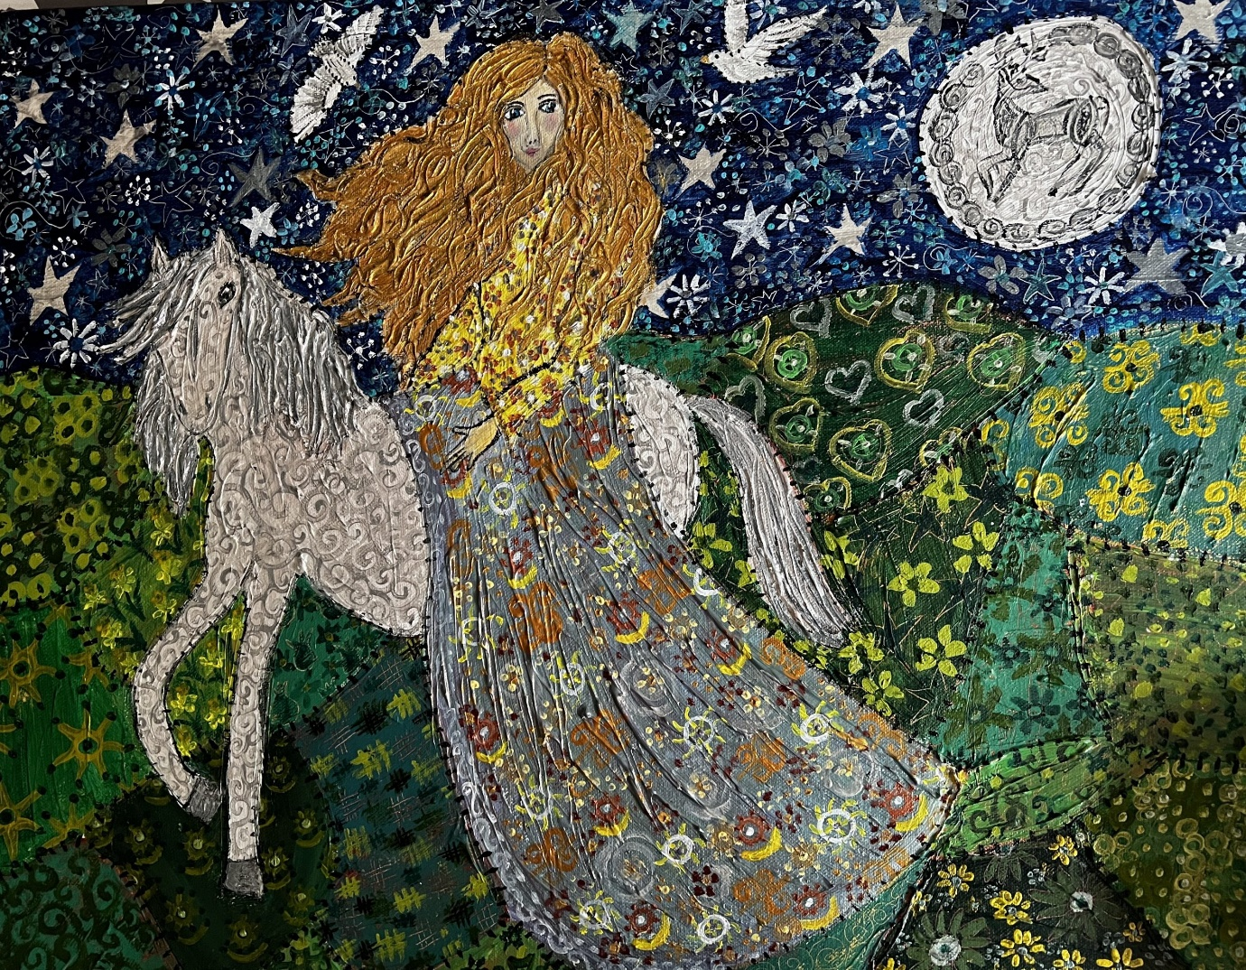Fig.1. Rhiannon on her horse, painted by Fi Marks.
Second Branch
The introduction of Branwen, daughter of Llyr, continues to perpetuate the cycle within women are placed in the Mabinogi – she is described as ‘one of the Three Chief Maidens of this Island: she was the most beautiful girl in the world.’ Nothing about her intellect is mentioned and she has no say in whether or not she is married to Matholwch – alternatively, her brother Efnysien’s character is almost immediately commented on, as a man who ‘would cause two of the most loving brothers to fight.’ He also immediately causes trouble, whilst Branwen seems to be calm and stable of mind. Instead of being conniving, Branwen also offers a respectable outcome to her own problems; she rears a starling and teaches it to carry letters, and sends it to Wales in order to reveal how she is being punished daily for the acts of her misguided family. The starling brings her help, as Bendigeidfran ‘grieved to hear how Branwen was being punished.’ Branwen’s actual first line of dialogue ends up standing up for herself – ‘Lady, they said, what do you think it is?’ ‘Though I am no ‘lady’,’ she said, ‘I know what it is: the men of the Island of the Mighty coming over, having heard of my punishment and dishonour.’’ Her reaching out for help is seen as a creative way of doing so but not in a conniving or dishonourable way, as perhaps Rhiannon’s way in the First Branch – she is calling for help in any way, because she was married off without permission and thus becomes mistreated unnecessarily. She also offers to her husband to heed his men’s advice due to her brother’s readiness for war – ‘He decided to accept; and that was all done on Branwen’s advice because she feared that the country would be laid waste.’ The difference between Branwen and Efnysien evidences a kind and gentle woman who dies of a broken heart, and a self-sacrificial psychopath who existed to cause harm to others. The kindness of Branwen in the branch also suggests R.L. Valente’s idea that ‘The women of the Mabinogi […] are amongst the most vivid characters’, emphasising that the portrayal of women is the most important within the four branches.
Third Branch
Whilst the First and Second branches offer different portrayals of women and men in the Mabinogion, the Third branch introduces a female character by the name of Cigfa, the wife of Pryderi. In the Third Branch, animals are yet again used as metaphor to communicate with the reader – Pryderi is approached by a white boar, symbolising purity yet aggression. Again Garlick’s argument makes a reappearance, as she writes ‘Animals are also linked to the birth, naming and death of heroes […] and pigs lead to the downfall of Pryderi.’ Once he and his mother disappear into mist, Cigfa seems to lament the loss of her husband, stating ‘she did not care whether she lived or died.’ Once she realises she has a friend, she seems to cheer up considerably; this paints her in a kind light, as she is sweet and friendly but not unfaithful to her husband and not manipulative to trick her last acquaintance, as Rhiannon herself was portrayed in the First Branch before. When she hears of Manawydan having trouble, she merely says ‘What have you in mind?’, emphasising her lack of conniving nature or wish to do ill. She actually shows support of the mice that wreck Manawyden’s fields – in fact she seems to be manipulated by the man’s way of thinking which prevents her kindness from taking action – ‘If you were to do the right thing, you would not bother with the creature […] There is no reason why I should help this creature, except to prevent you from being disgraced.’ As it turns out her kindness was foolishness, as it was because of the mouse that the curse was placed upon Dyfed, and it was only through negotiation that Manawydan was able to receive all of his land and people back. In comparison, Manawydan was also faithful to Rhiannon, was kind to everyone he met, but the marked difference between the two was that Cigfa was presented as foolish for her kindness whereas Manawydan is presented as a genius. Although the Third Branch seems to portray men and women differently to the others, it still ends up perpetuating gender standards by assuming Cigfa is less intelligent than her friend and therefore less useful. Jeffrey Gantz’s idea of the setting and structure of the Mabinogion ties into this, believing that ‘the first and third are set in the south of Wales, while the second and fourth are set in the north.’ Whilst this appears to be merely geographical, it actually reflects the idea that the stories set in the south are more violent and easy to fight, the stories in the north are more polite, standard to the Norman behaviour. This is evidenced in the aggression of ‘hanging a thief’ that is apparent throughout this story, whilst Cigfa’s polite nature mimics that more associated with women and the north of Wales.
Fourth Branch
Finally, the Fourth Branch introduces a female character by the name of Goewin and, following the pattern of beautiful female characters, Goewin is introduced as ‘the fairest maiden of her generation known at the time.’ Gwydion’s brother is in love with her, so he devises a plan to have them marry, evidencing his own form of mischief by using magic to trick Pryderi into giving away his swine – seeming to be a cruel trick ultimately as his brother takes Goewin against her will. Gwydion still seems to be read as a hero, however, as he is pitted against Pryderi personally in war for his tricks and succeeds – ‘And because of strength and valour, and magic and enchantment, Gwydion triumphed and Pryderi was killed’ When Goewin speaks out, she is treated well by Math although she seems to be ashamed; in return he says ‘what I can, I shall do. I will arrange recompense for you first, and then I will seek recompense for myself. And I will take you as my wife, and give you authority over my kingdom.’ Goewin is little mentioned after this point, however revenge is enacted on her behalf as Math curses Gwydion for three years, afterwards leading him free to live his own life. He takes in a son who he fights Aranhrod for, giving him a name and weapons and a wife to prove he raised him well; Aranhrod in exchange is described as an evil and wicked woman, who lied about her virginity and also refuses to let her son have a peaceful life. This too is an example of women portrayed as wicked while men are portrayed as heroes; even though Gwydion committed a crime initially, it is still Aranhrod and eventually Blodeuwedd (Lleu’s wife) who are seen as the enemies, and the most conniving of women within the text.
Ultimately there is a stark difference in the way men and women are portrayed within the Four Branches of the Mabinogi. While it seems that any man can be conniving and intelligent, it takes a specific kind of woman to be the same kind of conniving; and when she does so, she is seen as wicked in one way or another. At first glance, they can be characterised as quite similar due to their natures, but women seem to have more variety of being weaker and more shy – Goewin is much more reserved than Rhiannon, although Cigfa is kinder and more considerate than the both of them. Cigfa is as intelligent as Rhiannon, but more naïve to throw that aside, whereas Rhiannon uses her intellect to get exactly what she wants. The men seem to have equal intelligence but varying motivations; Gwydion will use his intellect to assist his brother in malicious deeds, but shows reserve in raising a son later, whilst Efnysien shows endless sadism and his only moment of self-sacrifice is in his own death. In this sense, the men and women are characterised in the Four Branches as not only different from each other, but different from each branch.
Bibliography
Primary Source
Davies, Sioned, The Mabinogion (Oxford University Press, 2007)
Secondary Sources
Garlick, Susan, ‘Horses, Swine and Magical Birds : The Role of Animals in the Mabinogion.’, 2011
Valente, R.L., ‘Merched y Mabinogi: Women and the thematic structure of the Four Branches’ (Ph.D. Thesis Cornell University), 1986
Winward, Fiona, ‘Some Aspects of the Women in The Four Branches’, Cambrian Medieval Celtic Studies 34, pp.77-106, 1997
Additional/Online Sources
Boyd, Matthieu, ‘The Four Branches Flowering: New Tales from the “Mabinogion”’, Proceedings of the Harvard Celtic Colloquium, 35 (2015), pp. 57–87
Gantz, Jeffrey. “Thematic Structure In The Four Branches Of The Mabinogi.” Medium Ævum, vol. 47, no. 2, 1978, pp. 247–54. JSTOR, https://doi.org/10.2307/43631333. Accessed 7 Jan. 2026.
Marks, Fi, ‘Women in the Mabinogion’, https://fimarks-art.co.uk/women-of-the-mabinogion-1-rhiannon/, last accessed 7/1/26
Valente, R. L., (1988) ‘Gwydion and Aranrhod: Crossing the Borders of Gender in Math’, Bulletin of the Board of Celtic Studies 35

Susan Garlick, ‘Horses, Swine and Magical Birds : The Role of Animals in the Mabinogion.’, 2011, p.61
Sioned Davies, The Mabinogion (Oxford University Press, 2007), p.11
Fi Marks, ‘Women in the Mabinogion’, https://fimarks-art.co.uk/women-of-the-mabinogion-1-rhiannon/ [last accessed 7/1/26]
Davies, Mabinogion, p.23
Mabinogion, p.22
P.28
P.29
P.30
R.L. Valente (1986) ‘Merched y Mabinogi: Women and the thematic structure of the Four Branches’ (Ph.D. Thesis Cornell University)
Garlick, ‘Horses, Swine and Magical Birds‘, p.61
Davies, Mabinogion, p.40
P.42
P.43
Jeffrey Gantz, “Thematic Structure In The Four Branches Of The Mabinogi.” Medium Ævum, vol. 47, no. 2, 1978, pp. 247–54. JSTOR, https://doi.org/10.2307/43631333. Accessed 7 Jan. 2026.
P.47
P.51
P.52

