Shereen Garraghan
Lecturer - Scott James
Marketing - BMIH4005
ASSESSMENT 2- MARKETING PLAN
Word count 1250

Table of Contents
Introduction 3
Situation Analysis 3
Objectives 6
Strategy 7
Tactics 7
Action 8
Control 8
Conclusion 9
References 10

Introduction
The purpose of the marketing plan is to discuss ways Hotel Holiday Inn is going to open hotel chains in Timor-Leste. The goal is participating in the country’s economically and environmentally sustainable National Tourism Policy. The marketing plan is prepared to give a message to think about improving the climate change issue by protecting the environment of Timor-Leste. It will be done by reaching net zero carbon emissions. To discuss the marketing plan this report is going to apply different frameworks like SWOT, PESTLE, Marketing Mix and many more. The purpose is also to discuss SMART objectives, business strategy through Ansoff, different communication mix, control and many more related to the marketing plan of Holiday Inn.

Situation Analysis
The task uses 5Cs to do the situational analysis of Hotel Holiday Inn.
Company: SWOT analysis

Strengths  - 68.3% of occupancy rate.  - Attractive locations  - Committed to maintaining sustainability | Weaknesses  - Limited international presence  - Hygiene-related issues  - Refund challenges
Opportunities  - Entering new markets like Timor-Leste.  - Innovative decor and focusing on upmarket room design. | Threats  - High competition  - Lockdown issue  - Legal threats

Table 1: SWOT of Holiday Inn
(Source: Gowrea, 2023)
Customers: Targeting and segmentation
Target- The marketers of Hotel Holiday Inn will target older generations from 50-75 years old who prefer to relax and enjoy green nature. Commitment to environmental sustainability will help Holiday Inn to expand its business in Timor-Leste.
Demographic segmentation-
- Age- 50-75 years old people.
- Gender- Both male and female
- Occupation- Servicemen, businessmen, retired persons.
- Income- Mid-high-income group.

Competitors: Perceptual positioning map
Holiday Inn to start a hotel business in Timor-Leste has to face major competition with Hilton Dili Palm Springs, Hotel Timor, Hotel the Ramelau, Balibo Fort Hotel and many other local players. The marketers will offer people of Timor-Leste value-based positioning (Pride and Ferrell, 2019). In this case, the company will promise its customers a healthy sleep at night in a sustainable environment. The hotel will offer quality services at affordable prices (Unstats, 2011).
Collaborations: Increasing awareness of Holiday Inn’s franchises.
The marketers will launch a campaign for launching franchises of Holiday Inn in different cities of Timor-Leste. The purpose of the campaign is to bring new positioning to life. This will help the Holiday Inn franchise increase awareness.
Climate: PESTLE of Timor-Leste

Deliverables | Factors
Political | - The political instability of Timor-Leste can hamper Holiday Inn from starting a hotel business (Unstats, 2011).
Economic | - Rising inflation of Timor-Leste forces Holiday Inn to set high prices of accommodation and services for customers. It can reduce sales (Halpern and Graham, 2021).
Social | - Social equality creates an opportunity for Holiday Inn to attract the maximum number of old people in Timor-Leste.
Technological | - High technological innovation will help old people in Timor-Leste to take services of automated procedures of Holiday Inn (Galli et al. 2021).
Legal | - Holiday Inn has to follow the National Tourism Policy of Timor-Leste to maintain environmental sustainability (Timor-Leste National Tourism Policy, 2023).
Environmental | - Holiday Inn will focus on net zero carbon emissions while starting a business in Timor-Leste. It will make them attract maximum customers.

Table 2: PESTLE of Holiday Inn
(Source: Created by the learner)
Marketing Mix 4Ps
- Product- Holiday Inn will offer customers an environmentally sustainable and green culture inside the hotel. They will focus on a less/zero carbon emissions policy to attract more old people to Timor-Leste.
- Price- Holiday Inn will use a value-based pricing strategy while starting a hotel business in Timor-Leste. The organisation will offer proper value to customers for the money.
- Place- Holiday Inn will open franchises in different cities of Timor-Leste. It will help them to attract old generations to come and enjoy their hotels.
- Promotion- Holiday Inn will promote its new launch hotel franchise through social media and the company website. Facebook, Instagram and YouTube are key social media platforms to reach a target audience in Timor-Leste (Morrison, 2022).

Objectives

Specific | Measurable | Achievable | Realistic | Time
To be committed to environmental sustainability and be economically sustainable. | It can be measured by how well Holiday Inn is maintaining net zero carbon emissions. | It can be achieved by implementing the National Tourism Policy of Timor-Leste and organising a campaign to create awareness of environmental sustainability. | Yes, because hiring local and skilled staff can promote sustainable tourism to local customers. | End of 2024.
To attract as many customers as possible. | It can be measured by how frequently customers visit Holiday Inn and the feedback they offer. | It can be achieved by social media promotion and by increasing the green environment in the surroundings. | Yes, because skilled staff can promote and make customers understand the health benefits they get. | End of 2025.

Table 3: SMART Goals of Holiday Inn
(Source: Created by the learner)

Strategy
Through the development of the marketing plan, Holiday Inn will focus on the Ansoff Matrix, which is an important area for the effectiveness of the marketing development. Differentiation will be the focus to make the development of the business in Timor-Leste. On this note, the business will apply the innovative approach following the sustainable development of the business. Through this, the company aims towards the reduction of carbon emissions.
There is also a focus on the market development strategy that involves the new market Timor-Leste. This market will be focused on by Holiday Inn as this will allow it to get a better market share. Considering this area there will be a focus on a cost-effective strategy that will be helpful for the competitive advantages of the organization (Desai and Vidyapeeth, 2019). On this note, the strategy will be involved with the management of the existing services. As the existing strategies of the services of the company are strong, the company will get competitive advantages in the market (Chaffey and Smith, 2022).

Tactics
The marketers will create brief and concise contents which can easily become eye-catchy to the target audience. They will upload photos and videos of Hotel Holiday Inn and its surroundings in Timor-Leste. Even the price will be tagged. This will help customers easily notice and can tally everything with other hotels before travelling or visiting Holiday Inn.
The marketers of Holiday Inn will use social media sites to communicate with potential customers and solve their queries. It can be done through personal chats or comments (Fahy and Jobber, 2019). Facebook, YouTube and Instagram are the best options to promote the environmental sustainability of Holiday Inn in Timor-Leste. Even marketers can launch online campaigns to attract the maximum number of customers to enjoy green nature and keep themselves fit.
Holiday Inn can send the latest discounts and attractive sales to the first 1000 customers after their launch in Timor-Leste. It will be communicated through social media platforms, company websites and through email. This will help the company to easily reach potential customers. Latest discounts and attractive sales will help customers to get exclusive deals in high inflations. Even a refund will be done within one week after cancellation and it will be informed via email.
Holiday Inn currently uses social media platforms, and Google Hotel Ads to reach the maximum number of customers (Ferrell et al. 2021). However, the company could not increase their international presence. To avoid this issue, Holiday Inn can hire local staff and promote their campaigns through them. This will make them easily understand customers about new economically and environmentally sustainable hotels (Jin et al. 2019).

Action
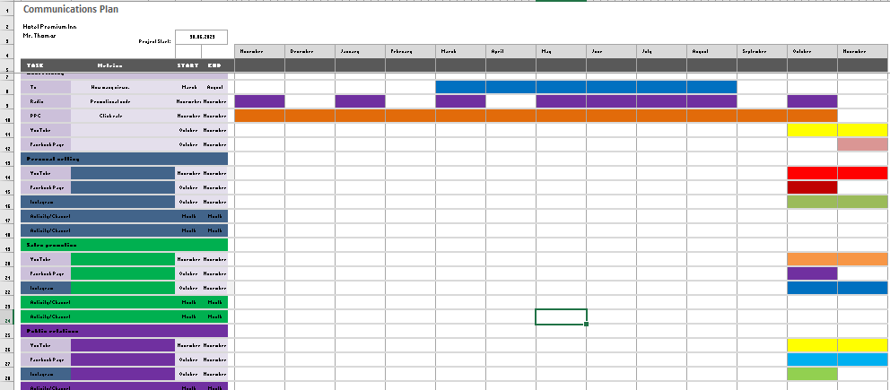
Holiday Inn
Fig 1: Gantt Chart to showcase the marketing plan of Holiday Inn
(Source: Created by the learner)

Control
KPIs are focused on how to work as the important metric for measuring the success of the marketing plan (Lee and Kotler, 2019). Considering this area Holiday Inn will focus on tracking the data related to consumer engagement. There is a focus on the analysis of website visitors (Huang and Rust, 2021). Considering the number of visitors, the marketers can get the data related to the engagement within the company. On this note, there will also be a focus on the measurement of the data related to the feedback within social media. This will help track the performance (Ghahremani-Nahr and Nozari, 2021). Focusing on this Holiday Inn will also develop its weakness through the marketing plan.

Conclusion
The task concludes with Holiday Inn getting an opportunity in Timor-Leste to open an environmentally and economically sustainable tourism business. The task determines an attractive location as a strength, hygiene-related issues as a weakness, and innovative décor as an opportunity for Holiday Inn. The hotel chain will target older-generation customers from the mid-high-income group in Timor-Leste. Through social media promotions, Holiday Inn will promote its environmentally sustainable tourism business to its customers.

References
Chaffey, D. and Smith, P.R., (2022). Digital marketing excellence: planning, optimizing and integrating online marketing. Taylor & Francis.
Desai, V. and Vidyapeeth, B., (2019). Digital marketing: A review. International Journal of Trend in Scientific Research and Development, 5(5), pp.196-200.
Fahy, J. and Jobber, D., (2019). EBOOK: Foundations of Marketing, 6e. McGraw Hill.
Ferrell, O.C., Hartline, M. and Hochstein, B.W., (2021). Marketing strategy. Cengage Learning.
Galli, B.J., Bongo, M.F., Yamagishi, K.D. and Ocampo, L.A., (2021). A critical literature analysis of the relationships of marketing and strategic planning under project environments. International Journal of Service Science, Management, Engineering, and Technology (IJSSMET), 12(2), pp.1-24.
Ghahremani-Nahr, J. and Nozari, H., (2021). A Survey for Investigating Key Performance Indicators in Digital Marketing. International journal of Innovation in Marketing Elements, 1(1), pp.1-6.
Gowrea, V. (2023). SWOT analysis of Holiday Inn (Holiday inn swot), www.howandwhat.net. Available at: https://www.howandwhat.net/swot-analysis-Holiday-inn-Holiday-inn-swot-analysis/ (Accessed: 15 June 2023).
Halpern, N. and Graham, A., (2021). Airport marketing. Routledge.
Huang, M.H. and Rust, R.T., (2021). A strategic framework for artificial intelligence in marketing. Journal of the Academy of Marketing Science, 49, pp.30-50.
Jin, S.V., Muqaddam, A. and Ryu, E., (2019). Instafamous and social media influencer marketing. Marketing Intelligence & Planning, 37(5), pp.567-579.
Lee, N.R. and Kotler, P., (2019). Social marketing: Behavior change for social good. Sage Publications.
Morrison, A.M., (2022). Hospitality and travel marketing. Taylor & Francis.
Pride, W.M. and Ferrell, O.C., (2019). Marketing. Cengage Learning.
Timor-Leste National Tourism Policy, (2023). National tourism policy - tourism timor-leste. Available at: https://www.timorleste.tl/wp-content/uploads/formidable/4/TL-National-Tourism-Policy.pdf (Accessed: 15 June 2023).
Unstats (2011). UNSD - Environment Statistics, United Nations. Available at: https://unstats.un.org/unsd/envstats/snapshots/ (Accessed: 15 June 2023).

Presentation slides



