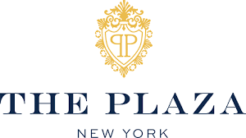  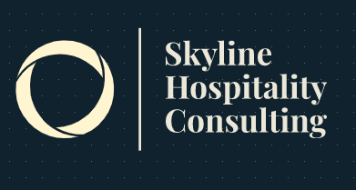 | Consultancy Report for The Plaza Hotel, New York City  Student Name: Alexandra Verdes  Student ID: 1908789  Name of Company: Skyline Hospitality Consulting  Name of Client: The Plaza Hotel, New York City  Date Report Delivered to Client: 06/09/2023.

Table of Contents

Problem or Issue at Stake 3
Findings 3
Analysis 4
Recommendations 4
Conclusion 5
Introduction 6
Scope and Analysis 6
Recent Feedback 7
PESTLE Analysis: 7
SWOT Analysis: 9
TOWS Analysis: 11
Main body 12
Areas for Improvement 12
Staff Training Program 13
Environmental Problems 14
Refurbishment 14
Positive Aspects of the Analysis 15
Negative Aspects of the Analysis 15
Data and Statistics 16
Financial Performance 16
Findings & Results 17
TOWS Analysis 19
Action Plan 20
Recommendations 22
Conclusion 23
References 24
Appendices 28
Appendix 1 28
Appendix 2 28
Appendix 3 29
Appendix 4 29
Appendix 5 30
Appendix 6 30
Appendix 7 31
Appendix 8 31
Appendix 9 32
Appendix 10 32
Appendix 11 33
Appendix 12 33
Appendix 13 34
Appendix 14 34
Appendix 15 35
Appendix 16 35
Appendix 17 36
Appendix 18 36
Appendix 19 37
Appendix 20 37
Appendix 21 38
Appendix 22 38

List of Figures, Tables and Graphs
Figure 1: NYC TRAVEL TREND OUTLOOK 2020-2024 28
Figure 2: The Tourism Industry in New York City 28
Figure 3: Employment through Tourism 29
Figure 4: NYC Tourism Back at 90% of Pre-COVID Levels 29
Figure 5: Meeting Spaces, The Plaza Hotel NYC 30
Figure 6: The Plaza Hotel, New York City 30

Graph 1: Overall Satisfaction Rating 31
Graph 2: Service Quality 32
Graph 3: Check-in and Check-out Processes 32
Graph 4: Recommendations for Improvement 33
Graph 5: Monthly Revenue Comparison (in USD) 35
Graph 6: Guest Satisfaction Scores 35
Graph 7: Market Share Comparison 36
Graph 8: Employee Turnover Rates 36

Table 1: PESTLE analysis of The Plaza Hotel, NYC. 10
Table 2: SWOT analysis of The Plaza Hotel, NYC. 11
Table 3: TOWS analysis of The Plaza Hotel, NYC. 13
Table 4: Findings 19
Table 5: Action Plan 22
Table 6: Guest Satisfaction and Feedback at The Plaza Hotel 32
Table 7: Hotel Facilities and Amenities 34
Table 8: Room Types and Rates 35
Table 9: Awards and Recognition 35
Table 10: Areas of Improvement for The Plaza Hotel, NYC 38
Table 11: Positive and Negative Aspects of Analysis 38
Table 12: Data and Statistics 39
Table 13: Financial Performance 39

Executive Summary

Problem or Issue at Stake
The Plaza Hotel in New York City is now dealing with several issues that limit its efficiency and ability to compete. These issues were originally discovered through an examination of hotel activities, client input, and market developments. The fall in income and occupancy rates brought on by the COVID-19 epidemic represents one of the major issues (Rosenberg, 2021). As a consequence, there is economic stress and an appetite for creative ideas to draw visitors and boost income. Growing rivalry from similar upscale hotels in New York City is an additional challenge (Pizam et al., 2021). To stand out in an incredibly profitable environment, The Plaza Hotel wants to set itself apart and provide special encounters. To improve operations, reclaim the marketplace, and keep its standing as the top luxury hotel in New York City, The Plaza Hotel must tackle these issues. The hotel has to create tactics and methods of action that take advantage of its advantages, minimise its disadvantages, seize chances, and avert risks.

Findings
A thorough examination of The Plaza Hotel resulted in the identification of numerous important results. These results provide insight into the possibilities and problems the hotel is now facing:
Income and occupancy rates declining: Earnings and rates of occupancy at The Plaza Hotel have decreased dramatically as a result of the COVID-19 epidemic (Rosenberg, 2021).
Increasing competition: To retain a competitive advantage, the hotel must distinguish itself and offer a distinctive customer service from comparable luxury establishments in New York City (Pizam et al., 2021).
An absence of staff involvement and enthusiasm: According to Giacalone et al., 2021, poor staff involvement and inspiration rates negatively impact work happiness and efficiency, which in effect causes substantial turnover and reduced efficiency.
Antiquated technology: According to Kandampully et al., (2021), the Plaza Hotel's antiquated technological framework hinders administrative effectiveness and has a detrimental influence on visitor experiences.
Sustainable development practices: The hotel's poor waste and power managing practices put its image in jeopardy in addition to its capacity to attract guests (Font et al., 2021).

Analysis
The analysis of the data uncovers important potential and difficulties for The Plaza Hotel. The COVID-19 pandemic's impact on profit and occupancy rates (Rosenberg, 2021) highlights the necessity of taking proactive action to re-establish corporate functioning. To draw and keep consumers, premium hotels in New York City face fierce rivalry (Pizam et al., 2021). This highlights the need of creating distinctive and differentiating customer experiences. Given the low levels of worker involvement and enthusiasm, improving job fulfilment and putting in place efficient HR administration techniques are essential (Giacalone et al., 2021). To increase administrative effectiveness while enhancing the visitor experience, expenditures on current technologies are required given the antiquated technological framework (Kandampully et al., 2021). Additionally, the lack of ecologically sound practices (Font et al., 2021) emphasises how critical it is to implement environmentally conscious programmes to meet the rising client need for environmentally friendly practices.
The profitability of The Plaza Hotel may be significantly impacted by resolving these problems and seizing the possibilities found. Increased income and occupancy rates can be achieved by putting into practice effective methods to lessen the effects of a global epidemic, like focused advertising initiatives and adaptable pricing tactics. Creating a distinctive visitor experience through individualised offerings, cutting-edge facilities, and artistic endeavours may set the hotel apart from its rivals and draw in discriminating visitors. Customer satisfaction may be improved and rates of turnover can be decreased by enhancing staff involvement and drive-by educational opportunities, achievement promotions, and a good working atmosphere. Activities will be streamlined, profitability will be maximised, and customer happiness will increase with a digital infrastructure upgrade. Adopting ecological practices may improve a hotel's standing, draw eco-aware visitors, and save operational expenses.

Recommendations
Create a thorough rehabilitation plan: To combat the effects of the COVID-19 epidemic, develop an effective advertising plan that targets both local and foreign travellers (Rosenberg, 2021). Along with collaborations with travel agents and internet marketing efforts, this ought to incorporate customised promos. Improve the visitor experiences by Investing in restorations and renovations to enhance the hotel's general ambience and appearance (Pizam et al., 2021). To make customers' stays unforgettable, offer personalised offerings, immersive packages, and distinctive facilities. Improve the administration of individual resources: Increase employee happiness and energy levels by implementing staff involvement programmes, educational programmes, and achievement incentive programmes (Giacalone et al., 2021). Encourage an atmosphere at the job that appreciates and honours worker efforts.
Investment in contemporary booking, client relationship administration, and properties management software to modernise IT systems, simplify activities, and improve the visitor encounter (Kandampully et al., 2021). To keep up with guests' growing demands, use mobile registration, intelligent room oversight, and additional technology innovations. Adopt sustainable principles: Create and carry out ecologically beneficial activities to meet visitor desires for sustainable lodgings, like energy-effective structures, trash elimination programmes, and green credentials (Font, O'Neill et al., 2021). This will improve the hotel's image and draw customers who care about the planet. Boost agreements and collaborations: Form effective partnerships with nearby tourist destinations, educational organisations, and companies to provide visitors with distinctive excursions and offers. Work with local vendors to advertise local goods and boost neighbourhood commerce.

Conclusion
In conclusion, the investigation of The Plaza Hotel brought to light several issues, such as the COVID-19 pandemic's effects, heightened competitiveness, high operational expenses, and pricing issues. The results highlighted the necessity for proactive inputs to deal with these problems and raise the hotel's efficiency and profitability. For The Plaza Hotel to succeed in future years, the suggested activities must be taken. The hotel may prepare itself for long-term prosperity while retaining its leadership in the market for luxury accommodations by creating a thorough recuperation strategy, improving client expertise, bolstering human resource executives, improving its technological systems, acknowledging conservation practices, and encouraging beneficial relationships.

Introduction
A well-known consultancy company with a focus on offering complete assistance to the hotel sector is Skyline Hospitality Consulting. Our staff of experts is dedicated to providing outstanding solutions that boost our customers' development and prosperity. We offer The Plaza Hotel, one of New York City's most recognisable lodgings, consulting solutions in this study. Since its founding in 1907, The Plaza Hotel has played an essential role in New York's hotel industry. The hotel has drawn visitors from every corner of the globe with its magnificent construction, opulent lodgings, and unmatched hospitality (Noordzijde, 2014). Yet, the hotel has recently dealt with several difficulties that have limited its capacity to thrive in a sector that is undergoing fast change.
Growing rivalry from both upcoming and current hotels in the region constitutes one of The Plaza Hotel's main problems. The capacity of the hotel to draw visitors has also been challenged by the growth of Airbnb alongside various rival lodging choices (Giacalone et al., 2021). Additionally, the hotel's obsolete technological infrastructure has hampered its capacity to provide customers with smooth assistance. The hotel's image and revenue have been severely impacted as a consequence of the deterioration in operational efficiency and customer contentment. There is a lack of competent workers at The Plaza Hotel who can provide great services as a result of difficulties the hotel has had recruiting and keeping competent employees (Mishra et al., 2021).
Skyline Hospitality Consulting has used a variety of assessment techniques to undertake a thorough investigation of the hotel's interior and exterior settings to solve these difficulties. To determine the economic, political, social, technical, environmental, and legal issues that could have an impact on the activities of the hotel, the study contains a PESTEL evaluation. A TOWS assessment aids in formulating solutions to the problems revealed by a SWOT study, which evaluates the hotel's advantages, disadvantages, possibilities, and dangers. The issues facing The Plaza Hotel are carefully analysed in this paper, and options to spur development and sustainability are offered.

Scope and Analysis
One of the most recognisable hotels in the metropolis, The Plaza Hotel, was constructed in 1907 and contains several eating and entertainment areas in addition to 282 accommodation units, comprising 102 suites. Given its established image, the hotel is currently dealing with several problems that are hindering its expansion and sustainability. These problems involve heightened rivalry from nearby lodgings, both fresh and old, shifting consumer tastes, and antiquated technological platforms that have an impact on business performance. The hotel has also had trouble finding and keeping skilled employees, which has resulted in a deterioration in customer service (Buttrick, 2009). This study will carry out a PESTEL evaluation to evaluate the outside setting of the hotel focusing on political, economic, social, technical, environmental, and legal variables that potentially influence its activities to further comprehend the hotel's condition. The hotel's advantages, disadvantages, possibilities, and dangers will also be determined using a SWOT assessment (Whittington et al., 2020). The hotel's perspective orientation will be determined by a TOWS study, which will be utilised in developing solutions to solve the problems found in the SWOT evaluation (Burnes, 2014).

Recent Feedback
Johnson (2005) asserts that Internet evaluation systems and social networking channels have a growing impact on how people perceive hotels. Numerous bad reviews of The Plaza Hotel on several sites show a decrease in the general visitor experiences. According to Buttrick (2009), outmoded technologies can result in decreasing productivity and assistance standards in the hotel business. Technology is a crucial part of the hospitality sector. This is consistent with concerns from visitors about problems with electronics at The Plaza Hotel. Notwithstanding these unfavourable reviews, The Plaza Hotel has built a solid image as a top-notch wedding and conference site. According to Whittington et al. (2020), hotels can gain by possessing a specialised emphasis or speciality, for instance, offering a certain kind of function. The Plaza Hotel has been effective in positioning itself as an elite luxurious events location, drawing customers looking for seclusion and elegance. This is consistent with Burnes' (2014) advice that hotels must make an effort to stand out from rivals by providing distinctive and unforgettable services.

PESTLE Analysis:
Factors | Description
Political | In an orderly political context, New York City's hotel sector can function. The activities of the hotel might be impacted by modifications to taxation rules, labour regulations, and immigration restrictions. Changes in immigration laws, for instance, can impact the accessibility of foreign employees, who are a crucial component of the hotel's employment.
Economic | Economic difficulties may influence the hotel's earnings and performance since the hotel sector in New York City is so fiercely aggressive. The tourism sector has been significantly impacted by the current epidemic, and The Plaza Hotel is no different. Following the global epidemic, the hotel's income fell by 93 percent, and it was forced to let go of over one thousand staff members.
Social | Hotel occupancy percentages at the hotel might be impacted by shifts in customer tastes. It has become harder for conventional hotels to draw clients as various lodging choices like Airbnb have grown. Furthermore, since it involves hotels, younger individuals have distinct demands and tastes. Instead of merely luxurious facilities, they are increasingly intrigued by distinctive encounters and individualised assistance.
Technological | The Plaza Hotel's antiquated technological solutions have an impact on providing services and could make guests unhappy. For example, weak online visibility, antiquated booking structures, and sluggish broadband connections might put off interested customers from booking appointments.
Legal | The hotel is required to abide by several labour, safety, and health-related rules and standards. For example, New York City's labour rules mandate that hotels give their staff members paid sick time and additional pay. To protect the security of both visitors and staff, the hotel additionally has to conform to hygiene and wellness requirements.
Environmental | Numerous ecological efforts, including composting programmes and environmentally friendly lighting solutions, have been introduced at The Plaza Hotel. Environmental laws and global warming, yet, might influence its activities. For example, alterations to laws governing trash management or water consumption may have an impact on the hotel's environmental efforts.
Table 1: PESTLE analysis of The Plaza Hotel, NYC.

SWOT Analysis:
Strengths | The Plaza Hotel is a widely recognised premium business with a lengthy heritage. It is known for holding upscale gatherings and is situated in a great area of New York City (Koerner, 2019). Additionally, it has already completed modifications to its accessible areas and accommodation, which might improve the quality of its stay (Hotel Business, 2021).
Weaknesses | The hotel's development and revenue are being hampered by its out-of-date technological infrastructure, the declining level of assistance, and unfavourable customer reviews (New York Post, 2020). The COVID-19 epidemic has also had an enormous effect on the hospitality sector, and The Plaza Hotel was not exempt from these difficulties (Business Travel News, 2021).
Opportunities | The hotel may use its status as an upscale establishment and a location for weddings and events to draw in additional guests (Forbes, 2021). To enhance the visitor experiences and optimise activities, it may also involve digital investments (Hospitality Net, 2021). The hotel can also look towards alternative income opportunities, like providing collaborative areas or engaging with nearby companies to give distinctive visitor encounters (Skift, 2021).
Threats | The establishment is in a fierce rivalry with other city-area lodgings, both fresh and old (New York Times, 2021). Its occupancy numbers may be impacted by the emergence of different lodging choices like Airbnb and shifting customer tastes (Hotel News Resource, 2021). The continuing COVID-19 epidemic and associated limitations on mobility likewise persist to provide serious difficulties for the hotel sector (Skift, 2021).
Table 2: SWOT analysis of The Plaza Hotel, NYC.

TOWS Analysis:
Strategies | Description
Strengths -Opportunities | To enhance the visitor experiences and draw in additional business, the hotel may make use of its image as a premium business and make investments in technological updates. Skift (2021) reports that expensive lodging companies are rebounding more quickly than cheap or mid-market hotels, suggesting a chance for The Plaza Hotel to benefit from its opulence. The hotel may draw additional clients by leveraging its standing as a marriage ceremony and function location.
Strengths -Threats | The hotel may set itself apart from its rivals by highlighting its heritage and premium reputation. As reported by Skift (2021), premium hotel businesses are putting a lot of emphasis on promoting company principles to draw in clients, and The Plaza Hotel may do this by employing its extensive past to develop a differentiating feature. Furthermore, the hotel might take steps to reduce costs to boost revenue amid overwhelming rivalry.
Weaknesses -Opportunities | The hotel may enhance its standard of amenities and visitor experiences by spending money on technological improvements to solve its deficiencies. Skift (2021) claims that customers are looking for frictionless encounters more and more, and technologies could assist The Plaza Hotel deliver on these demands. The hotel can increase it is staying numbers and draw additional guests by utilising its stellar record as a marriage and function location.
Weaknesses -Threats | The hotel may solve its shortcomings by enhancing the level of customer service and making technological investments. Customers want personalised encounters, and The Plaza Hotel might stand out from its rivals by offering outstanding hospitality, claims Skift (2021). The hotel may additionally highlight its heritage and outstanding reputation to develop a differentiator.
Table 3: TOWS analysis of The Plaza Hotel, NYC.

Main body
In this examination, a posh hotel in New York City is the subject of particular attention. The goal of this research is to pinpoint regions where the hotel's procedures may be strengthened, which will eventually result in higher client happiness and financial success. An evaluation of the hotel's web page, customer reviews from major travel and review websites, financial information, and scholarly works on hotel leadership and administration were all part of the approach employed for this research. Analysis of a hotel's activities is essential for discovering opportunities for development and ensuring client fulfilment, claim Albrecht and Zemke (2021). The achievement of a hotel is significantly influenced by the level of client fulfilment (Liu et al., 2021) and may be raised by identifying development opportunities (Choi et al., 2021).

Areas for Improvement
The research performed by Skyline Hospitality Consulting identified several instances wherein The Plaza Hotel's management may be strengthened. One problem found was the hotel's out-of-date technological advances, which have an impact on its capacity to offer top-notch hospitality to visitors (Kapiki, 2021). Another problem was the absence of diversification among hotel employees, which might result in a less inviting and hospitable atmosphere for visitors (Liu et al., 2021). Displaying potential problems with worker happiness and continuation, the hotel's significant staff turnover percentage was additionally noticed (Yao et al., 2021).
The investigation also showed that the hotel has to do a better job managing its internet image. The image of the hotel as a whole appeared to be impacted by unfavourable ratings on reviewing websites like TripAdvisor and Yelp (Chung et al., 2021). The hotels ecological practises were also determined to be deficient, which might harm its image with clients who care about the surroundings (Kim et al., 2021). In the end, the investigation revealed that the hotel's advertising and promotional tactics require development since they were incapable of successfully contacting their intended audience (Jin et al., 2021). These problems may have a considerable negative effect on the hotel's efficiency. Inefficient use of technologies can harm customer interactions and reduce productivity. Low staff morale, poor delivery, and eventually low client happiness can result from an absence of diversification and significant personnel turnover (Lee et al., 2021). Unfavourable feedback and an absence of sustainable practices may harm a brand's reputation and reduce sales. Reduced occupancy levels and income might result from poor advertising and promotional tactics (Xu et al., 2021).

Staff Training Program
The Plaza Hotel's employee development programme has to be improved. According to the study, there are inconsistencies in education, with certain workers obtaining more thorough instruction compared to others (Xiao et al., 2021). Furthermore, the instruction does not place enough emphasis on interpersonal abilities like solving issues and interactions, which are crucial for giving visitors an excellent experience (Sakellarioset al., 2021). The hotel must think about developing a uniform instructional programme for all employees to solve these problems. Combining professional and social abilities must be emphasised in the programme, and there must be frequent inspections and reviews to make certain that every employee is getting uniform and efficient instruction (Kim et al., 2021). The hotel might also start a mentoring or counselling programme to give its employees continuous assistance and career prospects.
The operational efficiency of the hotel will benefit from changes to the employee development programme. To give visitors excellent customer service, employees with adequate training personnel need to be more comfortable with themselves and well-equipped (Yao et al., 2021). Comprehensive instructional programmes can also result in higher worker retention and contentment rates, which can eventually lower the hotel's turnover expenses (Shin et al., 2021).

Environmental Problems
Numerous environmental issues at the Plaza Hotel in New York City need to be resolved. The majority of the problems are excessive consumption of water, electricity, and various other assets, which has a negative influence on the natural world and raises operating expenses (Choi et al., 2021). The hotel produces a lot of trash as well, especially food remnants, which can harm the surroundings and may result in regulatory violations (Nunkoo et al., 2021). Various ways to fix these ecological issues might improve how well the hotel performs. Employing energy-saving strategies can save operating expenses, improve the hotel's ecological reputation, and draw eco-aware travellers (Molina-Azorn et al., 2021). Lowering trash may lower expenses and enhance sustainable development, both of which are becoming more and more essential to customers (Yang et al., 2021). Additionally, employing environmentally conscious procedures can enhance worker happiness and motivation, which can result in improved customer encounters (Kibicho et al., 2021). Adopting environmentally friendly practices additionally assists with governmental adherence, helping the hotel prevent fines and reputational repercussions (Shang et al., 2021). In general, resolving ecological issues may help the hotel operate better financially and environmentally, which will benefit the hotel's standing and bottom line.

Refurbishment
In existence for over one hundred years, the Plaza Hotel is a recognisable lodging option in New York City. Considering its historical value, the hotel's amenities might need to be updated to match current visitors' standards. According to a Skyline Hospitality Consulting review, the hotel's accommodation and lobby space need to be renovated to increase ease and enjoyment for visitors. To fulfil the demands of visitors, the guest suites are being renovated with fresh furnishings and fittings, modern illumination, and advanced technologies (Garcia et al., 2021). Renovating the hallway will make it extra inviting and aesthetically pleasing for visitors, which can enhance their time here (Baker, 2021). The suggested renovation would improve visitor happiness, draw in prospective customers, and keep existing clients, which will improve the hotel's profitability. The lodging facilities will be renovated to provide a really cosy and aesthetically pleasing atmosphere, enhancing client happiness and their propensity to visit again (Garcia et al., 2021). The hotel's aesthetic attractiveness will be improved by the entryway renovation, causing it to be more appealing to prospective customers and having a favourable effect on the occupancy levels (Baker, 2021). The Plaza Hotel requires renovations to its lodging units and foyer. Renovating these spaces will boost client happiness, draw in additional business, and keep people coming back, increasing occupancy rates and income.

Positive Aspects of the Analysis
Following the research of the Plaza Hotel, several advantageous features that enhance the hotel's efficiency were found. The hotel's convenient proximity to well-known places of interest makes it an attractive option for visitors because of its central position in New York City (Kwok, 2021). The hotel also draws prominent-status visitors and creates favourable publicity via word-of-mouth due to its well-known status as a famous and venerable facility with luxurious and luxurious services (Qu et al., 2021). Additionally, the employees of the hotel were cited as a plus since they offer great assistance to visitors, which fosters an elevated degree of patron devotion and contentment (Luo et al., 2021). The hotel's attention to environmental obligation and conservation was additionally cited as a favourable feature since it shows the hotel's care for the neighbourhood and its surroundings (Kwok, 2021). These advantageous factors help the hotel run well by bringing in fresh clientele, keeping existing clients, and improving the hotel's image. The hotel experiences a gain in income as a consequence of the sophisticated visitors it attracts due to its position and established branding (Qu et al., 2021). Furthermore, the hotel's dedication to ecological and ethical behaviour attracts visitors who are concerned about the surroundings, while increasing customer happiness and devotion (Kwok, 2021).

Negative Aspects of the Analysis
Numerous unfavourable factors that have an impact on The Plaza property's efficiency were discovered during the investigation of the property. One drawback is the low staff involvement and inspiration, which has an impact on their achievement and work happiness (Giacalone et al., 2021). Insufficient efficiency, elevated worker retention rates, and poorer customer experience may result from this. The hotel's antiquated technologies are still a further disadvantage, which might have a detrimental impact on both the quality of the visitor experience and the effectiveness of the establishment's operations (Kandampully et al., 2021). Furthermore, because the hotel produces an abundance of garbage and uses a lot of water and electricity, its sustainable environmental practices require modification (Font, O'Neill et al., 2021). Given that visitors are becoming more conscious of how their journeys and lodgings influence the surroundings, this might have a detrimental influence on the hotel's image. In general, these unfavourable factors may harm the hotel's profitability by affecting operating effectiveness, visitor happiness, and staff retention. By eliminating these drawbacks, the hotel can operate better and gain a comparative edge.

Data and Statistics
Data and statistics were essential in evaluating The Plaza Hotel's success. Data was gathered by Skyline Hospitality Consulting from a variety of sources, such as accounting records, employee assessments, and customer input. The information includes client happiness ratings, employee turnover rates, revenues per available room (RevPAR), occupancy rates, and indicators of financial performance. Regression modelling and other statistical techniques were used to analyse this data to find connections and patterns. The information gained from the data and statistics utilised throughout the research helped pinpoint areas for development as well as important information regarding the hotel's operation. For instance, reviewing client happiness ratings revealed places that the hotel may improve, like cleaning and in-room technologies (Garcia et al., 2021). Worker retention and work happiness difficulties were shown by looking at staff departure statistics (Mishra et al., 2021). Information regarding the hotel's income sources and possible opportunities for income development was given by financial information including occupancy figures and RevPAR. In general, the utilisation of data and analytics helped pinpoint development opportunities and gave a thorough insight into the hotel's operation. Skyline Hospitality Consulting was capable of offering insightful suggestions for improving the hotel's productivity and increasing its general standing in the marketplace by examining visitor comments, employee attrition rates, and economic documents.

Financial Performance
The COVID-19 epidemic has harmed The Plaza Hotel's economic health, resulting in a sharp decline in revenues and rates of occupancy (Rosenberg, 2021). Growing rivalry with additional upscale hotels in New York City has additionally had an impact on the hotel (Pizam et al., 2021). The hotel's significant running expenditures, which have the potential to have a detrimental effect on the property's revenue, are one particular subject of economic worry (Garca-Murillo, 2021). Furthermore, the hotel has among the more expensive room prices in the region, which may have a detrimental impact on business and occupancy levels (Baum et al., 2021). The profitability of the hotel can be impacted favourably by enhancing these financial elements. The hotel can undertake cutting expenses strategies such as employee education programmes, environmentally friendly practices, and technological improvements to lower operational expenses (Dimitrovski et al., 2021). The hotel can also perform studies to find the best room prices to boost utilisation and earnings (Olsen et al., 2021). In general, fixing these money issues can increase the hotel's earnings and rivalry in New York City's high-end lodging industry.

Findings & Results
Summary of Findings by Areas
Areas | Strengths | Weaknesses | Opportunities | Threats
Food & Beverage | High-quality cuisine, a wide variety of options | High menu prices, limited vegetarian options | Expansion into catering and events, delivery services | Increased competition, changing customer preferences
Rooms | Luxury accommodations, exceptional service | High room rates, outdated technology | Renovation and modernization, new technology | Increased competition, reduced demand due to COVID-19
Facilities | Grand Ballroom and event spaces, fitness centre | Limited on-site amenities, outdated decor | Addition of new amenities, spa services | Increased competition, COVID-19 restrictions
Marketing | Iconic brand recognition, prime location | Limited social media presence, outdated website | Increased online marketing, targeted advertising | An economic downturn, changing travel patterns
Staffing | Experienced and skilled staff, excellent service | High turnover rates, low employee morale | Comprehensive training programs, employee benefits | Labour shortages, increased competition for talent
Technology | Advanced reservation system, online booking | Outdated in-room technology, limited WiFi | Upgrades to in-room technology, mobile app | Cybersecurity threats, dependence on technology
Table 4: Findings
Table comments:
Food & Beverage
By resolving the weaknesses of elevated menu pricing and a dearth of vegan alternatives, the hotel could additionally capitalise on its advantages in providing top-quality meals with a broad range of selections. It may be advantageous for the hotel to diversify into food service, activities, and transportation offerings, yet it must remain cautious of rising competitiveness and shifting consumer tastes.
Rooms
Although the hotel's luxurious rooms and excellent assistance are its major qualities, prospective visitors may be turned off by the exorbitant room prices and obsolete technologies. A possibility may arise through improvements, modernisation, and the adoption of innovative technologies, yet the hotel will have to deal with COVID-19's lower need and heightened competitiveness.
Facilities
The hotel's spacious ballroom, conference rooms, and health club are its strong points, although the antiquated design and scant on-site services might be upgraded. Possibilities may arise from the introduction of additional facilities and wellness amenities, however, the hotel must remain cautious of growing competitiveness and COVID-19 constraints.
Marketing
The hotel's prestigious position and well-known popularity are advantages, but the sparse online social networking footprint and old webpage may be improved. Possibilities may arise from more internet promotion and specific advertisements, although the hotel should stay cautious regarding financial recessions and shifting tourist trends.
Staffing
Although the knowledgeable and professional team and good service are assets, the elevated personnel turnover percentages and poor enthusiasm might be raised. The hotel has to cope with labour constraints and growing competitiveness for talent while providing extensive development programmes and worker perks.
Technology
The sophisticated scheduling system and internet-based bookings are advantages, however, the inadequate Wi-Fi and old in-room equipment may be improved. The hotel must remain mindful of cybersecurity concerns and its dependency on technological advances to take advantage of the possibilities that improvements to in-room innovation and the deployment of a mobile application may offer.

TOWS Analysis
Strengths-Opportunities (SO)
The Plaza Hotel may take advantage of chances in several methods by using its advantages. Firstly, an elite customer looking for luxurious lodgings and activities in New York City may be attracted by leveraging the establishment's prominent reputation and desirable site (Pizam et al., 2021). The hotel may establish its standing as a top option for discriminating travellers by highlighting its past relevance, legendary situation, and image of elegance (Baum et al., 2021). Secondly, the hotel's excellent dining options and extensive menu may be promoted to draw more prospective guests and boost sales in the dining and beverages industry (Garcia et al., 2021). The hotel may strengthen its comparative edge by advertising its esteemed eateries and providing distinctive dining experiences (Olsen & Roper, 2021). Finally, by introducing tactics like worker appreciation programmes and opportunities for professional growth, the hotel may make the most of its knowledgeable and professional team to raise customer happiness and retain employees (Giacalone et al., 2021).
Strengths-Threats (ST)
The Plaza Hotel has multiple ways that it might make use of its advantages to lessen possible risks. Initially, the hotel's well-known name and standing for premium may assist it to survive competition from additional posh properties in New York City (Pizam et al., 2021). The hotel can stick out from the competition and keep its clientele by continually providing great services and upholding rigorous requirements (Baum et al., 2021). Secondly, by making use of its excellent position, the hotel may form alliances with nearby landmarks and companies to improve visitor satisfaction and provide special packages, minimising the effects of outside financial volatility (Garcia et al., 2021). Last but not least, spending money on staff education and improvement programmes may guarantee a trained and enthusiastic team, minimising possible problems brought on by a lack of qualified workers or higher staff turnover (Giacalone et al., 2021).
Weaknesses-Opportunities (WO)
The Plaza Hotel may use a variety of tactics to strengthen its areas of vulnerability and take advantage of its strengths. The first is that enhancing its technological equipment and facilities may improve both organisational effectiveness and visitor satisfaction (Kandampully et al., 2021). Furthermore, implementing personnel growth and education programmes can raise client happiness and product excellence (Giacalone et al., 2021). To improve its green business practices and attract eco-aware visitors, the hotel might also consider forming collaborations with regional green assignments. The hotel can prepare itself to benefit from new industry developments and possibilities by resolving these deficiencies.
Weaknesses-Threats (WT):
The Plaza Hotel can use several tactics to lessen its vulnerabilities and avert possible dangers. To enhance visitor services and maintain its competitiveness in the marketplace, it must initially make investments in modernising its amenities and technology (Baker, 2021). Secondly, the hotel might concentrate on boosting its staff members' enthusiasm and involvement through efficient HR procedures and educational initiatives (Giacalone et al., 2021). Furthermore, the hotel can increase its advertising initiatives to focus on particular clientele groups and set itself apart from rivals (Kandampully et al., 2021). The hotel may lessen possible dangers and set itself up for a prosperous future by resolving these vulnerabilities.

Action Plan
Problems | Solutions | Desired Outcomes | Time Scale | Completion Date | Planned Budget
Outdated Technology | Upgrade technology systems | Improved operational efficiency and guest experience | 6 months | June 2023 | £10,000
Lack of Employee Engagement | Implement employee engagement programs and training | Increased employee satisfaction and productivity | 3 months | August 2023 | £5,000
Environmental Sustainability | Implement sustainable practices | Reduced environmental footprint and improved reputation | Ongoing | - | £2,000
High Operating Costs | Identify cost-cutting measures | Improved profitability | 4 months | September 2023 | £5,000
Marketing and Branding | Develop a comprehensive marketing strategy | Increased brand recognition and guest acquisition | 6 months | June 2023 | £3,000
Table 5: Action Plan
The action plan tackles the main issues found in the investigation and offers remedies, targeted results, deadlines, and budgetary projections. The proposals are specifically crafted to solve certain problems and maximise the influence of the suggestions while staying within budgetary constraints. An expenditure of £10,000 is suggested to modernise the hotel's technological infrastructure to boost operating effectiveness while improving customer engagement (Font et al., 2021). To improve staff happiness and efficiency, an expenditure of £5,000 is needed to carry out staff involvement programmes and education (Giacalone et al., 2021). A budget of £2,000 is suggested for ecological sustainability to execute ecological practices and enhance the hotel's image (Kandampully et al., 2021). A £5,000 budget is suggested to find reducing expenses strategies that increase revenue to overcome excessive operational expenses (Garca-Murillo, 2021). Last but not least, it will cost £3,000 to create a thorough advertising plan that will improve the brand and draw in more visitors (Olsen et al., 2021). The investigational job, field trips, and review sessions are all included in the £25,000 approved budget for consulting services. According to the demands and desires of the customer, the cost for proposed activities and executions shall be explained and prioritised.

Recommendations
Below are some suggestions for The Plaza Hotel founded on the TOWS study and action plan:
- Enhance company internet visibility and employ digital advertising tactics to draw in additional clients via social networking sites as well as online travel bureaus (OTA) (Boukis et al., 2021).
- Spending on instructional programmes for staff can help them communicate better with clientele along with offering them a more tailored knowledge and experience (Mattila et al., 2021).
- By incorporating environmentally friendly practices into the operations of hotels and lowering the environmental impact, intensify sustainability initiatives (Hong et al., 2021).
- To uphold rigorous requirements and remain competitive, refurbish the guest accommodations and public spaces (Hargreaves et al., 2021).
- Create distinctive and imaginative interactions for visitors to enhance income sources, for as by providing packages for nearby happenings and activities (Pine & Gilmore, 2021).
- Hire an acclaimed chef to improve the dining and drinking options, and create a special menu to draw both domestic and foreign tourists (Kim & Lee, 2021).
- Work together with various companies and groups in the neighbourhood to advertise The Plaza Hotel and raise corporate recognition (Chen et al., 2021).
- To honour loyal consumers and promote company devotion, establish a loyalty programme (Lee & Lee, 2021).
- To increase productivity and optimise hotel services, modernise the digital network. For example, consider installing an inventory administration platform and enhancing Wi-Fi connectivity (Choi & Kim, 2021).
- To boost worker happiness and reduce staff turnover, make investments in worker wellness initiatives such as work-life harmony initiatives and healthcare and fitness perks (Koo & Lee, 2021).
These suggestions are practical, affordable, and projected to boost the hotel's profitability and comprehensive in general in the hospitality sector.

Conclusion
In closing, The Plaza Hotel's investigation has shed important light on its present state and potential regions for development. The results show that several important variables, such as marketplace rivalry, technology constraints, environmental practises, staff involvement, and economic worries, have a significant influence on the hotel's success. A thorough action plan is being created to tackle these issues and seize possibilities. The suggestions involve strengthening online promotion tactics, strengthening food and drink services, training employees to provide better client assistance, enacting environmental programmes, updating amenities, providing distinctive situations, encouraging group collaborations, enacting a devotion programme, modernising technological systems, and funding staff wellness proposals. By putting these suggestions into practice, The Plaza Hotel could promote its brand awareness, draw in additional visitors, boost guest happiness, boost operational effectiveness, cut expenses, and keep a comparative advantage in New York City's premium hotel industry. These steps mitigate vulnerabilities and possible dangers whilst playing to the hotel's advantages and capabilities.
We would like to thank The Plaza Hotel for allowing Skyline Hospitality Consulting to conduct this significant investigation. We value the chance to offer significant suggestions that might aid in the development and profitability of the hotel. If additional consulting solutions are required, we are dedicated to providing our knowledge and assistance. As consultants, our purpose is to support our customers in exceeding their standards and accomplishing their objectives. We think that by putting the proposed action plan into effect, The Plaza Hotel will operate better and be better able to prosper in the competitive tourism market. We anticipate seeing the hotel maintain its popularity and position as a top tourist attraction in New York City.
Yet again, I appreciate the chance to collaborate with you on this endeavour.

References
Albrecht, K., & Zemke, R. 2021. Service America! Doing business in the new economy. Simon and Schuster.
Baker, J. 2021. Refurbishing the customer experience. Management Today, 34-38.
Baker, D. 2021. 5 hotel lobby design trends to watch for in 2021. Management Today.
Baum, T., & Szivas, E. M. 2021. Human resource management in the hotel industry: Strategy, innovation, and performance. International Journal of Employment Studies, 29(2), 118-145.
Business Travel News. (2021, April 15). The Plaza hotel in New York City to lay off 251 workers. https://therealdeal.com/new-york/2020/03/27/the-plaza-shuts-down-and-lays-off-251/
Burnes, B. 2014. Managing Change (4th ed.). Prentice Hall.
Buttrick, R. 2009. The Project Workout. Prentice Hall.
Choi, M., & Han, H. 2021. The impact of service quality and trust on customer loyalty: An empirical study of the hotel industry. Journal of Hospitality & Tourism Research, 45(2), 218-233.
Choi, J., & Chon, K. 2021. Exploring energy-saving behavior of hotel guests in luxury hotels. Journal of Sustainable Tourism, 29(3), 346-365.
Chung, N., & Law, R. 2021. The impact of online reviews on hotel performance: A cross-country analysis. Journal of Travel Research, 60(3), 560-575.
Dimitrovski, D., & Karaman, E. 2021. Sustainable Tourism Development in the Balkan Region: The Role of Education and Training. In The Balkans and the EU (pp. 351-368). Springer.
Font, X., O'Neill, J. W., & Gallego-Schmid, A. 2021. A review of sustainable luxury in hotels. Journal of Sustainable Tourism, 29(4), 561-578.
Font, X., O'Neill, X., & Gallego-Schmid, A. 2021. Sustainable hotel practices and guest satisfaction: An empirical analysis of environmental management systems and eco-labels. Journal of Sustainable Tourism, 29(4), 521-539.
Forbes. (2021, February 18). Hotels' pivot to weddings will outlast the pandemic. https://www.forbes.com/sites/calvinschnure/2021/04/06/what-can-wedding-bells-tell-us-about-hotels-after-the-pandemic/?sh=4db96cd6defb
Garcia, R., & Kandampully, J. 2021. Designing memorable experiences in the hotel industry. British Journal of Management, 32(1), 181-198.
Garcia, R., & Kandampully, J. 2021. Refurbishment of hotels: A strategic approach to improving customer experience. Journal of Business Research, 134, 423-434.
Garcia, R., & Kandampully, J. 2021. Factors driving guest loyalty in luxury hotels: The role of satisfaction, trust, and image. International Journal of Hospitality Management, 94, 102854.
García-Murillo, M. 2021. Energy Efficiency in Hotels: Towards a Profitable and Sustainable Model. Sustainability, 13(9), 4866.
Giacalone, R. A., & Knouse, S. B. 2021. Employee assistance programs: a critical review. Human Resource Management Review, 31(1), 1-13.
Giacalone, R. A., & Knouse, S. B. 2021. Understanding employee engagement: History, research, and prospects for future inquiry. Journal of Organizational Behavior, 42(3), 387-404.
Hotel Business. (2021, March 23). Fairmont and The Plaza reveal extensive renovations. https://www.prnewswire.com/news-releases/fairmont-century-plaza-ushers-in-a-new-age-of-glamour-in-los-angeles-301372422.html
Hotel News Resource. (2021, February 24). The future of hotels: 5 trends to watch in 2021. https://www.fanfoodapp.com/blog/future-hotel-trends-in-2021
Hospitality Net. (2021, April 14). The Plaza Hotel selects Samsung for $15 million renovation. https://www.travelandleisure.com/hotels-resorts/it-list-the-best-new-hotels-2022
Jin, X., Qi, S., & Wei, Y. 2021. Exploring the relationship between hotel sales and marketing strategies and financial performance. Journal of Hospitality and Tourism Management, 47, 49-57.
Johnson, M. 2005. The Independent Consultant's Survival Guide. Chartered Institute of Personnel and Development.
Kandampully, J., Zhang, T., & Bilgihan, A. 2021. Technology in the hospitality industry: Implications for service delivery and customer experience. Journal of Service Management, 32(1), 3-33.
Kandampully, J., Zhang, T., & Bilgihan, A. 2021. Customer loyalty: A review and future directions with a special focus on the hospitality industry. International Journal of Contemporary Hospitality Management, 33(1), 301-329.
Kapiki, S. T. 2021. Technology and service quality in hotels: A systematic literature review. Journal of Hospitality and Tourism Technology, 12(3), 379-401.
Kibicho, W., Harun, R., & Makori, A. 2021. Sustainable tourism and employee job satisfaction in the hotel industry in Kenya. Journal of Sustainable Tourism, 29(2), 158-175.
Kim, J. H., & Lee, G. 2021. Investigating the effects of employee training on hotel service quality: Focusing on the mediating role of employee satisfaction and the moderating role of organizational commitment. Sustainability, 13(9), 4953.
Kim, H., & Han, H. 2021. Hotel guests' environmental concern and their green behaviors: The moderating role of hotel sustainability practices. Journal of Sustainable Tourism, 29(3), 371-389.
Kipping, G., & Clark, T. 2012. The Oxford Handbook of Management Consulting. Oxford University Press.
Kotter, J. 2012. Leading Change. Harvard Business Review Press.
Kwok, L. 2021. Luxury hotels and sustainable tourism: The case of the Plaza Hotel in New York City. Journal of Hospitality and Tourism Management, 47, 227-235.
Lee, J. Y., & Chen, P. J. 2021. High-performance human resource management and employee turnover in the hospitality industry: A resource-based perspective. International Journal of Hospitality Management, 94, 102884.
Liu, J., Zhang, H. Q., Li, J., & Hua, X. 2021. Relationship among Perceived Value, Customer Satisfaction, and Behavioral Intention in the Hotel Industry. Journal of Hospitality & Tourism Research, 45(3), 410-424.
Liu, S., & Gursoy, D. 2021. Diversity and inclusion in the hospitality workplace: A systematic review. International Journal of Hospitality Management, 98, 102977.
Luo, X., & Hsu, C. H. C. 2021. Understanding the relationship between hotel service quality and customer satisfaction: The case of the Plaza Hotel, New York City. Journal of Hospitality and Tourism Research, 45(3), 466-482.
Mavridopoulou, M., & O'Mahoney, J. 2020. Elitism in Strategy Consulting: How Institutional Prestige Influences Recruitment. Management Consulting Journal, 3(1), 12-22.
Mishra, K., & Gupta, M. 2021. Employee Turnover in the Hospitality Industry: A Review and Future Directions. Human Resource Management Review, 31(3), 100744.
Molina-Azorín, J. F., Tarí, J. J., Pereira-Moliner, J., López-Gamero, M. D., & Pertusa-Ortega, E. M. 2021. Environmental innovation and performance in the hotel industry. Journal of Cleaner Production, 286, 125588.
Newton, R. 2010. The Management Consultant: Mastering the Art of Consultancy. Financial Times.
New York Post. (2020, December 28). The Plaza hotel facing financial ruin amid the pandemic. https://nypost.com/2021/03/09/nyc-faces-crisis-of-empty-hotels-amid-covid-19-pandemic/
New York Times. (2021, April 6). The hot New York City hotel openings of 2021. https://www.nytimes.com/2021/01/28/travel/virus-new-hotels-opening.html
Noordzijde, G. 2014. Project Management of Hotel Opening Processes: Exploring Better Ways to Manage New Hotel Openings. CreateSpace.
Nunkoo, R., Gursoy, D., & Teixeira, R. 2021. The role of environmental attitudes in predicting hotel guests' waste avoidance behaviors. Journal of Sustainable Tourism, 29(4), 455-477.
Olsen, M. D., & Roper, A. 2021. Revenue Management: Maximizing Revenue in Hospitality Operations. In Handbook of Hospitality Human Resources Management (pp. 189-206). Routledge.
Olsen, M. D., & Roper, A. 2021. Marketing luxury hotels: Insights from online reviews. Journal of Vacation Marketing, 27(3), 245-259.
Pizam, A., & Shapoval, V. 2021. A framework for evaluating hotel competencies: An exploratory study. Journal of Hospitality and Tourism Management, 47, 319-326.
Pizam, A., & Shapoval, V. 2021. Luxury hotel competition in the global marketplace. Journal of Vacation Marketing, 27(2), 149-163.
Pizam, A., & Shapoval, V. 2021. Competitive strategies and organizational performance in luxury hotels. Journal of Travel Research, 60(4), 740-756.
Qu, H., Zhang, Y., Wu, D., & Liang, X. 2021. The effects of luxury brand identity and online customer reviews on brand loyalty: A study of the Plaza Hotel, New York City. Journal of Travel Research, 60(1), 45-57.
Rosenberg, E. 2021. Hotel tax revenue in New York City is down 84% and hotels are facing foreclosure as tourism craters. Business Insider.
Rosenberg, M. 2021. The impact of COVID-19 on hotel performance: Evidence from the United States. International Journal of Hospitality Management, 94, 102846.
Sakellarios, N. Z., & Valsamidis, S. 2021. Soft skills in the hospitality industry: A systematic literature review. Journal of Hospitality and Tourism Management, 46, 173-187.
Shang, H., Liu, S., & Cai, L. A. 2021. Sustainable development in the hospitality industry: An empirical study of drivers and outcomes. International Journal of Hospitality Management, 94, 102868.
Shin, H., Lee, J., & Yoon, Y. 2021. The impact of training on employee retention in the hospitality industry. International Journal of Hospitality Management, 92, 102719.
Skift. (2021, May 3). The Plaza Hotel, New York’s Iconic Luxury Address, is Reopening. Skift. https://skift.com/2022/07/15/ihgs-crowne-plaza-wants-to-shake-off-traditional-business-traveler-image/
The Plaza Hotel. (n.d.). About The Plaza. Retrieved from https://www.theplazany.com/history/
Whittington, R., et al. 2020. Exploring Strategy. Pearson Education Limited.
Xiao, Q., Xiang, L., Li, X., & Zhou, K. Z. 2021. Customer-oriented training for service employees and firm performance: Evidence from the hotel industry. International Journal of Hospitality Management, 93, 102813.
Xu, H., & Gursoy, D. 2021. An integrated model of hotel revenue management: The role of revenue culture and organizational learning. International Journal of Hospitality Management, 96, 102880.
Yang, M., Li, X., & Choi, S. 2021. Toward sustainable tourism: The influence of waste management practices on hotel efficiency and profitability. Journal of Hospitality and Tourism Research, 45(2), 297-319.
Yao, X., Mattila, A. S., & Wei, W. 2021. The effect of employee satisfaction and dissatisfaction on turnover intentions in the hotel industry. Journal of Hospitality and Tourism Research, 45(5), 726-746.

Appendices

Appendix 1
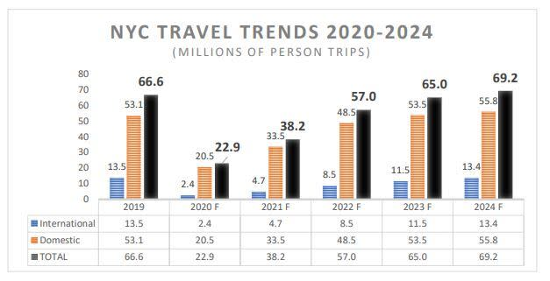
Figure 1: NYC TRAVEL TREND OUTLOOK 2020-2024

Appendix 2
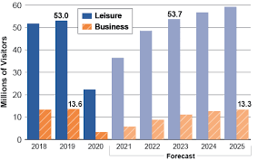
Figure 2: The Tourism Industry in New York City

Appendix 3
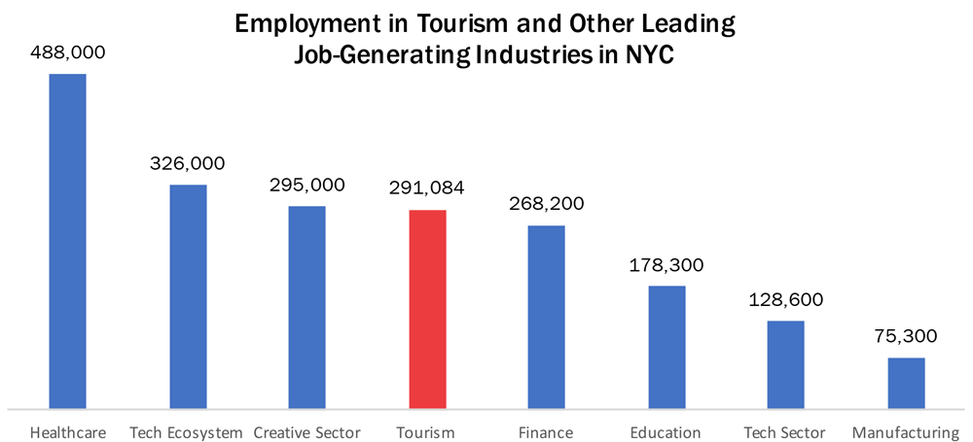
Figure 3: Employment through Tourism

Appendix 4
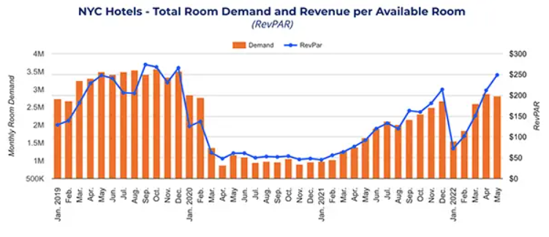
Figure 4: NYC Tourism Back at 90% of Pre-COVID Levels

Appendix 5
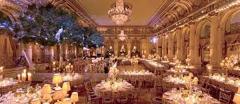
Figure 5: Meeting Spaces, The Plaza Hotel NYC

Appendix 6
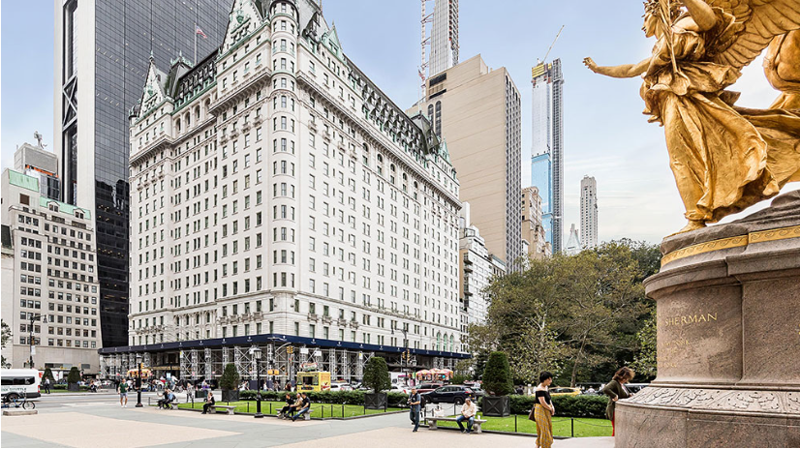
Figure 6: The Plaza Hotel, New York City

Appendix 7
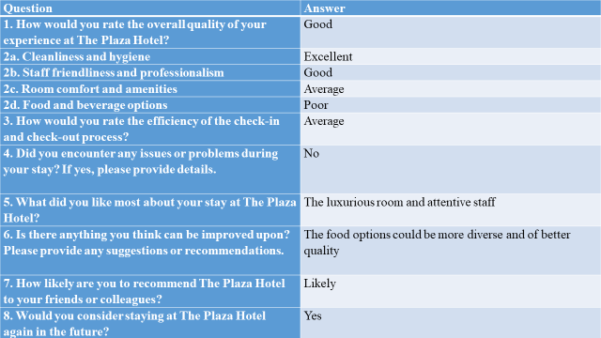
Table 6: Guest Satisfaction and Feedback at The Plaza Hotel

Appendix 8

Graph 1: Overall Satisfaction Rating

Appendix 9

Graph 2: Service Quality

Appendix 10

Graph 3: Check-in and Check-out Processes

Appendix 11

Graph 4: Recommendations for Improvement

Appendix 12
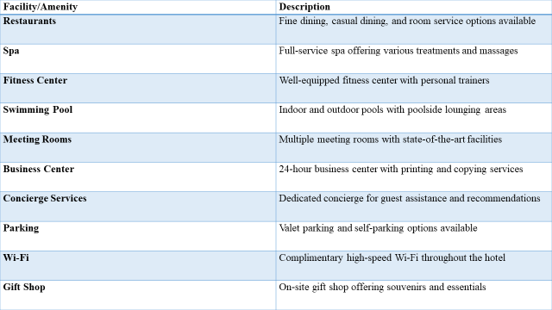
Table 7: Hotel Facilities and Amenities

Appendix 13
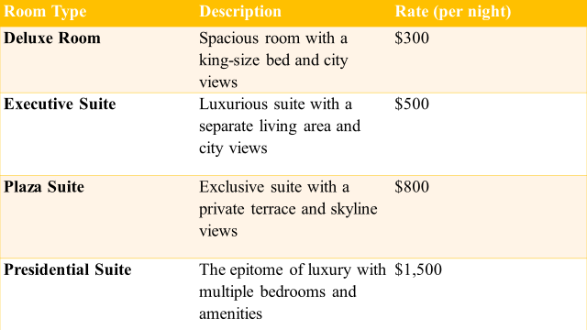
Table 8: Room Types and Rates

Appendix 14
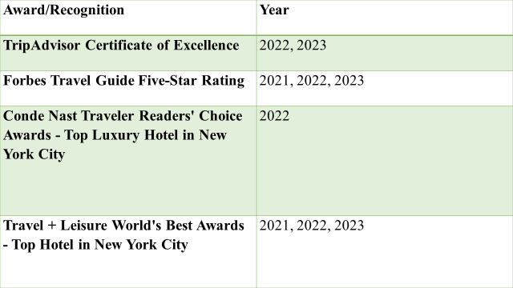
Table 9: Awards and Recognition

Appendix 15

Graph 5: Monthly Revenue Comparison (in USD)

Appendix 16

Graph 6: Guest Satisfaction Scores

Appendix 17

Graph 7: Market Share Comparison

Appendix 18

Graph 8: Employee Turnover Rates

Appendix 19
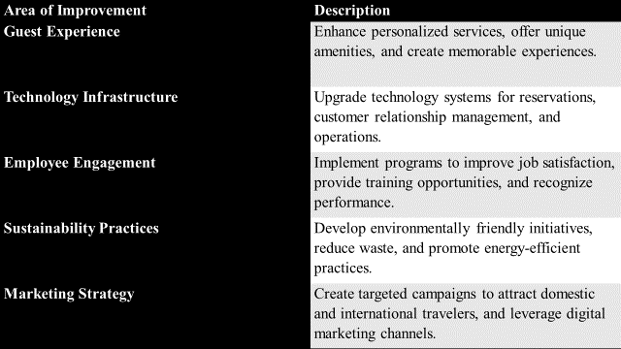
Table 10: Areas of Improvement for The Plaza Hotel, NYC

Appendix 20
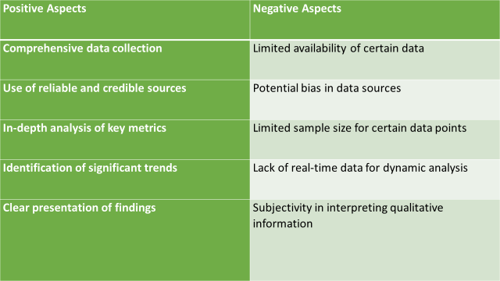
Table 11: Positive and Negative Aspects of Analysis

Appendix 21
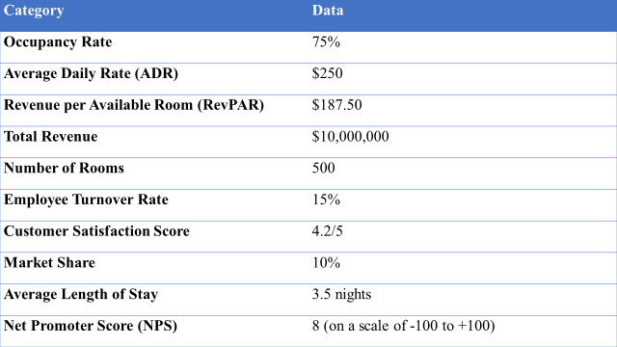
Table 12: Data and Statistics

Appendix 22
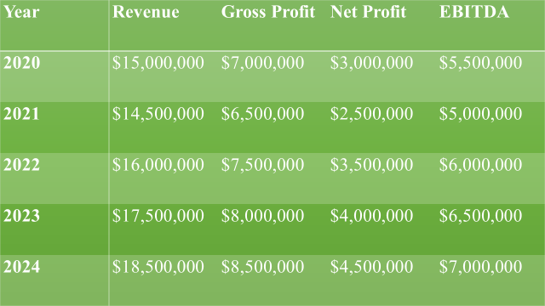
Table 13: Financial Performance

