Principles of Teaching, Learning and Pedagogy in the Secondary Sector
Lisa Jayne Craddock
P147554
Theme: Industry
Task: Creating a Soap Sculpture

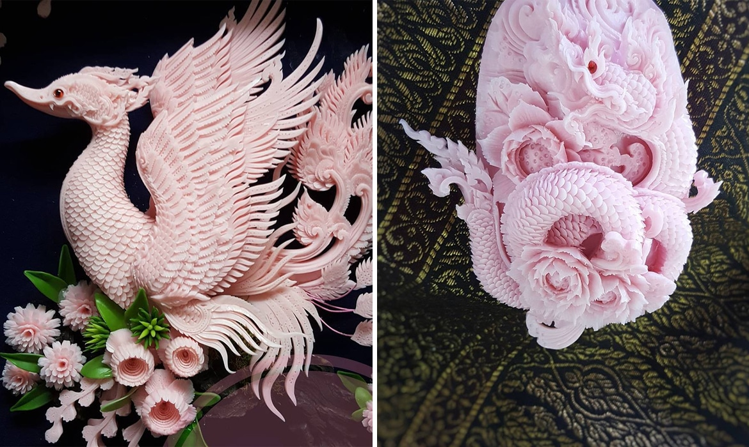

Fig 1: Soap Sculpture, Artist Narong.


APPENDIX GA36c

LEVEL 6 ASSESSMENT SPECIFICATION
Student name: | Lisa Jayne Craddock | Student ID number: | P147554
Programme: | Secondary PGCE, Art and Design
Module: | Principles of Teaching, Learning and Pedagogy in the Secondary Sector
Module code: | ECSP6001 | Contribution to Overall Module Assessment (%): | 50%
Lecturer: | Alison S Evans | Internal Verifier:
Assignment Title: | Part B, (i) and (ii) | Word count (or equivalent): | - = 1,500  - = 2,000
Submission deadline: | 26 November 2018 | Return date of provisional marks & written feedback: | 17 December 2018
Submission method: | All written assessments, where practical and possible, must be submitted via Turnitin unless otherwise instructed by the Lecturer. (Please DO NOT put this assessment specification into Turnitin or it will match many similarities with other students’ submissions.)  Alternative submission method (if applicable):  Late submission of the assessment will result in a late penalty mark. Penalties for late submission: Up to one week late, maximum mark of 40%. Over one week late, 0%. Only the Extenuating Circumstances Panel may approve a change to submission dates.
Academic honesty / referencing: | Academic honesty is required. In the main body of your submission you must give credit to authors on whose research and ideas your work is based. Append to your submission a reference list that indicates the books, articles, etc. that you have used, cited or quoted in order to complete this assessment.

Table of Contents:
Front Cover Page 1
Assignment Specification Page 2
Table of contents Page 3
Table of Figures Page 4
Title Page – Part B Task One Page 5
Introduction Page 6
Title Page – Part B Task Two Page 9
Scheme of Work Page 10
Lesson Plan Page 11
The National Curriculum for Art and Design in Wales Page 12
Y Cwricwlwm Cymreig Page 13
The National Literacy and Numeracy Framework Page 14
Digital Competency Page 15
The Skills Framework – Thinking Page 16
Teaching and Learning Theories Page 17
Differentiation Page 18
Equality of Educational Opportunities Page 19
Health and Safety Page 20
Action Plan Page 21
Bibliography Page 22

Table of Figures

Fig 1: Soap Sculpture, Artist Narong. Page 1
Fig 2: Andrew Rowe, Welsh Artist Page 13
Fig 3: George Little, Welsh Artist Page 13
Fig 4: Bilingual Keywords Page 14
Fig 5: Example shapes, handout Page 18
Fig 6: Health and Safety PowerPoint Slide Page 20

Principles of Teaching, Learning and Pedagogy in the Secondary Sector
Part B - Task One

Introduction
In order to address the brief, this reflective piece of writing discusses my six week scheme of work.
I have planned and delivered a sixty minute micro-teaching lesson. The lesson was planned for a Key Stage 3, mixed ability class, and the theme chosen was Industry.
Here is a brief overview of the scheme of work I had planned;
- Lesson one – Introduction to the topic and discussing what the final outcome over the six weeks would be. Pupils to sketch out a brief design of their interpretation of an industrial scene/industrial item. A task with an individual outcome for each pupil, however, with the encouragement of using oracy skills to discuss ideas.
- Lesson two –Pupils will start to make a paper sculpture. For this stage, pupils are given the option on whether they would like to work individually, within pairs, or within a larger group. This gives pupils the chance to develop their oracy skills, and the chance to collaborate with other members of the class.
- Lesson three – Pupils will look at mark making techniques, which could be used when making their soap sculpture. A task with an individual outcome for each pupil.
- Lesson four –Pupils will start to create their own individual sculptures out of soap. A task with an individual outcome for each pupil.
- Lesson five – Pupils to continue making their soap sculptures.
- Lesson six – Finish off the sculptures for those who haven’t, and to self-evaluate their progress over the scheme of work. By self-evaluating, it will give pupils a chance to reflect on their learning.

A scheme of work (SOW) is a series of lessons designed “to devise a long term plan for pupils’ learning” (Capel, Leask and Turner 2013 p101). A successful scheme of work ensures “continuity of pupil learning” (Capel, Leask and Turner 2013 p101).
A scheme of work is used to guide you through each lesson which includes information about the resources that are required, and the activities included. This is used alongside individual lesson plans for each week, which go into more depth about the specific requirements at each stage.
My SOW was developed with a progression of skills in mind. Starting off with an introduction to the topic and building on that information. The SOW also looked at using a range of different materials and a range of skills during its course, which would provide opportunities for all students to help discover and improve their strengths. Throughout the SOW pupils were given the chance to work with the following basic materials; paper, pencils, pens and soap. I believe these basic materials could encourage pupils to experiment with the tasks outside of the classroom, as the materials are likely to be available to most, if not all, pupils. This certainly makes the work and the ideas more accessible.
The lesson I chose to teach to my PGCE colleagues was lesson four of six. I chose this lesson as I felt it was a good way to combine all of the requirements of the Art and Design curriculum, Understanding, Investigating and Making. (Welsh Assembly Government, 2008).
I also felt it was a good opportunity to discuss with the group about the possibility of using ‘unusual’ materials during lessons, to inspire some new ideas.
The main focus was to look at historical art techniques from another culture and introduce it to the class, as part of learning about the wider world. As part of the Understanding element of the curriculum, “Pupils should be given the opportunities to explore the diverse working practices of artists, craft workers and designers from different:
• periods
• places
• cultures”

The Welsh Assembly’s Government Departments for Children, Education, Lifelong Learning and Skills (2008) Art and Design in the National Curriculum for Wales.

In this lesson I introduced a series of five artists that I felt gave a broad range of ideas that may have aided the pupils when trying to make their soap sculptures. The artists whose work I introduced were;
Narong, a Thai artist who makes soap sculptures – This tied directly into the task, as the end objective for the scheme of work was for the pupils to make an individual, successful soap sculpture.
Edouard Martinet, a French sculptor – A fantastic example, emphasising the way he uses materials to create his work, and how they are held together. His work was used to introduce the notion that some everyday items can be used in an alternative way to help produce something new.
Anish Kapoor, a British sculptor – A look at the complex shapes he uses to create form within his work. This would help aid the more able and talented portion of the classroom, and push their creativity. The detail of his work is also fascinating, and being a British Sculptor, felt it was important to share.
Andrew Rowe, a welsh sculptor – I looked at two of his sculptures, and how they vary in complexity, showing how each sculpture is completely individual. Andrew Rowe’s work also brought in an element of Cwricwlwm Cymreig, as a Welsh artist. His work was also local to where we are situated, as his work is visible along Aberavon Seafront. I felt this was an important element, as this is potentially something that could be factored into a school trip. And finally,
George little, another welsh artist – Little uses mixed media in his work. This was focussing on the simplicity of the shapes used within his work. I felt this was important, as it showed differentiation between sculptures we had looked at, to support and encourage any students with additional learning needs, or students who lacked confidence in their own abilities. I felt these basic shapes would be easier for them to follow and to incorporate into their sculptures, allowing them the same opportunity to produce work as their peers. “Learners of all abilities should have access to appropriate assessment and accreditation”. The Welsh Assembly’s Government Departments for Children, Education, Lifelong Learning and Skills (2008) Art and Design in the National Curriculum for Wales.

I believe all the artists I introduced where complimentary of one and another, as they all had different skill sets from working with a variety of different materials. I believe this would encourage the students, knowing there are a range of options they can work with, within the Art and Design discipline. “Art and design stimulates creativity and imagination by encouraging pupils to challenge assumptions, look at things in a new way, be receptive to new ideas and make informed judgments and practical decisions to communicate their ideas and feelings”. The Welsh Assembly’s Government Departments for Children, Education, Lifelong Learning and Skills (2008) Art and Design in the National Curriculum for Wales.

“Literacy and numeracy skills are absolutely essential in order for young people to reach their potential whether they are planning to enter further or higher education or the employment market”. Welsh Assembly Government (2013)
Within my micro-teach, I used oracy skills as part of the literacy framework. Highlighted in a star shape on my PowerPoint slides for the lesson, there were keywords displayed, with the intention of making these well known to the students, and to encourage them to use them during their discussions, and when completing a question and answer session of their work, during the plenary. There was no written tasks planned for this lesson, but the written elements were incorporated into the scheme of work. The last lesson, six of six, was planned as a self-evaluation task, where pupils would complete a written annotation of the process and their work.
Numeracy skills were demonstrated during the lesson, as the pupils were required to create accurate measurements. This was to ensure that the shape they were planning to carve out of the soap would fit correctly. Pupils were encouraged to sketch their designs on paper first, before beginning to carve them. If they had made incorrect calculations, their design would have been too big/too small, and therefore, their outcome would have been different to what they had envisioned.
Finally, to include an element of digital competency in the lesson, pupils were encouraged to take photographs of their work as it was developing. I felt that as well as improving their digital skills, that the images would also aid pupils when they would be evaluating their work. The last lesson of the scheme of work was planned as a reflective session; where pupils would develop their written annotate skills, by filling their sketch books with details of their process through the activities. The Welsh Assembly Government (2008) suggests, “In art and design, learners apply their ICT skills to investigate, manipulate, develop or realise creative ideas”.
After outlining the basis of my scheme of work, lesson plan, and reasons behind it, I will now look to critically evaluate my work, and the process, in light of having experienced a school setting in my PTE1. To do this, I will break down the plans into different components and critically evaluate my work.

Part B – Task Two
Critical Evaluation

Scheme of work
An effective SOW should include all National Curriculum requirements such as Understanding, Investigating and Making. (Welsh Assembly Government, 2008).
It should be built to include elements that help support the Literacy and Numeracy frameworks, the requirements for Y Cwricwlwm Cymreig and also meet the requirements for the skills frameworks (Literacy and Numeracy Framework and Digital Competency). A SOW should also take into account differentiation within the lessons for pupils, ESDGC and Health and Safety. (Welsh Assembly Government, 2008)
The Welsh Assembly Government (2008) states that “all children and young people must be provided with an education that develops their personality and talents to the full”.
The National Curriculum is “a plan or framework” (Addison and Burgess 2007, Pg69). The framework for the Art and Design Curriculum does not set a list of requirements that must be covered, or a list of materials that must be used. I feel this is more beneficial, as it allows for creativity for both the Teacher and the pupils.
I believe that my SOW covered the requirements outlined above, and in doing so, gave all pupils a chance to develop their own idea of industry (the topic that was chosen).
Since starting my PTE1, I now believe that my SOW would not be possible in the timeframe. To give pupils a chance to fully understand, and to fully investigate as per the curriculum, I feel they would need more time. I would suggest extending the time to twelve weeks.

Lesson Plan
A successful lesson plan is described as “an outline of one lesson within a unit of work”. (Capel, Leake and Turner 2013, p105).
The structure I followed to set out my lesson was, Mike Hughes’ four phases of a lesson. (Hughes, 2001)
- Phase One (Overview) – I provided clear lesson objectives at the start, which were spoken, and written on the PowerPoint slides. I also introduced the artists.

- Phase Two (Input) – I explained and gave a demonstration on how to complete the tasks of this lesson.

- Phase Three (Process) –I let each pupil process the information from phase two and let them attempt to complete the task successfully, with assistance where appropriate and necessary.

- Phase Four (Review) – I used question and answer strategies with the pupils throughout the lesson, to gauge their level of understanding about the task.

On reflection, I would change phase one of my lesson. I introduced the artists to the pupils by reading their information from a PP slide; I would now vary that task to make it more engaging and challenging. This could be done by setting the pupils the task of finding artist research themselves, or by providing them with an artist handout, along with questions, and asking them to read the information and answer the questions themselves, helping improve their literacy skills. I would also drastically reduce the number of artists. Five is far too many, and would limit myself to a maximum of two per lesson.

The National Curriculum for Art and Design in Wales
The National Curriculum requirements are that all pupils should be able to develop their skills within the context of ‘Understanding, Investigating and Making’. Welsh Assembly Government (2008).
During my micro-teach my aim was for each pupil to address the task by documenting their interpretation of industry. This would ensure that the outcomes would be diverse and unique.
The area from the National Curriculum requirement which was most prominent within my SOW was ‘Making’. There was a strong element of this in each lesson throughout the SOW including; sketching, mark-making, building a paper sculpture, and finally finishing with the soap sculpture.
Upon reflection, I feel that this SOW included too many ‘Making’ activities, and I could have created more even splits between the other areas of the curriculum, Understanding and Investigating more thoroughly. Welsh Assembly Government (2008).

Y Cwricwlwm Cymreig
“The programmes of study for art, music and PE provide an equally rich source of opportunities for pupils to explore the cultural characteristics of Wales, past and present”.
(Qualifications, Curriculum and Assessment Authority for Wales (ACCAC) 2003)

The common requirements statement identifies five aspects of the Cwricwlwm Cymreig: Cultural, Economic, Environmental, Historical and Linguistic. (Qualifications, Curriculum and Assessment Authority for Wales (ACCAC) 2003)
During my micro-teach I identified the Linguistic requirement during the start of my lesson by addressing to all pupils in welsh. I also requested pupils reply “yma” when calling the register, and I used incidental Welsh throughout the lesson.
I produced bilingual keywords and lesson objectives throughout my PowerPoint, and also included two Welsh artists during the lesson.
During lesson three of my SOW, I believe it would have been beneficial to use welsh coal to mark make. Not only would it have produced a unique experience for the pupils, but it could have opened up conversations surrounding the production of coal, historical facts relating to coal, the Welsh Mining community, and the impact that the mines had on the Culture of Wales, and the Economy. This is something I will take on board going forward.

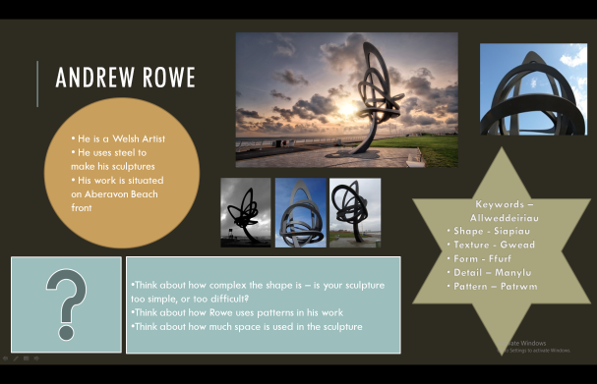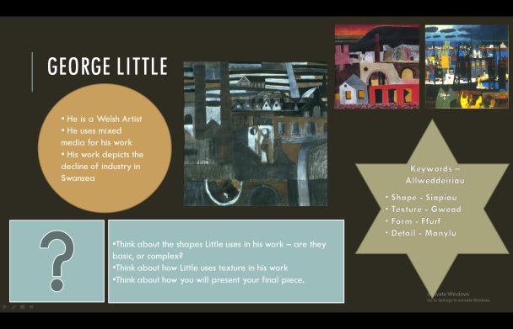
Fig 3: George Little, Welsh Artist
Fig 2: Andrew Rowe, Welsh Artist.

The National Literacy and Numeracy Framework
Literacy
“Literacy and numeracy are essential life skills”. National Literacy and Numeracy Programme – a strategic action plan (Welsh Government, 2016).
Within my micro-teach I found that oracy was continually present during the lesson. Pupils were encouraged to communicate with each other throughout, as well as the continuing dialogue between pupils and teacher. I also included keywords. These words were visible bi-lingually on every artist slide.
Fig 4: Bilingual Keywords

Going forward, I would introduce reading and writing tasks in my SOW.
Numeracy
During my micro-teach pupils were required to sketch a design for their sculpture, which would fit the size of a bar of soap. Most pupils decided to place the soap onto a piece of paper and draw around it. I could have made this more difficult, by giving them the measurements of the soap and asking them to draw it, using a pencil and a ruler – and providing them with the soap once this was complete.
Upon further reflection, I feel that I could have developed numeracy skills further, by putting emphasis on shapes. By holding a discussion about shapes, this would have aided their numeracy development. Shape is also one of the visual elements of art, so it would have been easy to fit into a discussion. Symmetry could have also been discussed when talking about creating a design for their sculpture. Both of the words shape and symmetry could have then been added to the keywords list for the scheme of work, adding enhancement to pupil’s vocabulary. “Improving literacy and numeracy ... remain our priorities and underpin the strategic objectives of Qualified for life”. Qualified for life (Welsh Government, 2014).

Digital Competency
“Digital competence is the set of skills, knowledge and attitudes that enable the confident, creative and critical use of technologies and systems”. Digital Competence Framework guidance, Welsh Government (2018).
During my micro-teach the pupils were encouraged to record their process by taking photographs as they progressed through the different stages of the task. The photos would also be useful to help describe the process for those who need additional support with literacy skills.
The skills they would learn by taking photos, uploading, saving and printing them, are all transferrable skills. “Digital competence is one of three cross-curricular responsibilities, alongside literacy and numeracy; it focuses on developing digital skills which can be applied to a wide range of subjects and scenarios that are transferrable to the world of work”. Digital Competence Framework guidance, Welsh Government (2018).

The Skills Framework – Thinking
The Welsh Assembly Government (2008) suggests “processes of thinking that we have defined are plan, develop and reflect”.
I feel that within my SOW that this structure worked well for the task that I had set. If I was to do my micro-teach again, I would use the same structure of plan, develop and reflect, but I would be open to using them in a different order. By creating a starter activity that opens a discussion, for example “what do you know about industry?” or “what does industry mean to you?” – This could encourage the pupils to reflect first. They would be able to reflect on any prior experiences/information they have on the subject, and apply that to the lesson. This reflection could then perhaps help them plan and develop the task ahead. Addison and Burgess (2010) suggest that there isn’t one method that will be sufficient for all pupils, for every task.

Teaching and Learning Theories
Since completing my micro-teach I have discovered that I need to apply various learning techniques and theories, not just the approach that Hughes (2001) suggests in his four phase lesson plan.
If I was to revisit the lesson, I would provide more opportunities for the pupils to learn for themselves – i.e. producing an Artist Study for themselves.
During my micro-teach, I did complete a demonstration to aid pupils; however, it was primarily focussed on the element of Health and Safety. If I was to revisit the lesson, I would use the demonstration to model exactly what is required in the task, and how to do it. This would break the task into more manageable chunks, so perhaps pupils wouldn’t feel the task is too daunting. I feel it would be beneficial to show pupils a fully completed example (which would need to be prepared beforehand); as it would help pupils visualise a finished sculpture, and set expectations.

Differentiation
Differentiation can be as simple as changing some content, or instructions for a pupil, or more complex, such as changing the materials or activity, to suit an individual pupils needs.
“Every child and young person benefits from personalised learning. Valuing diversity and inclusivity
means all children and young people should benefit from learning that meets their needs”. Qualified for life (Welsh Government, 2014).
During my micro-teach, I did provide a handout to all pupils, with some suggested ideas for their sculptural shape. This was to provide an aid to pupils who may struggle to visualise a final outcome. I provided a variety of tools to carve with, some being simpler to use than others. This was to help those pupils who may be unable to use a craft knife/scalpel. All pupils were provided the opportunity to use plastic knives, plastic spoons and paperclips – all which were just as effective.
Upon reflection, I could have provided some basic outline shapes of industrial buildings to match the size of the bars of soap – this would have given pupils the option to trace the outline, if they were struggling to sketch up their own designs.
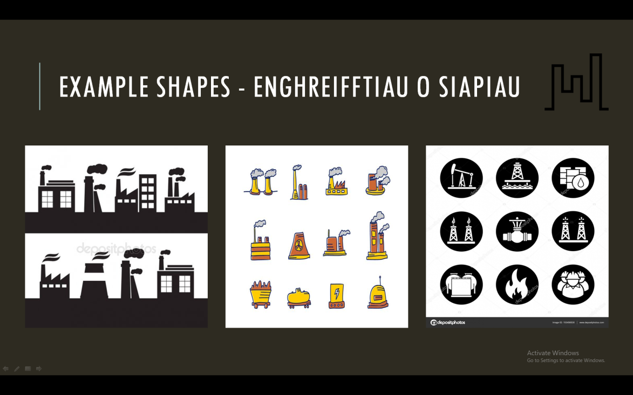
Fig 5: Example shapes, handout.

Equality of Educational Opportunity
“Every child and young person benefits from personalised learning. Valuing diversity and inclusivity
means all children and young people should benefit from learning that meets their needs”. Qualified for life (Welsh Government, 2014)
During my micro-teach, I ensured that handout resources were available for all pupils, with the option of having the resources printed at a larger scale, if needed. This ensures that any individual needs of pupils would be met.
On reflection I feel that I could have balanced my artist research more evenly. The artists I used were all male, so going forward over the course of my SOW; I would use more female artists to create more inclusivity for the females in the class.

Health and Safety
“Health and safety in a school is about taking a sensible and proportionate approach to ensure the premises provide a healthy and safe place for all who use them, including the school workforce, visitors and pupils”. Health and safety checklist for classrooms - The Health and Safety Executive (2011).

At the start of the lesson, I ensured pupils were lined up outside the classroom beforehand, and that they entered the room in an orderly manner. They were advised before entering, that they needed to place their bags under desks after finding their seat. This was to prevent any trip hazards.
Pupils were familiar with all materials being used during this lesson – however, as scalpels were being used to carve the soap, I had to ensure this was covered during the demonstration. I made sure I mentioned the hazards that could occur with the scalpel, and other tools, and how to avoid these. I also created a table showing possible risks with the materials used, and displayed this on my PowerPoint document, and provided it as a handout for all pupils.
I also prepped all the materials in advance for each table and counted the equipment. This ensured that I knew all the materials (including the scalpels and scissors) were returned, and therefore could not leave the classroom and cause harm when being used while unsupervised. I also included latex free gloves for pupils to use, in case they had sensitive skin, or allergies. I would not change how the health and safety rules were delivered.

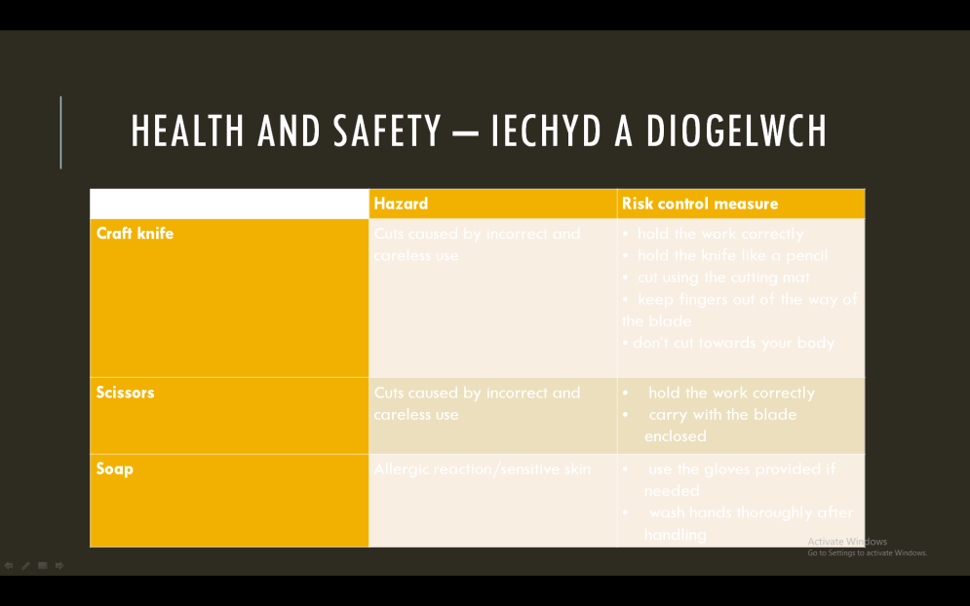
Fig 6: Health and Safety PowerPoint Slide.

Action Plan
Action Plan – Objectives and Programme for Term One

Name: Lisa Jayne Craddock | Subject: Art and Design | Date: 15th November 2018

Objectives | Actions to be taken | Success Criteria | Date to be Completed
S2.1 – Subject Knowledge | To research and build upon my knowledge of the National Curriculum, and what is required at each Key Stage. | To complete research and use this in any forthcoming lessons. | Ongoing.
S3.2.2 – Assessment to support learning | Research methods to use, to proactively involve learners in evaluating their work, so they are able to self-evaluate. | Give immediate and constructive feedback to pupils, and question their understanding of their work. | Ongoing – but consistently by the end of PTE 1.
S3.3.4 – Differentiating teaching | Research methods of differentiation.  Speak to TA support to discuss individual pupils needs where necessary. | To be able to successfully provide differentiated tasks for both students with ALN’s, and the more able and talented. | Ongoing – but consistently by the end of PTE 1.
S3.3.9 – Managing behaviour | Research methods of setting high classroom expectations of the pupils.  Set expectations at the start of the lesson, and continue to repeat when necessary. | Consistently reminding pupils of the expectations, until it becomes second nature to them. | Ongoing – but consistently by the end of PTE 1.

Bibliography
Books:

Addison and Burgess (2007) Learning to Teach Art and Design in the Secondary School. London:Routledge

Addison and Burgess (2010) Understanding Art Education: Engaging Reflexively with Practice (Teaching School Subjects 11-19). London:Routledge.

Boud, D (1995). Enhancing Learning through Self-Assessment. London:Routledge

Capel, Leask and Turner (2013) Learning to Teach in the Secondary School: A Companion to School Experience. London:Routledge.

Cunliffe, L. (2005) The problematic relationship between knowing how and knowing that in a secondary art education. Taylor and Francis.

Hughes, Mike (2001). Strategies for Closing the Learning Gap. Stafford: Network Educational Press Ltd.

Pritchard, A (2009) Ways of Learning. London: Routledge
Qualifications, Curriculum and Assessment Authority for Wales (ACCAC) (2003) Developing the Curriculum Cymreig. ACCAC Publications.
The Welsh Assembly Government Departments for Children, Education, Lifelong Learning and Skills (2013). National Literacy and Numeracy Framework; to support schools in introducing the National Literacy and Numeracy Framework.
The Welsh Assembly Government Departments for Children, Education, Lifelong Learning and Skills (2008) Art and Design in the National Curriculum for Wales.
The Welsh Assembly Government. Digital Competence Framework Guidance (2018).
The Welsh Assembly Government. National Literacy and Numeracy Programme – a strategic action plan. (2016)
The Welsh Assembly Government. Qualified for Life. (2014)

Online Articles:
(2011) Health and Safety Executive - Health and safety checklist for classrooms. Last accessed 17th November 2018
(2008). Scheme of Work. Available: https://www.teachingenglish.org.uk/article/scheme-work. Last accessed 17th November 2018.
The Importance of Planning. Available: http://www.tesol.org/docs/default-source/books/14002_lesson-planning_ch-1.pdf?sfvrsn=2. Last accessed 17th November 2018.
(2014). Promoting Equality & Diversity in the Classroom. Available: https://www.highspeedtraining.co.uk/hub/classroom-equality-diversity/. Last accessed 17th November 2018

