
Skills for the Workplace
Module Assignment Submission
Student Name: | Holly Gauci
Student Number: | 1910922
Module No: | BMSK4003
Module Title: | Digital Skills and Research Methods

Statement of Confirmation of Authenticity
By the act of making this submission, the student declares that this is the work of the student named above. The work has not, in whole or in part, been knowingly presented elsewhere for assessment, or where assessment has been built on a previous assessment, this has been identified. Where materials have been used from other sources it has been properly acknowledged. If this statement is untrue, the student acknowledges that an assessment offence has been committed.
Attention is drawn to the plagiarism and unfair practice policies of both the University and of ILM.
Permission for ILM to use this script
ILM uses learners’ submissions – on an anonymous basis – for assessment standardisation. By submitting, both the centre and the learner agree that ILM may use this script on condition that identifying information is removed. However, if you are unwilling to allow ILM use this script, please refuse by ticking the box: □

Table of Contents
What has been the impact of 21st Century Technologies on the modern workplace? 3
Part 1 3
An Overview of the 21st Century Workplace generally 3
An in-depth look at technologies used in own workplace 4
Mobile 4
Cloud 6
Wi-Fi 8
Business strategy dependant on modern technology 8
Part 2 8
An exploration of the use of social media in the workplace generally 8
An in-depth look at the use of social media in own workplace 9
The use of social media to enhance networking and career prospects 10
LinkedIn Profile link 11
Conclusion 11
References 12
Bibliography 12
Appendix 1 14
Appendix 2 15
Appendix 3 15

What has been the impact of 21st Century Technologies on the modern workplace?

Part 1

An Overview of the 21st Century Workplace generally

The impact that modern technology has had on the modern workplace is profound. It has enabled companies to connect with each other instantly and links everyone digitally. The changes since the year 2000 are extensive, technologies have advanced rapidly. Before technological advancements, businesses would rely on time consuming written letters instead of mobile contact or emails. Businesses wouldn’t have had the use of GPS to get them from one meeting to the next, they would have had to use directions and maps. Invitations to meetings or interviews would take longer to arrange, whereas now a meeting can be arranged instantly and can be conducted at the earliest convenience. Flyers would be used to advertise businesses far more than at current to connect to consumers and clients, in the 21st century we can use the internet and social media to invite people to events or to advertise our services which reduces costs and can reach a wider audience with the correct approach. All of these changes mean that businesses have been able to progress in the 21st century by saving time and money and increasing productivity.
For an insight into how the 21st century workplace has been impacted by modern technology, Vitez (Feb 2019) wrote a credible and current report on the impact of technology in the workplace, this text has been peer reviewed and contains a bibliography. Vitez stated “Technology has revolutionized the way companies conduct business by enabling small businesses to level the playing field with larger organizations” Vitez has also covered areas such as the impact on costs, stating “Small business owners can use technology to reduce business costs.” Ways in which technology has enabled business to store secure information, informing the reader that “Many types of business technology or software programs are user-friendly and allow business owners with only minor backgrounds in information technology to make the most of their tools and features.” Vitez has also mentioned how technology has improved communication and productivity stating, “Business technology helps small businesses improve their communication processes.” The report gives a good clear understanding in the many ways that technology has impacted the workplace.
Although modern technology can positively influence staff, productivity and spend, artificial intelligence is a technology that could in fact danger traditional job positions. If companies are flourishing with advancements in technology then there may be less of a demand for physical presence. You just need to look around a supermarket or train station to see that jobs must have been lost due to self service check outs. However it could be argued that those jobs are being counteracted with new and more creative positions. According to a survey report by Manyika (2017) “Activities most susceptible to automation include physical ones in predictable environments, such as operating machinery and preparing fast food. Collecting and processing data are two other categories of activities that increasingly can be done better and faster with machines. This could displace large amounts of labor—for instance, in mortgage origination, paralegal work, accounting, and back-office transaction processing. It is important to note, however, that even when some tasks are automated, employment in those occupations may not decline but rather workers may perform new tasks.”

An in-depth look at technologies used in own workplace

By making an observation the report writer has identified several modern technologies that are used in their workplace, these include mobile, Wi-Fi and cloud services. All play a key role in the day to day running of the business. The business relies on the use of a static telephone, for taking inbound calls from clients and suppliers as well as for making outgoing calls, a music system that links to Wi-Fi and mobile, a desktop computer for storing data and accessing cloud storage, an iPad for storing client data offline and mobile telephones to access social media for storing and sharing data. There are also security cameras that use Wi-Fi, rely on the backup of a Cloud service which can be operated and viewed with a mobile.

Mobile

Mobile phones are used in the work place to access social media, cloud services and apps as long as there is a Wi-Fi connection or other connection service such as 4G, tethering or hotspots. Mobile phones are personal possessions used in the report writers workplace and all of the staff use their own to connect to each other, capture and store pictures of their work, post their work on social platforms, access work files and contact suppliers and clients. The report writer also uses their mobile to access online business banking and merchant banking via pre-downloaded apps, before the turn of the century this would have involved a more time consuming trip to the bank. In the last 20 years the advancement of mobile banking has made transactions easily traceable and in most cases instant. The report writer uses online banking daily to track deposits made against appointments and without this it would interfere with the day to day running of the business.
It has been observed that the use of mobile telephones, has enabled the report writer to work independently and interdependently. The report writer can use their mobile to work on projects alone as well as work on projects that can be shared between the team for increased productivity, in a quick and easy way. It has also enabled staff to work remotely, away from the workplace. Work can be carried out at home, in the car, on holiday, in fact pretty much anywhere away from the workplace as long as there is a connection. If there’s no connection work can still be carried out on photo editing using pre-downloaded apps, video creations and word documents that need preparing for training or meetings. This is an efficient way to enhance productivity within the report writers workplace. However there is a negative impact that the ease of remote work can have on individuals in the workplace, work life balance can be easily interfered. The ability to leave work early and work from home can have no time restraints and restrict routine. This can and has affected work/life balance and has been reported in discussions between staff. The fact that the staff can work from home or even on holiday takes away from the balance of work and can generate a feeling of not being able to switch off. It has also been observed that staff can easily get distracted by personal notifications whilst using their own device. In a recent survey the report writer discovered that out of 6 participants, 33.33% only used cloud based services in the work place and 66.67% used it both in work and at home, this data and information backs the thought that some individuals would be happy to take their work home and assumes that the ones who only use it in work choose not to work from home. Yet all of the participants accept technology as a way to work productively and efficiently. There is a 50/50 split on the idea of having set time boundaries when contacting colleagues outside of work. The report writer believes that the same people who would want set boundaries would also be against the idea of working from home, however the results differ slightly, indicating that those who don’t mind working from home may still have their own limits to how they spend their leisure time and this should be something that is addressed in the work place to ensure everyone is working together to respect each other’s needs. According to Ackoff (1989) ‘from data to wisdom’ the report writer has collected raw data, processed information using questions and turned it into their own knowledge of the subject. This ultimately results in wisdom, the wisdom of evaluating the knowledge and being able to apply it to their situation.

Cloud

Cloud is an online backup service that stores your chosen data and information, there a number of cloud services that are rated by professionals. A recent review by Casserly (Jan 2020) compares some of the most well-known cloud services available however there is a disclaimer at the bottom of the article stating that they may earn commission when you buy storage using the links on the site. This could prove the information to be biased in terms of the commission they receive from the server and could be written to try and deliberately sell to the audience. The article compares prices and storage capacities and also recommends certain cloud storage to different target areas such as business compatibility or highest amount of free storage, this breakdown of information is helpful to the audience. The report writer has taken information from the text and researched into cloud services by going direct to the seller to ensure correct and up to date information. In the article Casserly stated that Dropbox is good for businesses and picture storage, which is suitable for the report writers business model. Dropbox isn’t currently being used in the report writers workplace but could be used to send protected and secure files between staff instead of using applications such as WhatsApp which is not a secure service.
Dropbox has been identified by the report writer as a service that can collate all work related pictures into one safe place, it could also be used for all staff to access workplace policies. Currently pictures are being stored on mobile devices with no back up, which in the event of a loss would be devastating. The report write takes around 20 suitable pictures a week for social media use, that’s 960 credible photos that could be used to increase traffic and engagement that can be lost. Dropbox offers a free 30 day trial and for £10 a month you can obtain a 5TB storage package for up to 3 users. The storage also has 180 days of file recovery, two factor authentication for security and can be integrated with Office 365 which is a credible and trusted service from Microsoft. For an extra £5 a month you can get as much storage as your team needs, however 5TB of storage should be sufficient and if not there is an option to increase your plan to avoid paying an extra £60 a year. The report writer should also bare in mind that if subscription is not paid then the package will revert to a free basic package but all of the previous uploaded data will be saved and available, but no more data will be stored. This provides peace of mind to the buyer and security in knowing that the data will not be deleted unless the user chooses to delete. Using a bigger well known file hosting service doesn’t necessarily mean it is the most suitable for a certain business model, but the integration with Office 365 and other security issues mentioned the report writer believes that Dropbox is a credible and reliable service to use. A similar file hosting service called Mega, offers renowned security and similar prices for storage. However due to the high end security, if you lost your data or private information you would be in trouble. It’s also £17.19 per month for 4TB, so more expensive than Dropbox for less storage than the standard package.
The report writer has discovered that cloud services are used in the work place in form of an online booking system. The system is accessible by all staff and has different levels of access and security for each staff member. This system is accessible via the desktop computer in the workplace and via personal mobiles or laptops. The information on the system is stored in a cloud setting, so is accessible to anyone with an internet connection. The use of the cloud system in this format enables staff to effectively track and trace their appointments and sales. Staff can check their availability at their next convenience and enter their own holidays and busy periods. This enables everyone to be aware of each other’s availability. This can have an impact on their own appointments and productivity as the staff sometimes rely on each other to group together appointments. The system also collects client data that complies with GDPR and compiles statistics to make it easier for the report writer to track and project profit and loss.
The cloud system has meant that the traditional diary is no longer needed, traditional paper diaries didn’t allow for automated calculations and data formulations, but the cloud system does. There is a concern over security when using online cloud services and complying with GDPR (April 2018). The report writer has observed that the online system may be unsecure due to being an American system, there may be a risk to potential loss of data if the company failed but in regards to the ethical handling of data the company limits the data it stores on the service. Only an abbreviation of the contact is stored on the system, which is taken from their social media name and any data that is stored regarding the clients treatment care is held on a mobile device that’s been disconnected from cloud storages and Wi-Fi, all appliances and log ins are password protected.
Cloud is now an integral part to the report writers business, the business could function without it but would be far more time consuming and costly to the business. There is an element of this cloud service which also contributes to the effect on work/life balance, being able to access the appointment system instantly means that staff can choose to reply to client booking requests at any time of the day including during their own leisure and downtime. When the report writer asked the question “Overall how do you feel Wi-Fi, Cloud services and Mobile have impacted the way you work?” a colleague responded “it’s easier to keep up with taking appointments, but the downside is I just don’t really shut off“ proving that technology may have in fact made it harder to shut off from work completely.

Wi-Fi

The report writer heavily relies on Wi-Fi in the work place, it is the heart of the businesses function. It connects the security cameras to mobile apps, the desktop computer to the booking system and websites that need accessing. It is needed to connect mobiles to all of the apps used in the workplace including the music system. If the Wi-Fi goes down during staff and client interactions then the booking system can not be accessed and card payments can’t be taken. This 21st century workplace would find it very hard to function without a Wi-Fi connection.

Business strategy dependant on modern technology

The report writer has enabled an efficient and cost effective strategy within the work place, which is dependent on Wi-Fi, cloud and mobile. Without these key technologies the strategy would be affected dramatically. To book appointments clients use social media to contact for the majority of bookings, to answer these requests staff need, Wi-fi to access the cloud server and although a desktop computer can be used to finalise the bookings mobile is also needed to work remotely and to contact each other to make linked bookings between staff or to solve issues.

Part 2

An exploration of the use of social media in the workplace generally

When comparing two businesses and their online presence it has been discovered that social media is widely being used to market products and services. The two professional accounts being compared via Instagram are ‘@plouise_makeup_acadamy’ and ‘@Piqinitauk’ both have a platform with a generous amount of followers.
Plouise Makeup Academy has a huge 934k followers on Instagram, their feed is creative and eye catching. They post pictures of their artists makeovers to advertise their skills but the also advertise their retail products every two posts. This communicates to the follower that they offer makeovers and products for sales. The follower can the contact them via the information held in their biography or by visiting their website. When analysing the post interaction, it has been noted that the creative makeup posts get an average of 18,500 likes, whereas the average for retail posts is much lower at 4,000.
Piqinita has 16.9k followers and has a more soft creative look, they rely on customer and influencer photos to fill their feed with their products and they catch between 100 and 200 likes per post. However when doing a brand collaboration post with a national influencer they hit 1,186k likes. Piqinita also has a website link for all of their retail stock.
On comparing the two, you can assume that the more followers you have the more likes you will receive per post. These likes mean that an individual has had an impression made on them, they have appreciated the post and not only could this lead to sales it also ups the companies search engine optimisation ranking. Both pages display an effective form of marketing and advertising with creative and visual posts.

An in-depth look at the use of social media in own workplace

My business uses social media to advertise work, marketing and to respond to clients that want to make bookings. We use Instagram to advertise availability, showcase our work, increase engagement and followers to increase traffic and bookings.
We can reach thousands of potential clients with targeted advertising and paid posts, we have probably only spent £60 on Instagram marketing in the first year and we are almost full each week. However we don’t have a system in place that tells us if clients have been referred from those paid posts so the risk of using these platforms for paid advertising could bear no ROI.
Social media use in My workplace is the driving force behind productivity. 100% of my colleagues use Instagram to advertise their services and 83.3% use Facebook (Appendix 1), in hope to increase engagement and result in bookings for their services.
I believe my workplace is effectively transitioning into the fourth industrial revolution, it demands creativity and proactivity and can not currently be over taken by artificial intelligence. Our use of social media promotes business well and showcases what each team member can deliver. Customer interaction is high, especially during competitions when a strategy is used to increase traffic to that particular page. However just like any social network, people can loose interest and new things can come along. Instagram may be our driving force now but according to my primary research 83.3% of survey participants believe their business wouldn’t survive without social media (Appendix 2). Therefor it is imperative that creativity and innovation become a key skill in my business. We are already considering new platforms such as ‘TikTok’ to start advertising our business in preparation for any shifts in platform interest.
Instagram as an estimate generates 98% of our bookings, during a week in work I tallied how many bookings came in via Instagram, Facebook, phone call and walk ins. Out of 28 enquiries, 27 where via Instagram, 1 via Facebook and none via phone or walk-ins. This is the normal expectancy on a weekly basis, however we do on occasion take bookings by phone or by walk-in.
Facebook would have been my chosen social media platform for business 5 years ago, now I only use Instagram. Instagram does however mirror my posts to Facebook, to provide for any of my followers who don’t have Instagram. I do not like the layout of Facebook for business pages, I find it hard to manage and visually cluttered. I have therefore chosen to use Instagram as my preferred platform. Instagram is easier to use, more uniform and visually pleasing to both myself and my audience and as you can link the two it means I don’t have to manage Facebook at all, apart from the occasional enquiry. Instagram is also a good tool for tracking audiences, traffic to posts and best times to post your adverts.
During my research I discovered that none of my colleagues use twitter for work related purposes (Appendix 3). With Twitter being an older platform I would choose not to venture into usage of this platform and instead prepare for new ones.
Instagram has also been used as a tool to screen potential employees, in fact we have looked at everyone’s profiles to make judgement on their personal brand, discussed whether they need help with their online presence and if we have the time to be able to help them. According to an article by Lebowitz (May 2017). ‘60% of employers use social media to screen job candidates’ and 60% of all employees are looking for something to support the candidates application rather than to make a negative impact. This was taken from a survey by CareerBuilder.com.

The use of social media to enhance networking and career prospects

LinkedIn is a social networking platform that is used to connect professionals. You can build your personal brand as a professional in your industry and showcase your skills. LinkedIn is much like an expansive and more connected version of your curriculum vitae. It holds a bigger picture of the individual and instantly connects to other professionals. It also targets your interest in progression and future prospects, making you admirable to recruiters or other business owners. I believe that the use of LinkedIn can connect me to professionals that may be able to appreciate my skillset and offer me opportunities that I am unaware of. Being present enables me to be noticed for positions I may not have known where suitable for me. However I have noticed that so far the individuals using linked in are predominantly sales focused, therefore this will be something I invest some more time and research into.
I am aware of the risk of using online platforms such as LinkedIn so have therefore only listed the information that I want people to see using privacy settings and choice of text. I do still believe that Instagram helps me enhance networking and career prospects in a way that is more suited to my products, services and future goals. I use my work Instagram pages mainly to advertise my work and post my availability. I only post information I want people to see and I am very aware of my personal brand in case people find me on my personal profiles. I regularly post videos on how I do my work including before and afters, I also make sure that I tag any professionals and brands as I am aware this could lead to opportunities to work with other companies. By doing this I have already been recognised and asked to work with certain brands and influencers which adds to my portfolio.

LinkedIn Profile link

https://www.linkedin.com/in/holly-gauci-00830419b

Conclusion

Ultimately I believe that businesses need growth and in the last 20 years they have done that evidently with the help of modern technology. There will always be evolution, whether its human form, geographical or technological. People evolve through the ages. Modern technology will most likely continue to evolve even if we can’t predict how it will look, if business reverted back to how it was 20 years ago for myself I believe that my business would fail as would others. In this case businesses should always stay educated and up to date and try to avoid loss of business due to falling behind.

References

Ackoff, R. L., "From Data to Wisdom", Journal of Applies Systems Analysis, Volume 16, 1989 p 3-9

Casserly, M. (2020) Best cloud storage 2020: Online file storage reviews and buying advice, [online] available at https://www.techadvisor.co.uk/test-centre/internet/best-cloud-storage-3614269/ [Accessed 19.01.2020]

Lebowitz, S. (2017) Your online image is more important than ever — here are 5 ways it can make or break you, [online] available at https://www.businessinsider.com/why-your-image-is-everything-2017-5?r=UK#60-of-employers-use-social-media-to-screen-job-candidates-1 [Accessed 23.01.2020]

Manyika, J., Lund, S., Chui, M., Bughin, J., Woetzel, J., Batra, P., Ko, R. and Sanghvi, S. (2017) Jobs lost, jobs gained: What the future of work will mean for jobs, skills, and wages. [online] McKinsey & Company. Available at: https://www.mckinsey.com/featured-insights/future-of-work/jobs-lost-jobs-gained-what-the-future-of-work-will-mean-for-jobs-skills-and-wages [Accessed 23 Jan. 2020].

Vitez, O. (2019) The Impact of Technological Change on Business Activity, [online] available at https://smallbusiness.chron.com/impact-technological-change-business-activity-2191.html
Accessed 17.01.2020

Bibliography

CareerBuilder. Available at: https://www.careerbuilder.com/share/aboutus/pressreleasesdetail.aspx?ed=12%2F31%2F2016&id=pr945&sd=4%2F28%2F2016 (Accessed 23.01.20)

Covey, S. (2015) The 7 habits of highly effective people. The interactive Ed. La Vergne : Mango Media Inc.

Data Protection (2018) Guide to the General Data Protection Regulation. Available at https://assets.publishing.service.gov.uk/government/uploads/system/uploads/attachment_data/file/711097/guide-to-the-general-data-protection-regulation-gdpr-1-0 [Accessed 13.01.2020]

Dephillips, K. www.contentfac.com [Online] Available at: https://www.contentfac.com/9-reasons-social-media-marketing-should-top-your-to-do-list/ [Accessed 13.01.2020]

Doyle, A. (2017) Learn how to make a better LinkedIn Profile, [online] Available at: https://www.thebalance.com/tips-to-make-a-better-linkedin-profile-2062332
(accessed 23.01.2020)

Hall, B. (2019) The Development of Internet Banking and Mobile Banking in the UK [Blog]. 27th February. Available at: https://www.cashfloat.co.uk/blog/money-borrowing/mobile-internet-banking-uk/ (Accessed 19.01.2020)

Harris, J (2018) Man versus machine: 9 human jobs that have been taken over by robots [Online] Available at: https://home.bt.com/tech-gadgets/future-tech/9-jobs-overtaken-by-robots-11364003046052 (Accessed 23.3.2020)

Appendix 1
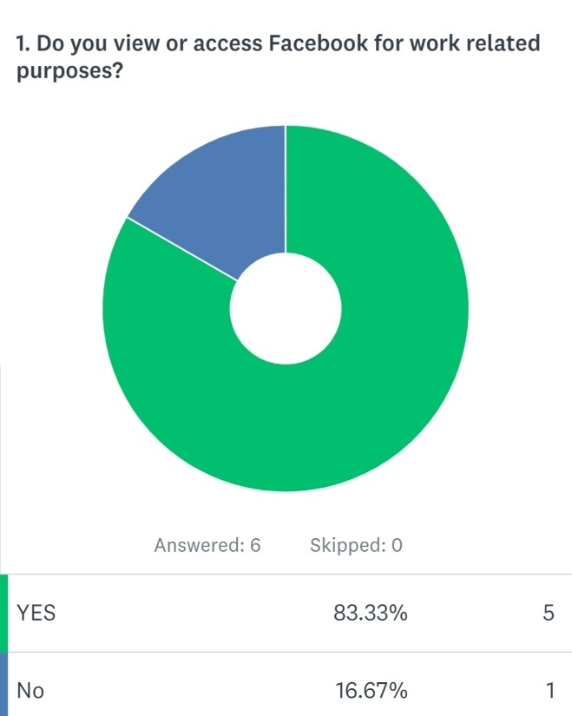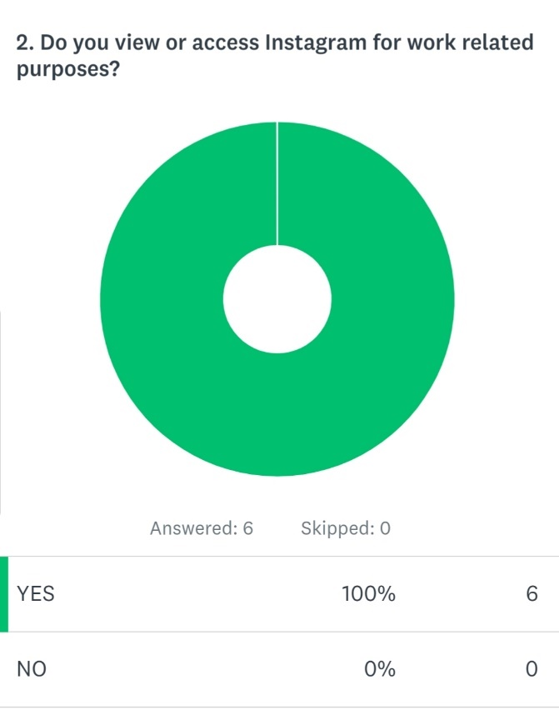

Appendix 2
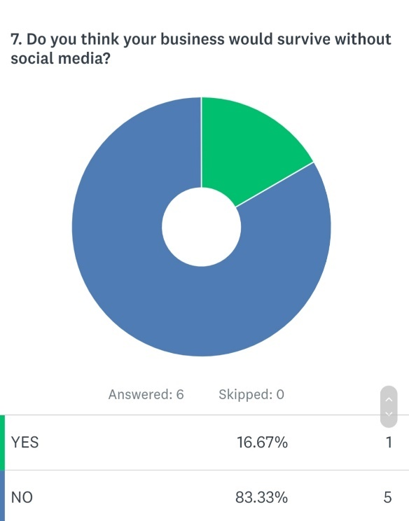

Appendix 3



